HW-6-REPORT

2. Part II: Identifying Bottlenecks (Single Task Setup)

Implementation summary:
- - Go service stores 100,000 products in memory.
- - Product fields implemented: id, name, category, description, brand.
- - Search endpoint: /products/search?q={query}.
- - Search logic checks exactly 100 products per request and stops.
- - Case-insensitive matching on name and category; returns max 20 products plus total_found.
- - Health endpoint /health used by ALB target group checks.
Verification evidence showed checked_products = 100 in API output.

Part II measured results:
- - Baseline (5 users, 2 min): 5,915 requests, 42.5 RPS, avg 79.5 ms, p95 83 ms, p99 120 ms, 0% failures.
- - Assigned stress case (20 users, 3 min): 35,589 requests, 195.5 RPS, avg 77.31 ms, p95 81 ms, p99 92 ms, 0% failures.
- - Creative stress extension (single task, 150 users): 256,128 requests, 1,273.8 RPS, avg 87.89 ms, p95 160 ms, p99 220 ms, 0% failures.
Resource analysis (from ECS/CloudWatch): CPU was the first constrained resource under heavy stress; memory stayed relatively stable because product data is preloaded at startup.

Part II required question answers:
- - Which resource hits the limit first? CPU utilization is the primary limiter; memory did not show equivalent pressure growth.
- - How much did response times degrade? At moderate load (5 -> 20 users) there was little degradation. Under strong stress (single task 150 users), p95 increased from 83 ms to 160 ms and p99 increased from 120 ms to 220 ms.
- - Could doubling CPU (256 -> 512) help? Yes, it would improve per-task headroom and delay saturation, but it does not provide failure isolation or elastic capacity like horizontal scaling.

3. Part III: Horizontal Scaling with ALB + Auto Scaling

Configuration summary:
- - Application Load Balancer forwarding to ECS Fargate tasks.
- - Target group health path: /health.
- - Autoscaling policy based on ECS Service Average CPU.
- - Min/desired/max settings validated at 2/2/4; CPU target tuned (70 then 20) to demonstrate scale events.

Observed scaling behavior:
- - Service scaled from 2 tasks to 4 tasks under sustained load.
- - Observed sequence: 2/2/0 -> 4/2/2 -> 4/3/1 -> 4/4/0 (desired/running/pending).
- - Targets remained healthy while additional tasks were registered.

Part III measured results:
- - Scaled service test (150 users): 260,587 requests, 1,421.1 RPS, avg 80.25 ms, p95 88 ms, p99 170 ms, 0% failures.
- - Extended scaled test: 552,209 requests, 1,450.5 RPS, avg 80.76 ms, p95 92 ms, p99 170 ms, 0% failures.
Compared with single-task heavy load, horizontal scaling improved latency tail behavior and kept failure rate at 0% while increasing throughput.

Resilience test (required):
- - During active load, one ECS task was stopped manually.
- - Load test continued successfully with no failures.
- - ECS replaced the stopped task and returned to steady state.
This demonstrates fault tolerance benefits of horizontal scaling over a single-instance approach.

4. Required Discussion Questions

How did the system respond to the load that broke Part II?
With multiple tasks behind the ALB, the service absorbed high request volume with stable success rate and lower tail latency than the single-task stress case.

When were new instances added?
New tasks were added after sustained CPU pressure crossed the autoscaling target and cooldown constraints; the service transitioned from 2 to 4 desired tasks.

How was load distributed?
The ALB distributed traffic across healthy targets in the target group. As tasks became healthy, request handling spread across additional task IPs.

What happened to response times as scaling occurred?
Response time tails improved relative to single-task heavy load. Under scaled runs, p95/p99 remained materially lower than the single-task 150-user run.

Role of each component:
- - ALB: front-door traffic distribution and availability abstraction.
- - Target Group: health-aware registration and routing only to healthy tasks.
- - Auto Scaling: adjusts ECS desired count based on CPU telemetry.

Horizontal vs vertical scaling trade-offs:
Horizontal scaling adds resilience and elasticity but increases orchestration/network complexity. Vertical scaling is simpler operationally but bounded by instance limits and does not remove single-task failure exposure.

Predicted behavior for load patterns:
- - Gradual increase: smoother scale-out, fewer latency spikes.
- - Sudden spikes: short-term queueing/latency increase before new tasks become healthy, then stabilization.

Creative stress testing evidence:
Beyond required 5 and 20-user tests, additional 150-user and autoscaling-threshold experiments were run, plus an in-flight task failure simulation under load.

5. Cleanup and Submission Status
Infrastructure was destroyed after testing, including ECS service, ALB resources, autoscaling resources, and ECR repository (after image cleanup).
This report is submit-ready and includes labeled screenshot evidence below.

6. Screenshot Evidence (Chronological)
Figure 1. Initial prerequisite setup and command execution overview.
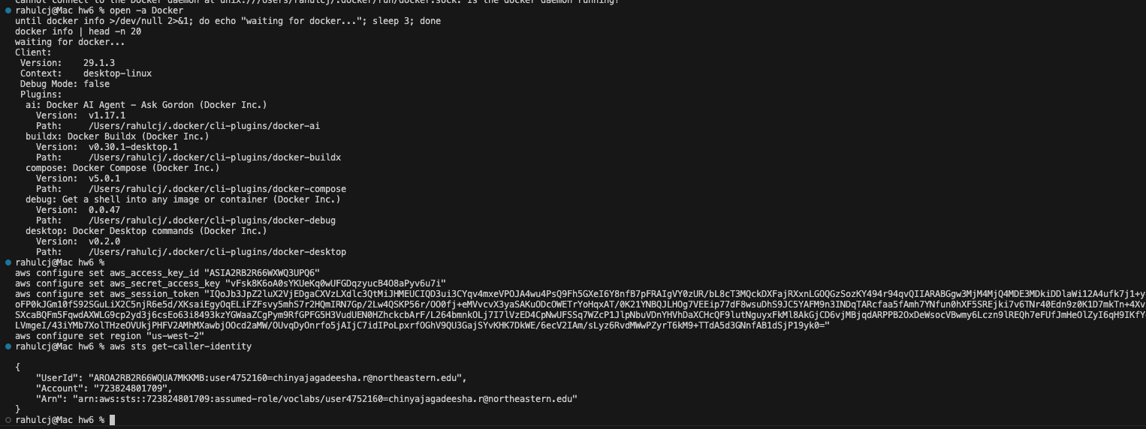

Figure 2. Docker and AWS credential validation evidence
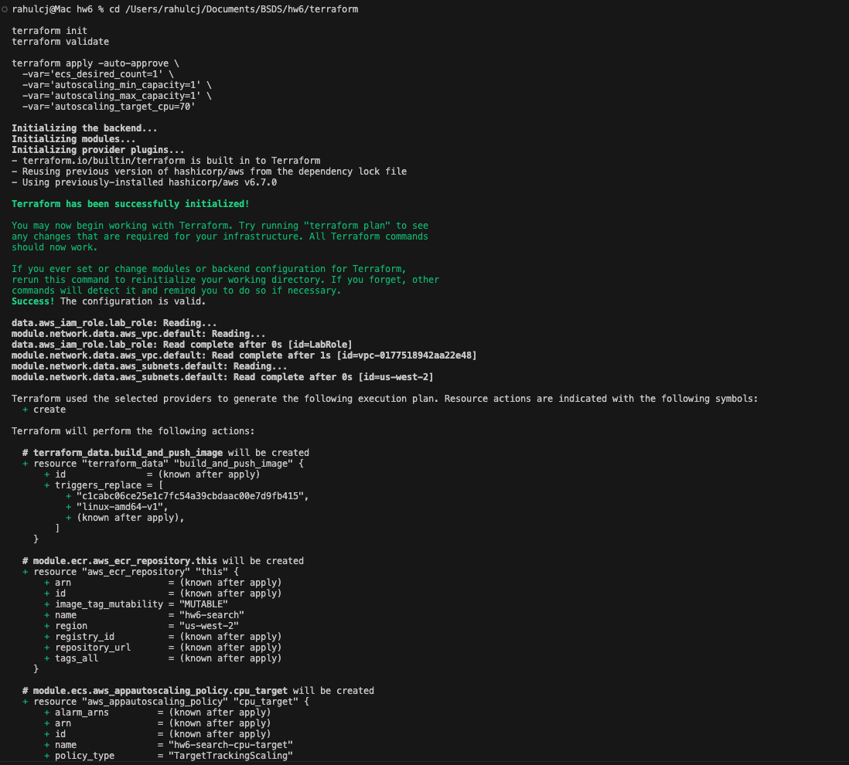

Figure 3. Terraform init/validate and first apply command execution.
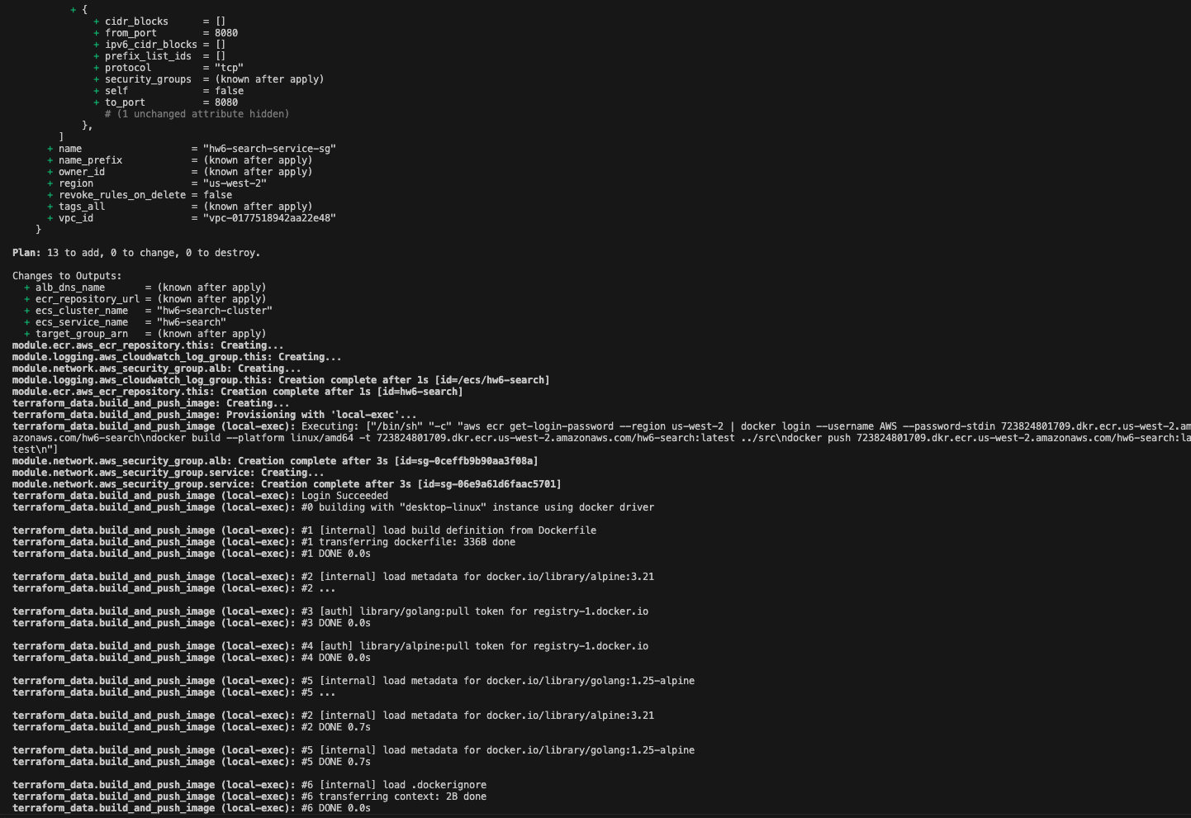

Figure 4. Terraform plan details for initial Part II deployment.
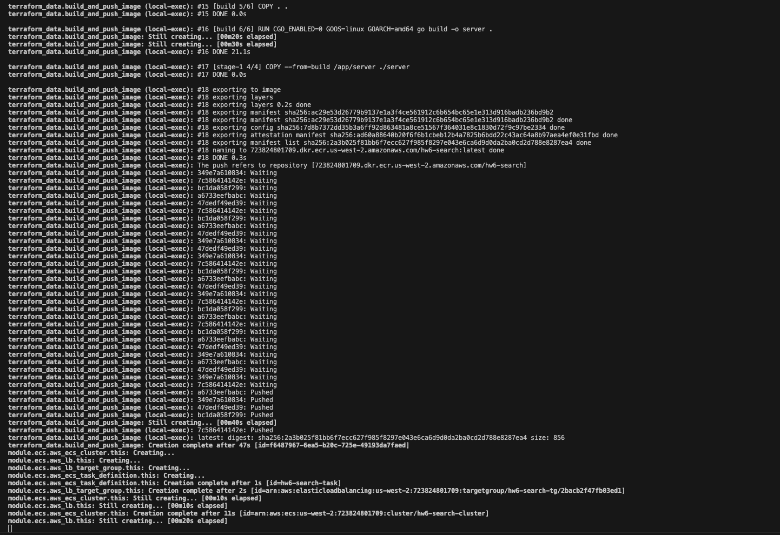

Figure 5. Docker image build and push to ECR during apply.
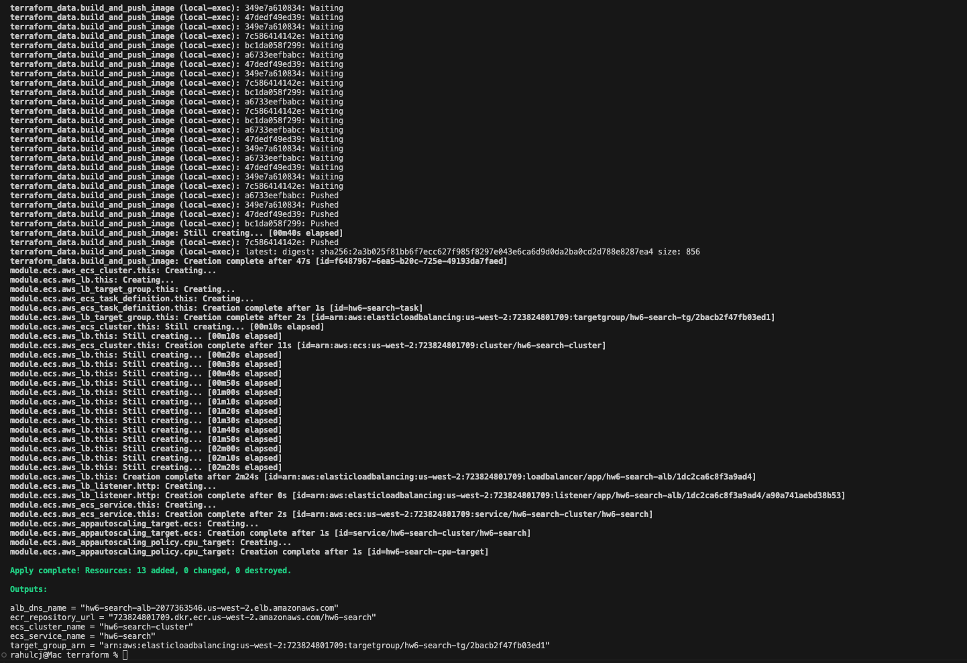

Figure 6. ECS, target group, and load balancer creation progress.
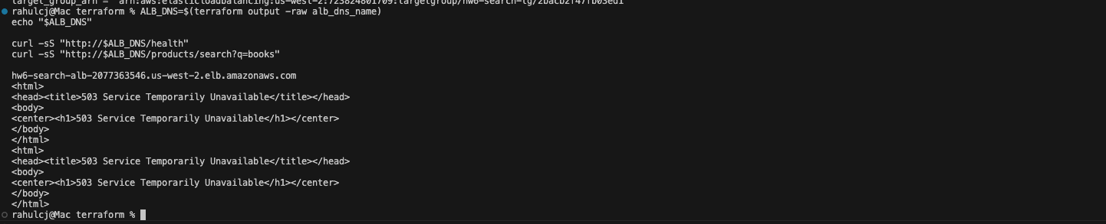

Figure 7. Terraform apply completion with output values.
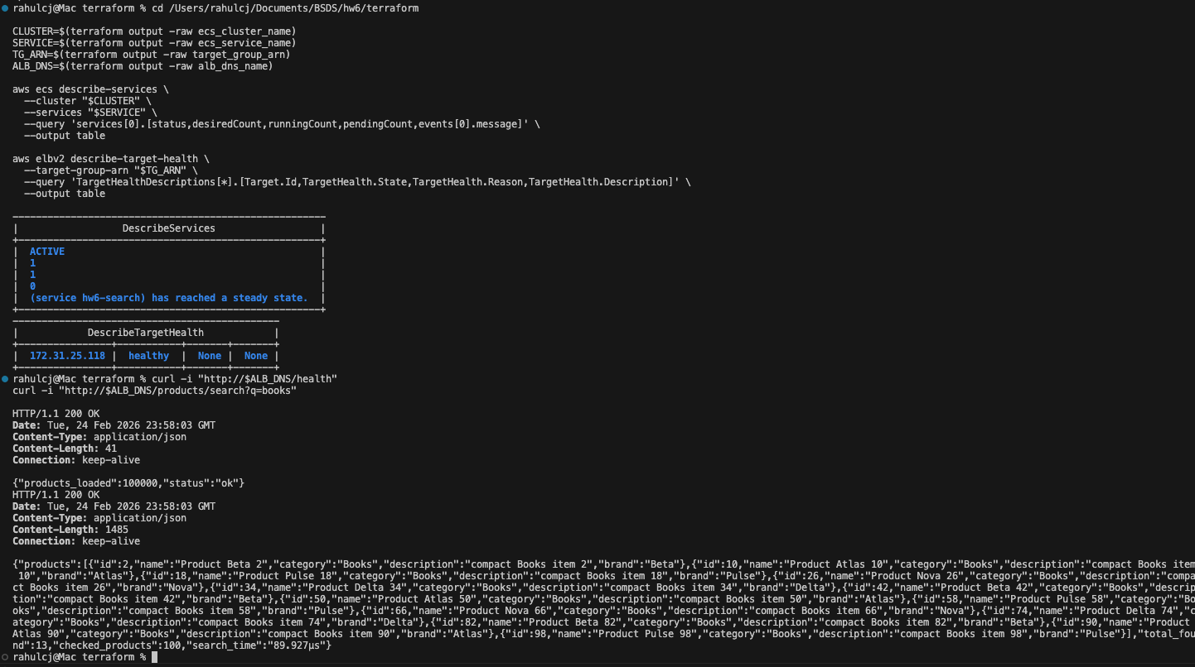

Figure 8. Initial ALB endpoint test showing temporary 503 during warm-up.
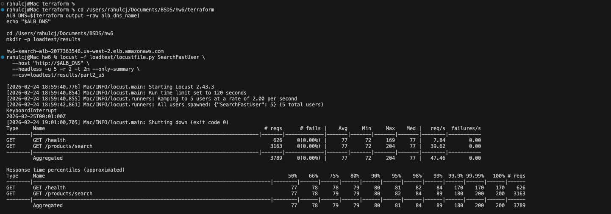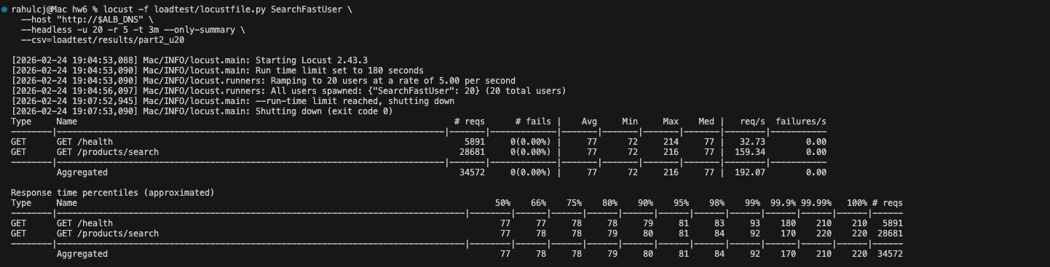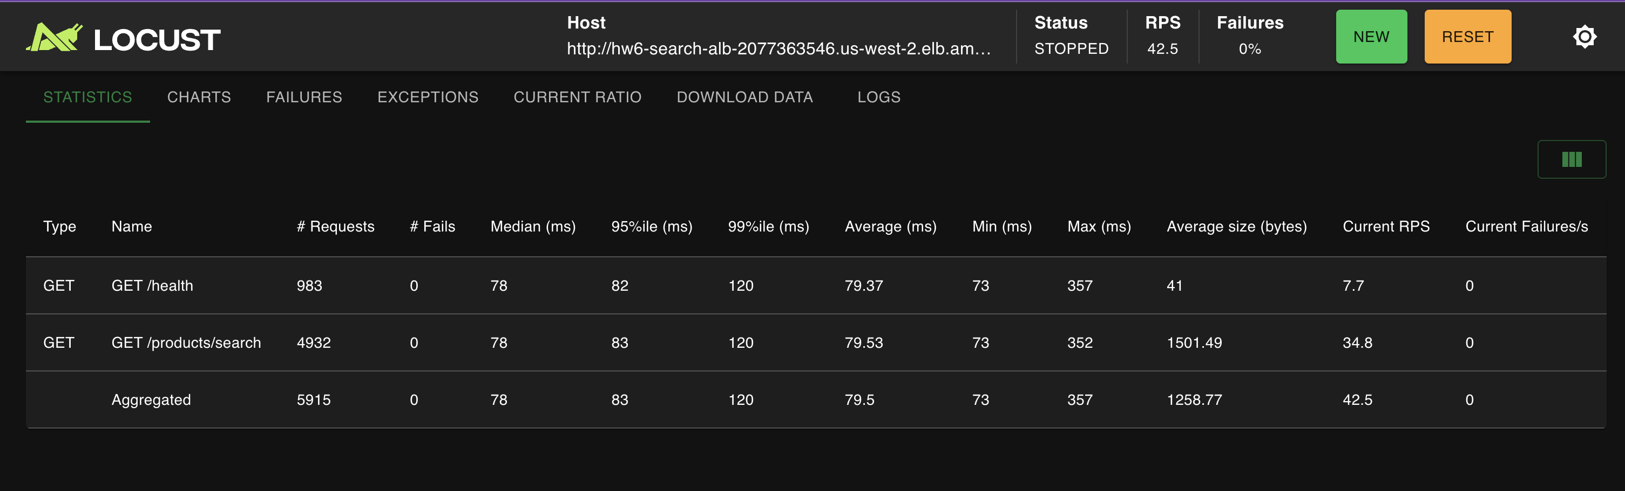

Figure 9. ECS service state and target group health verification.
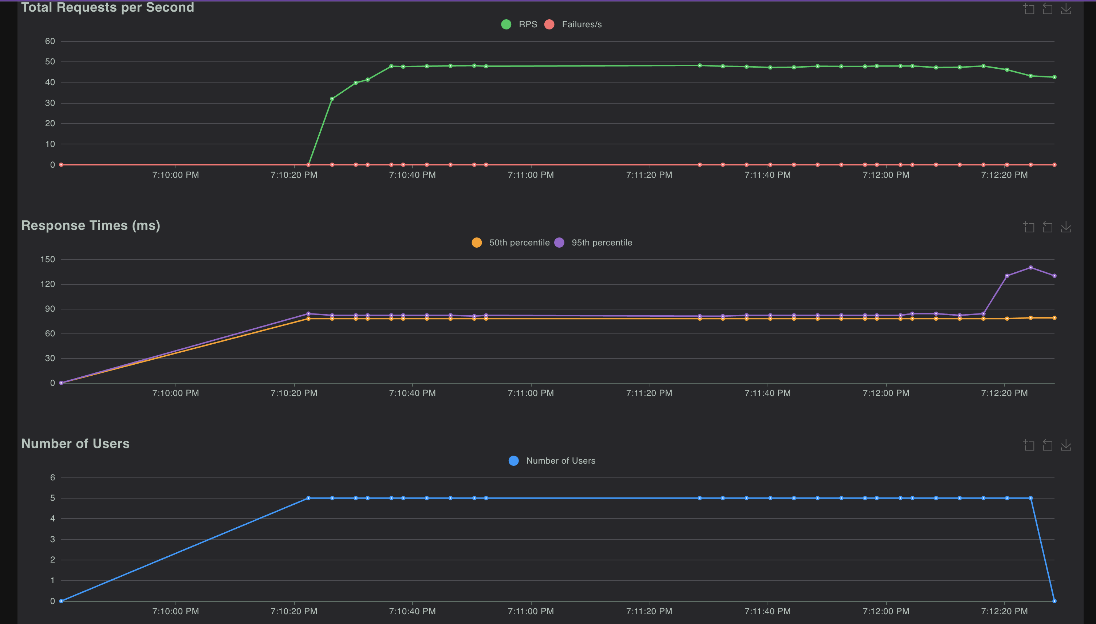

Figure 10. Successful /health and /products/search endpoint validation.
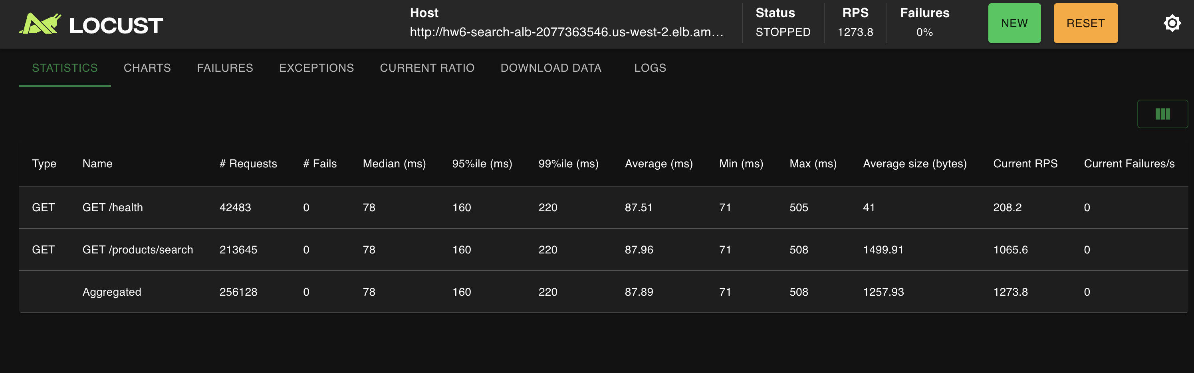

Figure 11. Baseline load test summary (5 users, 2 minutes).
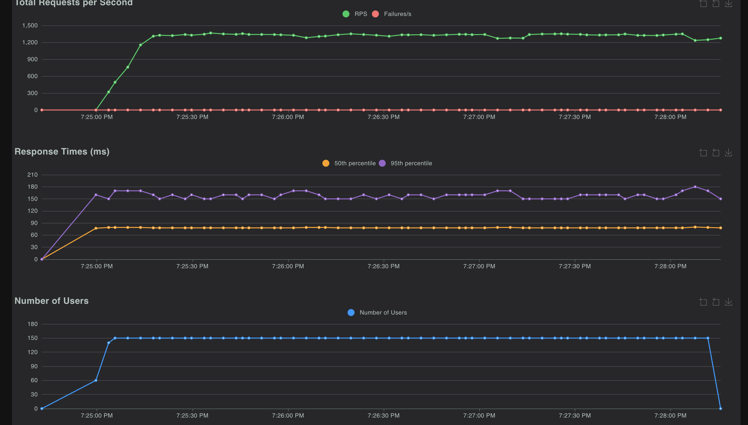

Figure 12. Early 20-user load test run and interruption record.
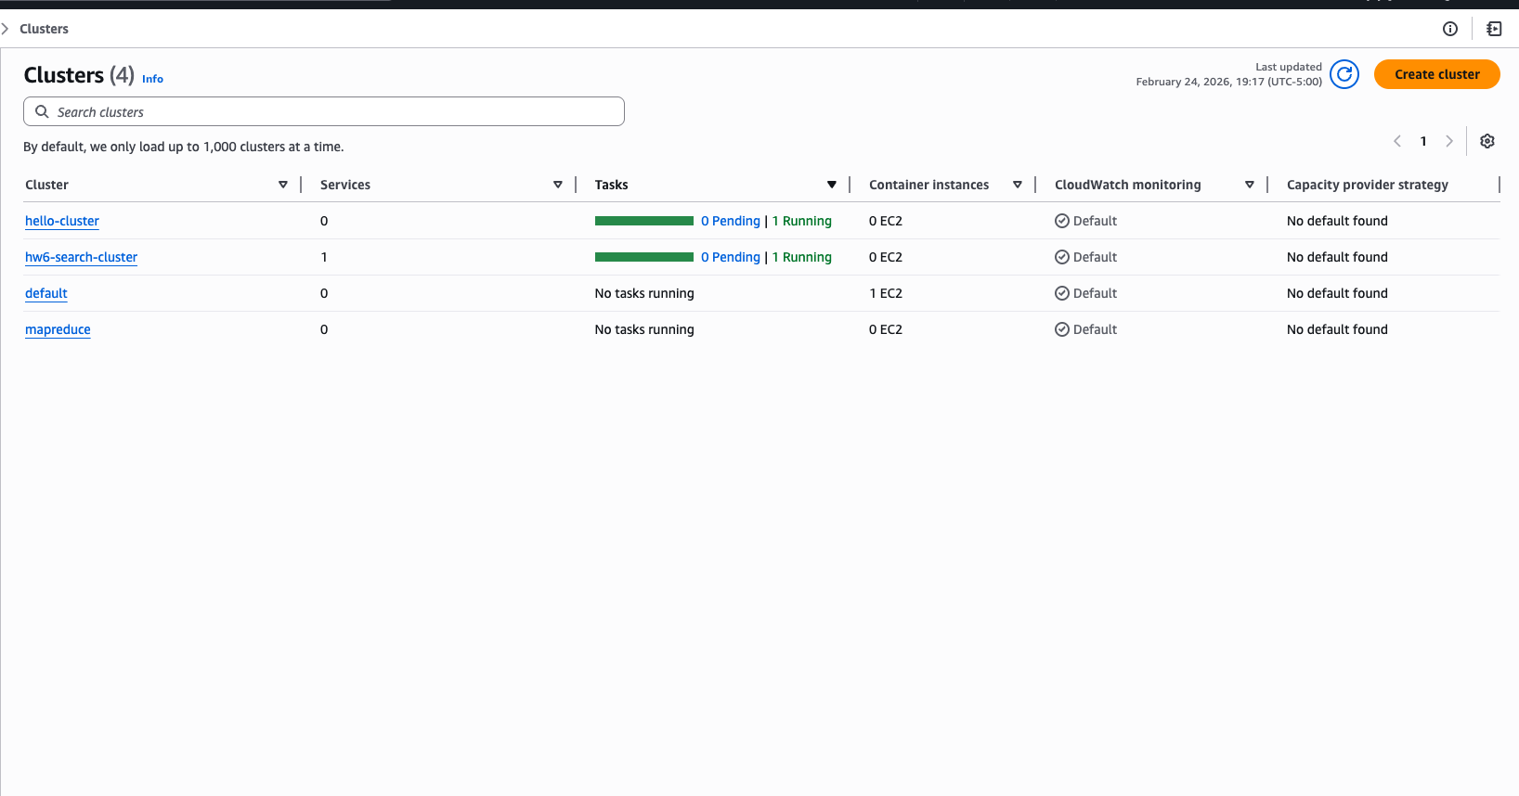

Figure 13. Locust UI baseline statistics for Part II baseline test.
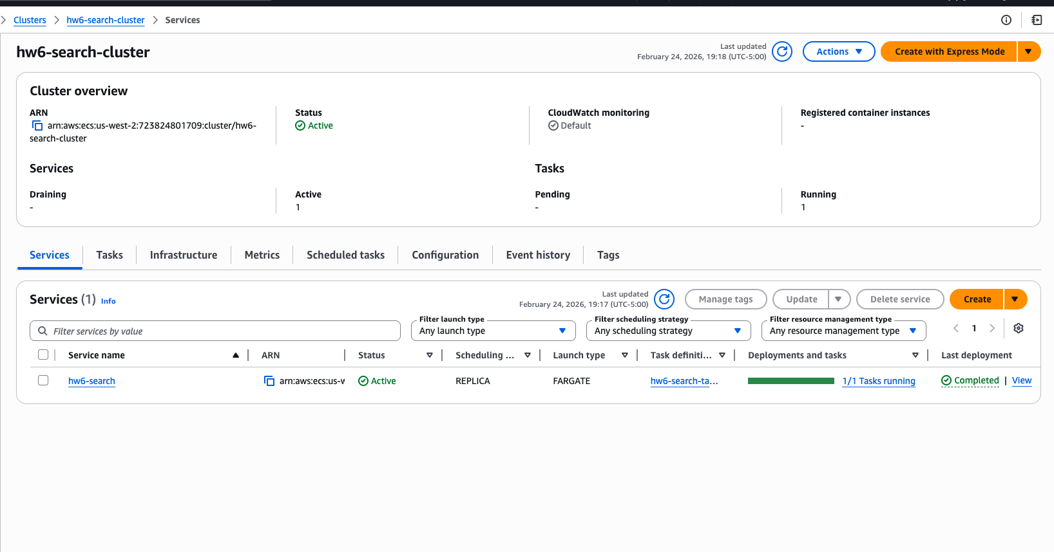

Figure 14. Locust UI baseline charts for throughput and latency.
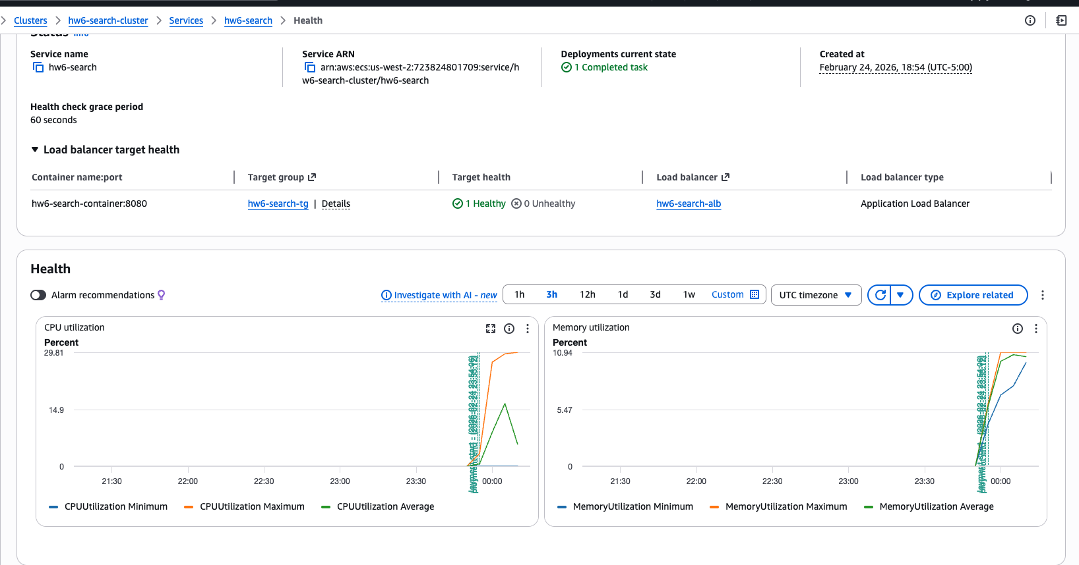

Figure 15. Locust UI 20-user statistics for Part II stress test.
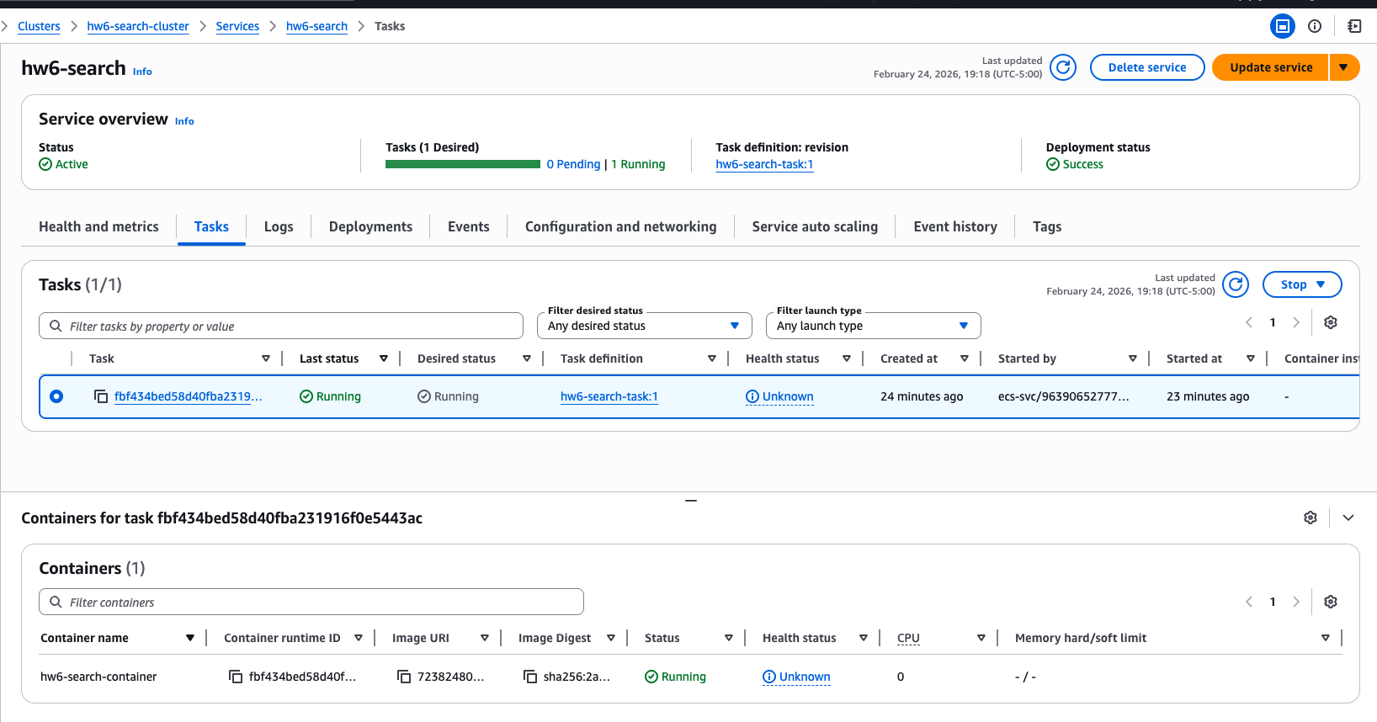

Figure 16. Locust UI 20-user charts for throughput and latency.
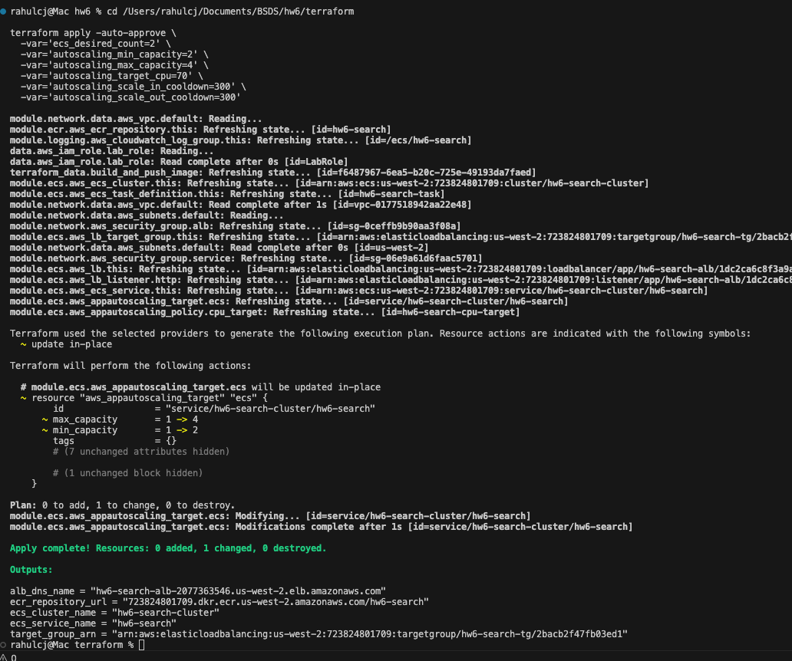

Figure 17. ECS cluster state during Part II execution.
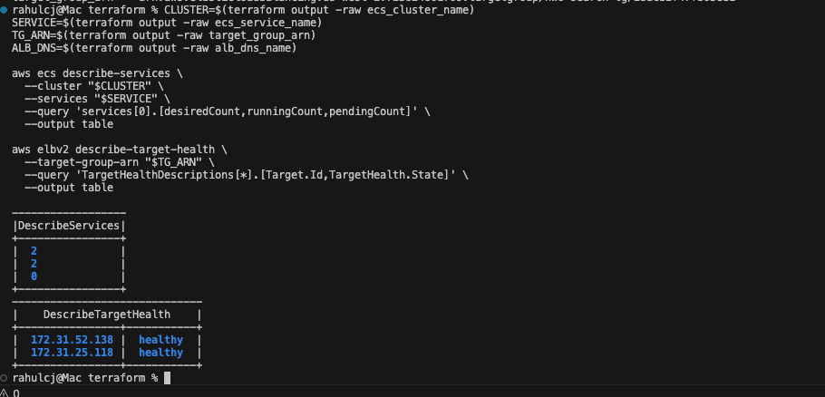

Figure 18. ECS service health and resource metrics during Part II.
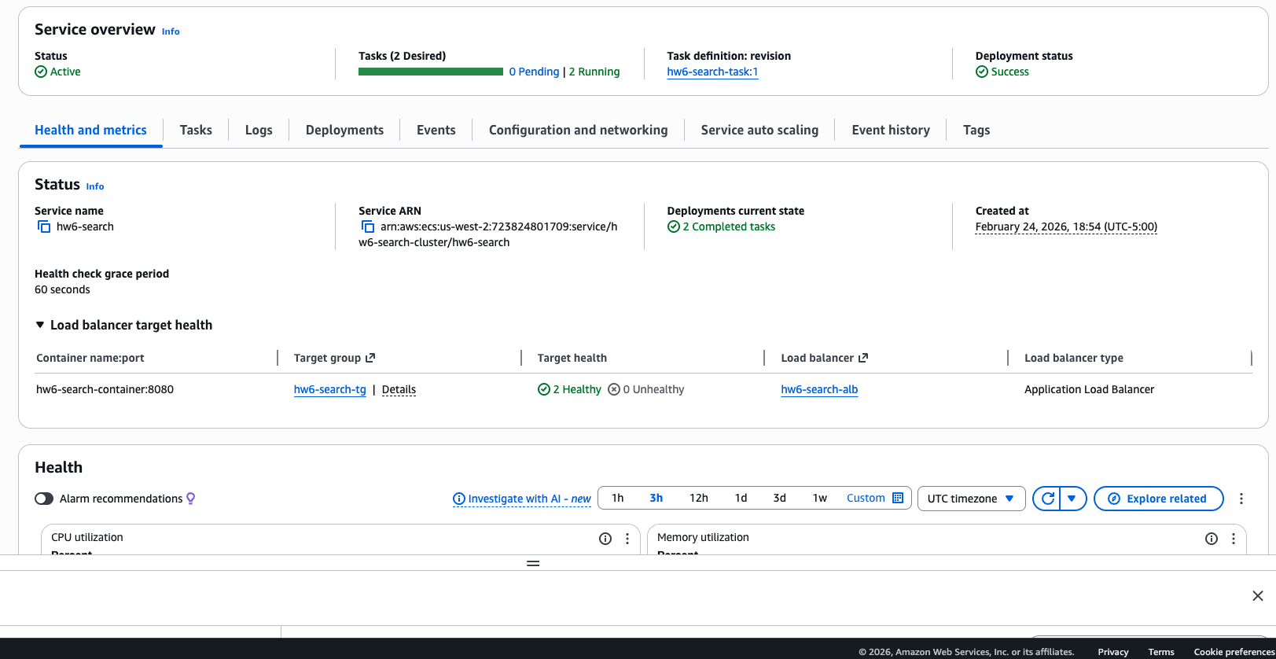

Figure 19. CloudWatch autoscaling alarm status view.
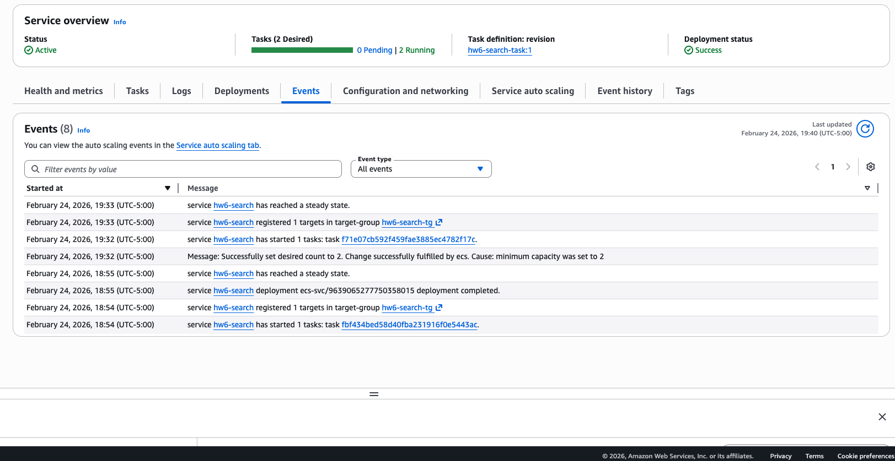

Figure 20. High-stress single-task test statistics (150 users).
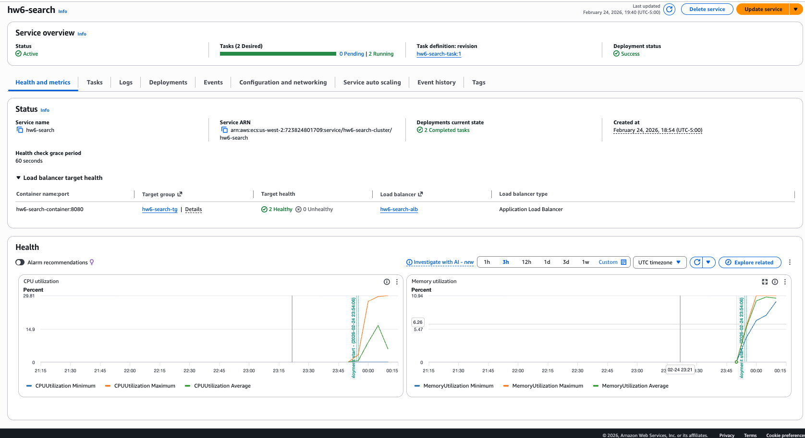

Figure 21. High-stress single-task test charts (150 users).
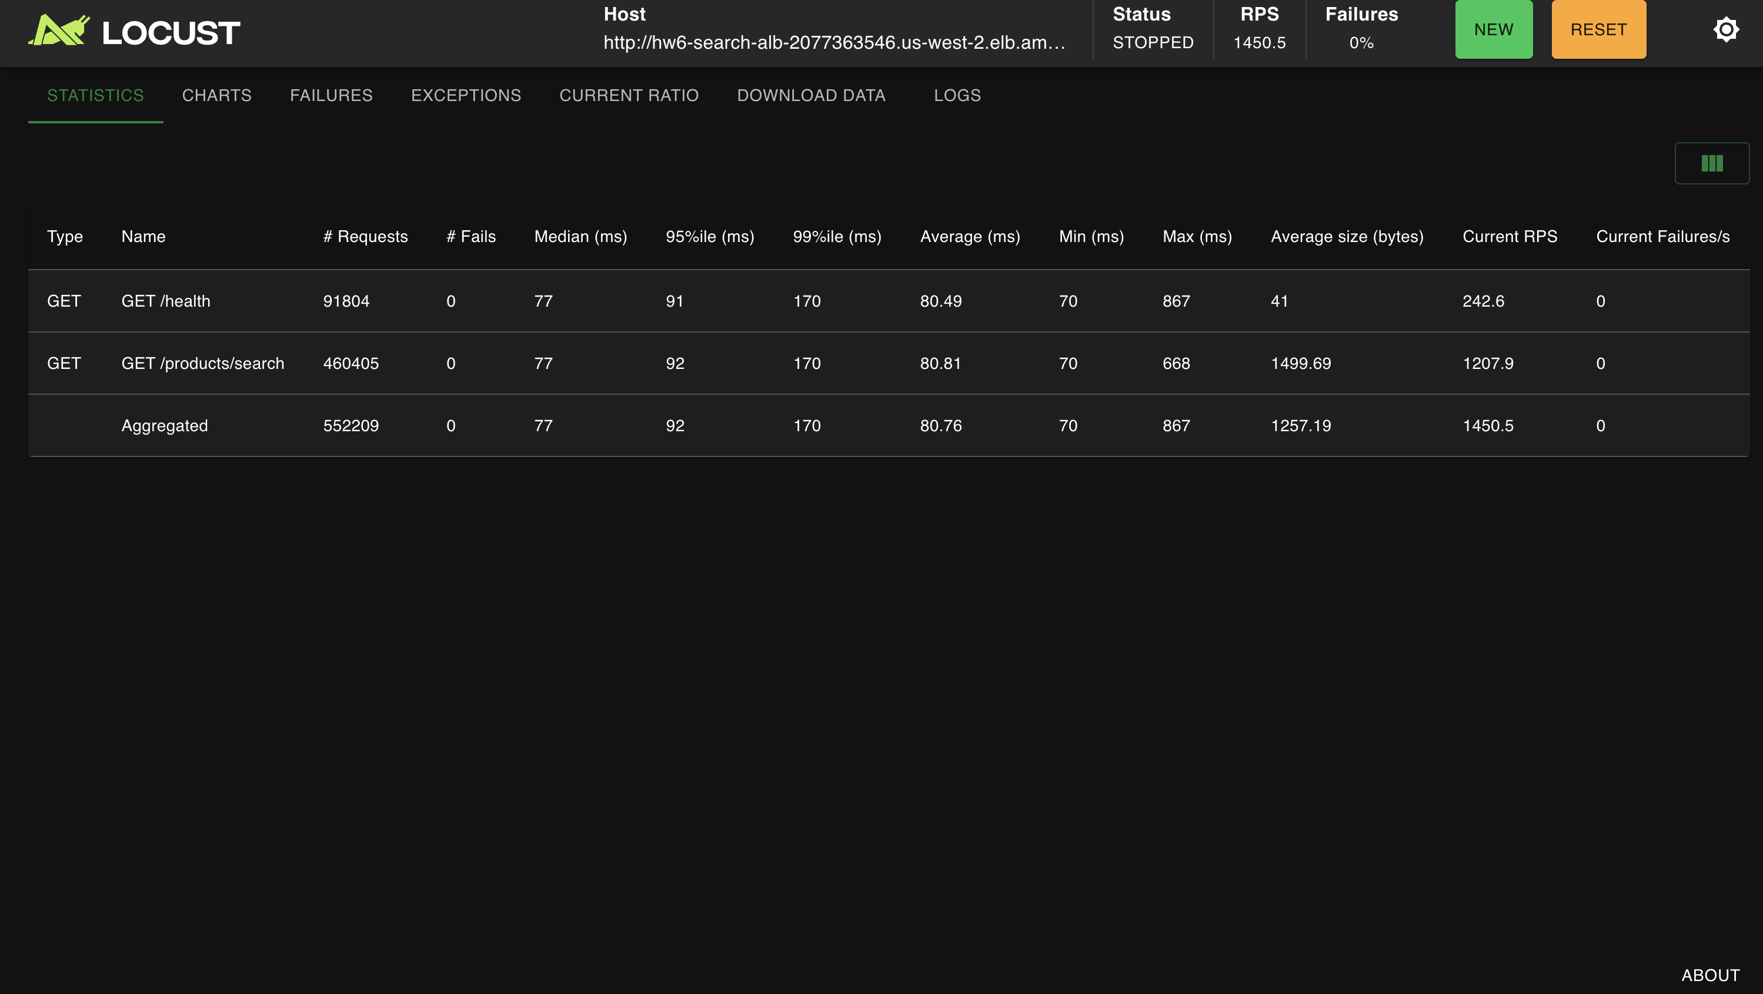
Figure 22. Terraform apply update for Part III autoscaling settings.
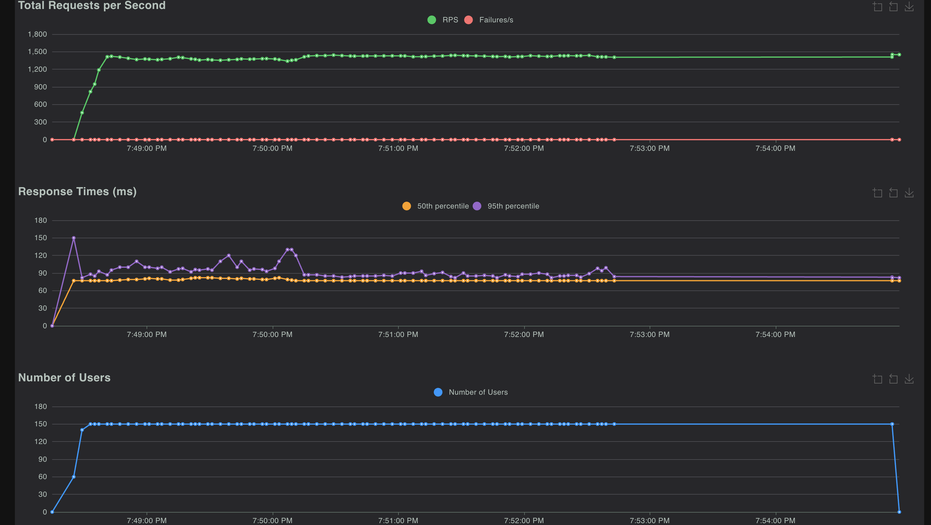

Figure 23. ECS desired/running count and target health after Part III apply.
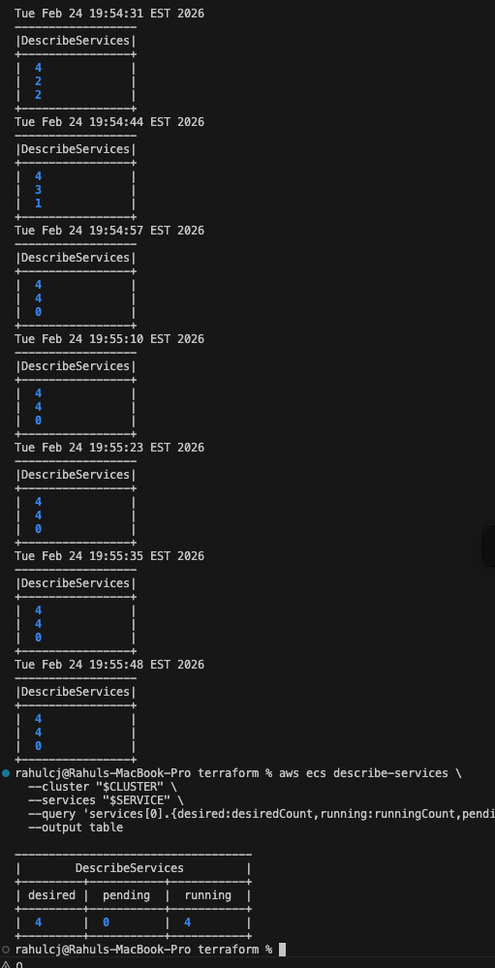

Figure 24. ECS service health tab after horizontal scaling rollout.
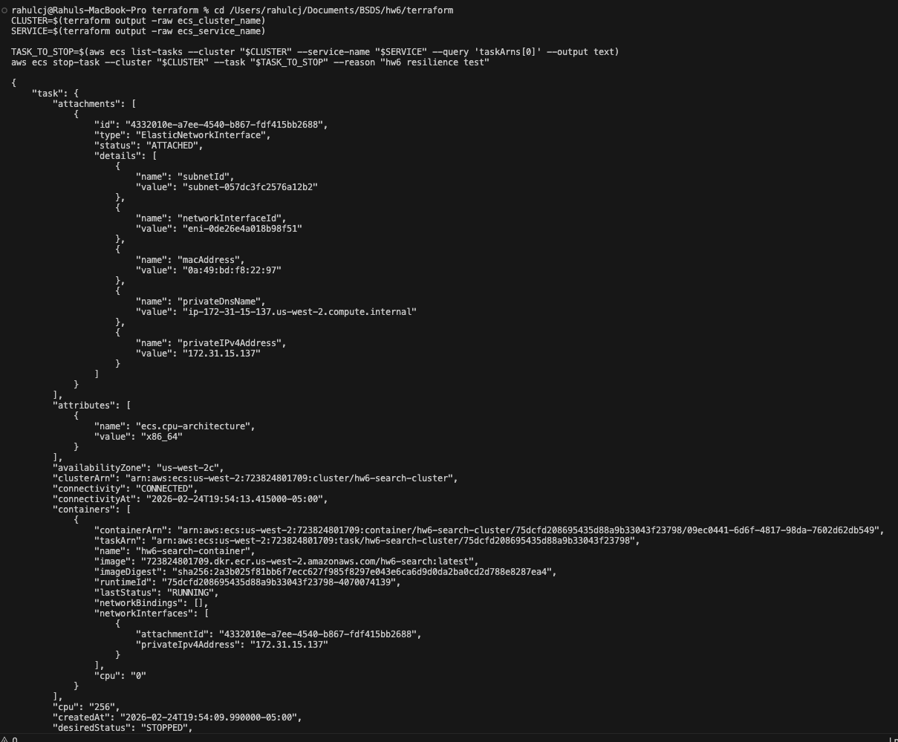

Figure 25. Part III Locust statistics under scaled service.
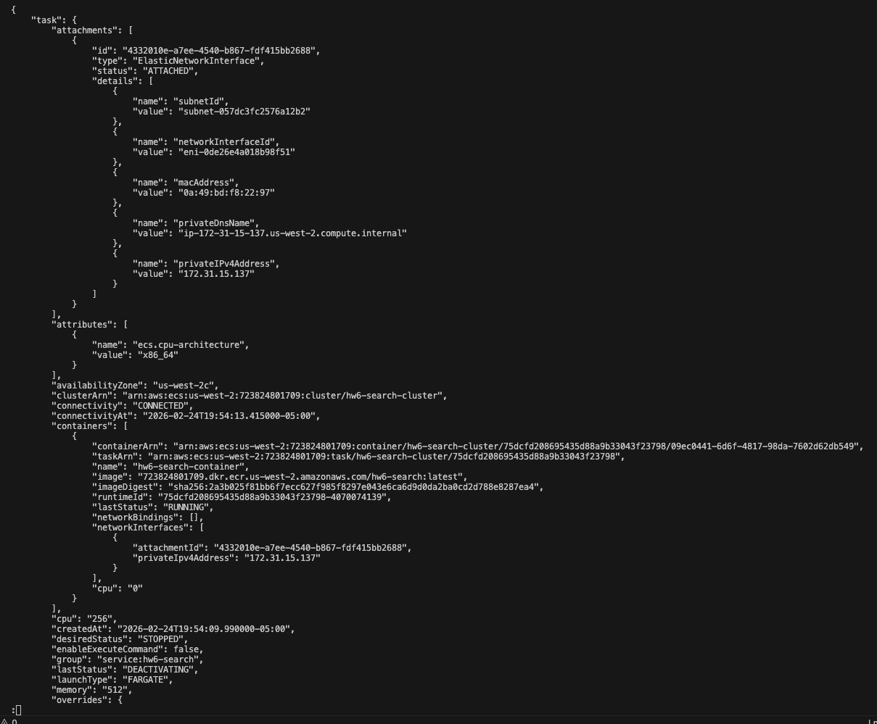

Figure 26. Part III Locust charts under scaled service.
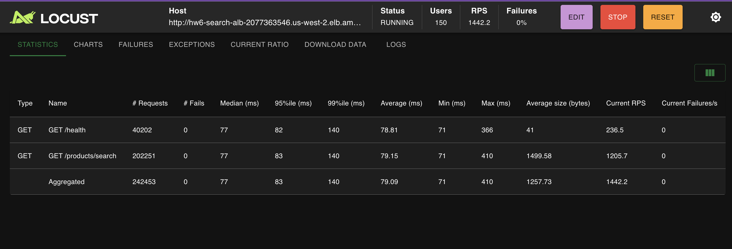

Figure 27. Service count transitions showing autoscale-out behavior.
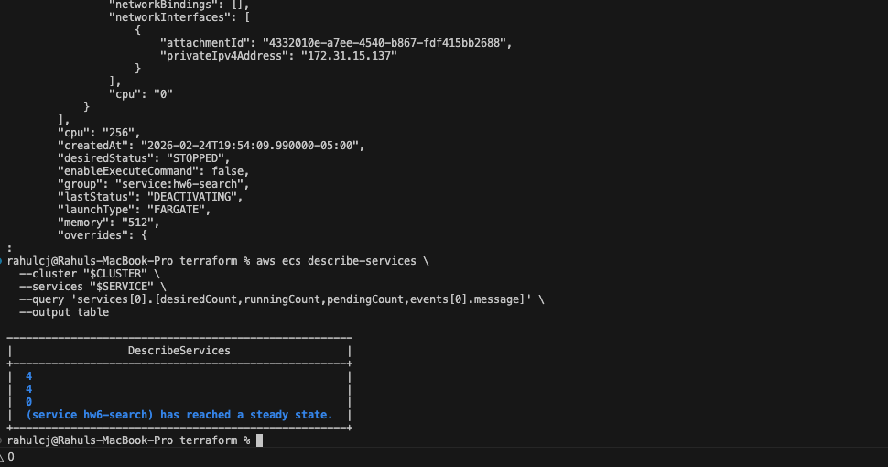

Figure 28. Resilience test stop-task command execution.
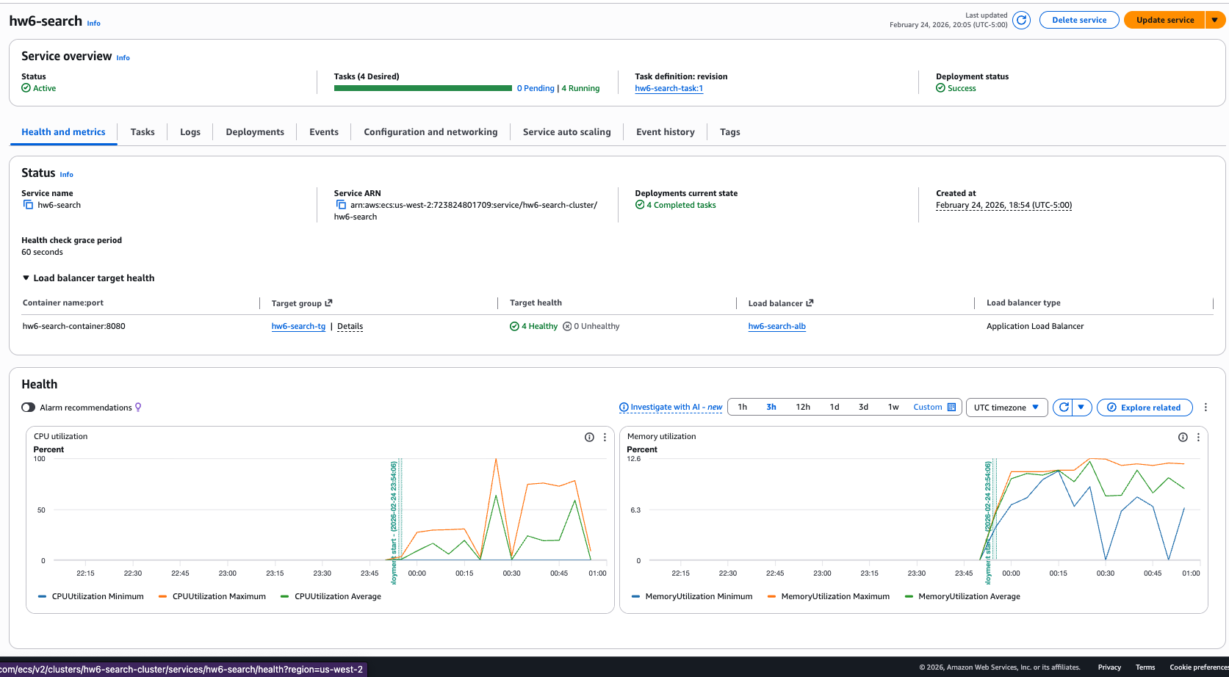

Figure 29. Detailed stop-task output from ECS API.
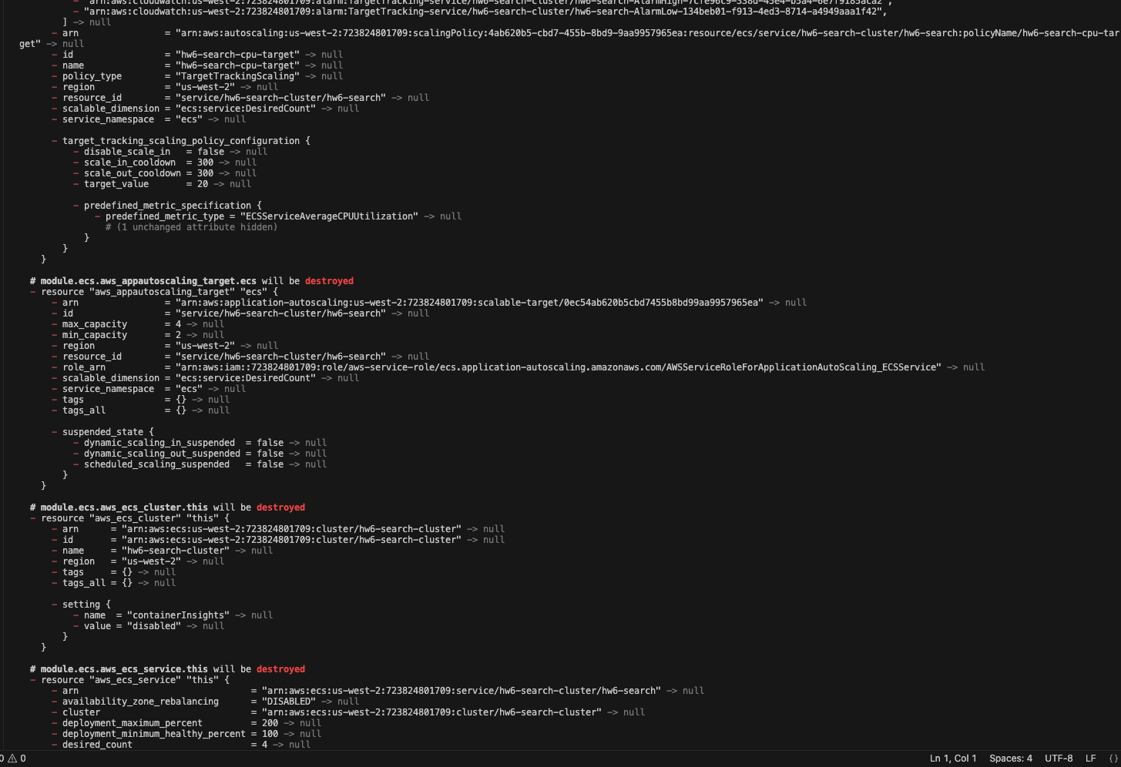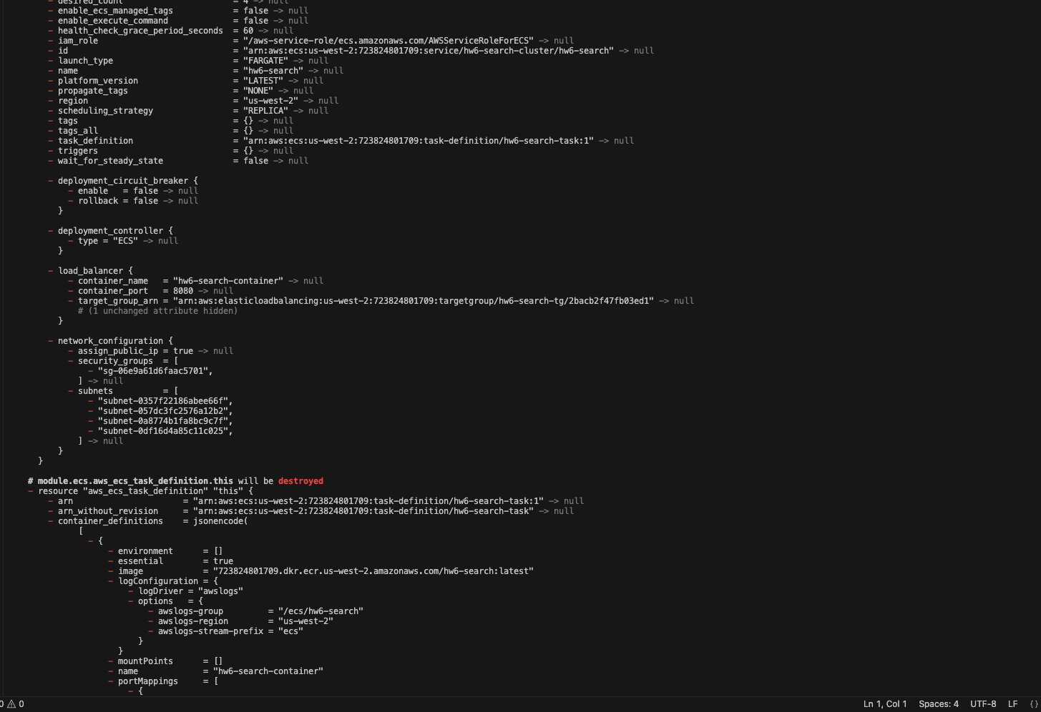

Figure 30. Locust remained stable during resilience task-stop event.
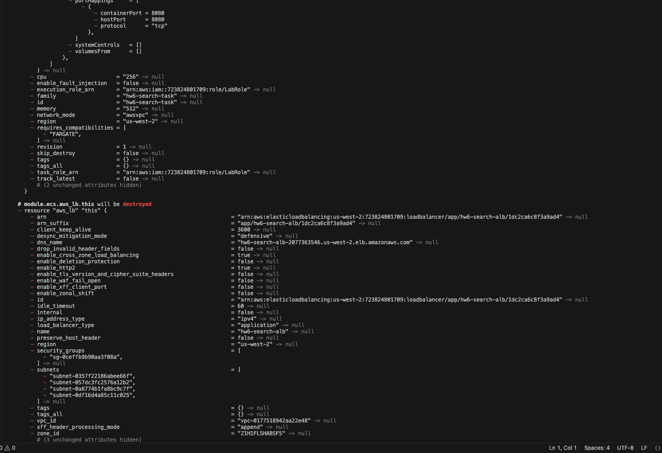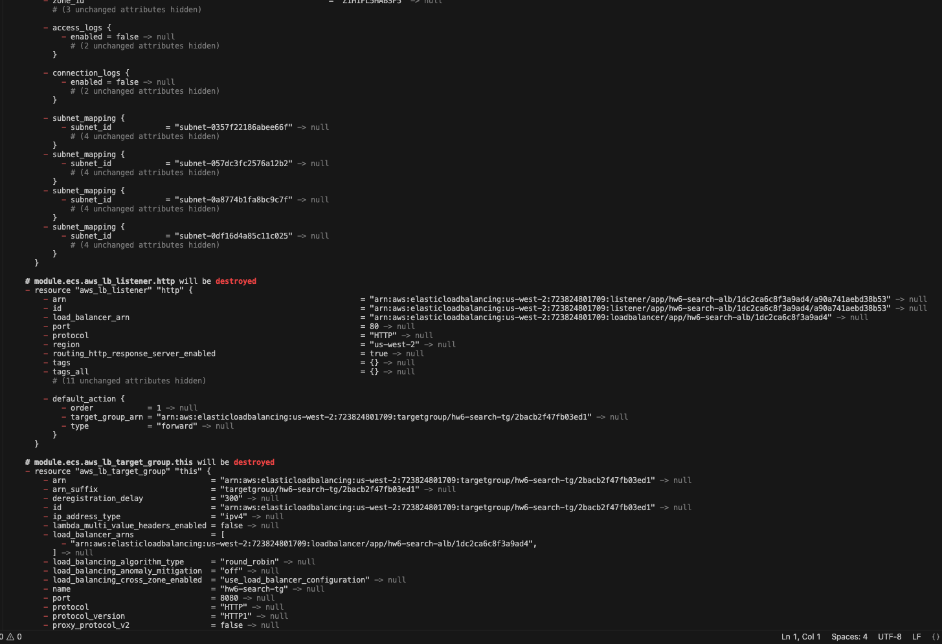

Figure 31. ECS service returned to steady healthy state after replacement.
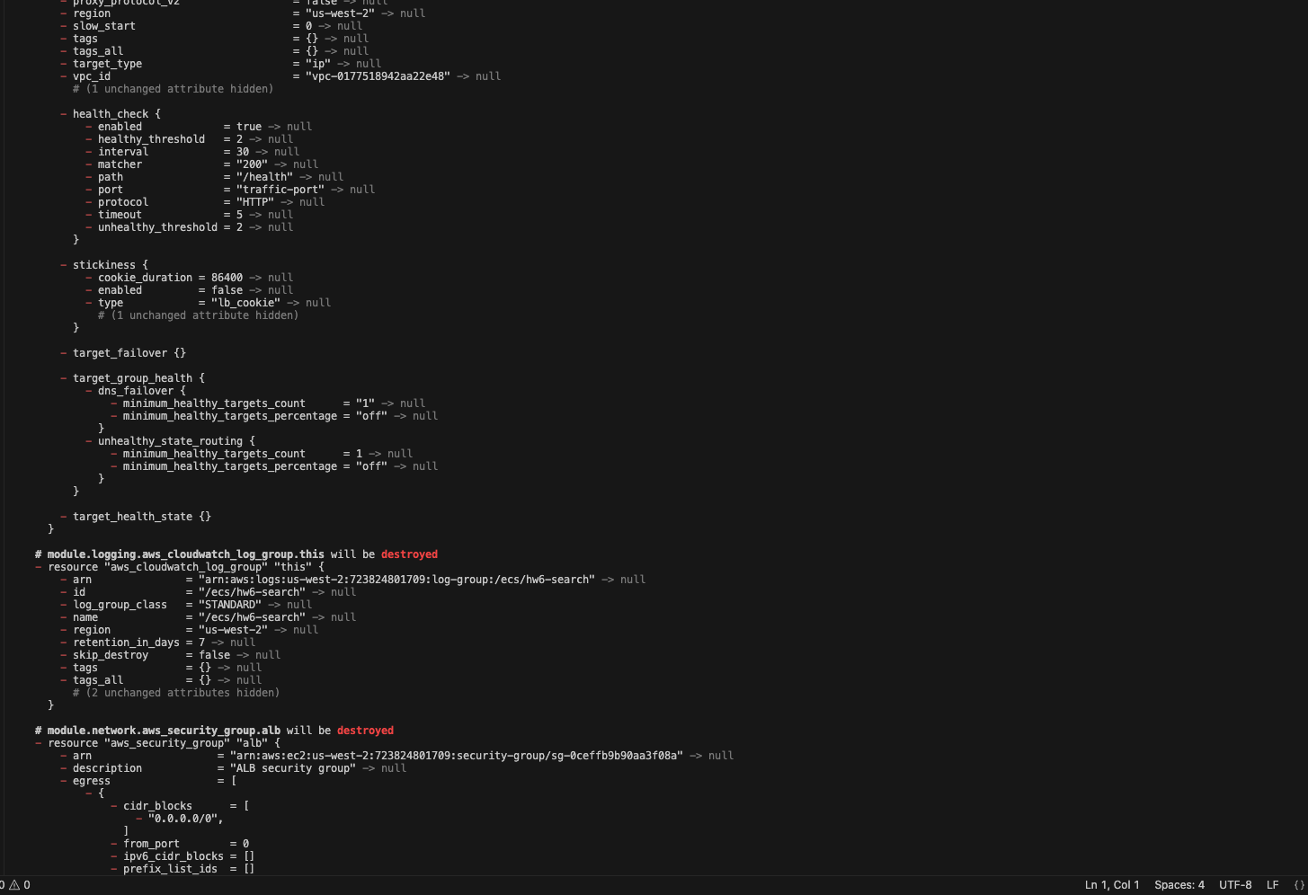

Figure 32. Terraform destroy execution with remaining resources listed.
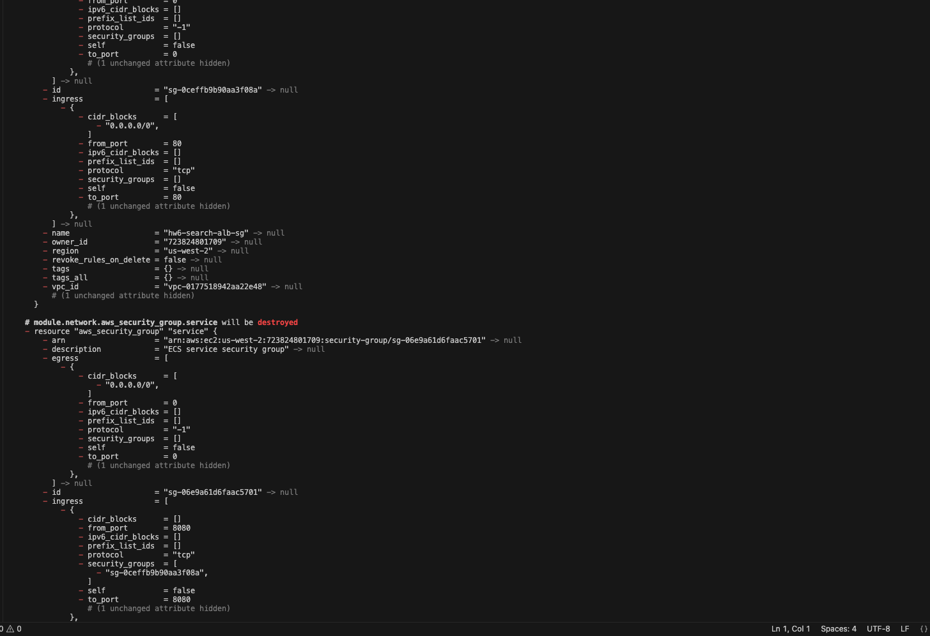

Figure 33. Terraform destroy detailed resource teardown (continued).
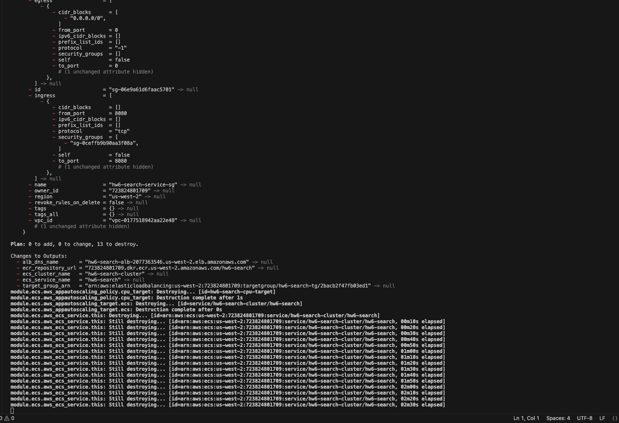

Figure 34. Terraform destroy detailed resource teardown (continued).
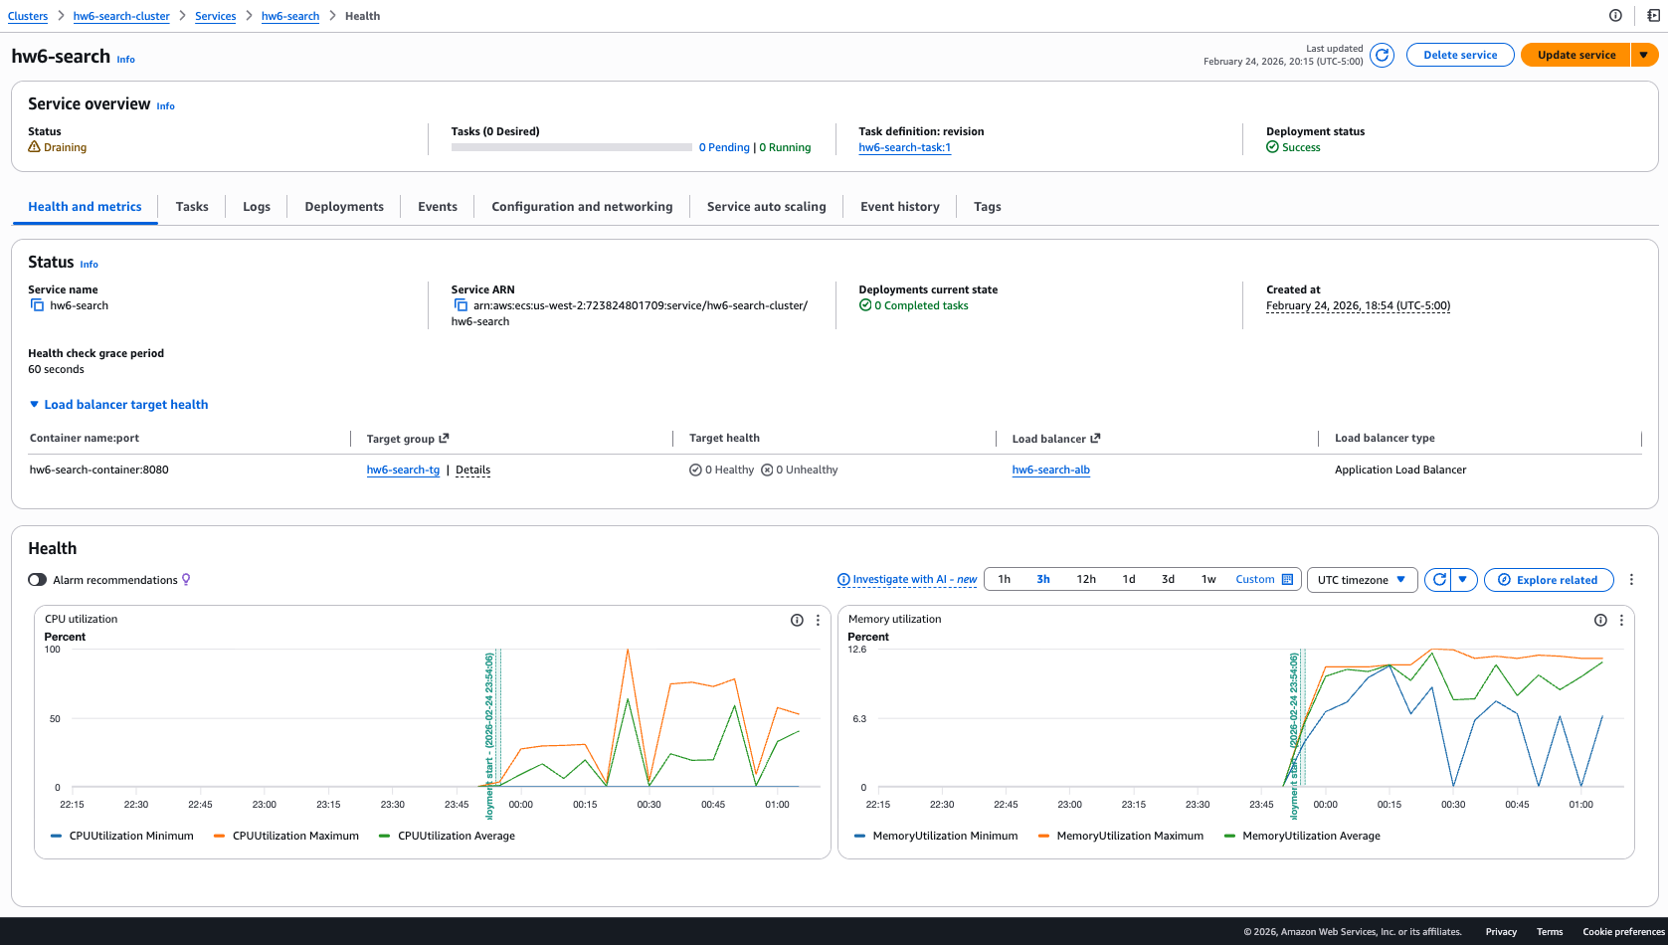

Figure 35. Terraform destroy detailed resource teardown (continued).
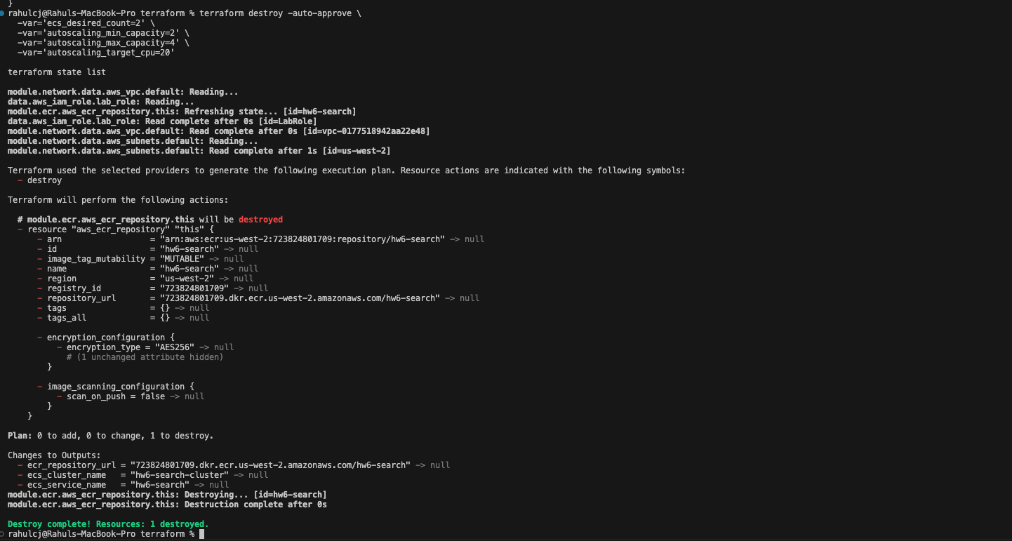

Figure 36. ECR non-empty repository cleanup error during destroy.
