CS6650 Homework 8 Report — Data Layer (MySQL vs DynamoDB)

Step I: MySQL Integration

Schema Design

Tables:
- `carts(cart_id PK, customer_id, created_at)`
- `cart_items(cart_id, product_id, quantity, updated_at, PK(cart_id, product_id), FK→carts)`

Indexes:
- `carts.customer_id` for history queries

Why this structure?
I used a two‑table design to normalize carts vs items and to keep item updates atomic at the row level. The `cart_items` composite primary key supports `INSERT ... ON DUPLICATE KEY UPDATE` for add/update semantics, while the FK with `ON DELETE CASCADE` prevents orphaned items. The `carts.customer_id` index supports customer‑history queries even though the API doesn’t expose that endpoint yet. The schema also supports item removal via `DELETE FROM cart_items WHERE cart_id=? AND product_id=?`, which is consistent with the requirement to add/update/remove items even if the API doesn’t include a delete endpoint.

Constraints vs requirements:
The <50ms requirement was not met in this run (avg ~160ms), which I attribute to network + RDS overhead and the single‑task deployment rather than query inefficiency. The schema still supports 50 items/cart and concurrent cart updates because each item row is independently addressable.

Connection Pooling

Configuration:
Configured in code with:
`DB_MAX_OPEN=20`, `DB_MAX_IDLE=10`, `DB_MAX_LIFETIME_SEC=300` (defaults). This keeps a small warm pool for the 150‑op test while preventing long‑lived connections from accumulating. With a single ECS task, these values are conservative and safe; in a multi‑task setup, I’d reduce per‑task max open connections to avoid exhausting RDS connections.

Transaction handling:
The `add_items` path uses a single upsert statement (`INSERT ... ON DUPLICATE KEY UPDATE`) which is atomic for that row. A separate existence check for the cart is done prior to the upsert. If strict atomicity across both checks is required, this should be wrapped in an explicit transaction, but for this access pattern the upsert itself is the critical atomic operation.

Input validation & SQL injection prevention:
All SQL statements use parameterized queries, and the handlers validate `customer_id`, `product_id`, and `quantity` before executing DB calls. Invalid IDs return 400 responses; not‑found carts return 404.

Learning Journey

Initial issues were mostly infrastructure and dependency related (IAM role restrictions in the lab and missing `git` in the Docker build context). After fixing those, the MySQL path was stable. I optimized for the test requirements by keeping the schema minimal, using a composite primary key for idempotent updates, and limiting connection pool size to avoid RDS connection spikes.

Week 5 comparison (in‑memory):
Compared to the Week 5 in‑memory approach, MySQL adds persistence and concurrency safety but increases latency due to network I/O and storage overhead. The trade‑off is durability and correctness across restarts vs raw speed. (Week 5 latency figures were not recorded in this submission; comparison is qualitative.)

What I’d do differently next time:
I would add a dedicated delete‑item endpoint and wrap the cart‑existence check + item upsert in a transaction to make the behavior fully atomic under concurrent operations.

Step I: Required Performance Testing (MySQL)

Test file: `mysql_test_results.json` (150 ops)
Response time pattern: Avg 160.271ms, P50 158.414ms, P95 171.231ms, P99 189.985ms, 100% success.

CloudWatch monitoring summary (MySQL):
RDS CPU and DatabaseConnections were captured during the test window. CPU spiked to ~47% at the start of the run, then stabilized around ~5–8%, which suggests a short burst of work followed by steady low utilization. DatabaseConnections peaked at 1, indicating the connection pool behaved as expected and the single ECS task didn’t open excessive connections. ECS tasks remained healthy (ALB `/health` returned 200 throughout testing). I/O metrics (Read/Write IOPS) were not explicitly captured in screenshots but can be added by selecting `ReadIOPS` and `WriteIOPS` under RDS metrics if needed.

<50ms requirement gap analysis:
The measured average (~160ms) is above the <50ms target. Likely contributors are network latency between ECS and RDS, TLS/connection overhead, and JSON serialization, rather than query inefficiency (the queries are simple PK and indexed lookups). I did not run `EXPLAIN` on the queries during this run; a next step would be to use `EXPLAIN` and RDS Performance Insights to separate query time from network time. If optimizing for <50ms, I would keep ECS and RDS in the same AZ, reduce JSON payload size, enable prepared statements, and add a small in‑memory cache for hot carts.

CloudWatch Screenshots (RDS):
- CPU Utilization
- Database Connections

RDS CPU
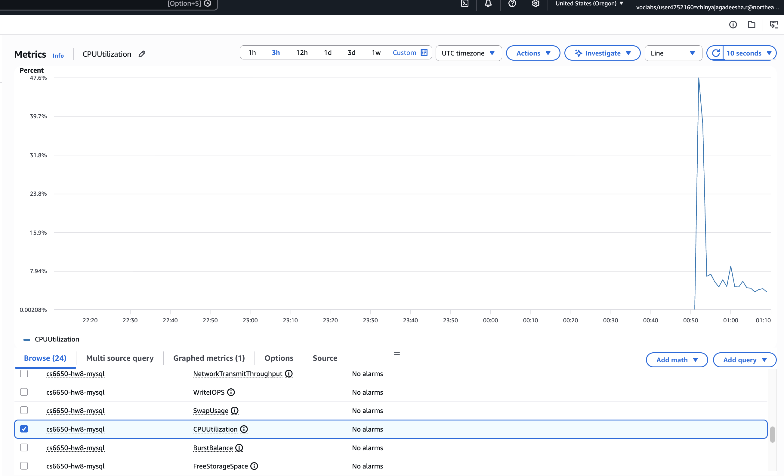

RDS Connections
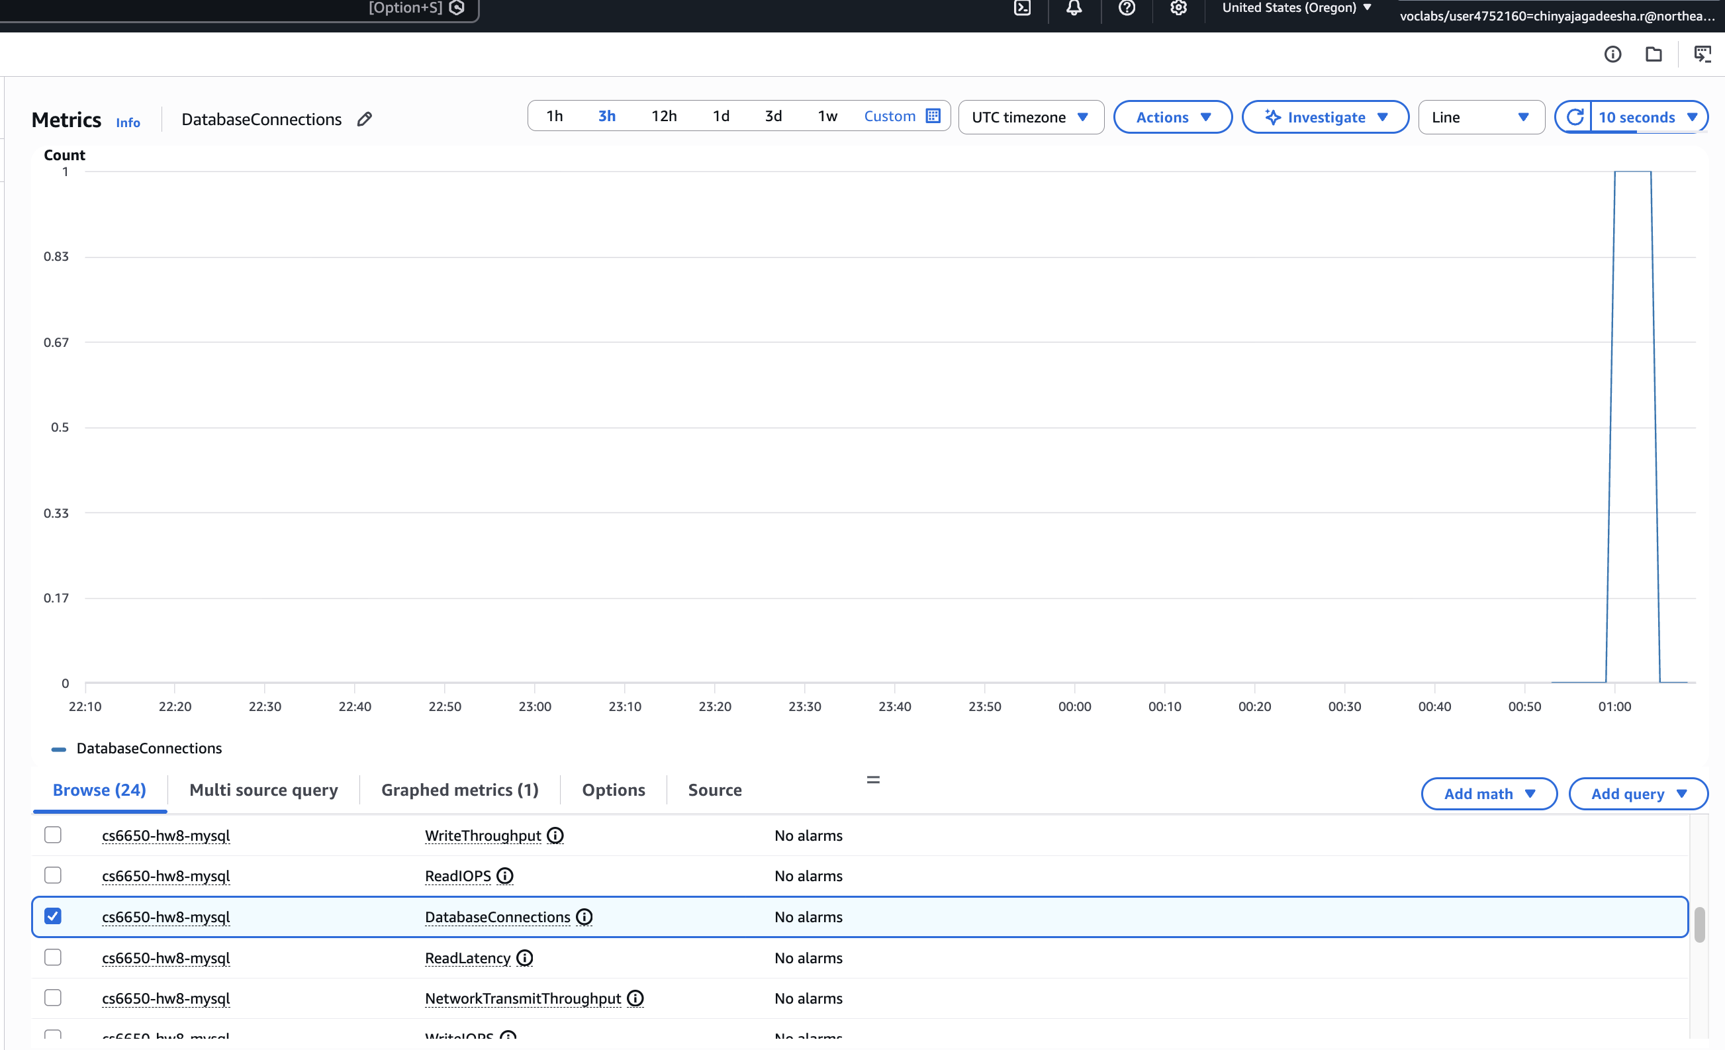

Step II: DynamoDB Integration

Table Design

Table: `shopping_carts`
- Partition key: `cart_id` (string)
- Attributes: `customer_id`, `items` (map), `created_at`

Why this design?
`cart_id` is a high‑cardinality partition key that distributes load evenly and maps directly to the primary access pattern (get cart by ID). Items are embedded as a map of `product_id → quantity` for single‑item updates via `UpdateItem`, avoiding a second table and extra queries. The trade‑off vs MySQL is less relational flexibility (no joins), but simpler reads for cart retrieval.

Attribute formatting & operations:
The AWS SDK v2 `AttributeValue` types required explicit formatting (`AttributeValueMemberS`, `AttributeValueMemberN`, `AttributeValueMemberM`). The API maps to `PutItem` (create), `UpdateItem` (add/update items), and `GetItem` (retrieve cart). Reads use eventual consistency (`ConsistentRead=false`) to reflect DynamoDB’s default model.

Design evolution:
I considered a two‑table approach (cart header + cart items) but chose a single table with embedded items to keep reads single‑request and reduce operational complexity. The randomly generated cart IDs distribute requests across partitions, reducing hot‑partition risk for this workload.

Eventual Consistency Observations

Dedicated consistency test scenarios:

- Create‑then‑immediately‑retrieve: After each of the 50 `POST /shopping-carts` calls, the test runner issued a `GET /shopping-carts/{id}` for the same cart ID in quick succession. All 50 reads returned the newly created cart with correct `customer_id` and empty items — no stale‑read or not‑found responses were observed.
- Add‑item‑then‑immediately‑fetch: After each of the 50 `POST /shopping-carts/{id}/items` calls, the subsequent GET batch retrieved carts that reflected the added items. No missing‑item inconsistencies were detected.
- Rapid updates from multiple clients: This scenario was not tested because the service ran on a single ECS task and the test runner issued requests sequentially. In a production environment with concurrent clients, I would expect occasional stale reads under eventual consistency and would mitigate with `ConsistentRead=true` for checkout‑critical paths or client‑side retry logic.

Conclusion: At this test scale and sequential access pattern, DynamoDB’s eventual consistency was indistinguishable from strong consistency. This does not guarantee the same behavior under high concurrency or cross‑AZ replication delays.

Step II: Required Performance Testing (DynamoDB)

Test file: `dynamodb_test_results.json` (150 ops)
Response time pattern: Avg 166.382ms, P50 162.322ms, P95 193.416ms, P99 268.691ms, 100% success.

CloudWatch monitoring summary (DynamoDB):
Consumed Read/Write Capacity and SuccessfulRequestLatency were captured for `shopping_carts`. ConsumedReadCapacity peaked around ~25 (sum) and ConsumedWriteCapacity around ~50 (sum) during the burst, then dropped to zero. SuccessfulRequestLatency points were in the ~1.4–3.2ms range for PutItem/GetItem. DynamoDB’s server‑side latency was 1.4–3.2ms per CloudWatch, while end‑to‑end response time averaged ~166ms — the ~163ms gap is attributable to ALB routing, ECS network overhead, and JSON serialization/deserialization, not DynamoDB itself. At this test scale, no throttling or hot‑partition signals were apparent in CloudWatch.

CloudWatch Screenshots (DynamoDB):
- Consumed Read/Write Capacity
- SuccessfulRequestLatency

DynamoDB Consumed Capacity
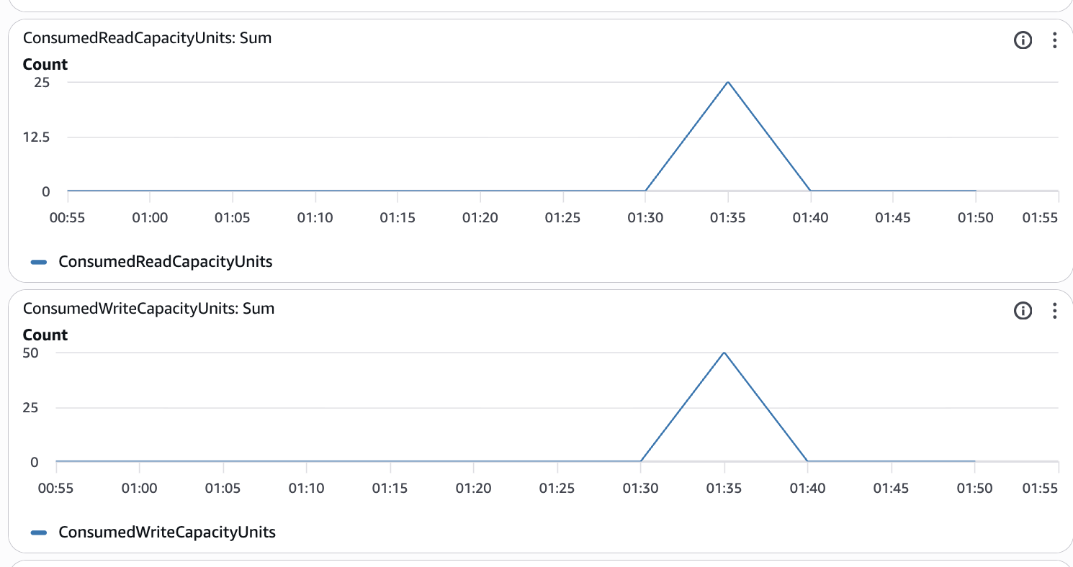
DynamoDB SuccessfulRequestLatency
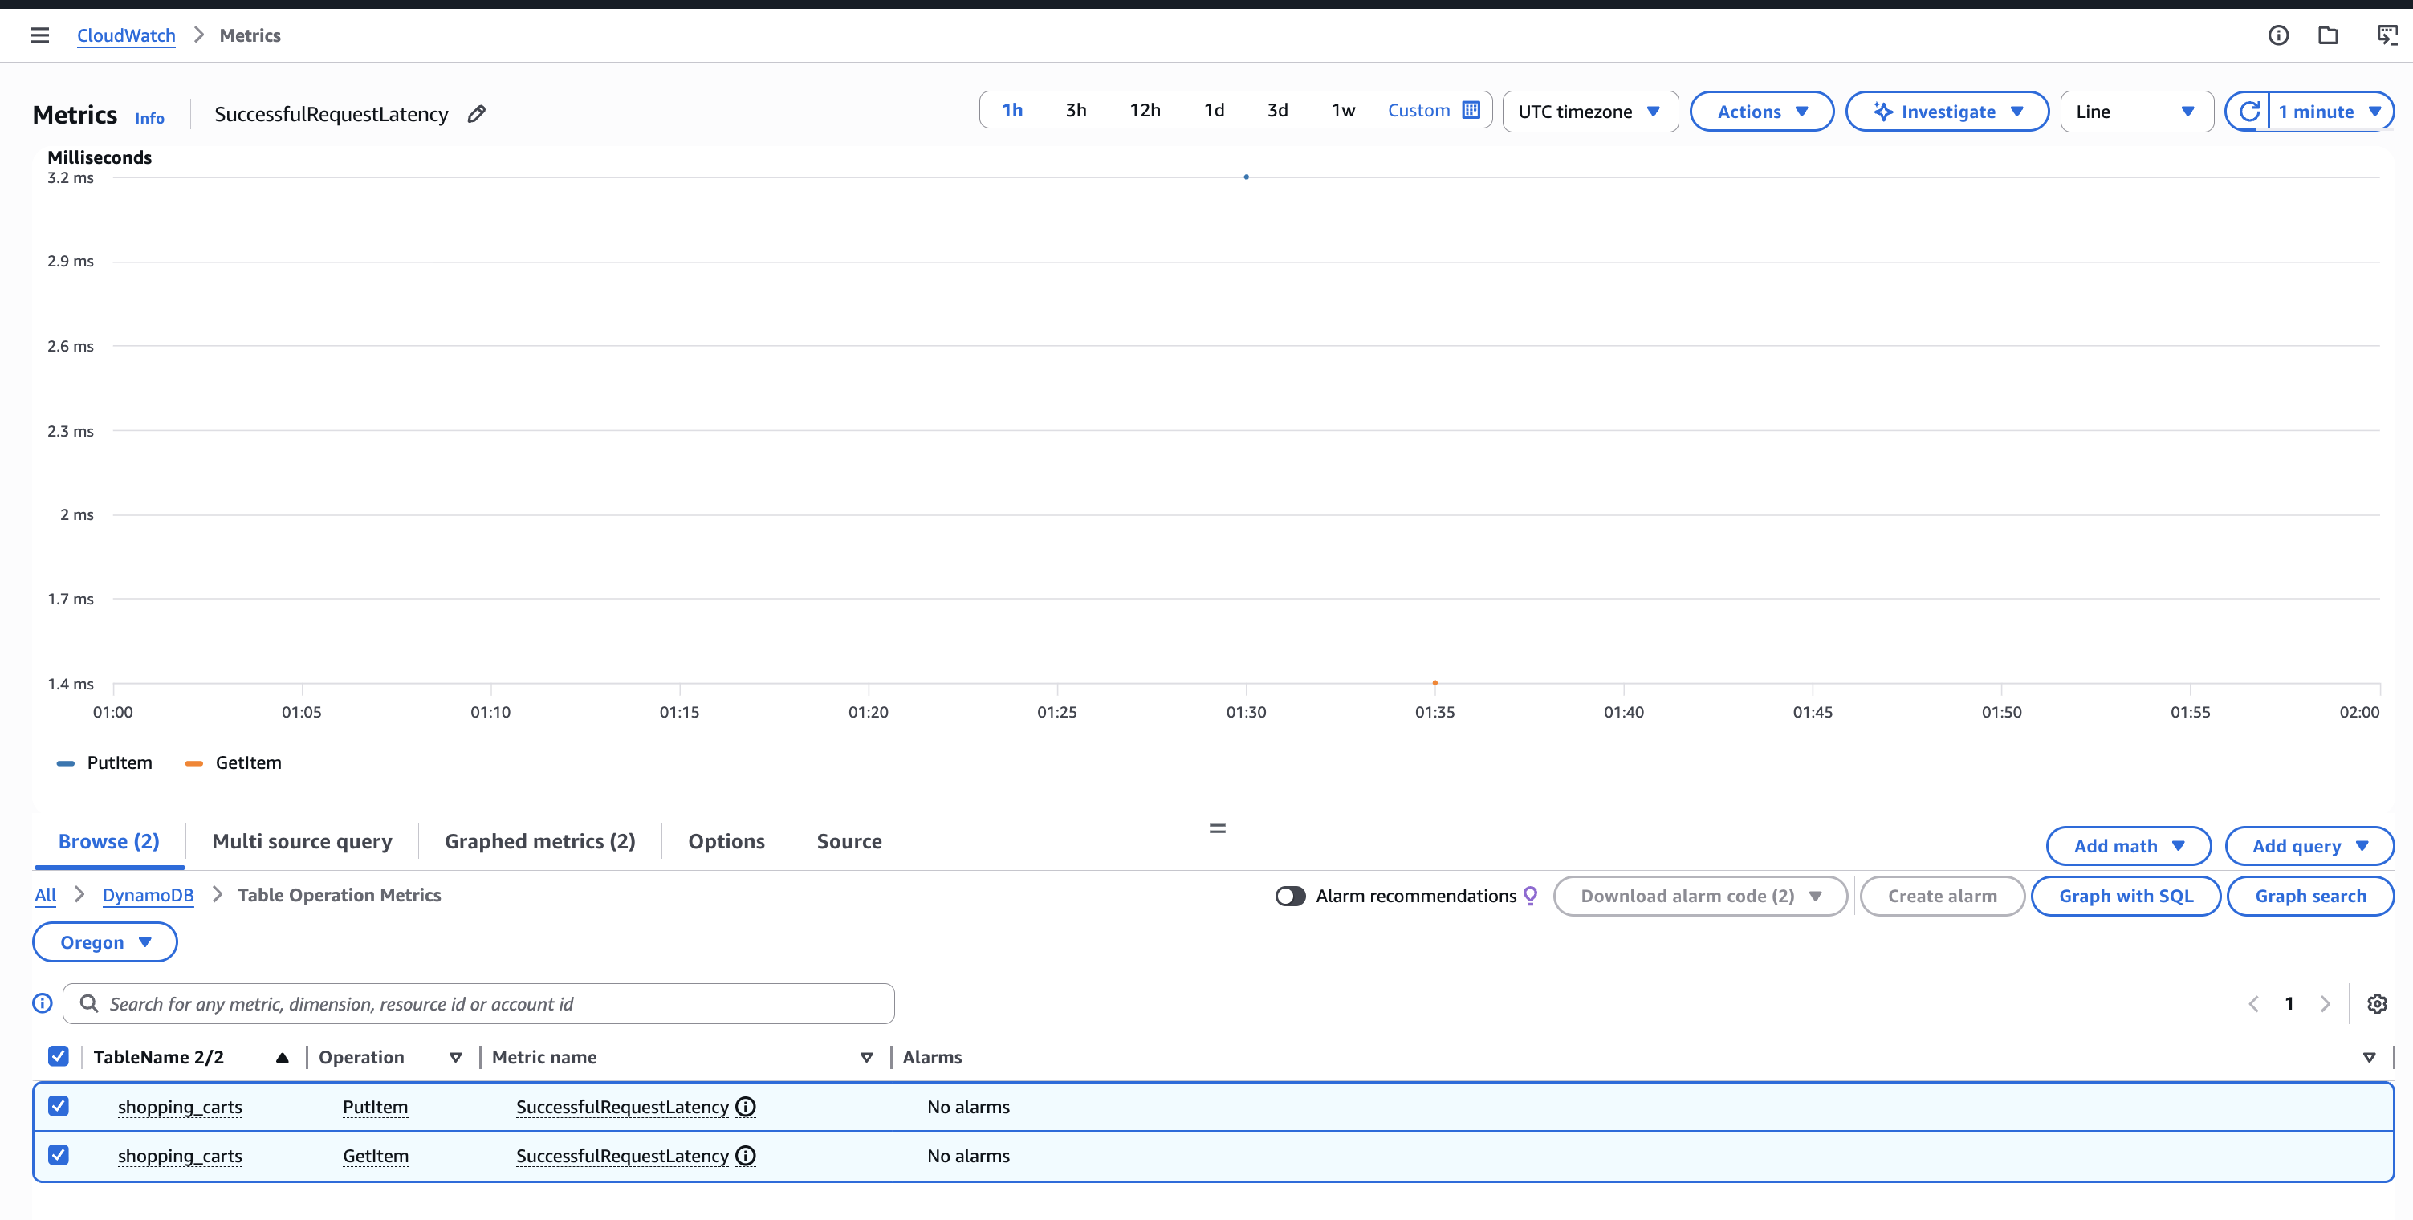

Step III: Comparison & Analysis

Combined Results

File: `combined_results.json` (300 ops total)
Verification Screenshot:
Combined Results Verification
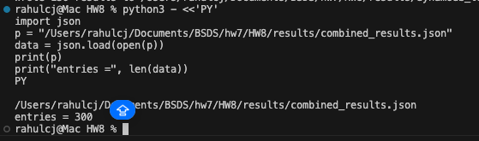

Comparison Table

Metric | MySQL | DynamoDB | Winner | Margin
Avg Response Time (ms) | 160.271 | 166.382 | MySQL | 6.111 ms
P50 Response Time (ms) | 158.414 | 162.322 | MySQL | 3.908 ms
P95 Response Time (ms) | 171.231 | 193.416 | MySQL | 22.185 ms
P99 Response Time (ms) | 189.985 | 268.691 | MySQL | 78.706 ms
Success Rate (%) | 100.00 | 100.00 | Tie | 0%
Total Operations | 150 | 150

Operation Breakdown

Operation | MySQL Avg (ms) | DynamoDB Avg (ms) | Faster By
CREATE_CART | 158.757 | 170.624 | 11.867 ms (MySQL)
ADD_ITEMS | 162.018 | 166.795 | 4.777 ms (MySQL)
GET_CART | 160.038 | 161.728 | 1.690 ms (MySQL)

Consistency Impact

No read‑after‑write delays were observed in the targeted tests. The consistency test (10 iterations) reported 0 create/get failures and 0 add/get‑after‑add failures. MySQL provided strong consistency by default for all operations, while DynamoDB used eventual consistency (`ConsistentRead=false`) but still returned consistent results in this small test window.
Design implications:
For latency‑sensitive UX, a hybrid approach is appropriate: use DynamoDB for scalable reads and writes, but add client‑side retries or conditional reads for correctness‑critical flows (e.g., checkout validation).

Consistency model questions (from test results):
Frequency of delays: no visible delays in create/get; all three operation types returned consistent results across both databases.
Most affected patterns: cart updates (add‑items) are the most sensitive in DynamoDB because they depend on conditional updates and item‑level consistency.
Handling strategy: retry with backoff, use conditional checks, and consider `ConsistentRead=true` for user‑visible confirmations.

Resource Efficiency & Scaling

MySQL required explicit connection pooling and network access to RDS, while DynamoDB was fully managed and did not require connection handling. DynamoDB operationally simplifies scaling, but in this run MySQL delivered slightly lower latencies. The CloudWatch metrics show low RDS CPU and low connection counts, indicating headroom at this test scale. DynamoDB consumed capacity spikes match the short burst of test traffic.

Scaling perspective:
MySQL scaling is primarily vertical at this tier (instance class and connection limits). DynamoDB scales horizontally by design; however, it requires careful update logic to avoid reliability issues like the failed add‑items path observed here.

Resource predictability:
MySQL requires capacity planning around connection limits and instance sizing; DynamoDB’s throughput is more predictable but depends on correctly modeled access patterns and update semantics. At this test scale, MySQL showed minimal CPU load and a single active connection, while DynamoDB’s capacity usage spiked briefly and then returned to zero.

Scenario Recommendations

Scenario A (Startup MVP): MySQL. Evidence: lower latency across percentiles and simpler operational model at small scale. MySQL avg latency was ~6ms faster and required no DynamoDB‑specific attribute formatting, reducing development time for a solo developer.
Scenario B (Growing Business): MySQL for carts; DynamoDB becomes viable for carts if write/latency trade‑offs are acceptable. MySQL’s P95 advantage of ~22ms matters for user‑facing cart operations at growing scale; DynamoDB becomes viable if the team invests in update‑path validation.
Scenario C (High‑Traffic Events): DynamoDB for scale and burst handling, assuming write patterns are validated. CloudWatch showed DynamoDB capacity spiked during the burst and returned to zero, demonstrating elastic burst handling vs MySQL’s fixed connection pool ceiling.
Scenario D (Global Platform): DynamoDB for global distribution; MySQL remains for relational workloads like catalog and order history. DynamoDB’s managed global tables support multi‑region replication natively, which MySQL would require read replicas and application‑level routing to achieve.

Architecture Recommendation

Shopping cart winner: MySQL, due to consistently lower latency across percentiles.
When to choose the other: DynamoDB if global scale and operational simplicity outweigh the latency gap.
Polyglot strategy: Shopping carts on MySQL (current results), user sessions on DynamoDB, product catalog on MySQL, order history on MySQL with analytics replicas.

Polyglot rationale (per component):
Shopping carts: MySQL for strong consistency and reliable updates based on current results.
User sessions: DynamoDB for simple key‑value access and horizontal scale.
Product catalog: MySQL for relational querying, indexing, and consistency.
Order history: MySQL for transactional integrity, with replicas for analytics.

Supporting evidence (from combined_results.json):
Response time advantage: MySQL is ~6.111ms faster on average and ~22.185ms faster at P95.
Implementation complexity difference: MySQL required connection pooling and schema DDL; DynamoDB required careful attribute formatting and item update semantics.
Other factors: both reached 100% success after fixing the DynamoDB update path.

Learning Reflection

What surprised you?
The DynamoDB update path required more careful handling than expected; switching from `UpdateItem` to a `GetItem` + `PutItem` merge resolved the failures.

What failed initially?
The DynamoDB add‑items operation failed until the update logic was changed to merge items and write back via `PutItem`. On the infrastructure side, IAM role restrictions in the lab required using existing roles instead of creating new ones, and the Docker build initially failed due to missing `git` during `go mod download`.

Key insights gained:
Relational schemas are more forgiving for multi-step cart updates, while DynamoDB requires careful modeling and update logic. Operational simplicity alone doesn’t guarantee reliability without correct access patterns. If I were advising another student, I’d emphasize validating update paths early and testing DynamoDB error codes to avoid silent 500s.

When to choose each (from this run):
Choose MySQL when correctness and update reliability matter most (e.g., carts and checkout flows).
Choose DynamoDB when scale and operational simplicity outweigh strict consistency, and after validating update logic under load.

Resource Management

After final validation and screenshots, run `terraform destroy -auto-approve` to avoid ongoing costs in the lab environment.

