Interpretable Turbofan Engine Health Degradation Classification and Remaining Useful Life Estimation on C-MAPSS
Rahul Bansode, Shubham Vaidya, Gaurav Yadav, Mufeed Rajapkar (TODO_ROLL_1, TODO_ROLL_2, TODO_ROLL_3, TODO_ROLL_4)
TODO_DEPARTMENT | GitHub Repository: https://github.com/rahulcodes-java/C-MAPSS-Digital-Twin
Abstract— Commercial aircraft engine condition monitoring requires reliable detection of degradation states before functional failure occurs. This project presents a multi-model prognostics framework evaluated across NASA C-MAPSS datasets FD001 through FD004 with all 21 telemetry sensors preserved. We formulate health management primarily as a 3-stage classification task (Healthy, Degrading, Critical) utilizing a Random Forest classifier interpreted with TreeSHAP. Secondary complementary tasks include an LSTM network for continuous Remaining Useful Life (RUL) regression and an Isolation Forest for unsupervised anomaly detection. On FD001, the Random Forest model achieves a 3-stage macro-F1 of 0.7303, while the LSTM achieves a macro-F1 of 0.8197 and provides a median lead-time advantage of 21.0 flight cycles over single-snapshot classification across 100 engines. TreeSHAP attributes 49.18% of degradation impact to High-Pressure Compressor sensors. Performance declines across multi-condition datasets FD002 and FD004 due to unnormalized operating regimes.
1. Introduction
Gas turbine engines operate under severe thermodynamic stresses, where continuous degradation of compressor and turbine aerofoils leads to efficiency losses and eventual component retirement. Within the Data Warehousing and Mining (DWM) curriculum, we structure turbofan prognostic health management primarily as a 3-stage classification task (Healthy: RUL > 100, Degrading: 30 < RUL <= 100, Critical: RUL <= 30). To provide actionable maintenance decision support, snapshot classification is complemented by sequence-based RUL regression and unsupervised anomaly detection.
2. Methodology
Telemetry streams comprise 21 sensors across 160359 training cycles and 104897 test cycles over four datasets (FD001 to FD004). Sensor values are scaled using MinMaxScaler fitted strictly on training data. Rather than discarding sensors with low sea-level variance, all 21 sensors are preserved because multi-condition datasets (FD002 and FD004) exhibit non-zero variance across all channels. As depicted in Fig. 1, the architecture routes temporal sliding windows of shape (50, 21) to an LSTM regression network, while single-cycle 21-dimensional vectors are evaluated by a 100-tree Random Forest classifier and an Isolation Forest detector.
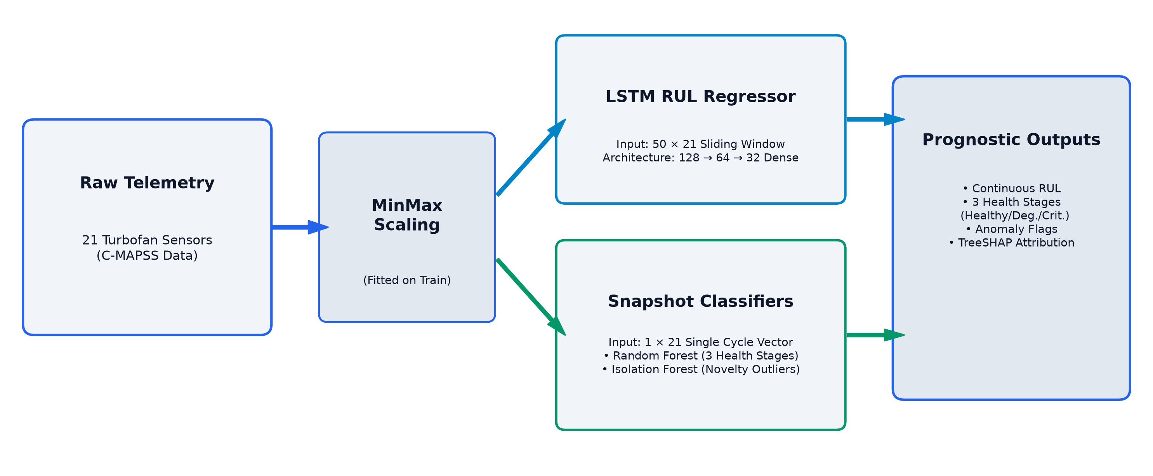
Fig. 1. Digital twin processing pipeline distinguishing sequence-window and single-cycle model inputs.

3. Experimental Results
Models were evaluated on test partitions without retraining. Table 1 summarizes 3-stage classification and binary Critical detection across all four datasets. On FD001, Random Forest snapshot classification attains a macro-F1 of 0.7303, while sequence-based LSTM achieves a macro-F1 of 0.8197. In critical cycle detection (RUL <= 30), LSTM achieves an F1 of 0.8158 (precision 0.7926, recall 0.8404), compared to 0.6938 for Random Forest and 0.2413 for Isolation Forest (precision 0.1372, recall 0.9970).
Dataset | Cycles | RF Macro-F1 | LSTM Macro-F1 | RF Crit. F1 | LSTM Crit. F1 | IF Crit. F1
FD001 | 13096 | 0.7303 | 0.8197 | 0.6938 | 0.8158 | 0.2413
FD002 | 33991 | 0.1283 | 0.0378 | 0.0607 | 0.0659 | 0.0620
FD003 | 16596 | 0.2785 | 0.2410 | 0.0974 | 0.1009 | 0.0345
FD004 | 41214 | 0.1004 | 0.0264 | 0.0479 | 0.0431 | 0.0411
Table 1. Standardized classification and critical-class F1 metrics across C-MAPSS test sets.
Lead-time analysis evaluated over all 100 FD001 training engines reveals that LSTM temporal modeling detects degradation with a median delay of -2.0 cycles (mean -10.57, IQR 41.5), compared to +15.5 cycles (mean 17.12, IQR 35.25) for single-snapshot Random Forest. The paired lead-time difference (RF delay - LSTM delay) yields a median advantage of 21.0 flight cycles (mean 27.69, IQR 32.5), with LSTM alerting earlier in 80 of 100 engines (80.0%). On held-out validation tail engines (83 to 100), the median advantage is 26.5 cycles (LSTM flags first in 17 of 18 engines, 94.44%). TreeSHAP attributes 49.18% ± 0.12% of degradation attribution to High-Pressure Compressor sensors (Ps30: 14.25%, Nc: 13.01%), consistent with simulated HPC degradation.
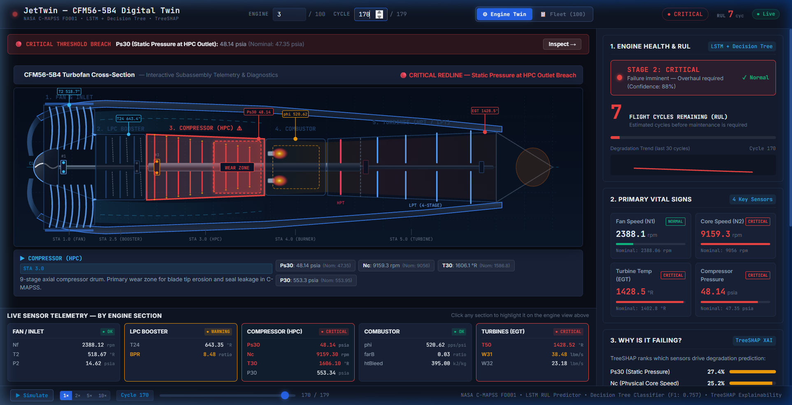
Fig. 2. Interactive digital twin interface displaying Stage 2 Critical state and live telemetry thresholds.
4. Limitations
Evaluations rely on simulated C-MAPSS data rather than commercial airline flight logs. Models trained exclusively on single-regime sea-level data (FD001) experience marked performance drops on FD002 and FD004 (macro-F1 0.1283 and 0.1004) due to unnormalized operating conditions. Isolation Forest exhibits low critical precision (0.1372 on FD001) due to erratic early triggers across non-stationary degradation trajectories.
5. Future Work
Future efforts will incorporate operating regime clustering prior to sensor normalization to enable reliable cross-condition transfer. Physics-informed loss constraints and bidirectional sequence attention will also be explored to refine remaining useful life bounds.

