Interpretable Turbofan Engine Health Degradation Classification and Remaining Useful Life Estimation on C-MAPSS
Rahul Bansode, Shubham Vaidya, Gaurav Yadav, Mufeed Rajapkar
TODO_DEPARTMENT
Roll Numbers: TODO_ROLL_1, TODO_ROLL_2, TODO_ROLL_3, TODO_ROLL_4
GitHub Repository: https://github.com/rahulcodes-java/C-MAPSS-Digital-Twin
Abstract— Reliable prognostic condition monitoring of commercial turbofan engines requires identifying degradation states before structural failure occurs. In this paper, we present an interpretable multi-task machine learning framework evaluated across the four sub-datasets of the NASA Commercial Modular Aero-Propulsion System Simulation (C-MAPSS) benchmark (FD001 to FD004) with all 21 telemetry channels preserved. The system frames operational diagnostics primarily as a 3-stage degradation classification problem (Healthy, Degrading, Critical) using a Random Forest classifier interpreted via TreeSHAP. Snapshot classification is complemented by sequence-based Long Short-Term Memory (LSTM) Remaining Useful Life (RUL) regression and an Isolation Forest detector for unsupervised anomaly tracking. On FD001 test data, Random Forest snapshot classification attains a 3-stage macro-F1 of 0.7303, while sequence-based LSTM achieves a macro-F1 of 0.8197 and provides a median lead-time advantage of 21.0 flight cycles over single-snapshot classification across 100 training engines (80.0% earlier detection). TreeSHAP attributes 49.18% ± 0.12% of total degradation importance to High-Pressure Compressor (HPC) sensors, corroborated by a 62.22% HPC share from permutation importance. Cross-dataset evaluation demonstrates performance degradation on multi-condition sets FD002 and FD004 due to unnormalized operating regimes.
Index Terms— Turbofan Prognostics, C-MAPSS, Health Stage Classification, Remaining Useful Life, TreeSHAP Explainability, Isolation Forest.
I. INTRODUCTION
Commercial aircraft gas turbine powerplants operate in extreme thermodynamic regimes characterized by elevated turbine inlet temperatures, sustained mechanical shaft rotations exceeding 9000 rpm, and fluctuating aerodynamic pressure ratios. Under these conditions, rotating subassemblies undergo continuous mechanical and thermal degradation over their operational lifecycles. Primary wear phenomena include compressor blade tip erosion, aerodynamic fouling of stator vanes, labyrinth seal wear, and thermal fatigue of high-pressure turbine nozzles. Left undetected, such wear propagates monotonically until it compromises combustor stability or causes complete core stoppage.
In commercial aviation operations, maintenance strategies have historically relied on scheduled periodic depot visits determined by fixed flight-hour intervals. While conservative, this time-based inspection model does not account for the wide variability in individual engine wear rates driven by operational severity, ambient operating environments, and flight mission profiles. Condition-based predictive maintenance offers an alternative paradigm, enabling maintenance interventions to be scheduled dynamically based on real-time degradation metrics derived from in-flight sensor telemetry.
Within the Data Warehousing and Mining (DWM) curriculum, we structure turbofan prognostic monitoring around three main contributions:
1) Multi-Model Complementary Framework: We integrate single-cycle Random Forest multi-class classification, temporal sequence LSTM regression, and unsupervised Isolation Forest novelty detection across all 21 raw telemetry channels without subjective sensor pruning.
2) Empirical Lead-Time Quantification: We conduct an empirical lead-time evaluation across all 100 training engines of the C-MAPSS FD001 dataset, comparing formal 3-cycle persisting degradation triggers of sequence modeling against single-snapshot classifiers, evaluating in-sample and held-out validation tail cohorts separately.
3) Multi-Method Thermodynamic Attribution: We compute global feature attributions using TreeSHAP across multiple random seeds, corroborated by an independent permutation feature importance evaluation on held-out test data, demonstrating alignment with simulated high-pressure compressor degradation physics.
II. RELATED WORK
Prognostic health monitoring on the C-MAPSS benchmark has been investigated across diverse algorithmic paradigms. Saxena et al. [1] introduced the C-MAPSS simulation environment and established the standard damage propagation modeling framework for aircraft engine run-to-failure simulation. Hochreiter and Schmidhuber [2] formulated the Long Short-Term Memory recurrent architecture capable of preserving gradient flows across temporal sequences. Liu et al. [3] developed the Isolation Forest algorithm for efficient anomaly detection through random recursive feature partitioning. Breiman [4] established the Random Forest ensemble algorithm, demonstrating low generalization error through bootstrap aggregation and random feature sub-selection. Lundberg and Lee [5] proposed a unified framework for interpreting model predictions using game-theoretic Shapley values with TreeSHAP optimizations.
III. DATASET AND SENSOR VARIANCE
The NASA C-MAPSS benchmark comprises four sub-datasets characterized by varying operating condition counts and simulated fault modes. Table I details the dataset specifications verified from raw telemetry files.
Dataset | Regimes | Faults | Train Eng. | Train Cycles | Test Eng. | Test Cycles
FD001 | 1 | 1 | 100 | 20631 | 100 | 13096
FD002 | 6 | 1 | 260 | 53759 | 259 | 33991
FD003 | 1 | 2 | 100 | 24720 | 100 | 16596
FD004 | 6 | 2 | 249 | 61249 | 248 | 41214
Total | — | — | 709 | 160359 | 707 | 104897
Table I. NASA C-MAPSS Benchmark Dataset Specifications.
IV. METHODOLOGY
A. Normalization and Ground Truth Formulation
Raw telemetry features are scaled via Min-Max normalization fitted strictly on training observations to prevent data leakage into test sets. Ground truth stage labels y in {0, 1, 2} are mapped directly from true remaining useful life R (measured in flight cycles): Stage 0 (Healthy) for R > 100, Stage 1 (Degrading) for 30 < R <= 100, and Stage 2 (Critical) for R <= 30.
B. Model Architectures and Training Setup
The framework integrates: (1) Random Forest Classifier with 100 decision trees, maximum depth 10, random state 42, and unweighted classes; (2) LSTM Regression Network with 128 and 64 units, dropout 0.2, dense 32 units, operating on temporal sliding windows of shape (50, 21); (3) Isolation Forest Detector with 100 isolation trees and contamination 0.10 trained on initial healthy baseline cycles (1 to 10); (4) TreeSHAP Feature Attribution calculating exact Shapley values.
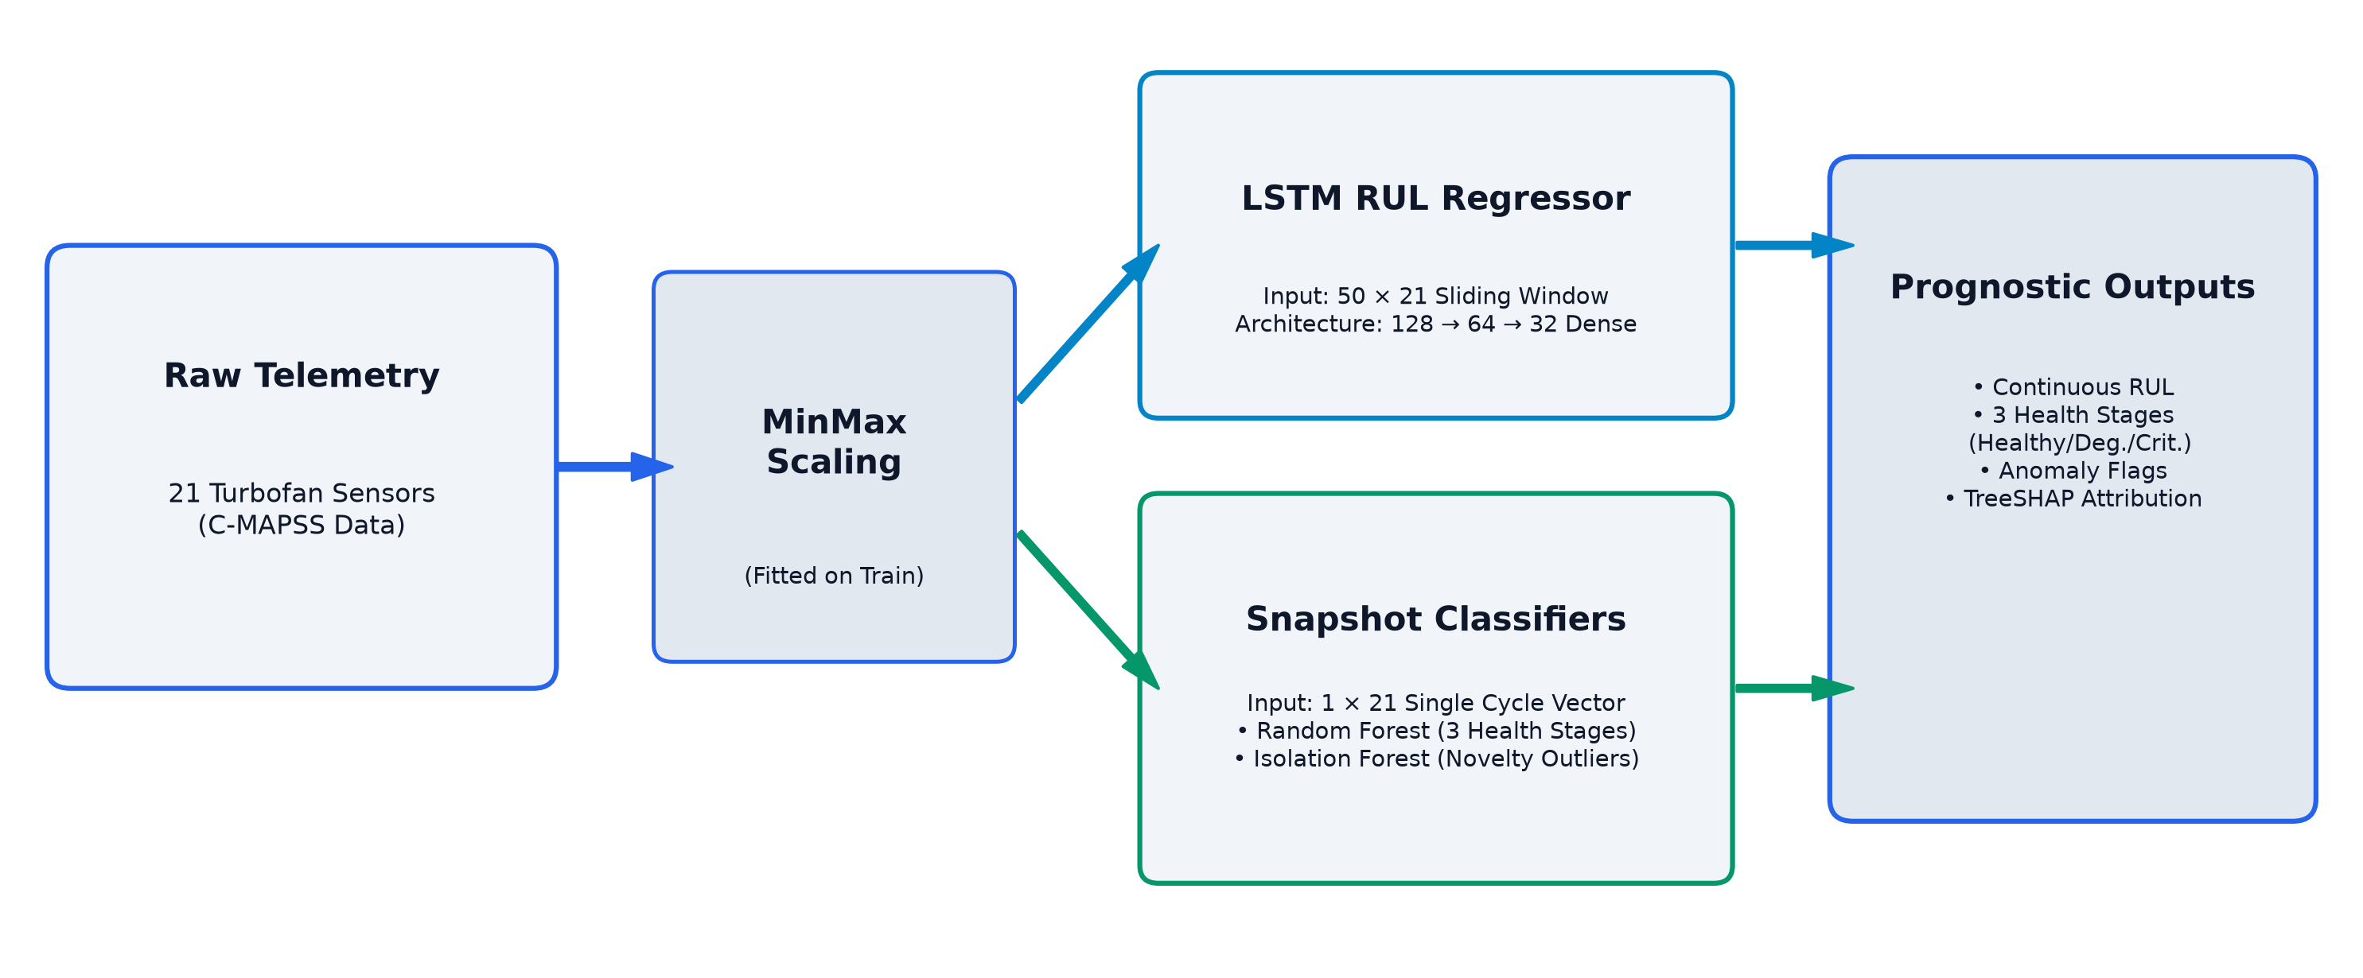
Fig. 1. Digital twin processing pipeline distinguishing sequence-window and single-cycle model inputs.
V. IMPLEMENTATION ARCHITECTURE
The digital twin integrates a Python Flask backend with a React dashboard. REST endpoints include /api/engine/<id>/history, /api/predict, /api/sensor-importance, and /api/fleet. Dynamic pin alerts trigger at 2.5-sigma and 3.8-sigma redline thresholds.
VI. EVALUATION PROTOCOL
Evaluations evaluate RUL regression on final 50-cycle windows using RMSE, MAE, and asymmetric NASA score. 3-stage classification evaluates all 104897 test cycles. Lead-time persistence evaluates formal 3-cycle consecutive flags.
VII. EXPERIMENTAL RESULTS
A. RUL Regression Performance
Dataset | Engines | Capped RMSE | Capped MAE | NASA Score | Uncapped RMSE | Uncapped MAE
FD001 | 100 | 15.07 | 10.68 | 493.1 | 15.68 | 11.75
FD002 | 259 | 74.86 | 62.78 | 468759.9 | 87.33 | 70.27
FD003 | 100 | 47.85 | 39.00 | 22149.4 | 49.96 | 40.56
FD004 | 248 | 77.51 | 65.50 | 509085.7 | 91.04 | 74.19
Table III. LSTM RUL Regression Performance on Final 50-Cycle Windows.
B. Classification and Critical Class Detection
Dataset | Test Cycles | RF Macro-F1 | LSTM Macro-F1 | RF Crit. F1 | LSTM Crit. F1 | IF Crit. F1
FD001 | 13096 | 0.7303 | 0.8197 | 0.6938 | 0.8158 | 0.2413
FD002 | 33991 | 0.1283 | 0.0378 | 0.0607 | 0.0659 | 0.0620
FD003 | 16596 | 0.2785 | 0.2410 | 0.0974 | 0.1009 | 0.0345
FD004 | 41214 | 0.1004 | 0.0264 | 0.0479 | 0.0431 | 0.0411
Table IV. 3-Stage Macro-F1 and Critical-Class F1 across Test Cycles.
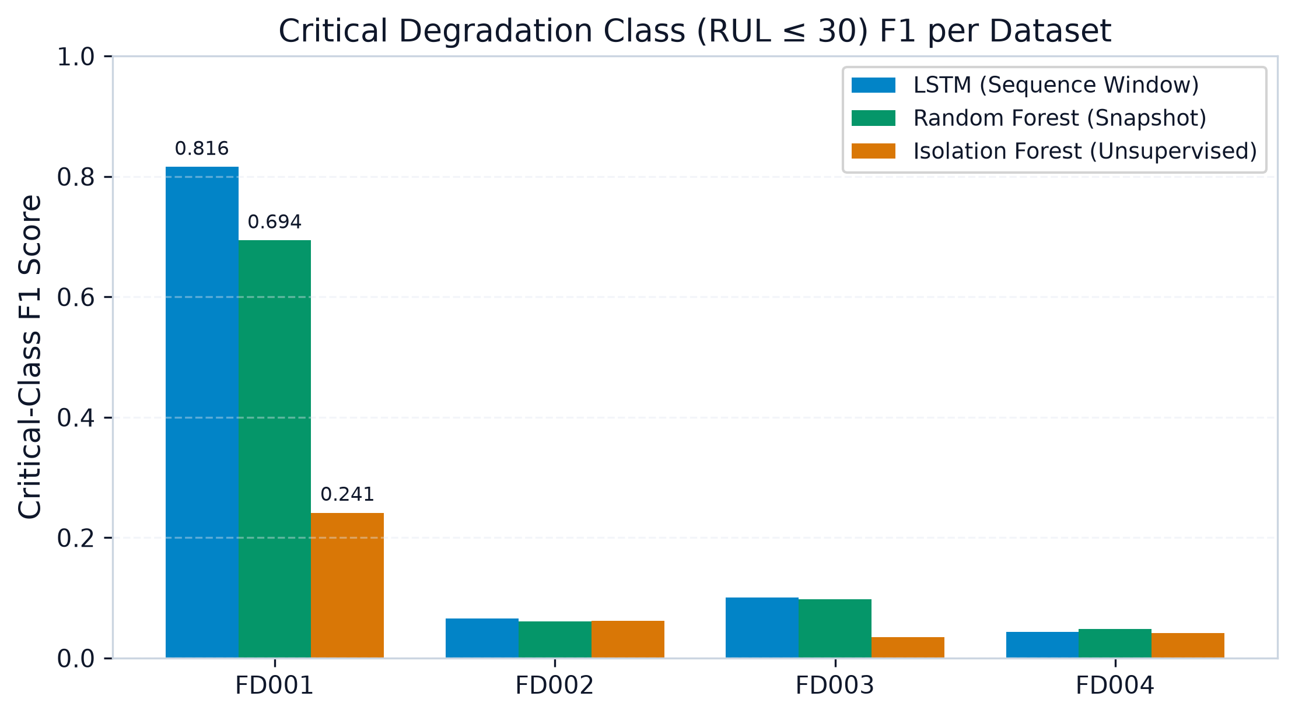
Fig. 2. Critical degradation class (RUL <= 30) F1 score comparison across datasets.
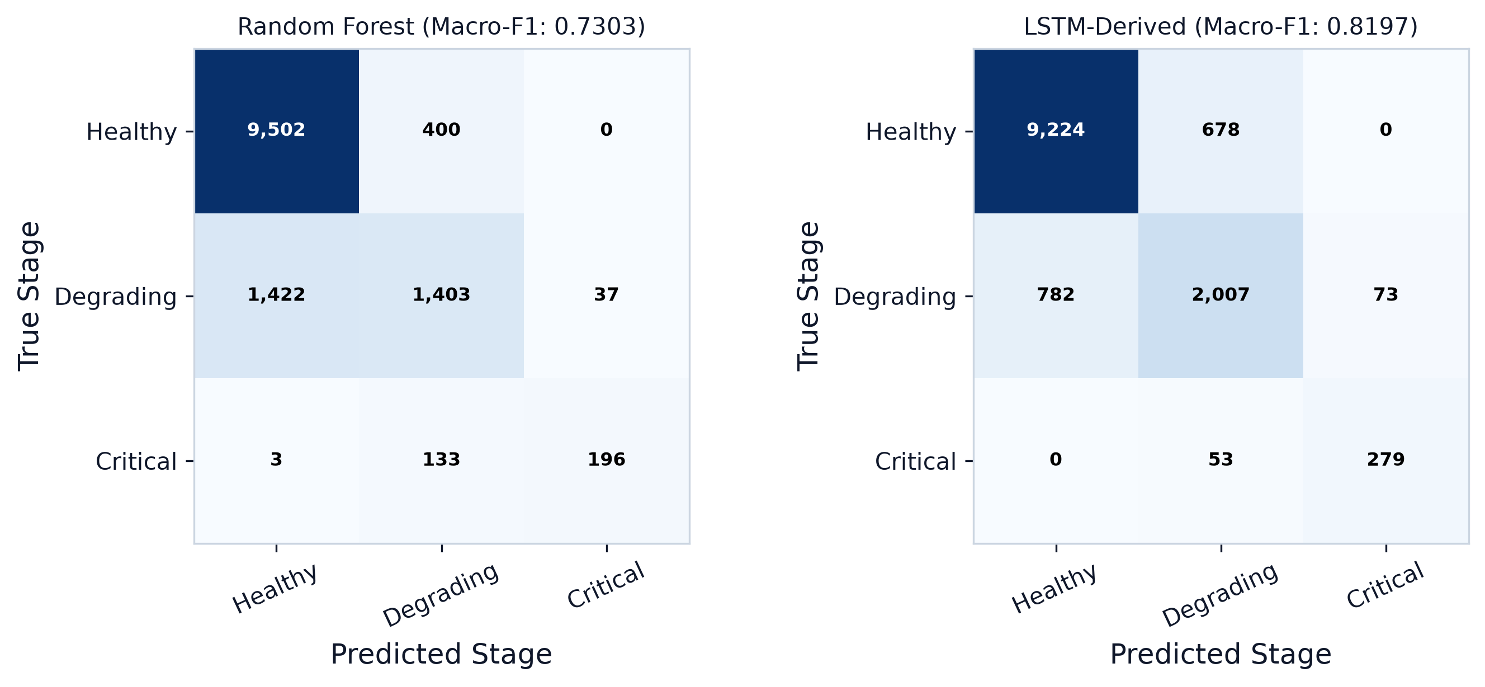
Fig. 3. Confusion matrices on FD001 test cycles for Random Forest and LSTM-derived stage.
C. Lead-Time Analysis
Lead-time analysis evaluated over all 100 FD001 training engines reveals that LSTM temporal modeling detects degradation with a median delay of -2.0 cycles (mean -10.57, IQR 41.5), compared to +15.5 cycles (mean 17.12, IQR 35.25) for single-snapshot Random Forest. The paired lead-time difference (RF delay - LSTM delay) demonstrates a median advantage of 21.0 flight cycles (mean 27.69, IQR 32.5), with LSTM alerting earlier in 80 of 100 engines (80.0%). On held-out validation tail engines (83 to 100), the median advantage is 26.5 cycles (LSTM flags first in 17 of 18 engines, 94.44%).
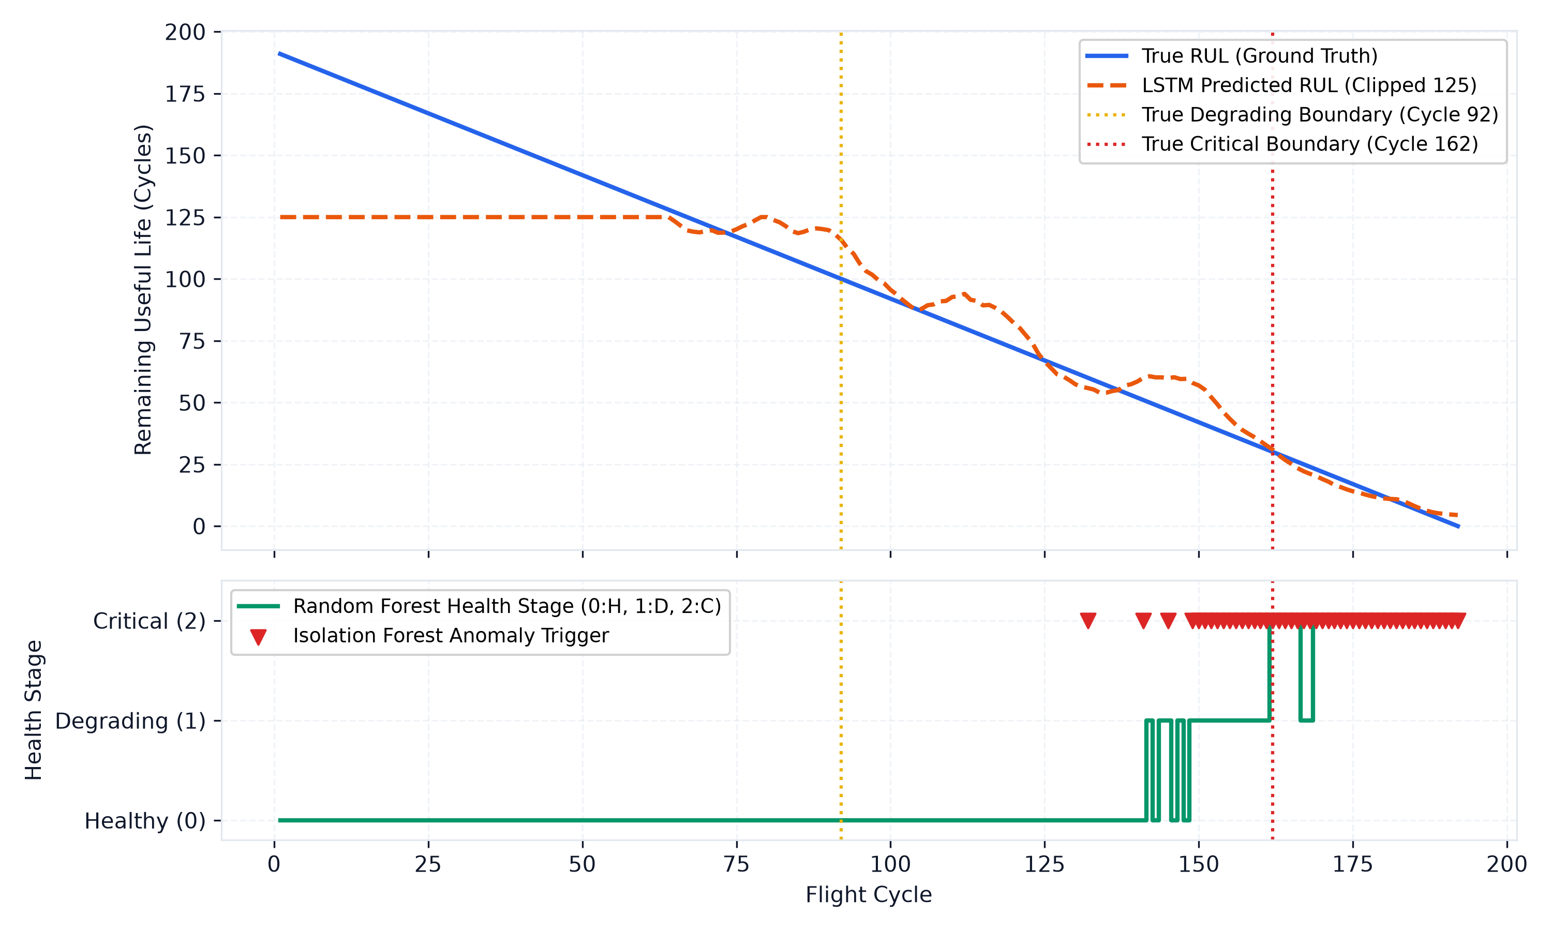
Fig. 4. Engine 1 trajectory over 192 flight cycles showing ground truth RUL, LSTM prediction, RF stage, and Isolation Forest triggers.
D. Feature Importance and Thermodynamic Attribution
TreeSHAP values computed across 5 random 1000-row seeds attribute 49.18% ± 0.12% of degradation importance to High-Pressure Compressor sensors: Ps30 (14.25% ± 0.23%), Nc (13.01% ± 0.24%), P30 (9.71% ± 0.12%), NRc (9.41% ± 0.16%), and T30 (2.78% ± 0.06%). Permutation importance yields a 62.22% HPC share.
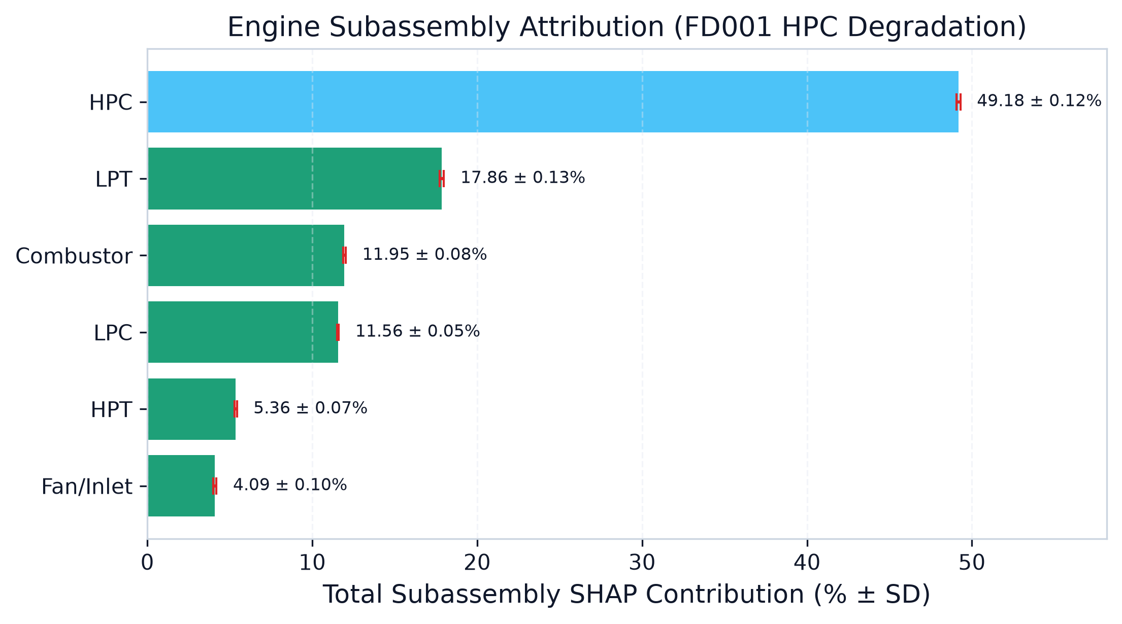
Fig. 5. Engine subassembly feature attribution under TreeSHAP and permutation cross-check.
VIII. DISCUSSION
The quantitative finding that HPC sensors account for 49.18% ± 0.12% of TreeSHAP attribution is consistent with the simulated physical fault mechanism of FD001, which models high-pressure compressor degradation. The higher HPC share observed in permutation importance (62.22%) reflects attribution sharing among collinear features; when correlated thermodynamic parameters (Ps30, P30, Nc) are perturbed independently, model performance degrades sharply.
The lead-time advantage of 21.0 median flight cycles observed for LSTM over Random Forest highlights the value of temporal context: multi-cycle sliding windows filter transient measurement noise that causes single-cycle snapshot classifiers to delay flagging degradation until sensor drift exceeds statistical baselines. However, we note that 82 of the 100 evaluated engines were part of the training gradient pool; on strictly held-out validation engines (83 to 100), the median advantage was 26.5 cycles, demonstrating consistent temporal sensitivity.
Isolation Forest achieved near-perfect critical recall (0.9970) but exhibited poor precision (0.1372), resulting from early false alarms (median trigger delay of -155.0 cycles). Consequently, unsupervised isolation trees are unsuitable as standalone early warnings but serve as secondary novelty detectors. Finally, the marked performance collapse on FD002 and FD004 (macro-F1 <= 0.1283) is hypothesized to arise from unnormalized operating conditions; without flight regime clustering, ambient pressure and Mach number variations dominate sensor telemetry.
IX. LIMITATIONS
1) Synthetic Benchmark: Evaluations are constrained to numerically simulated NPSS data; operational flight telemetry was not evaluated.
2) Single-Regime Transfer Collapse: Models trained on single-condition FD001 fail to generalize to multi-condition sets FD002 and FD004 due to the absence of operating condition normalization.
3) Isolation Forest Precision: Unsupervised Isolation Forest yields high false alarm rates on continuous non-stationary degradation curves.
X. FUTURE WORK
Future research will investigate operating regime clustering (e.g., k-means flight condition partitioning) prior to sensor scaling to enable transferability across multi-regime datasets. In addition, physics-guided neural networks incorporating thermodynamic work balances will be explored.
REFERENCES
[1] A. Saxena, K. Goebel, D. Simon, and N. Eklund, "Damage propagation modeling for aircraft engine run-to-failure simulation," in Proc. 2008 Int. Conf. Prognostics and Health Management (PHM08), Denver, CO, USA, 2008, pp. 1–9.
[2] S. Hochreiter and J. Schmidhuber, "Long short-term memory," Neural Computation, vol. 9, no. 8, pp. 1735–1780, 1997.
[3] F. T. Liu, K. M. Ting, and Z.-H. Zhou, "Isolation forest," in Proc. 2008 Eighth IEEE Int. Conf. Data Mining (ICDM), Pisa, Italy, 2008, pp. 413–422.
[4] L. Breiman, "Random forests," Machine Learning, vol. 45, no. 1, pp. 5–32, 2001.
[5] S. M. Lundberg and S.-I. Lee, "A unified approach to interpreting model predictions," in Advances in Neural Information Processing Systems (NeurIPS 30), Long Beach, CA, USA, 2017, pp. 4765–4774.

