CameraStore Document

1. All the code consist inside packages/CrownStack/CameraStore package.

2. Two othere depeadencies were used while creating this package.
prettus/laravel-repository -> is used to abstract the data layeyr.
tymon/jwt-auth -> For token generation and customer authentication.

3. Please follow the simple laravel installation proceudre addition with this command -

php artisan jwt:secret

4. According to the requirement, API has been created for storefront.
Here we are attaching some api’s working with screenshot.

5. Add to cart API -> For add to cart you need to pass token.

Route – 127.0.0.1:8000/api/cart/add/{product_id}

Parameter - {product_id: $id, qty: $qty}

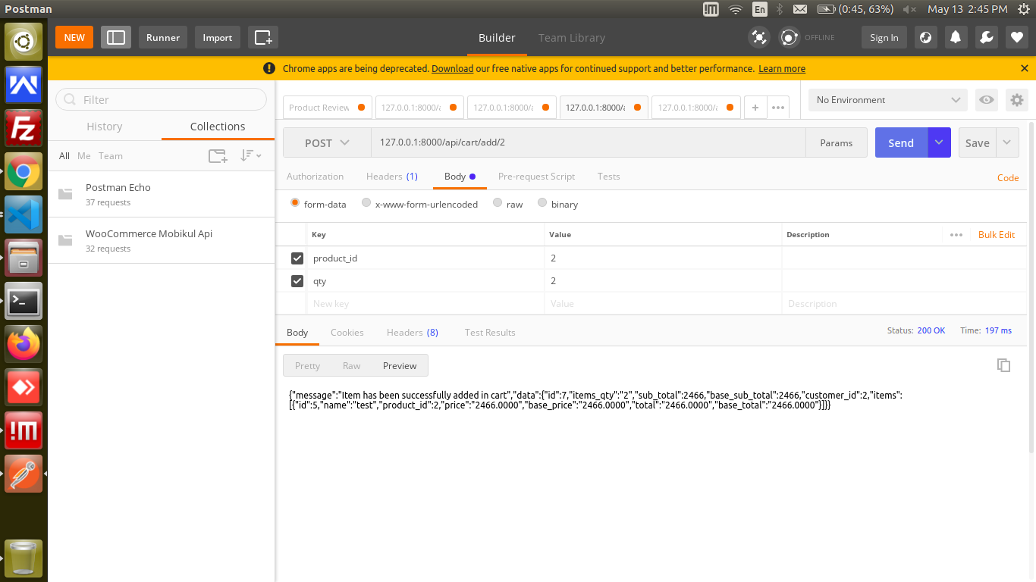
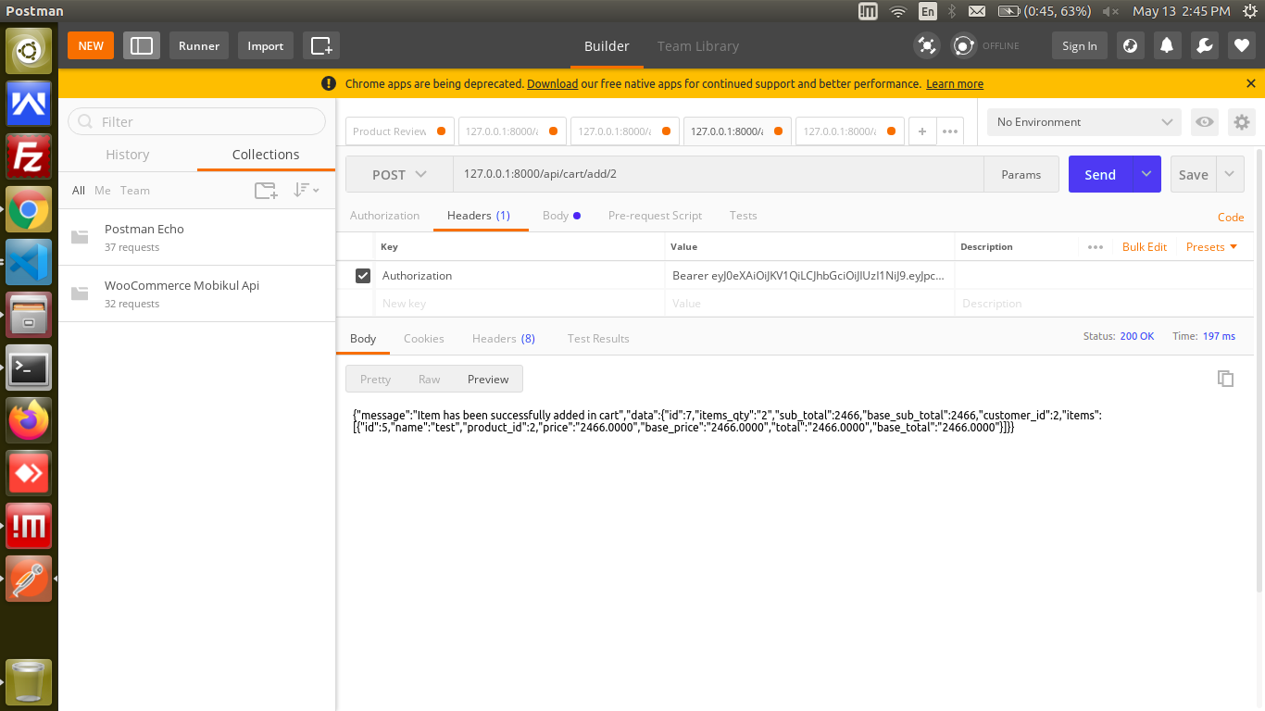

6. Get cart Data for customer -> This also needs token

Route - 127.0.0.1:8000/api/cart
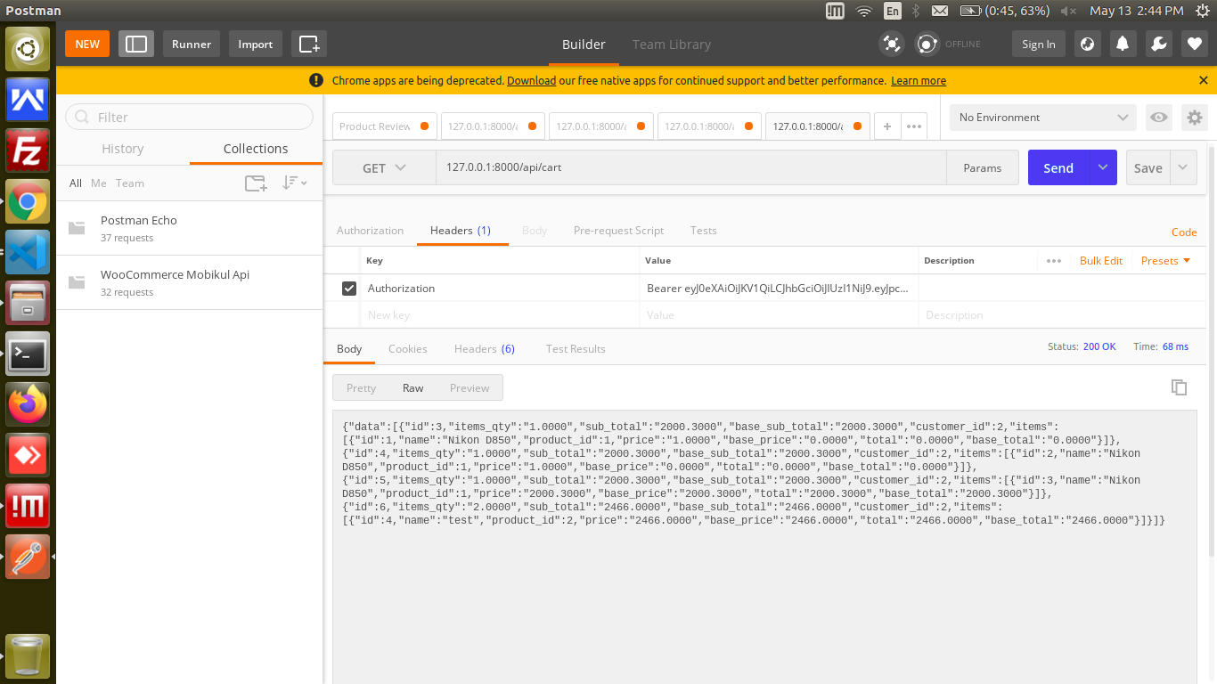

8. Apart from this, all other required API also has been cretaed as per need and are mentioned below.

127.0.0.1:8000/api/customer/login

127.0.0.1:8000/api/categories

127.0.0.1:8000/api/products

127.0.0.1:8000/api/customer/logout

and other can be found in route file.

