Home Tab

Swadharma Super App – Home Screen

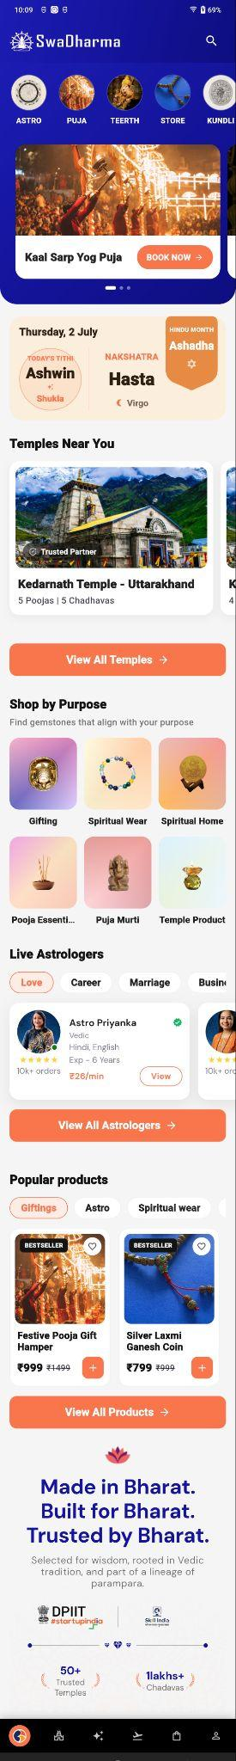
1. Screen Overview
The Home Screen is the primary landing screen of the Swadharma Super application. It provides users with quick access to astrology, puja services, temples, spiritual products, astrologers, and other spiritual content.
The screen is designed as a vertically scrollable dashboard with multiple sections and clear call-to-action buttons.

2. Top Header
The top section contains:
- Swadharma Logo – Displays the application branding.
- Search Icon – Allows users to search for relevant content or services.
- % Bonus Offer – Displays a % bonus on the user’s first recharge.

Search Screen
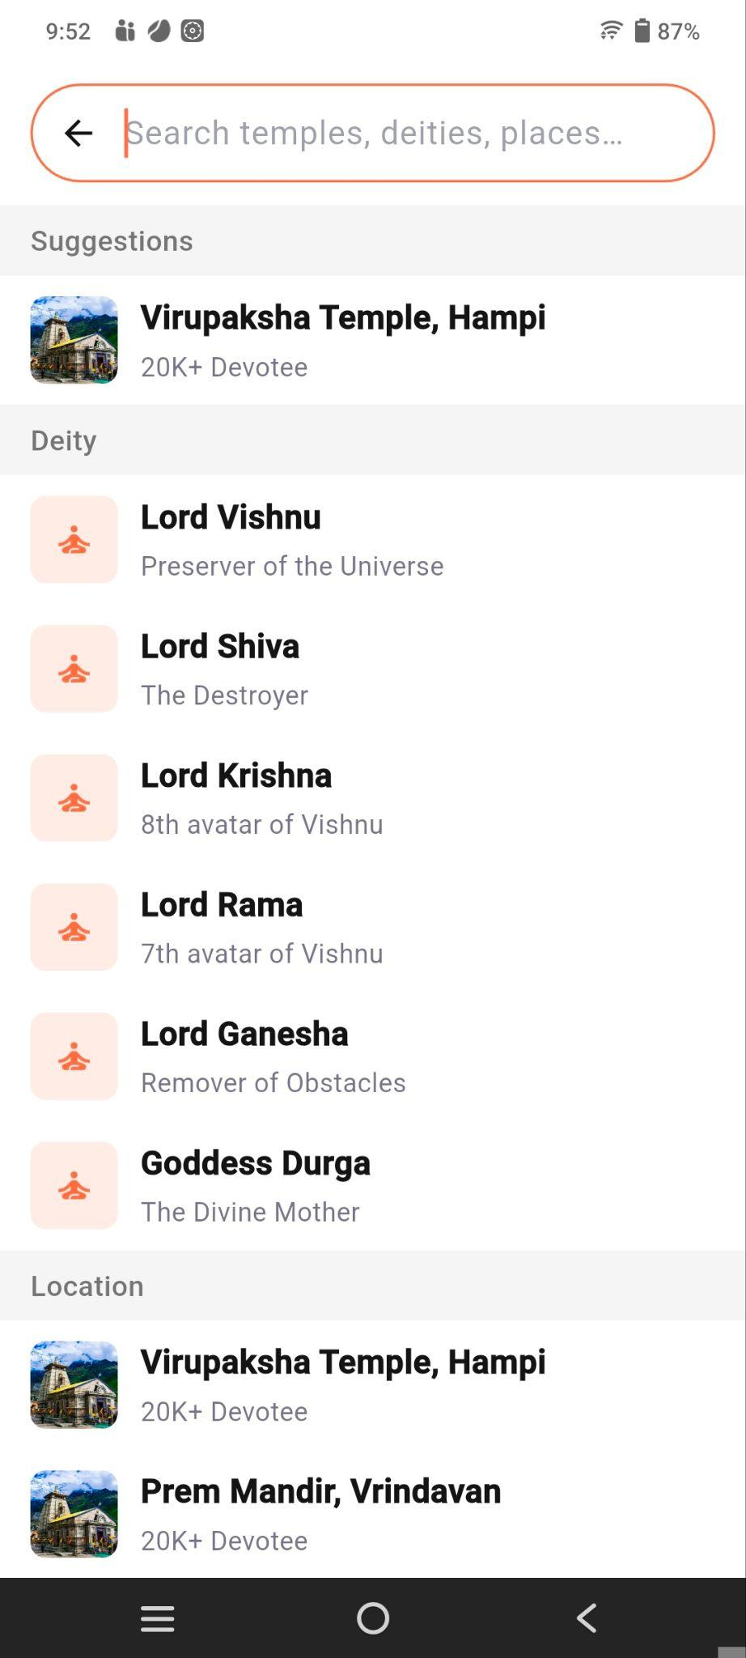

Allows users to search for temples, deities, and places using the search bar.
- Suggestions – Shows recommended temples.
- Deity – Displays popular deities with descriptions.
- Location – Shows temples based on location.

Bonus BottomSheet
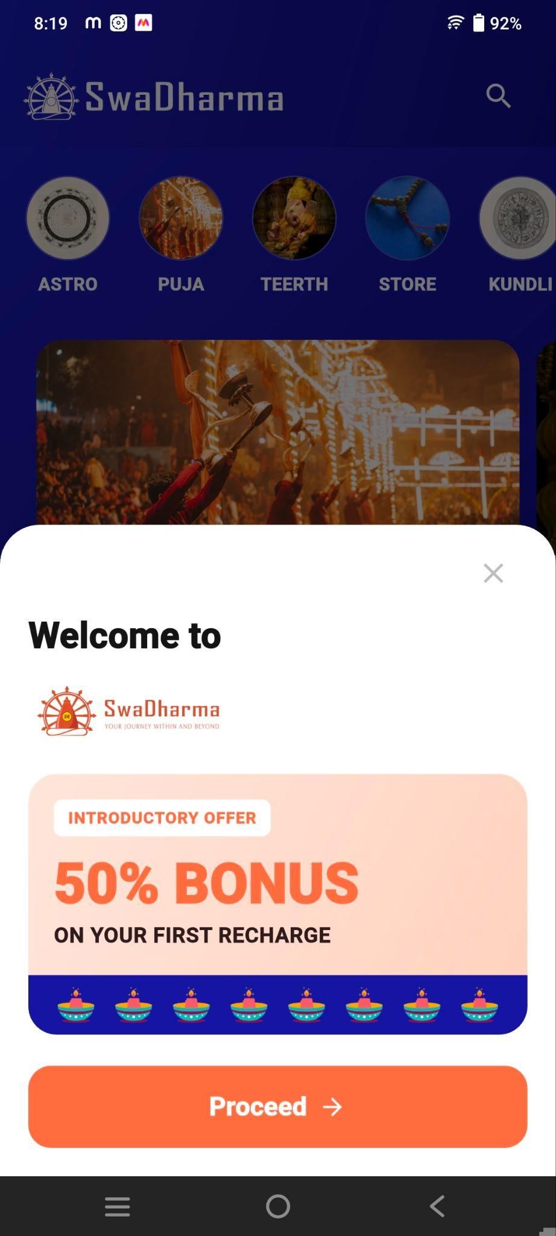

Displays a 50% bonus on the first recharge for new users, with a Proceed button to continue and an option to close the popup.

3. Quick Access Categories
Below the header, circular category shortcuts are displayed for quick navigation.
The visible categories include:
- Astro – Clicking on Astro redirects the user to the Astro Dashboard
- Puja – Clicking on Puja redirects the user to the Puja Dashboard
- Teerth – Clicking on Teerth redirects the user to the Teerth Dashboard
- Store – Clicking on Store redirects the user to the Store Dashboard
- Kundli – Clicking on Kundli redirects the user to the Kundli List
- Horoscope -Clicking on Horoscope redirects the user to the Horoscope Screen
These shortcuts allow users to reach frequently used features directly from the Home Screen.

4. Puja List
Below the Quick Access section, a list of available Pujas is displayed with:
- Puja image
- Puja name
- Purpose/description
- Participate Now/ Book Now option, where applicable

5. Today's Panchang
The Panchang section provides important daily Hindu calendar information.
The screen displays:
- Date and Day
- Today's Tithi
  - Ashwin
  - Shukla
- Nakshatra
  - Hasta
- Rashi
  - Virgo
- Hindu Month
  - Ashadha
This section gives users a quick overview of the day's important Panchang details.

6. Temples Near You
The Temples Near You section displays nearby temples.
Each temple card contains:
- Temple image
- Trusted Partner indicator
- Temple name
- Number of available poojas
- Number of available Chadhavas
Example:
Kedarnath Temple – Uttarakhand
Users can swipe horizontally to view additional temples.

Temple Card Navigation
Clicking on a Temple card redirects the user to the Temple Detail screen, which contains three tabs:
- Mandir – Displays temple-related information.
- Pujas – Displays Pujas available at the temple.
- Chadhavas – Displays Chadhava offerings available at the temple.

View All Temples
The View All Temples button navigates the user to the complete temple listing.

7. Shop by Purpose
This section helps users discover spiritual products based on their purpose.
Available categories shown include:
- Gifting
- Spiritual Wear
- Spiritual Home
- Pooja Essentials
- Puja Murti
- Temple Products
Each category is represented using an image and category title.
Selecting a category takes the user to the corresponding product listing.

8. Live Astrologers
The Live Astrologers section allows users to discover astrologers available for consultation.

Filters
Users can filter astrologers based on consultation purpose, such as:
- Love
- Career
- Marriage
- Business

Astrologer Card
Each astrologer card displays:
- Astrologer profile image
- Name
- Verification indicator
- Expertise
- Languages
- Experience
- Number of orders
- Consultation price per minute
- View button
Example:
Astro Priyanka
The View button opens the astrologer's detailed profile.

View All Astrologers
The View All Astrologers button navigates to the complete astrologer listing.

9. Popular Products
The Popular Products section displays currently popular spiritual products.

Product Categories
Products can be filtered using categories such as:
- Gifting
- Astro
- Spiritual Wear

Product Card
Each product card contains:
- Product image
- Bestseller label, where applicable
- Wishlist/favourite icon
- Product name
- Current price
- Original price
- Add-to-cart button
Example products shown:
- Festive Pooja Gift Hamper
- Silver Laxmi Ganesh Coin
Users can select a product to view its details or use the + button to add it to the cart.

View All Products
The View All Products button opens the complete product catalogue.

10. Brand/Trust Section
The lower section highlights the Swadharma brand proposition:
“Made in Bharat. Built for Bharat. Trusted by Bharat.”
This section communicates that the platform is:
- Rooted in Indian culture and traditions
- Built for Indian users
- Based on Vedic traditions
- Focused on spiritual and devotional experiences
It also displays trust/recognition elements and platform statistics.
Examples shown:
- 50+ Trusted Temples
- 1 Lakh+ Chadavas

11. Bottom Navigation
A fixed bottom navigation bar provides access to the application's primary modules.
The navigation contains icons for different areas of the application, including:
- Home
- Puja
- Astro
- Teerth
- Store
- Profile
The currently selected section is visually highlighted.

12. User Flow
The typical Home Screen flow is:
Open App → Home Screen → Select Required Category → View Listing/Details → Perform Action
Examples:
- Home → Puja → Select Puja → View Details → Book Now
- Home → Temples Near You → Select Temple → Temple Details
- Home → Live Astrologers → Select Astrologer → Astro Detail → Consultation
- Home → Shop by Purpose → Select Category → Product Listing → Product Details
- Home → Popular Products → Select Product → Add to Cart → Checkout

13. Key Purpose of the Home Screen
The Home Screen acts as a centralized discovery and navigation hub for the Swadharma application. It combines spiritual services, temples, astrology, Panchang information, and e-commerce products in a single interface, allowing users to quickly discover and access the application's major features.

Puja Tab

Swadharma Super App – Puja Screen

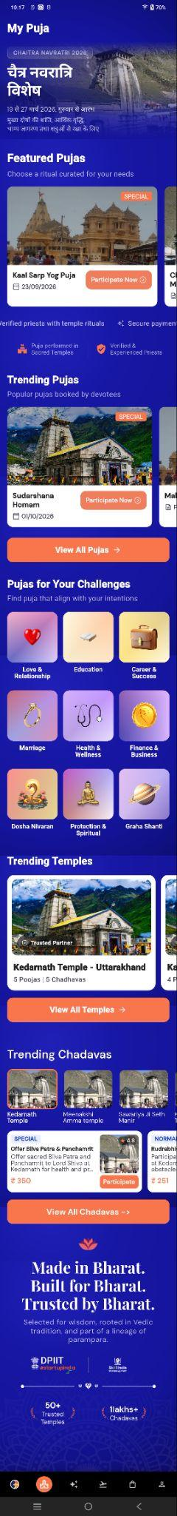
1. Screen Overview
The My Puja screen is the central section for discovering and exploring different Puja rituals and devotional services available on the Swadharma application.
The screen provides users with:
- Featured Pujas
- Trending Pujas
- Pujas based on personal challenges or intentions
- Trending Temples
- Trending Chadhavas
- Temple-related ritual information
- Quick access to view all available Pujas, Temples, and Chadhavas
The screen uses a vertically scrollable layout with horizontally scrollable cards within individual sections.

2. Screen Header
The top of the screen displays:
My Puja
This identifies the current module and provides users with access to the Puja-focused content.

3. Festival / Promotional Banner
The first section contains a large promotional banner for a featured festival or spiritual occasion.
Example shown:
Chaitra Navratri 2026
The banner includes:
- Festival name
- Festival date range
- Location/event information
- Short description
- Temple imagery
- Background promotional artwork
This section is used to highlight important festivals, campaigns, and special Puja opportunities.

4. Featured Pujas
The Featured Pujas section highlights curated Puja rituals recommended for users.
Subtitle:
Choose a ritual curated for your needs
Puja Card contains: Each Puja card displays different information based on the Puja type.

Normal Puja
A Normal Puja card contains:
- Temple/Puja image
- Normal label
- Puja title
- Puja description
- Book Now button
Navigation:
- Clicking anywhere on the Puja card redirects the user to the Puja Detail screen.
- Clicking Book Now also redirects the user to the Puja Detail screen.
The user can review the complete Puja details on the Puja Detail screen before proceeding with the booking.

Special Puja
A Special Puja card contains:
- Temple/Puja image
- Special label
- Puja title
- Scheduled date
- Participate Now button
Navigation:
- Clicking anywhere on the Puja card redirects the user to the Puja Detail screen.
- Clicking Participate Now also redirects the user to the Puja Detail screen.
The user can review the complete Puja details on the Puja Detail screen before proceeding with participation.
The cards are horizontally scrollable, allowing users to browse multiple featured Pujas.

5. Trust & Service Highlights
Below the Featured Pujas, the screen displays trust-related information to increase user confidence in the services.
Examples include:
- Verified priests
- Secure payments
- Puja performed in sacred temples
- Verified & experienced priests
These highlights communicate the authenticity, reliability, and security of the Puja services.

6. Trending Pujas
The Trending Pujas section displays popular Pujas based on user interest and participation.
Subtitle:
Popular pujas booked by devotees

Normal Puja
A Normal Puja card contains:
- Puja image
- Normal label
- Puja title
- Puja description
- Book Now button
Navigation:
- Clicking anywhere on the Puja card redirects the user to the Puja Detail screen.
- Clicking Book Now also redirects the user to the Puja Detail screen.
The user can review the complete Puja details on the Puja Detail screen before proceeding with the booking.

Special Puja
A Special Puja card contains:
- Temple/Puja image
- Special label
- Puja title
- Scheduled date
- Participate Now button
Navigation:
- Clicking anywhere on the Puja card redirects the user to the Puja Detail screen.
- Clicking Participate Now also redirects the user to the Puja Detail screen.
The user can review the complete Puja details on the Puja Detail screen before proceeding with participation.
Users can swipe horizontally to browse the available Trending Pujas.

View All Pujas
The View All Pujas button navigates the user to the complete list of available Pujas.
My Puja → View All Pujas → Puja List

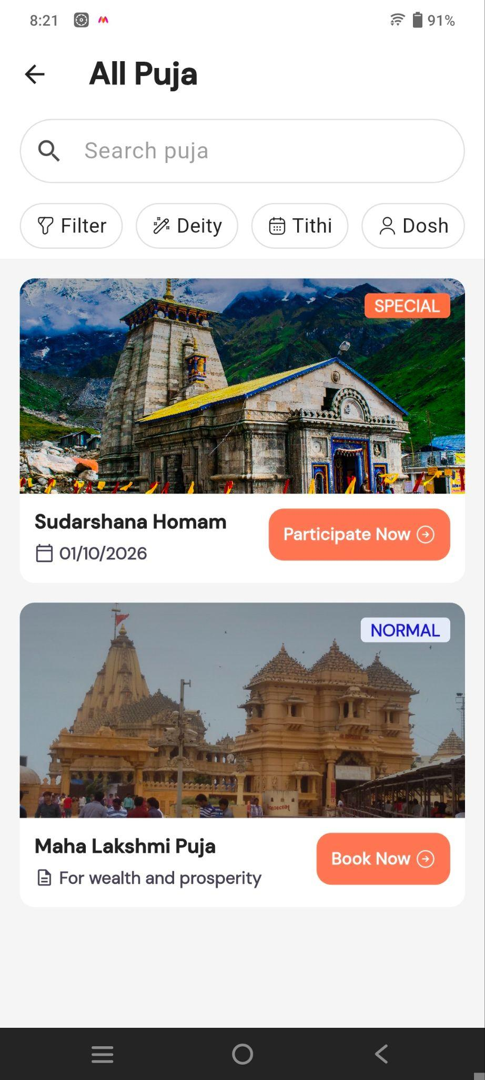
Puja List

Displays the list of available Pujas with:
- Search option to find a specific Puja.
- Filters by Deity, Tithi, and Dosh.
- Puja details such as name, date, purpose, and category.
- Participate Now / Book Now buttons to proceed with the selected Puja.

7. Pujas for Your Challenges
This section allows users to discover Pujas based on their personal goals, challenges, or intentions.
Subtitle:
Find puja that align with your intentions
The categories displayed include:
- Love & Relationship
- Education
- Career & Success
- Marriage
- Health & Wellness
- Finance & Business
- Dosha Nivaran
- Protection & Spiritual
- Graha Shanti
Each category is represented by an icon/image and category name.

Category Navigation
Clicking on a challenge category filters the Puja list based on the selected category and displays the relevant Pujas.
Example:
Career & Success → Filtered Puja List → Select Puja → Puja Detail Screen
Users can select different categories to view Pujas relevant to their specific needs or intentions.

8. Trending Temples
The Trending Temples section displays popular temples associated with available Puja services.
Each temple card contains:
- Temple image
- Trusted Partner badge
- Temple name
- Number of available Pujas
- Number of available Chadhavas
Example:
Kedarnath Temple – Uttarakhand
The temple cards are horizontally scrollable.

Temple Navigation
Clicking on a Trending Temple card redirects the user to the Temple Detail screen, where the user can review the temple information and available services before proceeding with any booking.

View All Temples
The View All Temples button opens the complete temple listing.
My Puja → View All Temples → Temple List

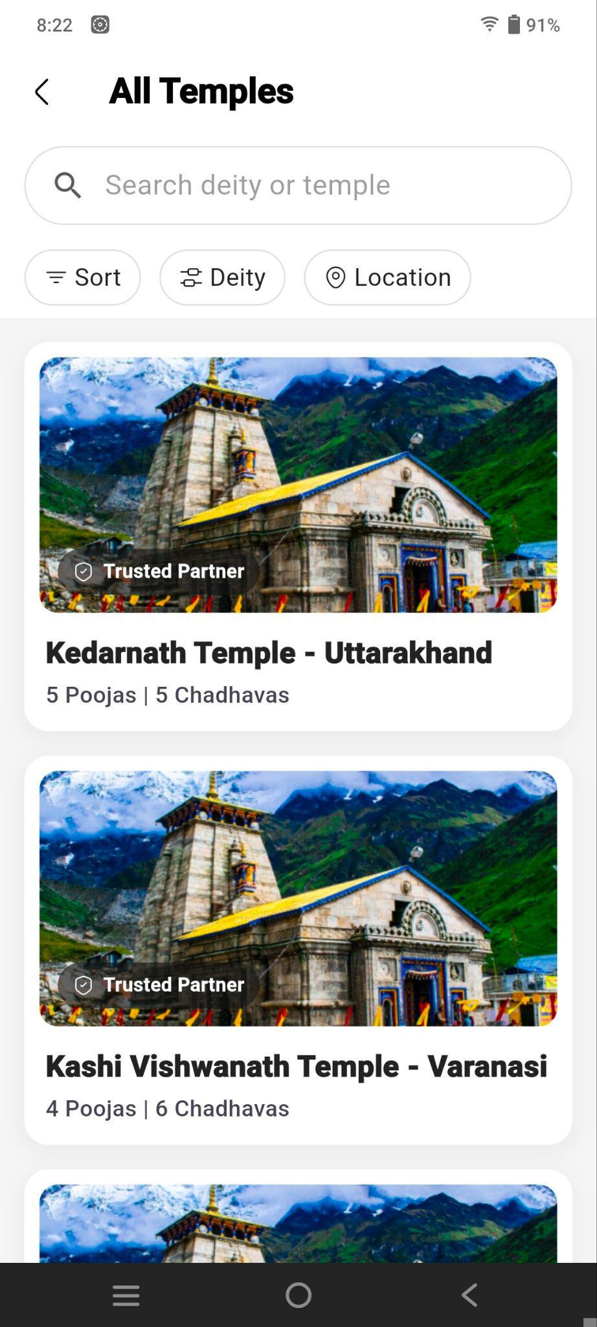
Temples List Screen

Displays a list of available temples with:
- Search option to find a deity or temple.
- Filters for Sort, Deity, and Location.
- Temple image and Trusted Partner status.
- Temple name and available Poojas & Chadhavas.
- Users can select a temple to view its details.

9. Trending Chadhavas
The Trending Chadhavas section showcases popular Chadhava offerings available through the application.
Chadhava refers to devotional offerings made at temples on behalf of devotees.
The section displays multiple Chadhava cards.
Each card can contain:
- Temple image
- Temple name
- Special/Normal badge
- Offering name
- Short description
- Price
- Rating/review information
- Book button(Normal Chadhava) / Participate button(Special Chadhava).
Example:
Offer Bilva Patra & Panchamrit
The user can select Participate to proceed with the selected Chadhava.

Chadhava Navigation
Clicking on a Trending Chadhava temple card redirects the user to the Chadhava detail screen, where the available Chadhavas for the selected temple are displayed.
The list is categorized into:
- Normal Chadhavas
- Special Chadhavas
Users can select the required Chadhava to view its details and proceed with participation.

View All Chadhavas
The View All Chadhavas button navigates to the complete Chadhava catalogue.
My Puja → View All Chadhavas → Chadhava Listing

Chadhavas List Screen
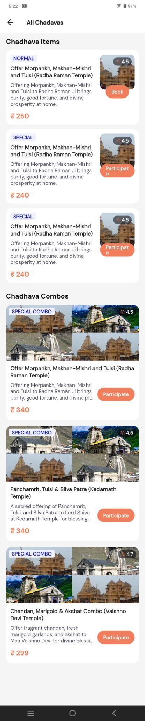
Displays available Chadhava items and combos with:
- Chadhava name, description, and price.
- Normal/Special category and ratings.
- Book / Participate options.
- Special Chadhava Combos with multiple offerings.
- Users can select a Chadhava or combo to participate.

10. Made in Bharat / Trust Section
The lower portion of the screen contains the Swadharma brand and trust section.
Main message:
“Made in Bharat. Built for Bharat. Trusted by Bharat.”
Supporting text explains that the platform is:
- Selected from wisdom
- Rooted in Vedic tradition
- Part of a lineage of parampara
The section also displays recognition/trust logos and platform statistics.
Examples:
- 50+ Trusted Temples
- 1 Lakh+ Chadhavas
This section reinforces the credibility and cultural foundation of the platform.

11. Bottom Navigation
A fixed bottom navigation bar is available throughout the screen.
It provides quick navigation to major application modules, including:
- Home
- Puja
- Astrology/Services
- Spiritual/Journey section
- Store
- Profile
The Puja section is highlighted because the user is currently viewing the My Puja screen.

12. Key Purpose of the Screen
The My Puja screen acts as a dedicated discovery hub for devotional services. It combines Puja booking, festival campaigns, personalized Puja categories, temples, and Chadhavas into one screen.
The primary objective is to help users quickly discover a suitable spiritual service based on:
- Current festivals
- Popular/trending Pujas
- Personal life challenges
- Temple availability
- Chadhava offerings
- Trusted priests and temples
This provides users with a simple journey from discovering a spiritual service to participating in the Puja or Chadhava online.

Normal Puja Flow
Puja Details Screen

Displays complete information about the selected Puja, including:
- Puja name, temple, and contribution amount.
- About the Puja and its spiritual significance.
- Temple details and related temples.
- Puja process and rituals.
- Spiritual benefits.
- Featured videos.
- Devotee reviews and experiences.
- Frequently Asked Questions (FAQs).
- Other related Pujas.
- Book Now option to participate in the Puja.

Book Puja Flow
The Book Puja flow guides the user through three steps:
- Date – Select the Puja date from the calendar.
- Devotee Details – Select or add the devotee participating in the Puja.
- Address – Select an existing address or add a new address.
After completing these steps, the user proceeds to Booking Preview, reviews the details, and continues to pay.

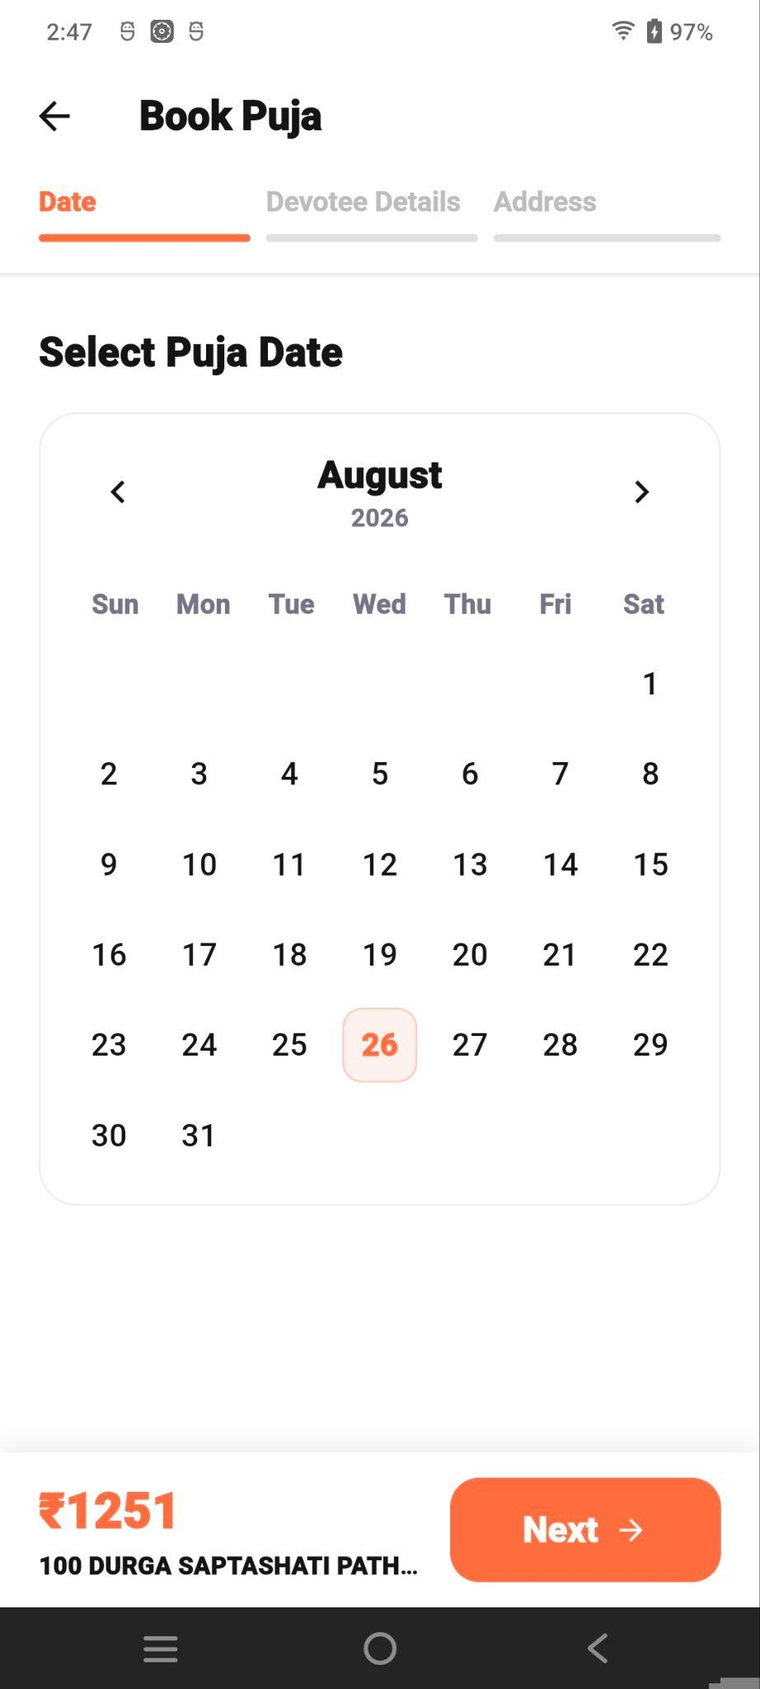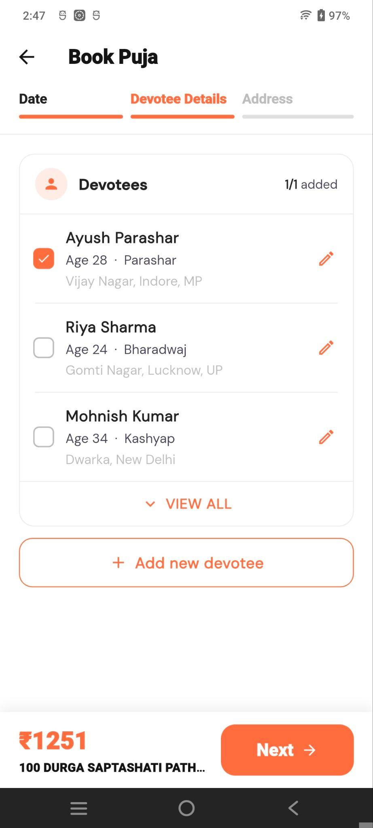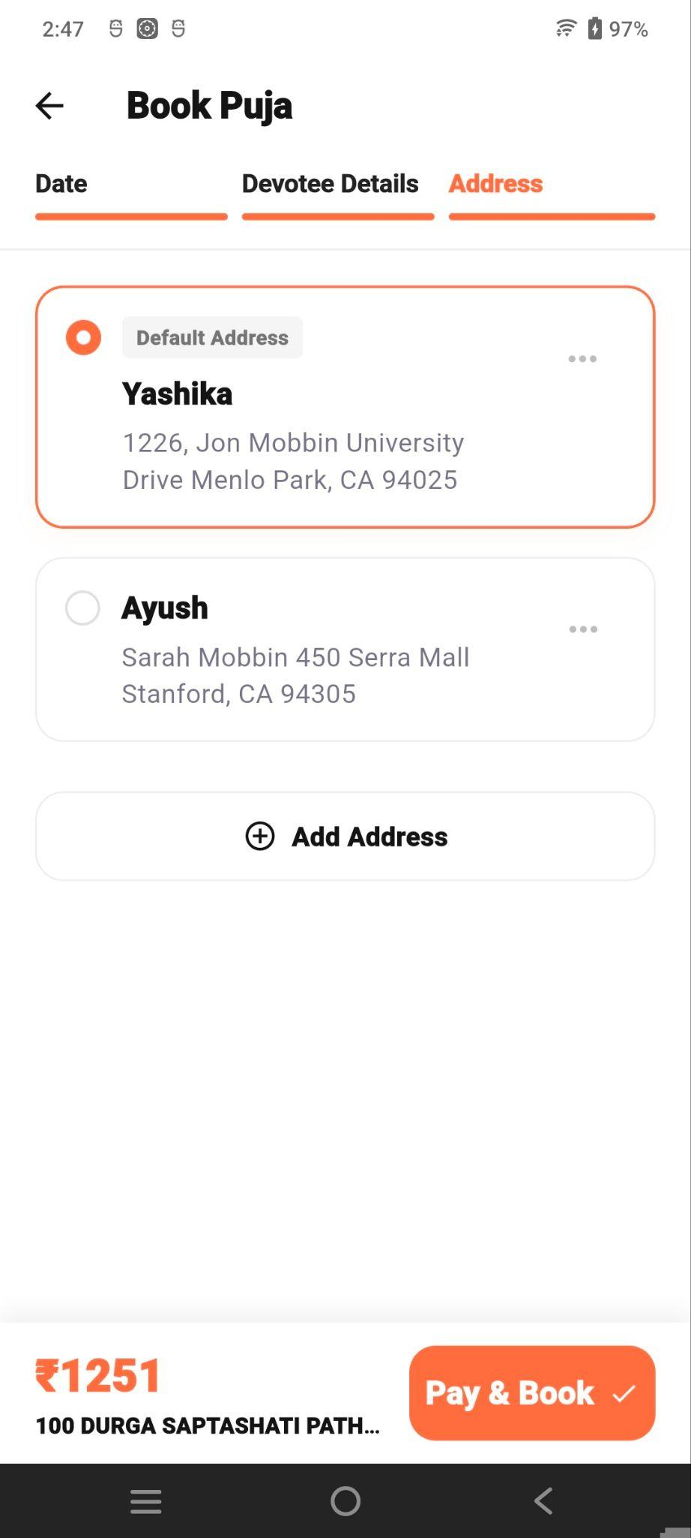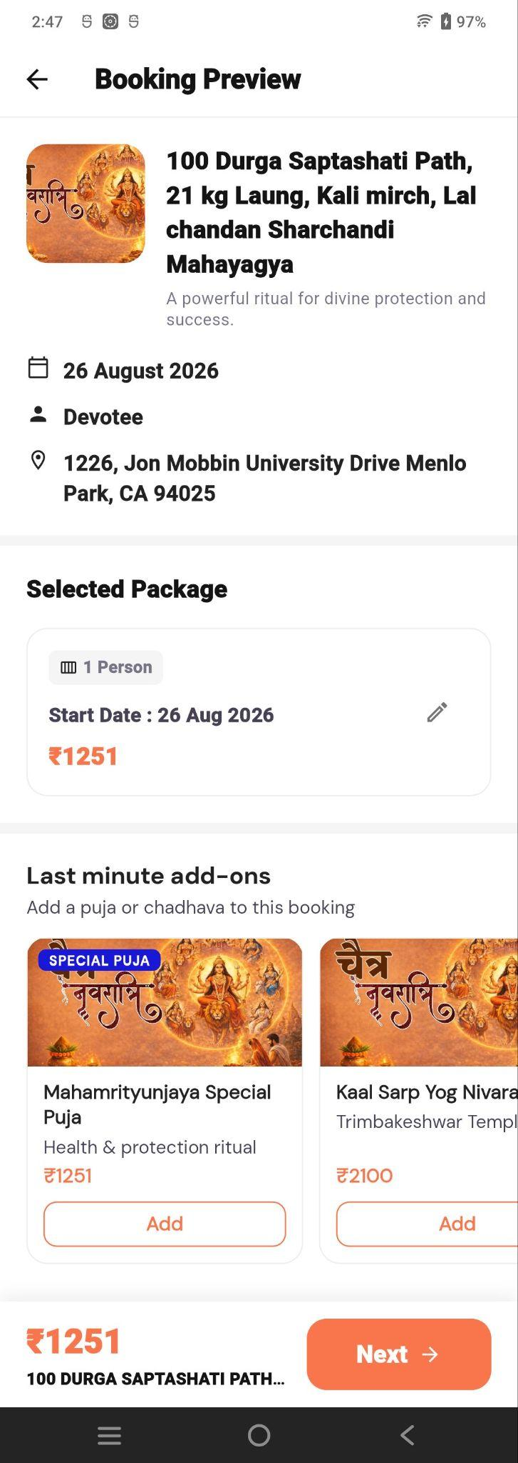

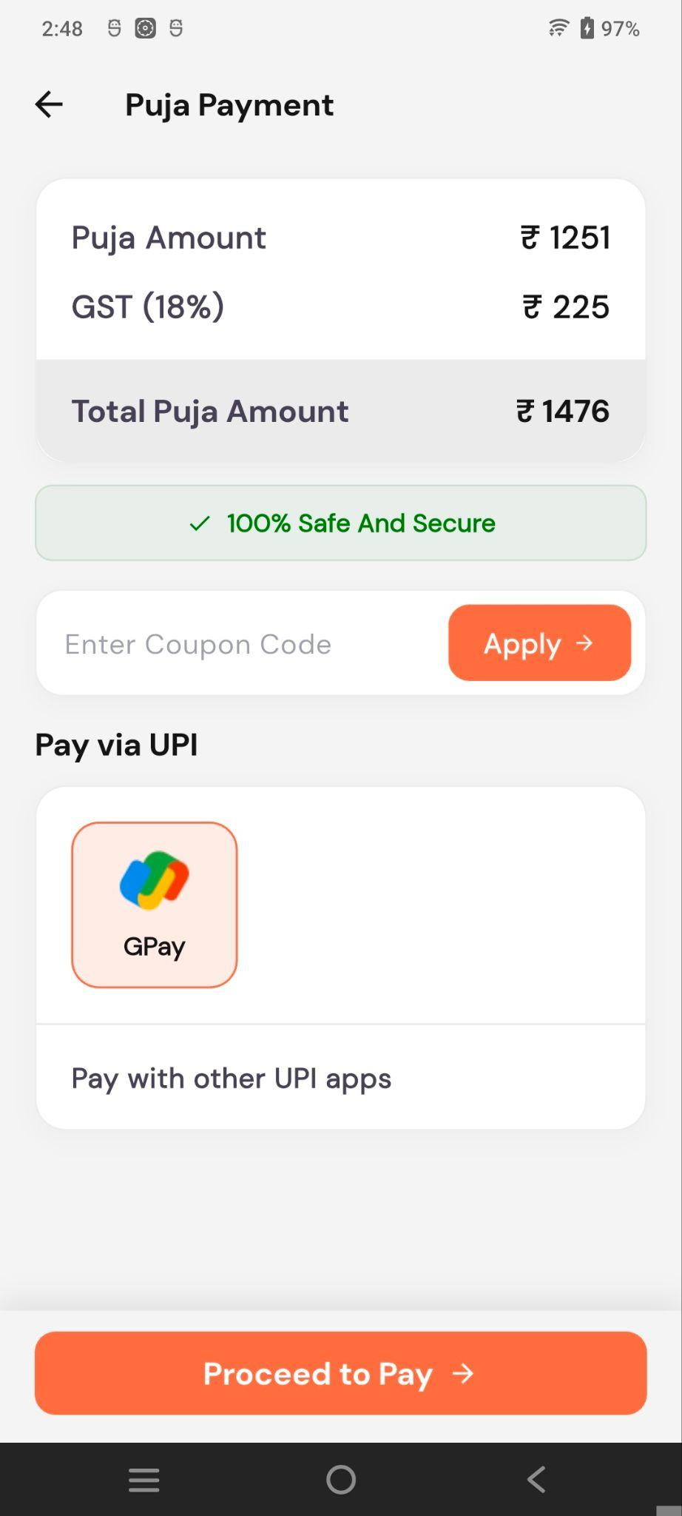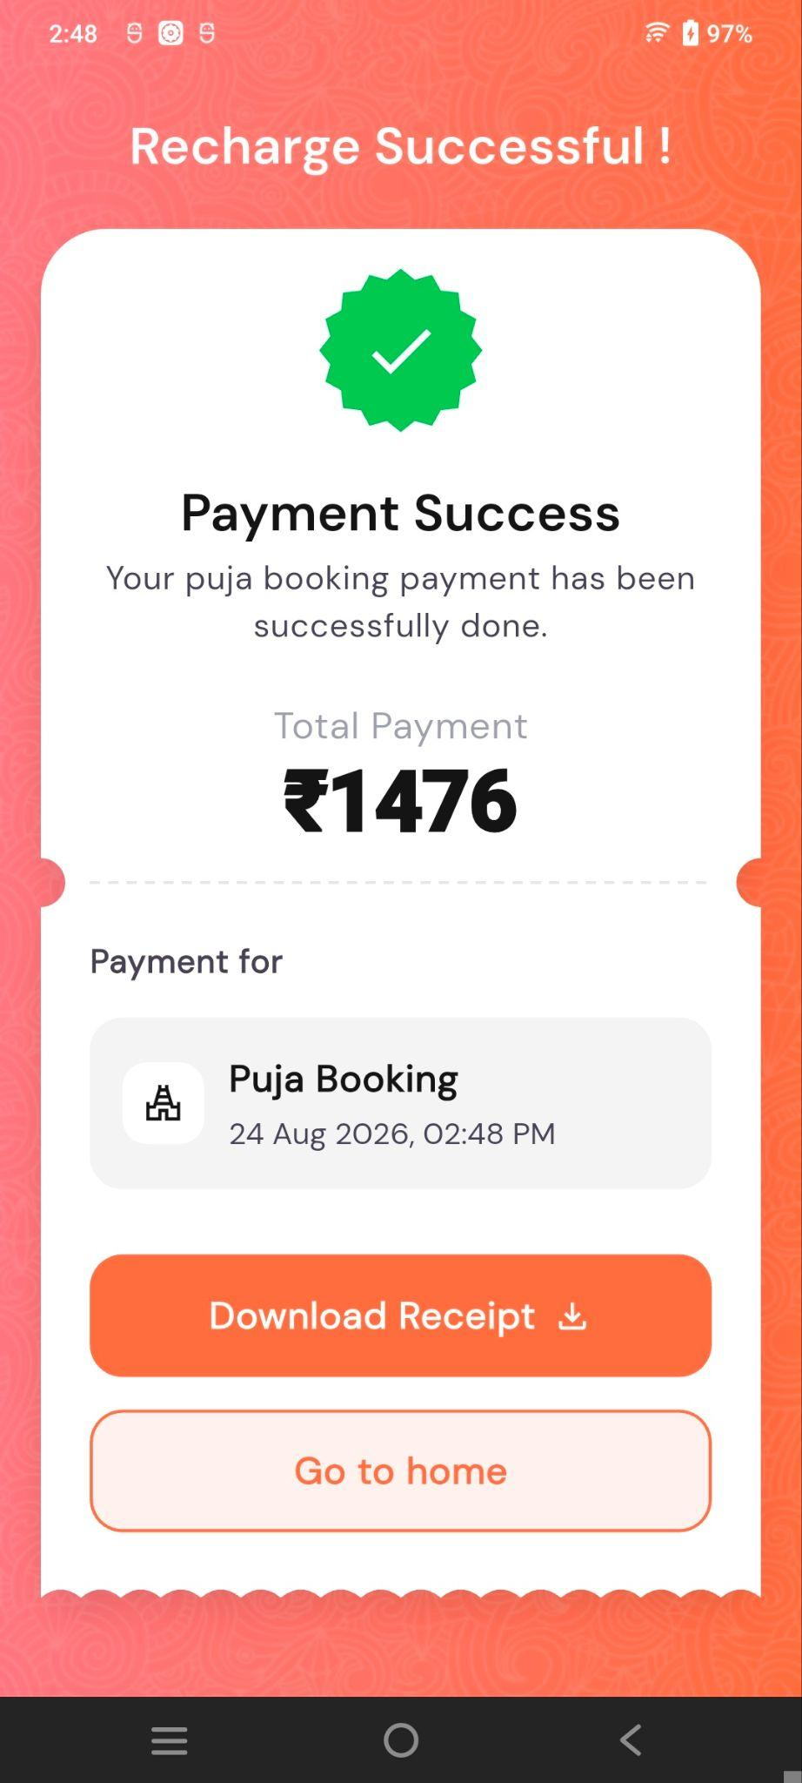

Special Puja Flow

Detail Screen

The Puja Detail screen provides complete information about the selected Puja and allows users to review the Puja before proceeding with booking or participation.

1. Puja Header
The top section displays:
- Puja/temple image
- Puja title
- Short description
- Location/temple name
- Puja date
- Availability/booking status
- Additional Puja information

2. Puja Information
This section provides additional information related to the selected Puja, such as:
- Performing temple/location
- Scheduled date
- Puja-related details
- Availability information

3. Countdown / Booking Closing Time
A countdown timer displays the remaining time before the Puja booking closes.
The timer shows:
- Days
- Hours
- Minutes
- Seconds
This helps users understand the booking deadline.

4. About This Puja
The About this Puja section explains the background and significance of the selected Puja.
Example content includes information about The Legend of Maa Chamunda & Bhairav and the religious/spiritual significance associated with the Puja.

5. Why Perform This Puja at This Temple?
This section explains why the selected temple is considered significant for performing the Puja.
It provides information about the temple's spiritual importance and the purpose of performing the Puja at that location.

6. Divine Puja Process
The Divine Puja Process section explains how the Puja is performed.
The screen displays individual process steps, such as:
- Sankalp – Personalised prayer/intention.
- Panchopachar Pujan – Ritual worship with prescribed offerings.

7. Spiritual Benefits
The Spiritual Benefits section highlights the expected spiritual purposes or benefits of performing the Puja.
Examples shown include:
- Protection – Protection from negative influences.
- Prosperity – Attraction of wealth.

8. Select Packages
The Select Packages section allows users to choose a suitable Puja participation package.
Each package displays:
- Package name/type
- Number of persons
- Price
- Popular/Premium indicator, where applicable
- Selection option
Examples include:
- Individual Puja
- Partner Puja
- Small Family
- Joint Family
The user can select one of the available packages before proceeding.

9. Included in Packages
This section explains what is included with the selected Puja package.
Examples shown include:
- Prasad delivery to the user's home
- Video recording of the Puja/Sankalp
- Blessings from the sacred temple

10. Puja Location
The Puja takes place at a section displaying the temple where the Puja will be performed.
Example:
Vaishno Devi (Katra)
The section includes:
- Temple name
- Temple description
- Temple images
Users can browse additional temple images horizontally.

11. Featured Videos
The Featured Videos section provides videos related to the temple or Puja.
Each video card contains:
- Video thumbnail
- Video title
- Playback option
Users can swipe horizontally to browse additional videos.

12. Devotee Experience
This section displays feedback or reviews from devotees who have participated in the Puja.
Each review can contain:
- Devotee name
- Rating
- Review text
A View All option allows users to access additional reviews.

13. Frequently Asked Questions
The Frequently Asked Questions section provides answers to common questions related to the Puja.
Examples include:
- What if I don't know my Gotra?
- Who performs the Puja?
- When will I receive the Prasad?
- Is the donation eligible for tax exemption?
The questions are displayed using an expandable accordion layout.

14. Explore Other Pujas
The Explore Other Pujas section recommends additional Pujas that users may be interested in.
Each Puja card can display:
- Puja image
- Special/Normal label
- Puja name
- Book Now or Participate button
Users can swipe horizontally to browse other available Pujas.

15. Bottom Booking Section
A fixed bottom section provides the final booking action.
The screen displays the selected package/booking status and a Continue button.
The user can select a package and then click Continue to proceed with the next step of the booking/participation flow.

User Flow
Puja List → Select Puja → Puja Detail → Select Package → Continue →Participation
The Puja Detail screen acts as the main information and decision-making screen, allowing users to review the Puja, temple, benefits, process, packages and FAQs before completing their booking.

Participate Puja - Booking
The Participate Puja screen is the first step in the Puja booking/participation flow. It allows the user to select the devotee(s) who will participate in the Puja and provide or manage their details.

Booking Steps
The screen displays a two-step progress flow:
- Devotee Details – Current step.
- Address – Next step.

Devotees Detail
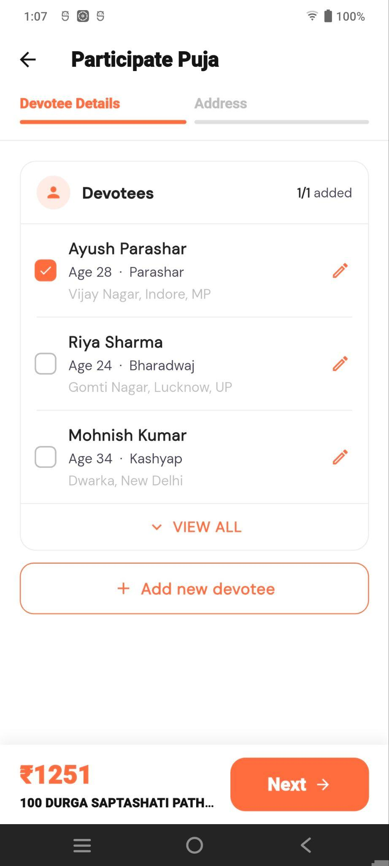
The Devotees section displays the user's saved devotees.
Each devotee entry contains:
- Full name
- Age
- Gotra
- Address
- Selection checkbox
- Edit option
The selected devotee is highlighted with a checked checkbox.
The screen also displays the number of selected devotees, for example 1/1 added.

View All
The View All option allows the user to view all saved devotees.

Add New Devotee
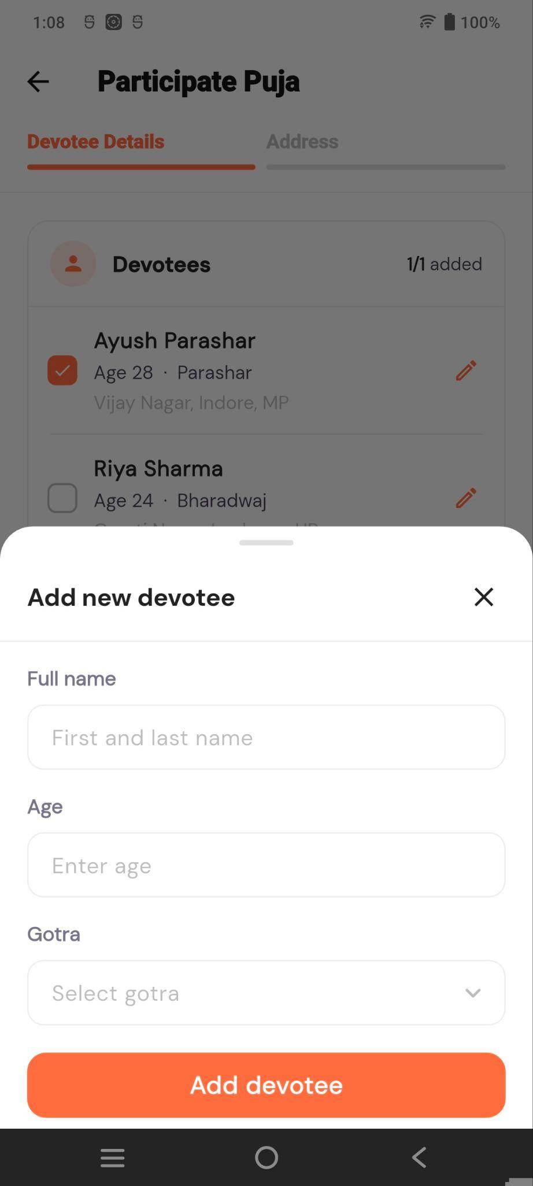
The Add new devotee button opens a form where the user can add a new devotee.
The form contains:
- Full name – Enter first and last name.
- Age – Enter devotee's age.
- Gotra – Select the devotee's Gotra.
Clicking Add devotee adds the new devotee to the available list.

Next
After selecting the required devotee, the user can click Next to proceed to the Address step.

Booking Flow
Puja Detail → Participate Now → Participate Members – Devotee Details → Select/Add Devotee → Next → Address

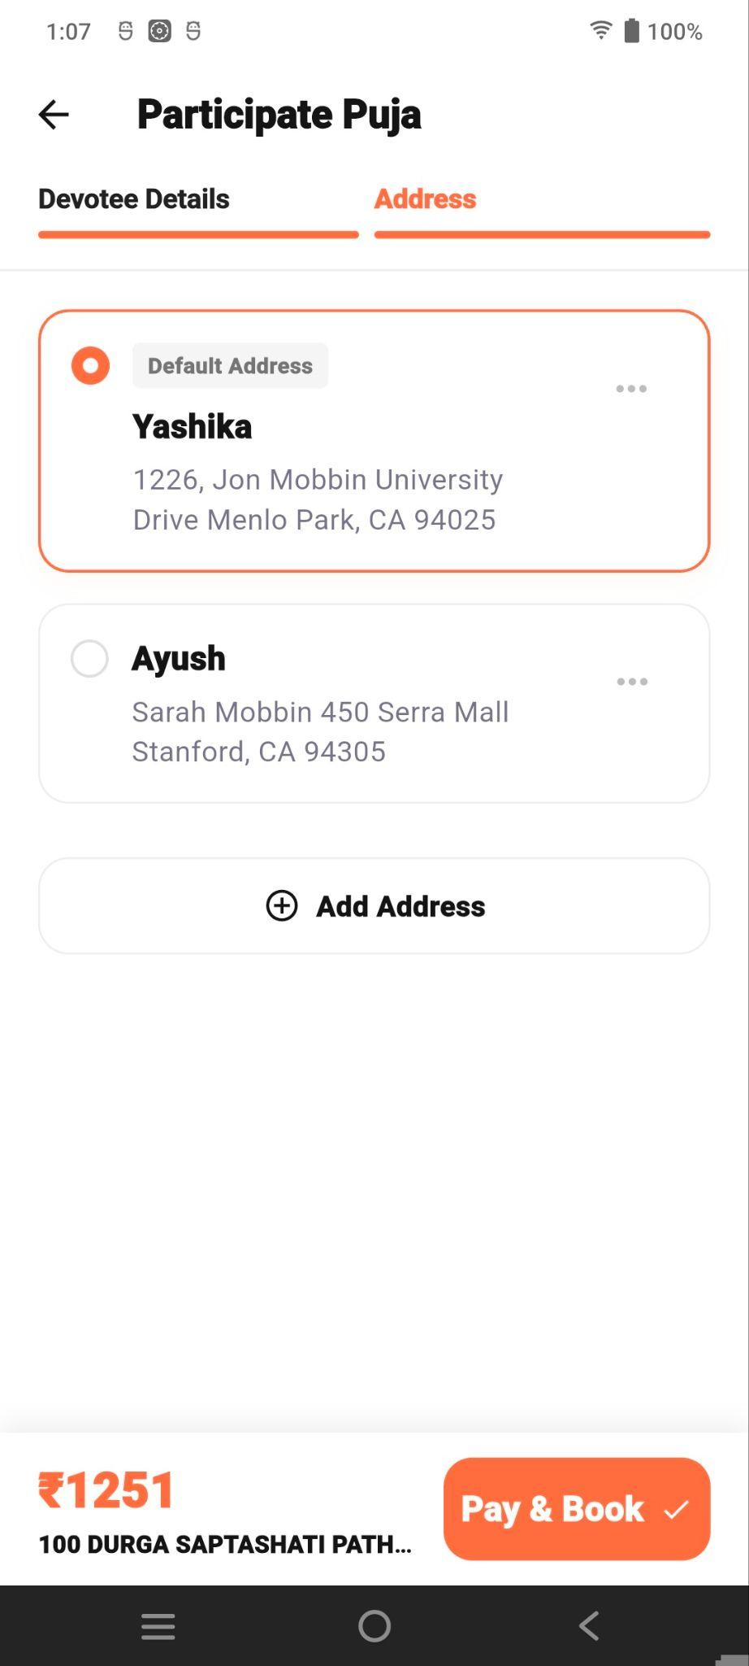
Address Selection
The Address step displays the user's saved addresses. The user can select an existing address or use Add Address to create a new one.
After selecting the required address, the user can proceed with Pay & Book to complete the Special Puja booking.

Add Address
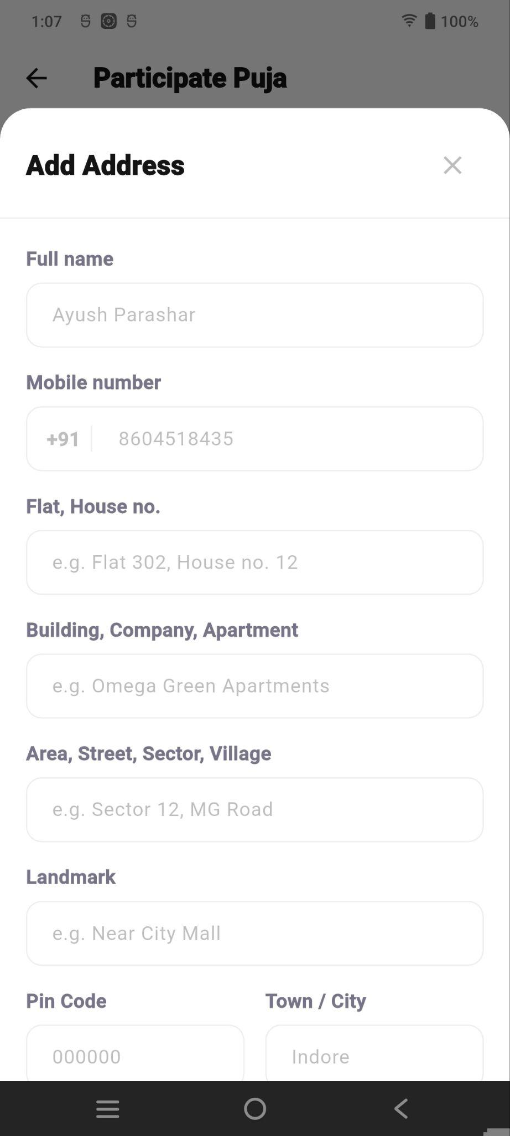
The Add Address option allows the user to add a new address during the Special Puja booking process.
The form contains the following fields:
- Full Name – Enter the name of the person associated with the address.
- Mobile Number – Enter the user's mobile number.
- Flat, House No. – Enter the flat or house number.
- Building, Company, Apartment – Enter the building, company, or apartment name.
- Area, Street, Sector, Village – Enter the area or street details.
- Landmark – Enter a nearby landmark for easier identification.
- PIN Code – Enter the postal PIN code.
- Town / City – Enter the town or city name.
After entering the required address details, the user can save the address and select it for the Puja booking.

Booking Preview
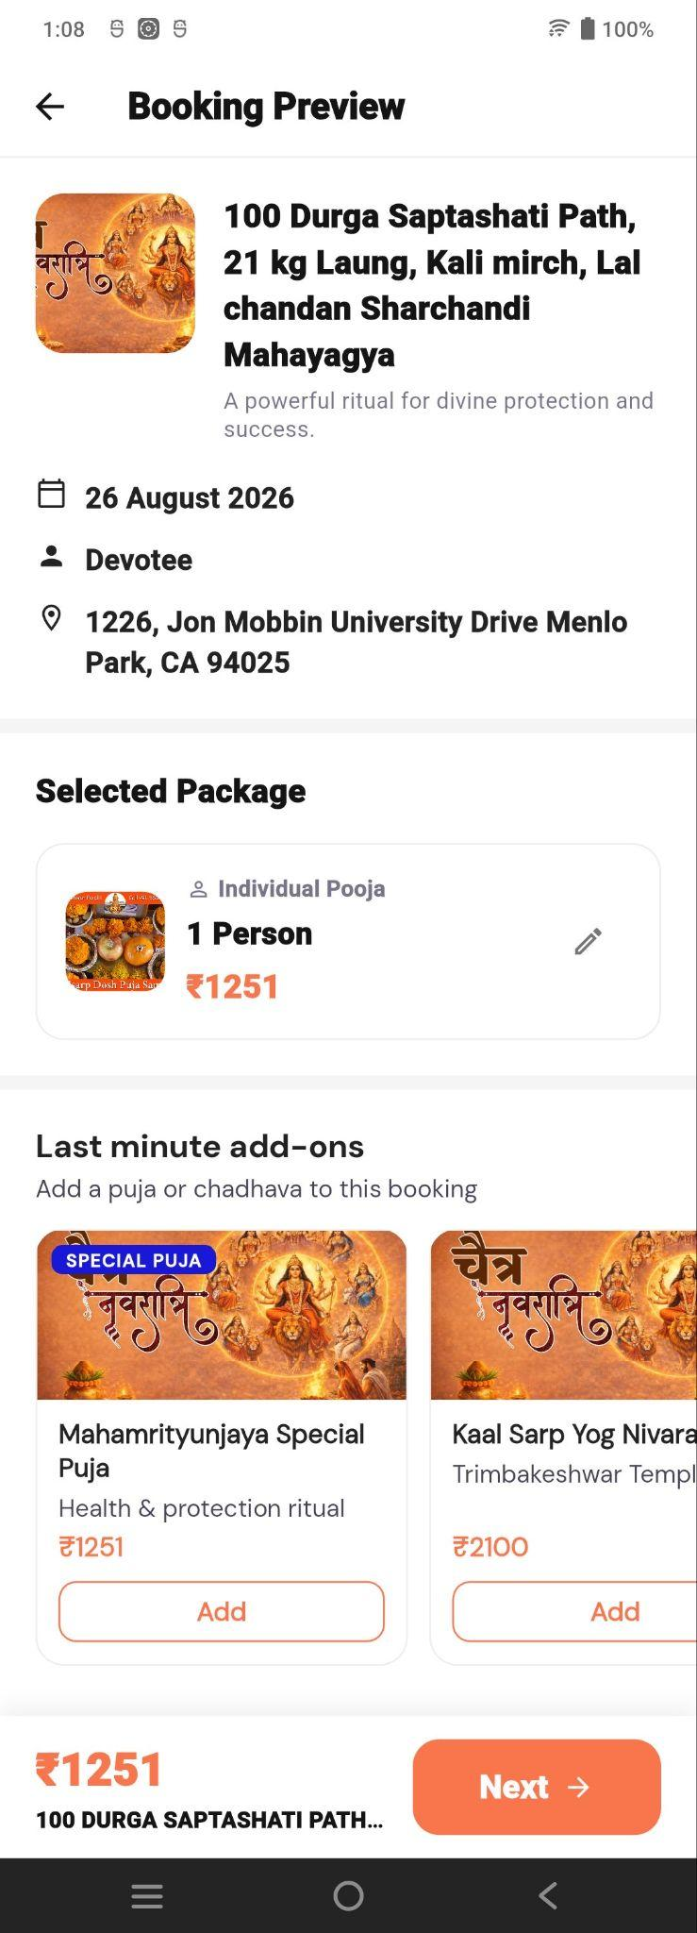
The Booking Preview screen displays a summary of the selected Puja booking before the user proceeds to the final booking/payment step.
The screen includes:
- Selected Puja details
- Puja date
- Selected devotee
- Selected address
- Selected package
- Package price
- Last-minute add-ons

Edit Selected Package / Devotee Details
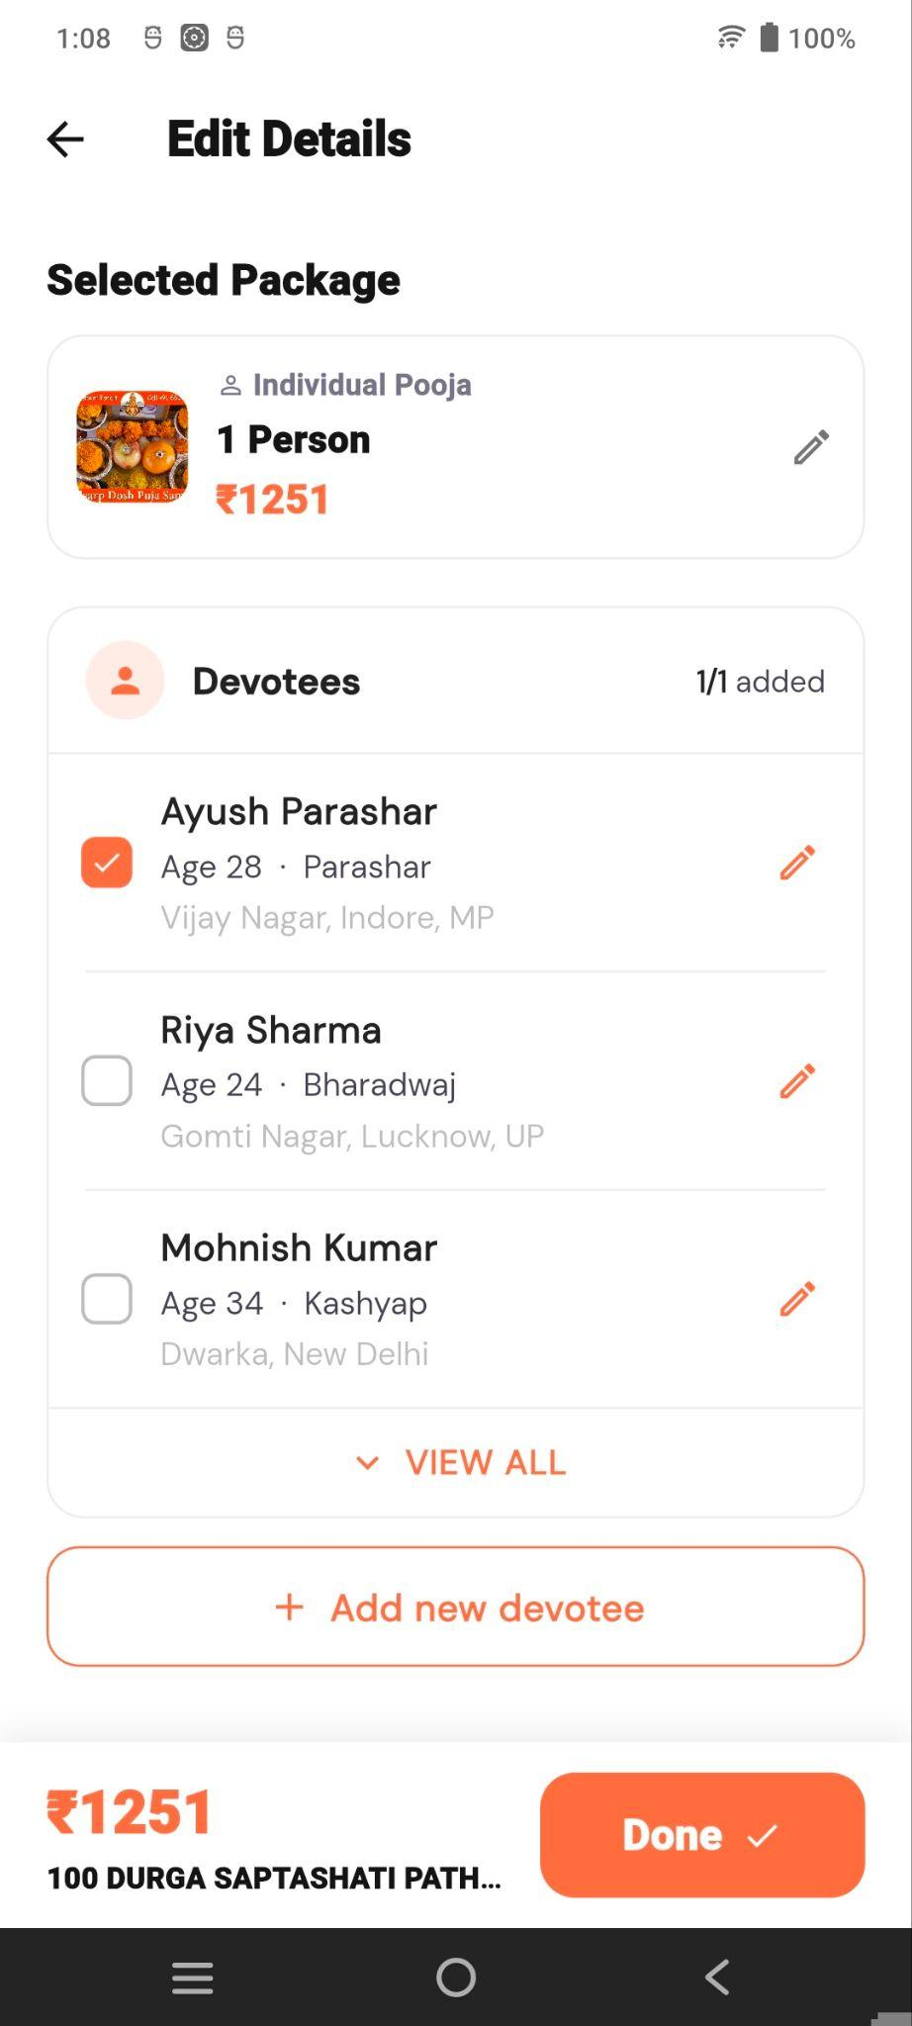
The Selected Package section displays the package chosen by the user, including:
- Package name
- Number of persons
- Package price
- Edit option
Clicking the Edit icon opens the Edit Details screen.
The Edit Details screen displays the selected package and the Devotees section, where the user can:
- Select or deselect devotees
- Edit existing devotee details
- View all saved devotees
- Add a new devotee
After making the required changes, clicking Done returns the user to the Booking Preview screen with the updated details.

Last-Minute Add-ons
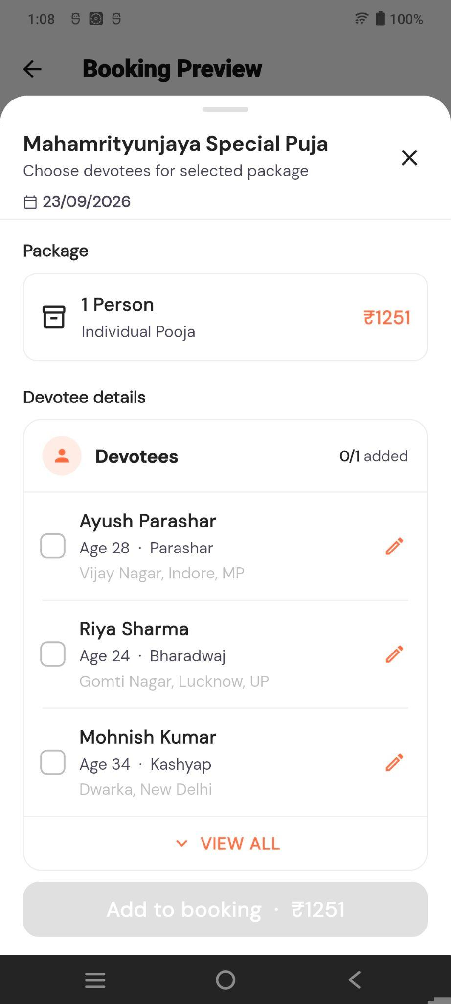
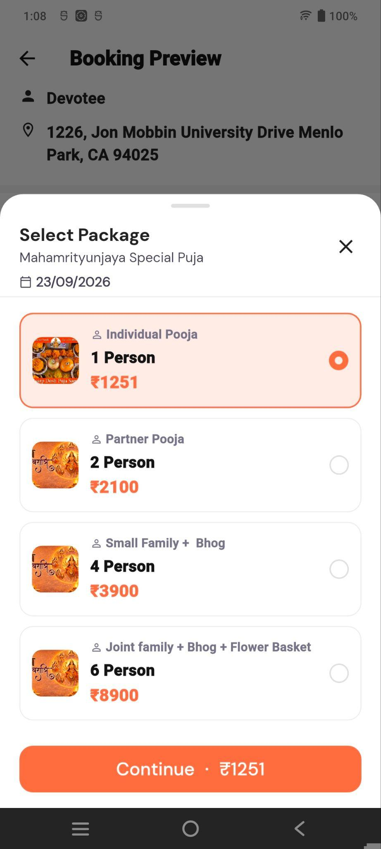
The Last-Minute Add-ons section allows users to add additional Pujas or Chadhavas to the current booking.
Each add-on includes an Add button
Clicking the Add button opens the relevant selection screen.
For an additional Puja, the Select Package screen is displayed, where the user can choose the required package based on the number of persons and package price.
After selecting a package, clicking Continue adds the selected Puja package to the booking.
The booking total is updated based on the selected add-on.

Next
After reviewing the booking details and making any required changes, the user can click Next to proceed to the next stage of the booking/payment flow.
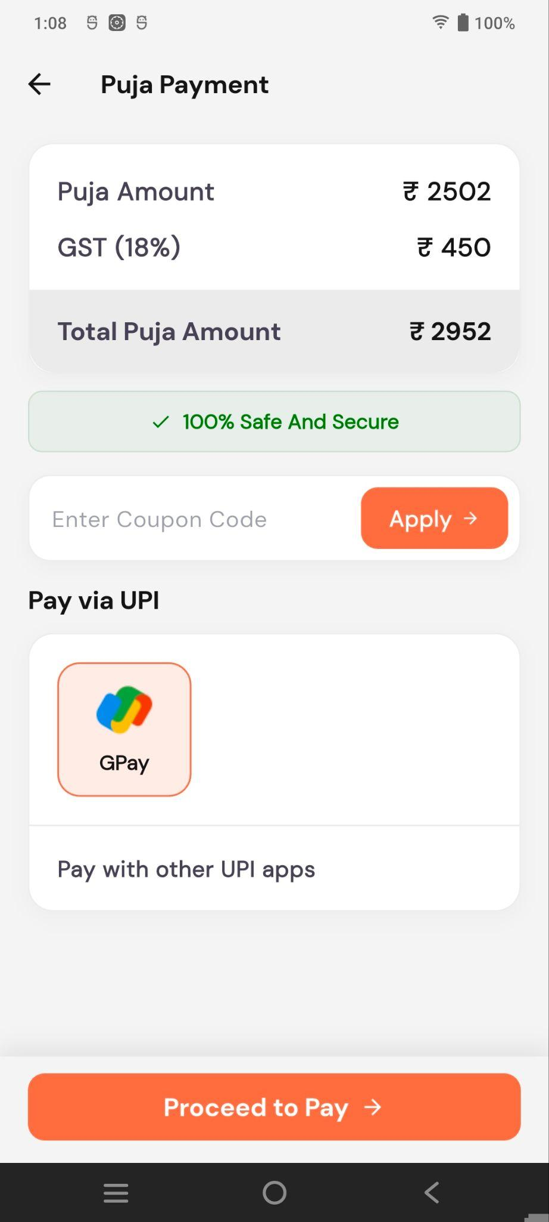
The Puja Payment screen shows the final Puja amount, including GST, and allows the user to apply a coupon and select a UPI payment option.
Clicking Proceed to Pay completes the payment.

Payment Success
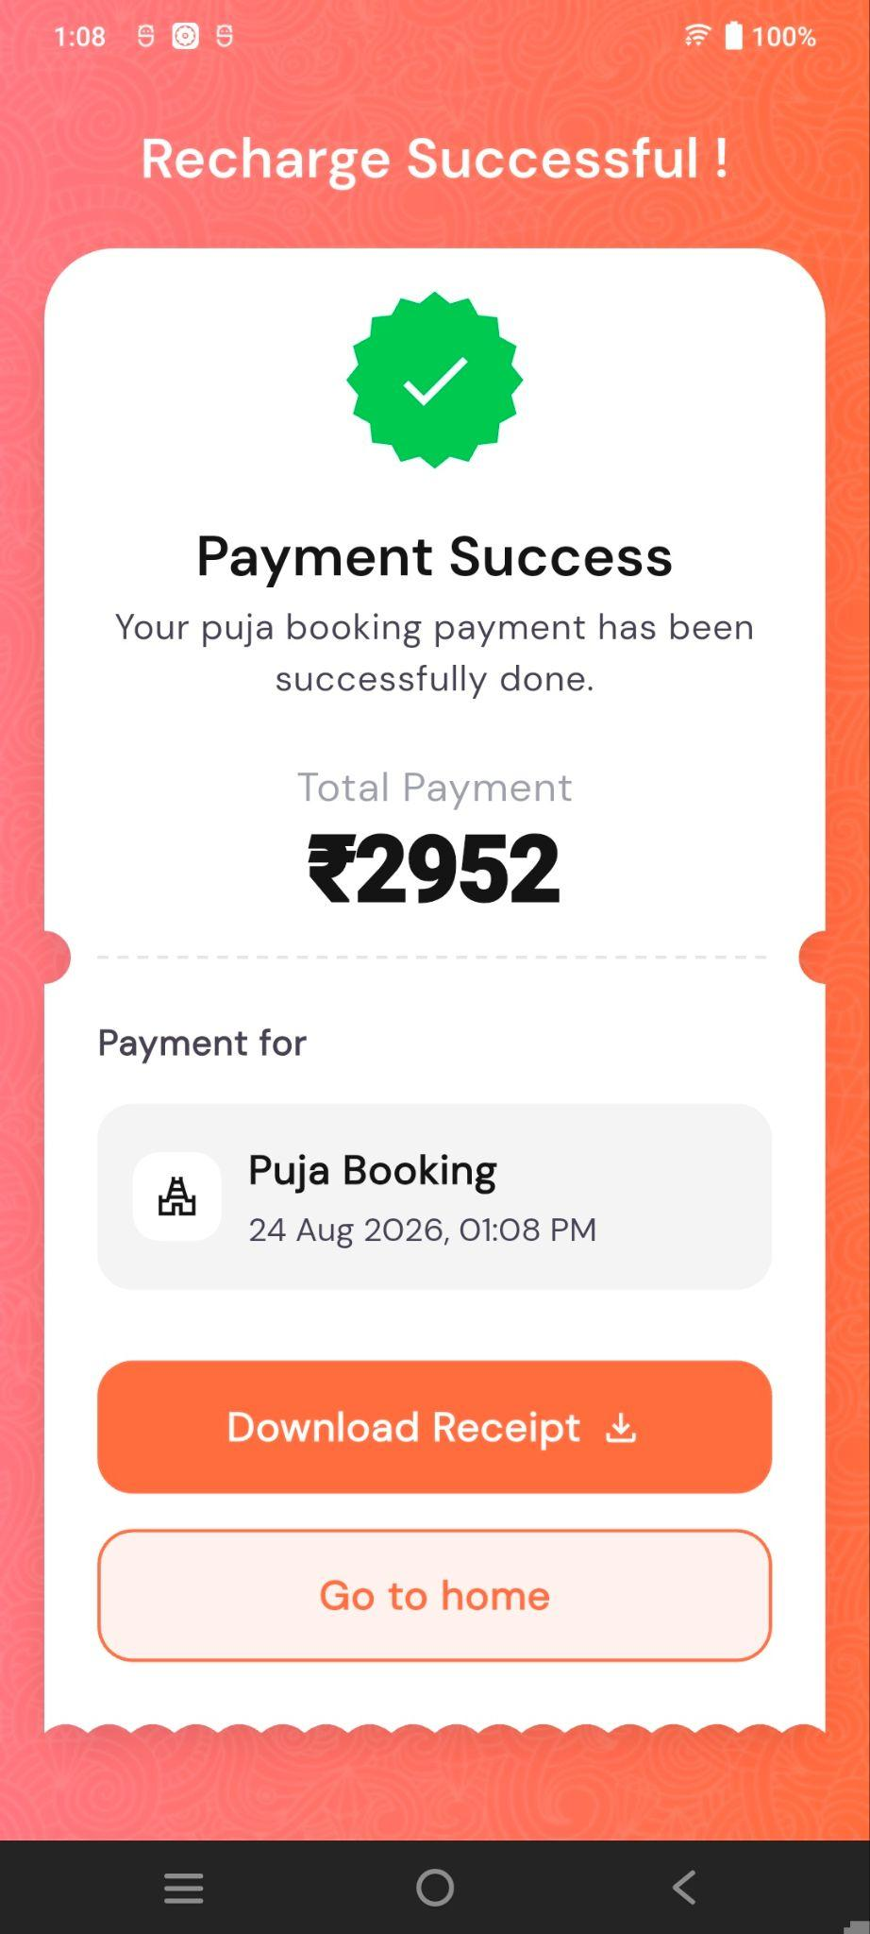
After successful payment, the Payment Success screen confirms the Puja booking and displays the total paid amount.
Users can:
- Download Receipt – Download the payment receipt.
- Go to Home – Return to the Home Screen.

Booking Flow
Puja Detail → Participate Now → Devotee Details → Address → Booking Preview → Edit Details (if required) → Next → Payment/Booking

Temple Detail Screen
The Temple Detail screen displays complete information about the selected temple and provides access to its available Mandir, Pujas, and Chadhavas.
- Temple Information – Displays temple image, name, deity, and Trusted Partner status.
- Mandir – Shows temple details, deity information, and related images.
- Pujas – Displays available Special and Normal Pujas. Special Pujas include a Participate Now button.
- Chadhavas – Displays available Special and Normal Chadhavas.
- Users can select a Puja or Chadhava to view its details before booking or participating.

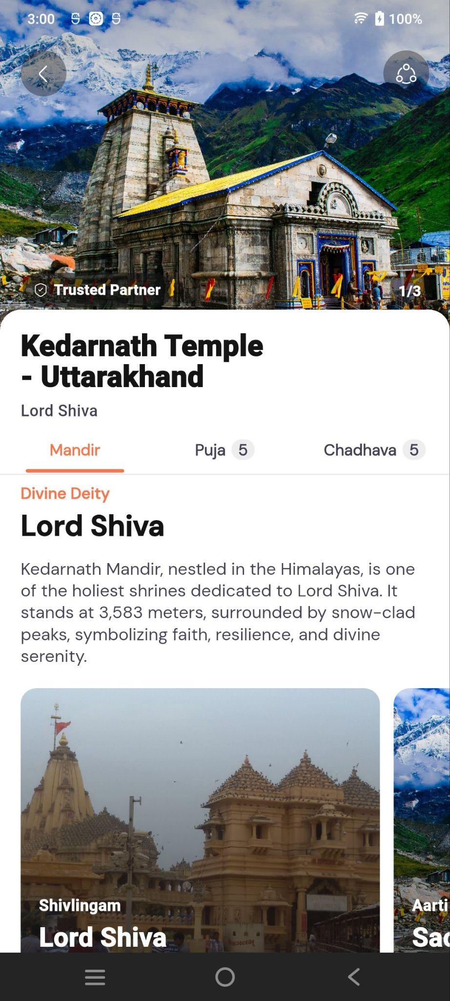
Mandir Tab

Displays detailed information about the selected temple, including:
- Temple name, deity, and Trusted Partner status.
- Story & Legends about the temple.
- Temple Highlights and spiritual significance.
- Visitor Guidelines such as dress code, photography, and crowd management.
- Temple Timings for morning and evening Darshan.
- Puja and Chadhava sections with available offerings.
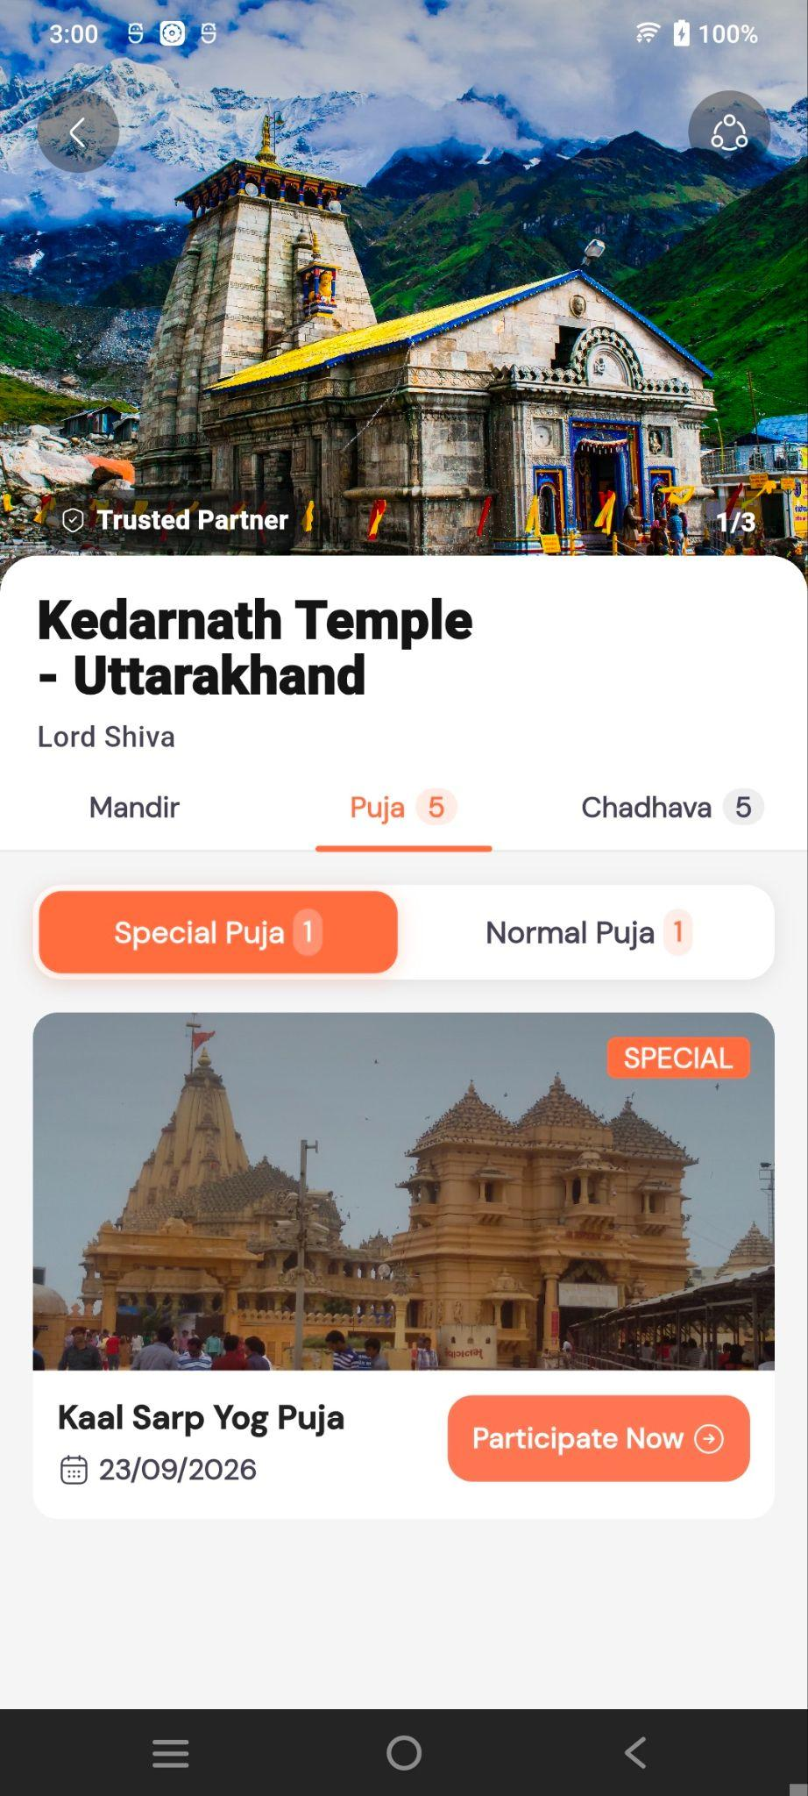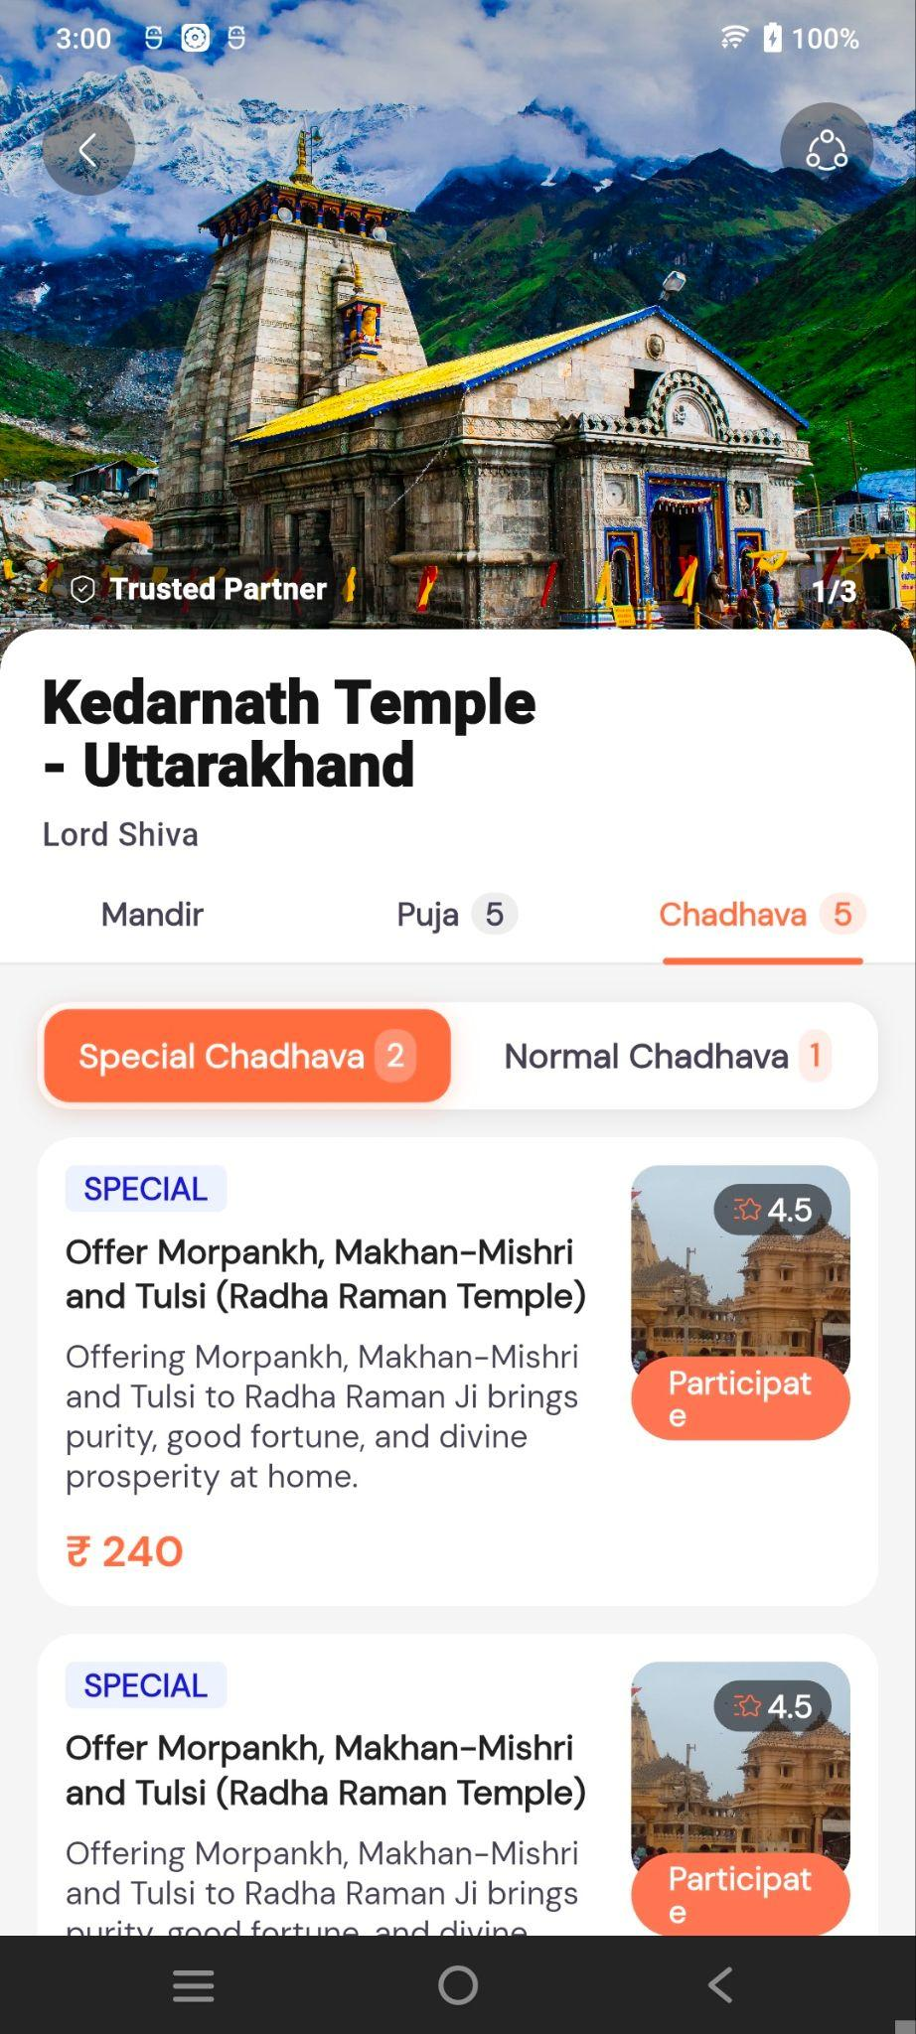

Normal Chadhava Detail Screen

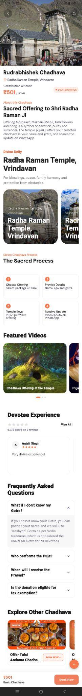
The Normal Chadhava Detail screen displays complete information about the selected Chadhava before booking.
- Chadhava Information – Displays the Chadhava name, temple, contribution amount and booking information.
- About This Chadhava – Provides details about the offering and its spiritual significance.
- Divine Deity – Displays the associated temple/deity and related temple images.
- Divine Chadhava Process – Explains the steps involved in the offering.
- Featured Videos – Displays related temple and Chadhava videos.
- Devotee Experience – Shows ratings and devotee reviews.
- Frequently Asked Questions – Provides answers to common Chadhava-related questions.
- Explore Other Chadhavas – Displays other Chadhavas available to the user.
- Book Now – Allows the user to proceed with the Normal Chadhava booking flow.

Book Chadhava Flow
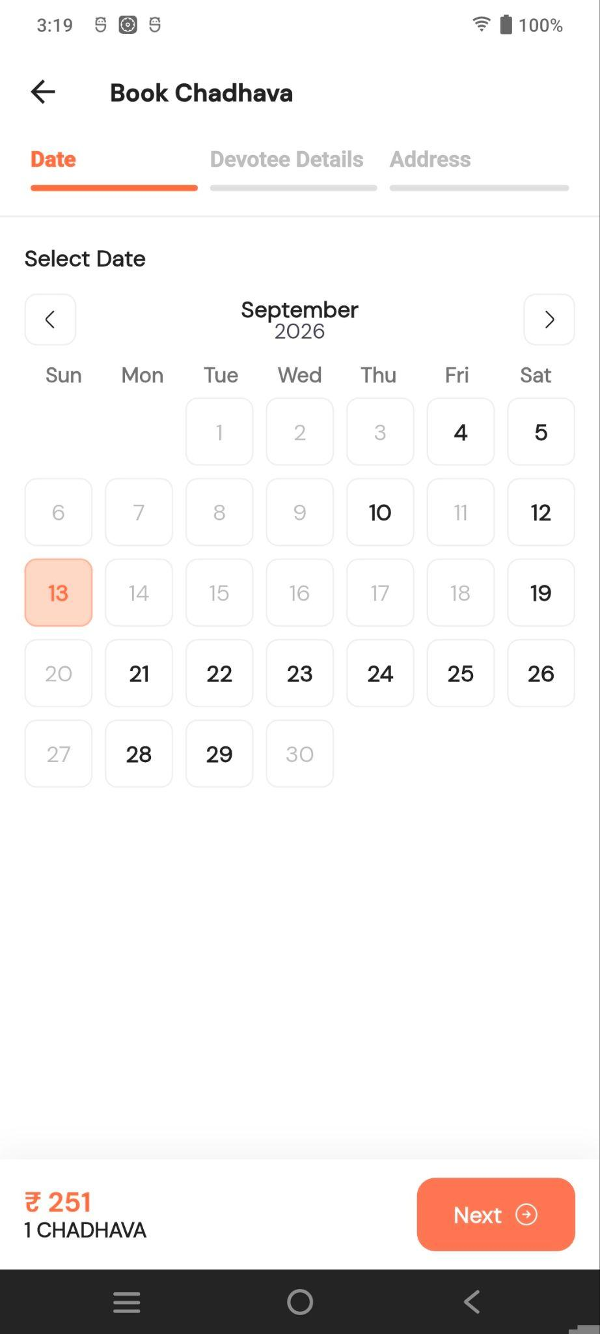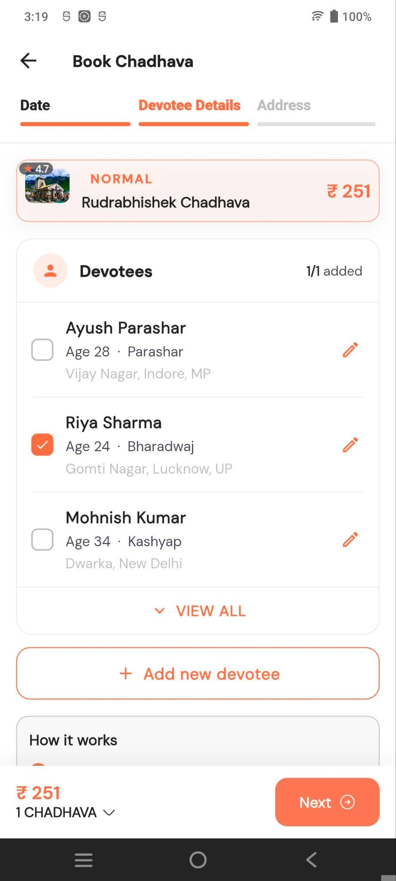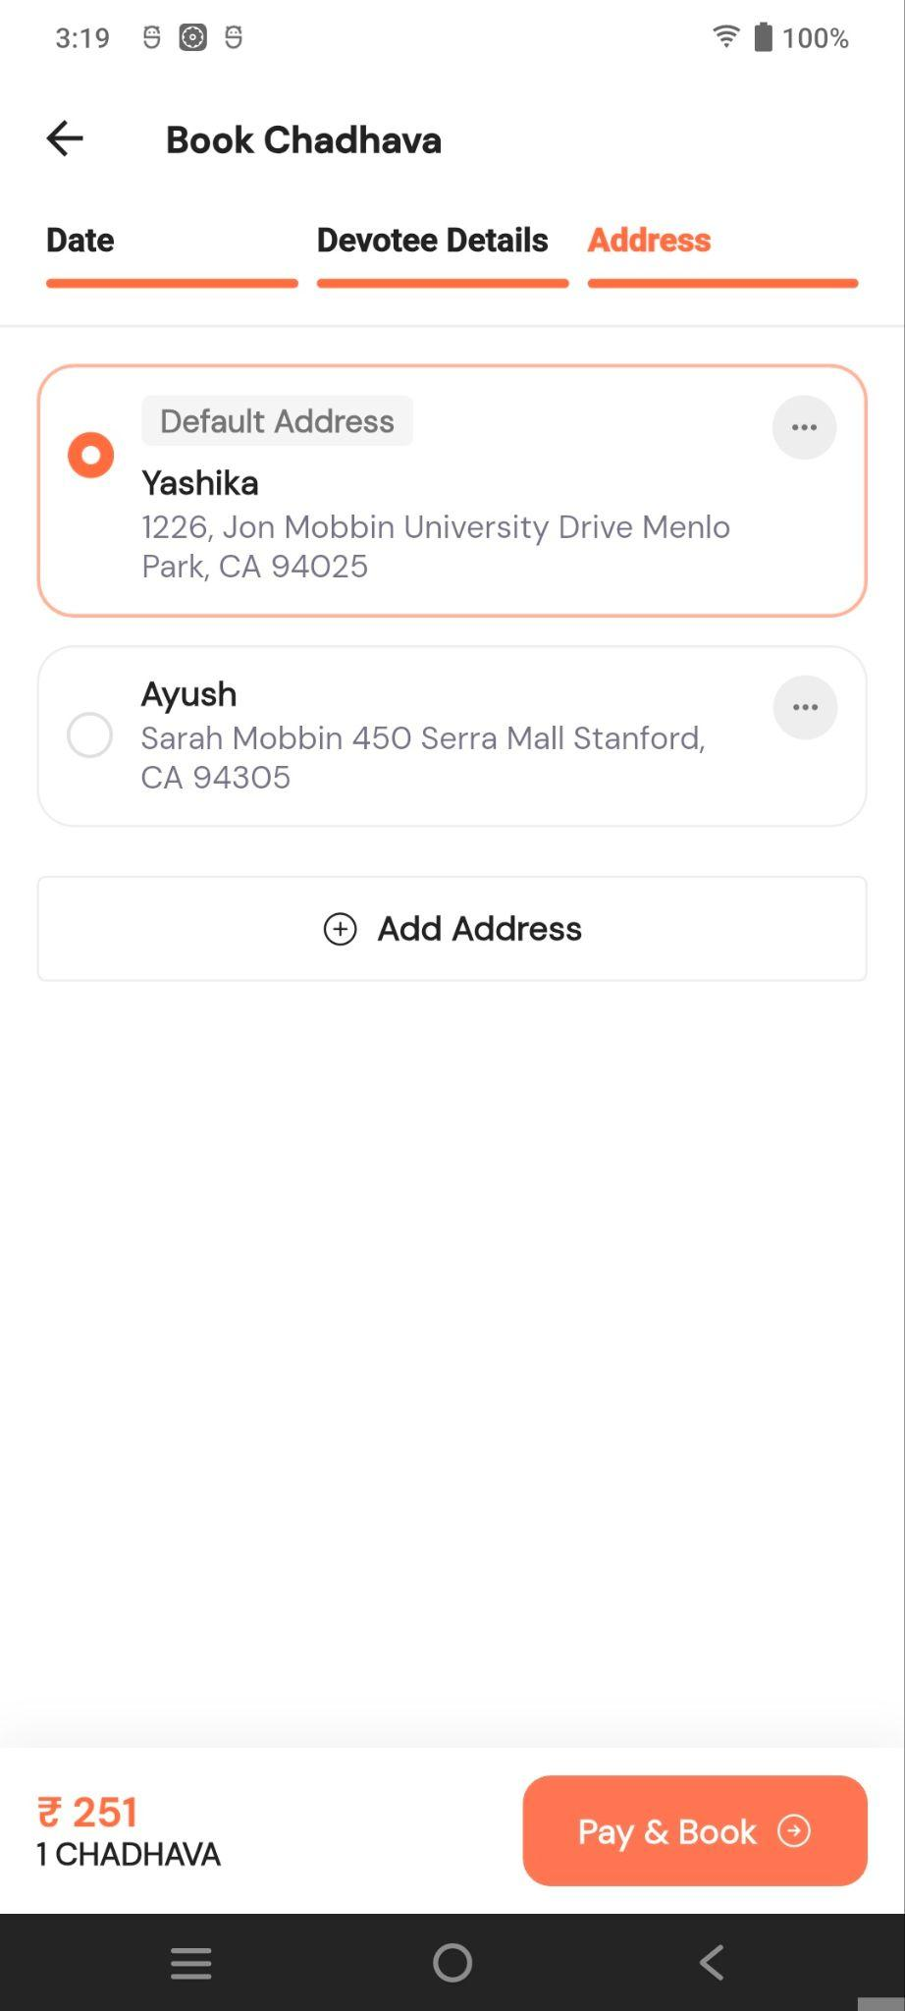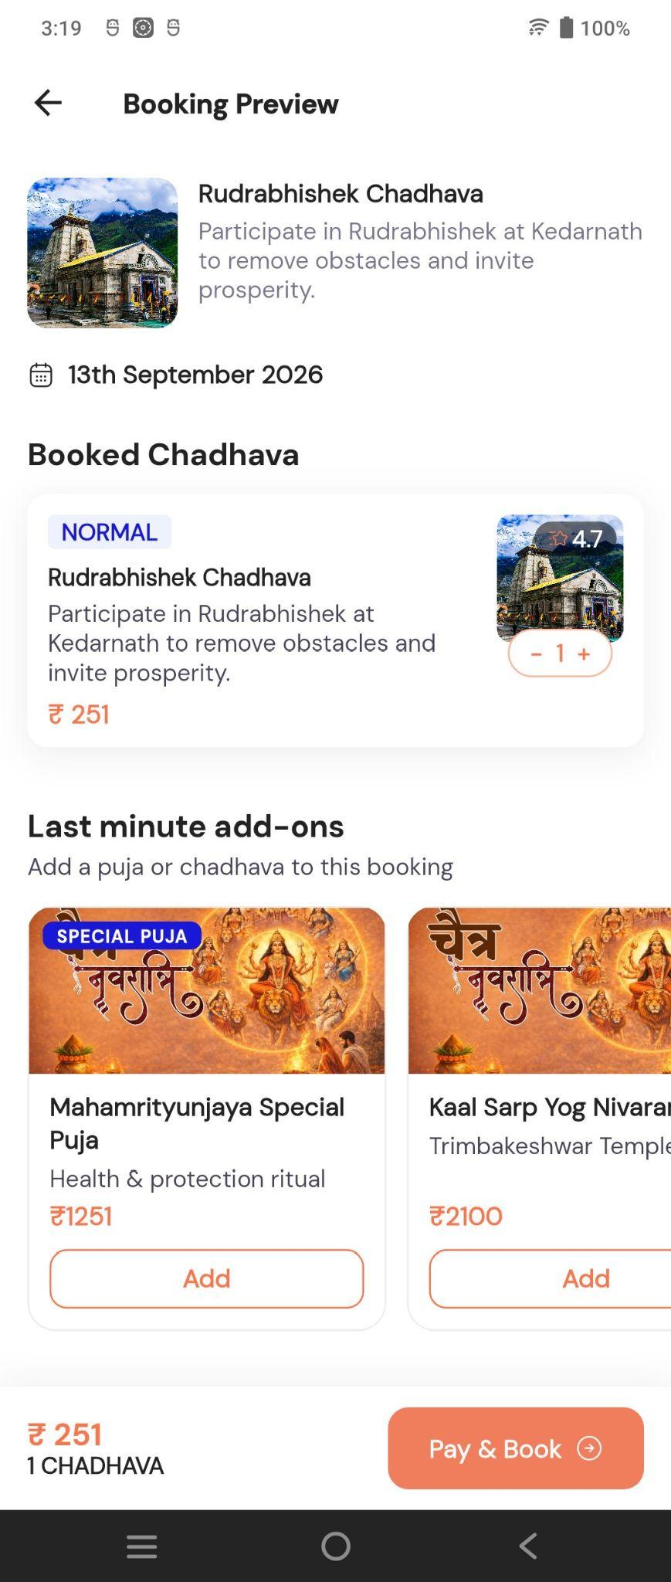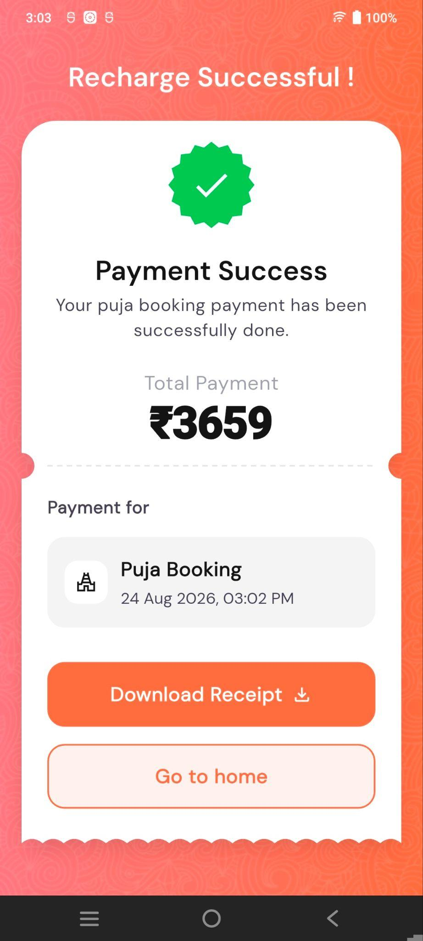

The Book Chadhava flow consists of three steps:
- Date – Select the Chadhava date.
- Devotee Details – Select or add the devotee for whom the Chadhava will be performed.
- Address – Select an existing address or add a new address.
After completing these steps, the user proceeds to Booking Preview, reviews the Chadhava details, and clicks Pay & Book to complete the booking.

Special Chadhava Detail Screen
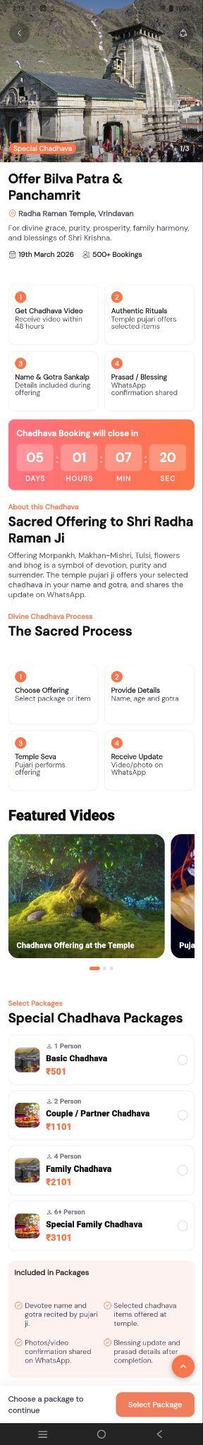
The Chadhava Detail screen provides complete information about the selected Special Chadhava before booking.
- Chadhava Information – Displays temple image, Chadhava name, temple location, price, date and booking information.
- How It Works – Explains the Chadhava process and included services.
- Booking Countdown – Shows the remaining time before booking closes.
- About This Chadhava – Provides details about the offering and its spiritual significance.
- Divine Chadhava Process – Explains the steps involved in performing the offering.
- Featured Videos – Displays related temple/Chadhava videos.
- Special Chadhava Packages – Allows users to select a package based on the number of persons and price.
- Included in Packages – Shows what is included, such as Sankalp, offering, and photo/video confirmation.
- Select Package – User selects a package to proceed with Chadhava booking.

Chadhava Booking Flow
The Chadhava booking flow allows users to select devotees and an address before completing payment for a Special Chadhava.

Special Chadhava – Devotee Details
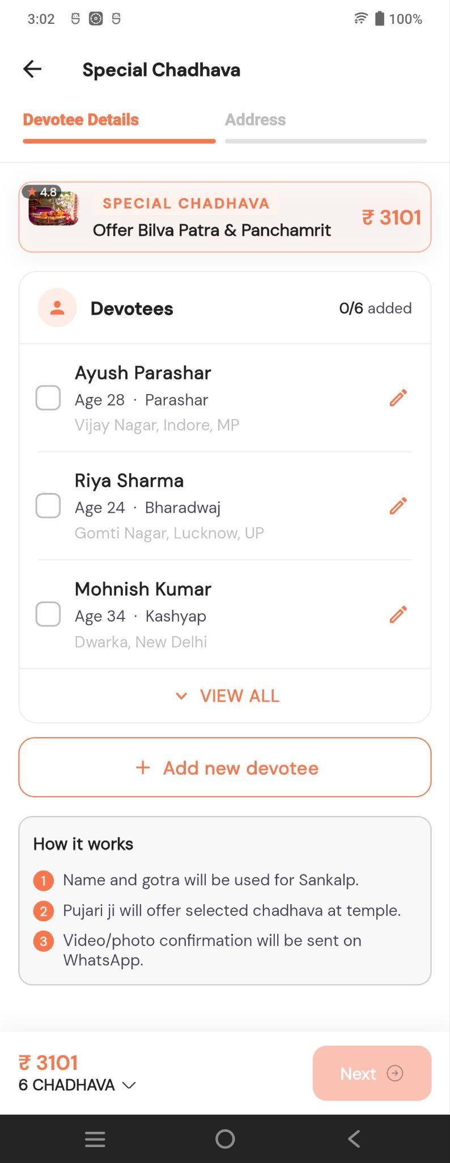

Users can select one or more devotees for the selected Chadhava. Existing devotees can be edited, and new devotees can be added.

Address
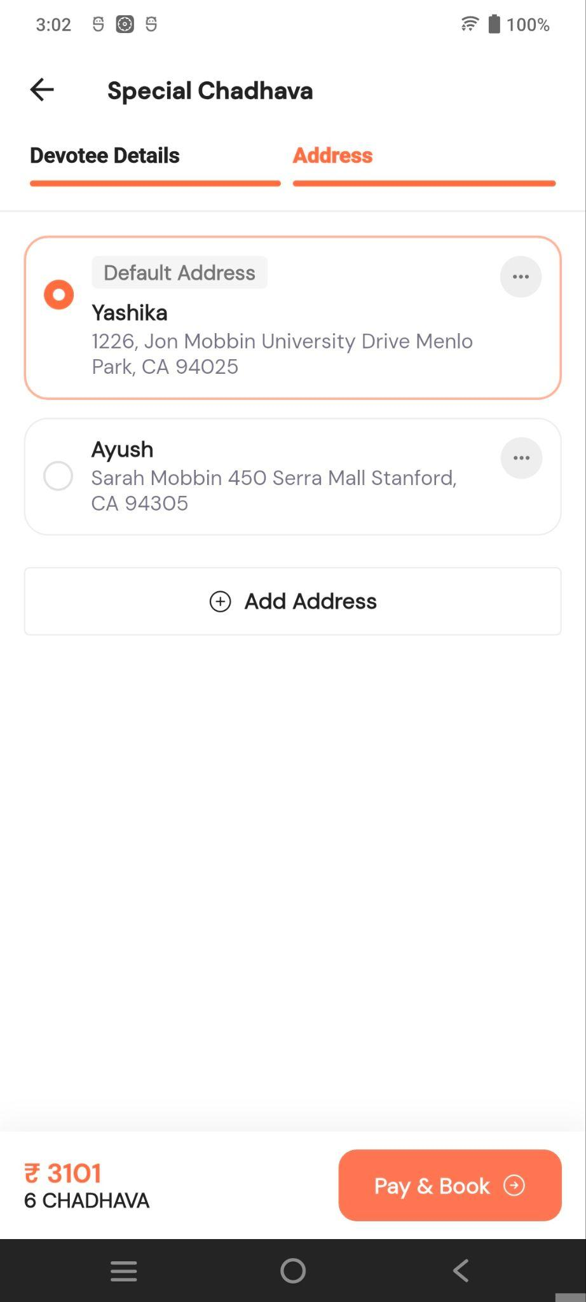
The user selects an existing address or adds a new address for the Chadhava booking. After selecting the address, Pay & Book becomes available.

Payment

The Puja Payment screen displays the Chadhava amount, GST and total payable amount. Users can apply a coupon and pay using available UPI options.

Payment Success

After successful payment, the confirmation screen displays the total payment and booking confirmation.
Users can:
- Download Receipt – Download the payment receipt.
- Go to Home – Return to the Home Screen.

Flow
Chadhava List → Select Chadhava → Special Chadhava → Select Devotee → Select/Add Address → Pay & Book → Payment → Payment Success

Astro Tab

Swadharma Super App – Astro Screen

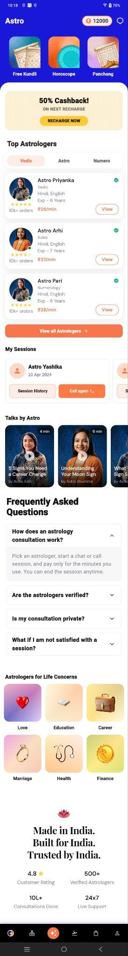
1. Screen Overview
The Astro screen is the dedicated astrology and astrologer consultation section of the Swadharma application.
It allows users to:
- Access astrology tools such as Kundli, Horoscope, and Panchang
- Recharge their consultation wallet
- Browse and consult astrologers
- View previous consultation sessions
- Reconnect with astrologers
- Watch astrology-related videos
- Read frequently asked questions
- Explore astrologers based on different life concerns
The screen is vertically scrollable and contains multiple horizontally scrollable sections.

2. Header Section
The top header displays:
- Astro – Indicates the current application module.
- Wallet Balance – Displays the user's available consultation balance, shown as ₹12,000 in the screenshot, Click to open the Wallet screen, where the user can view and manage their available consultation balance.

- Chat/Message Icon – Provides access to the user's astrology communication or chat-related functionality.

Wallet Screens

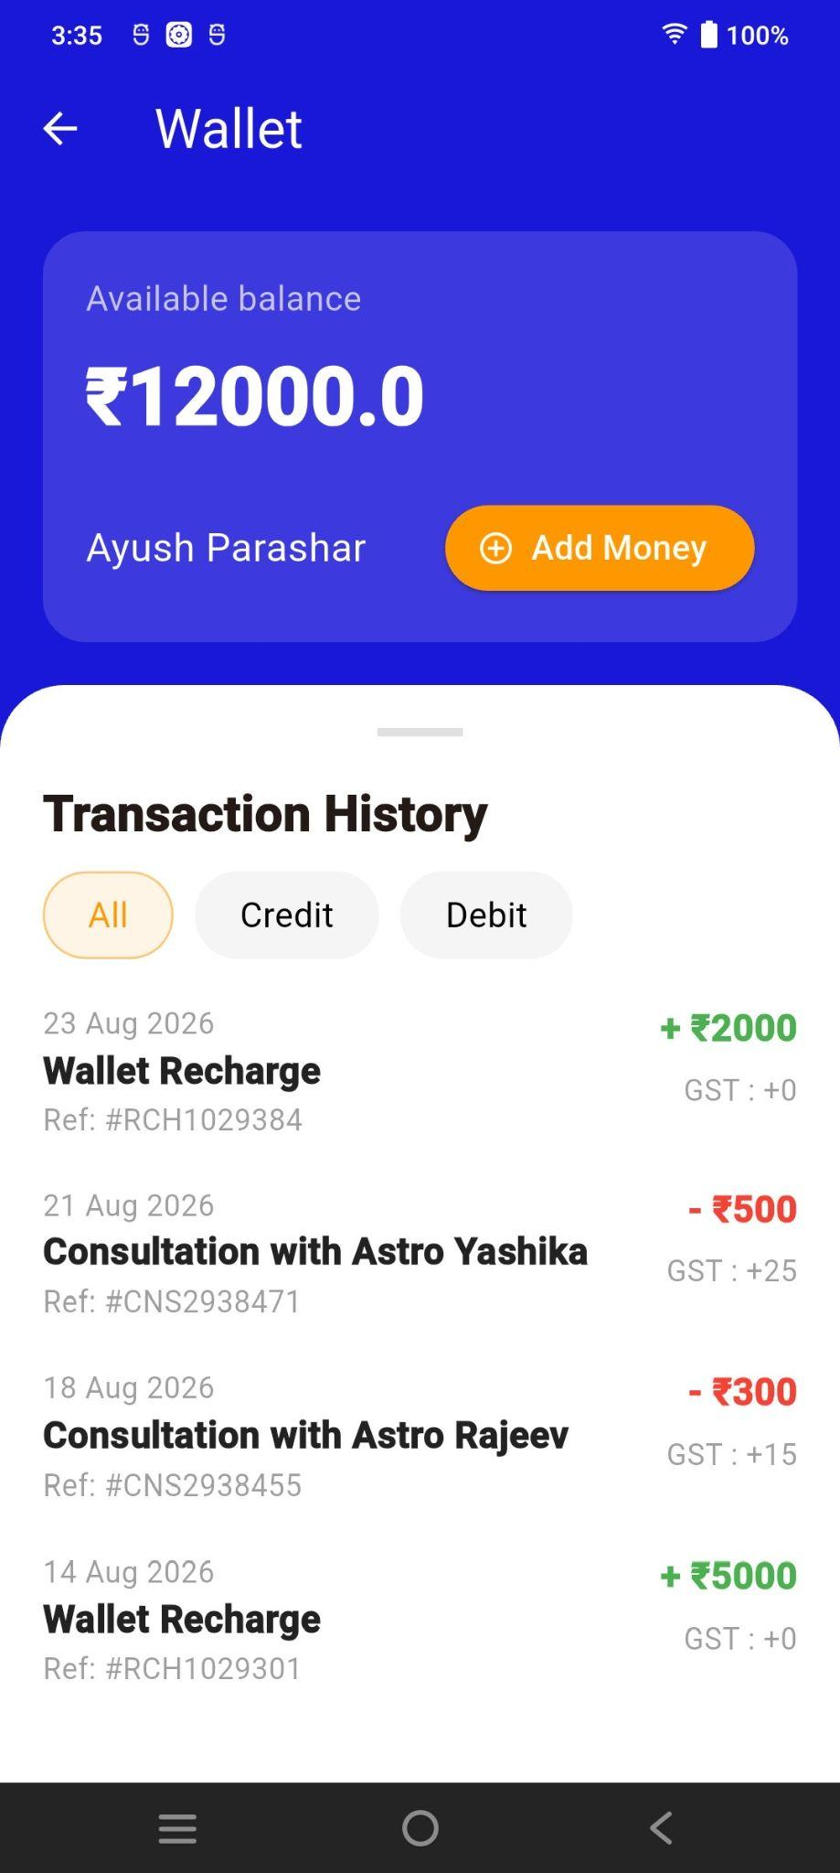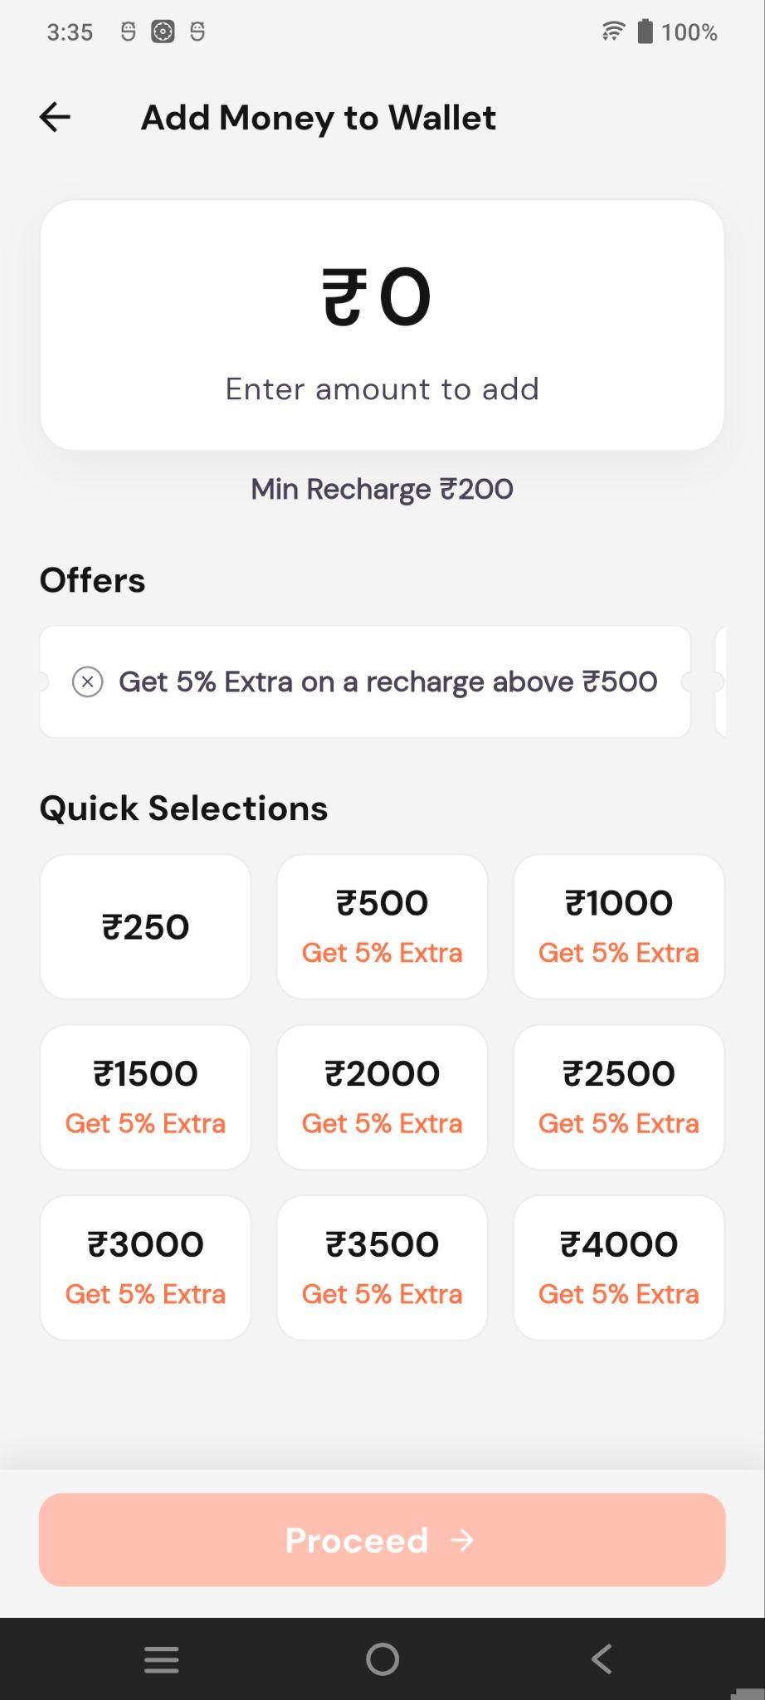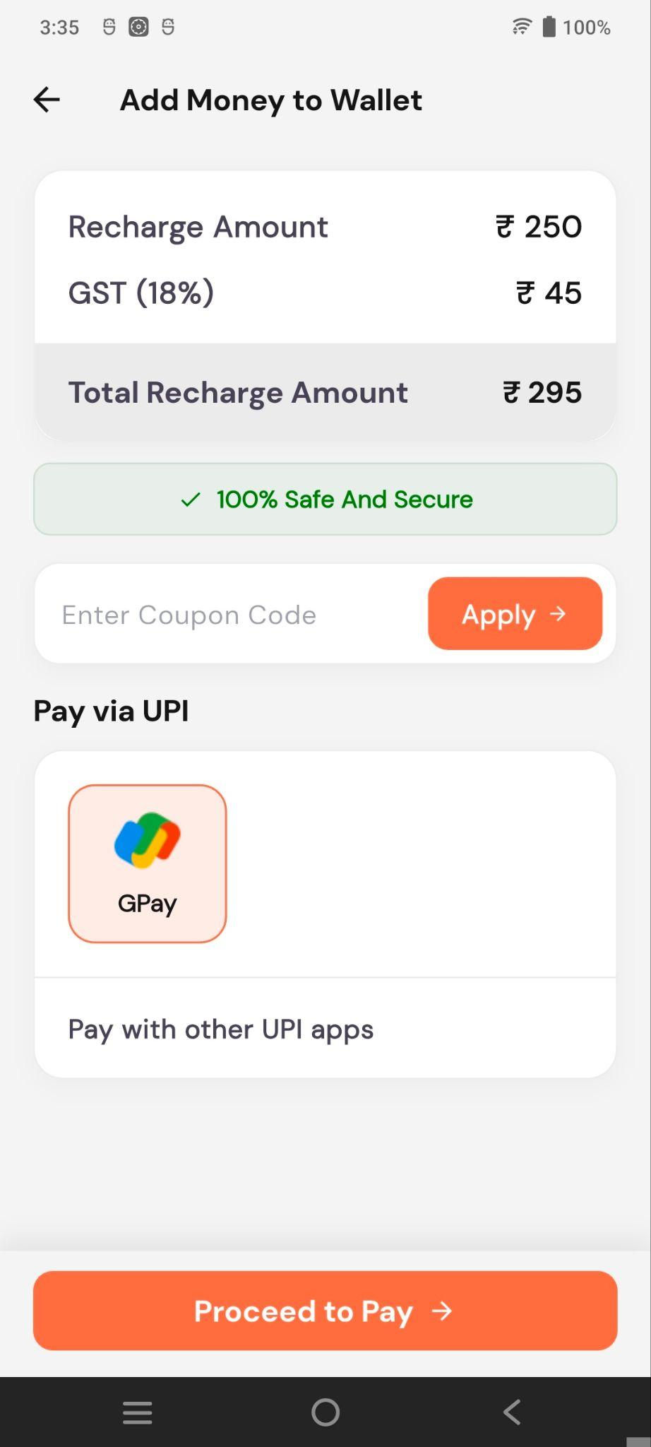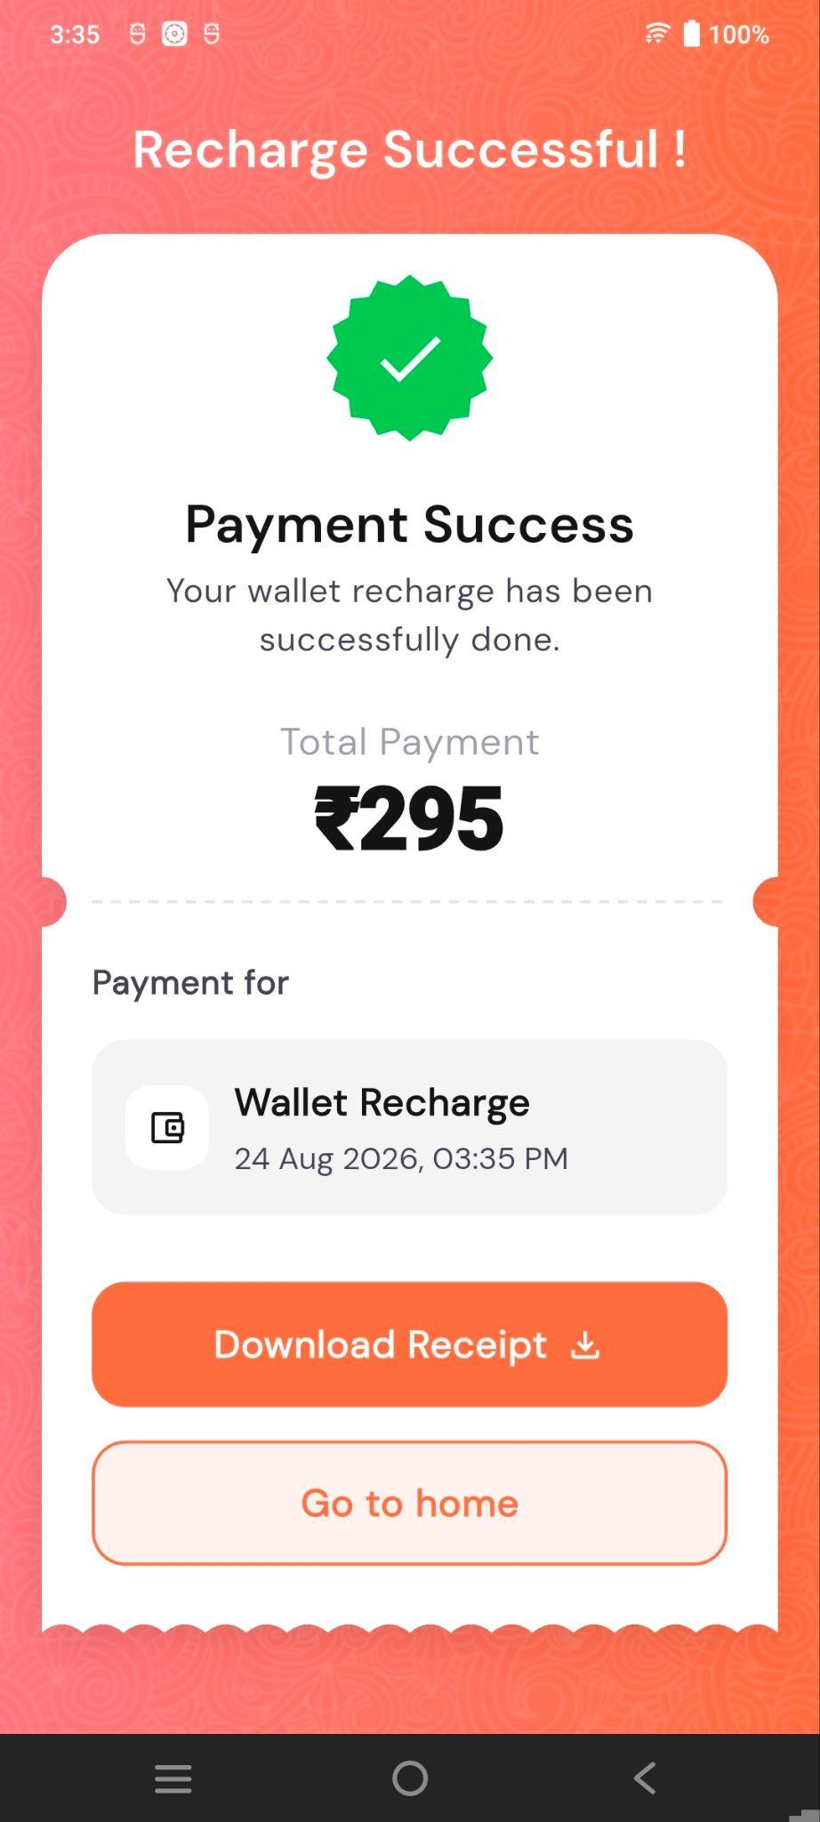
Wallet – Displays the available balance and transaction history, with options to filter transactions by All, Credit, or Debit.
Add Money to Wallet – Allows users to enter or select a recharge amount, view offers, and proceed with payment.
Recharge Payment – Shows the recharge amount, GST, coupon option, and UPI payment methods.
Recharge Successful – Confirms successful payment and provides options to download the receipt or return to the home screen.

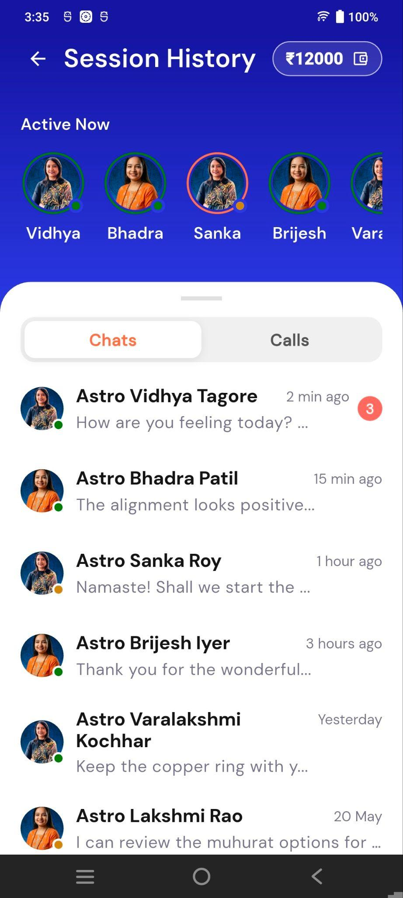
Session History
Session History – Displays ongoing and previous astrology consultation sessions.
Active Now – Shows astrologers currently available for consultation.
Chats / Calls – Allows switching between chat and call history.
Conversation List – Shows astrologer names, recent messages, last active time, and unread message count.
Wallet Balance – Displays the available consultation balance at the top.

3. Astrology Quick Access
Three quick-access cards are displayed below the header:

Free Kundli
Click on Free Kundli to open the Kundli list, then click on Create New Kundli.

Kundli Creation Flow
The Kundli Creation flow collects the user's birth details required to generate a Kundli.
- Step 1 – Name: Enter first and last name.
- Step 2 – Gender: Select Male, Female, or Other.
- Step 3 – Date of Birth: Select the date of birth.
- Step 4 – Birth Time: Select the exact birth time and AM/PM.
- Step 5 – Birth Place: Enter the birth location.
After submitting all details, the Kundli is generated based on the provided information.

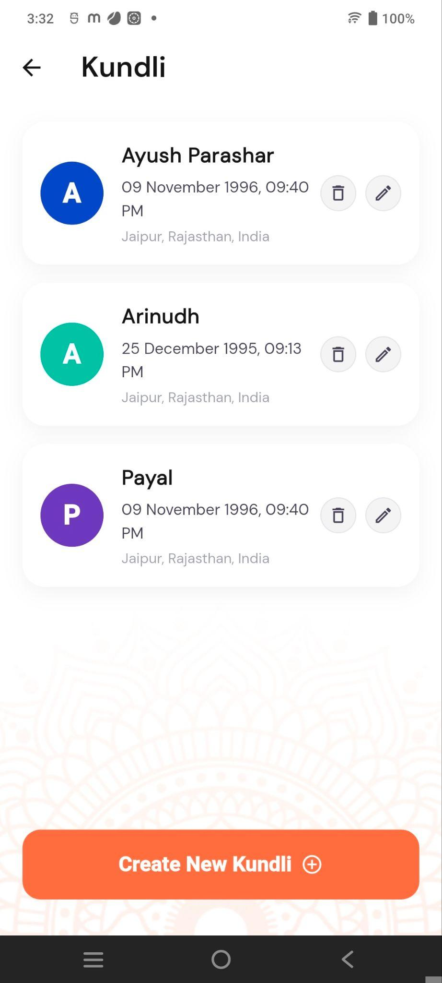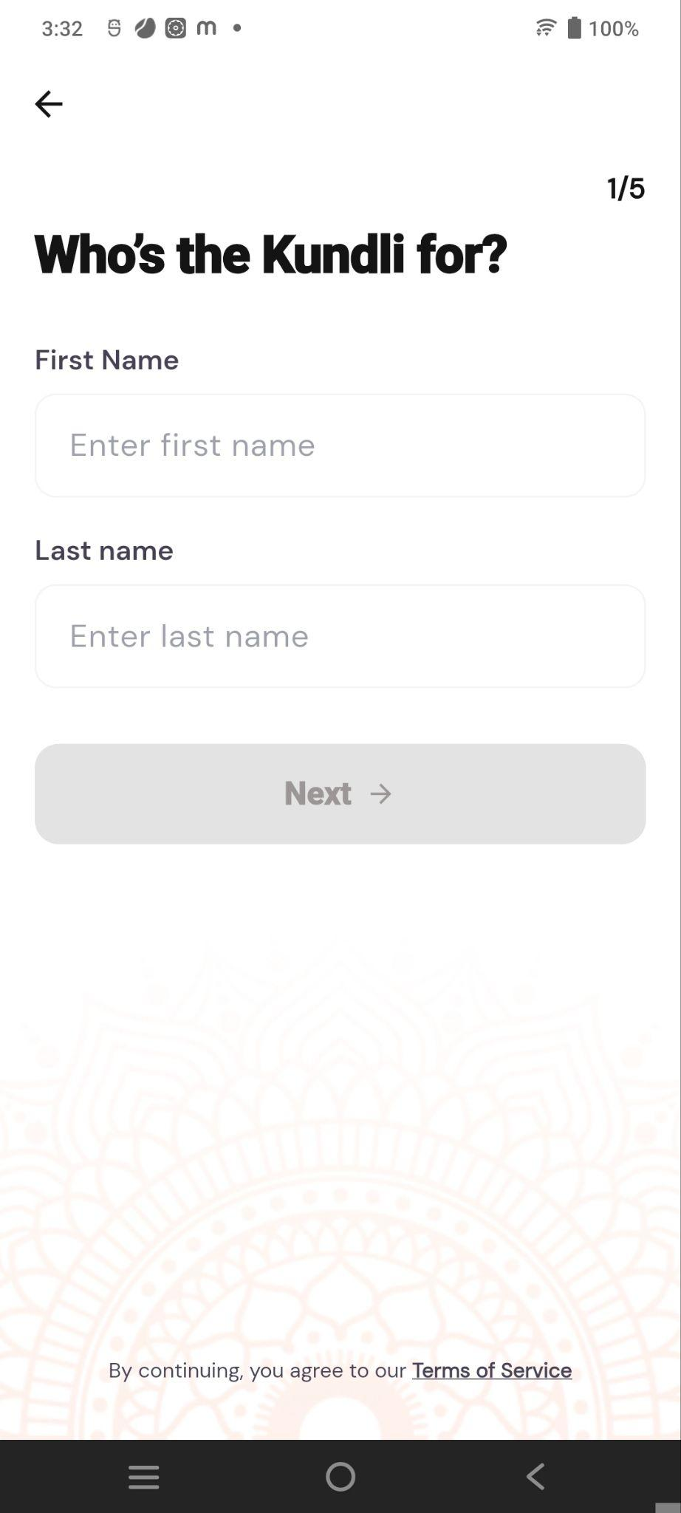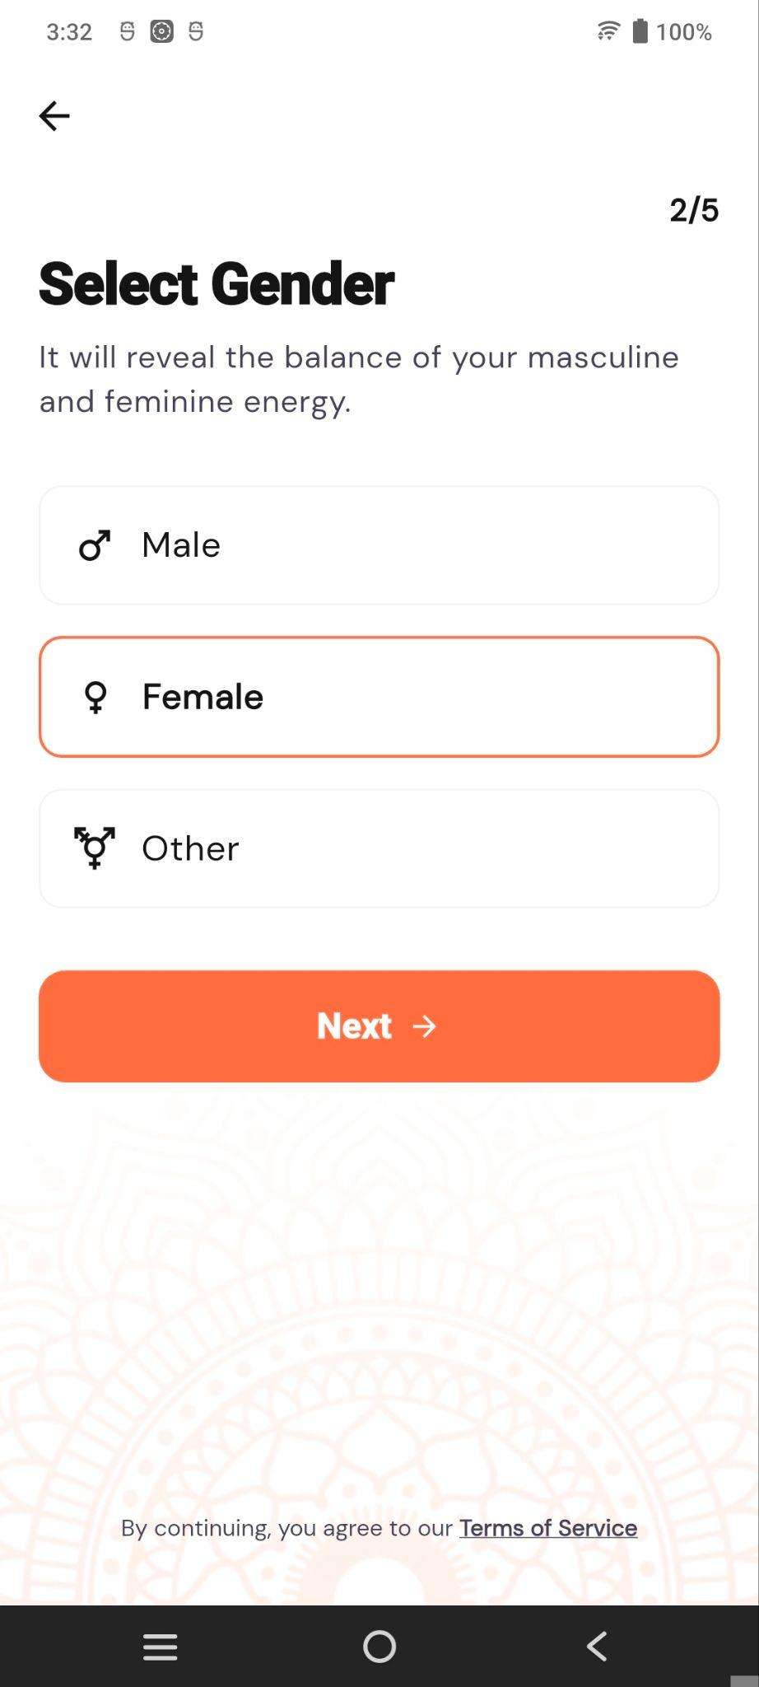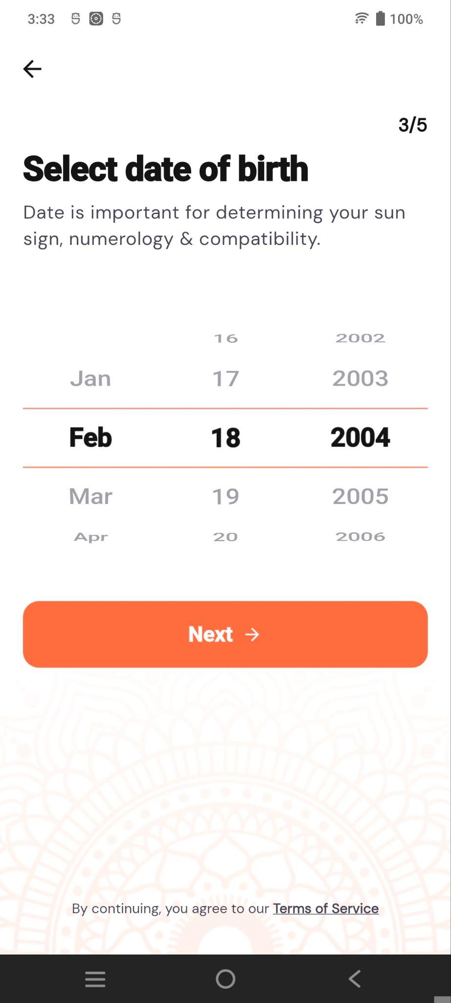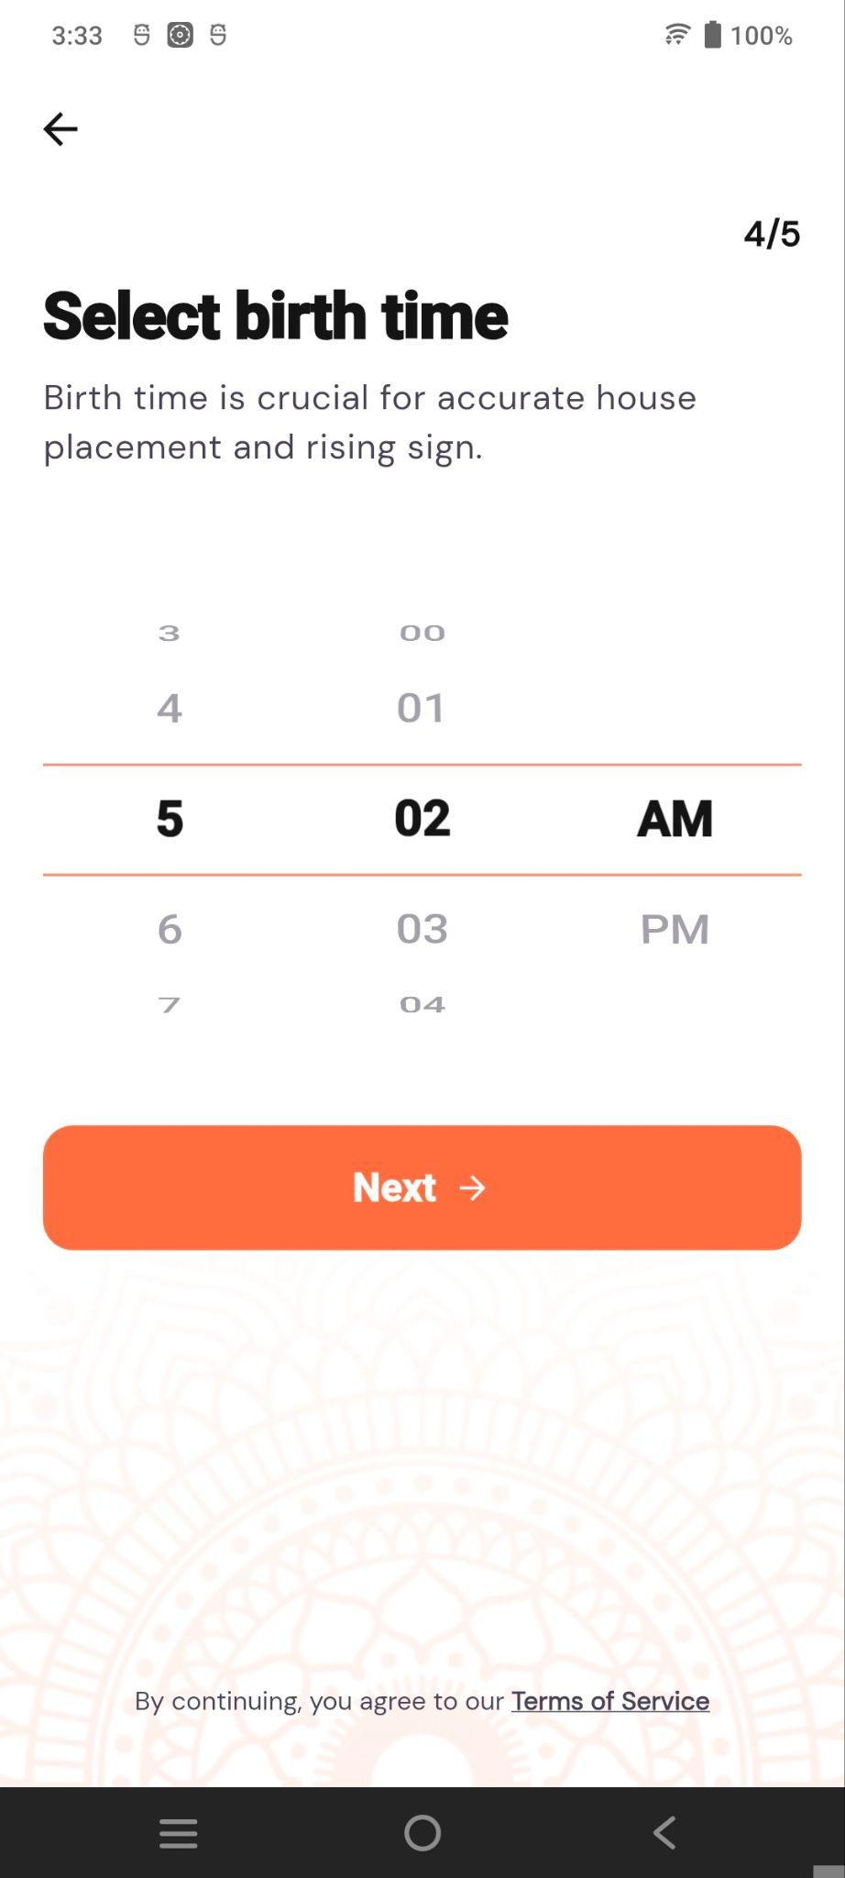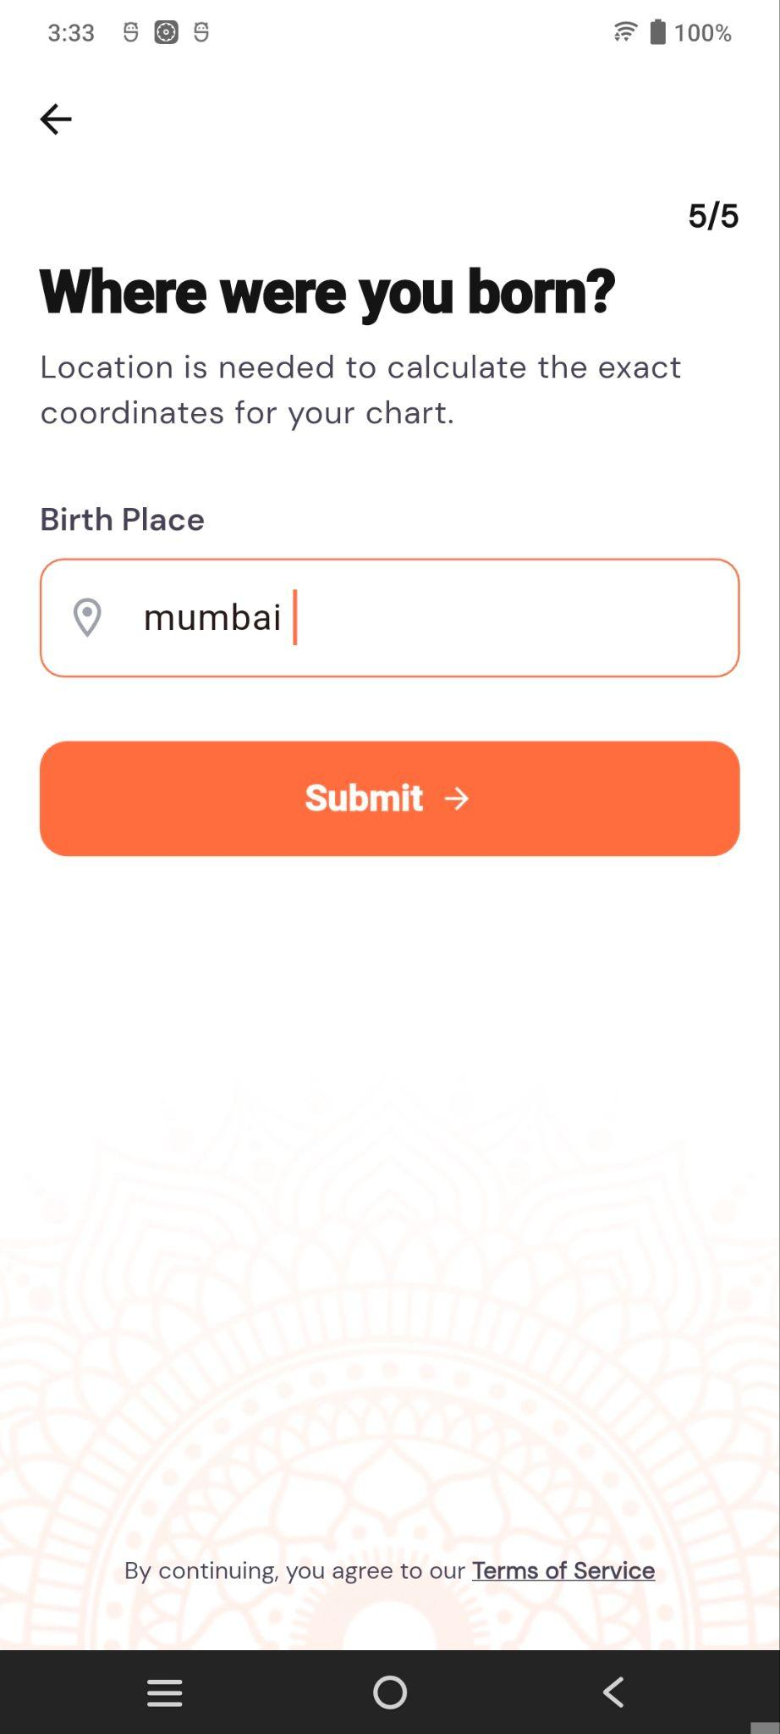

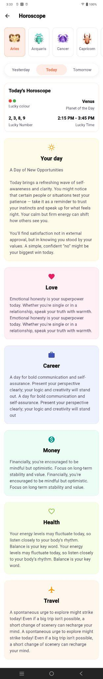
Horoscope
Provides access to horoscope-related information and predictions.
Clicking on Horoscope opens the Horoscope screen, where users can view their horoscope details.
Displays horoscope information based on the selected zodiac sign and day. Users can view lucky colour, lucky numbers, planet of the day, lucky time, and a detailed daily horoscope.

Panchang
Provides access to daily Panchang information and related astrological details.
Clicking on Panchang redirects the user to the Panchang Detail screen, where the user can view the complete daily Panchang information.

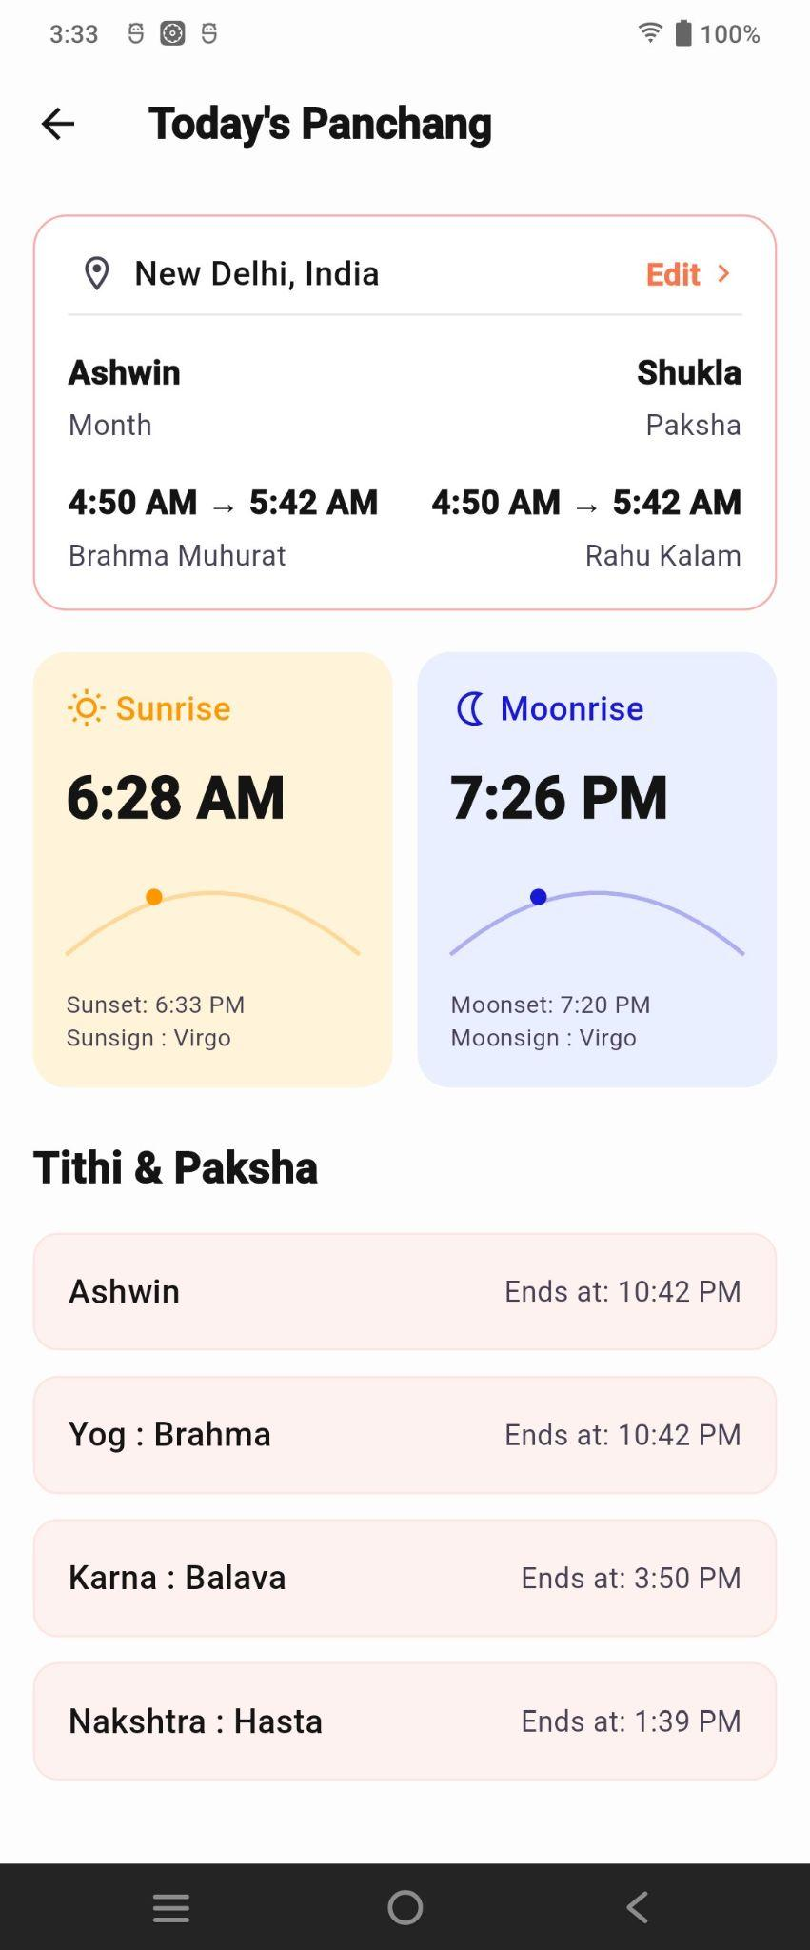

Today's Panchang
The Today's Panchang screen displays daily Panchang information based on the selected location.
- Location & Date Details – Displays the location, Hindu month, Paksha, Brahma Muhurat, and Rahu Kalam.
- Sunrise & Moonrise – Shows sunrise, sunset, moonrise, moonset, and Sun/Moon sign.
- Tithi & Paksha – Displays details such as Tithi, Yog, Karna, and Nakshatra with their end times.
- Edit – Allows the user to change the location for Panchang details.

4. Recharge Cashback Banner
A promotional recharge banner is displayed below the quick-access cards.
The banner offers:
50% Cashback!
ON NEXT RECHARGE
The RECHARGE NOW button allows users to recharge their astrology consultation balance.
This section is intended to encourage users to maintain sufficient balance for paid consultations.

5. Top Astrologers
The Top Astrologers section displays highly rated or popular astrologers available for consultation.

Astrologer Categories
Users can filter astrologers using categories such as:
- Vedic
- Astro
- Numero

Astrologer Card
Each astrologer card displays:
- Profile image
- Astrologer's name
- Astrology specialization
- Languages spoken
- Years of experience
- Verification indicator
- Total orders/consultations
- Consultation price per minute
- View button
Examples shown include:
- Astro Arhi
- Astro Pari
The View button opens the selected astrologer's profile/details page.

View All Astrologers
The View all Astrologers button navigates to the complete astrologer listing.

Astrologers List Screen
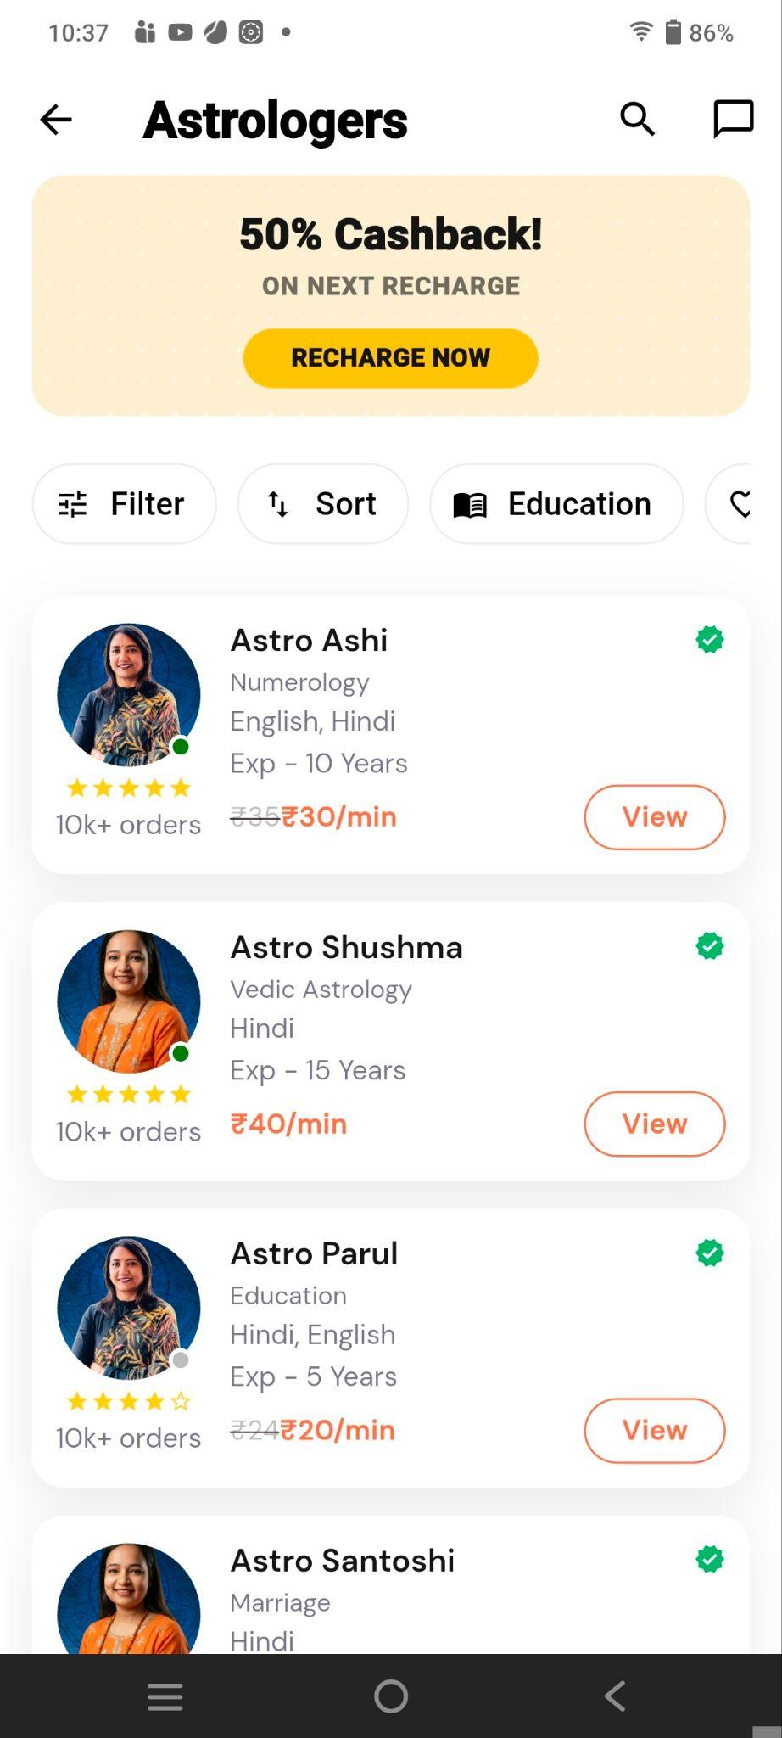
Displays a list of available astrologers with:
- Cashback/recharge offer.
- Filters and sorting options.
- Astrologer name, specialization, languages, and experience.
- Ratings, order count, and consultation charges.
- View button to check the astrologer’s details and proceed with consultation.

6. My Sessions
The My Sessions section displays the user's previous or available astrology consultation sessions.
Each session card contains information such as:
- Astrologer's name
- Session date
- Profile information
- Session History button
- Call again button

Session History
Allows the user to view details/history of previous consultations.

Call Again
Allows the user to reconnect with the same astrologer for another consultation.
The session cards are horizontally scrollable.

7. Talks by Astro
The Talks by Astro section provides short astrology-related video content.
Each video card contains:
- Astrologer thumbnail
- Video duration
- Play button
- Video title
- Astrologer name
Examples include topics related to:
- Career changes
- Moon signs
- Other astrology predictions and guidance
Users can horizontally scroll through the available videos and select a video to watch.

8. Frequently Asked Questions
The Frequently Asked Questions section provides answers to common questions about astrology consultations.
Example questions include:
- How does an astrology consultation work?
- Are the astrologers verified?
- Is my consultation private?
- What if I am not satisfied with a session?
The FAQ uses an expandable accordion layout.
When a question is selected, the answer is expanded below it. Selecting it again collapses the answer.
Example explanation shown for the consultation process:
Users can select an astrologer, start a chat or call session, and pay only for the minutes they use. The consultation can be ended at any time.

9. Astrologers for Life Concerns
This section helps users find astrology services based on specific life concerns.
Available categories include:
- Love
- Education
- Career
- Marriage
- Health
- Finance
Each category is represented using an image and category title.
Selecting a category allows the user to discover astrologers or consultations relevant to that particular concern.

10. Trust & Platform Statistics
The bottom section communicates the platform's trust and service credentials.
Main message:
“Made in India. Built for India. Trusted by India.”
The section displays key platform statistics, including:
- 4.8 – Customer Rating
- 500+ – Verified Astrologers
- 10L+ – Consultations Done
- 24x7 – Live Support
This section helps establish credibility and reassures users about the availability and quality of astrology services.

11. Bottom Navigation
A fixed bottom navigation bar provides access to the application's major modules.
The navigation includes options for areas such as:
- Home
- Puja/Spiritual services
- Astro
- Spiritual/Journey section
- Store
- Profile
The Astro tab is highlighted because the user is currently on the Astro screen.

Astro Detail
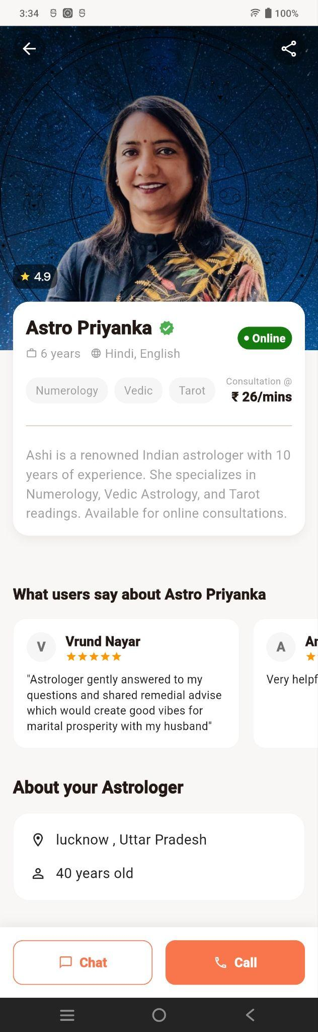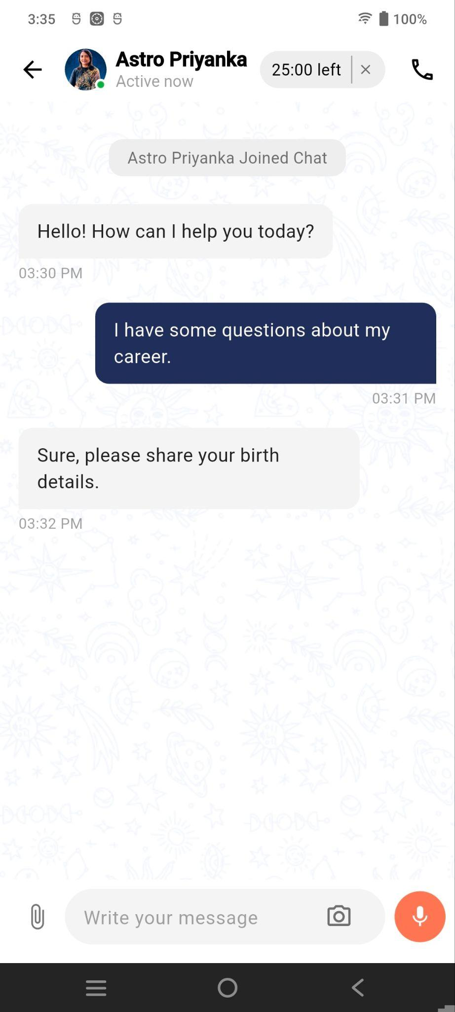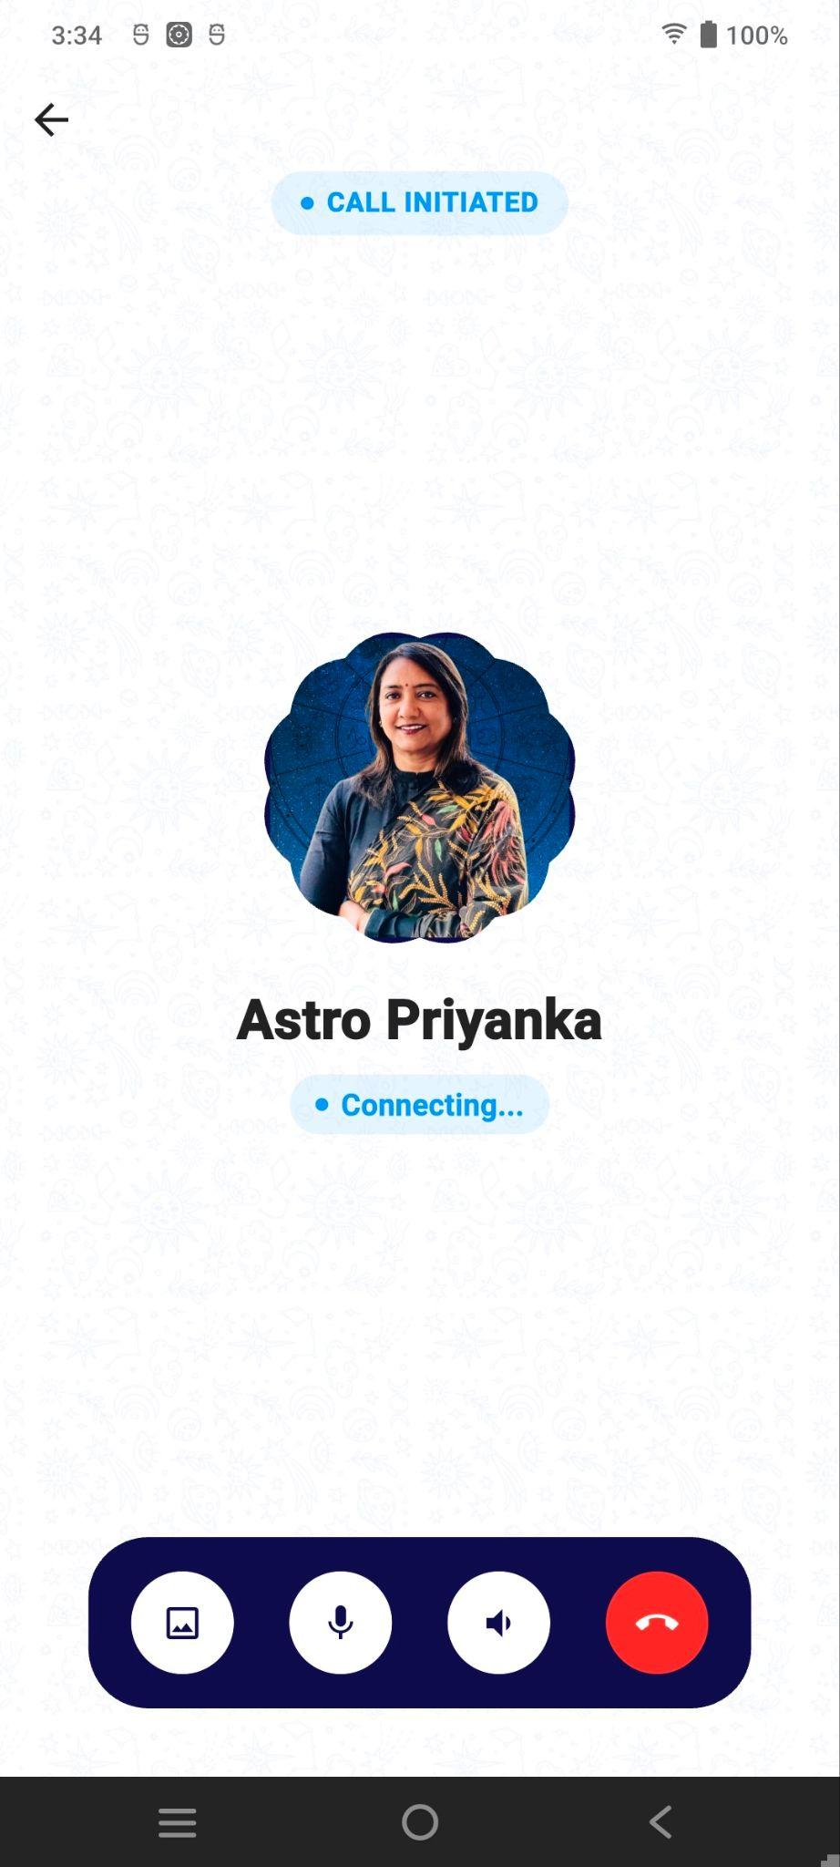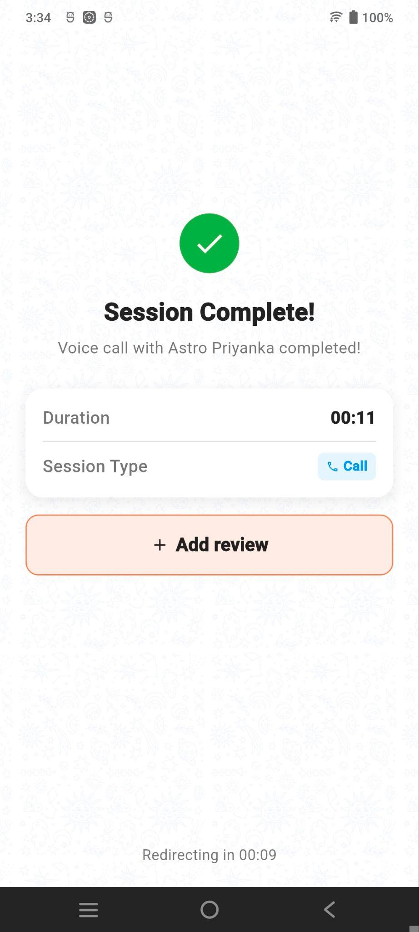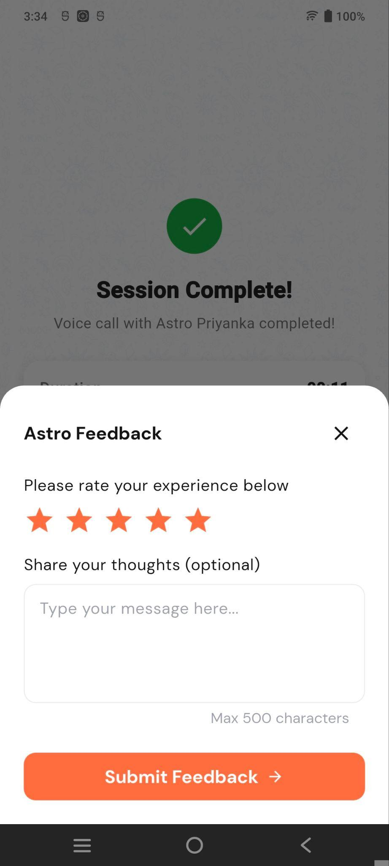

Displays astrologer profile information such as rating, experience, languages, expertise, consultation charges, reviews, and Chat/Call options.

12. User Flow
The main astrology consultation flow is:
Astro → Top Astrologers → Select Astrologer → View Profile → Start Consultation → Call/Chat
Other available flows include:
Astro → Free Kundli → Kundli Details
Astro → Horoscope → Horoscope Details
Astro → Panchang → Daily Panchang
Astro → Recharge Now → Recharge Wallet → Consultation
Astro → My Sessions → Session History / Call Again
Astro → Talks by Astro → Select Video → Watch Video
Astro → Life Concern → Select Concern → Relevant Astrologers

13. Key Purpose of the Screen
The Astro screen acts as a complete astrology consultation hub. It combines astrology tools, astrologer discovery, paid consultations, wallet recharge, previous sessions, educational video content, FAQs, and concern-based astrologer discovery in one place.
The primary objective is to provide users with a simple journey from discovering an astrology service to selecting a verified astrologer and starting a consultation.

Teerth Tab

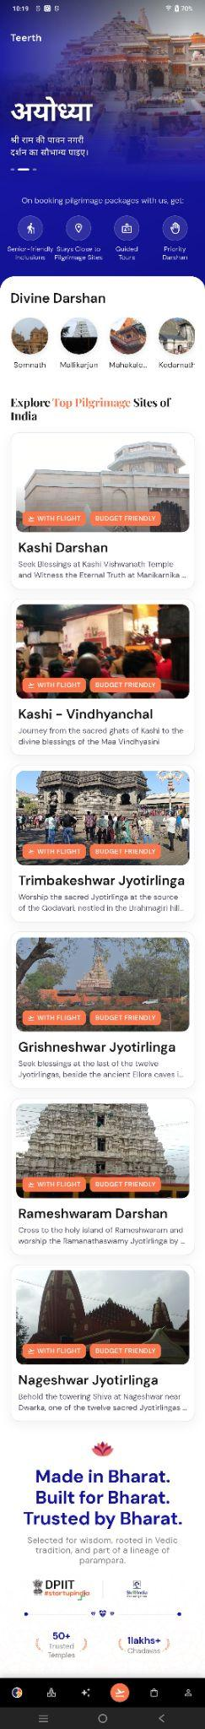
Swadharma App – Teerth Screen

1. Screen Overview
The Teerth screen is the pilgrimage and sacred-destination section of the Swadharma Super application.
It helps users discover and explore important pilgrimage destinations across India and provides access to pilgrimage-related packages and Darshan experiences.
The screen includes:
- Featured pilgrimage destination
- Pilgrimage booking benefits
- Divine Darshan
- Popular pilgrimage sites
- Pilgrimage packages
- Trusted temple information

2. Header & Featured Pilgrimage Banner
The top section displays the Teerth module title along with a large promotional banner.
The banner highlights a featured pilgrimage destination:
Ayodhya
It contains:
- Large destination image
- Destination name in Hindi
- Short spiritual description
- Carousel indicators
The banner can be used to promote important pilgrimage destinations, festivals, or special pilgrimage packages.

3. Pilgrimage Booking Benefits
Below the banner, the screen communicates the benefits of booking pilgrimage packages through the platform.
The displayed benefits include:

Senior-Friendly
Pilgrimage experiences and arrangements designed to be convenient for senior citizens.

Stay Close to Pilgrimage Sites
Accommodation options are arranged close to important pilgrimage locations.

Guided Tours
Users can receive assistance through guided pilgrimage tours.

Priority Darshan
Packages may provide priority access for Darshan at selected temples.
These benefits help communicate the convenience and value of booking pilgrimage packages through Swadharma.

4. Divine Darshan
The Divine Darshan section provides quick access to popular temple destinations.
The section displays circular destination cards with temple images and names.
Examples shown include:
- Somnath
- Mallikarjun
- Mahakaleshwar
- Kedarnath
Users can select a destination to explore its available Darshan or pilgrimage-related offerings.
The destination list is horizontally scrollable.

5. Explore Top Pilgrimage Sites of India
This section displays popular pilgrimage destinations and associated pilgrimage packages.
Each destination is presented as a detailed card.
The cards generally contain:
- Destination/temple image
- WITH FLIGHT badge
- BUDGET FRIENDLY badge
- Destination/package name
- Short description
- Pilgrimage-related information
The cards are vertically arranged, allowing users to browse multiple destinations.
Package Details – Shows the Kashi–Ayodhya 5 Days / 4 Nights spiritual travel package, including itinerary, highlights, inclusions, exclusions, places to visit, rules, reviews, and FAQs.

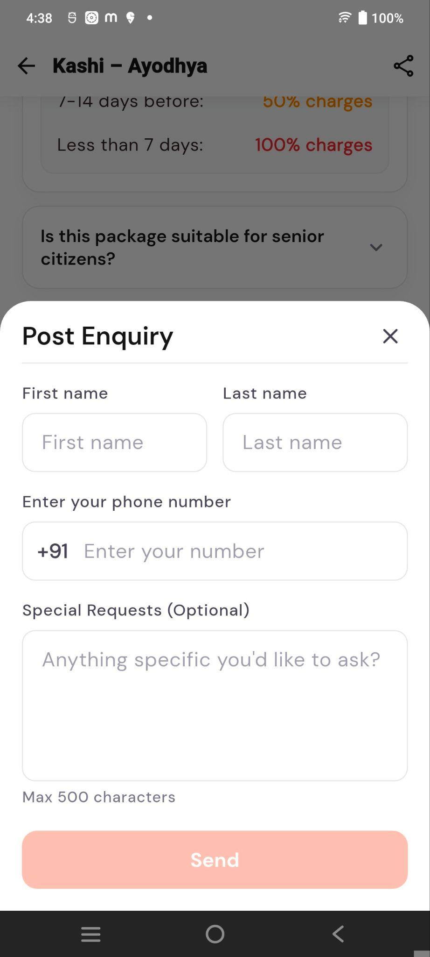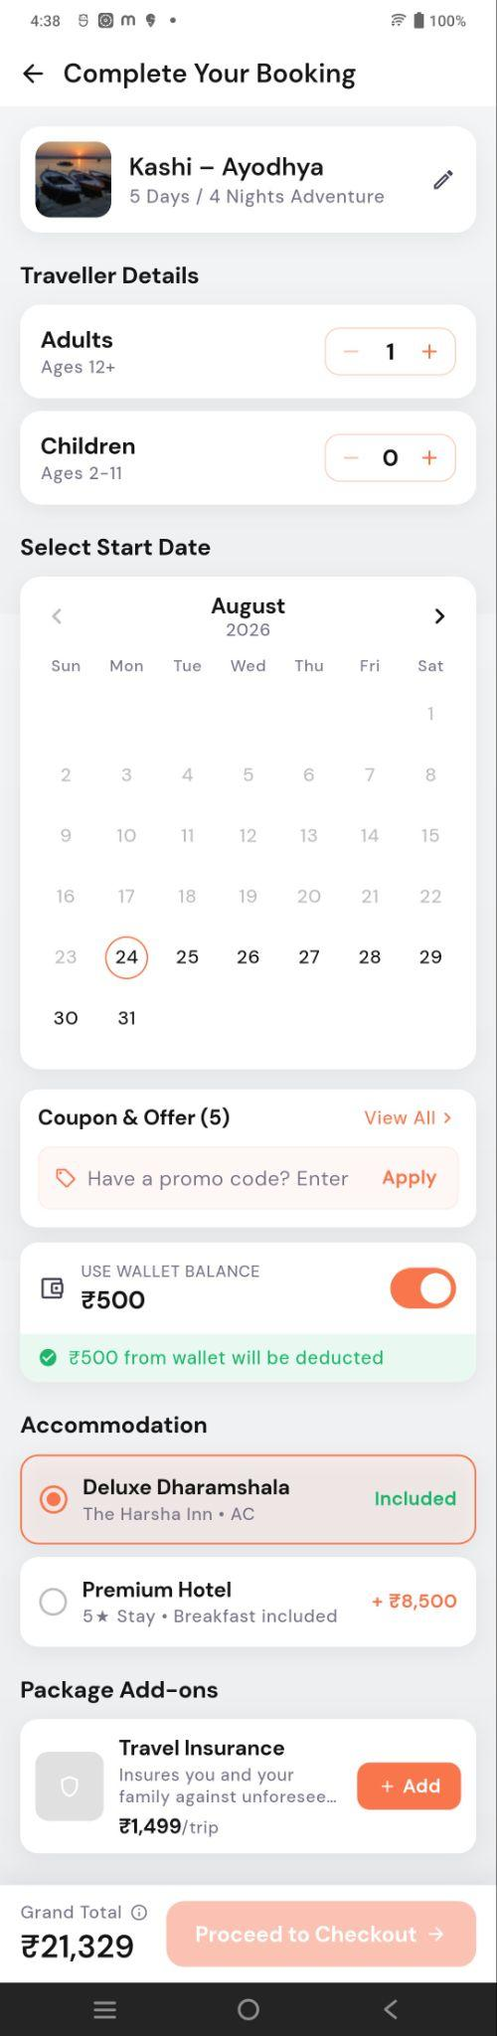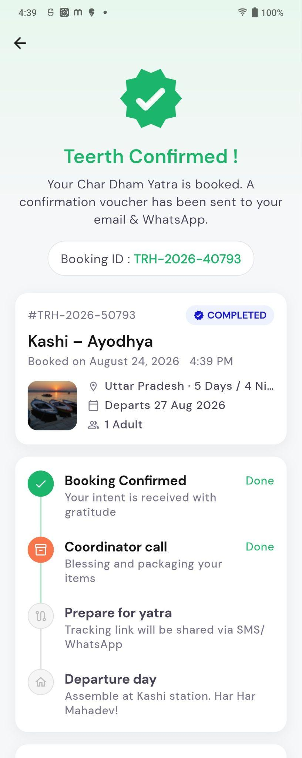

- Post Enquiry – Users can submit their name, phone number, and special requests for additional assistance.
- Booking Form – Users select travellers, travel date, apply coupons, use wallet balance, choose accommodation, and add travel insurance.
- Booking Confirmation – After successful booking, the app displays the Booking ID, trip details, booking status, coordinator call, preparation steps, and departure information.

6. Destination Card Interaction
Each pilgrimage destination card acts as a navigation point.
Typical flow:
Select Pilgrimage Card → View Package Details → Check Package Information → Proceed with Booking
The detailed package screen can provide information such as itinerary, travel arrangements, accommodation, Darshan details, pricing, and booking options.

7. Made in Bharat / Trust Section
At the bottom of the Teerth screen, the Swadharma brand message is displayed:
“Made in Bharat. Built for Bharat. Trusted by Bharat.”
The section communicates that the platform is:
- Rooted in Indian spiritual traditions
- Based on Vedic wisdom
- Connected to the Indian cultural heritage
Trust/recognition logos are also displayed.
Platform statistics shown include:
- 50+ Trusted Temples
- 1 Lakh+ Chadhavas

8. Bottom Navigation
A fixed bottom navigation bar provides quick access to the application's major modules.
The available navigation options include areas such as:
- Home
- Puja
- Astro
- Teerth
- Store
- Profile
The Teerth icon is highlighted because the user is currently viewing the Teerth screen.

9. User Flow
The primary Teerth flow is:
Teerth → Explore Pilgrimage Site → Select Destination → View Package Details → Book Pilgrimage
Other flows include:
Teerth → Divine Darshan → Select Temple → View Darshan Details
Teerth → Featured Destination → View Destination → Explore Packages
Teerth → Pilgrimage Package → Package Details → Booking

10. Key Purpose of the Screen
The Teerth screen acts as a pilgrimage discovery and booking hub for Swadharma.
Its primary objective is to help users discover sacred destinations, Jyotirlingas, temple Darshan experiences, and pilgrimage packages while highlighting convenient travel options such as flights, guided tours, nearby stays, senior-friendly arrangements, and priority Darshan.
The overall user journey is designed around:
Discover → Explore → Select Pilgrimage → View Package → Book

Store Tab

Swadharma App – Store Screen

1. Screen Overview

The Store screen is the e-commerce section of the Swadharma Super application. It allows users to discover and purchase spiritual, devotional, gemstone, and lifestyle-related products.
The screen provides:
- Product search
- Product categories
- Best-selling products
- Popular products
- Products by deity
- Products by purpose
- Products by life goal
- Zodiac-based products
- Unique spiritual collections
- Gemstone categories
- Product delivery and return information
The screen is vertically scrollable and contains multiple horizontally scrollable product/category sections.

2. Header Section
The top section contains:
- Store – Identifies the current module.
- Wishlist Icon – Allows users to access saved products.
- Cart Icon – Provides access to the shopping cart.
- Search Products – Allows users to search for products by name or keyword.
The search field also includes a microphone icon for voice-based search.

3. Quick Product Categories
Below the search bar, circular category shortcuts provide quick access to popular store categories.
Examples include:
- Astro Diyas
- Health & Wellness
- Gemstone
- Jap Mala
- Other spiritual product categories
These shortcuts allow users to quickly browse products based on category.

4. Product Trust/Service Highlights
A small information strip is displayed below the category shortcuts.
It highlights service attributes such as:
- 24/7 assistance
- Authentic products
- Secure/verified shopping experience
These indicators are intended to build customer confidence while shopping.

5. Promotional Product Banner
A large promotional banner is displayed below the category section.
The example shown features a:
Zodiac Pendant
The banner contains a large product image and promotional content.
Users can select the banner to explore the promoted product or collection.
Carousel indicators below the banner indicate that multiple promotional banners may be available.

6. Best Sellers
The Best Sellers section displays products that are currently popular among customers.
A Shop All option allows users to navigate to the complete collection.

Product Card
Each product card can contain:
- Product image
- Discount badge
- Wishlist icon
- Product name
- Product material/details
- Original price
- Discounted price
- Add-to-cart button
Example products shown include:
- Akhil Jyoti
- Black Agate Protection Bracelet
Users can directly add a product to the cart using the + button.

7. Popular Products
The Popular Products section showcases frequently viewed or purchased products.

Product Filters
Products can be filtered using categories such as:
- Gifting
- Astro
- Spiritual Wear
- Other product categories
Example products shown include:
- Silver Pooja Thali Set
- Sandalwood Gift Box
Each product card provides product information, pricing, discount details, wishlist functionality, and an add-to-cart option.

View All Products
The View All Products button navigates to the complete product catalogue.
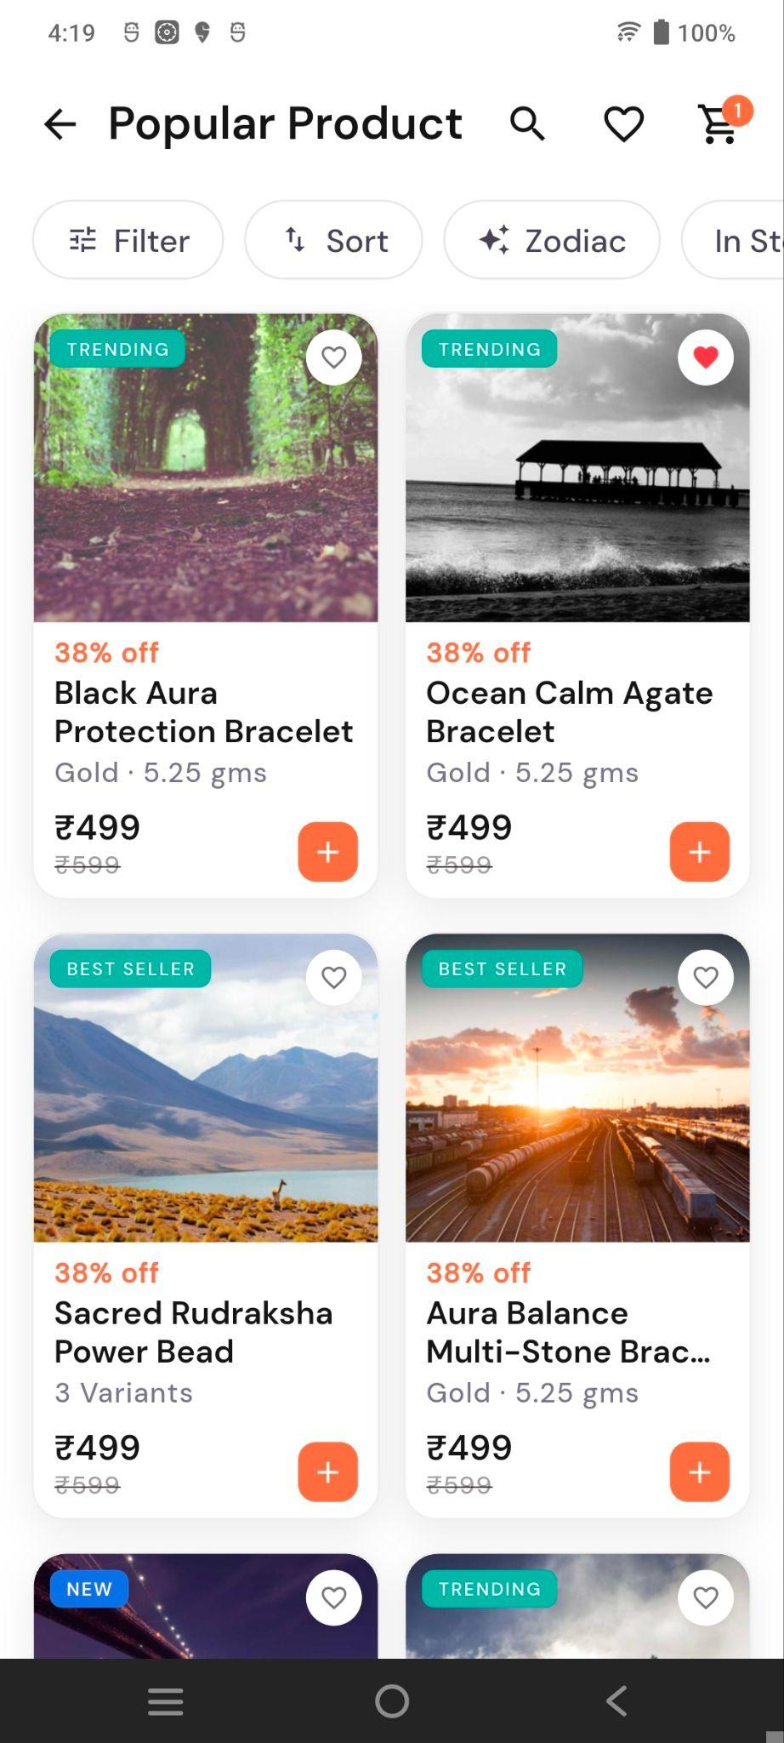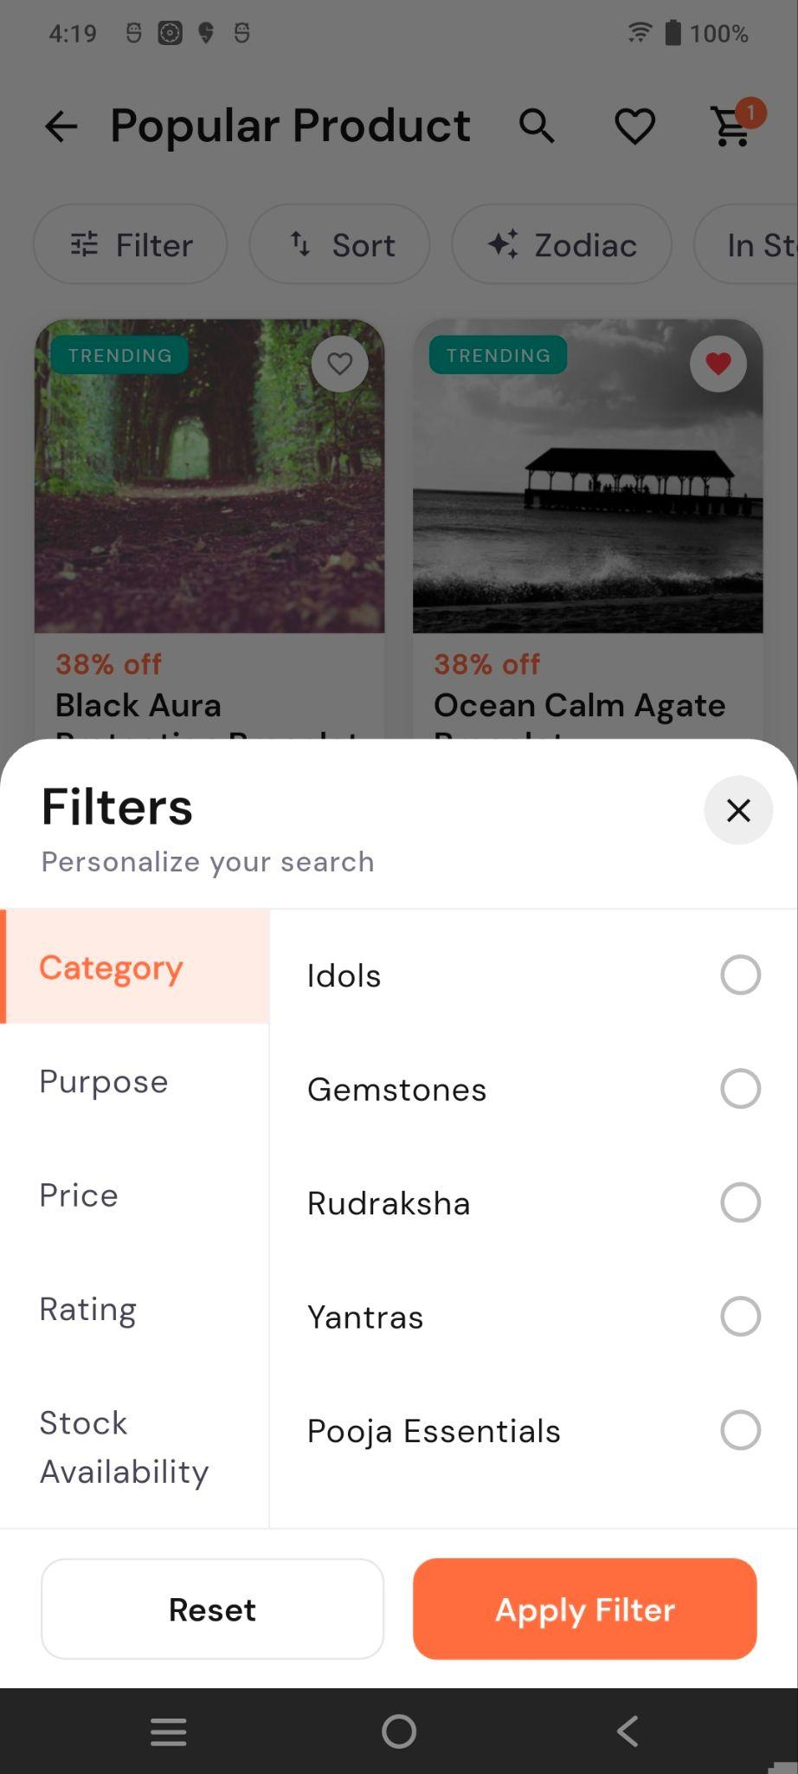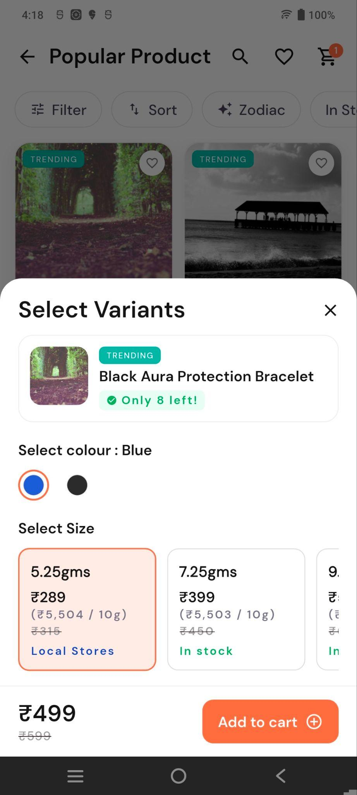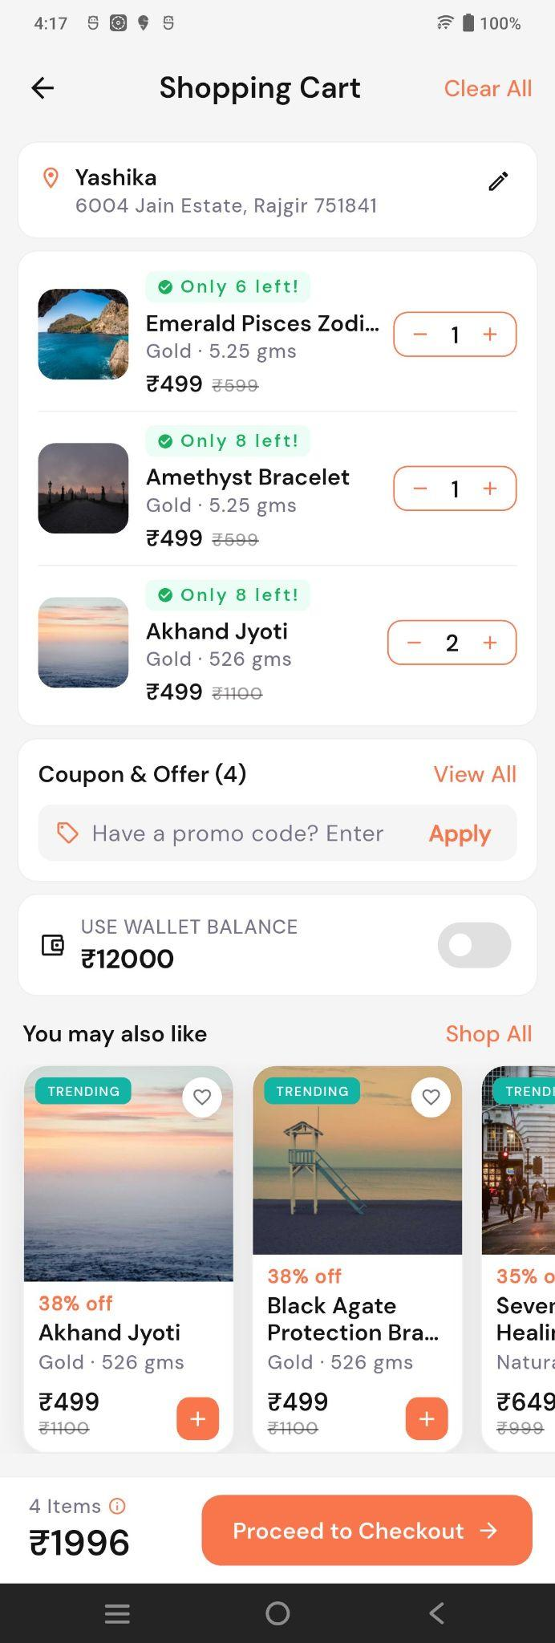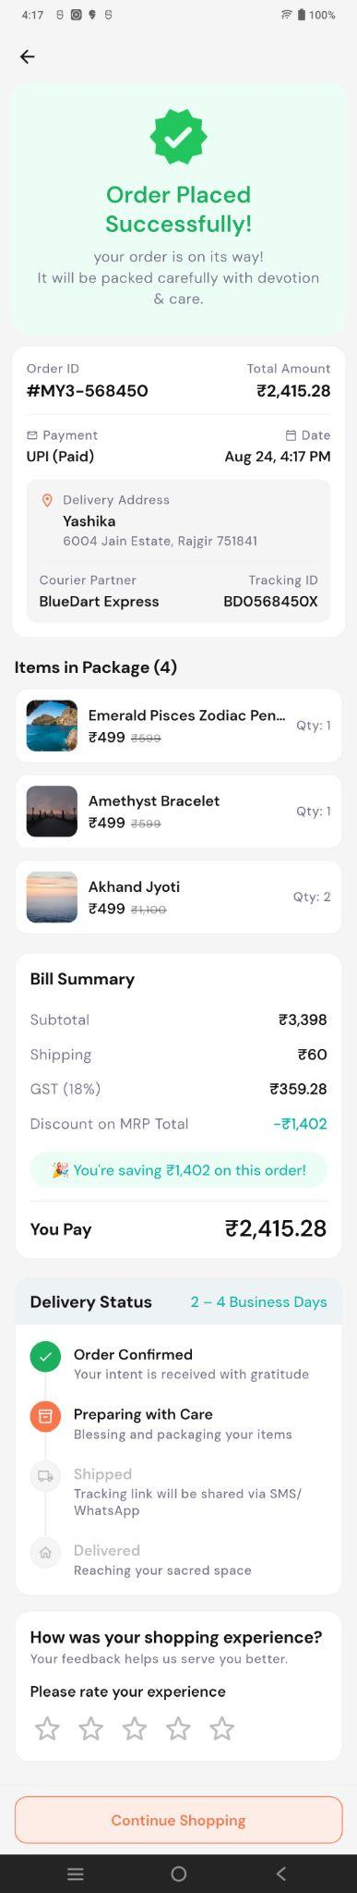
- Popular Product – Displays a list of trending, best-selling, and new spiritual products with search, filter, sort, zodiac, wishlist, and cart options.
- Filters & Variants – Users can filter products by category, purpose, price, rating, and stock, and select product colour/size before adding to cart.
- Product & Checkout – Users can view product details, offers, compatibility, reviews, and add items to cart or buy directly.
- Order Confirmation – Shows the order ID, payment and delivery details, purchased items, bill summary, savings, and delivery status with an option to continue shopping.

Wishlist Screen
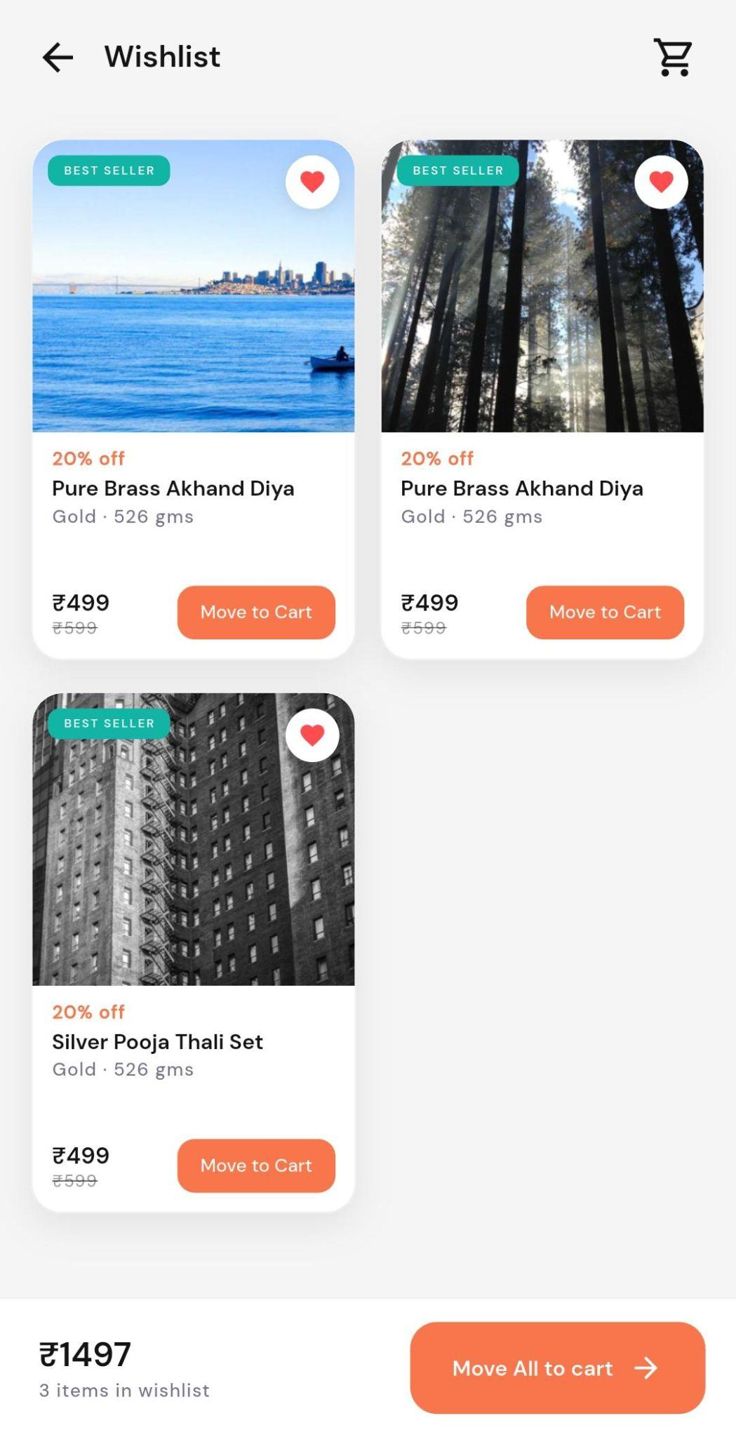
Displays products added to the user’s wishlist, with:
- Product image, name, discount, and price.
- Move to Cart option for individual items.
- Wishlist total amount and item count.
- Move All to Cart option to add all wishlist items to the cart.
- Cart icon to access the shopping cart.

Product Details
Product Detail – Displays the gemstone product image, name, rating, price, colour, and weight options.
Purchase Options – Shows offers, discounts, and payment/security information.
Compatibility Check – Allows users to check whether the gemstone suits their birth chart.
Frequently Bought Together – Suggests complementary gemstones/products with a combo price.
Reviews & Policies – Shows customer reviews, shipping/returns information, and FAQs.
Bottom Actions – Provides Add to Cart and Buy Now options.

8. Shop by Deity (God)
This section allows users to discover products associated with specific Hindu deities.
The subtitle indicates that users can:
Find items that align with your intentions
Example deity categories shown include:
- Balaji
- Maa Durga
- Maa Lakshmi
- Other deity categories
Each category contains an image and deity name.
Selecting a deity displays products associated with that deity.

9. Shop by Purpose
The Shop by Purpose section helps users find products based on their intended use.
Available categories include:
- Gifting
- Spiritual Wear
- Spiritual Home
- Pooja Essentials
- Puja Murti
- Temple Products
Each category is displayed using an image and category title.
Selecting a category opens the relevant product collection.

10. Shop by Life Goal
This section allows users to find spiritual products based on specific life goals or intentions.
Example categories include:
- Love & Relationship
- Protection & Peace
- Career & Success
- Spiritual Growth
- Health & Wellness
- Wealth & Prosperity
The section is intended to help users discover products according to their personal goals.

11. Zodiac Products
The Your Zodiac section provides products based on the user's zodiac sign.
The screenshot shows:
Leo
The section also indicates the availability of multiple curated products for the selected zodiac sign.
Users can select the zodiac section to browse products recommended for their zodiac sign.

12. Unique Collection
The Unique Collection section contains curated spiritual collections designed around specific concepts.
Examples include:

Brass Idols
Collection focused on traditional brass spiritual/decorative idols.

Vastu
Products associated with Vastu and positive surroundings.

Yantra Collection
Products intended to support spiritual practices and positivity.
Each collection includes:
- Collection name
- Short description
- Representative image
Selecting a collection opens the associated product listing.

13. Gem Stone Categories
The Gem Stone Categories section provides access to different types of spiritual and gemstone products.
The section describes these as curated collections of authentic spiritual products.
Categories shown include:
- Bracelets
- Pendants
- Comics
- Rudraksha
- Gemstones
- Pyramids
- Tumbles
- Anklets
Each category includes an image and short description.
Selecting a category opens the relevant gemstone/product collection.

14. Store Service & Trust Information
Near the bottom of the screen, the platform communicates its shopping service benefits.
The section displays:
“Made in India. Built for India. Trusted by India.”
It also highlights key shopping metrics and service promises, including:
- 1–3 Days – Fast pan-India delivery
- 500+ – Curated products
- 4.8 – Customer rating
- Easy returns – Hassle-free return policy
This section is intended to build trust and communicate the quality and convenience of the shopping experience.

15. Product Discovery Flow
The Store provides multiple ways for users to discover products:

Search Flow
Store → Search Products → Search Result → Product Details → Add to Cart
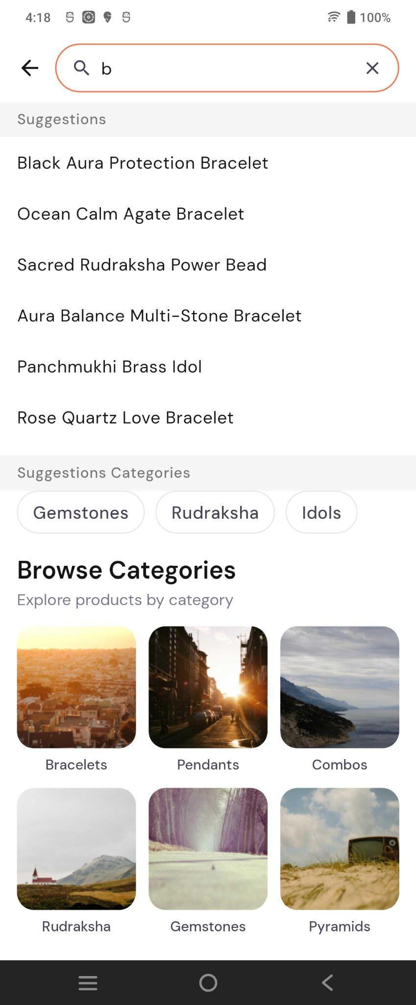

Category Flow
Store → Category → Product Listing → Product Details → Add to Cart

Purpose-Based Flow
Store → Shop by Purpose → Select Purpose → Relevant Products

Deity-Based Flow
Store → Shop by Deity → Select Deity → Relevant Products

Zodiac Flow
Store → Your Zodiac → Select Zodiac → Recommended Products

Gemstone Flow
Store → Gem Stone Categories → Select Category → Product Listing

16. Product Purchase Flow
The general purchase journey is:
Store → Select Product → Product Details → Add to Cart → Cart → Checkout → Payment → Order Confirmation
Users can also add products directly to the cart from product cards using the + button.

17. Bottom Navigation
A fixed bottom navigation bar provides access to the major modules of the application.
The navigation includes options for areas such as:
- Home
- Puja
- Astro
- Teerth/Spiritual section
- Store
- Profile
The Store icon is highlighted because the user is currently viewing the Store screen.

18. Key Purpose of the Screen
The Store screen acts as the main shopping and product-discovery hub of Swadharma Super App.
Instead of relying only on traditional product categories, it provides several personalized discovery methods, including:
- What the user wants – Shop by Purpose
- Who the user follows – Shop by Deity
- What the user wants to achieve – Shop by Life Goal
- What matches the user's zodiac – Zodiac Products
- What spiritual category interests the user – Gemstone Categories and Unique Collections
The overall journey is designed around:
Discover → Explore → Select Product → Add to Cart → Checkout → Purchase

Profile Tab

Swadharma App – My Profile Screen

1. Screen Overview
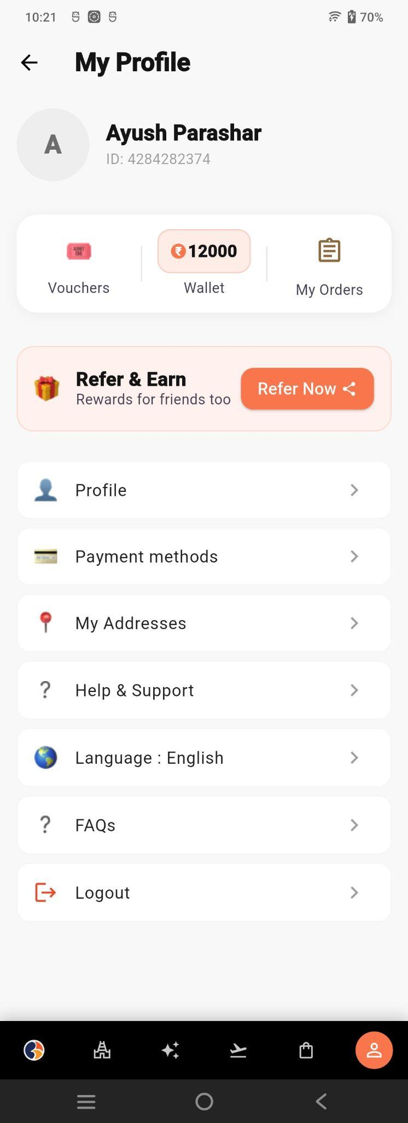
The My Profile screen is the user's account and personal settings section of the Swadharma Super application.
It provides access to:
- User profile information
- Wallet balance
- Vouchers
- Orders
- Referral rewards
- Payment methods
- Saved addresses
- Help and support
- Language settings
- FAQs
- Logout
The screen is vertically scrollable and provides a centralized location for managing account-related information and preferences.

2. Header Section
The top section contains:
- Back Arrow – Allows the user to return to the previous screen.
- My Profile – Screen title.
Below the header, the user's basic account information is displayed.

User Information
The profile header contains:
- User avatar/profile placeholder
- User name
- User ID
Example shown:
Ayush Parashar
The user ID is displayed below the name for account identification.

3. Account Summary
A summary card provides quick access to important account-related services.
The card contains three options:

Vouchers
Allows users to view and use available vouchers, coupons, and promotional offers. Clicking on a voucher opens its details.
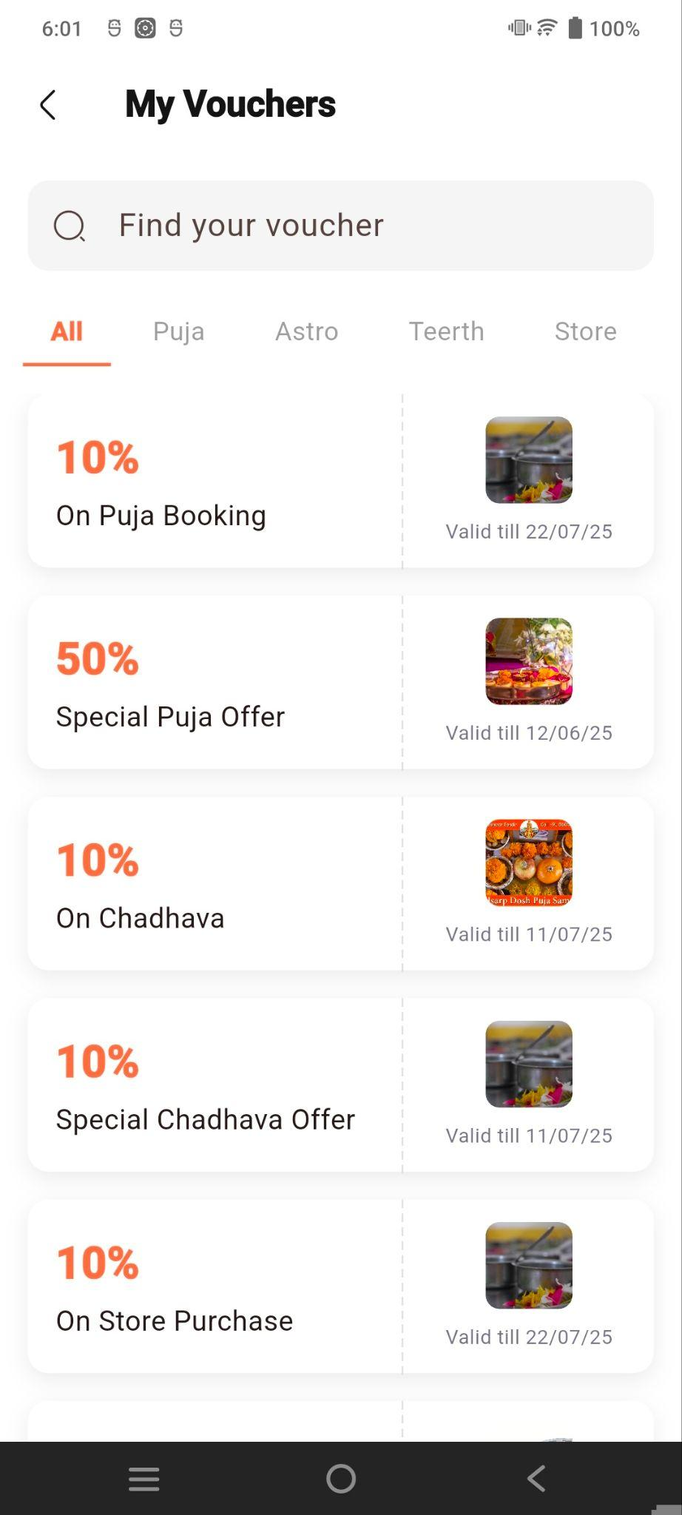
- Search: Find vouchers quickly.
- Categories: Filter vouchers by Puja, Astro, Teerth, Store, or view All.
- Voucher Details: Displays the discount percentage, offer type, and validity date.

Wallet
Displays the user's current wallet balance.
Example shown:
₹12,000
Selecting the Wallet option allows the user to manage or view wallet-related transactions.

My Orders
Provides access to the user's order history.
Users can view previously placed orders and their associated details.

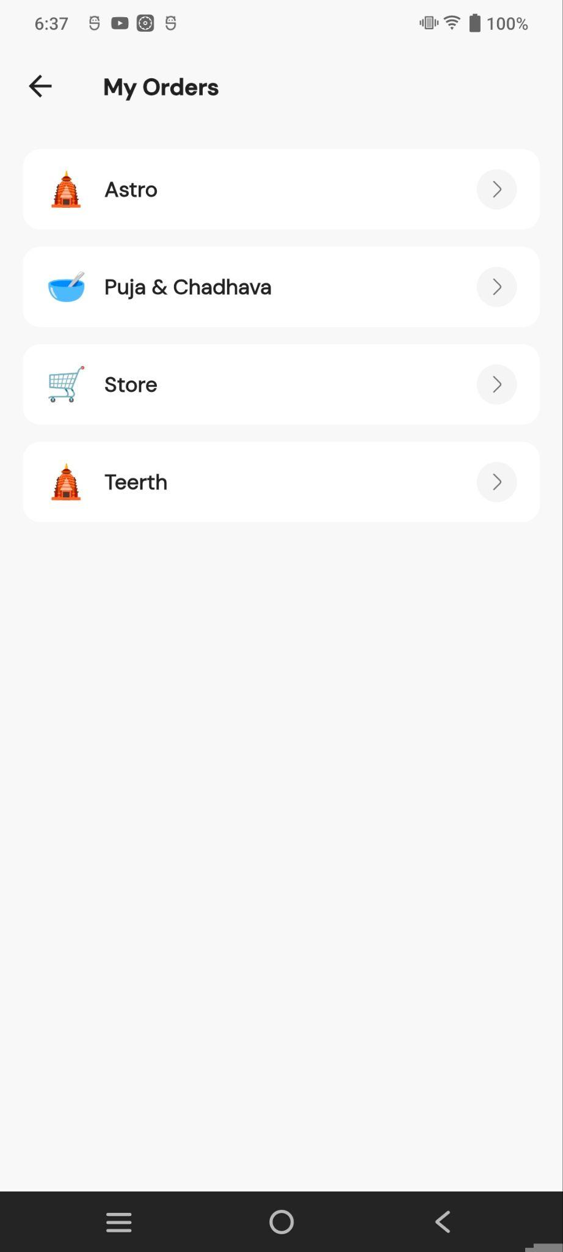

Puja & Chadhava Orders Screen
Gives orders list of all the puja & chadhavas booked by a user along with order details
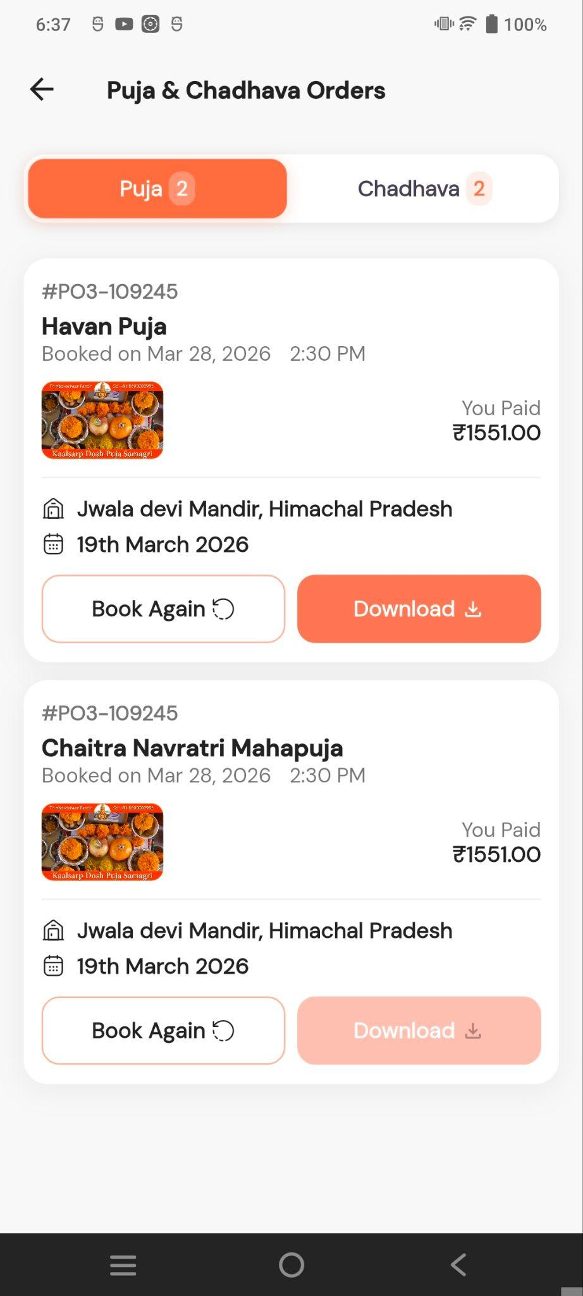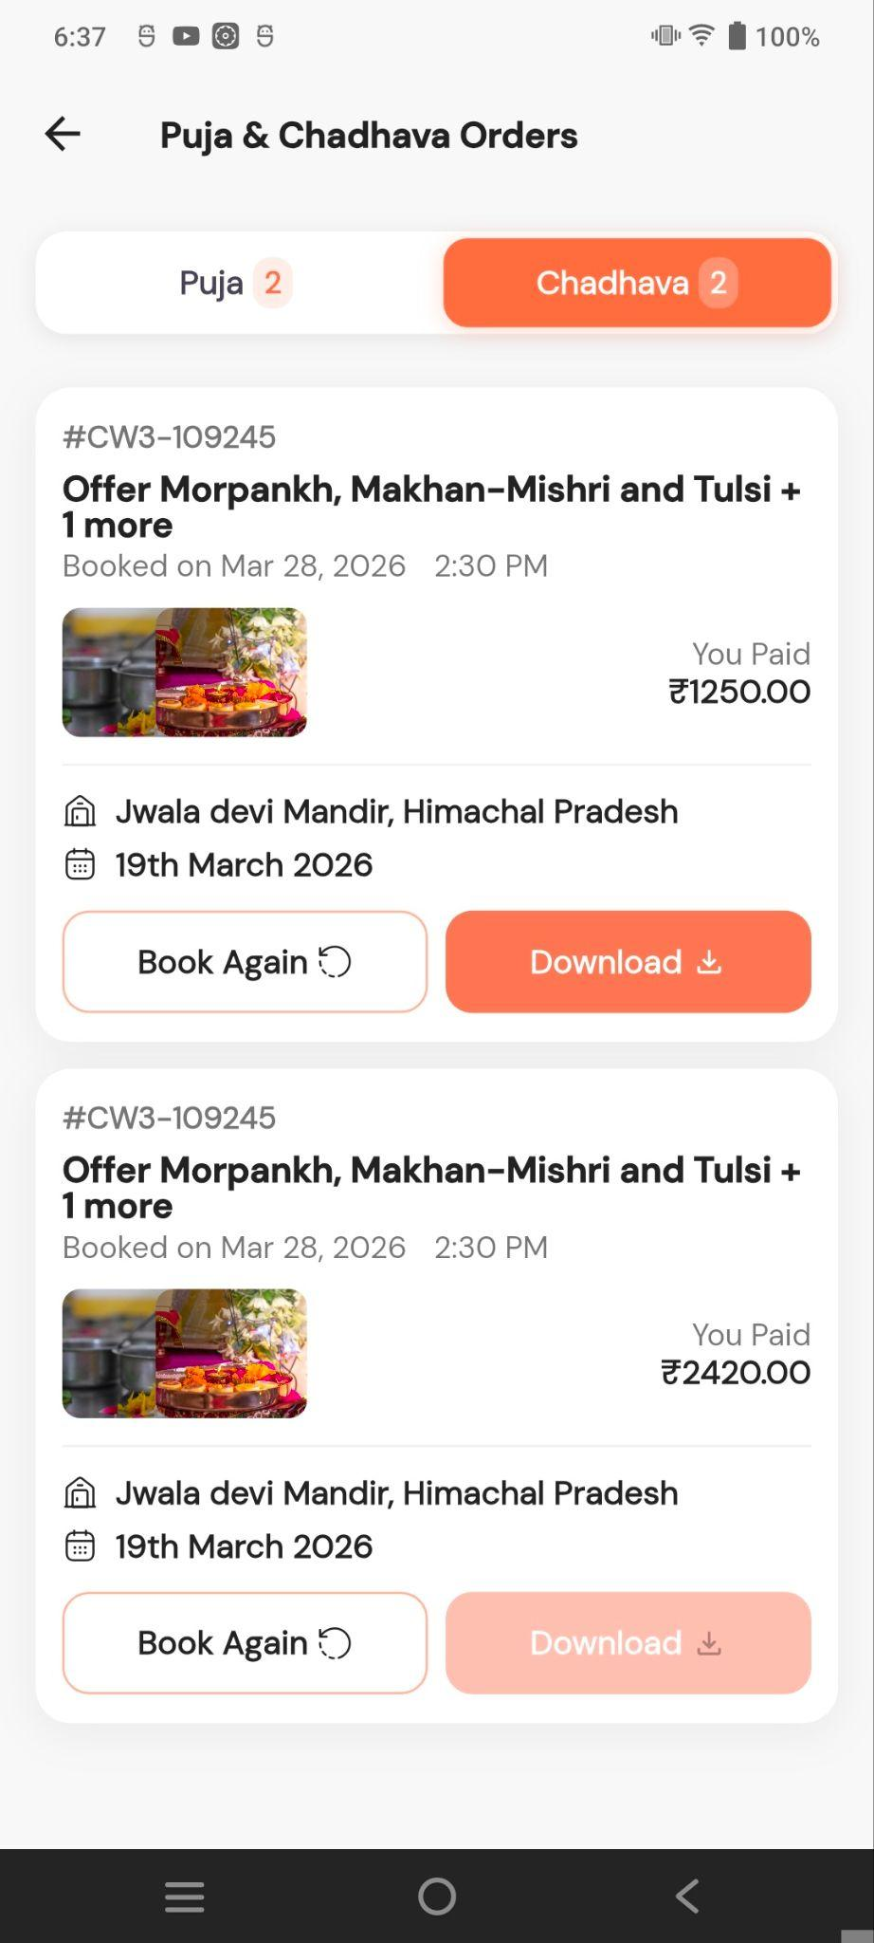
Store Orders Screen
- Gives orders list of all products purchased form store
- Order details screen is also there to display details like delivery timeline , order summary , options for cancellation or replacement depending on the time elapsed
- Further screens shows the flow to cancel an order or report any issue related to order
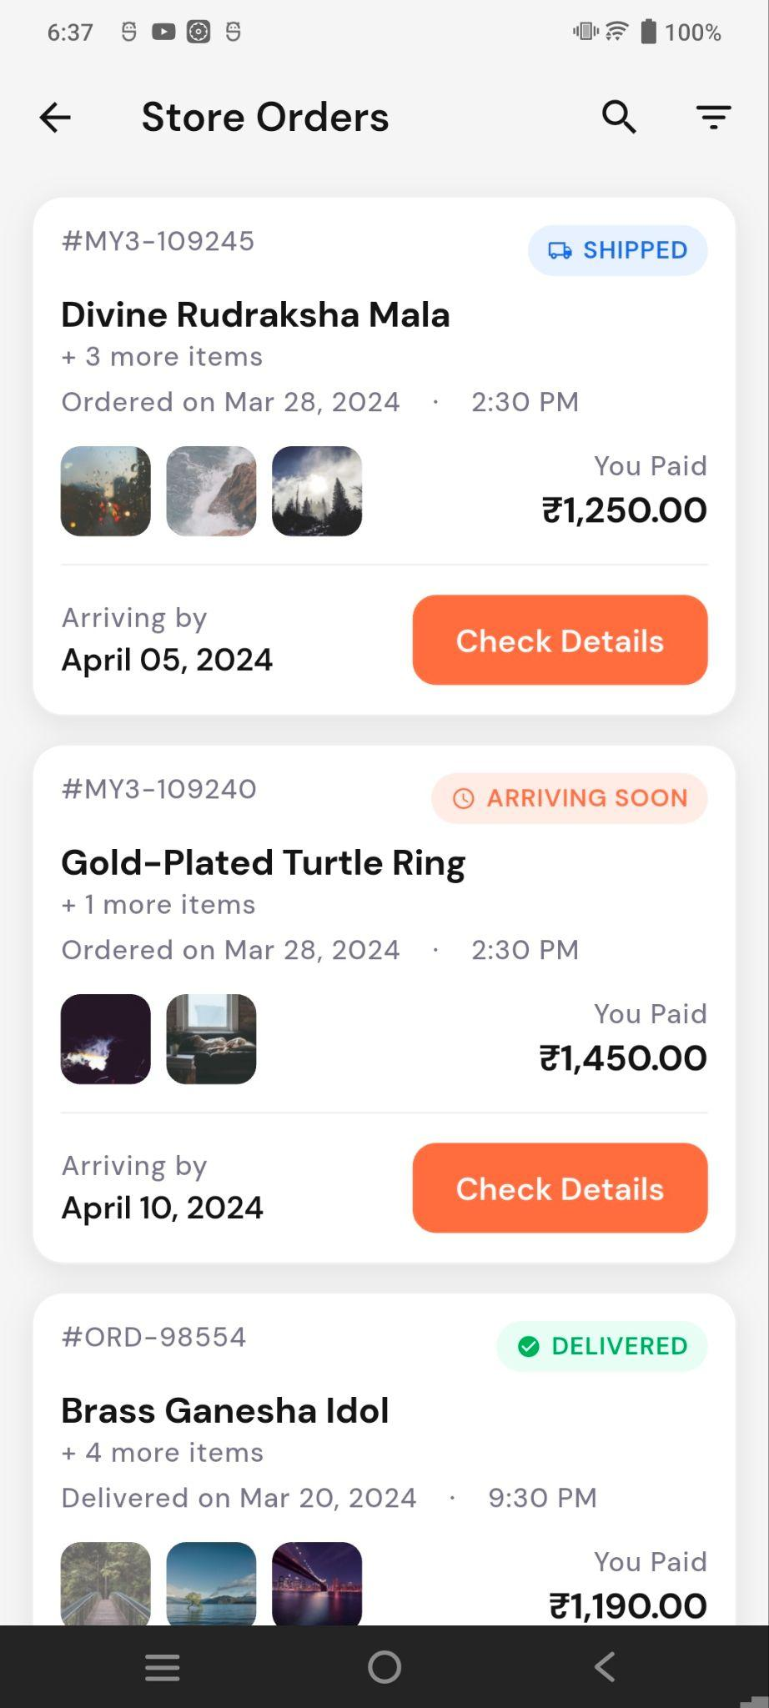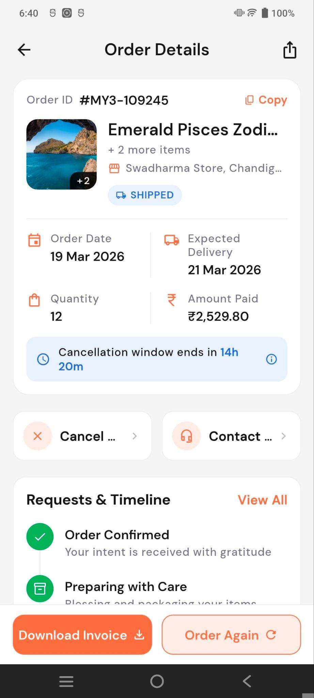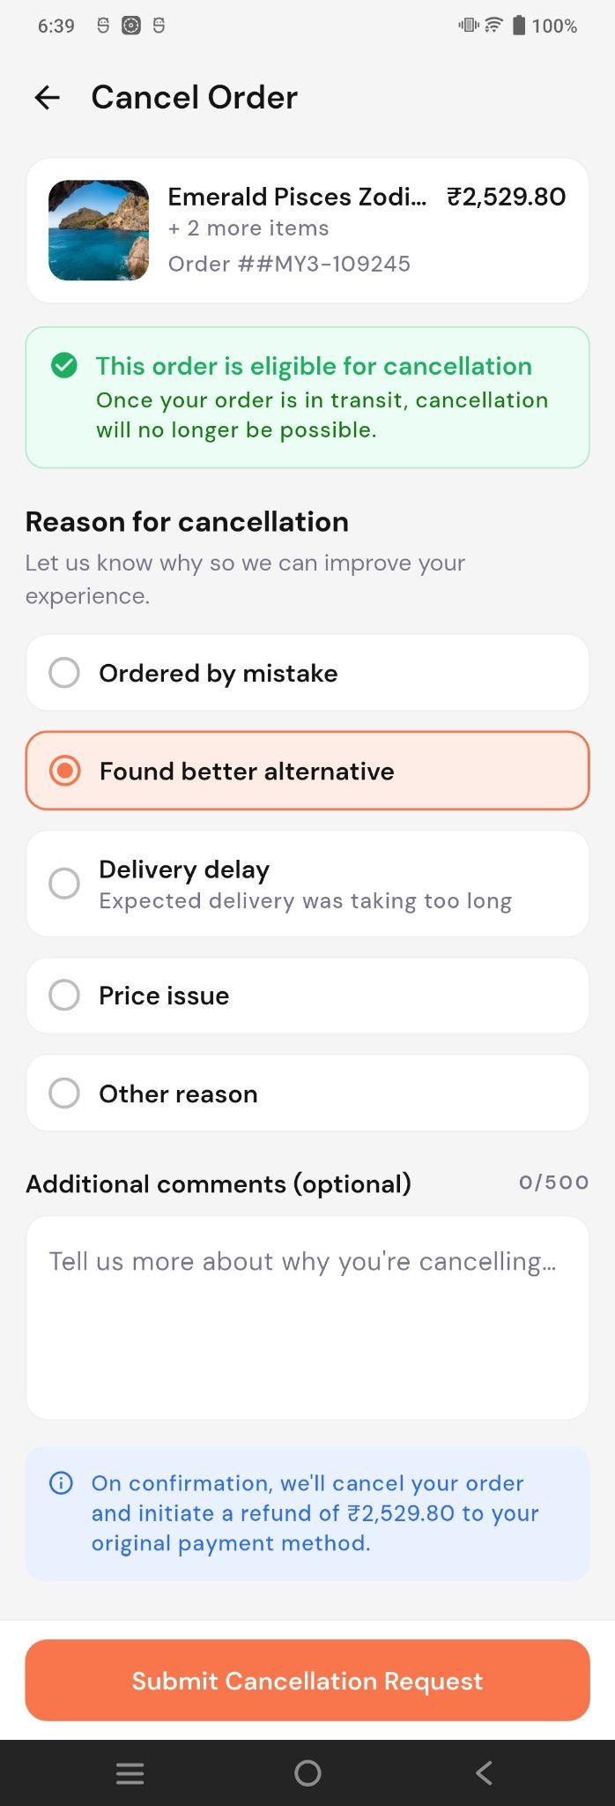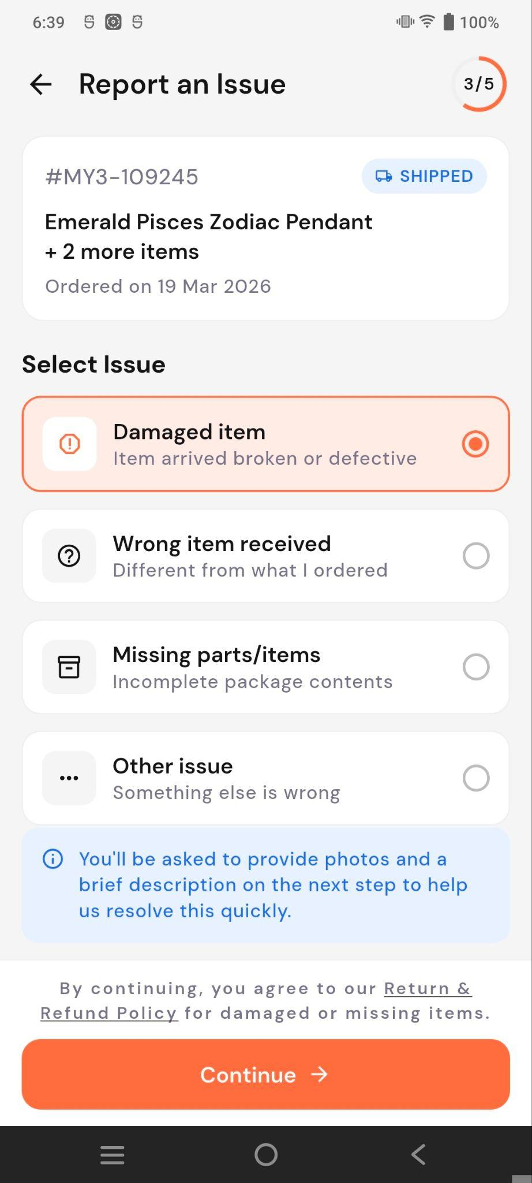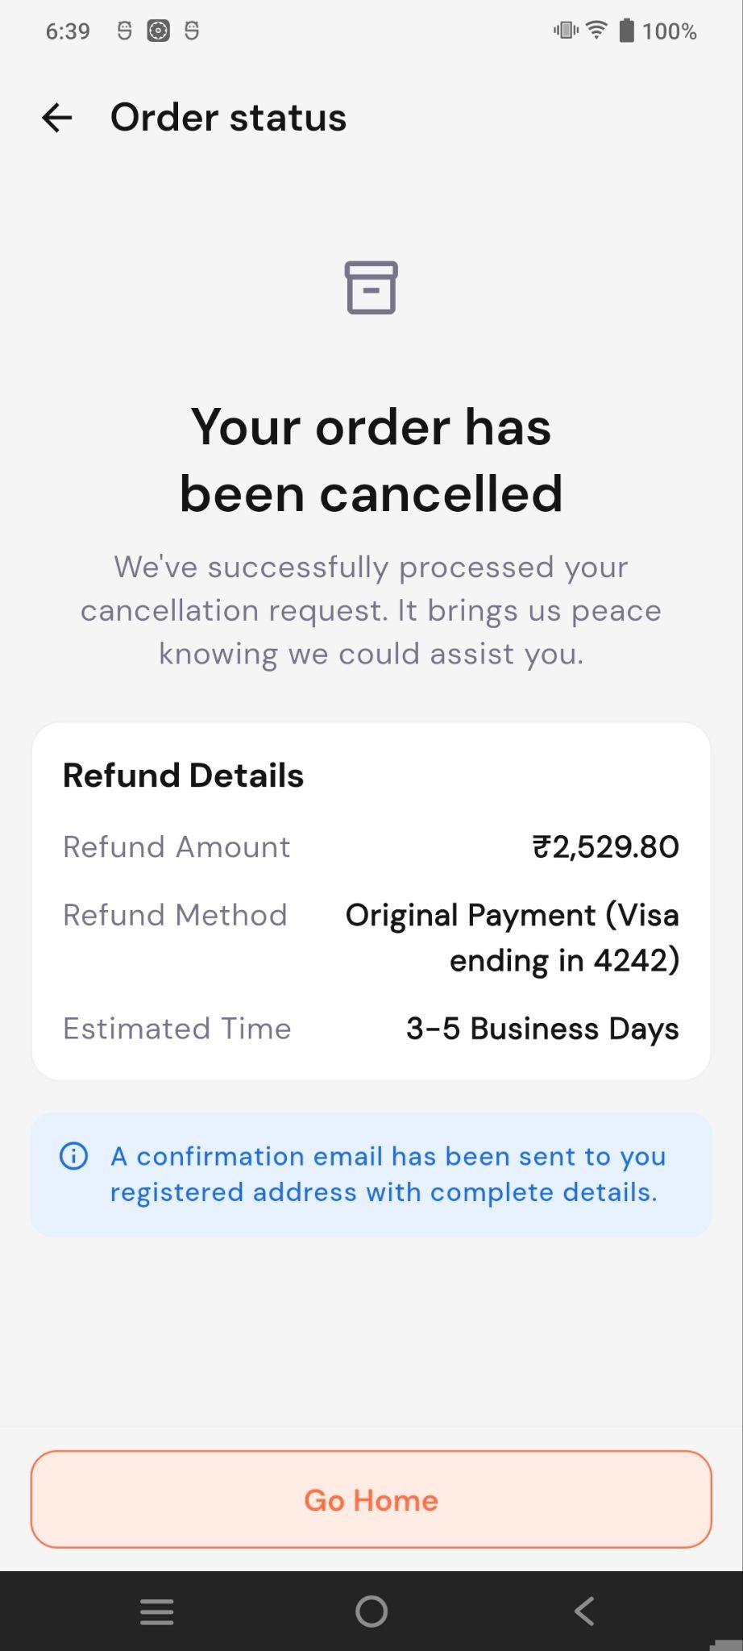

Teerth Orders Screen
- First screen shows the list of all booking done via teerth vertical
- Next screen is booking details screen giving booking summary and contact us option
- Booking cannot be cancelled or rescheduled by user individually, user has to contact customer support for any issues in case of teerth booking.
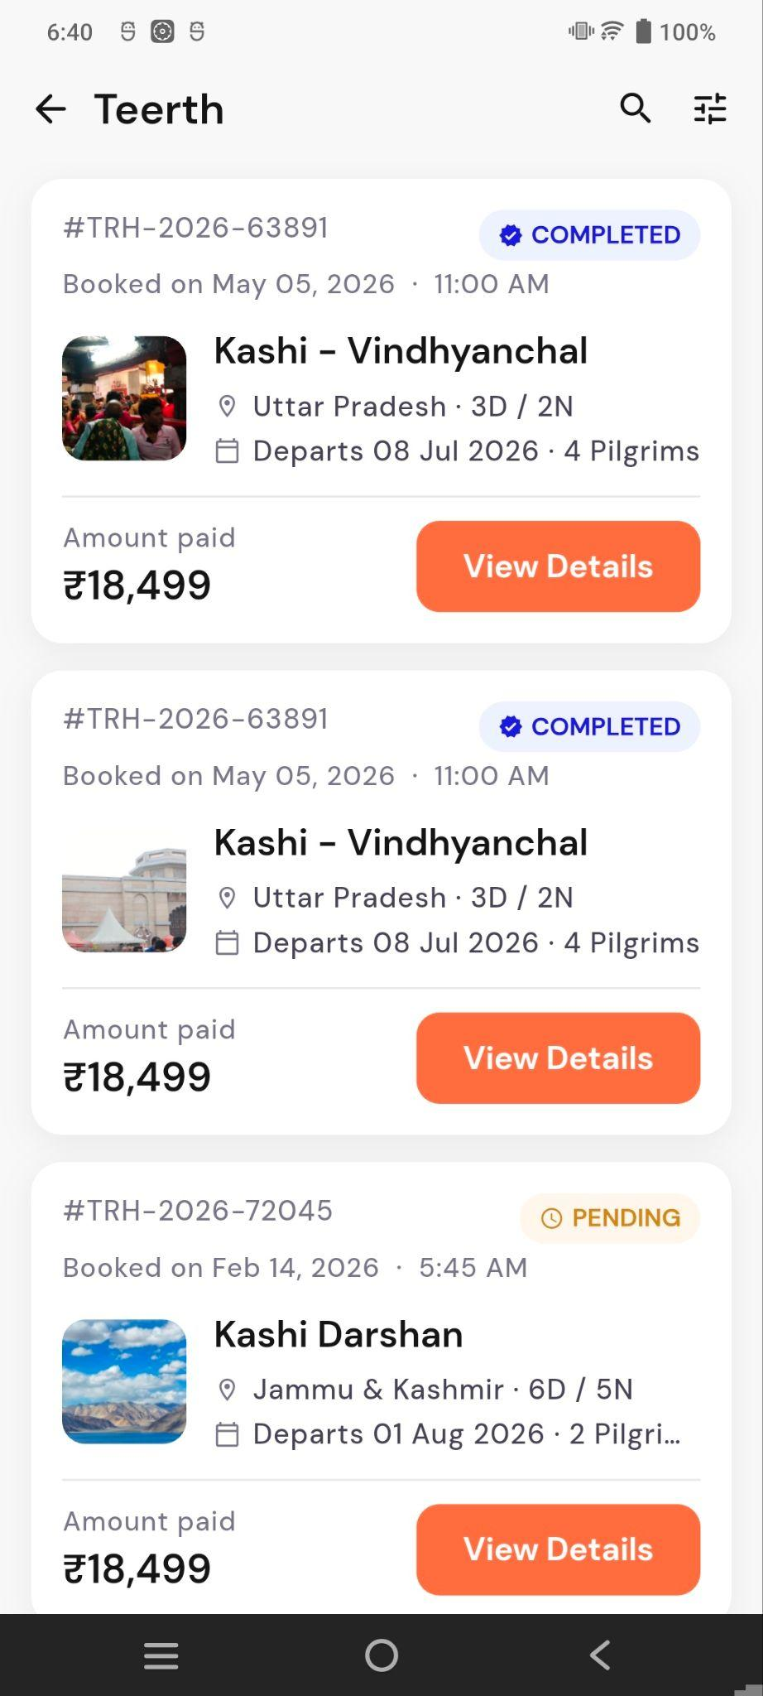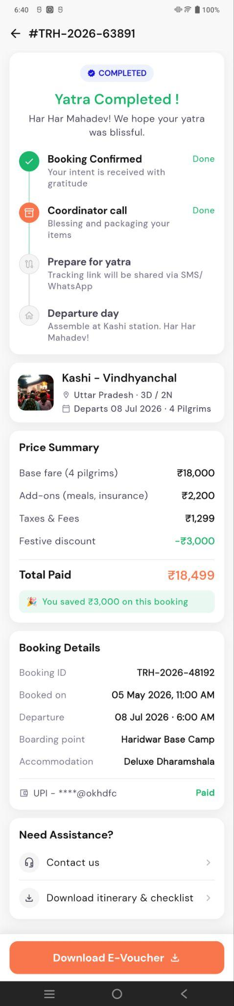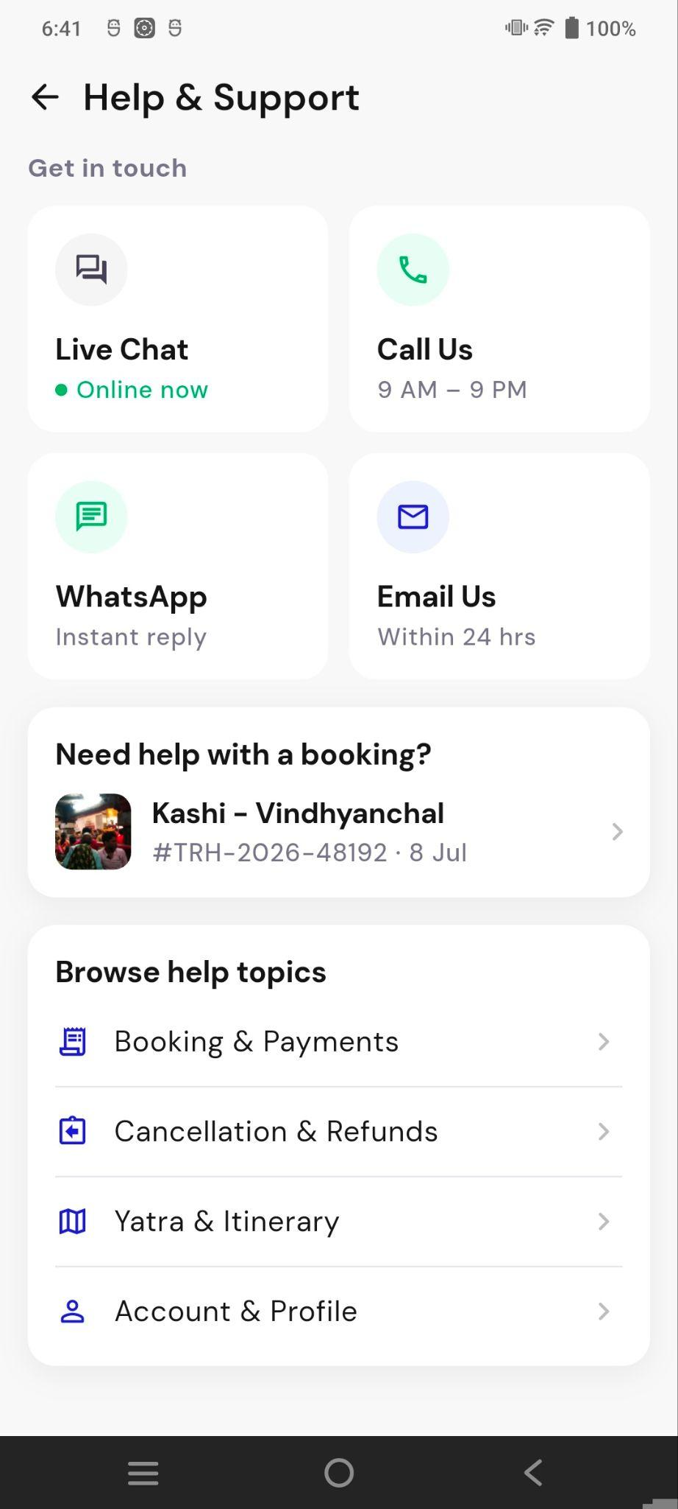

4. Refer & Earn
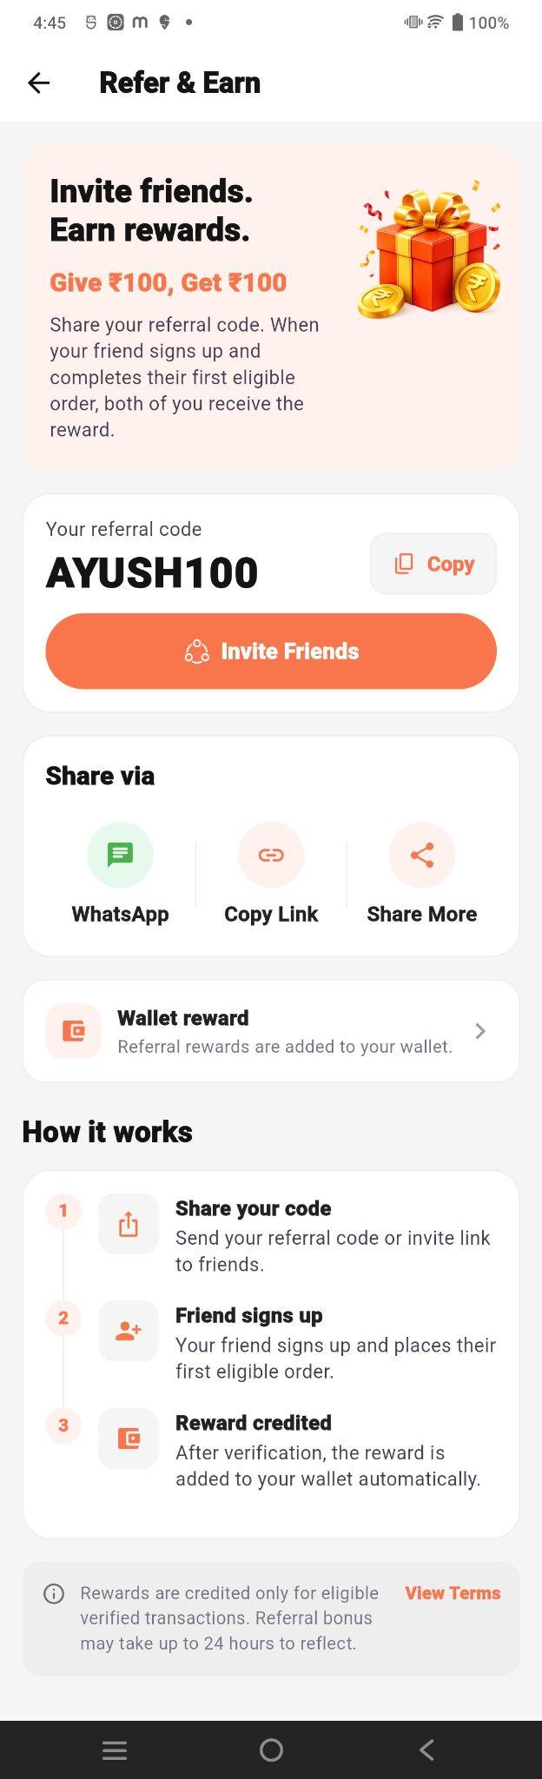
The Refer & Earn section allows users to invite friends using a referral code and earn rewards.
- Referral Code: Users can copy and share their code.
- Invite Friends: Share via WhatsApp, Copy Link, or other apps.
- Reward: Both the user and friend receive ₹100 after the friend completes the first eligible order.
- Wallet Reward: The referral reward is automatically credited to the wallet.
- How It Works: Share code → Friend signs up and places an eligible order → Reward is credited after verification.

5. Profile
Clicking the Profile option opens the Profile List screen, where users can view existing profiles and add or manage additional personal or family profiles.

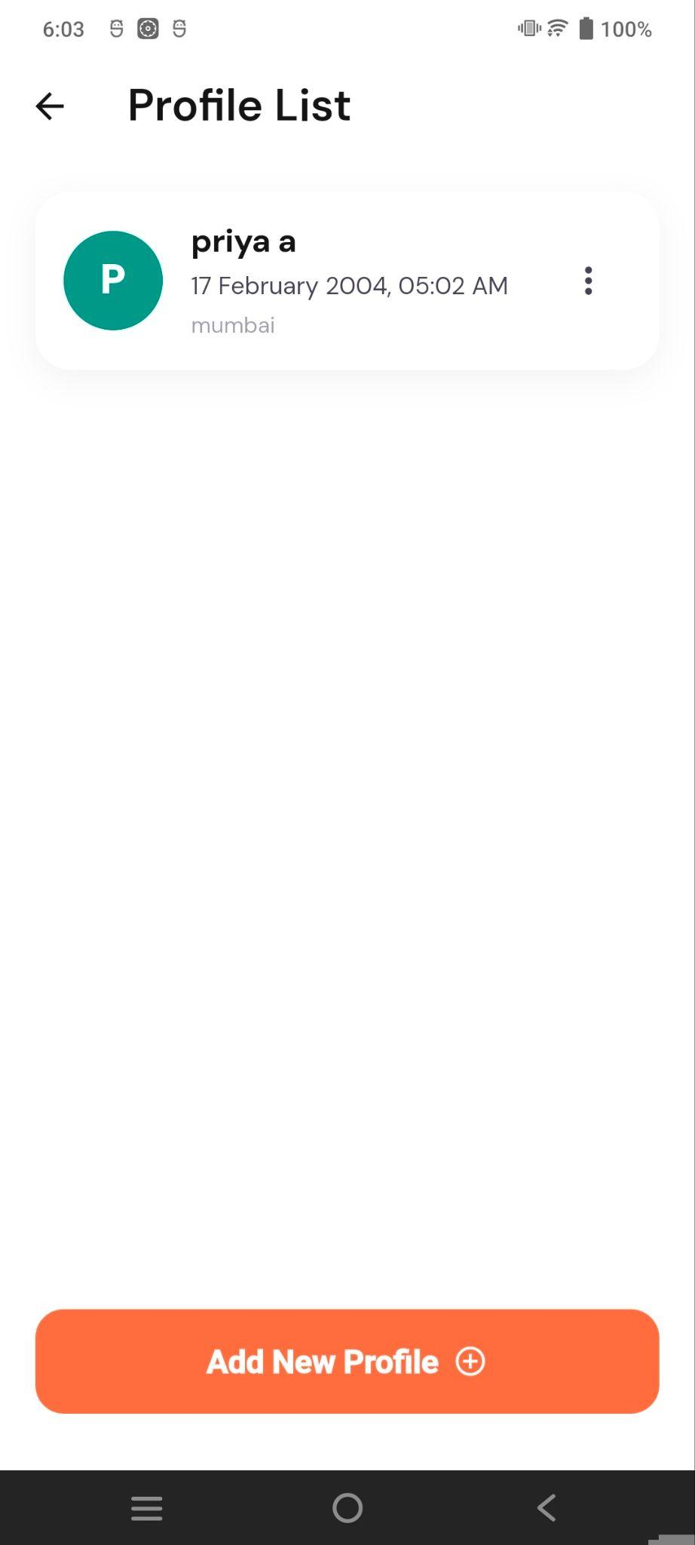
The Profile List allows users to manage multiple personal and family profiles. Users can view existing profiles, edit profile details, and add new profiles for family members.

6. Payment Methods
The Payment Methods option allows users to manage payment methods used for purchases, Puja bookings, Astro consultations, and other paid services.
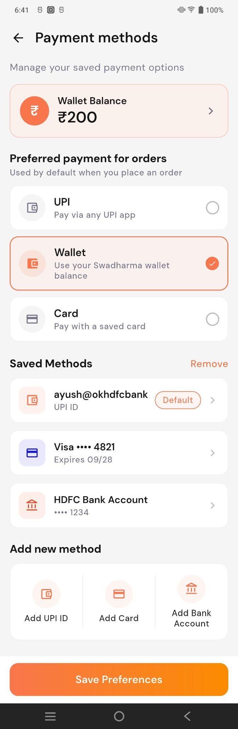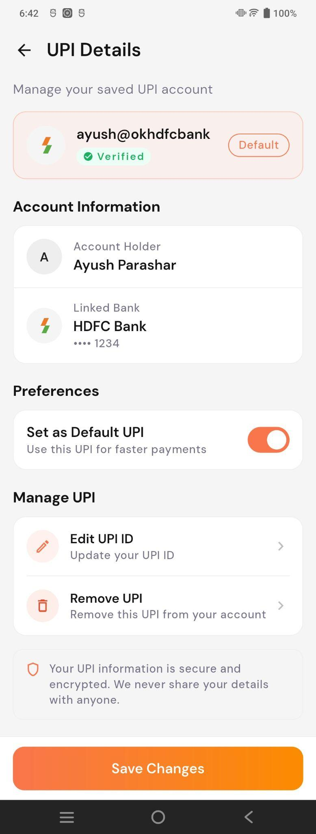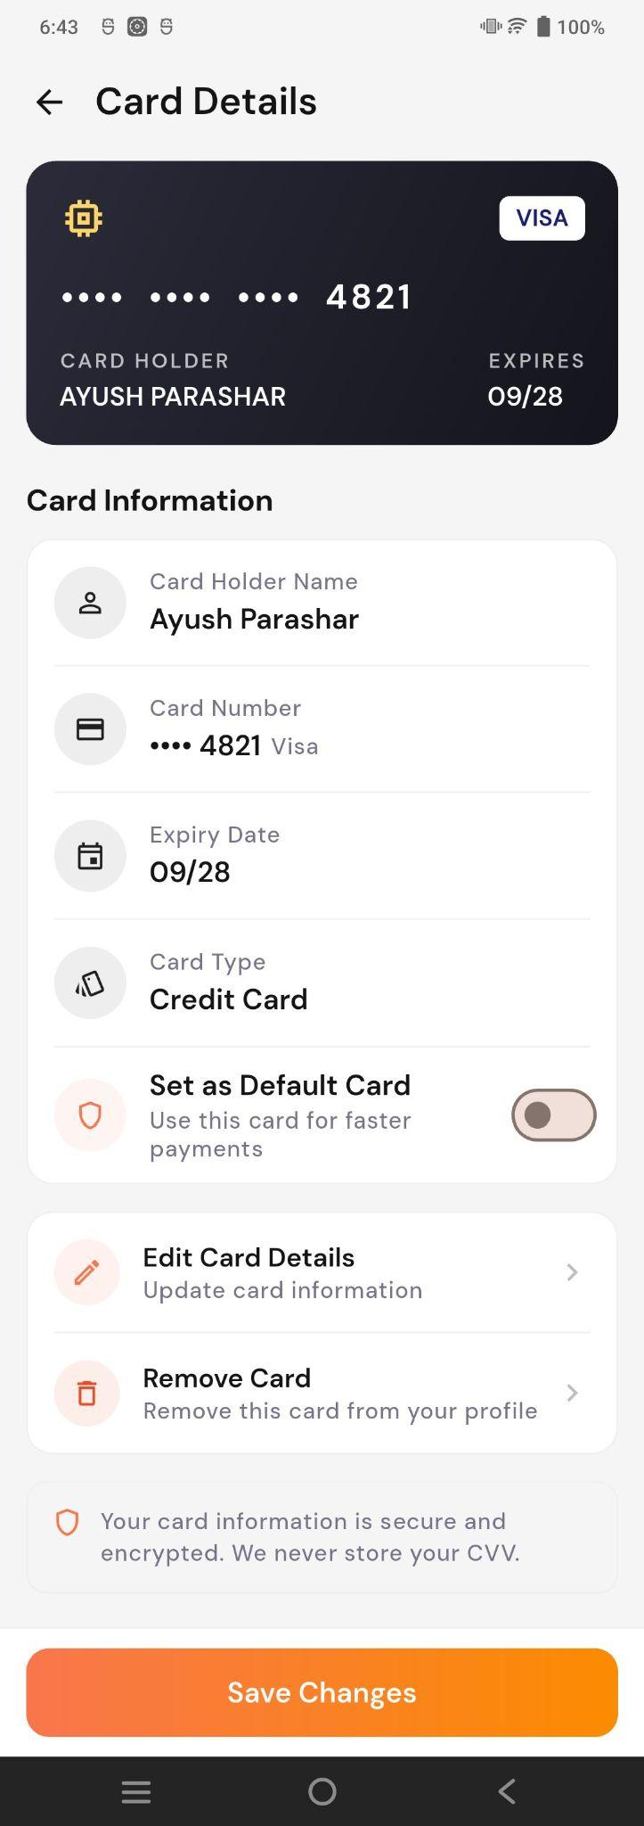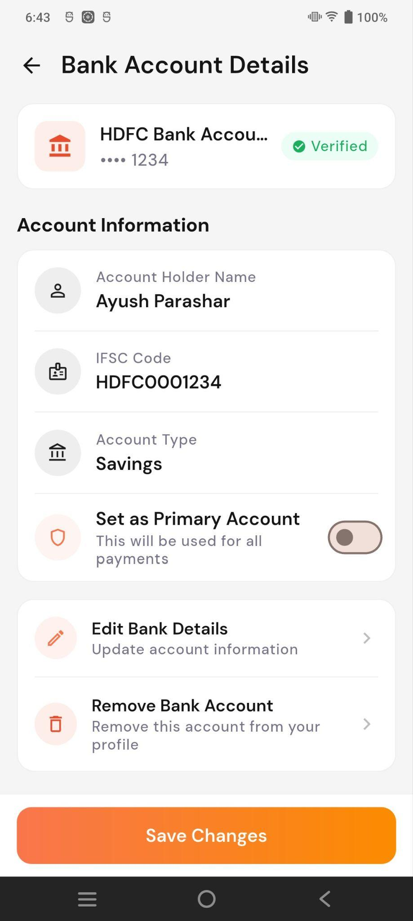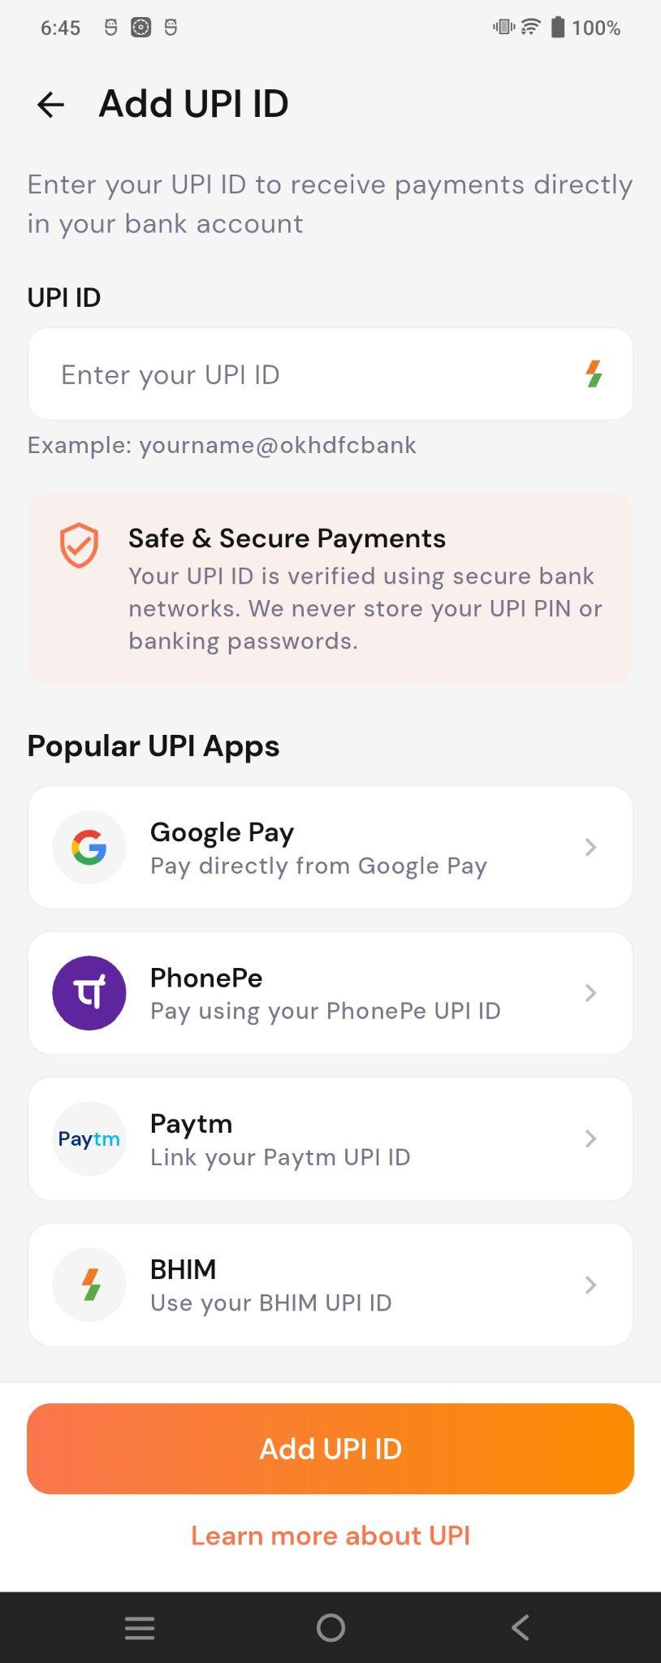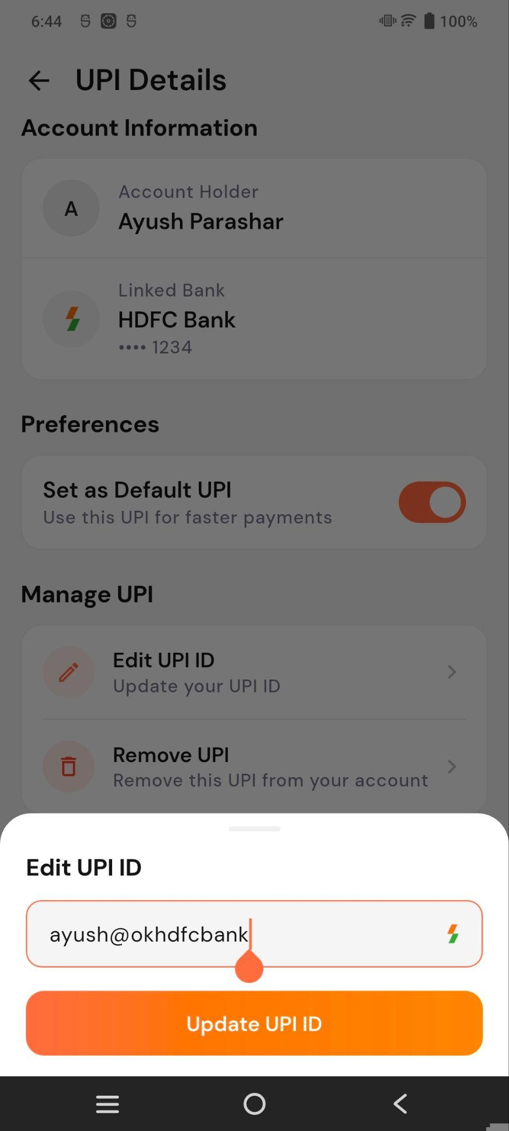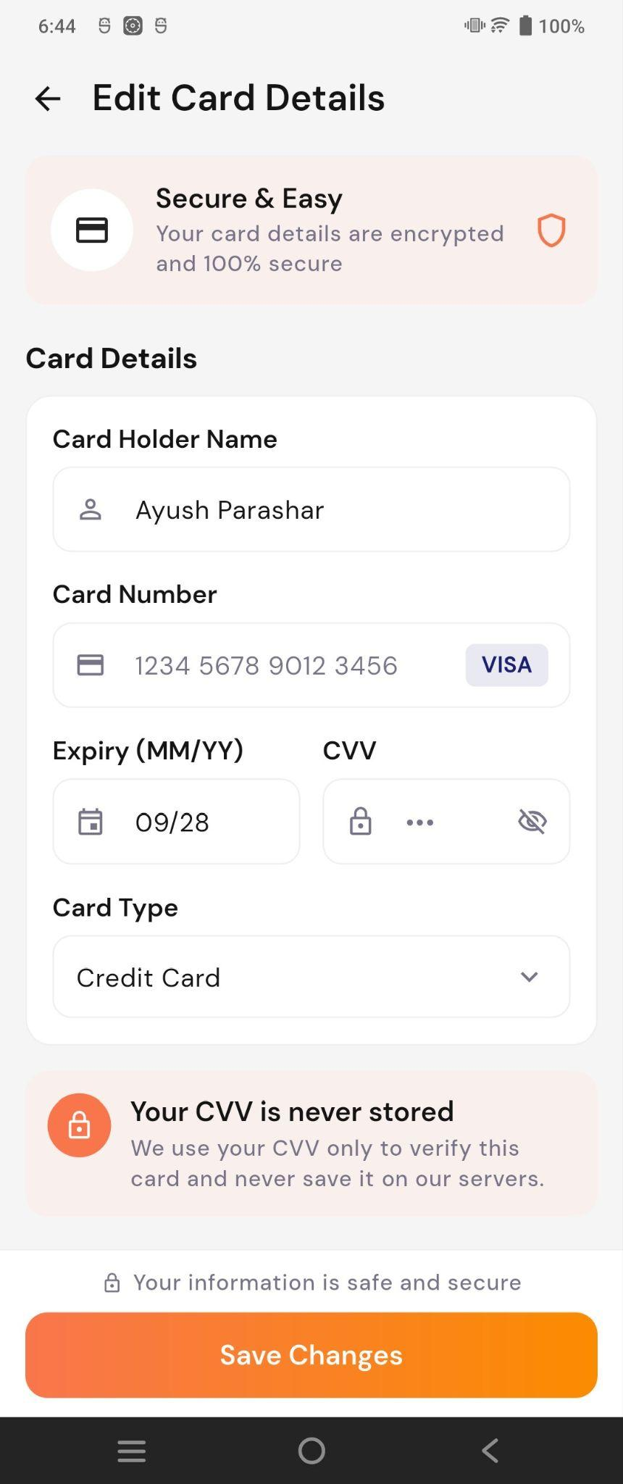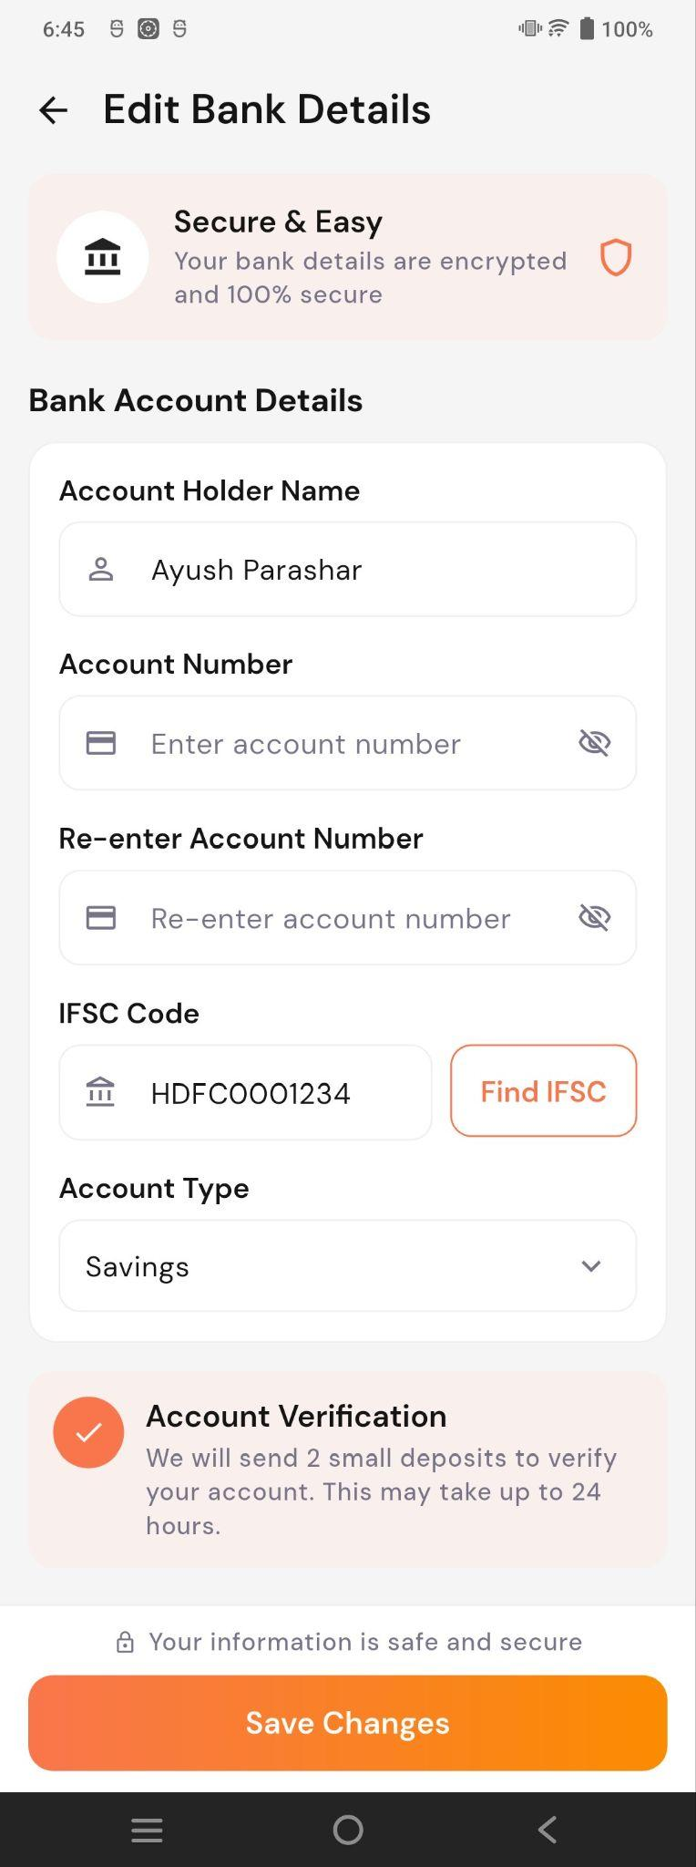
- Add: Add a new UPI ID, Card, or Bank Account.
- Edit: Update saved payment details.
- Details: View details, set a method as default, or remove it.
- Save Changes: Save the updated payment preferences.

7. My Addresses
The My Addresses section allows users to manage their saved delivery addresses.
This is primarily useful for Store purchases.
Users can:
- View saved addresses
- Add a new address
- Edit an existing address
- Select an address for delivery
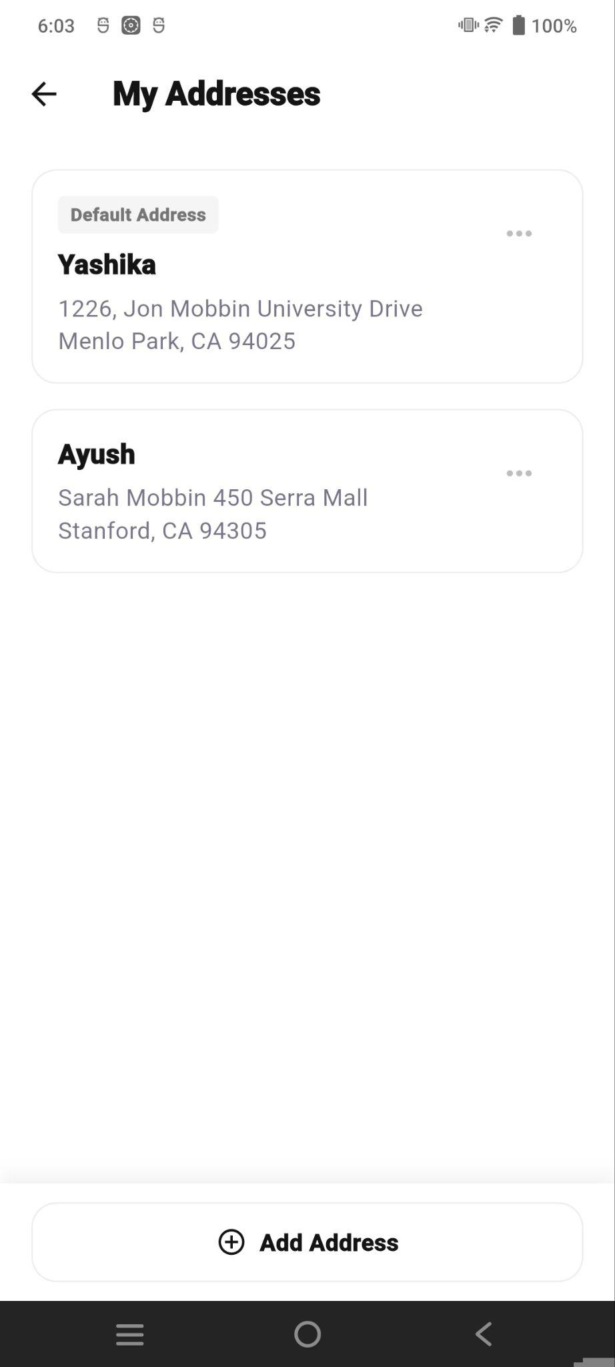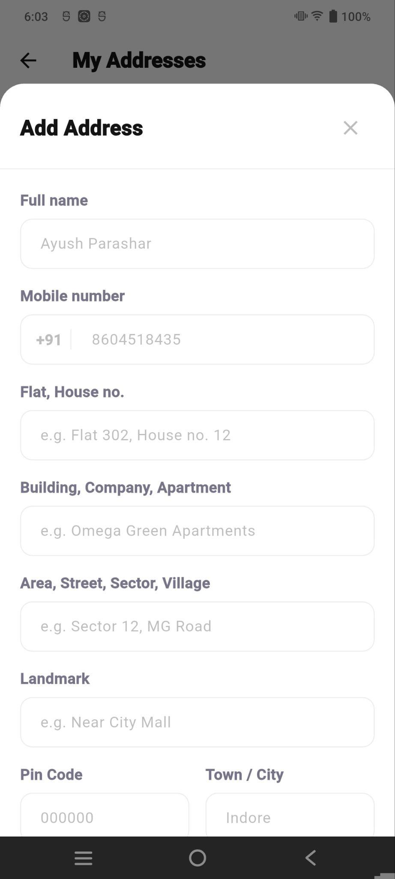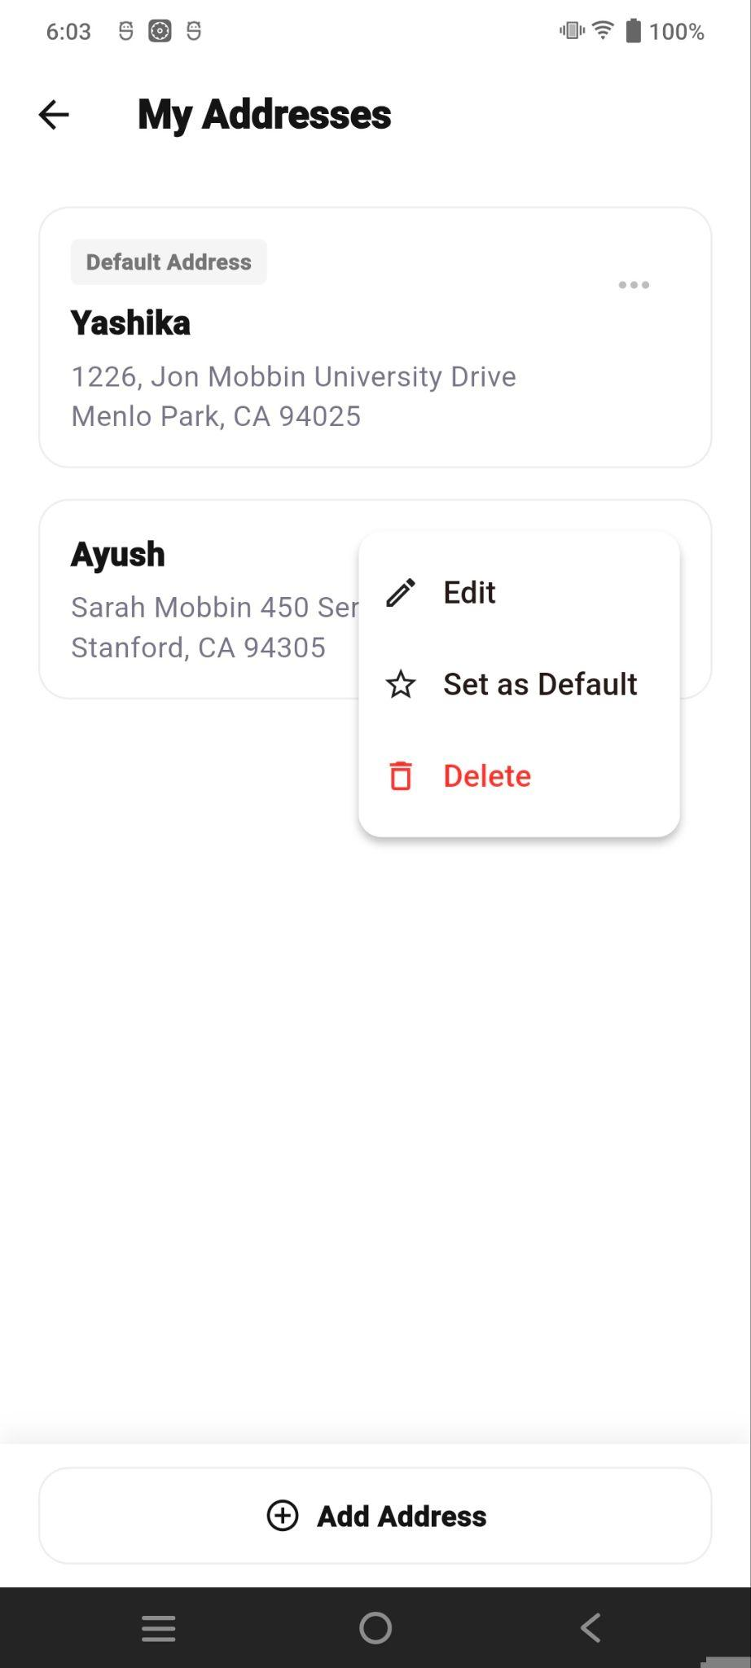

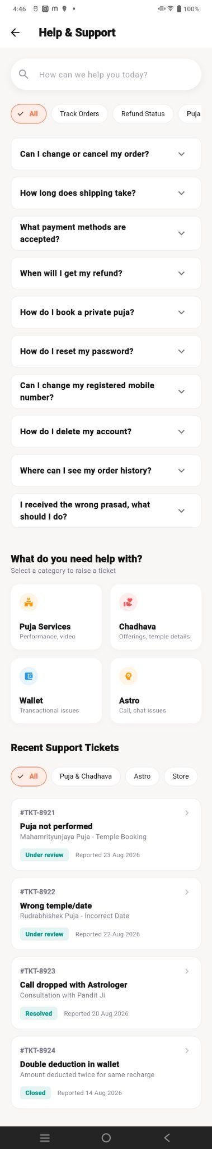
8. Help & Support
The Help & Support section provides users with assistance for common issues related to:
- Orders and payments
- Puja and Chadhava services
- Astrology consultations
- Store products
- Wallet and account-related issues
Users can also search FAQs, raise support tickets, and track recent support requests.

The Report an Issue flow allows users to report a problem with a Puja.
- Select Puja/ Chadhava / Wallet or Astro : Choose and proceed with the complaint.
- Resolution Options: Users can request a refund to the wallet, reschedule the consultation, clarification, or callback.
- Additional Notes: Users can add optional details about the issue.
- Confirmation: After submission, an “Issue reported” message confirms that the support team will review the request.

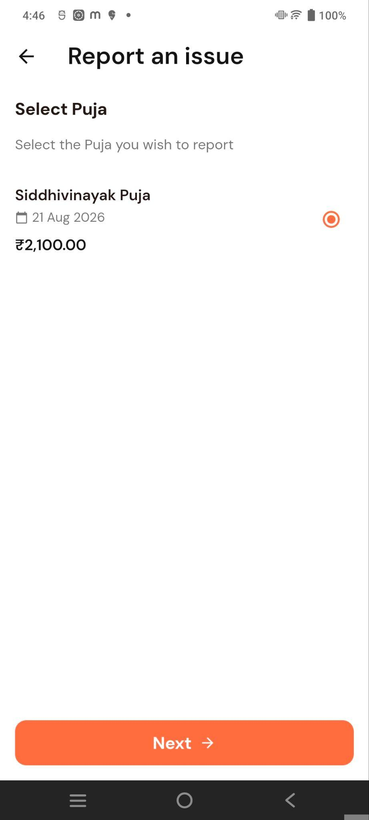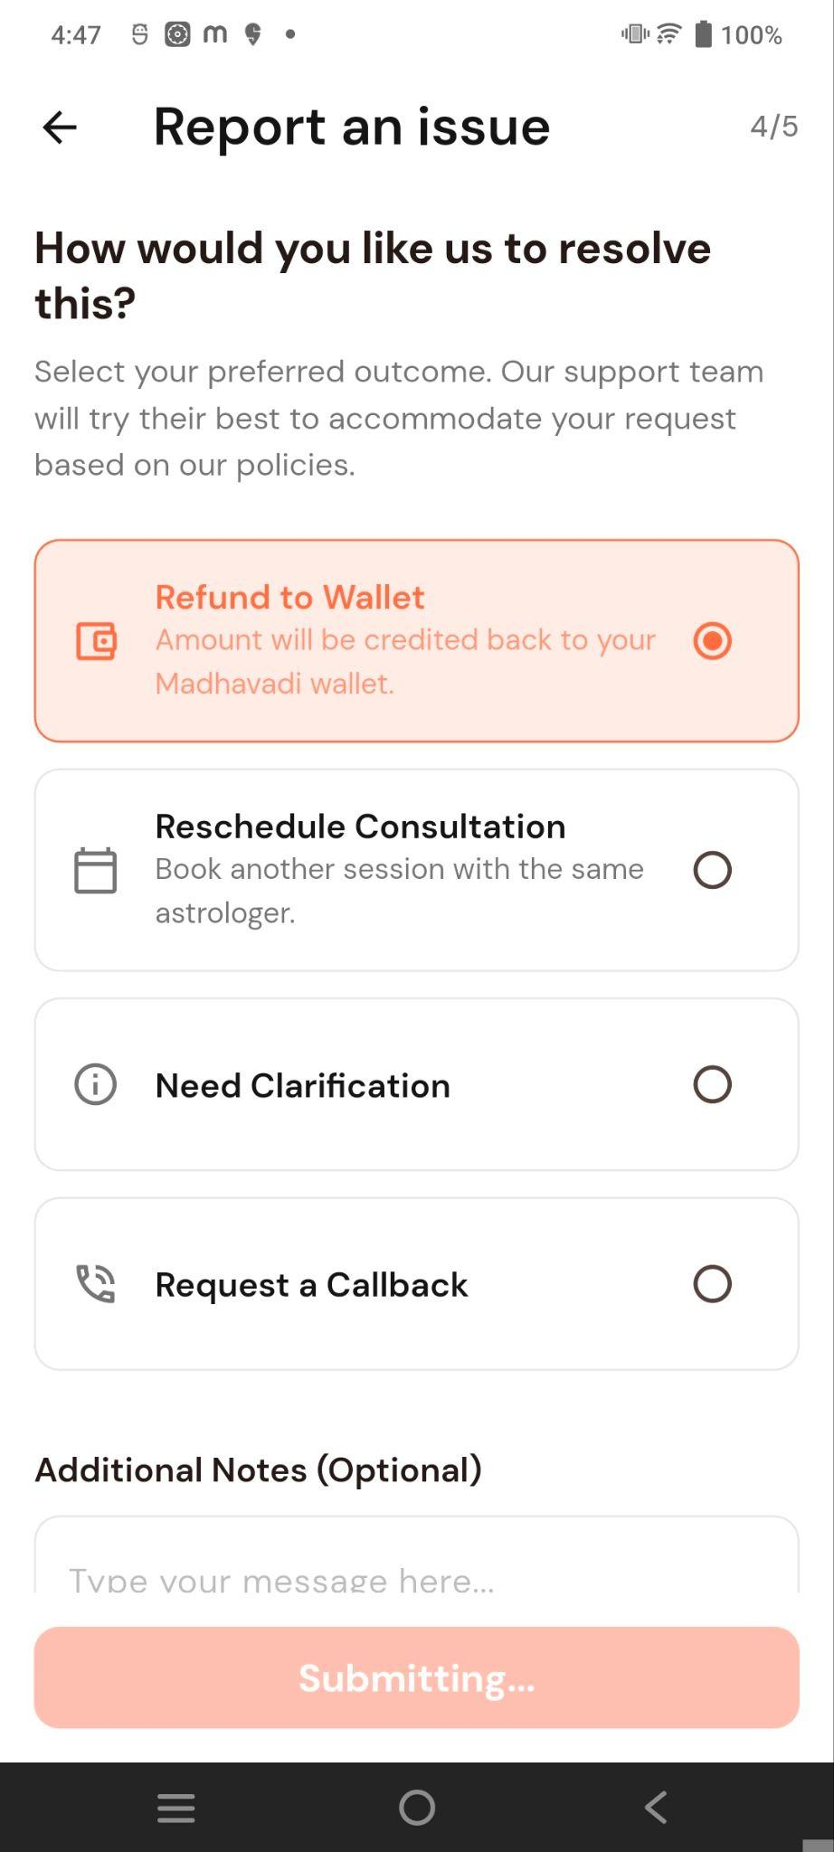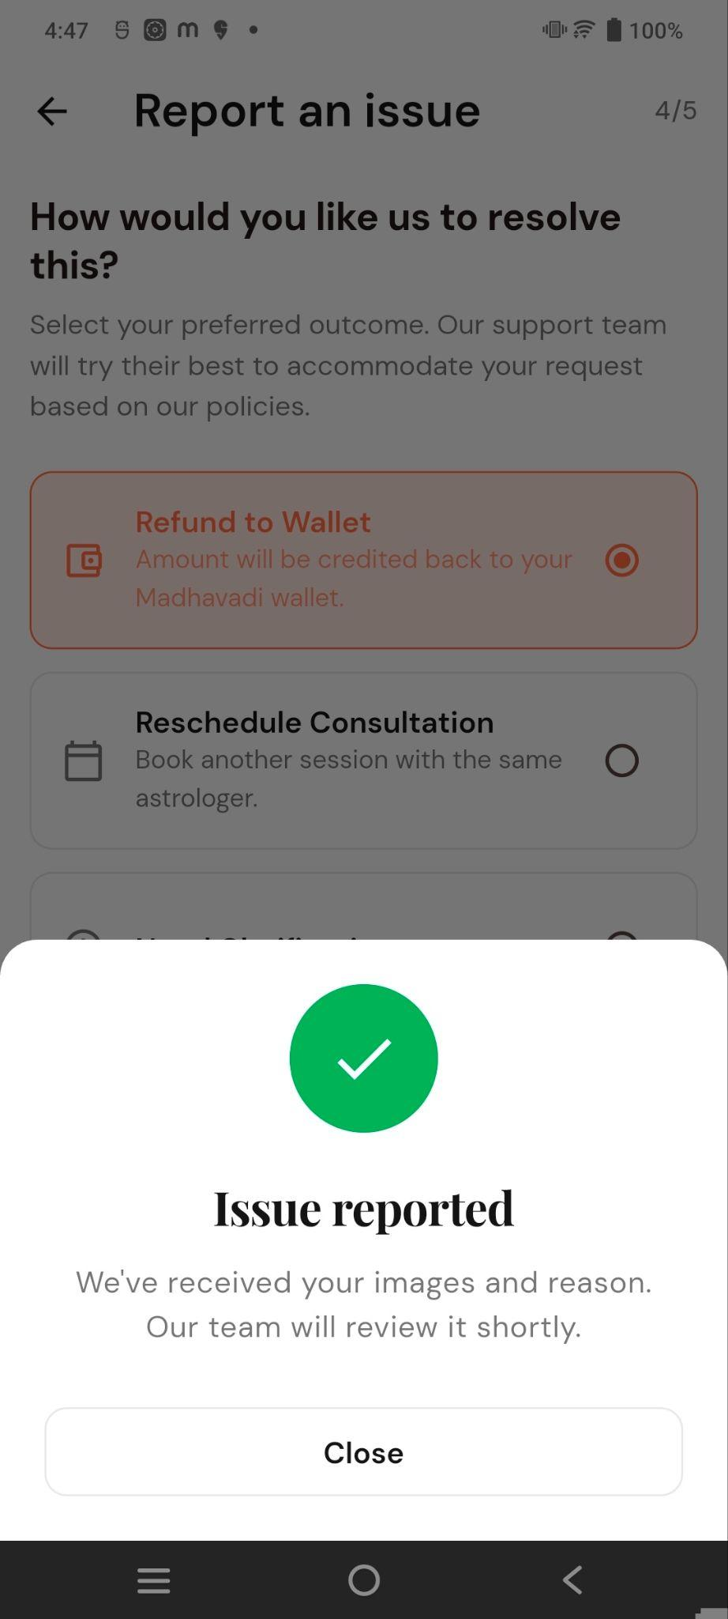

9. Language
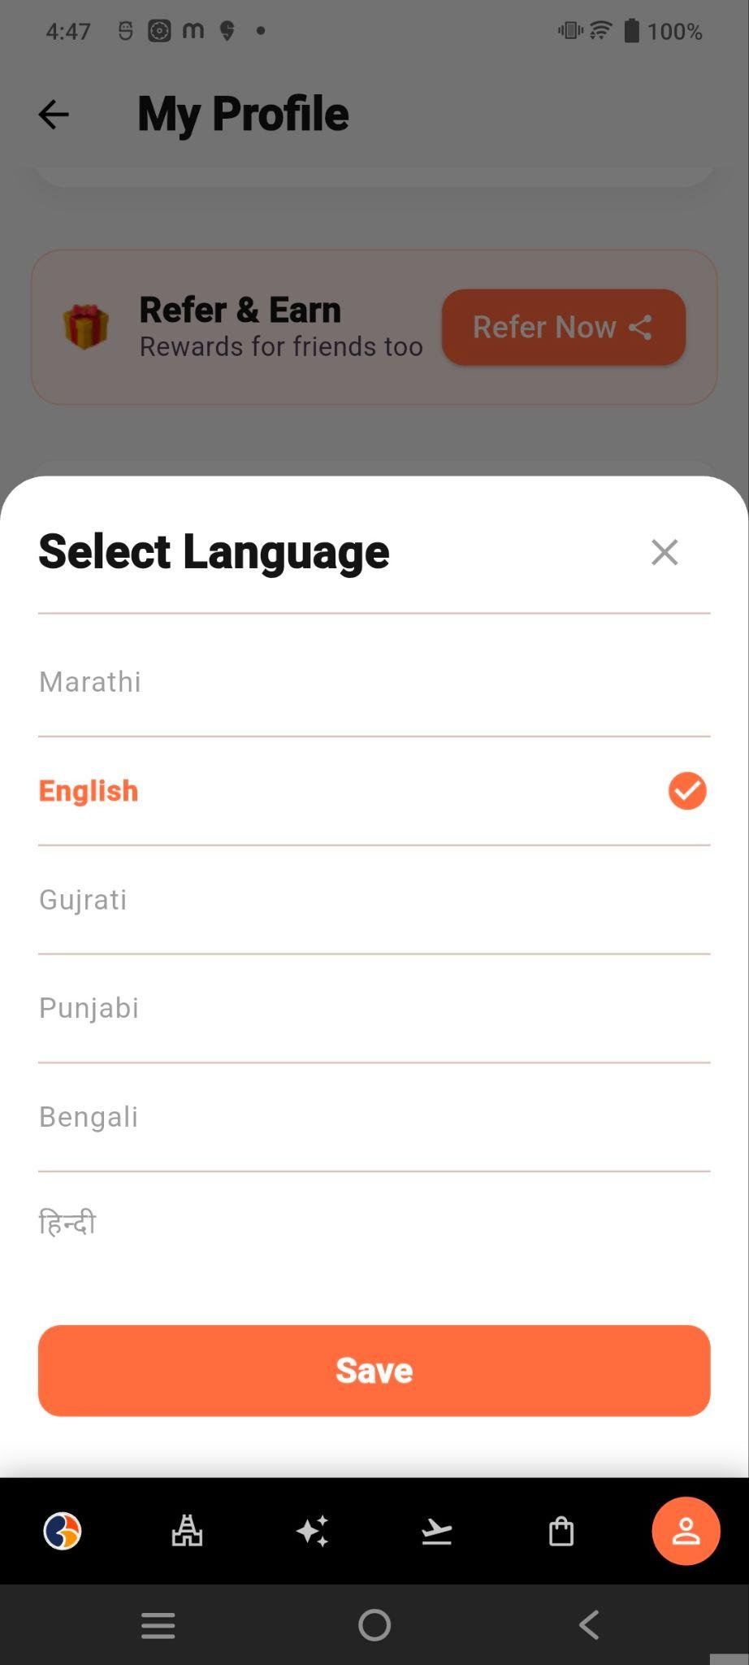
The language preference is displayed as:
Language : English
This option allows the user to change the application's supported language.
Selecting the option opens the available language selection screen.

10. FAQs
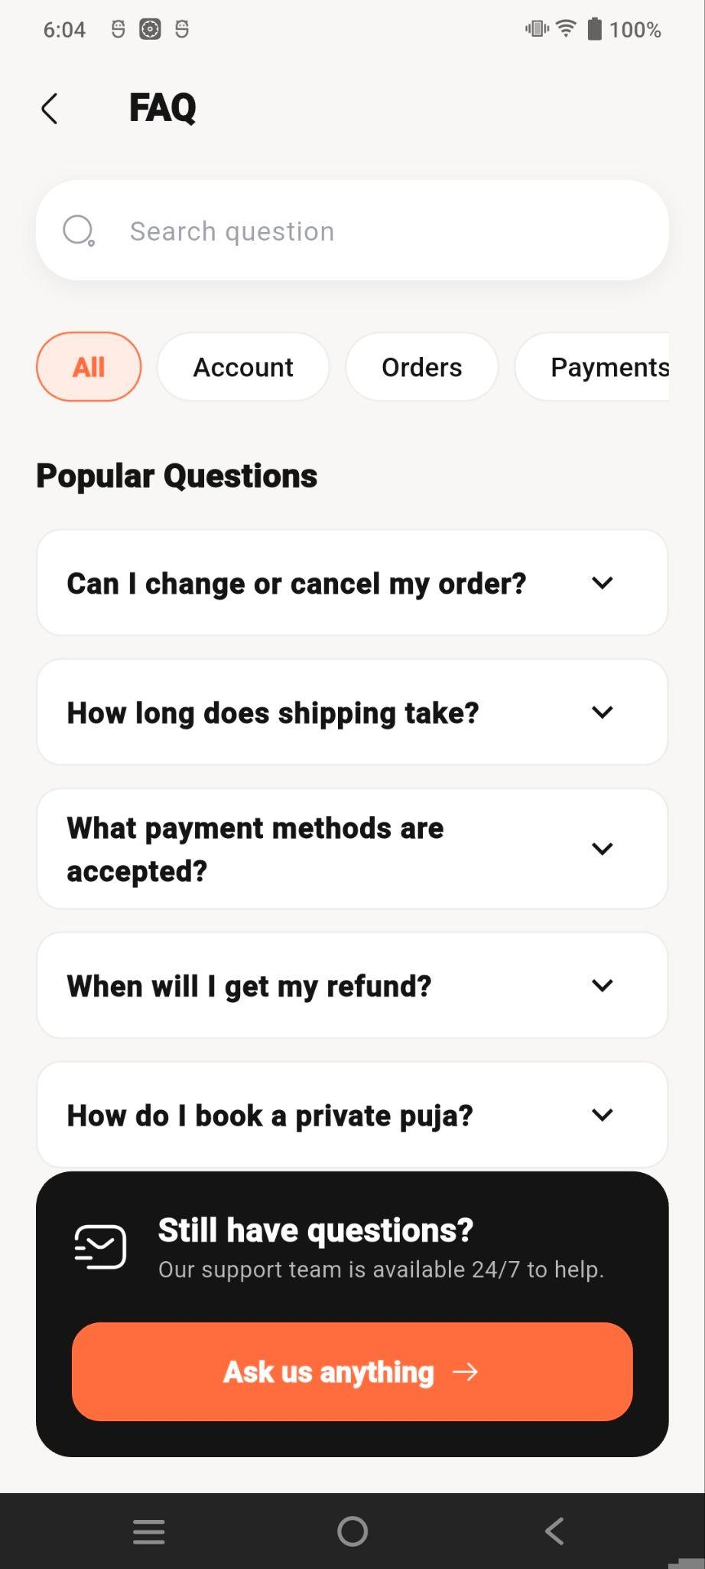
Selecting the FAQ option navigates to the FAQ screen.
The FAQs option provides access to frequently asked questions.
Users can find answers to common questions regarding application features, services, payments, orders, and account-related functionality.

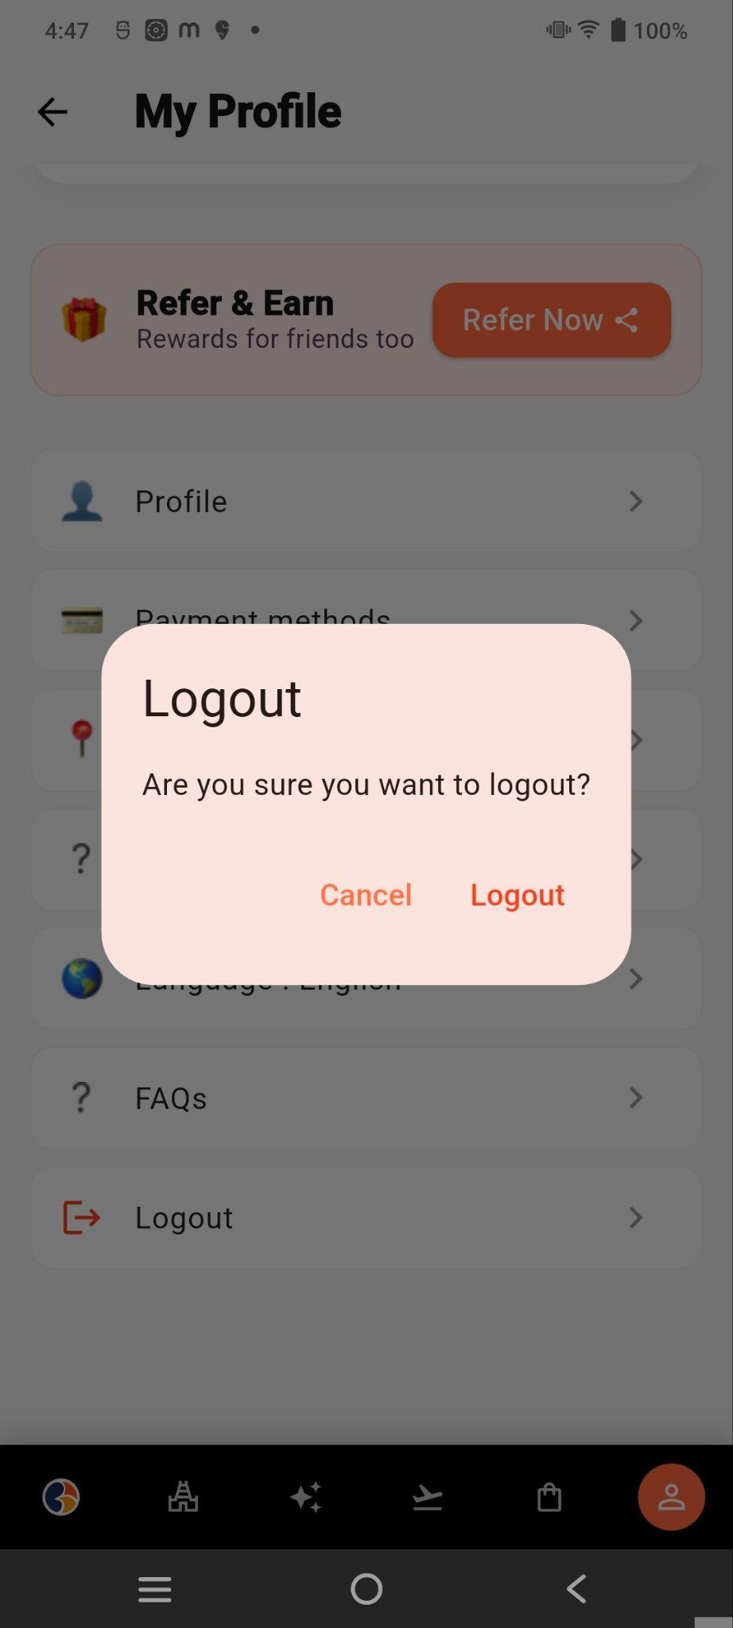
11. Logout

The Logout option allows the user to securely sign out of their Swadharma Super account.
Selecting Logout should end the current authenticated session and redirect the user to the appropriate login/authentication screen.

12. Bottom Navigation
A fixed bottom navigation bar provides quick access to the application's main modules.
The navigation includes:
- Home
- Puja / Temple
- Astro
- Teerth
- Store
- Profile
The Profile tab is highlighted because the user is currently on the My Profile screen.

13. User Flow
The main profile navigation flow is:
Profile → My Profile → Select Required Account Option
Examples:
My Profile → Profile → Profile List
My Profile → Wallet → View Wallet Balance/Transactions
My Profile → My Orders → View Order History
My Profile → Payment Methods → Manage Payment Methods
My Profile → My Addresses → Manage Delivery Addresses
My Profile → Help & Support → Get Assistance
My Profile → Language → Select Language
My Profile → FAQs → View Frequently Asked Questions
My Profile → Logout → Sign Out

14. Key Purpose of the Screen
The My Profile screen acts as the central account-management hub of the Swadharma Super application.
It brings together the user's personal information, wallet, vouchers, orders, referral program, payment methods, delivery addresses, support options, language preferences, FAQs, and logout functionality in one place.
The overall navigation structure is designed to provide users with quick and organized access to all account-related settings and services.

Login & Signup
Login

Users can log in using their mobile number. An OTP/6-digit verification code is sent to the registered number, which is entered to verify the user and access the account.
- Login Required for Booking – Users must log in before proceeding with any booking or participation. If the user is not logged in, a login bottom sheet is displayed.
- Login Required to Access Personal Details – Users must log in to view or manage their personal details.

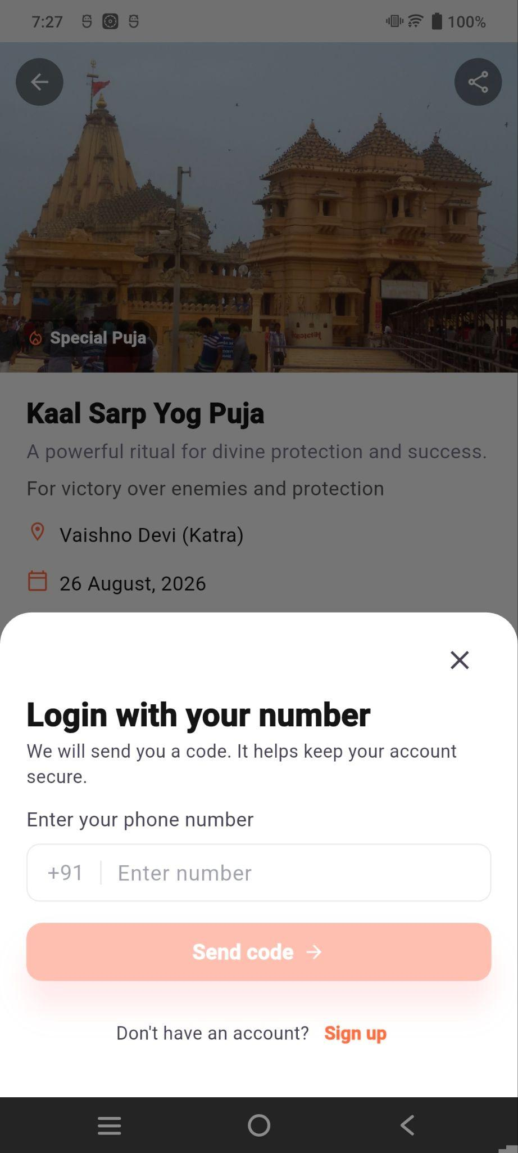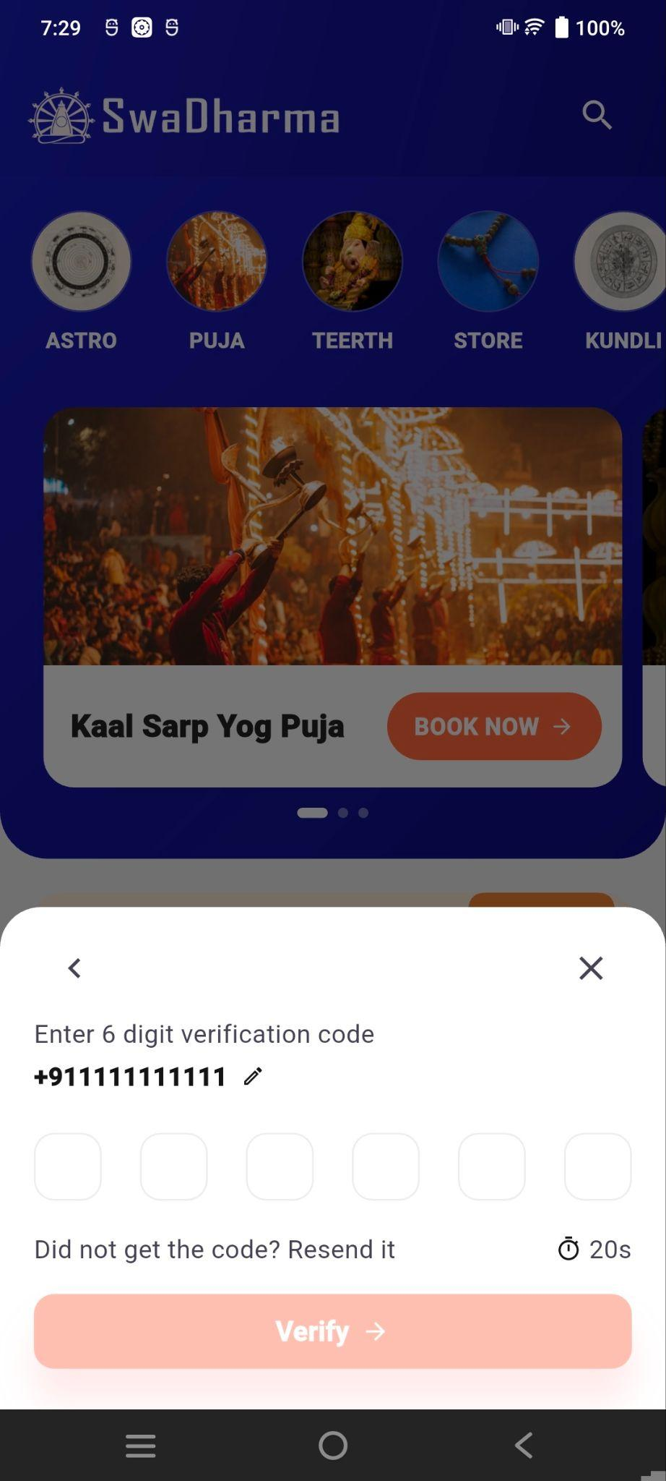

Signup

New users can create an account by entering their first name, last name, gender, date of birth, birth time, birth place, and mobile number. After mobile number verification through OTP, the account setup is completed.

