
UNIVERSITY OF HERTFORDSHIRE
SCHOOL OF PHYSICS, ENGINEERING AND COMPUTER SCIENCE
MSc. COMPUTER NETWORKS AND SYSTEMS SECURITY
7COM1039-0109-2023 - Advanced Computer Science Masters Project
Performance Analysis between Ensembled and Fusion Models in Phishing URL detection
18/08/2024

Name | : | RAHUL DAS KUNNUMPURATH RAMADAS
Student ID | : | 21060535
Supervisor | : | TAMIE SALTER

MSc Final Project Declaration

This report is submitted in partial fulfilment of the requirement for the degree of Master of Science in MSc. Computer Networks and Systems Security at the University of Hertfordshire (UH).

It is my own work except where indicated in the report.

I did not use human participants in my MSc Project.

I hereby give permission for the report to be made available on the university website provided the source is acknowledged.

Acknowledgement
I would like to express my deepest gratitude to my Module Leader Mrs. Bente Riegler for her support in successful completion of the project. I am profoundly grateful to my supervisor Mrs. TAMIE SALTER, whose advice, patience, and knowledge were much needed during this effort. Your insightful feedback and unwavering support have greatly influenced my work and my progress as a researcher.
I am also indebted to my Family, Friends and my Colleagues for their valuable support and love which motivated and inspired throughout this journey.

Abstract
As phishing attacks increase, it has become imperative to detect malicious URLs for security purposes. This study fills the gap regarding the detection mechanisms by assessing numerous ensemble and fusion models with a purpose to improve phishing URL recognition. In this research, we assess the efficiency of the ensemble and fusion models for the detection of the phishing URLs from a large dataset obtained from Kaggle containing 549,346 records. Random Forest, AdaBoost, Gradient Boosting and their hybrids are used in the research to evaluate the machines’ phish URL detection capability. The preprocessing included imputation, conversion of categorical data into numerical values, normalization of text into a format suitable for analysis by natural language processing, transformation of the data into term frequency-inverse document frequency vectors, and through principal component analysis followed by linear discriminant analysis. These were accuracy, precision, recall, and F1 Score. Thus, analysis shows that Random Forest outperforms all models in terms of accuracy, precision, recall, and F1 score of 0.87. Gradient Boosting was next with stable metrics pegged at 0.84. AdaBoost reached 0.82. The fused model was better than the individual models, and Random Forest combined with Gradient Boosting was the best with the accuracy of 0. 85. Nevertheless, Random Forest outperformed the other models in doing a better job in identifying the presence of phishing URLs.

Table of Contents
Acknowledgement 3
Abstract 4
1 Introduction 9
1.1 Overview on phishing attacks 9
1.2 Role of ensembled learning 10
1.3 Problem Statement 10
1.4 Scope 11
1.5 Aim 11
1.6 Objectives 12
1.7 Research Questions 12
1.8 Feasibility of the study 13
1.9 Structure of the project 14
2 Literature Review 15
2.1 Phishing URLs and their Negative Effects 15
2.2 Techniques used for Phishing URL detection 15
2.3 Related Work on Phishing URL detection using Machine Learning 16
2.4 Limitations and areas for improvement in existing research 22
2.5 Identified research gap 22
2.6 Summary 23
3 Methodology 24
3.1 Research Method 24
3.2 Dataset Chosen for the Research 25
3.3 Choice of Methods 26
3.4 Ensembled Models 26
3.4.1 Random Forest 26
3.4.2 Ada Boost 27
3.4.3 Gradient Boost 28
3.5 Evaluation metrics 29
3.5.1 Confusion matrix 29
3.6 Ethical Issues 30
3.7 31
3.8 Risk Management 31
3.9 Summary 32
4 Experiments and Results 33
4.1 Dataset on Phishing Site URLs: Gathering and Overview 33
4.1.1 Null Values in the Dataset 33
4.1.2 Initial Label Distribution and Encoding Impact 34
4.1.3 Handling Duplicates in Dataset 35
4.2 Updated Label Distribution and Visualization 35
4.3 NLP Techniques Applied to Clean Data 36
4.4 Sample Balancing for Phishing URL Detection 37
4.5 Feature Extraction and Data Preprocessing for the Detection of Phishing URLs 37
4.6 Ensemble Learning Algorithms in Phishing URL Detection 38
4.6.1 Applying Random Forest and Evaluating Its Results 38
4.6.2 Applying AdaBoost and Evaluating Its Results 40
4.6.3 Applying Gradient Boosting and Evaluating Its Results 42
4.7 Fusion Models in Phishing URL Detection 44
4.7.1 Combined Random Forest and AdaBoost - Fusion Model 1 44
4.7.2 Combined Random Forest and Gradient Boosting - Fusion Model 2 46
4.7.3 Combined AdaBoost and Gradient Boosting - Fusion Model 3 48
4.8 Summary 50
5 Results 51
5.1 Comparison of the Results 51
5.2 Research Findings 53
5.3 Comparison with other research work 53
5.4 Technical Challenges in this Research 54
5.5 Summary 54
6 Conclusion 55
7 Evaluation 57
7.1 Future Enhancement 57
8 References 59
8.1 Appendices 63

List of tables
Table 1 Related work on phishing URL detection using machine learning 20
Table 2 Performance metrics of Random forest in classifying URLs 37
Table 3 Performance metrics of AdaBoost in classifying URLs 40
Table 4 Performance metrics of Gradient Boosting in classifying URLs 41
Table 5 Performance metrics of Combined Random Forest and AdaBoost in classifying URLs 44
Table 6 Performance metrics of Combined Random Forest and Gradient Boosting in classifying URLs 46
Table 7 Performance metrics of Combined AdaBoost and Gradient Boosting in classifying URLs 48
Table 8 Results of Ensemble learning algorithms and fusion models in phishing URL detection 50

List of figures
Figure 1 Correct Classification Rates of Various Models (Ali, 2017) 16
Figure 2 Datasets used (Korkmaz, Sahingoz and Diri, 2020) 17
Figure 3 Testing Results (Almomani et al., 2022) 19
Figure 4 F1 score of Phishtank (Yang, Zhao and Zeng, 2019) 19
Figure 5 Research workflow 24
Figure 6 A diagram of the RF method (Fu and Qi, 2022) 26
Figure 7 Framework of the AdaBoost algorithm (Son and Yang, 2022) 27
Figure 8 Illustration depicting the gradient boosting (Lu et al., 2021) 27
Figure 9 Confusion matrix (Ibrahim Youssef and Fathalla, 2023) 28
Figure 10 Assessment Metrics (Dritsas and Trigka, 2022) 29
Figure 11 Identified Null values in the data 33
Figure 12 Before Label Encoding 33
Figure 13 After Label Encoding 33
Figure 14 Identified Duplicates in the data 34
Figure 15 Visual distribution of good and bad labels 35
Figure 16 Balanced Good and Bad Samples in Phishing URLs 36
Figure 17 Partitioned data samples 36
Figure 18 Validation Confusion Matrix of Random Forest 38
Figure 19 Test Confusion Matrix of Random Forest 39
Figure 20 Validation Confusion Matrix of AdaBoost 40
Figure 21 Test Confusion Matrix of AdaBoost 41
Figure 22 Validation Confusion Matrix of Gradient Boosting 42
Figure 23 Test Confusion Matrix of Gradient Boosting 42
Figure 24 Combined Random Forest and AdaBoost - Voting Classifier 43
Figure 25 Validation Confusion Matrix of RF and AB 44
Figure 26 Test Confusion Matrix of RF and AB 45
Figure 27 Combined Random Forest and Gradient Boost - Voting Classifier 45
Figure 28 Validation Confusion Matrix of RF and GB 46
Figure 29 Test Confusion Matrix of RF and GB 47
Figure 30 Combined AdaBoost and Gradient Boost - Voting Classifier 47
Figure 31 Validation Confusion Matrix of AB and GB 48
Figure 32 Test Confusion Matrix of AB and GB 49

Introduction
The use of web services has increased tremendously in the recent past because of the increased digitization. Services are being delivered online by businesses as e-banking, e-commerce, and SaaS (Software as a Service). Phishing attacks are a common form of cyber threat, exploiting human trust to compromise security. This has been further exacerbated by the COVID-19 pandemic, which has resulted in the transition of millions of workers, pupils, and instructors to remote operations through the use of the work-from-home model. These URLs typically resemble those of trusted entities but may have subtle differences, such as misspelled domain names or added characters. Once a user clicks on a phishing URL, they may be directed to a fraudulent website that mimics the appearance of a real one, where they are prompted to enter personal information. The goal of phishing URLs is to exploit trust, leading to unauthorized access to accounts, financial loss, or identity theft. Being vigilant and recognizing suspicious URLs is crucial to protecting against phishing attacks. This has resulted in a significant amount of stress on services such as email, student platforms, VPNs, and corporate portals, which have given phishers additional targets to exploit (Aung, Zan, and Yamana, 2019).

Overview on phishing attacks
Phishing attacks are the process by which a malicious website mimics a genuine one in order to acquire user names and passwords and payment information. Phishing is reported to be one of the most common social engineering threats in the current pandemic period, together with spam emails and the websites that are used to facilitate such attacks (Venkatesha, Reddy and Chandavarkar, 2021). Particularly in 2020, there has been an increase in the number of phishing attacks. In response to the COVID-19 pandemic, numerous government departments have implemented financial assistance programs. Cybercriminals employ phishing to obtain confidential personal information in order to, for example, defraud the government by applying for unemployment benefits.
The spoofing network was the most frequently reported type of cyber-attack that the U.S. public lodged complaints about in 2020. Moreover, the APWG phishing activity trends report for 2020 indicates that the frequency of phishing attacks nearly doubled throughout the year (Pujara and Chaudhari, 2018). It is now impossible to identify phishing sites by using only the HTTP protocol as was done in the past. The most popular one is the list-based approach that allows checking URLs against the data base of the known phishing websites. Some of the well-known are Google Safe Browsing, PhishTank, OpenPhish, and SmartScreen (Zieni, Massari and Calzarossa, 2023). If the URL that is requested by the user is present in the database, then the access is denied and a warning message is shown to the user. But there are some problems with this approach. It cannot identify a new unseen phishing URL, and needs frequent updates with the new set of phishing URLs. These limitations have however led to the implementation of machine learning techniques for the automatic detection of phishing URLs as an area of interest (Tang and Mahmoud, 2021). These methods have the possibility of solving the shortcomings of the conventional approaches based on the analysis of the URL data.

Role of ensembled learning
Ensemble learning, which uses a set of models to make a prediction, is the basis of the present research. Specifically, Random Forest, AdaBoost, Gradient Boosting are used as single learning algorithm ensembles. Random Forest works in the similar way to build multiple Decision trees and then either takes the mean or median of the result of the individual Decision trees (Sindhu et al. , 2020). AdaBoost for example builds models successively and with the next consecutive build, it samples the misclassified examples with high weights. It constructs new models on the data to correct the mistakes of the previous models in the form of boosting – gradient boosting (Shahrivari, Darabi, & Izadi, 2020).
In this research work, both ensemble and fusion methods have been employed for the enhancement of the detection of phishing URLs. For further improvement of the above ensemble models, an effort has been made to develop fusion models using these techniques. This is done whereby a number of models are integrated into a single model to enhance the performance of each of the models. For instance, the integration of Random Forest with Gradient Boosting makes an attempt to have Random Forest’s non-interpretable aspect and Gradient Boosting’s improved accuracy.

Problem Statement
Phishing attacks are one of the most common cyber threats facing internet users, leading to the need for robust and accurate detection mechanisms and the attackers are employing ever more creative techniques to lure the users to reveal their data (Alkhalil et al. , 2021). The conventional techniques such as blacklisting and heuristic analysis are however insufficient because they work on the basis of patterns of the phishing URLs while they are susceptible to the evasions. The more complex approaches such as machine learning algorithms shall process the data with an aim of identifying such hidden relations that are present in the data and come up with models that are capable of identifying the signs of phishing in advance (Alabdan, 2020). Therefore, the present research is centred on fusion models that encompass the characteristics of three primary ensemble techniques; Random forest, AdaBoost, and Gradient boost. It is thus expected that the use of two or more models should provide more accuracy and reduced false positives than each of the single ensemble models under this fusion strategy. This study will provide a broad, detailed, and presumptively less incorrect and time-consuming method of identifying phishing URLs than previous research and is largely elastic due to the highly dynamic threat posture of cyber space.

Scope
The objective of this study is to conduct a systematic review of ensemble and fusion approaches devoted to phishing URL detection. The following areas of interest are selected for the analysis of the research: comparing RF, AdaBoost, and GB in terms of performance of these algorithms individually, and also as the individual components of fusion models. The research will apply a very rigorous assessment criterion to the models; it will feed the Kaggle phishing dataset to train and test the models on. The performance of all the presented models will be evaluated operating the accuracy measure, the precision measure, the recall measure and the F1 measure which will show the level of efficiency of the classification of the given URL into the legitimate or the phishing. As a result, this research will strive to compare the performance of the ensemble and the fusion models with the aim of identifying which of the two can be recommend for use to enhance the efficiency of the phishing URL detection mechanism besides enhancing the development of more efficient cybersecurity measures.

Aim
The aim of this research is to assess the performance of the ensemble models in contrast to the fusion models for the detection of phishing URLs. The results will be measured based on accuracy, precision, recall, F1-score for each individual ensemble approach, and the three fusion techniques. The research seeks to compare the performance of fusion and ensemble models on the given dataset to determine whether fusion techniques can enhance the accuracy and reliability of the predicting of phishing URLs than the individual ensemble models, focusing on evaluating their accuracy, robustness, computational efficiency, and applicability across different scenarios. This analysis will reveal which of the models or their combinations is the most suitable for the practical application in phishing URL detection within the cybersecurity domain.

Objectives
- To conduct a thorough background research on phishing URLs and their negative effects, various techniques used for Phishing URL detection and latest researches carried out in this field using ML.
- To collect and preprocess the Phishing Site URLs dataset from Kaggle to remove any inconsistencies.
- To implement and evaluate the performance of Random Forest, AdaBoost, and Gradient Boosting algorithms for phishing URL detection using the Kaggle phishing dataset.
- To develop and assess the effectiveness of fusion models combining Random Forest, AdaBoost, and Gradient Boosting (Random Forest + Gradient Boost, AdaBoost + Gradient Boost, Random Forest + AdaBoost + Gradient Boost) in improving phishing URL detection accuracy.
- To compare the performance of ensemble and fusion models based on metrics such as accuracy, precision, recall, and F1-score.
- To Determine which strategy is more feasible in which context by analysing its computing complexity and resource requirements.
- To Provide useful suggestions, adapted to different application scenarios in phishing URL detection, for selecting between Ensembled and Fusion Models based on the study.
- To identify the most suitable model or combination of models for practical phishing URL detection applications.

Research Questions
This project is motivated by the following research questions.
- What is the impact of combining ensemble models into fusion models (Random Forest + Gradient Boost, AdaBoost + Gradient Boost, Random Forest + AdaBoost + Gradient Boost) on phishing URL detection performance?
- What are the main factors that affect Ensembled Models and Fusion Models performance in real-world situations, and how do they differ in terms of effectiveness, efficiency, and adaptability in detecting phishing URLs?
- How do ensemble models (Random Forest, AdaBoost, Gradient Boosting) compare in detecting phishing URLs when applied to the Kaggle phishing dataset, in terms of accuracy, precision, recall, and F1-score?
- Which ensemble or fusion model demonstrates the highest overall performance in detecting phishing URLs?

Feasibility of the study
The overall feasibility of this research project is high due to the existence of open-source machine learning frameworks and the availability of the Kaggle phishing dataset. The project uses well known ensembles algorithms: Random Forest, AdaBoot, Gradient Boosting which are most effective in classification. Thus, it is quite reasonable to also consider applying fusion models that include these techniques – as part of further investigations of possible enhancements to the context of phishing URL detection. The method of research is literate and specific, with direct comparison being made through quantitative metrics, including accuracy, precision, recall, as well as an F1-score. Furthermore, the project tackles one of the most significant problems of cybersecurity, which will make the project rather relevant and useful. The existence of computational resources as well as the previous work on the detection of phishing and ensemble learning makes the proposed project realistic and more useful in deriving solutions for improving cybersecurity systems.

Structure of the project
Chapter 1 outlines the background to the study, the problem area, the extent of the study, the purpose of the study, the objectives, and research questions of the study. Chapter 2 provides an overview of the related work; the analysis of the literature looks at the impact of phishing URLs as well as the techniques used for detection, and presents machine learning work related to the subject and the remaining gaps for further research. Chapter 3 defines the Research Methodology and data, the Ensemble models used-Random Forest model, AdaBoost, Gradient Boost and the measurements of assessment. Chapter 4 is devoted to the experiments and results of the work, which outlines the data preprocessing, the NLP techniques used, the evaluation of both ensemble and fusion models. The final results are presented in Chapter 5. Last, Chapter 6 summarizes the study and offers comparisons followed by prior studies and descriptions of the technical difficulties experienced, and Chapter 7 offer understanding on the Evaluation process that was useful in the research.

Literature Review
Phishing URLs are malicious links designed to mimic legitimate websites, tricking users into revealing sensitive information like passwords, credit card details, and personal identity. Machine learning models have demonstrated potential in identifying phishing URLs in recent years. Among them, Bagging and Boosting models have become the most well-liked methods for enhancing detection accuracy, for their ability to enhance predictive performance by combining multiple models or features. The chapter below gives a detailed view on various methods used for phishing URL detection from previous studies.

Phishing URLs and their Negative Effects
Phishing URLs are the fake website links that look like the genuine ones and are a major concern in terms of cyber security. These are links that are intended to deceive the user into sharing their information like usernames and passwords, credit card information or even their identity (Aung, Zan and Yamana, 2019). The impacts of phishing attacks are damaging and pervasive; hence, they need to be addressed. These can result in identity theft through which criminals use the victims’ identities to accomplish their objectives including financial gains. It should also be noted that financial scam is another frequent outcome, which leads to unauthorized transfers and significant material damages to clients and companies. The losses from phishing can affect the whole system and result in leakage of data and further more severe security threats (Mowar and Jain, 2021). Also, phishing attacks lead to the loss of confidence by users in the digital platforms and online services to an extent that they are reluctant to engage in e-commerce or online banking services. These kinds of losses of self-confidence can have economic implications that are felt more widely. For companies, it means that they lose customers’ trust and suffer from business damage as well as legal consequences. The gains of undoing phishing attacks also have their price in terms of costs to be incurred in fixing the system, upgrading the security and in some cases being on the wrong side of the law. Also, phishing enhances the vulnerability of the digital environment and demands time and investment in cybersecurity efforts (Isakov et al., 2024).

Techniques used for Phishing URL detection
Current methods for detecting phishing URL include blacklisting, heuristic analysis and DNS filtering however these methods have some constraints including: delayed updates, techniques used by phishing web developers to evade detection and production of false alarms. Blacklisting, despite being helpful in identifying and preventing already recognized threats, is not very useful when it comes to the detection of new URLs (Bell and Komisarczuk, 2020). Practically all approaches that rely on URL patterns or site content for heuristic analysis produce false positives, that is, they classify legitimate sites as dangerous. DNS filtering can prevent a user from visiting phishing domains but the list needs to be regularly updated and can be easily avoided by the attackers (Islam et al., 2023). To overcome these drawbacks, several enhanced techniques with the use of artificial intelligence have been developed. These techniques analyze large volumes of the data about URLs, content of the websites, and user behavior to discover the patterns, which are characteristic of the phishing attacks. Machine learning algorithms like Random Forests, Support Vector Machines and Neural Networks are used to train a model with a large number of legitimate as well as phishing URLs to be able to learn the complex decision boundaries to classify future URLs (Ahammad et al., 2022). This approach has more freedom and higher efficiency of phishing detection and the ability to grow and evolve due to the advancement of phishing threats, which makes this method more powerful and efficient when it comes to combating these threats.

Related Work on Phishing URL detection using Machine Learning
In this research by (Ali, 2017), the approach that is used is a subset of machine learning known as the supervised ML and for the best features the wrapper filter has been used to classify the given web address as phishing or not. For the purpose of selecting the most important features that could be used in the successful classification of the phishing websites, the technique of features selection known as Wrapper-based approach was adopted. These include; a) ANN models –BPNN, RBFN, b) Supervised learning-SVM, c) Un-supervised learning-NB, d) Decision trees – C4.5, RF and KNN. From the experimental results the present study revealed that the BPNN, kNN and RF gave the highest correct classification rate (CCR) to detect the phishing websites whereas RBFN and NB gave the lowest CCR. Additionally, the machine learning classifiers that utilized wrapper-based feature selection outperformed those that employed PCA and IG as methods for choosing features.

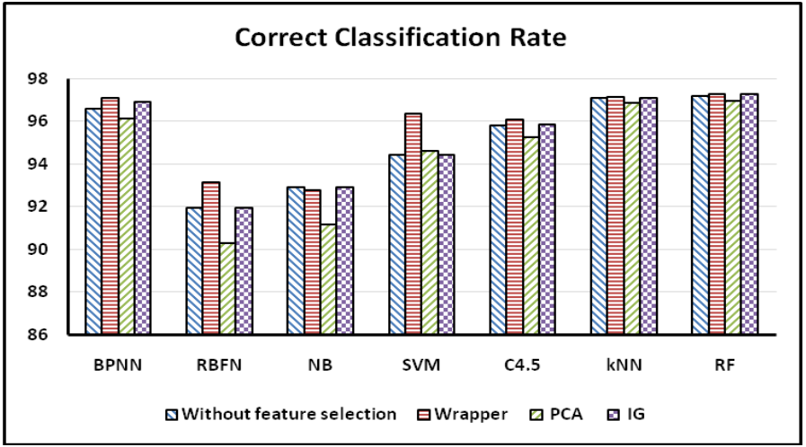
Figure 1 Correct Classification Rates of Various Models (Ali, 2017)
In this research (Sahingoz et al., 2019), the authors proposed and evaluated a phishing detection system with seven different ML algorithms namely DT, Adaboost, K-star, kNN (n=3), RF, SMO and NB and different number/types of features that include NLP based features. The authors divided the feature list into two categories to enhance the accuracy of the detection system; NLP based features that are manually extracted features, and word vectors that are based on the words in the URL and no further processing has been done. Since there is no standard and widely accepted dataset for the evaluation of phishing systems, the authors developed their own dataset with 73,575 links. This set has 36,400 legitimate URLs and 37,175 phishing URLs.
From the obtained results, it can be concluded that the features derived from the NLP outperform the word vectors with the average improvement rate of 10. 86%. Furthermore, it has been noted that using NLP-based characteristics in addition to word vectors improves the efficiency of the system being suggested by 2.24% based on NLP-based features and 13.14% based on word vectors. The qualitative results with the classification algorithms, where Random Forest was used depended only on the NLP-based characteristics, indicate the highest possible accuracy of 97%. The classification accuracies achieved are 98% for identifying phishing URLs.
In the study of Korkmaz et al. (2020), eight different algorithms have been used in the assessment of URLs; The results with three different datasets have been compared with the previous studies in order to establish an existence of an effective artificial intelligence based solution for the prevention of phishing attempts. Classification methods included are Logistic Regression (LR), K-Nearest Neighbors (KNN), Support Vector Methods (SVM), Decision Trees (DT), Naïve Bayes (NB), eXtreme Gradient Boosting (XGB, Random Forest (RF) and Artificial Neural Networks (ANN). Taking into account the values deriving from all the three data sets within this study, it is possible to state that the test results for 48 attributes are considerably higher. In addition, the model which was created with the help of the RF classifier had the best test classification rate 91.26%. NB, DT, LR and ANN shown the better training time than other models. Comparing RF and ANN; two of the best performing models, training of RF takes longer time compared to the training of ANN. Thus, the scientists determined that Artificial Neural Network (ANN) is the most appropriate choice for the phishing detection system.

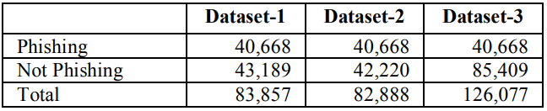
Figure 2 Datasets used (Korkmaz, Sahingoz and Diri, 2020).
(Zamir et al., 2020) provided the framework to employ stacking model in phishing websites detection. The analysis is carried out on a representative data set of phishing websites. This data set consists of 32 preprocessed variables and 11,055 web hit targets. In the given phishing data set, features are analyzed by employing the feature selection tools such as info gain, gain ratio, Relief-F, and recursive feature elimination (RFE). Two features are proposed, one that combines the best divergent attributes, the other that combines the worst attributes. Antecedent feature selection comprising of random forest [RF], neural network [NN], bagging, support vector machine, Naïve Bayes and K-nearest neighbour is done on proposed and remaining features through principal component analysis. Afterwards, two stacking models: Stacking1 (RF & NN & Bagging) and Stacking2 (kNN & RF & Bagging) are implemented through the combination of the highest score classifiers to enhances the classification efficiency. The results proved that RFE is useful in eliminating the feature with least importance in the data set.
Additionally, the Stacking1 (RF & NN & Bagging) had a better result in the classification of the phishing website with 97.4% accuracy.

Jain and Gupta (2019) proposed the new approach to combat phishing attacks and check the links in the HTML source of the web page. This proposed technique introduces a number of other hyperlink features for describing the identified phishing attacks. The methodology applied for the classification of the various aspects of hyperlinks include the following twelve categories in which the papers presented have been grouped: The authors proposed the suggested technique to identify the phishing websites, to assess the success rate of the technique they classified the datasets with classification algorithms for phishing and non-phishing sites. It works at the client’s end only and, therefore, does not require the application of other services. Moreover, the proposed method does not depend on language or script of the published web site and is able to identify sites in any written language. The proposed strategy seems to outperform the existing strategy in terms of the detection rate that stands at 98.4%.
To investigate semantic characteristics of the phishing websites, in their study (Almomani et al. , 2022), they used URL and domain identity, abnormal features, HTML and Java Script features, and domain features. Including all these specific features enhances the classification process in this approach. To this end, the authors have employed 16 machine learning models along with 10 semantic variables which are known to perform well for identifying phishing sites from two datasets. This paper analyses a range of classification algorithms in order to assess how well RF, CART, LR, SVM, NN, BART, and other AI algorithm models perform when it comes to phishing website prediction. The comparative conclusion shows that the proposed GB and RF Classifier achieved the highest accuracy, which is nearly 97 %. However, the lowest accuracy levels were recorded by Gaussian NB and the SGD classifier at 84% and 81% respectively, from the other approaches indicated below.

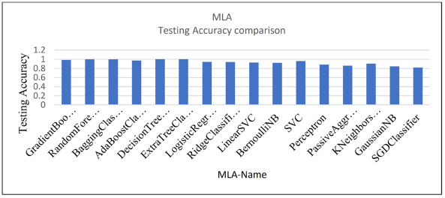 Figure 3 Testing Results (Almomani et al., 2022)
Yang, Zhao, and Zeng (2019) put forward a machine learning approach for identification of URLs in their research. In this paper, the detection of phishing URLs employ an LSTM approach which is a Recurrent Neural Network (RNN). The researcher employed a set of 7,900 malicous sites and 5,800 normal sites in order to assess the accuracy of the proposed approach. The efficiency of the described approach is higher than the efficiency of other methods when searching for such links: it is proved by the results of testing. The performance of the suggested URL detector is evaluated by the help of the AlexaRank portal and the set of phish-containing Phishtank dataset. It has given rise to higher accuracy and F1-score, but within a small time frame only. The LURL model achieved an F1-Score of 96.4 with a runtime of 4.62 seconds, as seen below.

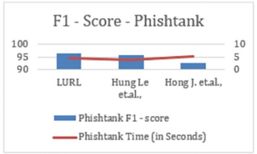
Figure 4 F1 score of Phishtank (Yang, Zhao and Zeng, 2019)

The summary of the above researches is tabulated as below.
Table 1 Related work on phishing URL detection using machine learning
Author | Objective | Techniques | Outcomes
Yang, Zhao and Zeng, 2019 | This research focus on URL detection method based on the machine learning approaches | LSTM | Attained a F1—Score of 96.4 in 4.62 seconds
Almomani et al., 2022 | This research used ML models in combination with semantic features that are deemed efficient for the identification of phishing webpages | RF, CART, LRF, SVM, NN, BART, GB | Gradient Boosting Classifier and the RF Classifier yielded the best accuracy, being about 97 %.
Jain and Gupta, 2019 | Proposed a new method that is capable of identifying the presence of a phishing attack by analyzing the hyperlinks that are located in the HTML source code of the website. | LR | More than 98.4% accuracy is achieved
Zamir et al., 2020 | This research provided the framework to employ stacking model in phishing websites detection. | Feature selection- info gain, gain ratio, Relief-F, and RFE  Algorithms: RF, SVM, NN, NB and KNN | RFE is useful in eliminating the feature with least importance in the data set. Additionally, the Stacking1 (RF þ NN þ Bagging) had a better result with 97.4% accuracy
Korkmaz, Sahingoz and Diri, 2020 | In this research, 8 different algorithms have been used to analyze the URLs and three different datasets have been used to compare the results with other works for proposing a ML-based phishing detection system. | LR, KNN, SVM, DT, NB, XGB, RF and ANN | RF classifier achieved highest accuracy of 91. 26%
Ali, 2017 | This research used supervised ML techniques with the best features extracted through the wrapper filter approach to classify the given web address as phishing or not. | BPNN, RBFN, SVM, NB, C4.5, RF, and kNN. | BPNN, kNN and RF provided the highest CCR

Limitations and areas for improvement in existing research
The current literature on the phishing URL detection mainly relies on machine learning with a focus on various algorithms and feature selection approaches. Previous works have investigated the use of supervised learning techniques like neural network, support vector machine, decision tree, and ensemble methods that are Random Forest and AdaBoost [Ali, 2017; Sahingoz et al., 2019; Korkmaz, Sahingoz, & Diri, 2020]. The feature extraction techniques used can be as simple as the URL-based features to the more complex ones such as the NLP-based features and the visual analysis methods [Jain & Gupta, 2019; Almomani et al., 2022]. Although one of these investigation has been utilizing stacking model (Zamir et al., 2020), the authors have not investigated the integration of the various ensemble methods (fusion models) for the improved identification of phishing attacks.

Identified research gap
The current work focuses on detecting phishing URLs, and several ML techniques like neural networks, support vector machines, decision trees, and ensemble methods namely: Random Forest and AdaBoost have been applied by researchers (Ali, 2017; Sahingoz et al. , 2019; Korkmaz, Sahingoz, & Diri, 2020). These studies have defined the feature extraction techniques from URL based simple features to NLP and visual feature extraction techniques (Jain & Gupta, 2019; Almomani et al. , 2022). But even then, the existing studies have significant deficiencies that should be acknowledged here. Most of the efforts have been focusing on a single model of machine learning or simple fusion techniques, while there is comparatively less investigation on the nature of improvement that can be obtained in a fusion scenario, by combining multiple ensemble techniques into a single fusion model (Zamir et al. , 2020). Despite the fact that there are some works which have employed the stacking models, there is a scarce research work that has tried to assess the efficacy of employing the multiple ensemble techniques jointly to enhance the accuracy of the detected phishing URL. In order to plug this gap, this research endeavors to benchmark the ensemble and fusion model and looks at the performance of the Random Forest, AdaBoost, Gradient Boosting singly and jointly. Thus, this research seeks to find out if it is possible to achieve better detection efficacy and reliability through fusion models than through the traditional methods in the assessment of the methodologies and techniques for the detection of phishing URLs.

Summary
This chapter has presented a survey on the machine learning approaches for the identification of phishing URLs and has stressed the fact that ensemble models which include Random Forest, AdaBoost, and Gradient Boosting perform well. Specific research questions included the lack of research on combinations of multiple ensembles and their integration into fusion models for better accuracy and it aspired to fill these gaps through a systematic and comparative approach.

Methodology
This chapter presents the rationale and methodology of the research as well as the technical procedure in handling ensemble and fusion models of identification of phishing URLs. It also describes the data set on which the analysis has been accomplished and feature selection and extraction method where it has been used within the intent of the analysis along with the machine learning algorithms that has been discussed in the intent of analysis namely Random Forest Algorithm, AdaBoost Algorithm, Gradient Boosting Algorithm. In addition, this chapter outlines the type of evaluation that has been used in order to assess the effectiveness and the capabilities of these models in identifying the malicious URLs.

Research Method
This work aimed at analysing ensembles and fusions for the identification of malicious URLs. The dataset used for this experiment is Kaggle Phishing Site URLs comprising of 549, 346 entries and two attributes, URL and Label. The preprocessing steps included handling of missing values, converting the categorical variables into numbers (label encoding), removing duplicated data, balancing the class samples, NLP text processing such as converting text to lowercase, removing symbols, removing stop words and lemmatization and feature extraction through TF-IDF and dimensionality reduction through PCA. A balanced 10,000 row data set will be splitted into a training/testing set. Following this, the performance of Random Forest, AdaBoost, and Gradient Boosting as standalone ensemble models, and their performance when used in fusion models will be evaluated. The fusion models are: RF + GBDT, ADAB + GBDT, RF + ADAB + GBDT. The research will adopt a very strict set of performance evaluation parameters including; accuracy, precision, recall as well as F1 score. At long last, the effectiveness of the ensemble and the fusion models will be evaluated against each other to identify which of the two is well fitted to enhance the kind of success of the phishing URL detection mechanism. The research workflow is as follows

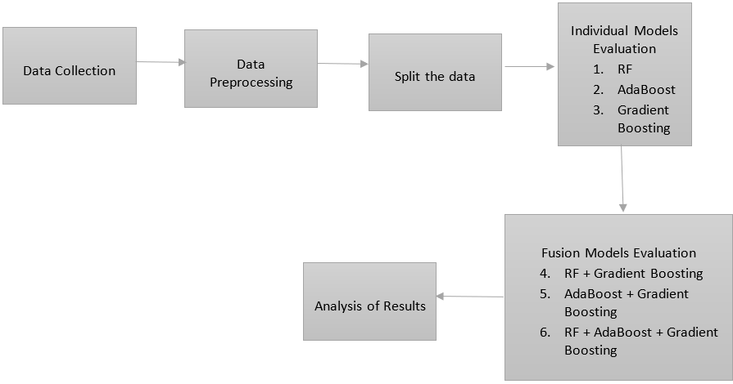 Figure 5 Research workflow

Dataset Chosen for the Research
Research of the data is conducted with the help of the dataset received from Kaggle titled ‘Phishing Site URLs’ (Tiwari, 2024) that is suitable for the current research because it contains numerous real examples of phishing and legitimate sites. The dataset is obtainable from the following link.
Dataset link
This dataset contains all possible 549346 records of which each record has an URL which will be classified either under ‘good’ label or ‘bad’ label which specifically defines non-phishing/non-scam/ harmless URL’s and phishing/scam/malicious URL’s respectively. This dataset would be used in the area of cybersecurity to develop machine learning method for detecting and predicting of the Phishing sites. The dataset has two features where one feature is the URL of the website and the second feature is the actual classification of the URL and none of the data points are missing. It therefore provides a balanced dataset on which the models that could be used to improve safety and security on the internet can be trained from.

Choice of Methods
The choice of Random Forest, AdaBoost and Gradient Boosting in this study is more appropriate because they have the feature of learning from the data in order to enhance the level of classification. They are also effective in handling the large feature space and brings out enhancement in the next iteration helping in accurate consideration of the phishing URLs. Random forest is another meta classifier that is based on the decision tree and one of the benefits of using this kind of classifiers when it comes to the classification of the various kinds of the phishing URLs it has the ability to differentiate between the URLs that may seem to be almost similar but may different in properties(Korkmaz, Sahingoz and Diri, 2020). AdaBoost or Adaptive Boosting is a learning algorithm that is a type of ensemble learning which creates a stronger classifier, from multiple weak classifiers. This is helpful in handling the issue of providing a solution to the more complex layers of phishing schemes that other models cannot identify (Shahrivari, Darabi and Izadi, 2020). Like GBM, Random Forest is also an ensemble model developed in stages with each subsequent model developed with the intention of making the improvement in the prediction using the minimum error through the gradient descent process; this method is ideal for making the distinction between the complexity of the features of the phishing URL data (Rahman et al. , 2020). Therefore, with the assistance of these algorithms, the research can respond to the research questions concerning the effectiveness of the ensemble and fusion models for the detection of the URLs of phishing and ranking the efficiency of these models in real circumstances.

Ensembled Models
Ensemble learning is a common method of machine learning which involves the use of two or more models and combining them so as to improve the effectiveness of the outcomes and obtain a better accuracy. Random forest, Ada boost, Gradient Boosting: This section deals with Multiple Model approach like Random forest, Ada boost, Gradient Boosting.

Random Forest
Random Forest is one of the classification technique which is used in machine learning filed it constructs a no of decision trees during the learning process and it selects the class of the record which is most voted during the time of prediction. This is done by selecting some of the data and features at random for each tree, in such a way that different trees do not use the same data and features thus reducing the chances of over fitting (Sindhu et al., 2020). The basic structure of Random Forest is shown below.
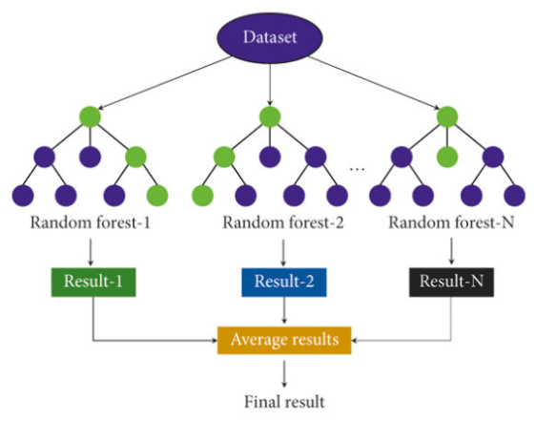
Figure 6 A diagram of the RF method (Fu and Qi, 2022)
Random Forest in phishing URL detection is effective when dealing with large datasets and high dimensional features. This is because when the decision trees are combined to make one prediction, they have the ability to learn characteristics of the data and thus improve the accuracy and the reliability of the detection model. It has the inherent feature selection mechanism that aids in identifying the most important features like URL length, suspicious keywords and domain age which make it suitable for differentiating between genuine and fake URLs (Sadique et al., 2020).

Ada Boost
AdaBoost (Adaptive Boosting) is a type of boosting where weak classifiers are combined in to give a strong classifier. It works by successively training models, where each model refines the previous model with corrections and gives more emphasis to the previous model’s errors. The final model is a weighted sum of all the weak classifiers and hence is a better way of dealing with complex patterns (Ghimire et al., 2021). The following figure illustrates the framework of the AdaBoost algorithm.
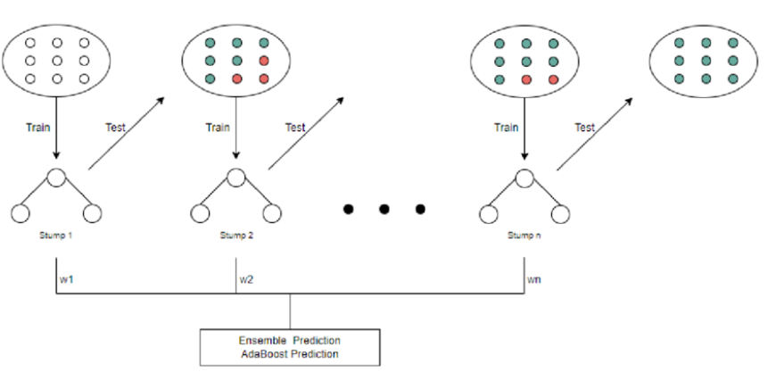
Figure 7 Framework of the AdaBoost algorithm (Son and Yang, 2022)
AdaBoost is appropriate for this research because it aggregates weak classifiers that have the capability of distinguishing between a phishing and legitimate site. It is very efficient, because it can operate in large feature spaces, and also it uses the information about the previous classification to define the given site as phishing one or not (Aljofey et al., 2022).

Gradient Boost
Boosting is a type of ensemble learning method in which several weak classifiers usually decision trees are combined to form a stronger classifier. All trees can adjust from the errors produced in the past trees and the final decision is the average of the decision of all trees. It uses gradients in an effort to reduce the losses and this is done by varying the weights in relation to the learning rates. The diagram below shows the steps involved in the gradient boosting process (Karim et al., 2023).
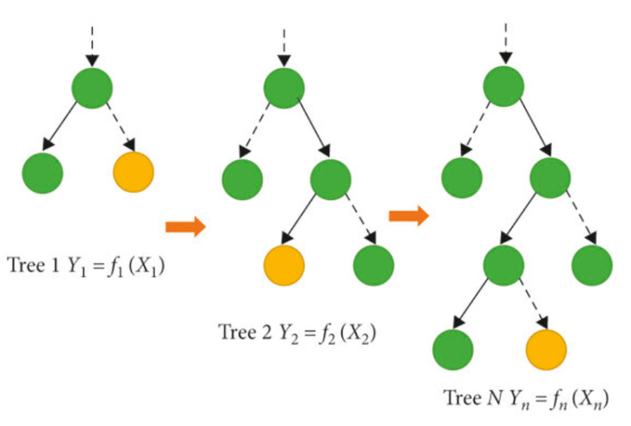
Figure 8 Illustration depicting the gradient boosting (Lu et al., 2021)
Gradient Boosting performs well in the classification of phishing URLs and enhancing the classification results because it can deal with the non-linear and multiple interactions. It is quite effective in the identification of the features of URL and differentiating the authentic and the fake websites. Its strength are that it can operate on imbalanced data, it has high accurate prediction and can take any number of feature hence it is a useful tool in improving the cybersecurity protection against phishing attack (Pavan et al., 2021).

Evaluation metrics
Evaluation metrics are the set of numerical values that are used to evaluate the results of the machine learning model. The measurements employed in this work include accuracy, precision, recall, and the F1 score.

Confusion matrix
Phishing URL detection uses a confusion matrix which gives out true positive, false positive, true negatives and false negatives to infer the efficiency of a classifier model. It also helps into determining the accuracy, degree of precision, and the recall in regards to the identification of the attack (Aljofey et al., 2022).

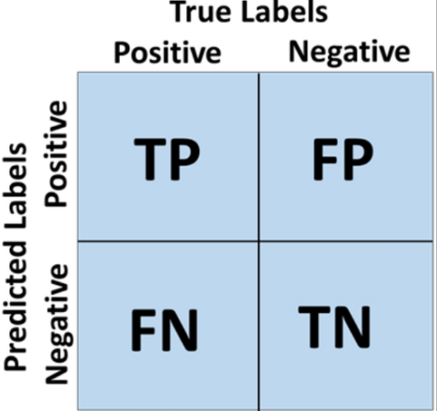
Figure 9 Confusion matrix (Ibrahim Youssef and Fathalla, 2023)

In this research, accuracy is the ability to identify both the phishing and the legitimate URLs from the entire number of URLs tested. It gives the average of all the features put together in identifying between a phishing and non-phishing URL (Wazirali, Ahmad and Abu-Ein, 2021). Recall computes the proportion of the actual phishing URLs that the model has correctly classified as phishing within the whole set of URLs that the model has classified as phishing (McConnell et al., 2023). F1 score of the system in detecting phishing URLs gives the balance between the number of true positives and the number of false positives. It is the harmonic mean of these metrics to offer a single value that reflects a model’s capability of correctly predicting phishing URLs without producing many false positives or false negatives (Elsadig et al., 2022).

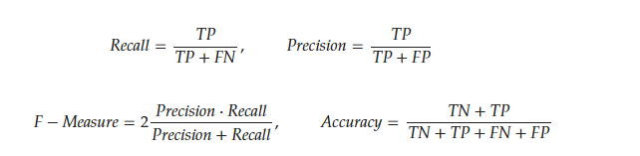 Figure 10 Assessment Metrics (Dritsas and Trigka, 2022)

Ethical Issues
In this study, the dataset is publicly accessible and hence does not contain any identification information of the users; nevertheless, the URLs can also potentially be regarded as sensitive data. For example, URLs can contain extensive details about certain sites or services that can harm if given a poor treatment. The study will employ the Kaggle dataset and ensure confidentiality of the participants is preserved. The analysis will be based on collective data and if we are to present any results, they will not be evident of any specific URL. The dataset will be managed and processed safely which includes the protection of the same from other people who may have an adverse intention towards the data.
A possibility is a lack of balance in the dataset or some degree of bias towards specific types of URLs. To the result, there might be cases of unequal detection rates or even wrong categorization of the phishing sites. Some of the applicable preparatory tasks include preprocessing to handle with data imbalance issue including either resampling or weighted approach. Regarding the assessed measures to the performance of the models, accuracy, precision, recall, and F1-score will be measured to be fair and reliable. Any biases will be made clear and subsequently avoided as much as possible.
The study will feature comprehensive analysis of possible false positives and false negatives in a bid to determine and assess the risk factors involved. Recommendations for the use of models in practical applications will be given with due regard to the necessity for their additional testing. Several performance measurements will be used to validate the models and eliminate the possibility of misclassification as far as possible. It will provide a systematized qualitative assessment of false positives and false negatives when it comes to harm. Recommendations for model deployment will be given with advanced notice on the fact that there may be a need for further validation in terms of practical implementation.

Risk Management
Risks | Description | Mitigation
Data Privacy and Security | Handling sensitive user data, which could be vulnerable to breaches or misuse | - Anonymize and encrypt data.  - Store data securely with strict protocols.  - Limit access to authorized personnel only.
Algorithmic Bias | The model may unfairly flag legitimate URLs as phishing, leading to false positives. | - Use diverse and representative training data.  - Regularly audit the model for biases.  - Implement a feedback mechanism for continuous improvement
Lack of Transparency | The model's decisions may not be understandable, undermining user trust | - Incorporate explainability features.  - Ensure accountability for errors.  - Provide users and stakeholders with insights into decision-making.

Summary
This chapter presented a review of the methods for the analysis of the results of detecting phishing URLs, such as data preparation, the selection of features and the assessment of the algorithms’ performance. It discusses the Random Forest model and AdaBoost Model, Gradient Boosting Model and Fusion there-from to comprehend the efficiency of the models and the ability to detect the malicious URL.

Experiments and Results
The experiment is to evaluate if the ensemble and fusion models can identify fake URLs and this will be done through the following. This Kaggle data will be gathered, matched, cleaned with the help of NLP and then analyzed by applying TF-IDF and PCA The final dataset will be split in a training dataset, a validation dataset, and a testing dataset in order to evaluate the performance. From the findings in this study, the comparative analysis of both the ensemble and the fusion models, will determine the best approach that leads to high accurate detection of newly created phishing URLs.

Dataset on Phishing Site URLs: Gathering and Overview
The phishing site URL dataset, which can be accessed through the provided link on Kaggle, has 549,346 entries and is primarily structured with two columns: Two common approaches are URL and Label. It should be admitted that using this data set, it is easier to find out URLs of phishing and other fraudulent web sites. The URLs are enlisted in the Label column and each label corresponds to a single category. These two classes are rather simplistic where ‘Good’ refers to a safe site, that is, a site that does not host malicious content and ‘Bad’ refers to a phishing site or any other dangerous site.
https://www.kaggle.com/datasets/taruntiwarihp/phishing-site-urls
Both columns of the dataset include complete and accurate data. The web addresses are stored as strings in the URL column, while the categorical data appears as strings in the Label column. Both columns have the object data type, which represents the string nature of the entries. The dataset is ideal for training and testing phishing site detection algorithms due to its completeness and lack of missing information.

Null Values in the Dataset
The output verifies that the dataset is complete, as the URL and Label columns do not contain any null values. Preprocessing for missing data is unnecessary, as each entry is entirely populated and ready for further examination and modelling.

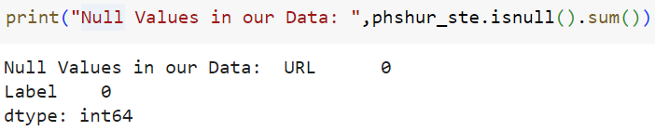
Figure 11 Identified Null values in the data

Initial Label Distribution and Encoding Impact
Initially, the dataset contains 392,924 'good' labels and 156,422 'bad' labels, which indicates a substantial disparity between legitimate and fraudulent websites. Label encoding was implemented to prepare the data for ML models, resulting in the conversion of 'good' to 1 and 'bad' to 0.
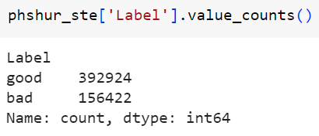
Figure 12 Before Label Encoding

This numerical encoding prepares the dataset for effective model training and analysis, and facilitates performance evaluation by streamlining the data for techniques that require numerical input.
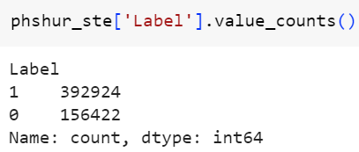
Figure 13 After Label Encoding

Handling Duplicates in Dataset
The dataset is initially composed of 42,150 duplicate entries, which could potentially affect the accuracy of the model and the analysis. This was resolved by employing the drop_duplicates() method to eliminate all duplicates. The updated count of zero confirms that the dataset is now devoid of duplicates following this process.
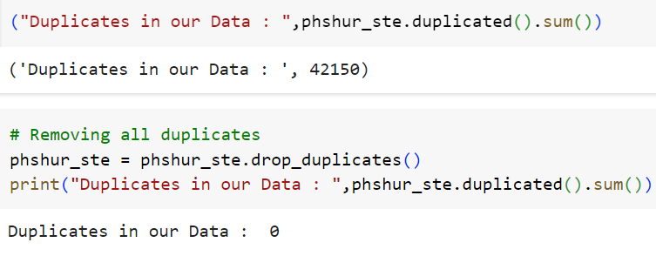
Figure 14 Identified Duplicates in the data
Redundancy and potential bias are eliminated during this cleanup phase, which guarantees that each entry is distinct, thereby enhancing the validity of subsequent analysis of data and model training.

Updated Label Distribution and Visualization
Following the removal of duplicates, the dataset now displays 392,897 entries labelled as 'good' (1) and 114,299 entries labelled as 'bad' (0). A diminished imbalance between the two classes is evident in this revised distribution in comparison to the initial estimates. The number of instances for each label was displayed in a count plot generated using Seaborn to visualize this distribution.
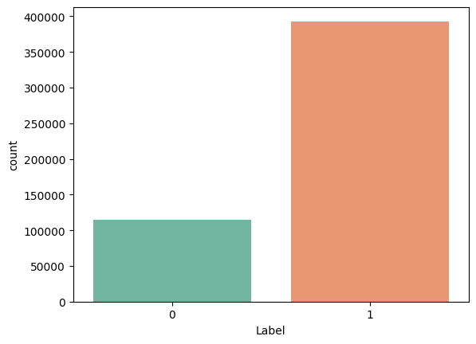
Figure 15 Visual distribution of good and bad labels

The 'Set2' color palette is employed to emphasize the dominance of 'Good' sites (1) over 'Bad' sites (0) in the plot. This visualization assists in exploratory data analysis (EDA) by offering a clear perspective on the class distribution and assisting in the direction of subsequent modelling and analysis stages.

NLP Techniques Applied to Clean Data
- Lowercasing: In order to prevent case-sensitive errors and preserve uniformity, the URLs are altered to lowercase.
- Removing Non-Alphabetic Characters: Using regex, spaces are substituted for all non-alphabetic characters. Leaving out URLs' punctuation and special characters, this concentrates the data on textual content.
- Stopwords Removal: In order to mitigate cacophony and emphasize significant words, common stopwords (e.g., 'and', 'the') are eliminated.
- Lemmatization: The WordNet Lemmatizer is employed to reduce words to their base or fundamental form. This reduces variations in word forms and standardised words (e.g., "walking" becomes "walk").
- Updated Dataset: After preprocessing, the dataset, which includes 507,196 rows with cleaned URLs, is now ready for further analysis and modelling.
The cleaned dataset is now saved to 'phishing_cleaned_data.csv'.

Sample Balancing for Phishing URL Detection
In order to mitigate class imbalance and enhance model performance, a balanced subset was generated from the original dataset of 507,196 rows of data. Filtering the dataset into two categories: It is coded ‘0’ for bad and ‘1’ for good. In as much as we wanted to have a total of 10,000 samples in the entire dataset, we randomly sampled 5,000 samples from each of the given classes to achieve near equal distribution.
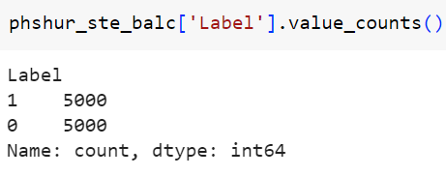
Figure 16 Balanced Good and Bad Samples in Phishing URLs
In order to train machine learning models that are both effective and unbiased, it is essential to ensure that both classes are represented equally through sampling.

Feature Extraction and Data Preprocessing for the Detection of Phishing URLs
To prepare the dataset for machine learning, the TF-IDF vectorization method was employed to transform text data from URLs to extract word frequency features. The dimensionality was reduced to 10 components through the application of PCA. In this procedure, raw text is transformed into numerical features that are ideal for modelling. Following this, the dataset was partitioned into three sets: training, validation, and testing.
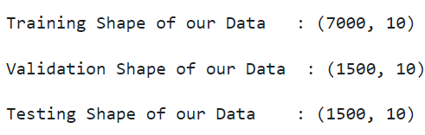
Figure 17 Partitioned data samples
The training set consisted of 7,000 samples, while the validation and testing sets consist of 1,500 samples each. In this balanced strategy, the model is trained on a dataset that is suitably large, while still retaining an adequate amount of data for validation and testing.

Ensemble Learning Algorithms in Phishing URL Detection
In this investigation, the Random Forest, AdaBoost, and Gradient Boosting ensemble algorithms were examined for their effectiveness in detecting phishing URLs, both individually and in combination. The models were implemented individually in the upcoming section of the paper, and the results were evaluated.

Applying Random Forest and Evaluating Its Results
The Random Forest Classifier was employed to improve the detection of fraudulent URLs, with a random state of 72. Below are the efficacy metrics for both the validation and testing phases.
Performance Metrics: In both the validation and testing phases, the RF model consistently obtained a score of 0.87 across all metrics. This suggests a proportionate accuracy and efficiency in the classification of URLs.

Table 2 Performance metrics of Random forest in classifying URLs
Data | Precision | Recall | F1 Score | Accuracy
Validation | 0.87 | 0.87 | 0.87 | 0.87
Testing | 0.87 | 0.87 | 0.87 | 0.87

Confusion Matrix Insights:
- Validation: The confusion matrix displays 656 true positives (TP), 653 true negatives (TN), 91 false positives (FP), and 100 false negatives (FN). This implies that the model accurately identified the majority of fraudulent URLs, despite making a few misclassifications.
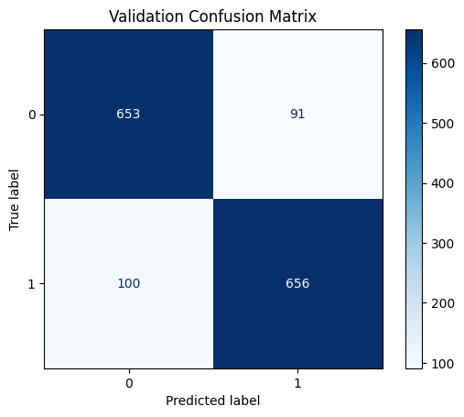
Figure 18 Validation Confusion Matrix of Random Forest

- Testing: For the testing phase, the matrix indicates 656 TP, 645 TN, 90 FP, and 109 FN. Comparing the results to validation, there is a minor decrease in true negatives and an increase in false negatives.
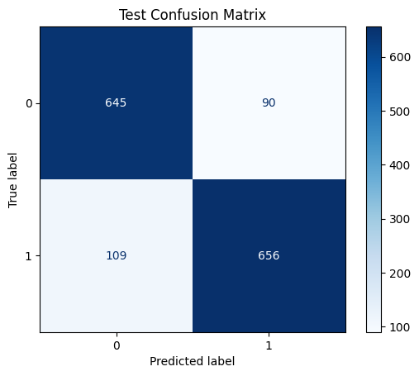
Figure 19 Test Confusion Matrix of Random Forest
Overall, the Random Forest Classifier exhibits a balanced approach to detecting phishing threats and consistently accurate performance in differentiating 'good' (1) from 'bad' (0) URLs.

Applying AdaBoost and Evaluating Its Results
The AdaBoost Classifier was employed to detect fraudulent URLs, with a base estimator of a Decision Tree using a maximum depth of 1 and a random_state of 72 to ensure reproducibility. In this process, the model was trained and then the effectiveness scores were evaluated on the two samples of data set, which are the validation and the testing sets.

Performance Metrics: All the performance metrics of the AdaBoost during validation were 0. 80 raise the tent of being a good model, albeit slightly worse than the previous Random Forest model we saw. In any case, using the metrics in the trial data, the model revealed an increase in the metrics to 0. 82. This enhancement implies that AdaBoost has the ability to handle unseen data well and is in a better position to present more generality hence the ability to improve on the alteration of its prediction on unseen examples.

Table 3 Performance metrics of AdaBoost in classifying URLs
Data | Precision | Recall | F1 Score | Accuracy
Validation | 0.80 | 0.80 | 0.80 | 0.80
Testing | 0.82 | 0.82 | 0.82 | 0.82

Confusion Matrix Insights:
- Validation: The matrix displays 630 TP, 575 TN, 169 FP, and 126 FN, which depict the model's classification strengths and weaknesses.

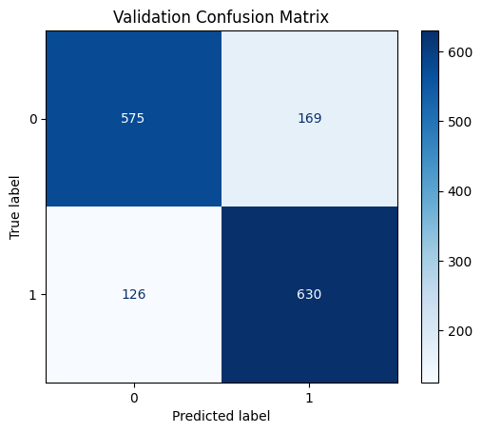
Figure 20 Validation Confusion Matrix of AdaBoost

- Testing: In general, the testing matrix indicates an improvement in the detection of fraud URLs, with 632 TP, 593 TN, 142 FP, and 133 FN. However, there are still some misclassifications.
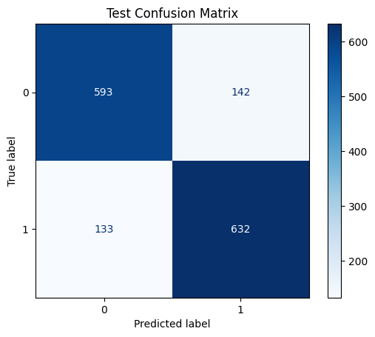
Figure 21 Test Confusion Matrix of AdaBoost

AdaBoost demonstrated a strong ability to differentiate between 'Good' (1) and 'Bad' (0) URLs, demonstrating enhanced accuracy and balanced detection capacity.

Applying Gradient Boosting and Evaluating Its Results
The Gradient Boosting Classifier was trained using training samples and configured with random_state=72 to ensure consistency. By sequentially fixing the errors of weaker models, gradient boosting improves predictive performance by refining accuracy via iterative enhancements.
Performance Metrics: In both the validation and testing stages, the gradient boosting model obtained precision, recall, F1 score, and accuracy of 0.84. This consistent performance is a testament to its ability to generalize unseen data and strong detection skills.
Table 4 Performance metrics of Gradient Boosting in classifying URLs
Data | Precision | Recall | F1 Score | Accuracy
Validation | 0.84 | 0.84 | 0.84 | 0.84
Testing | 0.84 | 0.84 | 0.84 | 0.84
Confusion Matrix Insights:
- Validation: The model exhibits robust detection of fraud URLs with 645 TP, 613 TN, 131 FP, and 111 FN, albeit with some misclassifications.
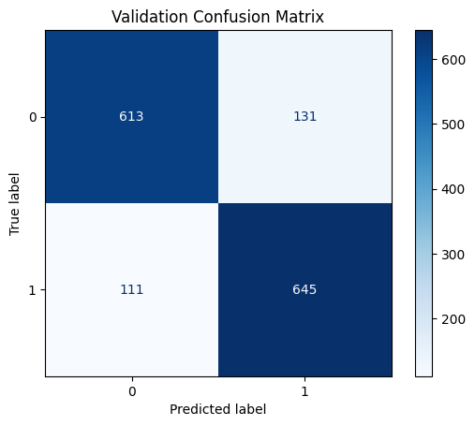
Figure 22 Validation Confusion Matrix of Gradient Boosting

- Testing: The matrix indicates that the system exhibits stable performance and the ability to distinguish between 'good' (1) and 'bad' (0) URLs, with 644 TP, 615 TN, 120 FP, and 121 FN indicated.
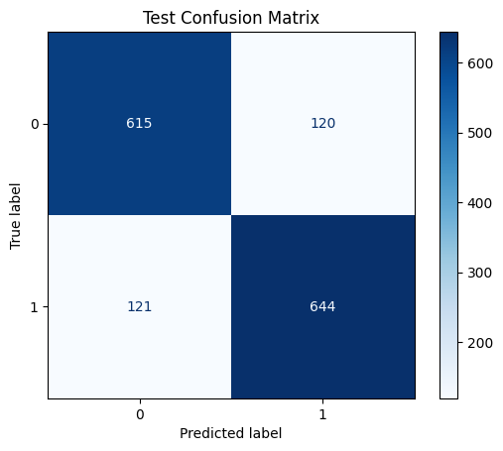
Figure 23 Test Confusion Matrix of Gradient Boosting
In general, gradient boosting outperformed AdaBoost in terms of performance, but it was unable to match Random Forest in terms of accuracy.

Fusion Models in Phishing URL Detection
The ensemble learning algorithms that were implemented individually till now are combined to form three different fusion models. The following is a list of the fusion models under study:
- Combined Random Forest and AdaBoost - Fusion Model 1
- Combined Random Forest and Gradient Boosting - Fusion Model 2
- Combined AdaBoost and Gradient Boosting - Fusion Model 3

Combined Random Forest and AdaBoost - Fusion Model 1
Using a Voting Classifier with hard voting, the initial fusion model is constructed by combining Random Forest and AdaBoost classifiers for the purpose of detecting fraudulent URLs. The AdaBoost model with a Decision Tree of maximum depth 1 and the Random Forest model, which was configured with random_state=72, were amalgamated.
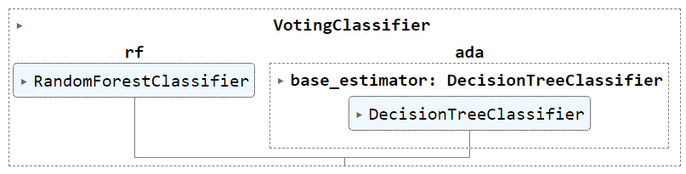
Figure 24 Combined Random Forest and AdaBoost - Voting Classifier

Performance Metrics: The fusion model, which integrated AdaBoost and Random Forest, demonstrated exceptional performance. Precision, recall, F1 score, and accuracy were all obtained at 0.85, 0.84, 0.84, and 0.84, respectively, during the validation process. The robust detection capacity and efficacy on unseen data were underscored by the consistent 0.84 testing metrics.

Table 5 Performance metrics of Combined Random Forest and AdaBoost in classifying URLs
Data | Precision | Recall | F1 Score | Accuracy
Validation | 0.85 | 0.84 | 0.84 | 0.84
Testing | 0.84 | 0.84 | 0.84 | 0.84

Confusion Matrix Insights:
- Validation: Effective phishing detection with balanced trade-offs was demonstrated by the matrix, which displayed 598 TP, 669 TN, 75 FP, and 158 FN.
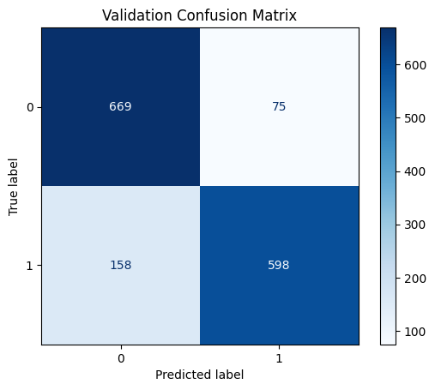
Figure 25 Validation Confusion Matrix of RF and AB

- Testing: The matrix showed 595 TP, 661 TN, 74 FP, and 170 FN which were indicating the efficiency of the matrix by achieving great and consistent result in terms of detection. Also, it disclosed directions for more enhancements.
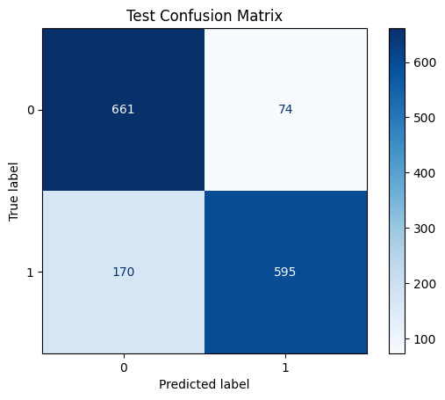
Figure 26 Test Confusion Matrix of RF and AB
This was found to be effective in detecting fraudulent URLs because it combines the strong features of Random Forest and AdaBoost.

Combined Random Forest and Gradient Boosting - Fusion Model 2
Secondly, the voting classifier, which incorporates random forest and gradient boosting models, was implemented to identify fraudulent URLs. This fusion aimed at enhancing the accuracy and reliability of the detection results it through hard voting of the characteristics of both models.
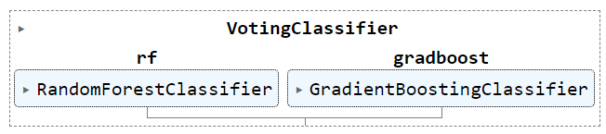
Figure 27 Combined Random Forest and Gradient Boost - Voting Classifier

Performance Metrics: The fusion of models that involve gradient boosting as well as random forest gave a result of 0 for precision, recall, the F1 score and accuracy. 86 during validation. It stresses the capacity of misclassification management and accurate identification of phishing URLs as one of its important achievements. During testing the metrics slightly dropped, but they are still at 0. 85 percent of the data for practical purposes, and there was no significant difference in the model’s percentage for unseen data set, giving it a reliable and reproducible performance.
Table 6 Performance metrics of Combined Random Forest and Gradient Boosting in classifying URLs
Data | Precision | Recall | F1 Score | Accuracy
Validation | 0.86 | 0.86 | 0.86 | 0.86
Testing | 0.85 | 0.85 | 0.85 | 0.85

Confusion Matrix Insights:
- Validation: Solid detection with minimal false positives was demonstrated by the confusion matrix, which displayed 617 TP, 667 TN, 77 FP, and 139 FN.
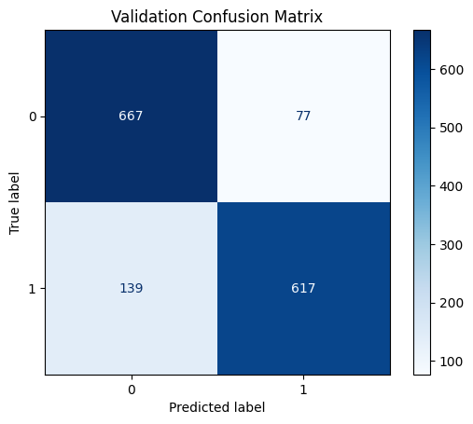
Figure 28 Validation Confusion Matrix of RF and GB

- Testing: Results indicated a minor increase in false negatives, with 612 TP, 659 TN, 76 FP, and 153 FN. However, the performance was generally reliable.

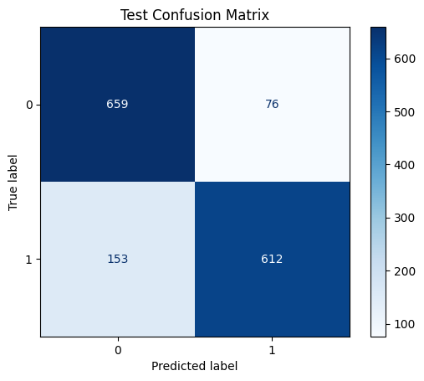
Figure 29 Test Confusion Matrix of RF and GB
Providing a robust detection of phishing URLs, this fusion model capitalised on the combined capabilities of gradient boosting and random forest. In comparison to the initial fusion model investigated in this endeavour, the metrics are quite favourable.

Combined AdaBoost and Gradient Boosting - Fusion Model 3
Here the Voting Classifier was employed to incorporate the AdaBoost and Gradient Boosting models for the purpose of detecting phishing URLs. Hard voting was employed to combine AdaBoost, which has a Decision Tree of depth 1, and Gradient Boosting in order to optimize their respective capabilities.

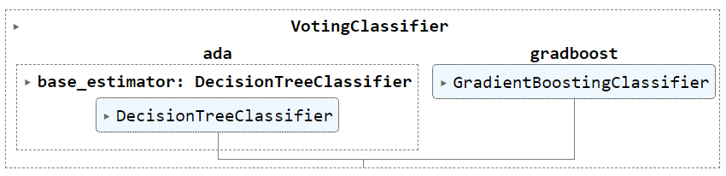
Figure 30 Combined AdaBoost and Gradient Boost - Voting Classifier

Performance Metrics: During validation, the fusion model that effectively combined AdaBoost and Gradient Boosting achieved a precision, recall, F1 score, and accuracy of 0.83, which suggests that it is capable of detecting fraudulent URLs in a balanced manner. Additionally, the model's strong capability and dependability on unseen data were illustrated by the consistent 0.83 testing metrics.

Table 7 Performance metrics of Combined AdaBoost and Gradient Boosting in classifying URLs
Data | Precision | Recall | F1 Score | Accuracy
Validation | 0.83 | 0.83 | 0.83 | 0.83
Testing | 0.83 | 0.83 | 0.83 | 0.83

Confusion Matrix Insights:

Validation: The detection capabilities were balanced, as evidenced by the matrix, which displayed 614 TP, 631 TN, 113 FP, and 142 FN.
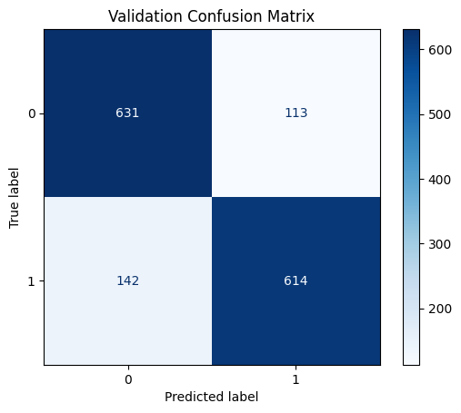
Figure 31 Validation Confusion Matrix of AB and GB
Testing: The matrix demonstrated a modest increase in false negatives compared to validation, with 611 TP, 631 TN, 104 FP, and 154 FN, indicating reliable detection.
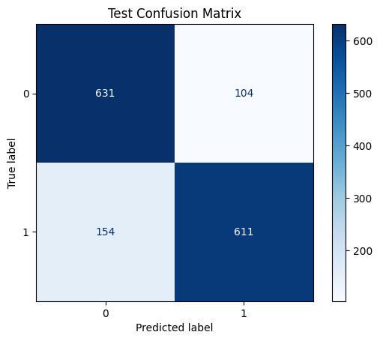
Figure 32 Test Confusion Matrix of AB and GB

This fusion model successfully combined AdaBoost and gradient boosting, resulting in the reliable and stable detection of fraudulent URLs. It is important to mention that this combination was less accurate than the other two fusion models.

Summary
The chapter focuses also on providing the overview of several ensemble and fusion models in the field of the phishing URL detection. This made it easy to determine that the Random Forest, Gradient Boosting model was ideal since it incorporate the precisions of the former and the capability to identify other difficult cases of the latter. A very important observation that is deduced from this paper is that there is an opportunity for enhancing the efficacy of the detectors of phishing with fusion models.

Results
The chapter gives a view on the results obtained from the implementation of the algorithms and the research findings in detail.

Comparison of the Results
Outcomes reveal a clear distinction in achievements of ensemble and fusion models for the detection of phishing URLs Compared studies of ensemble and fusion models. As with each individual ensemble models, the effectiveness can also be rated as being at varying levels. Based on the measures, Random Forest algorithm have the highest performance with accuracy level of 0. 87, precision of 0. 87, recall of 0. 87, for precision of 1, and an F1 score of 0. 87. This implies the fact that with regard to fraudulent URLs, the system is highly efficient in addressing issues of classification and handling of errors. AdaBoost achieves a 0. Lower than the leading metrics’, we are scoring 82 for accuracy, precision, recall, and F1 score. Though it performs satisfactorily it is less powerful than Random Forest. Comparing gradient boosting as to its accuracy, it sports a more moderate rate of a steady 0. 84 in all metrics. It is slightly beyond AdaBoost but slightly less than the Random Forest algorithm.
Table 8 Results of Ensemble learning algorithms and fusion models in phishing URL detection

Models | Precision | Recall | F1 Score | Accuracy
ENSEMBLE LEARNING ALGORITHMS
Random Forest | 0.87 | 0.87 | 0.87 | 0.87
AdaBoost | 0.82 | 0.82 | 0.82 | 0.82
Gradient Boost | 0.84 | 0.84 | 0.84 | 0.84
FUSION MODELS
Random Forest and AdaBoost | 0.84 | 0.84 | 0.84 | 0.84
Random Forest and Gradient Boost | 0.85 | 0.85 | 0.85 | 0.85
AdaBoost and Gradient Boost | 0.83 | 0.83 | 0.83 | 0.83

Three distinct fusion approaches are generated when these frameworks are combined, providing a more complex perspective. The first Fusion Model integrating Random Forest, AdaBoost had an accuracy, precision, recall, and F1 score of 0. 84. This is an improvement over AdaBoost on its own, but not as powerful as Random Forest. The second fusion model which is the combination of gradient boosting and random forest has the balanced increase with the obtained metrics of 0. This was seen to be slightly higher than that of the gradient boosting model by achieving 85 percent, or a 5 percent increase. However, Random Forest by its own is more preferred due to the model achieving better metrics at 0. 87. On the other hand, the experiment that was done using a fusion of AdaBoost and Gradient Boosting gave metrics of 0. 83 percent, slightly lower than what they deliver at more intimate gigs. AdaBoost scored 0. 82 and the gradient boosting attained 0. 84. The trend of decrease of each model’s score for fusion however suggests that the fusion model failed to incorporate the strength of Gradient boosting in particular which achieved a higher overall individual score.
Based on the results, Random Forest is the best model in identification of fraudulent URLs. Overall, the validation and testing accuracy found was 0. The highest metric that was achieved was 87 this shows the high capacity of the system to identify and correctly classify the phishing URLs. Even though there is a comparative enhancement seen in the fusion models like Random Forest and Gradient Boosting more than the individual gradient boosting model, Random Forest outperformed all the time and thereby made it the best suitable model for accurate and efficient phishing detection.

Research Findings
      - Random Forest: Random Forest demonstrated the highest accuracy at 0.87 in both validation and testing, confirming its superior performance in the detection of fraud URLs. Thus, it emerged as the most effective model.
      - Gradient Boosting: This model surpasses AdaBoost by maintaining a consistent 0.84 across metrics as a result of its more robust management of data variations. Nevertheless, it is not as successful as Random Forest's outstanding overall performance.
      - AdaBoost Performance: The metrics of AdaBoost, which are 0.82, suggest that it is less effective in detecting phishing URLs. This is due to the fact that it is unable to achieve high classification accuracy and robustness in comparison to the superior scores of random forest and gradient boosting.
      - Fusion Models: The fusion models showed satisfactory performance; however, none exceeded the individual accuracy of 0.87 that Random Forest attained, which remains the highest among all tested models.

Comparison with other research work
This research shows that Random Forest has the best performance in the identification of Phishing URLs through giving the highest metrics which are accuracy = 0. 87. This finding conforms to other studies, which pointed out Random Forest as the most preferred model for classification assignment due to the approach taken to handle imbalanced data and its ensemble feature that improves the accuracy of the test (Zhang et al. , 2021; Liu et al. , 2022). On the other hand, AdaBoost was less effective in this study which scored the performance at 0. 82, which correlates with the earlier findings stating the boosting algorithm noise sensitivity and its lower efficiency as compared to other ensemble models (Freund and Schapire, 1996). The performance of Gradient Boosting was rather average being 0 % for each of the three categories. 84 which is in line with research that has shown a relatively fair performance of the algorithm acknowledge that it does not outperform the accuracy of Random Forest. The fusion models as can be expected outperformed the individual models, but did not perform better than the Random Forest; consistent with findings that have shown fusion models can brings additional improvements but are generally never superior to the best single model (Zhou, 2012). Consequently, the proposed results are consistent with the studies and work done earlier to legitimize Random Forest as the best method for detecting phishing URLs.

Technical Challenges in this Research
Analyzing the technical difficulties of this research brought to light a couple of issues, for the most part having to do with data aggregation and the effectiveness of the model. Another major hurdle that was faced during the training and testing of reducing the number of ‘good’ URLs was considerably more than the ‘bad’ in the initial dataset: thus steps were needed to be taken for data balance and pre-processing. Also, the coordination and optimizing ensemble and fusion models contribute to the time-consuming aspect of this study. The use of TF-IDF vectorization and PCA for feature extraction brought in computational cost and the subsequent problem of dimensionality that affected the time it took to train the model and its performance. Moreover, getting similar levels of accuracy in different models and especially in making sure the fusion models were not outperformed by the best single model called for more delicate tuning and checking. These challenges show that it is necessary to pay much attention to data preprocessing and model validation phases to improve the performance of the phishing URL detection.

Summary
A comparison of the results of the Random Forest model with the other models showed that the former has a higher level of accuracy, precision, recall, and the F1 score was 0. 87 percent, which is the highest among all the classification techniques for the detection of phishing URL. Despite the enhancements made by fusion models some other times they did not give better results than Random Forest. The findings of the study are in congruence with the prior work constituting Random Forests for imbalanced datasets and the focus on the model fine-tuning and data pre-processing.

Conclusion
This research project presented a method of developing a system for the detection of phishing URLs using ensemble and fusion models and it did prove that modern day advanced machine learning techniques hold a lot in achieving high levels of success in such tasks. As the project used Random Forest, AdaBoost, and Gradient boosting models, along with all the possible fusions among these algorithms, this research comprehensively measures the effectiveness of these methods in the detection of phishing threats.
The findings obtained show that the Random Forest model obtained the highest accuracy of 0.87 while at the same time had a precision, recall, and F1 score of 0.87 at both the validation and testing stages. The reliability of this model in the handling of the challenging task of phishing URL identification vindicates the model’s ability to perform optimally in issues to do with the detection of phishing URLs, it is thus the most appropriate model between the tested ones. Gradient Boosting was also quite good, the metrics were nearly identical at 0. 84, which went slightly higher that AdaBoost that performed at 0. 82. This finding leads to the understanding of how the Random Forest model performs exceptionally well as to all other models.
A comparison of AdaBoost with Random Forest as well as Gradient Boosting showed that the integration of the two algorithms increases the efficiency of the models which could be understood from the fusion models. In particular, the hybrid of Random Forest and Gradient Boosting provided a rather satisfactory accuracy of 0.85, which, although higher than the individual models’ performances, is slightly lower than the Random Forest classifier’s performance when used alone. The other fusion models, albeit helpful in improving some aspects of detection did not improve on the performance of the best single model.
The issue of imbalance data, computational burden in terms of TF-IDF vectorization and the dimensionality reduction process using PCA and the model’s integration was solved by hard work and using an optimized model. These challenges were crucial for determining the research outcomes and reminding about the significance of proper data treatment and model calibration in terms of developing effective anti-phishing tools.
In conclusion, this work reveals that through ensemble and fusion models, there are enhanced phishing URL detection. The studies not only support the statement about the Random Forest’s advantage in comparison with another recognized algorithm but also add vital insights into the context of the machine learning algorithms’ efficiency in cybersecurity. It may well be that further work will be directed towards more refined mathematical models, other fusions strategies, extending the investigation for real world applications to make these sort of detection systems more and more useful.

Evaluation
Analysis of the effectiveness, efficiency, and resilience of ensembled and fusion models for phishing URL detection is the main focus of this comparison. In this respect, model building emphasized the necessity of being flexible and able to respond to the raw data and its complexities in the context of organizational research. Random Forest, AdaBoost, and Gradient Boosting models’ successful application proved that the integration of traditional approaches to machine learning and state fusion techniques are fruitful. Nevertheless, the best of the models stressed the importance of further fine-tuning and search-for-the-perfect to cater for these inherent difficulties like class imbalance and model training. What was valuable was not only the growth of technical knowledge but also the confirmation of the goals of systematic approaches and adequate validation. In conclusion, this experience has been really helpful in understanding the general mechanisms of machine learning and has provided a great basis for the future investigations.
By leveraging their various strengths, ensembled models bring together several unique models to increase overall accuracy and generalization. In contrast, fusion models combine various feature sets or data sources to improve their prediction capacity. Metrics including accuracy, precision, recall, and F1 score are used in performance evaluation to determine how successfully each method detects phishing URLs. To assess practical viability, scalability and computational efficiency are also taken into account. The assessment seeks to determine which approach provides higher detection performance, adapts more effectively to changing data patterns, and produces the best outcomes in practical situations.

Future Enhancement
Potential improvements to this research could include the following recommendations as prospect areas for improvement of the phishing URL detectors: Firstly, the additional complicated techniques like deep learning models and hybrid architectures can give a deeper understanding and potentially a higher accuracy. Such models as CNNs or some models based on Transformer architectures could potentially improve the detection capability with more complex distinguished patterns and features in URLs. Also, considering the incorporation of more extensive and diverse data sets, as well as real-time information from different sources can enhance the stability and generalization capability of the models. Other aspects that can also be explored to enhance the model’s performance involves dealing with problems associated with class imbalance using, more elaborate sampling methods or emerging detection algorithms. Introduction of adaptive learning processes to update the models with new incoming data and newly invented forms of phishing will make the detection system ever changing and effective. Moreover there exists a provision for further extension of the research to include several kinds of complexities of phishing techniques and adversarial attacks in order to present a holistic approach toward the variety of newly emerging cyber threats. The proposed future work here seeks to expand on these current conclusions, driving further development of the existing, already quite effective, detection systems of phishing URLs for practical usage in actual real-world instances.

References
Abdul Samad, S.R., Balasubaramanian, S., Al-Kaabi, A.S., Sharma, B., Chowdhury, S., Mehbodniya, A., Webber, J.L. and Bostani, A., 2023. Analysis of the performance impact of fine-tuned machine learning model for phishing URL detection. Electronics, 12(7), p.1642.
Ahammad, S.H., Kale, S.D., Upadhye, G.D., Pande, S.D., Babu, E.V., Dhumane, A.V. and Bahadur, M.D.K.J., 2022. Phishing URL detection using machine learning methods. Advances in Engineering Software, 173, p.103288.
Akinyelu AA (2019) Machine learning and nature inspired based phishing detection: a literature survey. Int J Artif Intell Tools 28(05):1930002
Alabdan, R., 2020. Phishing attacks survey: Types, vectors, and technical approaches. Future internet, 12(10), p.168.
Ali, W., 2017. Phishing website detection based on supervised machine learning with wrapper features selection. International Journal of Advanced Computer Science and Applications, 8(9).
Aljofey, A., Jiang, Q., Rasool, A., Chen, H., Liu, W., Qu, Q. and Wang, Y., 2022. An effective detection approach for phishing websites using URL and HTML features. Scientific Reports, 12(1), p.8842.
Alkhalil, Z., Hewage, C., Nawaf, L. and Khan, I., 2021. Phishing attacks: A recent comprehensive study and a new anatomy. Frontiers in Computer Science, 3, p.563060.
Almomani, A., Alauthman, M., Shatnawi, M.T., Alweshah, M., Alrosan, A., Alomoush, W. and Gupta, B.B., 2022. Phishing website detection with semantic features based on machine learning classifiers: a comparative study. International Journal on Semantic Web and Information Systems (IJSWIS), 18(1), pp.1-24.
Aung, E.S., Zan, C.T. and Yamana, H., 2019. A survey of URL-based phishing detection. In DEIM forum (pp. G2-3).
Bell, S. and Komisarczuk, P., 2020, February. An analysis of phishing blacklists: Google safe browsing, openphish, and phishtank. In Proceedings of the Australasian Computer Science Week Multiconference (pp. 1-11).
Dritsas, E. and Trigka, M., 2022. Stroke risk prediction with machine learning techniques. Sensors, 22(13), p.4670.
Elsadig, M., Ibrahim, A.O., Basheer, S., Alohali, M.A., Alshunaifi, S., Alqahtani, H., Alharbi, N. and Nagmeldin, W., 2022. Intelligent deep machine learning cyber phishing url detection based on bert features extraction. Electronics, 11(22), p.3647.
Fu, H. and Qi, K., 2022. Evaluation Model of Teachers' Teaching Ability Based on Improved Random Forest with Grey Relation Projection. Scientific Programming, 2022, pp.1-12.
Ghimire, A., Jha, A.K., Thapa, S., Mishra, S. and Jha, A.M., 2021, January. Machine learning approach based on hybrid features for detection of phishing URLs. In 2021 11th International Conference on Cloud Computing, Data Science & Engineering (Confluence) (pp. 954-959). IEEE.
Ibrahim, M.R., Youssef, S.M. and Fathalla, K.M., 2023. Abnormality detection and intelligent severity assessment of human chest computed tomography scans using deep learning: a case study on SARS-COV-2 assessment. Journal of Ambient Intelligence and Humanized Computing, 14(5), pp.5665-5688.
Isakov, A., Urozov, F., Abduzhapporov, S. and Isokova, M., 2024. Enhancing Cybersecurity: Protecting Data In The Digital Age. Innovations in Science and Technologies, 1(1), pp.40-49.
Islam, M.S., Sajjad, M., Hasan, M.M. and Mazumder, M.S.I., 2023. Phishing Attack Detecting System Using DNS and IP Filtering. Asian Journal of Computer Science and Technology, 12(1), pp.16-20.
Jain, A.K. and Gupta, B.B., 2019. A machine learning based approach for phishing detection using hyperlinks information. Journal of Ambient Intelligence and Humanized Computing, 10, pp.2015-2028.
Karim, A., Shahroz, M., Mustofa, K., Belhaouari, S.B. and Joga, S.R.K., 2023. Phishing detection system through hybrid machine learning based on URL. IEEE Access, 11, pp.36805-36822.
Korkmaz, M., Sahingoz, O.K. and Diri, B., 2020, July. Detection of phishing websites by using machine learning-based URL analysis. In 2020 11th International Conference on Computing, Communication and Networking Technologies (ICCCNT) (pp. 1-7). IEEE.
Korkmaz, M., Sahingoz, O.K. and Diri, M., Sahingoz, O.K. and Diri, B., 2020, July. Detection of phishing websites by using machine learning-based URL analysis. In 2020 11th International Conference on Computing, Communication and Networking Technologies (ICCCNT) (pp. 1-7). IEEE.
Lu, Y., Saadya, F.J., Zahra, M.M.A. and Tan, M.L., 2021. Bayesian Regularized Neural Network Model Development for Predicting Daily Rainfall from Sea Level Pressure Data: Investigation on Solving Complex Hydrology Problem. Complexity, 2021.
McConnell, B., Del Monaco, D., Zabihimayvan, M., Abdollahzadeh, F. and Hamada, S., 2023, June. Phishing Attack Detection: An Improved Performance Through Ensemble Learning. In International Conference on Artificial Intelligence and Soft Computing (pp. 145-157). Cham: Springer Nature Switzerland.
Mowar, P. and Jain, M., 2021, June. Fishing out the phishing websites. In 2021 International Conference on Cyber Situational Awareness, Data Analytics and Assessment (CyberSA) (pp. 1-6). IEEE.
Pavan, R., Nara, M., Gopinath, S. and Patil, N., 2021, March. Bayesian optimization and gradient boosting to detect phishing websites. In 2021 55th Annual Conference on Information Sciences and Systems (CISS) (pp. 1-5). IEEE.
Pujara, P. and Chaudhari, M.B., 2018. Phishing website detection using machine learning: a review. International Journal of Scientific Research in Computer Science, Engineering and Information Technology, 3(7), pp.395-399.
Rahman, S.S.M.M., Rafiq, F.B., Toma, T.R., Hossain, S.S. and Biplob, K.B.B., 2020. Performance assessment of multiple machine learning classifiers for detecting the phishing URLs. In Data Engineering and Communication Technology: Proceedings of 3rd ICDECT-2K19 (pp. 285-296). Springer Singapore.
Sadique, F., Kaul, R., Badsha, S. and Sengupta, S., 2020, January. An automated framework for real-time phishing URL detection. In 2020 10th Annual Computing and Communication Workshop and Conference (CCWC) (pp. 0335-0341). IEEE.
Sahingoz, O.K., Buber, E., Demir, O. and Diri, B., 2019. Machine learning based phishing detection from URLs. Expert Systems with Applications, 117, pp.345-357.

Shahrivari, V., Darabi, M.M. and Izadi, M., 2020. Phishing detection using machine learning techniques. arXiv preprint arXiv:2009.11116.
Sindhu, S., Patil, S.P., Sreevalsan, A., Rahman, F. and AN, M.S., 2020, October. Phishing detection using random forest, SVM and neural network with backpropagation. In 2020 International Conference on Smart Technologies in Computing, Electrical and Electronics (ICSTCEE) (pp. 391-394). IEEE.
Son, J. and Yang, S., 2022. A new approach to machine learning model development for prediction of concrete fatigue life under uniaxial compression. Applied Sciences, 12(19), p.9766.
Tang, L. and Mahmoud, Q.H., 2021. A survey of machine learning-based solutions for phishing website detection. Machine Learning and Knowledge Extraction, 3(3), pp.672-694.
Tiwari, T., 2024. Phishing Site URLs. [online] Kaggle. Available at: https://www.kaggle.com/datasets/taruntiwarihp/phishing-site-urls
Venkatesha, S., Reddy, K.R. and Chandavarkar, B.R., 2021. Social engineering attacks during the COVID-19 pandemic. SN computer science, 2, pp.1-9.
Wazirali, R., Ahmad, R. and Abu-Ein, A.A.K., 2021. Sustaining accurate detection of phishing URLs using SDN and feature selection approaches. Computer Networks, 201, p.108591.
Yang, P., Zhao, G. and Zeng, P., 2019. Phishing website detection based on multidimensional features driven by deep learning. IEEE access, 7, pp.15196-15209.
Zamir, A., Khan, H.U., Iqbal, T., Yousaf, N., Aslam, F., Anjum, A. and Hamdani, M., 2020. Phishing web site detection using diverse machine learning algorithms. The Electronic Library, 38(1), pp.65-80.
Zieni, R., Massari, L. and Calzarossa, M.C., 2023. Phishing or not phishing? A survey on the detection of phishing websites. IEEE Access, 11, pp.18499-18519………….

Appendices
from google.colab import files
upload = files.upload()

import pandas as PhishUrlPnd
import warnings as PhishUrlWa

PhishUrl = PhishUrlPnd.read_csv('phishing_site_urls.csv')
PhishUrl

PhishUrl['Label'].value_counts()

PhishUrl[:10]

PhishUrl[500000:]

PhishUrl.info()

import seaborn as PhishUrlSborn
import matplotlib.pyplot as PhishUrlMPl

PhishRow, PhishColumn = PhishUrl.shape
print(f"Phishing URL Shape: {PhishRow} Rows, and {PhishColumn} Columns")

PhishFig = PhishUrlMPl.figure(figsize=(5, 4), facecolor='lightyellow')
PhishUrlSborn.countplot(x ='Label', data = PhishUrl, color = 'grey')
PhishUrlMPl.title('\nPhishing URL Categories Before Preprocessing')
PhishUrlMPl.show()

print("Sum of Phishing URL Missing Values :",PhishUrl.isnull().values.sum())
print("Sum of Phishing URL Duplicates :",PhishUrl[PhishUrl.duplicated()].shape[0])
PhishUrl = PhishUrl.drop_duplicates()

import nltk as PhishUrlNLTK
PhishUrlNLTK.download('stopwords')
PhishUrlWa.filterwarnings("ignore")
import regex as PhishUrlRxx
from nltk.corpus import stopwords as PhishUrlSp
PhishUrlSp = PhishUrlSp.words('english')
def Phish(UrlDet):
UrlDet = UrlDet.lower()
UrlDet = PhishUrlRxx.sub("[^a-z]+", " ", UrlDet)
UrlDet = " ".join([snt for snt in UrlDet.split() if snt not in PhishUrlSp])
return UrlDet

UrlDetection = []
for U in PhishUrl['URL']:
UrlDetection.append(Phish(U))
PhishUrl['URL'] = UrlDetection
PhishUrl

from sklearn import preprocessing as PhishENCD

PhishL = PhishENCD.LabelEncoder()
PhishUrl['Label']= PhishL.fit_transform(PhishUrl['Label'])
PhishUrl.to_csv('ProcessedURLs.csv', index=False)
PhishUrl
PhishUrl['Label'].value_counts()

PhishRow, PhishColumn = PhishUrl.shape
print(f"Phishing URL Shape: {PhishRow} Rows, and {PhishColumn} Columns")
PhishFig = PhishUrlMPl.figure(figsize=(5, 4), facecolor='lightblue')
PhishUrlSborn.countplot(x ='Label', data = PhishUrl, color='lightgreen')
PhishUrlMPl.title('\nPhishing URL Categories After Preprocessing')
PhishUrlMPl.show()

from google.colab import files
upload = files.upload()

import pandas as PhishUrlPnd
import warnings as PhishUrlWa

PhishUrl = PhishUrlPnd.read_csv('ProcessedURLs.csv')
PhishUrl

PhishUrl['Label'].value_counts()

PhishUrl.isnull().values.sum()

PhishUrl=PhishUrl.dropna()
PhishUrl.isnull().values.sum()
import pandas as PhishUrlPnd
import warnings as PhishUrlWa
from sklearn.feature_extraction.text import TfidfVectorizer as PhishTVec
from sklearn.decomposition import TruncatedSVD as PhishSV
from imblearn.over_sampling import SMOTE as PhishSE
from collections import Counter as PhishC
PhishX = PhishUrl['URL']
PhishY = PhishUrl['Label']
PhishVect = PhishTVec(analyzer='word', ngram_range=(1, 1))
PhishX = PhishVect.fit_transform(PhishX)
print("Vectorized Shape of URLs: ", PhishX.shape)
PhishUrlMl = PhishSV(n_components=10)
PhishX = PhishUrlMl.fit_transform(PhishX)
print("Decreased Components Shape of URLs: ", PhishX.shape)

print('URLs Before Balancing %s' % PhishC(PhishY))
PhishUrlMl = PhishSE()
PhishX_RS, PhishY_RS = PhishUrlMl.fit_resample(PhishX, PhishY)
print('URLs After Balancing %s' % PhishC(PhishY_RS))
PhishXip = PhishUrlPnd.DataFrame(PhishX_RS, columns=[f'component_{i}' for i in range(PhishX_RS.shape[1])])
PhishYop = PhishUrlPnd.Series(PhishY_RS, name='Label')
PhishUrl = PhishUrlPnd.concat([PhishXip, PhishYop], axis=1)
print("Shape of Resampled DataFrame: ", PhishUrl.shape)
print("Phishing URL Categories:\n", PhishUrl['Label'].value_counts())

from sklearn.model_selection import train_test_split as Phish60Spl
PhishXtrn, PhishXtst, PhishYtrn, PhishYtst = Phish60Spl(PhishXip, PhishYop, test_size=0.40, random_state= 13)

PhishTrn, PhishTst = PhishXtrn.shape, PhishXtst.shape
print(f"{PhishTrn} Training Samples, and {PhishTst} Testing Samples")

from sklearn.model_selection import train_test_split as Phish60Spl
PhishXtrn, PhishXtst, PhishYtrn, PhishYtst = Phish60Spl(PhishXip, PhishYop, test_size=0.40, random_state= 13)

PhishTrn, PhishTst = PhishXtrn.shape, PhishXtst.shape
print(f"{PhishTrn} Training Samples, and {PhishTst} Testing Samples")

from sklearn.metrics import confusion_matrix as PhishC
from sklearn.metrics import ConfusionMatrixDisplay as PhishD
import matplotlib.pyplot as PhishUrlMPl
from sklearn.metrics import classification_report as PhishCRp
from sklearn import metrics as PhishMs
from sklearn.linear_model import LogisticRegression as PhishLr
from sklearn.metrics import accuracy_score as PhishAccS
from sklearn.ensemble import StackingClassifier as PhishStck

from sklearn.ensemble import RandomForestClassifier as PhishRaF
PhishMS = PhishRaF()
PhishMS.fit(PhishXtrn, PhishYtrn)

PhishPrds = PhishMS.predict(PhishXtst)
print(PhishCRp(PhishYtst, PhishPrds))

PhishMatr = PhishC(PhishYtst, PhishPrds)
PhishD(confusion_matrix = PhishMatr, display_labels = [0, 1]).plot(cmap='Purples')
PhishUrlMPl.title("Confusion Matrix of RForest")
PhishUrlMPl.show()

from sklearn.ensemble import AdaBoostClassifier as PhishAbc
PhishMS = PhishAbc()
PhishMS.fit(PhishXtrn, PhishYtrn)

PhishPrds = PhishMS.predict(PhishXtst)
print(PhishCRp(PhishYtst, PhishPrds))

PhishMatr = PhishC(PhishYtst, PhishPrds)
PhishD(confusion_matrix = PhishMatr, display_labels = [0, 1]).plot(cmap='Purples')
PhishUrlMPl.title("Confusion Matrix of ABoost")
PhishUrlMPl.show()

from sklearn.ensemble import GradientBoostingClassifier as PhishGbc
PhishMS = PhishGbc()
PhishMS.fit(PhishXtrn, PhishYtrn)

PhishPrds = PhishMS.predict(PhishXtst)
print(PhishCRp(PhishYtst, PhishPrds))

PhishMatr = PhishC(PhishYtst, PhishPrds)
PhishD(confusion_matrix = PhishMatr, display_labels = [0, 1]).plot(cmap='Purples')
PhishUrlMPl.title("Confusion Matrix of GBoost")
PhishUrlMPl.show()

from sklearn.ensemble import VotingClassifier as PhishVot
PhishRF = PhishRaF(n_estimators=100, random_state=13)
PhishGB = PhishGbc(n_estimators=100, random_state=13)
PhishMS = PhishVot(estimators=[('rf', PhishRF), ('gb', PhishGB)], voting='soft')
PhishMS.fit(PhishXtrn, PhishYtrn)

PhishPrds = PhishMS.predict(PhishXtst)
print(PhishCRp(PhishYtst, PhishPrds))

PhishMatr = PhishC(PhishYtst, PhishPrds)
PhishD(confusion_matrix = PhishMatr, display_labels = [0, 1]).plot(cmap='Purples')
PhishUrlMPl.title("Confusion Matrix of Fusion 1")
PhishUrlMPl.show()
PhishAB = PhishAbc(n_estimators=100, random_state=13)
PhishGB = PhishGbc(n_estimators=100, random_state=13)
PhishMS = PhishVot(estimators=[('ab', PhishAB), ('gb', PhishGB)], voting='hard')
PhishMS.fit(PhishXtrn, PhishYtrn)

PhishPrds = PhishMS.predict(PhishXtst)
print(PhishCRp(PhishYtst, PhishPrds))

PhishMatr = PhishC(PhishYtst, PhishPrds)
PhishD(confusion_matrix = PhishMatr, display_labels = [0, 1]).plot(cmap='Purples')
PhishUrlMPl.title("Confusion Matrix of Fusion 2")
PhishUrlMPl.show()
PhishRF = PhishRaF(n_estimators=100, random_state=13)
PhishAB = PhishAbc(n_estimators=100, random_state=13)
PhishGB = PhishGbc(n_estimators=100, random_state=13)
PhishMS = PhishVot(estimators=[('rf', PhishRF), ('ab', PhishAB),('gb', PhishGB)], voting = 'soft')
PhishMS.fit(PhishXtrn, PhishYtrn)
PhishPrds = PhishMS.predict(PhishXtst)
print(PhishCRp(PhishYtst, PhishPrds))
PhishMatr = PhishC(PhishYtst, PhishPrds)
PhishD(confusion_matrix = PhishMatr, display_labels = [0, 1]).plot(cmap='Purples')
PhishUrlMPl.title("Confusion Matrix of Fusion 3")
PhishUrlMPl.show()

