## **P1: Test a Perceptual Phenomenon**

**1. What is our independent variable? What is our dependent variable?**

Independent variable is if the font name and color are similar or different. Dependent variable is the time it takes to name the ink colors..

**2. What is an appropriate set of hypotheses for this task? What kind of statistical test do you expect to perform? Justify your choices.**

The null hypothesis would be “The time taken to name the ink colors in incongruent condition would be similar to the time taken to name the ink colors in congruent condition”. Alternative Hypothesis is “It takes more time to name the ink colors in incongruent condition than it takes for congruent condition”.

(Null Hypothesis) H0 : μI = μc (or μI - μc = 0) (where μI is sample mean for incongruent condition, μc is sample mean for congruent condition)

(Alternative Hypothesis ) HA : μI > μc (or μI - μc > 0) (where μI is sample mean for incongruent condition, μc is sample mean for congruent condition)

In this problem, we will perform inferential analysis to observe if there is any effect of incongruency on the time it takes to correctly identify correct words.

In this case, we collect two independent samples to find which case performs better. Hence, we use 2-sample test.

We use t-test to perform our calculations. This test was selected because of following reasons:

1. The number of samples is less
2. The distribution of samples follow T-distribution and do not follow a normal distribution.
3. We do not know the standard deviation of the entire population.

Hence, I feel, t-test would perform better in this case.

3. **Report some descriptive statistics regarding this dataset. Include at least one measure of central tendency and at least one measure of variability.**

Mean for Congruent Condition (*C)* = 14.051

Mean for Incongruent Condition (*I)* = 22.016

Standard Deviation for Congruent Condition (*SC*) = 3.559

Standard Deviation for Incongruent Condition (*SI*) = 4.797

**4. Provide one or two visualizations that show the distribution of the sample data. Write one or two sentences noting what you observe about the plot or plots.**

The figure below is histogram for congruent condition. From the plot, we can observe that the response time almost follows normal distribution with mean at about 14. From the calculations, we can find the mean is 14.051.

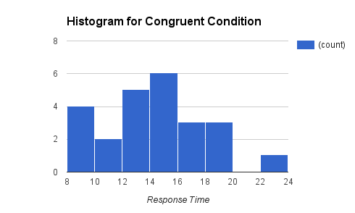

The figure below is histogram for incongruent condition. From the plot, we can observe that the response time almost follows normal distribution with mean at about 22. From the calculations, we can find the mean is 22.016.

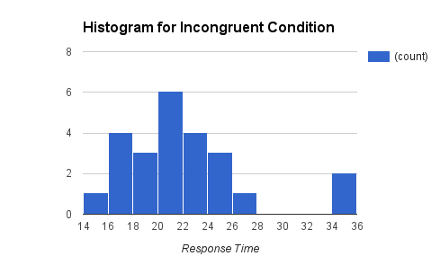

**5. Now, perform the statistical test and report your results. What is your confidence level and your critical statistic value? Do you reject the null hypothesis or fail to reject it? Come to a conclusion in terms of the experiment task. Did the results match up with your expectations?**

*C* = 14.051

*I* = 22.016

*SC* = 3.559

*SI* = 4.797

*nc* = 24

*ni* = 24

Mean Difference (*D*) = 7.964

Standard Deviation of the Differences (*SD*) = 4.865

Standard Error (SE) of Mean Difference = 0.993

T-Statistic = 8.02

P-value = 0

Calculating t-critical value at α = 0.05, This is one tailed test.

T-critical = 1.68

As, t-critical is much less than t-statistic, we can reject the null hypothesis.

95% confidence interval (Considering positive values) : (5.917, 10.01)

**Detailed Conclusion :**

1. The t-statistic obtained is much higher than t-critical. Hence, the sample mean falls in the critical region.
2. We can reject the null hypothesis and accept the alternative hypothesis.
3. We can say with much confidence that “It takes more time to name the ink colors in incongruent condition than it takes for congruent condition”.
4. Yes, the results did match up with my expectations.