For this example, we will MySQL database. We are using Employee-Meeting relationship as a many to many relationship example. Each Employee can attain more than one meetings and each meetings can have more than one employee  
.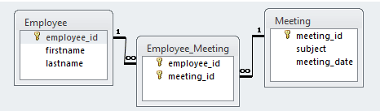

use test;

CREATE TABLE `employee` (

`employee_id` BIGINT(10) NOT NULL AUTO_INCREMENT,

`firstname` VARCHAR(50) NULL DEFAULT NULL,

`lastname` VARCHAR(50) NULL DEFAULT NULL,

PRIMARY KEY (`employee_id`)

)

CREATE TABLE `meeting` (

`meeting_id` BIGINT(20) NOT NULL AUTO_INCREMENT,

`subject` VARCHAR(50) NOT NULL,

`meeting_date` DATE NOT NULL,

PRIMARY KEY (`meeting_id`)

)

CREATE TABLE `employee_meeting` (

`employee_id` BIGINT(20) NOT NULL,

`meeting_id` BIGINT(20) NOT NULL,

PRIMARY KEY (`employee_id`, `meeting_id`),

INDEX `FK_MEETING` (`meeting_id`),

CONSTRAINT `FK_EMPLOYEE` FOREIGN KEY (`employee_id`) REFERENCES `employee` (`employee_id`),

CONSTRAINT `FK_MEETING` FOREIGN KEY (`meeting_id`) REFERENCES `meeting` (`meeting_id`)

)

