For this example, we will use MySQL database. Create following two tables in MySQL. Note that Employee and Department table exhibits One-to-many relationship. Each Department can be associated with multiple Employees and each Employee can have only one Department.
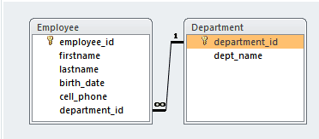
use test;
CREATE TABLE `department` (
`department_id` BIGINT(20) NOT NULL AUTO_INCREMENT,
`dept_name` VARCHAR(50) NOT NULL DEFAULT '0',
PRIMARY KEY (`department_id`)
)
CREATE TABLE `employee` (
`employee_id` BIGINT(10) NOT NULL AUTO_INCREMENT,
`firstname` VARCHAR(50) NULL DEFAULT NULL,
`lastname` VARCHAR(50) NULL DEFAULT NULL,
`birth_date` DATE NULL DEFAULT NULL,
`cell_phone` VARCHAR(15) NULL DEFAULT NULL,
`department_id` BIGINT(20) NULL DEFAULT NULL,
PRIMARY KEY (`employee_id`),
INDEX `FK_DEPT` (`department_id`),
CONSTRAINT `FK_DEPT` FOREIGN KEY (`department_id`) REFERENCES `department` (`department_id`)
)
