1. Check all the hardware including JBOD is any amber light or red light glowing?
2. Check the I/O server (OSS and MDS) in the cluster
3. Login to OSS and MDS check the load on the servers by the below commands.

free –g, top , df -Th

1. Run below commands

List all MDT devices in the Lustre cluster – “lfs mdts”

List all OST devices in the Lustre cluster – “lfs osts”

Show space usage per MDT and OSTs -"lfs df -h"

# Check home directory mounted on all the nodes:

Check whether home directory is mounted or not by running “df -Th” command, if it is not showing the output, check lustre services.

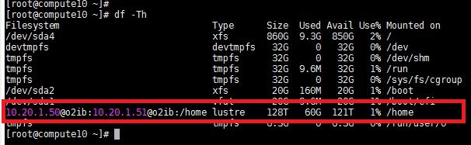

To check whether Infiniband (IB) interface is active and Lustre service is running or not. Run below command

To Verify IB status, run below command and make sure that State: Active and Physical sate: Linkup:

[root@compute10 ~]# **ibstat**

CA ’mlx4_0’

CA type: MT26428

Number of ports: 1

Firmware version: 2.6.0

Hardware version: a0

Node GUID: 0x50800200008e4d38

System image GUID: 0x50800200008e4d3b

Port 1:

State: **Active**

Physical state: **LinkUp**

Base lid: 7

Rate: 56

LMC: 0

SM lid: 13

Capability mask: 0x02510868

Port GUID: 0x50800200008e4d39

If state is showing Down, and Physical state is Polling, run the below command to activate IB interface.

[root@compute10 ~]# **/etc/init.d/openibd start**

**To verify whether Lustre service is running or not run below command.**

[root@compute10 ~]# **/etc/init.d/lnet status**

If it is not running, start the service by running below command

[root@compute10~]# **/etc/init.d/lnet start**

and mount /home using below command

[root@compute10 ~]# **mount -a**

# Jobs are running:

Make sure that all nodes are showing load status 0.00 or greater value as shown below:

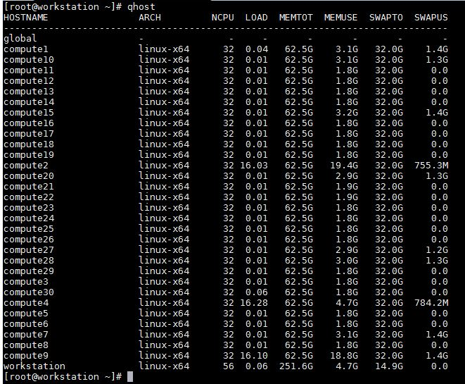

If any one or all nodes’s load status is “-” as shown below example for compute5 to compute8, then the node is down or sge_execd service is not running in the nodes, to diagnose the node further:

# If jobs are not running or scheduler have any issue then:

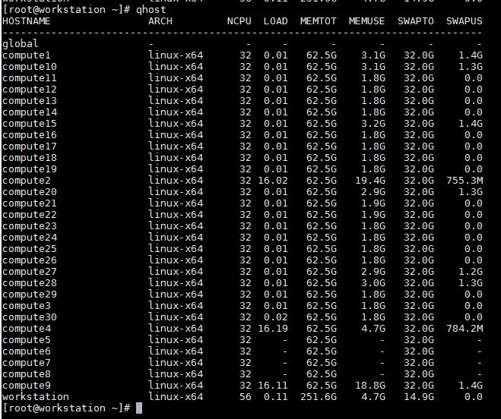

check the node is accessible using ssh command, if we are able to login using ssh, login to the node and make sure that “/**home/SGE/ge2011.11/bin/linux-x64/sge_execd”** process is running in the node, as shown below, “ps aux |grep sge_execd” command output.

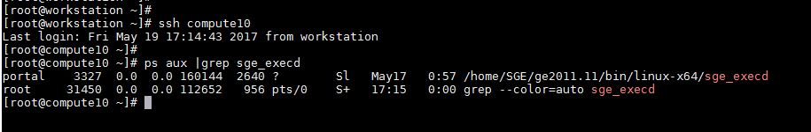

if sge_execd process is not running run the below command to start sge_execd service and check the load of the node using “qhost” command.

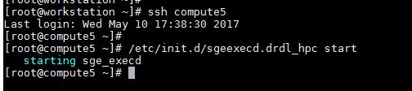

To start the service in multiple nodes, login to masternode and run **pdsh -w compute[5-8] "/etc/init.d/sgeexecd.drdl_hpc start”** command to start sge_execd service in compute5 to compute8 nodes as shown below:

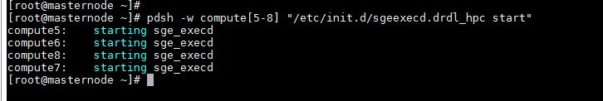

Make sure that “qstat -f” output of all nodes are showing “status” as blank, as shown below

[root@workstation ~]# qstat -f

queuename qtype resv/used/tot. load_avg arch states

---------------------------------------------------------------------------------

all.q@compute1 BIPC 0/0/32 0.01 linux-x64

---------------------------------------------------------------------------------

all.q@compute10 BIPC 0/0/32 0.01 linux-x64

---------------------------------------------------------------------------------

all.q@compute11 BIPC 0/0/32 0.03 linux-x64

---------------------------------------------------------------------------------

all.q@compute12 BIPC 0/0/32 0.01 linux-x64

If any one or all nodes showing “s” status, (“s” for Suspended), then “all.q” may be in suspended state.

[root@workstation ~]# **qstat -f**

queuename qtype resv/used/tot. load_avg arch states

---------------------------------------------------------------------------------

all.q@compute1 BIPC 0/0/32 0.01 linux-x64 **s**

---------------------------------------------------------------------------------

all.q@compute10 BIPC 0/0/32 0.01 linux-x64 **s**

---------------------------------------------------------------------------------

all.q@compute11 BIPC 0/0/32 0.03 linux-x64 **s**

---------------------------------------------------------------------------------

all.q@compute12 BIPC 0/0/32 0.01 linux-x64 **s**

To unsuspend all.q queue run below command from masternode or workstation or submitnode

[root@workstation ~]# **qmod -us all.q**

Queue instance "all.q@compute25" is already in the specified state: unsuspended

Queue instance "all.q@compute12" is already in the specified state: unsuspended

Queue instance "all.q@compute26" is already in the specified state: unsuspended

Queue instance "all.q@compute16" is already in the specified state: unsuspended

Queue instance "all.q@compute5" is already in the specified state: unsuspended

Queue instance "all.q@compute11" is already in the specified state: unsuspended

If any one or all nodes showing “d” status, (“d” for disabled state), then “all.q” queue is in state.