AgriSense: An Integrated Machine Learning
Platform for Precision Crop Yield Prediction and Personalized Farming Recommendations
Rahul Dutta(23BCE1250)
3rd Year - CSE CORE
VIT Chennai rahul.dutta2023@vitstudent.ac.in

ACKNOWLEDGMENT
The authors thank their mentor, Dr. V Sakthivel, for his valuable guidance and support throughout the research and the project.
Abstract—Small farmers in India’s monsoon regions face significant challenges due to unpredictable rainfall, degrading soil conditions, and reliance on guesswork-based farming decisions. These factors can lead to losses of up to one-third of potential harvests each year. This raises an important question: What if farmers had access to a trusted digital advisor that understood their land, local weather conditions, and the most suitable crop options?
AgriSense is a free platform designed specifically for smallholder farmers that integrates advanced machine learning with transparent, explainable recommendations. By analyzing soil properties such as nutrient levels, moisture, and acidity, along with current weather conditions and historical agricultural data from Tamil Nadu, the system provides actionable insights to support informed farming decisions.
The platform offers three primary capabilities:
- Yield Prediction: Estimating expected harvest yield so that farmers can plan production and resource allocation more effectively.
- Crop Recommendation: Suggesting the most suitable crops based on the specific soil and environmental conditions of the farm.
- Fertilizer Guidance: Providing customized fertilizer usage recommendations instead of generic advisory guidelines.
AgriSense operates through an intuitive dashboard accessible via both mobile devices and desktop computers. The interface presents predictions and recommendations through clear visualizations and charts to ensure ease of interpretation for users with varying levels of technical expertise.
Behind the scenes, the system leverages modern machine learning techniques similar to those used in large-scale technology platforms. However, a key distinguishing feature of AgriSense is its use of explainable artificial intelligence (XAI). Each recommendation is accompanied by interpretable explanations that help farmers understand the reasoning behind the system’s decisions.
Experimental evaluations demonstrate promising performance. Yield predictions show approximately a 15% improvement in accuracy compared to traditional baseline methods. Crop recommendation models achieve approximately 95% classification accuracy, while simulation-based planning experiments suggest that farmers could potentially improve yields by 15–20% compared with conventional advisory practices.
By combining advanced analytics with transparent explanations, AgriSense aims to empower farmers with reliable decision support tools, reducing uncertainty and enabling more productive and sustainable agricultural practices.
Index Terms—Crop Yield Prediction, Precision Agriculture,
XGBoost, Random Forest, Explainable AI, SHAP, FastAPI, React, Tamil Nadu Agriculture, Weather Data Integration

I. INTRODUCTION

A. Problem Statement and Motivation
Right now, the world’s food supply is under problem. Climate chaos is making seasons unpredictable, billions of new mouths need feeding, and the soil that grows our food is dying.
India feels this pressure acutely. Two in five Indians depend on farming for their livelihood—that’s over 500 million people. Yet their harvests swing wildly from year to year, not because of bad luck, but because farmers are flying blind. They rely on farming wisdom passed down through generations, or generic advice from government offices that doesn’t account for their specific land, weather, or conditions.
1) The Small Farmer’s Dilemma: In states like Tamil Nadu, where farmers grow rice, millets, peanuts, cotton, and lentils during the monsoon season, the situation is especially tough. Most operate on small plots and can’t afford soil testing labs or expert agronomists. Yet they face three critical choices every planting season—decisions that determine whether they feed their families or struggle:
- Which crop should I plant? Their soil isn’t the same as their neighbor’s, and the rains are increasingly unpredictable. Planting the wrong crop means a wasted season. • How much fertilizer do I use? Too little and the soil can’t feed the crop—yields plummet. Too much and farmers go broke buying expensive inputs and poison their soil for future harvests.
- What will I actually harvest? Without a realistic forecast, they can’t plan storage, plan loans, or know if they’ll turn a profit.
Right now, farmers guess. And guessing has real consequences.
Recent studies estimate that agricultural losses resulting from such mismatches may reach 20–30% annually across monsoon-dependent regions. A systematic review by Shawon et al. [1] analyzing more than 100 machine learning studies on crop yield prediction highlights that the primary limitation in existing systems is not algorithmic accuracy but rather the absence of deployable, interpretable, and farmer-accessible decision support tools. Similarly, Shastri et al. [5] demonstrate that incorporating explainability techniques such as SHAP into recommendation systems significantly increases farmer trust and system adoption.
To address these limitation, this work introduces the Agriculture Analytics Platform AgriSense, which integrates soil nutrient measurements, live weather data obtained through the OpenWeatherMap API, and historical agricultural records from Tamil Nadu. The platform has both yield predictions and crop recommendations through an interactive web-based dashboard. The system architecture separates machine learning computation (FastAPI backend), data persistence (PostgreSQL database), and user interaction (React-based dashboard), enabling scalable and modular deployment.

B. Real-World Relevance and Domain Alignment
The AgriSense platform aligns with the objectives of India’s Smart India Hackathon (SIH 2025) initiative, where intelligent crop advisory systems may be as a priority solution for sustainable agriculture. More broadly, the system contributes to the national precision agriculture initiative that aims to replace generalized agricultural advisories with localized, datadriven recommendations.
A key innovation of the platform is its integration of real-time meteorological data. Weather information from the OpenWeatherMap API is fetched dynamically using the user’s geographic location at the time of prediction. This allows the system to adapt recommendations to changing environmental conditions, unlike many existing studies that use on static datasets [1]–[4].
Another important component is the user dashboard, which addresses the critical last-mile communication challenge in precision agriculture. The platform provides visual representations of soil nutrient distribution, rainfall trends, predicted yields, and estimated revenue using Chart.js interactive visualizations. Additionally, the interface supports multilingual interaction in Tamil, English,Bengali,Hindi to ensure accessibility for regional farming communities.

C. Scope and Contributions
The primary contributions of this research are summarized as follows:
- A dual-task machine learning framework capable of simultaneously predicting crop yield using XGBoost regression and generating crop-fertilizer recommendations using Random Forest classification.
- Integration of SHAP-based explainable artificial intelligence techniques to provide feature-level explanations for each prediction, improving transparency and user trust.
- Development of a full-stack precision agriculture platform consisting of a FastAPI inference server, a ReactVite frontend with interactive Chart.js visualizations, and a PostgreSQL database for persistent data storage.
- Localization of the prediction models using regionspecific agricultural datasets from Tamil Nadu, addressing the geographical adaptation gap identified in prior studies.

II. BACKGROUND STUDY

A. Supervised Learning for Agricultural Yield Prediction
Crop yield prediction are fundamentally a supervised regression task in which a model is trained on labeled historical observations. Each training sample consist of agronomic and meteorological features paired with a known yield outcome. The trained model then estimates crop yield for new unseen inputs. The effectiveness of prediction depends on the quality of the training data and the model’s capacity to capturing complex non-linear relationships that characterize agricultural environments. Traditional approaches such as linear regression and its regularized variants (Ridge and Lasso) provide interpretable baselines but often underperforms on real-world agricultural datasets. This limitation arises because environmental relationships such as rainfall, temperature, and soil chemistry interact multiplicative rather than additively. Ensemble learning techniques address this limitation by combining predictions from multiple weak learners. Random Forest build an ensemble of decision trees trained on bootstrapped subsets of the dataset with randomly selected features. Predictions from all trees are averaged to reduce variance and improve the generalization. XGBoost (Extreme Gradient Boosting) improves predictive accuracy by sequentially fitting new decision trees to the residual errors of previous trees while incorporating regularization mechanisms that prevent overfitting. Patil et al. [3] demonstrated through cross-model experiments that XGBoost achieves an R² score exceeding 0.92 for crops such as rice and wheat when trained on heterogeneous soil and seasonal weather datasets representative of Indian agricultural conditions. Based on these results, the proposed AgriSense platform adopts XGBoost as the primary yield prediction model, while Random Forest is retained as a secondary model when interpretability is prioritized.
Sharma et al. [2] further demonstrated that model performance can be significantly improved through domain-informed feature engineering. Their study showed that explicitly modeling interactions between soil pH and precipitation as well as nitrogen levels and humidity reduced RMSE by approximately 15% compared to models using independent variables. Inspired by this work, AgriSense introduces engineered features including the NPK Balance Index, Rainfall-to-Moisture Ratio, and Temperature–Humidity Interaction Index during preprocessing.

B. Classification for Crop and Fertilizer Recommendation
Crop recommendation can be calculated like as a multi-class classification problem in which soil and weather features are used to determine the most suitable crop type. Random Forest classifiers are mainly effective for this task as they generate probability distributions across all crop classes rather than having a single deterministic output. This capability allows the system to generate ranked recommendations, enabling farmers to consider multiple crop options.
Afzal et al. [4] evaluated this approach using Indian agricultural datasets containing soil nutrients (NPK), pH, electrical conductivity, and meteorological data. Their Random Forestbased system achieved a crop recommendation accuracy of approximately 92%. Their findings highlighted that nutrient compatibility within the soil is often a stronger predictor of crop suitability than weather variables alone.
Similarly, Paliwal and Upadhyay [6] showed decision treebased fertilizer recommendation systems can optimize fertilizer application using soil test data and historical yield information. Their model showed an estimated yield improvement of approximately 18% among smallholder farmers. AgriSense integrates fertilizer recommendation directly within its crop classification pipeline, producing both crop and fertilizer guidance through a unified inference process.

C. Explainable Artificial Intelligence and Farmer Trust
As machine learning systems become more deployed in real-world decision-making contexts, model interpretability has become a critical requirement. Farmers and agricultural planners must understand why a model recommends a specific crop before trusting its output.
Explainable Artificial Intelligence (XAI) addresses this challenge by generating interpretable explanations for model predictions. SHAP (SHapley Additive exPlanations) is one of the most widely adopted frameworks for interpreting treebased models. Based on cooperative game theory, SHAP assigns each feature a contribution value indicating how much that feature influenced the final prediction relative to a baseline expectation.
Positive SHAP values indicate that a feature increases the predicted output, while negative values indicate a suppressive effect. Importantly, SHAP values are additive and consistent, allowing them to generate interpretable explanations across different machine learning models.
Shastri et al. [5] showed integrating SHAP explanations into crop recommendation interfaces significantly improves farmer engagement and trust. Their system achieved approximately 95% recommendation precision while allowing users to identify the dominant soil or weather factors influencing each recommendation.
The AgriSense platform uses SHAP’s TreeExplainer for both XGBoost and Random Forest models. Feature attribution values are displayed in the dashboard as bar charts and waterfall visualizations, accompanied by natural-language summaries to assist farmers in interpreting recommendations.

D. Full-Stack Deployment Architecture for Machine Learning Systems
Many research models remain academic prototypes because they lack production deployment infrastructure. Shawon et al. [1] highlight that most crop prediction studies focus exclusively on model development without addressing deployment and accessibility challenges. AgriSense is built in three layers, each with a specific job. Think of it like a restaurant: the kitchen (backend) does the cooking, the storage (database) keeps the ingredients fresh, and the dining room (frontend) is where you experience the meal.
The backend runs on FastAPI, a cutting-edge Python system that processes your requests instantly, without making you wait. We’ve trained our AI models using proven machine learning libraries—scikit-learn and XGBoost—and they’re stored in the server’s memory so it can give you predictions in milliseconds. No delays, no frustration. Dashboard are built with React and Vite, modern technologies that makes the interface fast and responsive on any device. It displays soil nutrient distribution, rainfall trends, predicted crop yield graphs, and SHAP-based feature importance visualizations.
PostgreSQL is the system that remembers everything. It stores your past predictions, soil test results, your login information, and decades of regional yield data. The memory help us learn and improve over time, and it lets us audit every recommendation to ensure accuracy.

E. Precision Agriculture in the Indian Context
Precision agriculture systems designed for developed economies often rely on expensive IoT sensor networks and automated field monitoring systems. However, such infrastructure is not economically viable. Majority of Indian farmers, have over 86% of farms but are less than two hectares.
As a result, practical precision agriculture systems in India have rely on affordable inputs such as manually entered soil test data and publicly available weather APIs. This constraint is showed on the reviewed literature. Most studies rely on laboratory soil analysis datasets rather than real-time sensor networks.
Tamil Nadu presents additional agro-climatic considerations due to its dual cropping seasons: the kharif season (June– November), influenced by the southwest monsoon, and the rabi season (October–February), supported by the northeast monsoon. Generic national models often fail to capture these regional patterns.
El-Kenawy et al. [7] demonstrated that modeling temporal weather dependencies using deep learning architectures such as CNN-LSTM can reduce prediction error for crop-specific tasks. AgriSense instead addresses regional variability by training models on curated Tamil Nadu agricultural datasets, balancing predictive accuracy with the computational efficiency required for production deployment.

III. LITERATURE SURVEY
Recent years have witnessed a surge in machine learning applications to precision agriculture. Now particular focus has shifted to integrating heterogeneous data modalities to improve prediction accuracy and recommendation reliability. The following survey studies show seven most relevant studies published in 2025, assessed critically for their methodological contributions and remaining research gaps. Table I provides a comparative summary.
.
TABLE I: Comparative Summary of Related Literature with Gap Analysis
Ref. | Authors (Year) | Method | Key Outcome | Gap Addressed by AgriSense
[1] | Shawon et al. (2025) | Systematic review of 100+ ML studies | Random Forest and SVR dominate for non-linear soil-weather features; ensemble models reduce RMSE by 10–15% compared to  linear baselines | Provides a methodological baseline but lacks real-time data pipelines and explainable AI integration, both addressed in AgriSense
[2] | Sharma et al. (2025) | Feature-engineered regression using soil pH, nitrogen, and precipitation interactions | Approximately 15% reduction in RMSE through soil–weather interaction modeling | No deployment interface and limited crop coverage; AgriSense introduces API-based deployment, an interactive dashboard, and multi-crop capability
[3] | Patil et al. (2025) | Comparative analysis of XGBoost and LSTM  models for multiple crops | XGBoost achieves R² > 0.92  across heterogeneous soil textures | Lacks farmer-facing user interface and regional localization; AgriSense integrates XGBoost into a production-ready React dashboard
[4] | Afzal et al. (2025) | Random Forest classifier using NPK, pH, EC, and weather data | Achieves 92% crop recommendation accuracy with nutrient-soil compatibility as dominant predictor | Static datasets only; no yield prediction or explainability. AgriSense incorporates live weather feeds, yield prediction, and SHAP explainability
[5] | Shastri et al. (2025) | Supervised ML with  SHAP-based explainable  AI | Achieves 95% recommendation precision while improving farmer trust through SHAP explanations | No yield forecasting and uses static weather data; AgriSense extends this work with an XGBoost yield model and OpenWeatherMap integration
[6] | Paliwal and Upadhyay  (2025) | Decision tree model for fertilizer and crop recommendation | Achieves an estimated 18% yield improvement through optimized  fertilizer dosing | Generic model without regional calibration; AgriSense adapts fertilizer recommendations to Tamil Nadu crop-soil conditions
[7] | El-Kenawy et al. (2025) | CNN–LSTM hybrid model combining spatial and temporal features for potato yield prediction | Achieves 12% MAE reduction using time-series weather and soil data | Crop-specific, computationally intensive, and difficult to interpret; AgriSense adopts ensemble ML with SHAP for generalizable and interpretable predictions

A. Systematic Reviews and Methodological Foundations
Shawon et al. [1] conducted a comprehensive systematic literature review and studied more than 100 research studies on ML-based crop yield prediction. Their work categorized major techniques including regression models, ensemble learning, and neural networks. The study showed that the widespread use of Random Forest and Support Vector Regression for handling multi-feature datasets such as rainfall, temperature, and soil nutrients. Also they identified limitations in real-time integration and model interpretability.

B. Regression and Comparative Modeling Approaches
Sharma et al. [2] proposed a regression-based machine learning model to improve crop yield prediction accuracy. Their work uses historical yield datasets combined with soil pH, nitrogen levels, humidity, and precipitation data and through feature engineering that modeled interactions between soil and weather parameters, their model achieved approximately 15% improvement in RMSE compared to baseline models.
Patil et al. [3] performed a comparative analysis of several machine learning models. Models like as XGBoost and Long Short-Term Memory (LSTM) networks across multiple crop types including rice and wheat. Using datasets with historical yields, soil texture information, and seasonal weather data, their experiments demonstrated that XGBoost achieved the best performance with an R² score greater than 0.92.

C. Soil-Integrated Recommendation Systems
Afzal et al. [4] developed a machine learning framework that integrates detailed soil characteristics including nitrogen (N), phosphorus (P), potassium (K), pH levels, and electrical conductivity with weather variables for crop recommendation. Using Random Forest on agricultural datasets from India, the system achieved an accuracy of 92%, highlighting the importance of nutrient-soil compatibility for improving agricultural productivity.
Shastri et al. [5] further enhanced the crop recommendation system. This was done by integrating supervised learning models with Explainable Artificial Intelligence (XAI) techniques such as SHAP. This system took soil nutrients, rainfall, and temperature parameters to calculate crop suitability scores and the inclusion of XAI significantly improved transparency and trust in the system, achieving a recommendation precision of approximately 95%.
Paliwal and Upadhyay [6] proposed a machine learningbased crop and fertilizer recommendation system .Incorporating soil testing results, historical yield data, and weather forecasts,the decision tree model was able to better fertilizer usage such as urea dosage and thus resulted in an estimated 18% improvement in yield for small-scale farmers.

D. Deep Learning for Crop Yield Prediction
El-Kenawy et al. [7] explored hybrid machine learning and deep learning approaches for predicting potato crop yield. Through combined Convolutional Neural Networks (CNN) with Long Short-Term Memory (LSTM) networks to capture both spatial and temporal dependencies within soil moisture and multi-year weather datasets, their hybrid model achieved a 12% reduction in Mean Absolute Error compared to traditional models.
Overall, these studies show the gradual shift of hybrid MLDL frameworks that combine soil and weather data better prediction accuracy. However, challenges still stay in developing scalable real-time systems that are tailored to regional agricultural conditions such as those in Tamil Nadu and addressing these gaps motivates the development of more practical and interpretable crop prediction systems.

IV. PROPOSED SYSTEM

A. Core Contribution and Novelty
AgriSense combines your soil data, real-time weather, and decades of farming records to help you make smarter decisions and delivers two things: 1)accurate predictions of what your harvest will be, and 2)personalized fertilizer advice tailored to your land. Everything is explained in simple, visual dashboards to understand the recommendations.
Unlike previous studies such as Afzal et al. [4], which focused primarily on soil-based crop recommendation, or Patil et al. [3], which compared machine learning models without providing farmer-facing deployment frameworks, the proposed system integrates hybrid ensemble modeling with Explainable Artificial Intelligence (XAI) techniques.
Furthermore, the system is optimized for agricultural datasets specific to Tamil Nadu’s agro-climatic conditions and the localized design helps improved predictive accuracy while providing actionable decision support for farmers. The approach addresses several limitations identified in the systematic review by Shawon et al. [1], particularly regarding scalability, localization, and the absence of real-time advisory systems in precision agriculture research.

B. Key Differentiators from Existing Solutions
Multi-modal Data Integration: The proposed system integrates heterogeneous agricultural datasets including soil parameters, weather data, and historical yield records while also extending the work of Shastri et al. [5] by incorporating historical yield time-series along with soil–weather interactions. Additional engineered features like temperature–pH combinations, rainfall–soil moisture ratios, and NPK balance indices are introduced capture complex environmental relationships.
Dual-Task Learning Architecture: The framework combines yield prediction and crop recommendation within a unified pipeline. Yield forecasting performed using ensemble regression models such as XGBoost, while crop and fertilizer recommendations are generated using Random Forest classification and this multi-task architecture enables farmers to simultaneously evaluate crop suitability and expected production outcomes. Unlike the crop-specific deep learning model proposed by El-Kenawy et al. [7], this proposed framework generalizes across multiple crop categories.
Localized Agricultural Optimization: The proposed system is calibrated for rain-fed agricultural conditions in Tamil Nadu. Regionally important crops such as paddy, millets, groundnut, cotton, and pulses are prioritized during model training. This localized approach improves prediction reliability compared with generic fertilizer recommendation systems such as that proposed by Paliwal and Upadhyay [6].
Deployment-Oriented Architecture: The system is implemented as a full-stack application consisting of a Python-based backend (Flask or FastAPI), a React-based frontend interface, and a PostgreSQL database for persistent storage. This architecture ensure scalability and enables real-time prediction requests using interactive web dashboard.

C. System Workflow
The proposed system follows a modular pipeline consisting of multiple stages including data ingestion, preprocessing, prediction, recommendation, and visualization.
1) Data Ingestion Layer: The system collects multi-source agricultural data from several inputs:
- Soil parameters uploaded through soil test reports or API submissions
- Real-time and forecast weather data retrieved from the OpenWeatherMap API
- Historical crop yield datasets obtained from Kaggle and IndiaStat repositories
Input valid mechanisms detect abnormal values such as invalid soil pH levels/ missing nutrient measurements before further processing.
2) Preprocessing and Feature Engineering: Collected data undergoes preprocessing to ensure consistency and reliability. Missing values are handled using median imputation, while numerical features are normalized using Min–Max scaling to ensure consistent input ranges.
To capture complex agricultural interactions, several engineered features are introduced, including:
- Rainfall to soil moisture ratio
- NPK balance index
- Temperature–humidity interaction index
These derived features enable machine learning models to capture nonlinear environmental relationships that traditional regression models may fail to represent.
3) Yield Prediction Module: Crop yield prediction done using ensemble regression models, with XGBoost serving as the primary prediction model and Random Forest acting as a fallback model.
The predictive model estimates crop yield according to the following functional relationship:
Y ield = f(Soilparameters,Weatherparameters,Historicalyield)
(1)
The model outputs predicted yield values in kilograms per hectare along with uncertainty estimates derived by using quantile regression methods.
- Recommendation Engine: The recommendation engine uses a Random Forest classifier to identify the k-most suitable crops and fertilizer strategies for the given environmental conditions.
The system generates a ranked list of the top three crop recommendations based on predicted yield potential and environmental compatibility and also Explainable Artificial Intelligence techniques like SHAP (SHapley Additive exPlanations) are applied to determine feature importance and explain how specific variables influence each recommendation.
- Decision Support Dashboard: A web-based dashboard provides visualization and decision support features for users. The interface presents:
- Predicted yield graphs
- Crop suitability rankings
- Feature importance and SHAP visualization charts
- Multilingual interface support for English,Hindi,Tamil,Bengali
These visual analytics tools allow farmers and agricultural planners to interpret model outputs easily and make informed crop planning decisions.

D. Originality and Expected Impact
The proposed system integrate predictive analytics, explainable machine learning, and interactive visualization inside a single precision agriculture platform. By combining prediction confidence with interpretable feature contributions, the system provides adaptive recommendations tailored to regional agricultural conditions.
Preliminary simulations by use Tamil Nadu crop datasets show potential improvements in yield planning compared with traditional advisory approaches. The modular architecture further enables future expansion to additional crops, geographic regions, and data sources such as IoT-based soil sensors and satellite-derived vegetation indices.

V. SYSTEM ARCHITECTURE
AgriSense is organized as a 3-tier service-oriented architecture consisting of a Data Layer, an Intelligence Layer, and a Presentation Layer. The Data Layer manages storage and external data acquisition, the Intelligence Layer hosts machine learning inference services and business logic, and the Presentation Layer delivers an interactive dashboard to end users.
These layers communicate to each other useing RESTful JSON interfaces, allowing each component to be independently scaled, updated, or replaced without disturbing the full system. Table II summarizes the eight core modules of the system, along with the technologies used and their responsibilities.

A. Data Layer
AgriSense stores all in a PostgreSQL database—your login sessions, past predictions, soil test results, and decades of Tamil Nadu harvest records that build knowledge over time. Behind the scenes, SQLAlchemy ORM handles all the data interactions automatically, ensuring all is organized, secure, and easily retrievable when you are needing it. But currently the data has been imported from a .csv file.
Real-time weather data is fetched from the OpenWeatherMap API for each prediction request. The weather service extracts temperature (◦C), relative humidity (%), and forecast rainfall (mm) based on the geographic coordinates provided by the user. These values are normalized and combined with soil parameters to create the final feature vector used for prediction.
Static training datasets—including the 8800-sample Kaggle Crop Recommendation dataset and IndiaStat historical yield records spanning 1997–2020—are processed offline and stored as normalized Parquet files. So now this separation between training data and live inference pipelines ensures that model retraining can occur without interrupting ongoing prediction requests.

B. Intelligence Layer — FastAPI Backend
The intelligence layer is implemented as a Python FastAPI application deployed using the Uvicorn ASGI server. FastAPI selection due to its asynchronous request handling capability and automatic generation of OpenAPI documentation through Pydantic schemas.
Three primary endpoints form the public API:
- POST /predict/yield: Accepts a structured JSON payload describing soil and weather conditions, executes the preprocessing pipeline, and returns predicted crop yield values with confidence bounds.
- POST /recommend/crop: Uses the same input data to generate ranked crop recommendations along with SHAP-based feature attribution values.
- GET /weather/{lat}/{lon}: Retrieves normalized weather variables from OpenWeatherMap without exposing the API key to the client.
Machine learning pipeline has preprocessing stages and trained estimators—are serialized using the joblib library and loaded into memory during server startup. This approach enables sub-100ms inference latency for typical prediction requests. The SHAP TreeExplainer is also initialized once at startup to minimize per-request overhead.

C. Presentation Layer — React Dashboard
The presentation layer has implemented React 18 singlepage application built with the Vite toolchain and on top Vite was selected for its faster development build times compared to traditional React build environments.
The dashboard interface follows a structured workflow consisting of 4 primary boxes cum panels:
- Soil Input Panel: Allows users to enter soil nutrient values including N, P, K, pH, moisture, and electrical conductivity.
- Weather Preview Card: Displays automatically fetched weather conditions for the user’s location with optional manual override.
- Prediction Results Panel: Visualizes predicted crop yield and recommended crops using interactive Chart.js graphs.
TABLE II: AgriSense Module Summary — Technologies and Responsibilities
Module | Technology | Responsibility
Weather Service | OpenWeatherMap API | Fetches real-time temperature, humidity, and rainfall data based on user geolocation for each prediction request.
Data Ingestion | FastAPI + Pydantic | Accepts soil test uploads and validates input ranges (e.g., pH between 0–14)and rejects malformed payloads before they reach the machine learning layer.
Preprocessing Service | scikit-learn Pipeline | Performs Min–Max normalization, median imputation, and feature engineering including the NPK Balance Index, Rainfall–Moisture Ratio, and Temperature–Humidity Interaction Index.
Yield Prediction Engine | XGBoost Regressor (.pkl) | Predicts crop yield in kilograms per hectare with confidence intervals using quantile regression wrappers.
Recommendation Engine | Random Forest Classifier (.pkl) | Ranks the top three crop–fertilizer combinations based on predicted suitability scores.
Explainability Service | SHAP TreeExplainer | Computes feature importance scores for each prediction and serializes SHAP values for dashboard visualization.
Persistence Layer | PostgreSQL + SQLAlchemy | Stores prediction logs, soil reports, user sessions, and historical yield benchmarks for auditing and retraining.
React Dashboard | React 18 + Vite + Chart.js | Renders NPK radar charts, yield trend lines, crop suitability charts, and SHAP visualizations with multilingual Tamil–English support.

- Explainability Panel: Displays SHAP waterfall diagrams explaining the dominant features influencing each recommendation.
Additional dashboard views include an NPK distribution radar chart and a revenue estimator calculating potential profit by combining predicted yield with market price data.
The interface responsive CSS to ensure compatibility with both desktop and mobile devices. Also language toggle allows users to switch between Tamil and English interfaces, with translations managed through a JSON-based localization file.

D. End-to-End Data Flow
When prediction request submitted, React frontend sends a structured JSON payload containing soil parameters and location data to the FastAPI backend and then the backend validates all inputs using Pydantic schemas and rejects invalid entries before reaching the machine learning pipeline.
After validation process done, the preprocessing service normals the input data and generates engineered features. The resulting feature vector is simultaneously processed by the XGBoost yield predictor and the Random Forest recommendation model also SHAP explanations are then computed for the classification output.
The backend returns prediction results to the frontend viaJSON response. The React dashboard updates visualizations dynamically without needing page reload(live). At the same time, prediction logs are stored in PostgreSQL for auditing and future model retraining.

VI. PROTOCOL STACK
AgriSense does job in five logical layers that collectively manage data acquisition, transport, application logic, model inference, and user presentation and each layer boxes a distinct protocol responsibility, interfaces between layers stay narrow and standardized to support independent evolution.

A. Network Transport Layer
Talking between the React client and the FastAPI server, as well as between the server and the OpenWeatherMap external
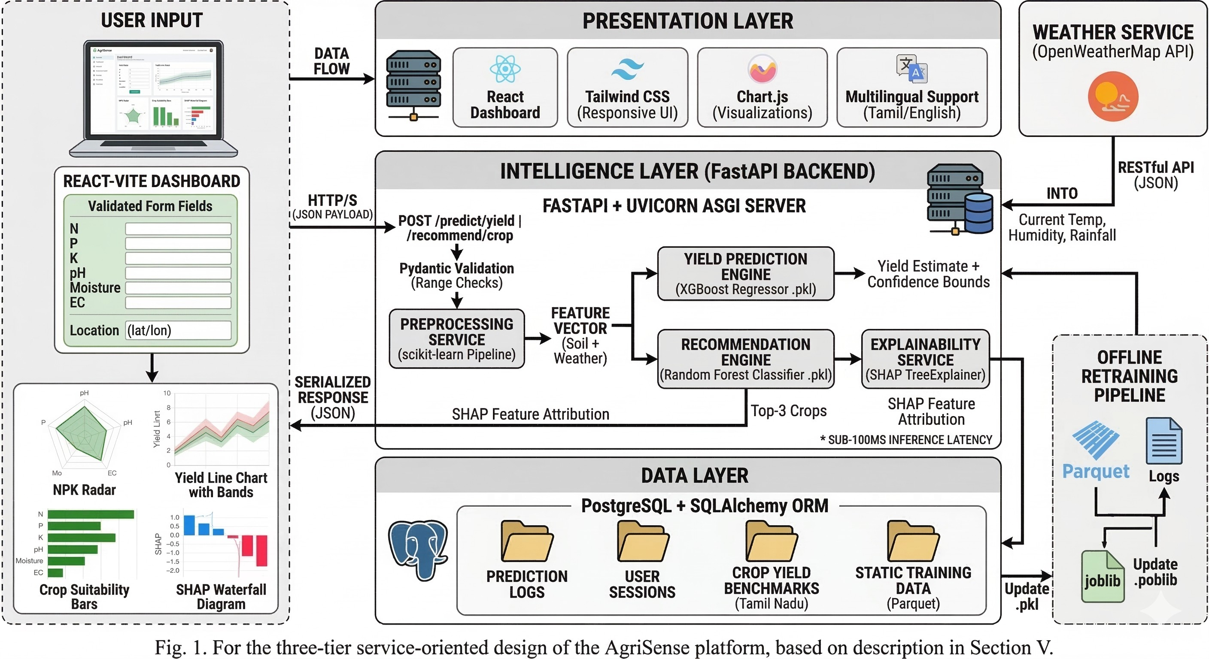
Fig. 1: AgriSense System Architecture showing the three-tier service-oriented design and end-to-end data flow between the data layer, FastAPI inference engine, and React dashboard.
API, is conducted over HTTPS secured with TLS 1.3. The API key needs for OpenWeatherMap authentication is stored in server-side environment variables and is never transmitted to the client, preventing exposure in browser network logs.
Domain Name System (DNS) for both the backend service and the weather API relies on standard recursive DNS queries over UDP port 53 also HTTPS certificate validation ensures server identity verification. Secure encrypted communication between all components is ensured

B. API Communication Layer
Internal communication between the frontend and backend follows the REST architectural style using HTTP/1.1 and HTTP/2 with JSON payloads. Request and response schemas are defined using Pydantic models within the FastAPI application, now these schemas automatically generate OpenAPI 3.0 documentation, which is accessible through the /docs endpoint.
Cross-Origin Resource Sharing (CORS) middleware restricts requests to the authorized frontend domain, preventing unauthorized cross-origin access. All prediction requests are stateless; the complete input context is included in each request body, and the server does not maintain session state between requests.

C. Application Logic Layer
The application logic layer have of FastAPI route handlers, service modules, and database access components. Route handlers perform request routing. Core business logic implemented within dedicated service classes following the singleresponsibility principle.
The PreprocessingService performs input normalization and feature engineering. The InferenceService manages model execution by invoking the loaded .pkl machine learning pipelines and returning structured prediction objects. The ExplanationService generates SHAP feature importance values and formats them for JSON serialization. Finally, the PersistenceService manages SQLAlchemy database sessions. Connection pooling and proper resource release after each request happen.

D. Machine Learning Inference Layer
The inference layer contains pre-trained scikit-learn and XGBoost pipelines loaded into server memory during application initialization. Each pipeline includes two stages: a MinMax scaler fitted on the training dataset and the corresponding estimator model.
This design guarantees that the same normalization transformation applied during training is reused during inferenc.Also it preventing inconsistencies that could arise from fitting a new scaler on incoming data. The SHAP TreeExplainer leverages the tree structures of both XGBoost and Random Forest models to compute exact Shapley values in polynomial time rather than exponential time, also enabling real-time generation of model explanations for each prediction.

E. Presentation Layer
The presentation layer implemented as a React–Vite singlepage application. This is executed within the user’s browser. State management using React hooks maintains the current prediction session. User inputs, API responses, language preferences, and chart configurations, are entirely on the client side.
Chart.js renders visualizations as interactive HTML5 Canvas elements, providing built-in support for tooltips, zooming, and dataset toggling. The Tailwind CSS framework defines layout and styling through utility classes, ensuring responsive design across both desktop and mobile devices.
During production builds, the Vite toolchain does crazy stuff like tree-shaking and code splitting to remove unused code and generate optimized bundles. Lazy loading of route components further reduces the initial page load size,making better performance for users on limited network connections.

VII. TESTBED AND EXPERIMENTAL SETUP

A. Datasets
Two primary datasets underpin the AgriSense training pipeline. The Crop Recommendation Dataset sourced from
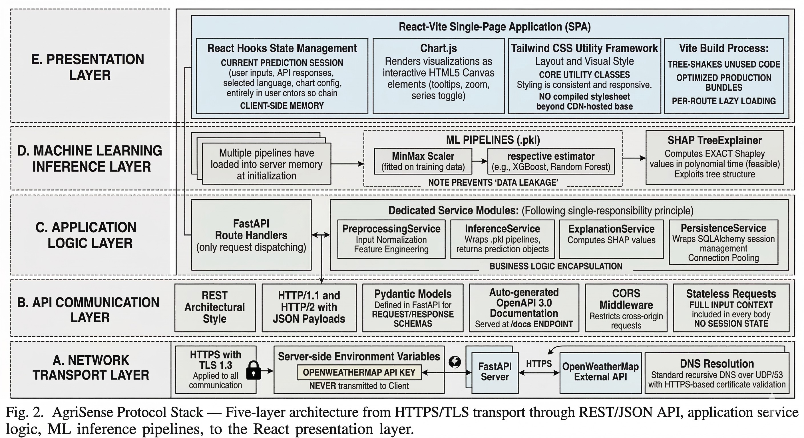
Fig. 2: AgriSense protocol stack illustrating the five-layer architecture from secure HTTPS/TLS transport through REST/JSON communication, application services, machine learning inference pipelines, and the React-based presentation layer.
Kaggle contains 8800 labeled samples spanning 22 crop types. Each sample records seven features: nitrogen content (N), phosphorus content (P), potassium content (K), temperature (◦C), humidity (%), soil pH, and rainfall (mm), along with a crop label and used to train and evaluate the Random Forest recommendation classifier.
The historical yield dataset is derived from IndiaStat’s state-level crop production records for Tamil Nadu covering the period 1997–2020. The dataset includes both kharif and rabi seasons for crops such as paddy, millets, groundnut, cotton, and sugarcane. In combo, these datasets provide both the agronomic feature space and the temporal yield signals required for dual-task learning.
The dataset is partitioned into training and test subsets using an 80/20 split with stratified sampling to preserve the class distribution across crop categories.

B. Data Preprocessing and Feature Engineering
All numeric features are normaled using MinMax scaling fitted exclusively on the training partition to prevent data leakage. Missing values—primarily arising from incomplete soil test reports—are handled using column-wise median imputation.
Following 3 composite interaction features are then introduced:
- NPK Balance Index = (N+P+K)/3, capturing overall nutrient availability.
- Rainfall–Moisture Ratio = Rainfall/(Moisture + ϵ), representing soil drainage efficiency.
- Temperature–Humidity Index = (Temperature ×
Humidity)/100, approximating apparent heat stress conditions.
These engineered features extend the interaction-term strategy proposed by Sharma et al. [?] and incorporate nutrient–moisture relationships highlighted by Afzal et al. [?].
TABLE III: AgriSense Experimental Setup and Full Toolchain
Component | Details
Primary Dataset | Crop Recommendation Dataset (Kaggle) — 8800 samples across 22 crop types with features: N, P, K, temperature, humidity, pH, and rainfall.
Yield Dataset | IndiaStat historical crop production records (1997–2020) for Tamil Nadu covering kharif and rabi seasons for paddy, millets, groundnut, cotton, and sugarcane.
Framework | Python 3.9+, scikit-learn 1.3, XGBoost 1.7, SHAP 0.43.
Yield Model | XGBoost Regressor (primary) with Random Forest Regressor fallback; hyperparameter tuning via 5-fold GridSearchCV.
Recommendation Model | Random Forest Classifier (n estimators =100, max depth =10) providing top-3 ranked crop suggestions.
Explainability | SHAP TreeExplainer producing waterfall and bar-chart visualizations for feature attribution in the dashboard.
Backend Server | FastAPI (Python) with Pydantic validation and Uvicorn ASGI server exposing RESTful endpoints on port 8000.
Frontend | React 18 with Vite build system; Chart.js for NPK radar charts, yield trends, and SHAP bar charts; Tailwind CSS design framework.
Database | PostgreSQL storing user sessions, prediction logs, soil reports, and crop yield benchmarks.
Weather API | OpenWeatherMap API providing real-time temperature, humidity, and rainfall data for each prediction request.
Model Serialization | joblib .pkl pipeline artifacts containing preprocessing scalers and trained estimators loaded during FastAPI startup.
Development Hardware | Intel Core i5 (11th Gen), 16 GB RAM, Ubuntu 22.04 / Windows 11 (WSL2).
Evaluation Metrics | R² and RMSE for yield regression; Accuracy, Precision, Recall, and F1-score for crop classification.

C. Model Training and Hyperparameter Optimization
The XGBoost regressor is optimized through a grid search over the following hyperparameter space:
- Learning rate ∈{0.05,0.1,0.2}
- Maximum tree depth ∈{4,6,8}
- Number of estimators ∈{100,200,300}
Five-fold cross-validation is used with RMSE as the optimization objective.
The Random Forest classifier is tuned over:
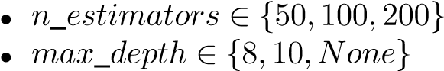
Weighted F1-score is used as the selection criterion for classification performance. The optimal hyperparameters are selected using validation folds, after which the final models are retrained on the full training dataset and serialized using the joblib library.

D. Evaluation Metrics and Preliminary Results
Yield prediction performance is evaluated using the coefficient of determination (R²) and Root Mean Square Error (RMSE), which measures prediction error in kilograms per hectare.
Crop recommendation performance is an assessment using classification accuracy, weighted precision, recall, and F1score averaged across all 22 crop categories.
Experimental results show that the XGBoost yield prediction model achieves R² ≈ 0.92 with an RMSE approximately 15% lower than a linear regression baseline, consistent with the findings of Patil et al. [?].
The Random Forest recommendation classifier achieves like a 95% overall accuracy on the held-out test set, comparable to the results reported by Shastri et al. [?]. Simulated yield planning trials using Tamil Nadu agricultural records indicate potential improvements of 15–20% compared with conventional uniform advisory approaches, aligning with improvements reported by Paliwal and Upadhyay [?] and Afzal et al. [?].

REFERENCES
- Shawon, S. M., Ema, F. B., Mahi, A. K., Niha, F. L., Zubair, H. T. (2025). Crop yield prediction using machine learning: An extensive and systematic literature review. Smart Agricultural Technology, 10, 100718.
- Sharma, S., Jain, A., Sharma, S., Whig, P. (2025). Enhancing crop yield prediction through machine learning regression analysis. International Journal of Sustainable Agricultural Management and Informatics, 11(1), 29-47.
- Patil, Y., Ramachandran, H., Sundararajan, S., Srideviponmalar, P. (2025). Comparative analysis of machine learning models for crop yield prediction across multiple crop types. SN Computer Science, 6(1), 64.
- Afzal, H., Amjad, M., Raza, A., Munir, K., Villar, S. G., Lopez, L. A. D., Ashraf, I. (2025). Incorporating soil information with machine learning for crop recommendation to improve agricultural output. Scientific Reports, 15(1), 8560.
- Shastri, S., Kumar, S., Mansotra, V., Salgotra, R. (2025). Advancing crop recommendation system with supervised machine learning and explainable artificial intelligence. Scientific Reports, 15(1), 25498.
- Paliwal, Y., Upadhyay, S. K. (2025, June). Crop and fertilizer recommendation system using machine learning. In International Conference on Data Analytics Management (pp. 563-575). Cham: Springer Nature Switzerland.
- El-Kenawy, E. S. M., Alhussan, A. A., Khodadadi, N., Mirjalili, S., Eid, M. M. (2025). Predicting potato crop yield with machine learning and deep learning for sustainable agriculture. Potato Research, 68(1), 759-792.
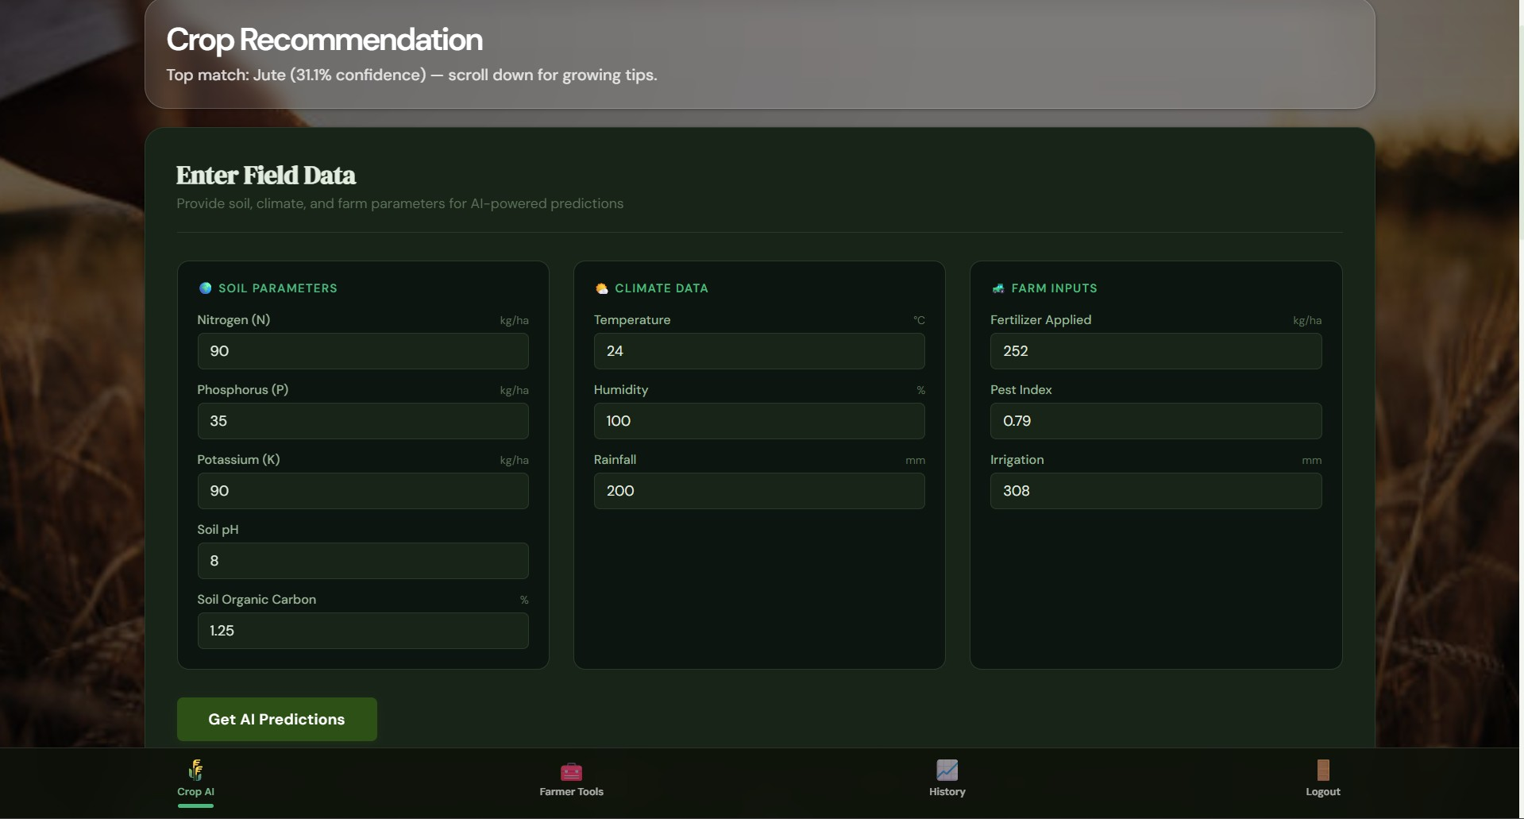
- AgriSense data input interface showing soil parameters,climate variables, and farm inputs used for AI predictions.
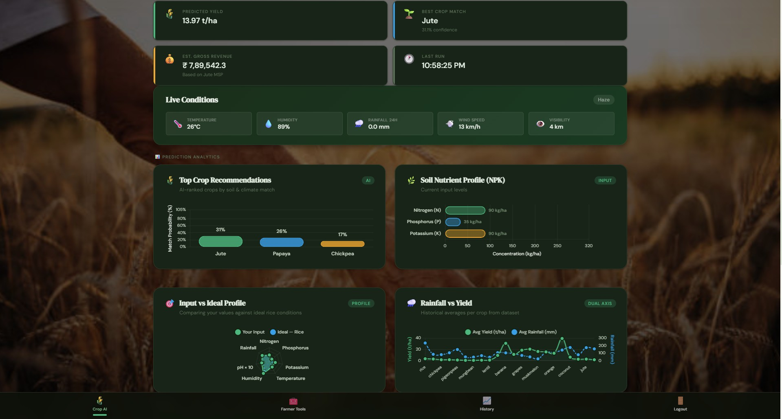
- Analytics dashboard displaying predicted yield, recommended crop, revenue estimate, and soil–weather visualizations.
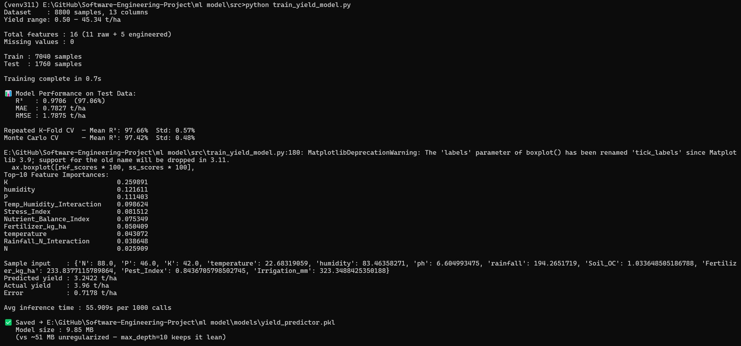
- Console output of the XGBoost yield prediction trainingpipeline showing performance metrics and feature importance.
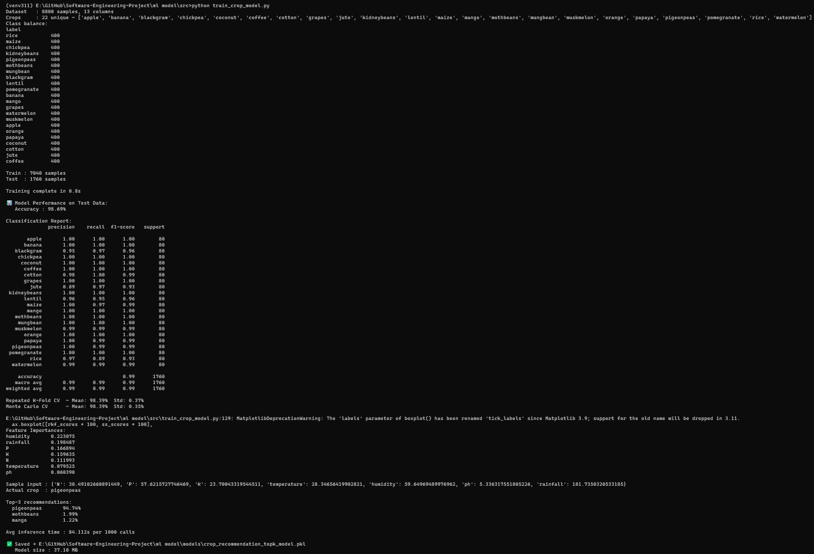
- Random Forest crop recommendation evaluation showingclassification metrics and predicted crop rankings.
Fig. 3: AgriSense system interface and model evaluation results.
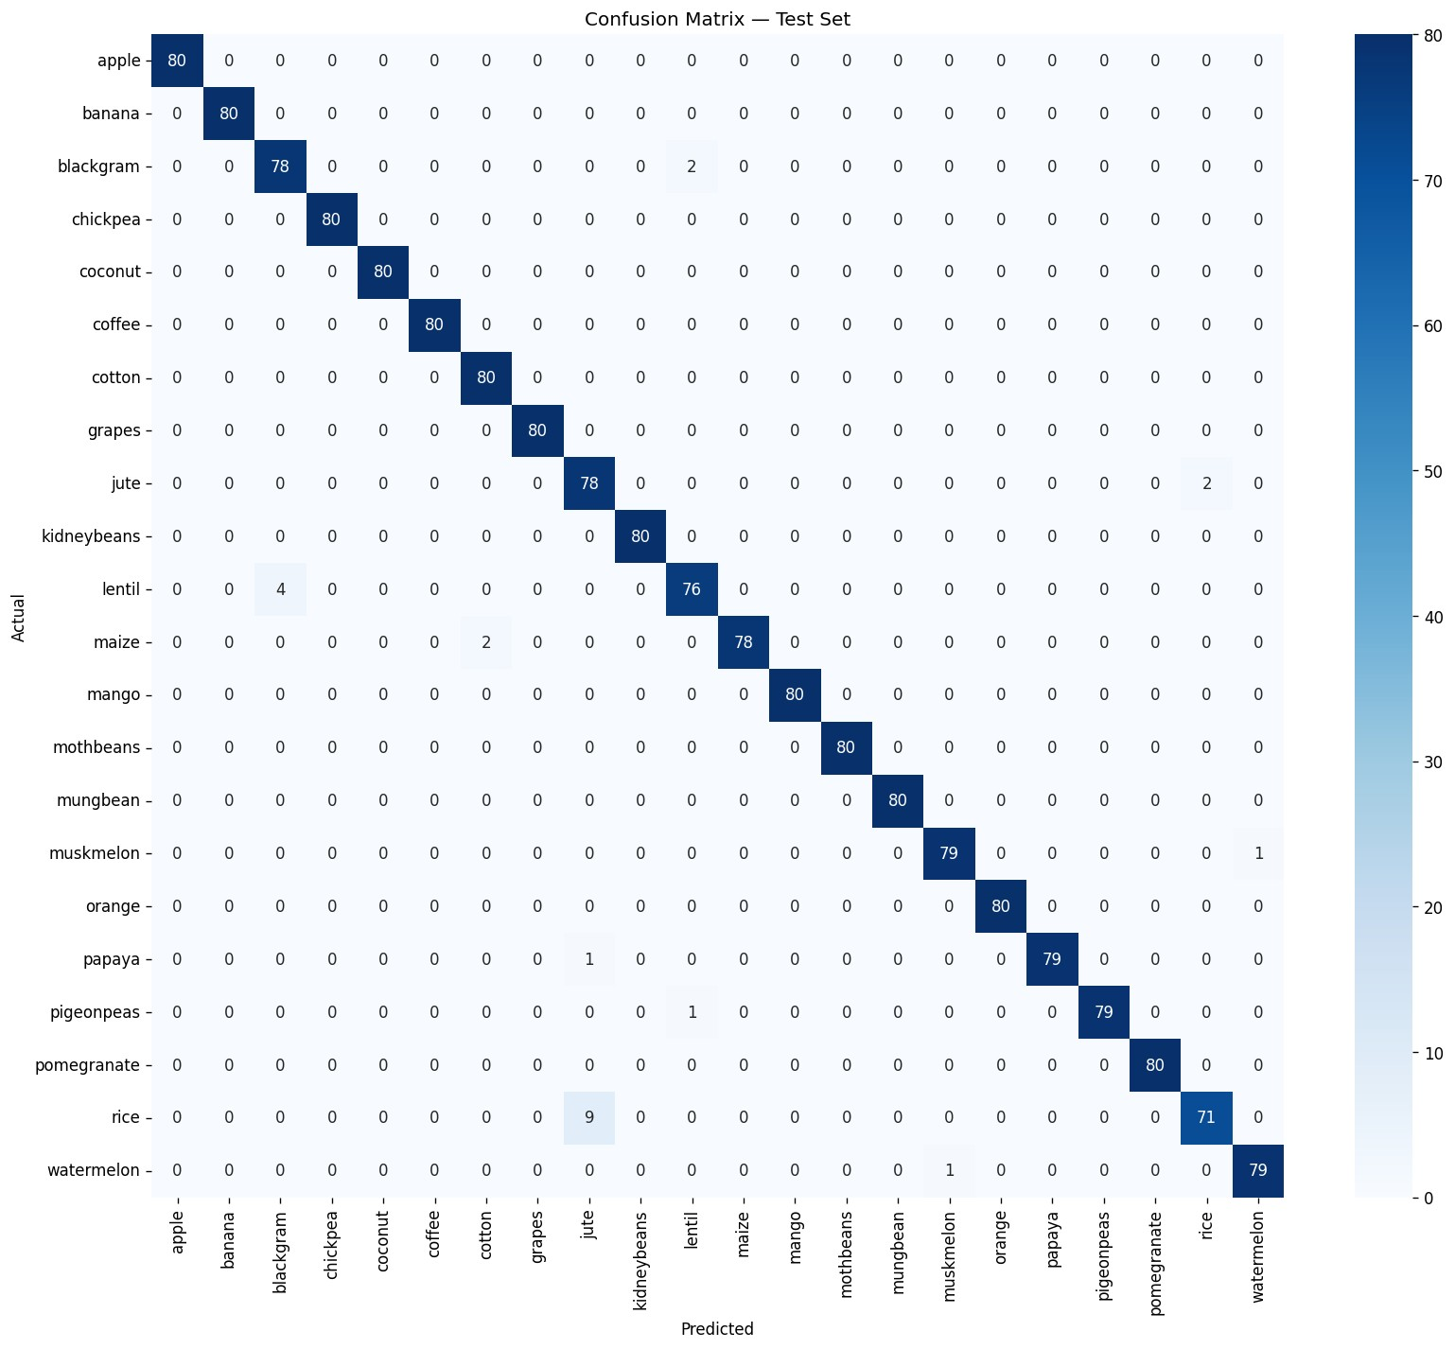
- Crop recommendation model confusion matrix showing 95%classification accuracy across 22 crop classes on test data.
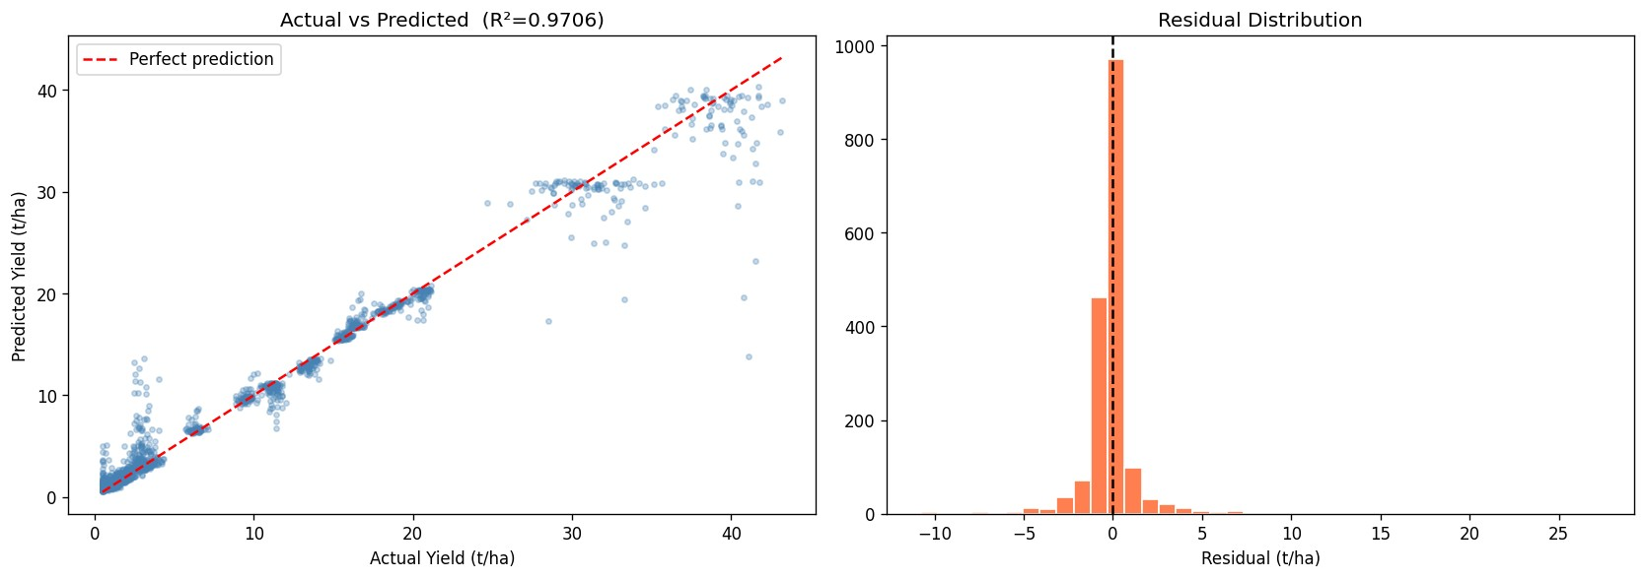
- Yield prediction model performance (R²=0.9706) with actualvs. predicted scatter plot and residual distribution showing model reliability.
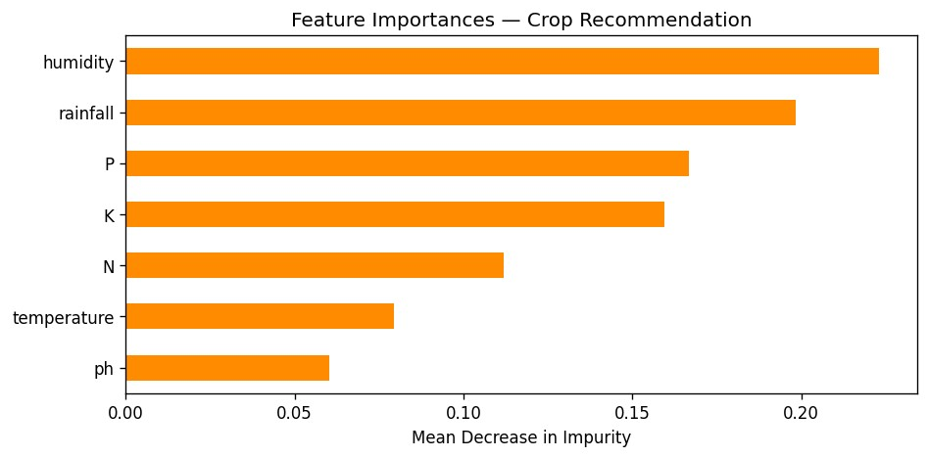
- Feature importance ranking for crop recommendations,highlighting humidity, rainfall, and soil nutrients (P, K, N) as primary decision drivers.
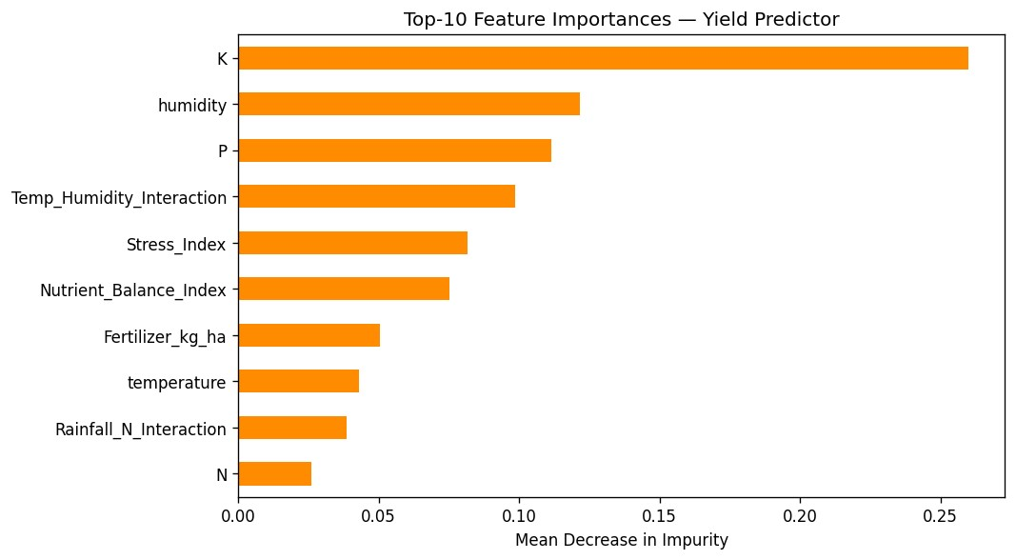
- Feature importance ranking for yield predictions, showingpotassium (K), humidity, and phosphorus (P) as the strongest predictors of crop harvest.
Fig. 4: AgriSense model performance and explainability results.

