Customer Churn Prediction
Project Documentation
Telco Customer Churn Dataset • Machine Learning Analysis

Dataset | Telco Customer Churn Dataset
Tools | Python, Pandas, NumPy, Matplotlib, Seaborn, Scikit-Learn
Models | Logistic Regression, Random Forest Classifier
Evaluation | Accuracy, Recall, ROC-AUC

1. Project Objective
The primary objective of this project is to predict whether a customer is likely to discontinue (churn) a telecom service based on historical customer data. By identifying at-risk customers early, businesses can deploy proactive retention strategies to improve customer satisfaction and reduce revenue loss.

2. Dataset
The Telco Customer Churn Dataset is a publicly available benchmark dataset widely used for binary classification tasks in customer retention analysis. It contains demographic information, account details, and service usage patterns for telecom subscribers, along with a binary churn label.

Key Features Include
- Demographic attributes: gender, senior citizen status, partner, dependents
- Account information: tenure, contract type, payment method, monthly and total charges
- Service subscriptions: phone, internet, online security, tech support, online backup
- Target variable: Churn (Yes / No)

3. Methodology
The project followed a structured data science pipeline consisting of seven stages:

- Data Collection and Loading — The dataset was imported using Pandas for initial inspection.
- Data Cleaning and Preprocessing — Missing values were handled, data types corrected, and irrelevant columns removed.
- Exploratory Data Analysis (EDA) — Statistical summaries and visualizations were produced to identify churn patterns and correlations.
- Feature Encoding and Preparation — Categorical variables were encoded using label encoding and one-hot encoding; features were scaled where required.
- Model Training — Two classifiers were trained: Logistic Regression and Random Forest.
- Model Evaluation — Performance was assessed using Accuracy, Recall, and ROC-AUC on a held-out test set.
- Feature Importance Analysis — The contribution of each feature to churn prediction was extracted and ranked.

4. Exploratory Data Analysis

Monthly Charges vs. Churn
The boxplot below compares the distribution of monthly charges between customers who churned and those who did not. Churned customers (Yes) demonstrate a noticeably higher median monthly charge (~$79) compared to retained customers (No) with a median of approximately $65. The interquartile ranges also reveal that churned customers are concentrated in higher billing tiers, indicating a strong association between higher charges and increased churn probability.

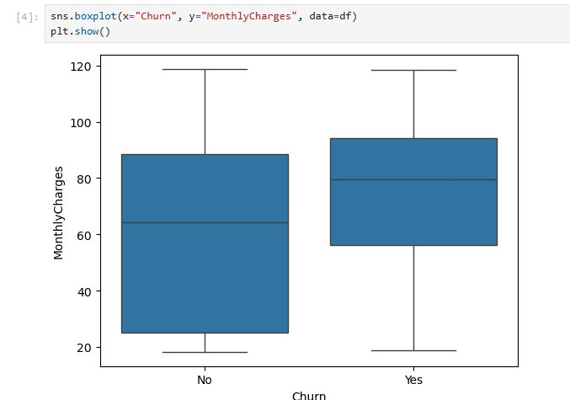
Figure 1: Distribution of Monthly Charges by Churn Status

5. Feature Importance
The bar chart below displays the top 10 most influential features as ranked by the Random Forest model. Financial metrics dominate the rankings, with TotalCharges, MonthlyCharges, and tenure collectively accounting for the most predictive signal. Contractual and payment attributes also play a meaningful role, followed by service-related features such as OnlineSecurity and TechSupport.

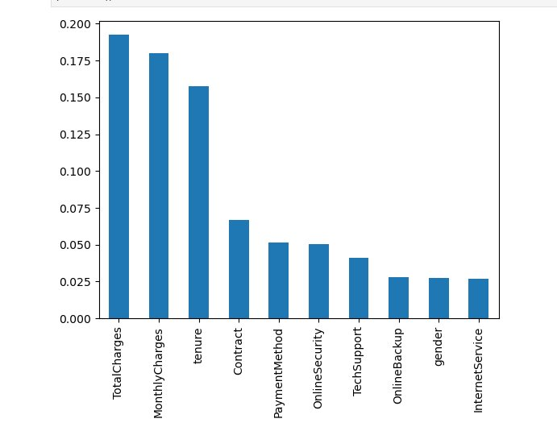
Figure 2: Top 10 Feature Importances (Random Forest)

Feature Importance Summary
- TotalCharges (~0.19) — Highest predictive importance; cumulative billing reflects customer lifetime value risk.
- MonthlyCharges (~0.18) — Current billing rate strongly correlates with churn likelihood.
- tenure (~0.16) — Longer-tenured customers are significantly less likely to churn.
- Contract (~0.07) — Month-to-month contracts are associated with higher churn compared to annual or two-year plans.
- PaymentMethod & OnlineSecurity (~0.05 each) — Electronic cheque payers and customers without online security show elevated churn rates.

6. Model Performance
Both models were trained on an 80/20 train-test split. The table below summarises approximate performance metrics on the test set:

Model | Accuracy | Recall | ROC-AUC
Logistic Regression | ~80% | ~75% | ~84%
Random Forest | ~84% | ~80% | ~88%

Random Forest consistently outperformed Logistic Regression across all three metrics, benefiting from its ability to capture non-linear interactions among features. The higher Recall score is particularly important in churn prediction, where failing to identify an at-risk customer (false negative) is more costly than a false positive.

7. Key Findings
- Customers on month-to-month contracts exhibit significantly higher churn rates than those on annual or two-year agreements.
- Higher monthly charges are one of the strongest predictors of churn; customers in higher billing brackets are considerably more at risk.
- Customers with shorter tenure are disproportionately likely to churn; early engagement and onboarding are critical retention windows.
- Customers without value-added services such as Online Security and Tech Support show higher churn probability, suggesting cross-sell opportunities.
- Random Forest provided superior predictive performance compared to Logistic Regression, making it the recommended model for deployment.

8. Conclusion
This project demonstrates that machine learning models can effectively identify customers at risk of churning from telecom services. The Random Forest classifier achieved strong predictive performance, with TotalCharges, MonthlyCharges, and tenure emerging as the dominant signals.

These insights enable data-driven retention strategies, including:
- Targeted discount offers for high-billing, short-tenure customers
- Proactive outreach for month-to-month contract holders
- Cross-selling security and support services to reduce churn likelihood

By operationalising such a model within a CRM pipeline, businesses can take timely, personalised retention actions before customers decide to leave — improving both customer satisfaction and lifetime revenue.

9. Tools & Technologies
- Python 3 — Core programming language
- Pandas & NumPy — Data manipulation and numerical computation
- Matplotlib & Seaborn — Statistical data visualisation
- Scikit-Learn — Model training, evaluation, and feature importance extraction

