
Yeshwantrao Chavan College of Engineering
(An Autonomous Institution affiliated to Rashtrasant Tukadoji Maharaj Nagpur University)
Accredited ‘A’ Grade by NAAC
Hingna Road, Wanadongri, Nagpur-441110

Department of Applied Mathematics & Humanities

Electronic Question Bank
Course Name: Discrete Mathematics & Graph Theory Course Code: GE-1206

Sr.No. | Unit No. | Text of Question | Time required in Minutes | Marks allotted | lengthiness | Difficulty level | CO Mapping | Type Descriptive / Numerical
1 | Unit 1 | If A and B are any two non-empty sets then show that  i) $A∪B=B∪A$ ii) $A∩B= B∩A$ | 10 | 3.5 | low | Easy | Co1 | Descriptive
2 | Unit 1 | If A,B and C are any non-empty sets then show that  i)$A∪\left(B∩C\right)=\left(A∪B\right)∩(A∪C)$ ii)$(A∪B)∪C=A∪(B∪C)$ | 10 | 3.5 | medium | Easy | Co1 | Descriptive
3 | Unit 1 | If A and B are any two non-empty sets then show that  i) $\left(A∪B\right)'=A'∩B'$ ii)$(A∩B)'=A'∪B'$ | 10 | 3.5 | medium | Easy | Co1 | Descriptive
4 | Unit 1 | Write the following statements in symbolic forms and also find their truth tables  i) If Jack studies hard then he pass the exam.  ii) x is an even number iff it is divisible by 2.  iii) Either Shyam is successful or he is a peon. | 10 | 3.5 | low | Easy | Co1 | Descriptive
5 | Unit 1 | Write the converse, inverse and contrapositive of the following statements.  i) If a triangle is equilateral, then it is equiangular.  ii) If x is divisible by 2, then it is even. | 10 | 3.5 | low | Easy | Co1 | Descriptive
6 | Unit 1 | Test the validity of the following argument.  $p→\sim q, r→ q, r$  $∴\sim p.$ | 10 | 3.5 | low | Easy | Co1 | Descriptive
7 | Unit 1 | If A,B and C are any non-empty sets then show that  $$\left(A∩B\right)-C=\left(A-C\right)∩(B-C)$$ | 10 | 3.5 | low | Easy | Co1 | Descriptive
8 | Unit 1 | If A and B are any non-empty sets then show that  $$\left(A∩B\right)∪\left(A∩B'\right)=A$$ | 10 | 3.5 | low | Easy | Co1 | Descriptive
9 | Unit 1 | Check for the tautology, contradiction and contingency?  i) $\left(\left(p→q\right)∧\left(q→r\right)\right)→(p→r)$  ii) $p∧(q∧\sim p)$ | 12 | 3.5 | medium | moderate | Co1 | Descriptive
10 | Unit 1 | Check for the tautology, contradiction and contingency?  i) $\left(p→q\right)↔(\sim p∨q)$  ii) $\left(\left(p∨q\right)∧r\right)∨(p∨q)$ | 12 | 3.5 | medium | moderate | Co1 | Descriptive
11 | Unit 1 | If A,B and C are any non-empty sets then show that  i) $A∪\left(B-C\right)=\left(A∩B\right)-(A∩C)$  ii) $A∩\left(B-C\right)=\left(A∪B\right)-(A∪C)$ | 12 | 3.5 | medium | moderate | Co1 | Descriptive
12 | Unit 1 | If $A⊂B$ , Prove that the following statements are equivalent  $i) A∩B^{c}=∅ ii) A∩B=A iii) A∪B=B iv) B^{c}⊂A^{c}$ | 12 | 3.5 | medium | moderate | Co1 | Descriptive
13 | Unit 1 | Show that $\left(p↔q\right)≡\left(\sim p∨q\right)∧(\sim q∨p)$ without using truth table. | 12 | 3.5 | low | moderate | Co1 | Descriptive
14 | Unit 1 | Show that $p→(q∧r)≡\left(p→q\right)∧(p→r)$ using truth table. | 12 | 3.5 | low | moderate | Co1 | Descriptive
15 | Unit 1 | Without using truth table, show that  i) $\left(p∨(p∧q\right)≡p$  ii) $p∧(p∨q)≡p$ | 12 | 3.5 | low | moderate | Co1 | Descriptive
16 | Unit 1 | Using truth table, show that  $\left(p∧\left(\sim p∨q\right)\right)∨\{q∧\sim (p∧q)\}≡q$ | 12 | 3.5 | low | moderate | Co1 | Descriptive
17 | Unit 1 | Using truth table, show that $\{\left(p∧\sim q\right)∧\left(\sim p∨\sim q\right)\}∨q≡p∨q$ | 12 | 3.5 | low | moderate | Co1 | Descriptive
18 | Unit 1 | Verify for tautology  $$\left\{p→\left(q→r\right)\right\}↔\left\{p→\left( \sim q∨r\right)\right\}$$ | 12 | 3.5 | low | moderate | Co1 | Descriptive
19 | Unit 1 | Test the validity of the following argument.  If I study then I will not fail in mathematics.  If I do not play basketball then I will study.  But I fail in mathematics.  $∴$ I must have played basketball. | 12 | 3.5 | medium | Difficult | Co1 | Descriptive
20 | Unit 1 | Test the validity of the following argument.  If Siddarth solve this problem then he obtain the answer.  Siddarth obtained the answer.  $∴$ siddarth solve this problem correctly | 12 | 3.5 | medium | Difficult | Co1 | Descriptive
21 | Unit 1 | Test the validity of the following argument.  If I graduate this semester, then I will have passed DMGT.  If I do not study DMGT for 10 hrs a week, then I will not pass DMGT.  If I study DMGT for 10 hrs a week, then I cannot play cricket.  Therefore, if I play cricket, I will not graduate this semester. | 12 | 3.5 | medium | Difficult | Co1 | Descriptive
22 | Unit 1 | Test the validity of the following argument.  “ If my plumbing plans do not meet the construction code, I cannot build my house.  If I hire a licensed contractor, then my plumbing plans meet the construction code.  I hire a licensed contractor.”  $∴$ I can build my house | 12 | 3.5 | medium | Difficult | Co1 | Descriptive
23 | Unit 1 | Test the validity of the following argument.  If it rains, the streets gets wet,  If it rains, accidents happen.  The streets get wet.  $∴$ Accidents happen. | 12 | 3.5 | medium | Difficult | Co1 | Descriptive
24 | Unit 1 | Test the validity of the following argument.  If it rains today, we will not have a party today.  If we do not have party today, we will have a party tomorrow.  $∴$ If it rains today, we will have a party tomorrow. | 12 | 3.5 | medium | Difficult | Co1 | Descriptive
25 | Unit 1 | Test the validity of the following argument.  If 7 is less than 4. Then 7 is not prime number.  7 is not less than 4  $∴$ 7 is prime number. | 12 | 3.5 | medium | Difficult | Co1 | Descriptive
26 | Unit 1 | Test the validity of the following argument.  If the initialization is correct and loop terminate then the required output is obtained.  The output has been obtained  Therefore , If the initialization is correct then loop must terminate. | 12 | 3.5 | medium | Difficult | Co1 | Descriptive
27 | Unit 1 | Using contrapositive method,  Show that $x^{2}$ is an even number if and only if x is an even number. | 12 | 3.5 | medium | Difficult | Co1 | Descriptive
28 | Unit 1 | Using method of contradiction, Prove that $\sqrt{2}$ is an irrational number. | 12 | 3.5 | medium | Difficult | Co1 | Numerical
29 | Unit 1 | Prove that the following using principal of mathematical induction  $3^{4n+1}+5^{2n+1}$ is multiple of $14, ∀ n>0$ | 15 | 3.5 | medium | Very difficult | Co1 | Numerical
30 | Unit 1 | Prove by mathematical induction that $6^{n+2}+7^{2n+1}$ is divisible by 43 ,$∀ n>0$ | 15 | 3.5 | medium | Very difficult | Co1 | Numerical
31 | Unit 1 | Prove the following by using principal of mathematical induction  i) $n<2^{n}$ , $n≥0$  ii) $2^{n}<n!, n≥4$ | 15 | 3.5 | medium | Very difficult | Co1 | Numerical
32 | Unit 1 | Prove the following by using principal of mathematical induction  $\frac{1}{1.2}+\frac{1}{2.3}+\frac{1}{3.4}+-- - -+\frac{1}{n(n+1)}=\frac{n}{n+1}$ | 15 | 3.5 | high | Very difficult | Co1 | Numerical
33 | Unit 1 | Prove the following by using principal of mathematical induction  $1^{2}+2^{2}+3^{2}+…+n^{2}=\frac{n\left(n+1\right)(2n+1)}{6}, n≥1$ | 15 | 3.5 | high | Very difficult | Co1 | Numerical
34 | Unit 1 | Prove the following by using principal of mathematical induction  $1^{2}+3^{2}+5^{2}+…+{(2n-1)}^{2}=\frac{n\left(2n+1\right)(2n-1)}{3}$ | 15 | 3.5 | high | Very difficult | Co1 | Numerical
35 | Unit 1 | Prove the following by using principal of mathematical induction  “ $n^{3}+2n$is divisible by 3 ” | 15 | 3.5 | medium | Very difficult | Co1 | Numerical
36 | Unit 1 | Prove the following by using principal of mathematical induction  $2^{1}+2^{2}+2^{3}+…+2^{n}=2^{n+1}-2$ | 15 | 3.5 | medium | Very difficult | Co1 | Numerical
1 | Unit 2 | If both the relation A & B are reflexive, symmetric and transitive then prove that $A∩B$ is also reflexive, symmetric and transitive | 10 | 4 | low | Easy | Co 2 | Descriptive
2 | Unit 2 | Prove that $R=\{(x,y)/x^{2}-4xy+{3y}^{2}=0,∀ x,y∈N\}$ is reflexive but not symmetric and not transitive. | 10 | 4 | low | Easy | Co 2 | Descriptive
3 | Unit 2 | Define the relation on set $S = \{1, 2, 3, 4\}$ which is  i) Reflexive, symmetric but not transitive  ii) Reflexive, transitive but not symmetric | 10 | 4 | low | Easy | Co 2 | Descriptive
4 | Unit 2 | A relation R is defined by $R=\left\{\left(A,B\right)\right|A⊆B\}$. Show that R is a partial order relation. Is this R compatible? | 10 | 4 | medium | Easy | Co 2 | Descriptive
5 | Unit 2 | Draw the digraph corresponding to the matrix $M_{R}=\left[\begin{matrix}\begin{matrix}0 & 1 \\ 0 & 0\end{matrix} & \begin{matrix}0 & 0 \\ 1 & 1\end{matrix} \\ \begin{matrix}1 & 1 \\ 1 & 0\end{matrix} & \begin{matrix}0 & 1 \\ 0 & 0\end{matrix}\end{matrix}\right]$  find the transitive closure of the digraph | 10 | 4 | medium | Easy | Co 2 | Descriptive
6 | Unit 2 | Let $f:R→R$ and $f\left(x\right)=x^{3}+1 , ∀ x∈R$. Then show that$f$is bijective. | 10 | 4 | medium | Easy | Co 2 | Descriptive
7 | Unit 2 | Let $f:R→R$ and $f:R→R$ where R is set of real number and  $f\left(x\right)=x^{2}-2 g\left(x\right)=x+4 , for all x∈R$. Is $f.g$ bijective? | 10 | 4 | medium | Easy | Co 2 | Descriptive
8 | Unit 2 | List all possible function from the set $X=\{a,b,c\}$ to the set$Y=\{0,1\}$. Indicate in each case whether the function is one-one or on-to or both. | 10 | 4 | medium | Easy | Co 2 | Descriptive
9 | Unit 2 | If A,B and C are any non-empty sets then show that  $\left(A∪B\right)×C=\left(A×C\right)∪(B×C)$ | 12 | 4 | low | moderate | Co 2 | Descriptive
10 | Unit 2 | If A,B and C are any non-empty sets then show that  $A×(B∩C)=\left(A×B\right)∩(A ×C)$ | 12 | 4 | low | moderate | Co 2 | Descriptive
11 | Unit 2 | If A,B and C are any non-empty sets then show that  $\left(A-B\right)×C=\left(A×C\right)-\left(B×C\right)$ | 12 | 4 | low | moderate | Co 2 | Descriptive
12 | Unit 2 | If A,B and C are any non-empty sets then show that  $A×\left(B∪C\right)=\left(A×B\right)∪(A ×C)$ | 12 | 4 | low | moderate | Co 2 | Descriptive
13 | Unit 2 | .Let $A=R×R.$ A relation $R$ on $A$is defind as  $\left(a,b\right)R\left(c,d\right) iff a^{2}+b^{2}= c^{2}+d^{2} .$ Show that R is an equivalence relation. | 12 | 4 | medium | moderate | Co 2 | Descriptive
14 | Unit 2 | If Z is a set of Integers and $a,b∈Z, aRb if b=a^{r}$ for some positive integer $r,$ then show that R is a partial order on Z. | 12 | 4 | medium | moderate | Co 2 | Descriptive
15 | Unit 2 | Let $S = \{1, 2, 3, 4, 5\}$ . Find the relation $R$_{A}$and R$_{B} generating the partition$A =\left\{ \left(1,2\right), \left(3\right), \left(4, 5\right)\right\} and B =\{ (1,2,3), (4, 5)\}$ respectively. Also prove that $R$_{A}$and R$_{B} is equivalence Relation. | 12 | 4 | medium | moderate | Co 2 | Descriptive
16 | Unit 2 | Let R denote a relation on the set of ordered pairs of positive integers defined by $\left(x,y\right)R\left(u,v\right)$ iff $xv=yu,$ Show that R is equivalence relation. | 12 | 4 | medium | moderate | Co 2 | Descriptive
17 | Unit 2 | let A= {1, 2, 3}. The relation matrix$M_{R}\& M_{S}$ are given by  $M_{R}=\left[\begin{matrix}1 & 1 & 0 \\ 1 & 1 & 0 \\ 0 & 0 & 1\end{matrix}\right]$ , $M_{S}=\left[\begin{matrix}1 & 1 & 0 \\ 1 & 1 & 1 \\ 0 & 1 & 1\end{matrix}\right]$  Find ${ \left(M_{R}\right)}^{'} , { (M}_{s})' , { M}_{R∪S} , { M}_{R∩S.}.$ | 12 | 4 | medium | moderate | Co 2 | Descriptive
18 | Unit 2 | For the relation R ={(1,2), (2,3), (3,4),(4,5)} Find M_{R} and draw the graph. Also find transitive closure of R. | 12 | 4 | medium | Difficult | Co 2 | Descriptive
19 | Unit 2 | Let f be the set of all one-one mapping from X to X, where X= {1, 2, 3}. Find all element of $f$and also find inverse of each element. | 12 | 4 | high | Difficult | Co 2 | Descriptive
20 | Unit 2 | For any integer n , $S_{n}$denotes the set of all divisors of n and D denotes the division operation.  Find the Hassse diagram for $〈S_{30},D〉$ , $〈S_{36},D〉 and 〈S_{45},D〉$ | 12 | 4 | medium | Difficult | Co 2 | Descriptive
21 | Unit 2 | For any integer n , $S_{n}$denotes the set of all divisors of n and D denotes the division operation.  Find the Hassse diagram for $〈S_{75},D〉$ , $〈S_{105},D〉 and 〈S_{81},D〉$ | 12 | 4 | medium | Difficult | Co 2 | Descriptive
22 | Unit 2 | Prove that, if $f:A→B \& g:B →C$ are one-one & on- to functions,  then ${(gof)}^{-1}=f^{-1}o g^{-1}$ | 12 | 4 | medium | Difficult | Co 2 | Descriptive
23 | Unit 2 | Let $A=\{a,b,c\}$ be the given finite set and P(A) is its power set. Let $≤$ be the inclusion relation on P(A). Find the Hasse diagram of $〈P(A) ,≤ 〉$. Also show that $〈P(A) ,≤ 〉$ forms a partially order relation. | 12 | 4 | high | Difficult | Co 2 | Descriptive
24 | Unit 2 | Show that function defined by $f:Q→Q$ such that $f(x)= 3x+4$ for all $x∈Q$ is 1-1 & onto where Q is the set of rational numbers. Also find a formula that defines the inverse function $f^{-1}$. | 12 | 4 | high | Difficult | Co 2 | Descriptive
25 | Unit 2 | Let X={1,2,3,4,5,6,7}and $R=\{\left(x,y\right)/ x-y is divisible by 3\}$. Draw the graph of R also find relation matrix $M_{R}$ . Show that R is an equivalence relation. | 12 | 4 | medium | Difficult | Co 2 | Descriptive
26 | Unit 2 | Given $f:X→Y$ and $g:Y→Z$ show that  i) if $g.f$ is 1-1 then $f$ is 1-1  ii) if $g.f$ is onto then $g$ is onto.  iii) $f^{-1}$ is exist iff $f$ is bijective. | 15 | 4 | high | Very difficult | Co 2 | Descriptive
27 | Unit 2 | Let $A=B=C=R$ and consider the function $f:A→B$ and  $g:B→C$defined by  $f(a)= 2a+1$, $g(b)= \frac{b}{3}$ show that ${(g o f)}^{-1}=f^{-1} o g^{-1}$ | 15 | 4 | medium | Very difficult | Co 2 | Numerical
28 | Unit 2 | If $f:X→Y$ and A,B are any two subset of Y then prove that  i) $f^{-1}\left(A∪B\right)=f^{-1}\left(A\right)∪f^{-1}\left(B\right)$  ii) $f^{-1}\left(A∩B\right)=f^{-1}\left(A\right)∩f^{-1}\left(B\right)$ | 15 | 4 | high | Very difficult | Co 2 | Descriptive
29 | Unit 2 | Let $A=\left\{0,1,2,3\right\} .$Find the matrix for $R=\{(x,y)/x+y=3\}$ ,  $S=\{(x,y)/x+y≤4\}$ .  Also find ${{( M}_{R} . M_{S})}^{'} and show that {{( M}_{R }.M_{S})}^{'}≠{{( M}_{R})' .{(M}_{S})}^{'}$ | 15 | 4 | medium | Very difficult | Co 2 | Descriptive
30 | Unit 2 | Using properties of characteristics function , show that  i) $A∪\left(B∩C\right)=\left(A∪B\right)∩(A∪C)$  ii) ${(A^{'})}^{'}=A$ | 15 | 4 | medium | Very difficult | Co 2 | Descriptive
31 | Unit 2 | Using properties of characteristics function , show that  i) $A∩\left(B∪C\right)=\left(A∩B\right)∪(A∩C)$  ii) $A+\left(B+C\right)=\left(A+B\right)+C$ | 15 | 4 | medium | Very difficult | Co 2 | Descriptive
32 | Unit 2 | Using properties of characteristics function , show that  i) $f_{\left(A∪B\right)}\left(x\right)=f_{A}\left(x\right)+f_{B}\left(x\right)-f_{A}\left(x\right).f_{B}\left(x\right)$  ii) $f_{\left(A∩B\right)}\left(x\right)=f_{A}\left(x\right).f_{B}\left(x\right)$ | 15 | 4 | medium | Very difficult | Co 2 | Descriptive
33 | Unit 2 | Let A = {1,2,3}, B ={a,b,c,d}. Let R & S be relation from A to B with relation matrix given by  $M_{R}=\left[\begin{matrix}1 & 1 & 1 \\ 0 & 0 & 0 \\ 1 & 1 & 0\end{matrix} \begin{matrix}0 \\ 0 \\ 1\end{matrix}\right]$ , $M_{S}=\left[\begin{matrix}0 & 1 & 0 \\ 1 & 0 & 0 \\ 0 & 1 & 1\end{matrix} \begin{matrix}0 \\ 1 \\ 0\end{matrix}\right]$  Find i) ${{ M}_{R}}^{-1}, {ii) M_{S}}^{-1}$ iii) ${M_{R}}^{-1}∪{M_{S}}^{-1}$. | 15 | 4 | medium | Very difficult | Co 2 | Descriptive
34 | Unit 2 | Let A= {1,2,3},B={a,b,c,d}. Let R & S be relation from A to B with relation matrix given by  $M_{R}=\left[\begin{matrix}1 & 1 & 1 \\ 0 & 0 & 0 \\ 1 & 1 & 0\end{matrix} \begin{matrix}0 \\ 0 \\ 1\end{matrix}\right]$ , $M_{S}=\left[\begin{matrix}0 & 1 & 0 \\ 1 & 0 & 0 \\ 0 & 1 & 1\end{matrix} \begin{matrix}0 \\ 1 \\ 0\end{matrix}\right]$  show that ${ M_{(R∪S)oR}}^{-1}={ M_{RoR}}^{-1}∩{ M_{SoR}}^{-1}$ | 15 | 4 | high | Very difficult | Co 2 | Descriptive
1 | Unit 3 | Prove that cube root of unity forms a group under multiplication. | 10 | 3.5 | medium | Easy | Co 3 | Descriptive
2 | Unit 3 | Prove that fourth root of unity forms an abelian group under multiplication | 10 | 3.5 | medium | Easy | Co 3 | Descriptive
3 | Unit 3 | If * is a binary operation defined on$Q^{+}$ by $a * b =\frac{ab}{3} , ∀ a, b ∈Q^{+}$, then prove that ($Q^{+},$ $*$) forms a group. | 10 | 3.5 | medium | Easy | Co 3 | Descriptive
4 | Unit 3 | Show that the set A = {1, 2 , 3}under multiplication modulo 4 is not a group but B = {1, 2, 3, 4} under multiplication modulo 5 is a group. | 10 | 3.5 | low | Easy | Co 3 | Descriptive
5 | Unit 3 | Check whether ($Z,$ $*$) is a group where the operation * is defined by $a*b =a+b-ab, ∀ a, b ∈Z$. | 10 | 3.5 | medium | Easy | Co 3 | Descriptive
6 | Unit 3 | Prove that the set {1, 2, 3, 4, 5, 6}of order 6 is a finite abelian group under multiplication modulo 7 as composition. | 10 | 3.5 | medium | Easy | Co 3 | Descriptive
7 | Unit 3 | Check whether the set {0, 1, 2, 3, 4} of order 5 is a finite abelian group under multiplication modulo 5 as composition | 10 | 3.5 | medium | Easy | Co 3 | Descriptive
8 | Unit 3 | Show that set of matrices $A_{α}=\left[\begin{matrix}cosα & -sinα \\ sinα & cosα\end{matrix}\right], α∈R$ form a monoid under matrix multiplication. | 10 | 3.5 | low | Easy | Co 3 | Descriptive
9 | Unit 3 | If G is a group, then  i) The identity element of G is unique  ii) Every $a∈G$ has unique inverse in G. | 12 | 3.5 | medium | moderate | Co 3 | Descriptive
10 | Unit 3 | If G is a group, then i) for every$a∈G$, ${(a^{-1})}^{-1}=a$  ii) ${(a.b)}^{-1}=b^{-1}.a^{-1}$ for all $a, b ∈G$ | 12 | 3.5 | low | moderate | Co 3 | Descriptive
11 | Unit 3 | Let ($Q,$ $*$) be an algebraic structure where $a * b =\frac{a+b}{2}$. Determine which of the following properties holds for this structure. I) closure ii) Commutative iii) associative iv) Identity v) inverse. | 12 | 3.5 | medium | moderate | Co 3 | Descriptive
12 | Unit 3 | Prove that for any element a in a group G if $a^{2}=e$, then G must be an abelian group. | 12 | 3.5 | low | moderate | Co 3 | Descriptive
13 | Unit 3 | Show that set of matrices $A_{α}=\left[\begin{matrix}cosα & sinα \\ -sinα & cosα\end{matrix}\right], α∈R$ form a group under matrix multiplication. | 12 | 3.5 | high | moderate | Co 3 | Descriptive
14 | Unit 3 | Prove that monoid homomorphism preserve associativity, identity, commutativity and invertibility. | 12 | 3.5 | low | moderate | Co 3 | Descriptive
15 | Unit 3 | Prove that if H is a non empty finite subset of a group G and H is closed under multiplication, then H is a subgroup of G. | 12 | 3.5 | medium | moderate | Co 3 | Descriptive
16 | Unit 3 | If H and K are any two subgroups of a group G, then show that $H∩K$ is also a subgroup of G. Is $H∪K$ a subgroup of G ? | 12 | 3.5 | medium | moderate | Co 3 | Descriptive
17 | Unit 3 | Show that the multiplicative group $G = \{1, i, -1, -i \}$ is isomorphic to the group $G’ = \{0, 1, 2, 3 \}$ with addition modulo 4 as composition. Write the composition table for $G$ and $G’.$ | 12 | 3.5 | medium | Difficult | Co 3 | Descriptive
18 | Unit 3 | A non-empty subset H of a group G is a sub group of G iff.  i) $a, b∈H ⇒a*b∈H.$  ii) $a∈H⇒ a^{-1}∈H$ . | 12 | 3.5 | medium | Difficult | Co 3 | Descriptive
19 | Unit 3 | Show that if G is an abelian group then ${(a.b)}^{n}=a^{n}.b^{n} ∀ a, b ∈G$, for every integer n. | 12 | 3.5 | medium | Difficult | Co 3 | Descriptive
20 | Unit 3 | Let $G =\left\{\left(a, b\right)| a ,b ∈R, a≠0 \right\}.$ Define a binary operation$*$ on G by $\left(a,b\right)*\left(c,d\right)=(ac,bc+d)$ for all $\left(a,b\right),(c,d)∈G$ . Show that $(G,*)$ is a group. | 12 | 3.5 | medium | Difficult | Co 3 | Descriptive
21 | Unit 3 | Let $a∈G$ and $N\left(a\right)=\left\{x∈G\right|x*a=a*x\}$ . Show that $N\left(a\right)$ is a subgroup of G. | 12 | 3.5 | medium | Difficult | Co 3 | Descriptive
22 | Unit 3 | If in a group G, $a^{5}=e, aba^{-1}=b^{2}$ $∀ a, b ∈G$.  Find order of element $b$. | 12 | 3.5 | medium | Difficult | Co 3 | Descriptive
23 | Unit 3 | N be the normal subgroup of group G iff $gNg^{-1}=N ,$ $∀ g∈G$. | 12 | 3.5 | medium | Difficult | Co 3 | Descriptive
24 | Unit 3 | If N be the normal subgroup of group G then. $G/N$ is also a group. | 12 | 3.5 | medium | Difficult | Co 3 | Descriptive
25 | Unit 3 | Show that the set of matrices $\left[\begin{matrix}1 & 0 \\ 0 & 1\end{matrix}\right], \left[\begin{matrix}-1 & 0 \\ 0 & 1\end{matrix}\right]$ , $\left[\begin{matrix}1 & 0 \\ 0 & -1\end{matrix}\right], \left[\begin{matrix}-1 & 0 \\ 0 & -1\end{matrix}\right]$ form a multiplicative abelian group. | 15 | 3.5 | medium | Very difficult | Co 3 | Descriptive
26 | Unit 3 | Let G be the set of all $2×2$ matrices $\left[\begin{matrix}a & b \\ -b & a\end{matrix}\right]$ where a & b are real numbers,not both zero such that $a^{2}-b^{2}≠0$ Show that G is an abelian group under matrix multiplication. | 15 | 3.5 | medium | Very difficult | Co 3 | Descriptive
27 | Unit 3 | Let G be the set of all $2×2$ matrices $\left[\begin{matrix}a & b \\ c & d\end{matrix}\right]$ where $ad-bc≠0$ and $a, b, c, d∈Q$. Show that G is a group under matrix multiplication. | 15 | 3.5 | medium | Very difficult | Co 3 | Descriptive
28 | Unit 3 | Show that the multiplicative group of residues 1, 2, 3, 4, 5, 6 modulo 7 is cyclic. Find the order of each element of the group. Find two generators of a group. | 15 | 3.5 | medium | Very difficult | Co 3 | Descriptive
29 | Unit 3 | Let f is homomorphism of $G$ into $G’$ then  i) $f\left(e\right)=e^{'},where e^{'} is the identity in G’$  ii) $f\left(x^{-1}\right)={\left[f\left(x\right)\right]}^{-1}$ $∀ x∈G$.  iii) if H is subgroup of G then $f(H)=\{f(h) / h∈H\}$ is also a subgroup of G | 15 | 3.5 | medium | Very difficult | Co 3 | Descriptive
30 | Unit 3 | Show that the set $G = \left\{1, i, -1, -i \right\}$ is multiplicative abelian group. Also find the order of each element in G. | 15 | 3.5 | medium | Very difficult | Co 3 | Descriptive
31 | Unit 3 | Show that the group G $=\{0,1,2,3\}$ under multiplication modulo 4 is isomorphic to group$G=\{1,2,3,4\}$ under multiplication modulo 5 . | 15 | 3.5 | medium | Very difficult | Co 3 | Descriptive
32 | Unit 3 | If (H,*) and (K,*) are any two subgroups of finite group G of order $O(H)$and $O(K)$ respectively, then $O\left(H*K\right)=\frac{O\left(H\right)*O(k) }{O\left(H∩K\right)}$. | 15 | 3.5 | medium | Very difficult | Co 3 | Descriptive
1 | Unit 4 | If R is a ring and $a, b ∈R$ , then show that  ${\left(a+b\right)}^{2}=a^{2}+ab+ba+b^{2}≠a^{2}+2ab+b^{2}$ | 10 | 4 | medium | Easy | Co 4 | Descriptive
2 | Unit 4 | Let R be a ring of all 2x2 matrices with entries as integers. Then show that  ( R , + , $·$ ) is a ring with zero divisors. | 10 | 4 | low | Easy | Co 4 | Descriptive
3 | Unit 4 | Show that the intersection of any two subrings is also a subring. | 10 | 4 | low | Easy | Co 4 | Descriptive
4 | Unit 4 | For any integer n, let$D_{n}$ denote the set of all divisor of n.  Find the Hasse diagram for n = 6 , n = 8 , n = 20 , n = 36 and n = 75 | 10 | 4 | low | Easy | Co 4 | Descriptive
5 | Unit 4 | Let A = {a₁, a₂, a₃} and B = {b₁, b₂, b_{3,} b₄ }. Let R be a relation from A to B given by  R = $\left\{\frac{0.1}{\left(a_{1},b_{3}\right)}, \frac{0.8}{\left(a_{1},b_{4}\right)}, \frac{0.8}{\left(a_{2},b_{2}\right)},\frac{0.1}{\left(a_{3},b_{1}\right)},\frac{0.8}{\left(a_{3},b_{2}\right)},\frac{0.1}{\left(a_{3},b_{3}\right)},\frac{0.8}{\left(a_{3},b_{4}\right)}\right\}$  Write fuzzy matrix M_{R} and draw graph. | 10 | 4 | low | Easy | Co 4 | Descriptive
6 | Unit 4 | Given A$=\left\{\frac{0.8}{3},\frac{0.9}{4}, \frac{0.6}{5}\right\}$ and $B= \left\{\frac{0.7}{3} , \frac{0.3}{5}\right\}$ be two fuzzy sets.  Verify De-Morgan’s law $\overline{A∪B}$ = $\overline{A}$ $∩ \overline{B}$ symbols have their usual meaning. | 10 | 4 | medium | Easy | Co 4 | Descriptive
7 | Unit 4 | If X = {x₁, x₂, x₃ } and Y = {y₁, y₂, y₃ }, the fuzzy set A of X and fuzzy set B of Y are defined as A = $\left\{\frac{0.3}{x_{1}},\frac{0.4}{x_{2}},\frac{0.5}{x_{3}}\right\}$ and B = $\left\{\frac{0.5}{y_{1}} ,\frac{0.6}{y_{2}}, \frac{0.7}{y_{3}}\right\}$  Find A $×$ B. | 10 | 4 | low | Easy | Co 4 | Descriptive
8 | Unit 4 | Let the fuzzy sets A,B and C are given by,  A = { 0.3a, 0.8b, 0.9c, 0.5d } , B = { 0.6d, 0.9c , 0.7b , 0.3a },  C = { 0.8b, 0.9c, 0.3a, 0.5d }  Which of the above fuzzy sets are equal?  Write (i) $∪B$ , (ii) A$∩B$ , (iii) $\overline{A }$ . | 10 | 4 | medium | Easy | Co 4 | Descriptive
9 | Unit 4 | If R is a ring such that $a^{2}=a,∀ a∈R$ , then show that  i) $a+a=0, ∀ a∈R$  ii) $a+b=0⇒a=b, ∀ a, b∈R$  iii) R is a commutative ring . | 12 | 4 | medium | moderate | Co 4 | Descriptive
10 | Unit 4 | Show that the set$\{0, 1, 2, 3, 4, 5, 6\}$is a commutative ring w.r.t. addition modulo 7 and multiplication modulo 7 as a composition. | 12 | 4 | medium | moderate | Co 4 | Descriptive
11 | Unit 4 | Draw the lattice $\left(L, ≤_{1} \right) , \left( L^{2} , { ≤}_{2} \right), ( L^{3} , ≤_{3} )$ if L = {0, 1} . | 12 | 4 | medium | moderate | Co 4 | Descriptive
12 | Unit 4 | Given the membership function for the fuzzy sets A,B and C  $μ_{A }(x)$ = $\frac{x}{x + 2}$ , $μ_{B }(x)$ = $2^{-x}$ , $μ_{C }(x)$ = $\frac{1}{1 + 10{(x-2)}^{2}}$  Let X={0,1,2,3,4,5} be the Universal set.  Find (i) A$∩B$ , (ii) B$∩C$ , (iii) $A∪B∪C$ | 12 | 4 | high | moderate | Co 4 | Numerical
13 | Unit 4 | If X = {x₁, x₂, x₃ } and Y = {y₁, y₂, y₃ }, the fuzzy set A of X and fuzzy set B of Y are defined as A = $\left\{\frac{0.1}{x_{1}},\frac{0.3}{x_{2}},\frac{0.4}{x_{3}}\right\}$ and B = $\left\{\frac{0.4}{y_{1}} ,\frac{0.5}{y_{2}}, \frac{0.6}{y_{3}}\right\}$  Find (i) A $×$ B, (ii) $A∪(\overline{A }$ $∩B)$ , (iii) A$∩B$ , (iv) $∪B$ . | 12 | 4 | high | moderate | Co 4 | Numerical
14 | Unit 4 | Let R be a ring and${ x}^{2}=x,∀ x∈R$. show that R is a commutative ring | 12 | 4 | medium | moderate | Co 4 | Descriptive
15 | Unit 4 | Prove that a field has no zero divisors. | 12 | 4 | medium | moderate | Co 4 | Descriptive
16 | Unit 4 | Define the Hasse diagram and For any integer n, let$D_{n}$ denote the set of all divisor of n. Find the Hasse diagram for n = 36 , n =75 , n =105 . | 12 | 4 | medium | moderate | Co 4 | Descriptive
17 | Unit 4 | Show that the commutative ring D is an integral domain, iff for $a, b , c∈D$ with $a≠0,$the relation $ab=ac⇒b=c$ | 12 | 4 | medium | Difficult | Co 4 | Descriptive
18 | Unit 4 | If R is a ring, then show that $∀ a, b∈R$  (i)$a .0=0=0 .a$,  (ii) $a.\left(-b\right)=\left(-a\right).b= -\left(a.b\right),$  iii)$\left(-a\right).\left(-b\right)= a.b$ | 12 | 4 | high | Difficult | Co 4 | Descriptive
19 | Unit 4 | Prove that a ring D is without zero divisors, iff the cancellation laws hold in D. | 12 | 4 | medium | Difficult | Co 4 | Descriptive
20 | Unit 4 | Prove that every field is an integral domain. Does the converse hold? | 12 | 4 | medium | Difficult | Co 4 | Descriptive
21 | Unit 4 | If $S =\{a,b,c\}$ and P(S) denotes the power set of S then Show that the  Lattices $〈 P\left(S\right),⊆ 〉$ and $〈 L^{3},≤ 〉$ are isomorphic, where $L = \{0, 1\}.$ | 12 | 4 | medium | Difficult | Co 4 | Descriptive
22 | Unit 4 | Show that the Algebraic structure R =$(\left\{0, 1, 2, 3, 4\right\} ,⨁_{5} , ⨂_{5} )$ is a finite integral domain. | 12 | 4 | medium | Difficult | Co 4 | Descriptive
23 | Unit 4 | Prove that a non empty subset S of a ring ( R, +, ·) is a sub ring iff  $a- b∈S, a·b∈S for all a,b∈S$ | 12 | 4 | medium | Difficult | Co 4 | Descriptive
24 | Unit 4 | If R is a set of all real numbers, then prove that ( R , + , $·$ ) is an integral domain. | 12 | 4 | medium | Difficult | Co 4 | Descriptive
25 | Unit 4 | Show that the set $R=\{a+b\sqrt{2 } / a,b∈Q \}$ is a field w.r.t. addition and multiplication. | 15 | 4 | high | Very difficult | Co 4 | Numerical
26 | Unit 4 | Show that the set of real numbers of the form $a+b\sqrt{2}$ , where $a$ and $b$ are integers is an integral domain but not a field. | 15 | 4 | high | Very difficult | Co 4 | Numerical
27 | Unit 4 | Prove that the set$R=\left\{0, 2, 4, 6, 8 \right\}$is a commutative ring w.r.t. addition and multiplication modulo 10. Verify that it is an integral domain. | 15 | 4 | medium | Very difficult | Co 4 | Descriptive
28 | Unit 4 | Show that the set of all matrices of the form $\left[\begin{matrix}a & b \\ -b & a\end{matrix}\right]$ where a, b are real numbers is a field w.r.t addition and multiplication of matrices. | 15 | 4 | high | Very difficult | Co 4 | Descriptive
29 | Unit 4 | Show that $〈 Z_{6} ,+_{6} , x_{6} 〉$ is a ring but not an integral domain. | 15 | 4 | medium | Very difficult | Co 4 | Descriptive
30 | Unit 4 | Given the membership function for the fuzzy sets A,B and C  $μ_{A }(x)$ = $\frac{x}{x + 2}$ , $μ_{B }(x)$ = $2^{-x}$ , $μ_{C }(x)$ = $\frac{1}{1 + 10{(x-2)}^{2}}$  Let X={0,1,2,3,4,5} be the Universal set.  Find (i) fuzzy sets A,B and C  Prove that (i) $A∪(\overline{A }$ $∩B)=A∪B$ , (ii) $A∩\overline{A }≠ ∅$ , (iii) $A∪\overline{A }≠ X$ | 15 | 4 | high | Very difficult | Co 4 | Numerical
31 | Unit 4 | Let X ={a,b,c}. The fuzzy sets A and B are defined as  A={0.3a, 0.5 b, 0.7c} , B={0.4a, 0.5b, 0.8c}.  Find (i) $A∪B$ , (ii) A$∩B$ , (iii) $\overline{A }$ and $\overline{B }$ , (iv) $A∩\overline{A }≠ ∅$ ,  (v) $A∪\overline{A }$ = $∅$. | 15 | 4 | medium | Very difficult | Co 4 | Descriptive
32 | Unit 4 | If ($L_{1}$, $≤_{1}$ ) and ($L_{2}$, $≤_{2}$ ) are lattices, then show that ($L_{1}× L_{2 }$, $≤$ ) is also a lattice. | 15 | 4 | medium | Very difficult | Co 4 | Descriptive
1 | Unit 5 | Construct the tree for the following algebraic expression. Also draw its Venn diagram  $$\left[x+\left( y+z \right)\right]-[a ×\left(b+c\right)]$$ | 12 | 5 | low | Easy | Co 5 | Descriptive
2 | Unit 5 | Construct the tree for the following algebraic expression. Also draw its Venn diagram  $\left\{x+\left[ y-\left(x+y\right)\right] \right\}*\{ [3+(2x)$] $∙$ y} | 12 | 5 | low | Easy | Co 5 | Descriptive
3 | Unit 5 | Represent the following algebraic expression using binary tree. Also draw the Venn diagram  $$\left(3-2\left(-\left(11-\left(9-4\right)\right)\right)\right)÷\left(2+\left(3+\left(4+7\right)\right)\right)$$ | 12 | 5 | low | Easy | Co 5 | Descriptive
4 | Unit 5 | Represent the following algebraic expression using binary tree. Also draw the Venn diagram  $$\left\{\left(3-\left(2x\right)\right)+\left[\left(x-2\right)-\left(3+x\right)\right]\right\}+xy$$ | 12 | 5 | low | Easy | Co 5 | Descriptive
5 | Unit 5 | Construct the tree for the following algebraic expression  $\left(a-b\right)* [c+\left(d+e\right)]$  Also give the Venn diagram. | 12 | 5 | low | Easy | Co 5 | Descriptive
6 | Unit 5 | Prove that the following graphs are isomorphic.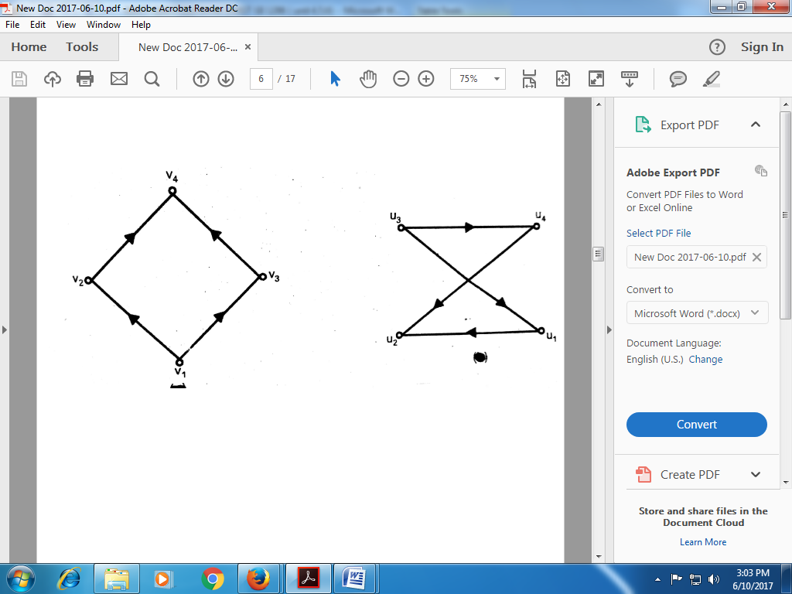 | 12 | 5 | medium | Easy | Co 5 | Descriptive
7 | Unit 5 | Check whether the digraphs given below are isomorphic. | 12 | 5 | medium | Easy | Co 5 | Descriptive
8 | Unit 5 | If R= {(1,2),(2,3),(3,4),(2,1)} then draw the digraph of R and find$M_{R}$ .  Also find the transitive closure of R. | 12 | 5 | medium | Easy | Co 5 | Descriptive
9 | Unit 5 | Let A={1,2,3,4,5,6}. Let R be the relation defined on the set A as  R= {(1,2),(1,3),(2,4),(2,5),(3,6)}.  Draw the tree represented by the relation R and the corresponding binary tree. | 15 | 5 | medium | moderate | Co 5 | Descriptive
10 | Unit 5 | Draw a tree for the relation R= {(1,2),(1,3),(1,4),(2,5),(4,6),(4,7)}on a set A={1,2,3,4,5,6,7}. Also give the corresponding binary tree. | 15 | 5 | medium | moderate | Co 5 | Descriptive
11 | Unit 5 | Let A={1,2,3,4,5,6,7,8,9,10}, T={(2,3),(2,1),(4,5),(4,6),(5,8),(6,7),(4,2),(7,9),(7,10)}.  Identify the root and show that T is a rooted tree. Also give the corresponding binary tree. | 15 | 5 | medium | moderate | Co 5 | Descriptive
12 | Unit 5 | Draw a directed tree with 2 nodes at level 1, 5 nodes at level 2, 3 nodes at level 3. Obtain the corresponding binary tree. | 15 | 5 | medium | moderate | Co 5 | Descriptive
13 | Unit 5 | Draw a directed tree with 4 nodes at level 1, 6 nodes at level 2. Also Obtain the corresponding binary tree. | 15 | 5 | medium | moderate | Co 5 | Descriptive
14 | Unit 5 | Draw the digraph of the following adjacency matrices A and B. Are these graphs isomorphic?  $A=\left[\begin{matrix}\begin{matrix}0 & 1 \\ 0 & 0\end{matrix} & \begin{matrix}0 & 0 \\ 1 & 1\end{matrix} \\ \begin{matrix}1 & 1 \\ 1 & 0\end{matrix} & \begin{matrix}0 & 1 \\ 0 & 0\end{matrix}\end{matrix}\right]$, $B=\left[\begin{matrix}\begin{matrix}0 & 1 \\ 1 & 0\end{matrix} & \begin{matrix}0 & 1 \\ 1 & 1\end{matrix} \\ \begin{matrix}1 & 0 \\ 0 & 0\end{matrix} & \begin{matrix}0 & 0 \\ 1 & 0\end{matrix}\end{matrix}\right]$ | 15 | 5 | medium | moderate | Co 5 | Descriptive
15 | Unit 5 | Draw the digraph corresponding to the adjacency matrices  $A=\left[\begin{matrix}\begin{matrix}0 & 1 \\ 1 & 0\end{matrix} & \begin{matrix}0 & 1 \\ 1 & 1\end{matrix} \\ \begin{matrix}1 & 1 \\ 1 & 0\end{matrix} & \begin{matrix}0 & 1 \\ 1 & 0\end{matrix}\end{matrix}\right]$ , $B=\left[\begin{matrix}\begin{matrix}0 & 1 \\ 1 & 0\end{matrix} & \begin{matrix}0 & 1 \\ 1 & 0\end{matrix} \\ \begin{matrix}1 & 1 \\ 1 & 1\end{matrix} & \begin{matrix}0 & 1 \\ 1 & 0\end{matrix}\end{matrix}\right]$  Prove that digraphs of A and B are isomorphic. | 15 | 5 | medium | moderate | Co 5 | Descriptive
16 | Unit 5 | Draw the digraph corresponding to the adjacency matrices A and B.  $A=\left[\begin{matrix}\begin{matrix}0 & 1 \\ 0 & 0\end{matrix} & \begin{matrix}1 & 0 \\ 0 & 0\end{matrix} \\ \begin{matrix}0 & 1 \\ 0 & 1\end{matrix} & \begin{matrix}1 & 1 \\ 0 & 0\end{matrix}\end{matrix}\right]$, $B=\left[\begin{matrix}\begin{matrix}0 & 1 \\ 0 & 1\end{matrix} & \begin{matrix}0 & 0 \\ 0 & 0\end{matrix} \\ \begin{matrix}0 & 0 \\ 1 & 0\end{matrix} & \begin{matrix}0 & 1 \\ 1 & 0\end{matrix}\end{matrix}\right]$  Are these two digraphs isomorphic? | 15 | 5 | medium | moderate | Co 5 | Descriptive
17 | Unit 5 | Draw the digraph of the following adjacency matrix and interpret the result $AA^{T},{ A}^{T}A, A^{2}, A^{3}.$  $A=\left[\begin{matrix}\begin{matrix}0 & 1 \\ 0 & 0\end{matrix} & \begin{matrix}0 & 0 \\ 1 & 1\end{matrix} \\ \begin{matrix}1 & 1 \\ 1 & 0\end{matrix} & \begin{matrix}0 & 1 \\ 0 & 0\end{matrix}\end{matrix}\right]$ | 15 | 5 | medium | Difficult | Co 5 | Descriptive
18 | Unit 5 | Draw the digraph corresponding to the adjacency matrix $A=\left[\begin{matrix}\begin{matrix}0 & 1 \\ 0 & 0\end{matrix} & \begin{matrix}0 & 1 \\ 1 & 1\end{matrix} \\ \begin{matrix}0 & 0 \\ 0 & 0\end{matrix} & \begin{matrix}0 & 1 \\ 1 & 0\end{matrix}\end{matrix}\right]$  with vertex set V = { $v_{1}$, $v_{2}, v_{3}, v_{4}\}$ .  (i) Find three different elementary paths from $v_{1}$ to$v_{3}$.  (ii) What is the shortest distance between $v_{1}$ and${ v}_{3}$ $?$  (iii) Is there any cycle in this digraph $?$ | 15 | 5 | medium | Difficult | Co 5 | Descriptive
19 | Unit 5 | Draw the digraph of the following adjacency matrix and interpret the result $AA^{T},{ A}^{T}A,{ A}^{2}.$  $A=\left[\begin{matrix}\begin{matrix}0 & 1 \\ 1 & 0\end{matrix} & \begin{matrix}0 & 1 \\ 1 & 0\end{matrix} \\ \begin{matrix}0 & 1 \\ 1 & 0\end{matrix} & \begin{matrix}0 & 1 \\ 1 & 0\end{matrix}\end{matrix}\right]$ | 15 | 5 | medium | Difficult | Co 5 | Descriptive
20 | Unit 5 | Draw the digraph corresponding to matrix $M_{R}=\left[\begin{matrix}\begin{matrix}0 & 1 \\ 0 & 0\end{matrix} & \begin{matrix}0 & 0 \\ 1 & 1\end{matrix} \\ \begin{matrix}1 & 1 \\ 1 & 0\end{matrix} & \begin{matrix}0 & 1 \\ 0 & 0\end{matrix}\end{matrix}\right]$  Find the transitive closure of the digraph. | 15 | 5 | medium | Difficult | Co 5 | Descriptive
21 | Unit 5 | Let $A=\left[\begin{matrix}\begin{matrix}0 & 1 \\ 0 & 0\end{matrix} & \begin{matrix}0 & 1 \\ 1 & 1\end{matrix} \\ \begin{matrix}0 & 0 \\ 0 & 0\end{matrix} & \begin{matrix}0 & 1 \\ 1 & 0\end{matrix}\end{matrix}\right]$Draw the digraph of the above matrix .Write the relation defined by the digraph.  Is the relation transitive $?$ | 15 | 5 | medium | Difficult | Co 5 | Descriptive
22 | Unit 5 | Find the minimal spanning tree for the weighted graph given below.  Also find the minimal weight. | 15 | 5 | medium | Difficult | Co 5 | Descriptive
23 | Unit 5 | Draw a railway network of minimal cost for the following cities.  Also find the minimal cost.  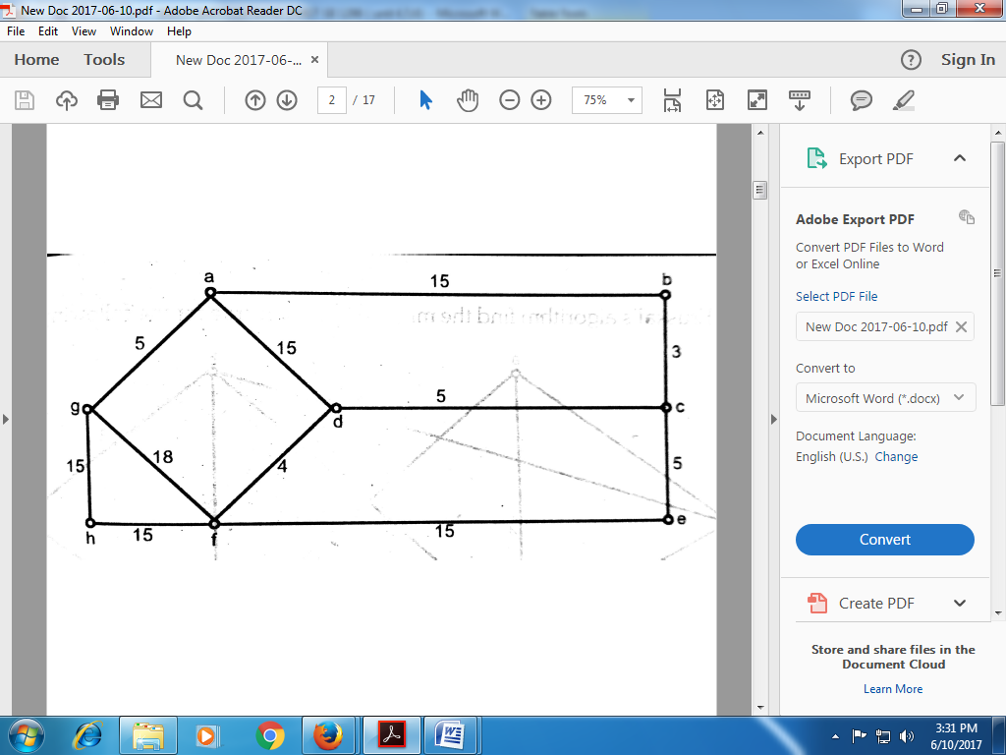 | 15 | 5 | medium | Difficult | Co 5 | Descriptive
24 | Unit 5 | Using Kruskal’s algorithm find the minimal spanning tree for the following  Weighted graph. Also find the minimal weight.  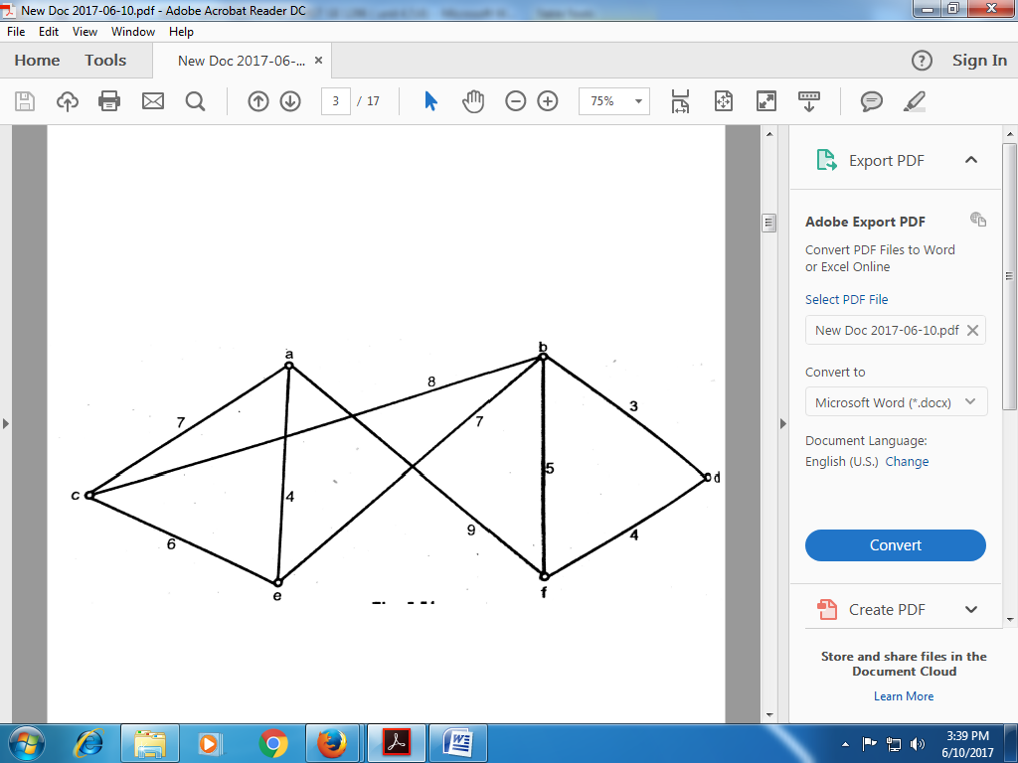 | 15 | 5 | medium | Difficult | Co 5 | Descriptive
25 | Unit 5 | Find the minimal spanning tree for the weighted graph given below.  Also find the minimal weight. | 20 | 5 | medium | Very difficult | Co 5 | Descriptive
26 | Unit 5 | Find the minimal spanning tree for the weighted graph given below.  Also find the minimal weight. | 20 | 5 | medium | Very difficult | Co 5 | Descriptive
27 | Unit 5 | Apply Prim’s algorithm to construct a minimal spanning tree for the following  Weighted graph. Also find the minimal weight | 20 | 5 | high | Very difficult | Co 5 | Descriptive
28 | Unit 5 | Apply Prim’s algorithm to construct a minimal spanning tree for the following  Weighted graph. Also find the minimal weight. | 20 | 5 | medium | Very difficult | Co 5 | Descriptive
29 | Unit 5 | Define isomorphic graphs. State whether the following digraphs are isomorphic | 20 | 5 | medium | Very difficult | Co 5 | Descriptive
30 | Unit 5 | Apply Prim’s algorithm to construct a minimal spanning tree for the following  Weighted graph. Also find the minimal weight. | 20 | 5 | medium | Very difficult | Co 5 | Descriptive
31 | Unit 5 | Use Prim’s algorithm to find the minimal spanning tree for the following  Weighted graph. Also find the minimal weight.  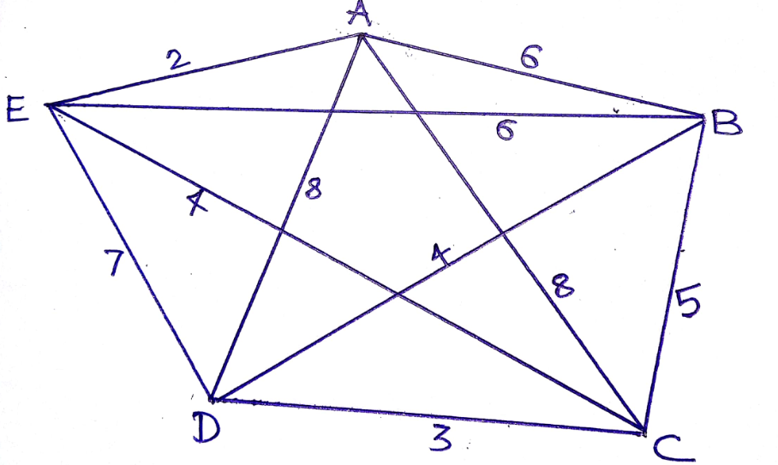 | 20 | 5 | high | Very difficult | Co 5 | Descriptive
32 | Unit 5 | Find all the indegrees and outdegrees of the nodes of the following digraph.  Give all the elementary cycles of this digraph. Obtain an acyclic digraph by deleting an edge. Also list all the nodes which are reachable from other nodes. | 20 | 5 | high | Very difficult | Co 5 | Descriptive
33 | Unit 5 | Find the minimal spanning tree for the weighted graph given below.  Also find the minimal weight. | 20 | 5 | medium | Very difficult | Co 5 | Descriptive
34 | Unit 5 | Use Prim’s algorithm to find the minimal spanning tree for the following  Weighted graph. Also find the minimal weight.  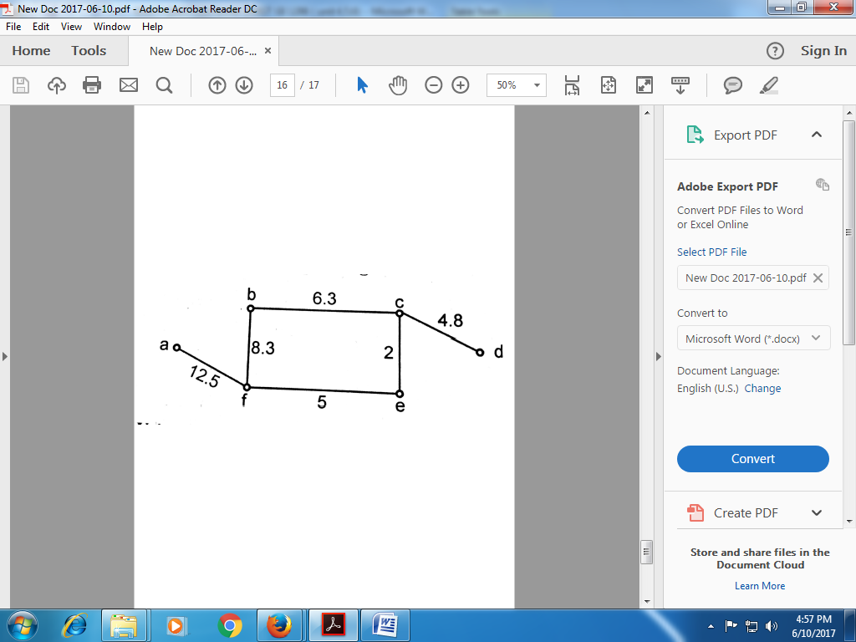 | 20 | 5 | medium | Very difficult | Co 5 | Descriptive
1 | Unit 6 | The joint probability function of two random variables X and Y is given by  $$f\left(x,y\right)=\left\{ \begin{aligned}\begin{matrix}C xy , x=1,2,3 , y=1,2,3 \\ \end{matrix} \\ 0 , otherwise \end{aligned}\right.$$  Find (i) the constant C , (ii )$P(X=3, Y=1),$  (iii) P($1≤X≤2 , Y≤3),$ (iv) $P(X ≥2)$ (v) P($Y<2)$ | 12 | 5 | medium | Easy | Co 6 | Numerical
2 | Unit 6 | Let X and Y be two random variables with joint density function  $$f\left(x,y\right)=\left\{ \begin{aligned}9 e^{-3\left(x+y\right) }\begin{matrix}, x,y≥0 \\ \end{matrix} \\ 0 , otherwise \end{aligned}\right.$$  (i) Check whether this is a valid density function.  (ii) Find P ($0≤X≤1 , 0≤Y≤1)$. | 12 | 5 | medium | Easy | Co 6 | Numerical
3 | Unit 6 | Find the conditional probability function of X given Y and Y given X  for the distribution  $$f\left(x,y\right)=\left\{\begin{aligned}\begin{matrix} \frac{xy}{36} , x=1,2,3 , y=1,2,3 \\ \end{matrix} \\ 0 , otherwise \end{aligned}\right.$$ | 12 | 5 | medium | Easy | Co 6 | Numerical
4 | Unit 6 | Let X and Y be two continuous random variables having joint density function  $f\left(x,y\right)=\left\{ \begin{aligned}C(x^{2}+y^{2}), 0≤x≤1 ,0≤y≤1 \\ 0 , otherwise \end{aligned}\right.$  Find (i) constant C, (ii) P$\left(X<\frac{1}{2} , Y>\frac{1}{2} \right)$ , (iii) P$\left(\frac{1}{4}<X<\frac{3}{4}\right)$  (iv) P$\left(Y<\frac{1}{2}\right)$ | 12 | 5 | medium | Easy | Co 6 | Numerical
5 | Unit 6 | The joint density function of two random variables X and Y is given by  $$f\left(x,y\right)=\left\{ \begin{aligned}\begin{matrix}Cxy , 0<x<4 , 1<y<5 \\ \end{matrix} \\ 0 , otherwise\end{aligned}\right.$$  Find (i) constant C, (ii) P(X$≥3,Y≤2)$ , (iii) Are X and Y independent$?$ | 12 | 5 | medium | Easy | Co 6 | Numerical
6 | Unit 6 | The joint probability function of two discrete random variables X and Y is given by  $$f\left(x,y\right)=\left\{\begin{aligned}\begin{matrix}C \left(2x+y\right) , 0≤x≤2, 0≤y≤3 \\ \end{matrix} \\ 0 , otherwise\end{aligned}\right.$$  Find (i) constant C, (ii) P(X$≥1,Y≤3)$ , (iii) P($1≤X≤2 , Y≤2),$  $\left(iv\right) P(X ≥1)$ (v) P($Y<2)$. | 12 | 5 | medium | Easy | Co 6 | Numerical
7 | Unit 6 | Let X and Y be two random variables with joint density function  $$f\left(x,y\right)=\left\{\begin{aligned}\begin{matrix} C (x+y) , 0≤x≤1 ,0≤y≤1 \\ \end{matrix} \\ 0 , otherwise\end{aligned}\right.$$  Find (i) constant C, (ii) P$\left(X<\frac{1}{2} , Y>\frac{1}{2}\right)$ , (iii) P$\left(\frac{1}{4}<X<\frac{3}{4}\right)$ ,  (iv) P$\left(X<\frac{1}{2}\right)$ | 12 | 5 | medium | Easy | Co 6 | Numerical
8 | Unit 6 | Let X and Y be two random variables with joint probability function  $$f\left(x,y\right)=\left\{\begin{aligned}\begin{matrix}C \left(x+2y\right), x=0,1,2 , y=0,1,2 \\ \end{matrix} \\ 0 , otherwise \end{aligned}\right.$$  Find (i) constant C, (ii) $(X=0, Y=2)$ , (iii) P($1≤X≤2 , Y≤1),$ $\left(iv\right) P(Y ≥1)$ (v) P($X≤2)$. | 12 | 5 | medium | Easy | Co 6 | Numerical
9 | Unit 6 | The joint probability function of two discrete random variables X and Y is given by  $$f\left(x,y\right)=\left\{\begin{aligned}\begin{matrix}C \left(2x+y\right) , 0≤x≤2, 0≤y≤3 \\ \end{matrix} \\ 0 , otherwise\end{aligned}\right.$$  Find (i) constant C, (ii) P(X$≥1,Y≤2)$ , (iii) marginal probability functions of X and Y. Also determine whether X and Y are independent | 15 | 5 | medium | moderate | Co 6 | Numerical
10 | Unit 6 | Let X and Y be two random variables with joint probability function  $$f\left(x,y\right)=\left\{\begin{aligned}\begin{matrix}\frac{x+2y}{27}, x=0,1,2 , y=0,1,2 \\ \end{matrix} \\ 0 , otherwise \end{aligned}\right.$$  Find (i) $P(X=0, Y=2),$ (iii) $P(X ≥1)$ (iii) marginal probability functions of X and Y. Also determine whether X and Y are independent. | 15 | 5 | medium | moderate | Co 6 | Numerical
11 | Unit 6 | Let X and Y be two continuous random variables having joint density function  $f\left(x,y\right)=\left\{\begin{aligned}c(x^{2}+y^{2}), 0≤x≤1 ,0≤y≤1 \\ 0 , otherwise .\end{aligned}\right.$  Find (i) constant C, (ii) Marginal density functions of X and Y,  (iii) P$\left(X<\frac{1}{2},Y>\frac{1}{2}\right)$ , (iv) P$\left(Y<\frac{1}{2}\right)$. | 15 | 5 | medium | moderate | Co 6 | Numerical
12 | Unit 6 | Let X and Y be two random variables with joint density function  $f\left(x,y\right)=\left\{\begin{aligned}x+y , 0≤x≤1 ,0≤y≤1 \\ 0 , otherwise .\end{aligned}\right.$  Find (i) E(X), (ii) E(Y), (iii) Var(X), (iv) Var(Y). | 15 | 5 | medium | moderate | Co 6 | Numerical
13 | Unit 6 | Let X and Y be two continuous random variables having joint density function  $f\left(x,y\right)=\left\{ \begin{aligned}\frac{2}{5}\left(2x+3y\right) , 0≤x≤1 ,0≤y≤1 \\ 0 , otherwise \end{aligned}\right.$  Find (i) P$\left(X<\frac{1}{2},Y>\frac{1}{2}\right)$ , (ii) P$\left(Y<\frac{3}{4}\right)$,  (iii) Conditional probability function of Y given X . | 15 | 5 | medium | moderate | Co 6 | Numerical
14 | Unit 6 | Let X and Y be two random variables with joint probability function  $$f\left(x,y\right)=\left\{ \begin{aligned}\begin{matrix}\frac{2x+y}{10}, x=0,1,2 , y=0,1,2,3 \\ \end{matrix} \\ 0 , otherwise \end{aligned}\right.$$  Find (i) E(XY), (ii) E(2X+3Y), (iii) E($X^{2}∕$ Y= y) ,(iv) E($Y^{2}∕$ X= x) | 15 | 5 | medium | moderate | Co 6 | Numerical
15 | Unit 6 | Let X and Y be two random variables with joint density function  $$f\left(x,y\right)=\left\{\begin{aligned}\begin{matrix}C\left(6-x-y\right) , 0<x<2 , 2<y<4 \\ \end{matrix} \\ 0 , otherwise\end{aligned}\right.$$  Find (i) ) constant C, (ii) P$\left(X<1,Y<3\right)$ ,(iii) P$\left(X<\frac{1}{2},Y>3\right)$,  (iv) P$\left(X<\frac{1}{2}\right)$. (v) P$\left(Y>\frac{5}{2}\right)$ | 15 | 5 | medium | moderate | Co 6 | Numerical
16 | Unit 6 | Let X and Y be two discrete random variables with joint probability function  $$f\left(x,y\right)=\left\{\begin{aligned}\begin{matrix} C (x+y) , x=0,1,2 , y=1,2,3 \\ \end{matrix} \\ 0 , otherwise\end{aligned}\right.$$  Find (i) constant C, (ii) P($X<2 , Y>1)$ , (iii) marginal probability functions of X and Y, (iv) Conditional probability function of X given Y . | 15 | 5 | medium | moderate | Co 6 | Numerical
17 | Unit 6 | Find the conditional density function of (i) X given Y and (ii) Y given X  for the distribution  $$f\left(x,y\right)=\left\{\begin{aligned}\frac{3(x^{2}+y^{2})}{2}, 0≤x≤1, 0≤y≤1 \\ 0 , otherwise \end{aligned}\right.$$ | 15 | 5 | medium | Difficult | Co 6 | Numerical
18 | Unit 6 | Let X and Y be two random variables with joint density function  $f\left(x,y\right)=\left\{\begin{aligned}x+y , 0≤x≤1 ,0≤y≤1 \\ 0 , otherwise .\end{aligned}\right.$  Find conditional expectation and variance of Y given X. | 15 | 5 | medium | Difficult | Co 6 | Numerical
19 | Unit 6 | Let $f\left(x,y\right)=\left\{\begin{aligned}e^{-(x+y)} , x≥0,y≥0 \\ 0 , otherwise\end{aligned}\right.$  be the joint density function of X and Y .  Find (i) Marginal density functions of X and Y , (ii) Conditional density function of X given Y. | 15 | 5 | medium | Difficult | Co 6 | Numerical
20 | Unit 6 | If the joint density function of two random variables X and Y is given by  $$f\left(x,y\right)=\left\{\begin{aligned}\begin{matrix}C \left(2x+y\right) , 2<x<6 , 0<y<5 \\ \end{matrix} \\ 0 , otherwise\end{aligned}\right.$$  Find (i) constant C, (ii) Marginal distribution functions of X and Y  (iii) Marginal density function of X and Y. | 15 | 5 | medium | Difficult | Co 6 | Numerical
21 | Unit 6 | Let X and Y be two continuous random variables having joint density function  $f\left(x,y\right)=\left\{\begin{aligned}c(x^{2}+y^{2}), 0≤x≤1 ,0≤y≤1 \\ 0 , otherwise .\end{aligned}\right.$  Find (i) constant C, (ii) Marginal distribution functions of X and Y ,  (iii) Determine whether X and Y are independent. | 15 | 5 | medium | Difficult | Co 6 | Numerical
22 | Unit 6 | The joint density function of two random variables X and Y is given by  $$f\left(x,y\right)=\left\{ \begin{aligned}\begin{matrix}\frac{xy}{96} , 0<x<4 , 1<y<5 \\ \end{matrix} \\ 0 , otherwise\end{aligned}\right.$$  Find (i) E(X), (ii) E(Y), (iii) E (XY), (iv) E (2X + 3Y). | 15 | 5 | medium | Difficult | Co 6 | Numerical
23 | Unit 6 | The joint probability function of two discrete random variables X and Y is given by  $$f\left(x,y\right)=\left\{\begin{aligned}\begin{matrix}C \left(2x+y\right) , 0≤x≤2, 0≤y≤3 \\ \end{matrix} \\ 0 , otherwise\end{aligned}\right.$$  Find (i) constant C, (ii) E(X), (ii) E(Y), (iii) E (XY), (iv)Var(X). | 15 | 5 | medium | Difficult | Co 6 | Numerical
24 | Unit 6 | Let X and Y be two discrete random variables having joint probability function  $f\left(x,y\right)=\left\{\begin{aligned}c(x^{2}+y^{2}), 0≤x≤2 ,0≤y≤2 \\ 0 , otherwise .\end{aligned}\right.$  Find (i) constant C, (ii) Marginal distribution functions of X and Y  (iii) Determine whether X and Y are independent. | 15 | 5 | medium | Difficult | Co 6 | Numerical
25 | Unit 6 | Given the joint probability density function of random variables X and Y as $f\left(x,y\right)=\left\{ \begin{aligned}\frac{1}{4}\left(1+xy\right), \left|x\right|<1,\left|y\right|<1 \\ 0 , otherwise \end{aligned}\right.$  Find the marginal and conditional probability density function of X and Y. | 20 | 5 | medium | Very difficult | Co 6 | Numerical
26 | Unit 6 | A fair coin is tossed three times. Let X denotes o or1 according as a head or a tail occurs on the first toss and let y denotes the number of heads which occurs. Determine  (i) The marginal probability function of X and Y and  (ii) The joint distribution function of X and Y. | 20 | 5 | high | Very difficult | Co 6 | Numerical
27 | Unit 6 | Let X and Y be two random variables with joint density function  $$f\left(x,y\right)=\left\{\begin{aligned}\begin{matrix}\frac{1}{8} \left(6-x-y\right) , 0<x<2 , 2<y<4 \\ \end{matrix} \\ 0 , otherwise\end{aligned}\right.$$  Find (i) P(X$<1,Y<3)$ , (ii) P( X$+ Y<3)$  (iii) Marginal distribution functions of X and Y. | 20 | 5 | medium | Very difficult | Co 6 | Numerical
28 | Unit 6 | Let X and Y be two random variables having joint density function  $f\left(x,y\right)=\left\{ \begin{aligned}\frac{3x\left(x+y\right)}{5}, 0≤x≤1 ,0≤y≤2 \\ 0 , otherwise \end{aligned}\right.$  Find (i) Var(X) , (ii) Var(Y) , (iii) $σ_{xy}$ . | 20 | 5 | medium | Very difficult | Co 6 | Numerical
29 | Unit 6 | Let X and Y be two random variables having joint density function  $f\left(x,y\right)=\left\{\begin{aligned}e^{-(x+y)} , x≥0,y≥0 \\ 0 , otherwise\end{aligned}\right.$  Find (i) Var(X) , (ii) Var(Y) , (iii) Coefficient of correlation between X and Y. | 20 | 5 | medium | Very difficult | Co 6 | Numerical
30 | Unit 6 | Let X and Y be two random variables with joint density function  $$f\left(x,y\right)=\left\{\begin{aligned}\begin{matrix} 2-x-y , 0≤x≤1 ,0≤y≤1 \\ \end{matrix} \\ 0 , otherwise\end{aligned}\right.$$  Find (i) Var(X) , (ii) Var(Y) and (iii) Cov(X,Y). | 20 | 5 | medium | Very difficult | Co 6 | Numerical
31 | Unit 6 | Let X and Y be two random variables having joint probability function  $f\left(x,y\right)=\left\{\begin{aligned}C\left(x^{2}+y^{2}\right), x=0,1,2 , y=0,1,2 \\ 0 , otherwise \end{aligned}\right.$  Find (i) Constant C, (ii) conditional expectation of X given Y and Y given X. | 20 | 5 | high | Very difficult | Co 6 | Numerical
32 | Unit 6 | The joint probability function of two discrete random variables X and Y is given by  $$f\left(x,y\right)=\left\{\begin{aligned}\begin{matrix}C \left(2x+y\right) , 0≤x≤2, 0≤y≤3 \\ \end{matrix} \\ 0 , otherwise\end{aligned}\right.$$  Find (i) Constant C, (ii) conditional expectation of X given Y and  (iii) Conditional variance of X given Y. | 20 | 5 | high | Very difficult | Co 6 | Numerical

