PIMPRI CHINCHWAD COLLEGE OF ENGINEERING, PUNE
(An Autonomous Institute affiliated to Savitribai Phule Pune University)
DEPARTMENT OF INFORMATION TECHNOLOGY


MINI PROJECT REPORT
of
DataBase Management System
on
"Smart-Parking-Management-System"

Submitted by:
Rahul Gadekar : 124B1F007
Ganesh Kure : 124B1F008

Under Guidance of:
Prof. Alpana Borse

Academic Year: 2025–26

TABLE OF CONTENTS
Sr. No. | Content | Page No.
1 | Introduction | 3
2 | Objectives | 4
3 | System Requirements | 5
4 | System Design | 6
5 | Database Design | 7
6 | Implementation | 9
7 | Output Screens | 10
8 | Advantages & Limitations | 11
9 | Conclusion | 12
10 | References | 13

2

1. INTRODUCTION
The Smart Parking Management System is a web-based application designed to simplify and automate parking-related activities in urban areas, shopping complexes, educational institutions, and commercial buildings. The system provides a centralized digital platform for managing parking slots, bookings, user registrations, and payment transactions.

In traditional parking systems, slot availability tracking, booking, and payment collection are handled manually or through disconnected systems. These methods are inefficient and prone to errors such as double bookings, inaccurate records, and delays in slot allocation. With rapid urbanization and the growing number of vehicles, there is a pressing need for an automated and reliable digital parking solution.

1.1 Problem Statement
The current manual or semi-automated approach to parking management faces numerous challenges:
- Difficulty in tracking real-time parking slot availability
- Lack of an organized booking and cancellation system
- Inefficient payment collection and record management
- Poor communication between parking administrators and users
- High risk of data inconsistency, duplication, and record loss

These challenges significantly reduce the efficiency of parking operations and highlight the need for a well-structured system based on DBMS principles.

1.2 Proposed Solution
To overcome the limitations of the existing system, the Smart Parking Management System is proposed as a centralized digital platform. The system allows registered users to view available parking slots, make bookings, and process payments online. Administrators can monitor slot occupancy, manage bookings, assign slots, and generate payment reports.

The application uses a MySQL relational database to store and manage data efficiently. This ensures data consistency, eliminates redundancy, and enables rapid retrieval of information whenever required by the system or its users.

1.3 Scope of the Project
The scope of this project includes:
- Managing user and administrator account information
- Handling parking slot availability and status updates
- Processing and tracking booking records
- Recording and managing payment details
- Providing role-based access control for users and admins
- Maintaining structured relational data using MySQL

The system is designed for small to medium-scale parking facilities and can be extended with additional features in future development phases.
3

2. OBJECTIVES
The primary objective of this project is to develop an efficient, user-friendly parking management system that automates slot booking and payment processes while ensuring proper data management.

Primary Objectives
- To design a web-based parking slot management system
- To automate parking slot booking and cancellation
- To maintain accurate records of users, slots, and payments
- To reduce manual effort and minimize human errors
- To provide a centralized and organized platform for parking management

Technical Objectives
- To implement a normalized relational database using MySQL
- To establish proper relationships using primary and foreign keys
- To perform all CRUD operations effectively on the database
- To ensure data integrity, consistency, and security
- To integrate frontend, backend, and database layers seamlessly

Learning Objectives
- To understand the real-world application of DBMS concepts
- To gain practical full-stack development experience
- To improve analytical and system design skills
- To understand three-tier application architecture
4

3. SYSTEM REQUIREMENTS
3.1 Hardware Requirements
The system can run on standard hardware without requiring high-end specifications.
- Processor: Intel i3 or higher
- RAM: Minimum 4 GB (recommended 8 GB for better performance)
- Storage: At least 100 MB free space
- Display: Standard monitor with 1280×720 or higher resolution

3.2 Software Requirements
Operating System
- Windows 10/11
- Linux (Ubuntu 20.04 or later)
- macOS 12 or later

Frontend Technologies
- React.js for UI development
- HTML5 and CSS3 for structure and styling
- JavaScript (ES6+) for dynamic behavior
- Vite for faster build and development process

Backend Technologies
- Node.js for server-side logic and API handling
- Express.js for routing and middleware management

Database
- MySQL for relational data storage and management
- Used to store users, parking slots, bookings, and payments

Tools Used
- Visual Studio Code (IDE)
- MySQL Workbench (Database Management)
- Git Bash (Version Control)
- Postman (API Testing)

3.3 Functional Requirements
The system must:
- Allow user registration, login, and profile management
- Enable users to view available parking slots in real time
- Allow users to book and cancel parking slots
- Manage payment records and generate billing information
- Provide full administrative control over slots and bookings

3.4 Non-Functional Requirements
- Fast and responsive system performance
- Secure user authentication and role-based access
- User-friendly and intuitive interface design
- Scalable architecture to accommodate more users
- Reliable and consistent data storage
5

4. SYSTEM DESIGN
4.1 Architecture
The system follows a three-tier architecture:
- Presentation Layer: Handles user interface (React.js)
- Application Layer: Processes business logic (Node.js + Express.js)
- Data Layer: Manages persistent data storage (MySQL)

4.2 ER Diagram Description
The Entity-Relationship (ER) diagram for the Smart Parking Management System consists of the following entities and relationships:

- Users Entity: Stores user details such as user_id, name, email, password, phone, and role (user/admin). Each user can make multiple bookings.
- ParkingSlots Entity: Contains slot_id, slot_number, location, slot_type (two-wheeler/four-wheeler), and status (available/occupied/reserved).
- Bookings Entity: Represents a booking transaction with booking_id, user_id (FK), slot_id (FK), booking_date, start_time, end_time, and status.
- Payments Entity: Stores payment_id, booking_id (FK), user_id (FK), amount, payment_date, and payment_status.
- Admin Entity: Contains admin_id, name, email, password, and contact for administrative staff.

Relationships
- One User → Many Bookings (One-to-Many)
- One ParkingSlot → Many Bookings (One-to-Many)
- One Booking → One Payment (One-to-One)
- One User → Many Payments (One-to-Many)
6

5. DATABASE DESIGN
5.1 Tables

Users Table
CREATE TABLE Users (
user_id INT PRIMARY KEY AUTO_INCREMENT,
name VARCHAR(50) NOT NULL,
email VARCHAR(100) UNIQUE NOT NULL,
password VARCHAR(255) NOT NULL,
phone VARCHAR(15),
role ENUM('user', 'admin') DEFAULT 'user'
);

Admin Table
CREATE TABLE Admin (
admin_id INT PRIMARY KEY AUTO_INCREMENT,
name VARCHAR(50) NOT NULL,
email VARCHAR(100) UNIQUE NOT NULL,
password VARCHAR(255) NOT NULL,
contact VARCHAR(15)
);

ParkingSlots Table
CREATE TABLE ParkingSlots (
slot_id INT PRIMARY KEY AUTO_INCREMENT,
slot_number VARCHAR(10) UNIQUE NOT NULL,
location VARCHAR(100),
slot_type ENUM('two-wheeler', 'four-wheeler') NOT NULL,
status ENUM('available','occupied','reserved') DEFAULT 'available'
);

Bookings Table
CREATE TABLE Bookings (
booking_id INT PRIMARY KEY AUTO_INCREMENT,
user_id INT,
slot_id INT,
booking_date DATE NOT NULL,
start_time TIME NOT NULL,
end_time TIME,
status ENUM('active','completed','cancelled') DEFAULT 'active',
FOREIGN KEY (user_id) REFERENCES Users(user_id),
FOREIGN KEY (slot_id) REFERENCES ParkingSlots(slot_id)
);

Payments Table
CREATE TABLE Payments (
payment_id INT PRIMARY KEY AUTO_INCREMENT,
booking_id INT,
user_id INT,
amount DECIMAL(10, 2) NOT NULL,
payment_date DATE NOT NULL,
payment_status ENUM('pending','paid','failed') DEFAULT 'pending',
FOREIGN KEY (booking_id) REFERENCES Bookings(booking_id),
FOREIGN KEY (user_id) REFERENCES Users(user_id)
);

5.2 Relationships
- One user can make multiple bookings
- One parking slot can be linked to multiple bookings over time
- One booking generates exactly one payment record
- One user can have multiple payment records

5.3 Normalization
- 1NF: All attributes contain atomic values; no repeating groups
- 2NF: All non-key attributes are fully dependent on the primary key
- 3NF: No transitive dependencies exist between non-key attributes
8

6. IMPLEMENTATION
6.1 Technologies
- React.js (Frontend)
- Node.js with Express.js (Backend)
- MySQL (Database)

6.2 Features
- User registration and authentication
- Real-time slot availability display
- Parking slot booking and cancellation
- Online payment tracking and billing
- Admin dashboard for management and reporting

6.3 CRUD Operations
The system implements full CRUD functionality across all database tables:

INSERT Queries
-- Register a new user
INSERT INTO Users (name, email, password, phone, role)
VALUES ('Rahul Deshmukh', 'rahul@example.com', 'hashed_pass', '9876543210', 'user');

-- Book a parking slot
INSERT INTO Bookings (user_id, slot_id, booking_date, start_time, status)
VALUES (1, 5, '2026-04-20', '10:00:00', 'active');

SELECT Queries
-- View all available slots
SELECT * FROM ParkingSlots WHERE status = 'available';

-- View bookings for a specific user
SELECT B.booking_id, P.slot_number, B.booking_date, B.status
FROM Bookings B JOIN ParkingSlots P ON B.slot_id = P.slot_id
WHERE B.user_id = 1;

UPDATE Queries
-- Update slot status after booking
UPDATE ParkingSlots SET status = 'occupied' WHERE slot_id = 5;

-- Mark payment as completed
UPDATE Payments SET payment_status = 'paid' WHERE payment_id = 3;

DELETE Queries
-- Cancel a booking
DELETE FROM Bookings WHERE booking_id = 7 AND status = 'active';

-- Remove an inactive user
DELETE FROM Users WHERE user_id = 10;
9

7. OUTPUT SCREENS
The following section describes the key output screens of the Smart Parking Management System application. Each screen represents a critical functionality of the system.

7.1 Login Page
The login page allows registered users and administrators to securely authenticate into the system. Users enter their email address and password to access the platform. Role-based redirection ensures that regular users are taken to the Resident Dashboard while administrators are directed to the Admin Panel.

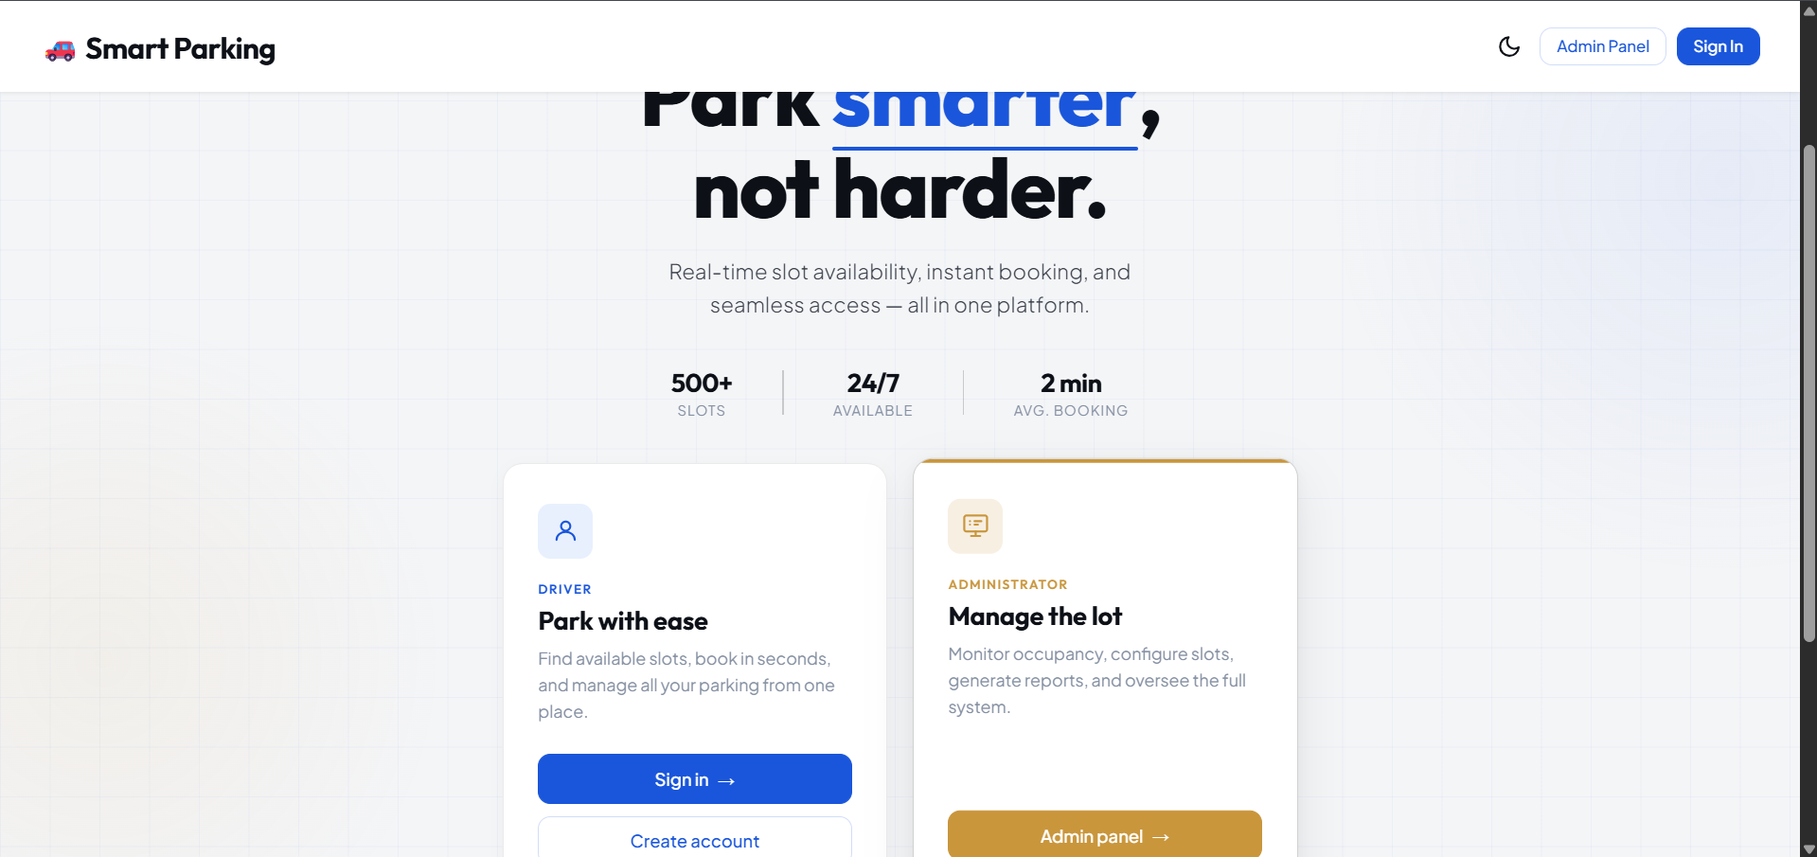
7.2 Slot Booking Page
The Slot Booking Page enables users to view all available parking slots filtered by type (two-wheeler or four-wheeler) and location. Users can select a desired slot, choose a date and time, and submit the booking request. The system updates the slot status to 'occupied' in real time upon successful booking.
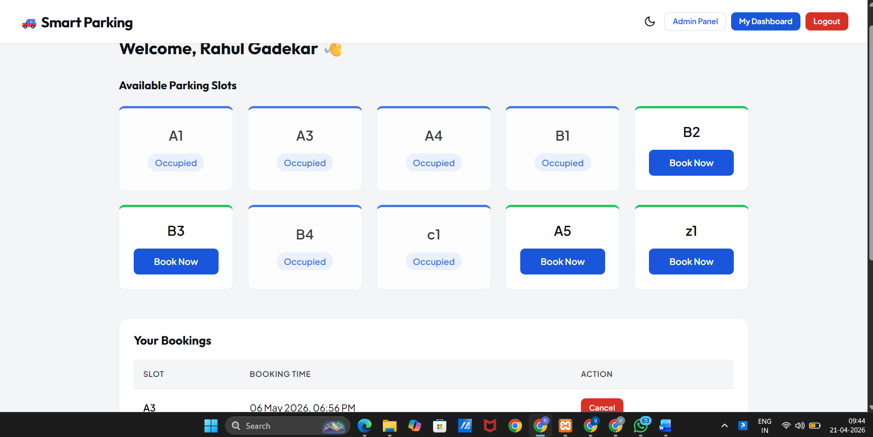7.3

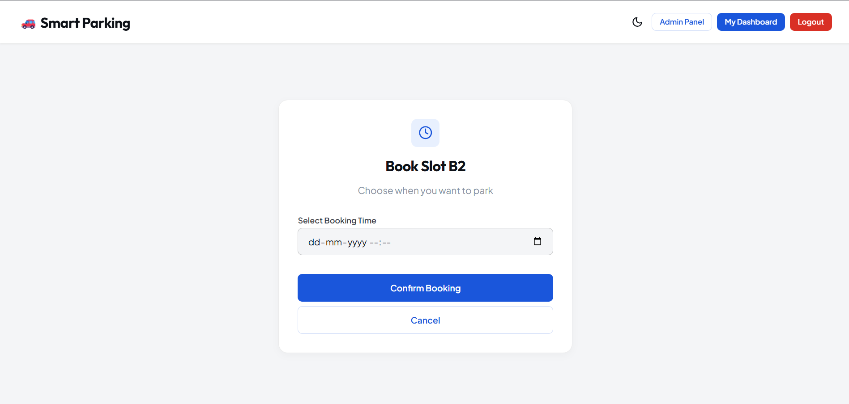

7.4 Admin Dashboard
The Admin Dashboard provides a comprehensive view of all parking operations. Administrators can monitor total bookings, pending requests, slot occupancy statistics, and payment summaries. They can also manage technician assignments, update slot statuses, and access data analytics for reporting purposes.
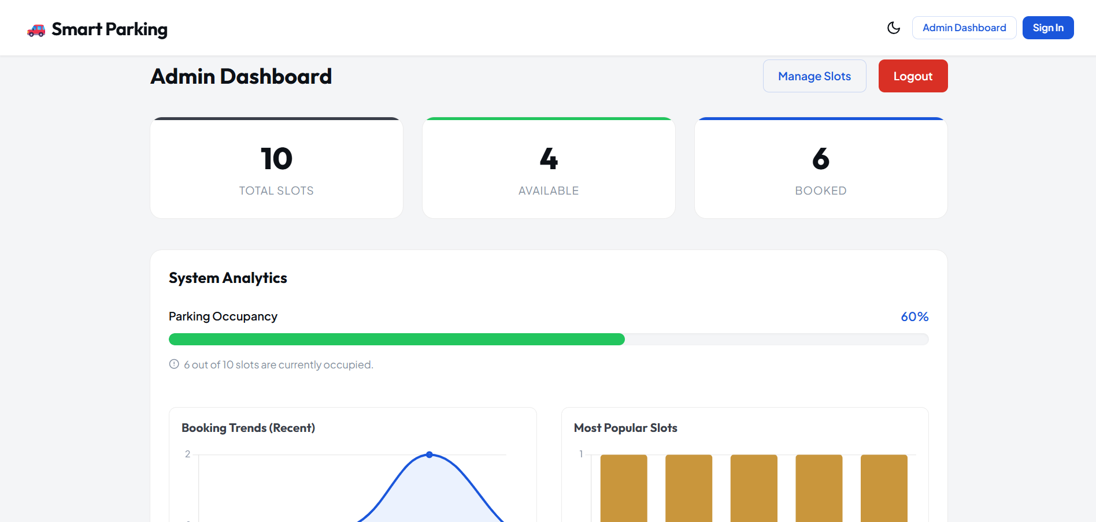

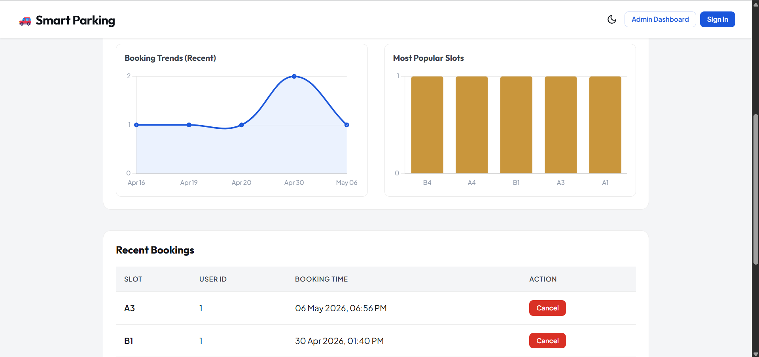

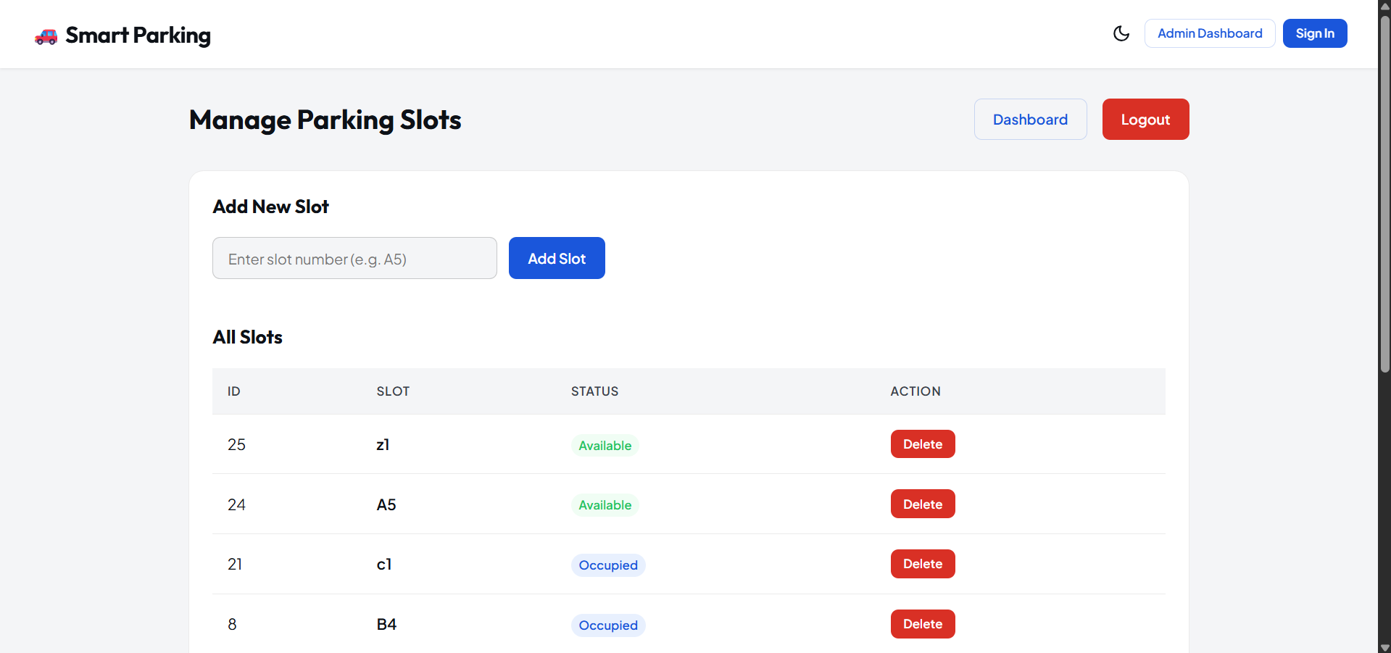

8. ADVANTAGES & LIMITATIONS
8.1 Advantages
The Smart Parking Management System offers several significant benefits:
- Reduction in Manual Work: Eliminates manual registers and spreadsheets, reducing human effort and saving time in slot allocation and record keeping.
- Real-Time Slot Availability: Users can instantly view and book available slots without any manual intervention or delay.
- Centralized Data Management: All records related to users, slots, bookings, and payments are stored in a single relational database for easy access and management.
- Improved Transparency: Users can track their booking history and payment status, increasing trust and accountability in the system.
- Accurate Record Keeping: Digital storage minimizes data loss, duplication, and inconsistency that are common in manual systems.
- Role-Based Access Control: Different access levels for users, administrators, and technicians ensure data security and system integrity.
- Scalability: The system can be extended to support more users, additional parking floors, or multiple parking facilities.

8.2 Limitations
- Requires stable internet connectivity for real-time operations.
- Currently lacks integration with IoT-based slot sensors for fully automated status updates.
- Payment gateway integration is not implemented in the current version.
- Mobile application support is not available in the current release.
- The system is designed for small to medium-scale facilities and may require further optimization for large-scale deployment.

12

9. CONCLUSION
The Smart Parking Management System successfully demonstrates the practical implementation of Database Management System (DBMS) concepts in addressing a real-world urban challenge. The system provides a structured and efficient approach to managing parking slots, user bookings, and payment transactions.

By automating processes such as slot booking, availability tracking, and payment management, the system significantly reduces manual workload and improves overall operational efficiency. The use of a normalized relational MySQL database ensures that data is stored in an organized and consistent manner, with well-defined relationships between tables.

The application of DBMS concepts including normalization (1NF, 2NF, 3NF), primary and foreign key constraints, and role-based data access ensures data integrity and eliminates redundancy throughout the system. The integration of React.js frontend, Node.js backend, and MySQL database results in a complete, user-friendly, and scalable solution.

Overall, this project has enhanced the team's understanding of system design, full-stack development, and practical database implementation. It also highlights the growing importance of digital solutions in managing modern urban infrastructure efficiently.

Future Enhancements
The system can be further improved by incorporating:
- Mobile application support for Android and iOS platforms
- IoT sensor integration for real-time automated slot monitoring
- Online payment gateway integration (Razorpay, PayPal)
- SMS and email notification system for booking confirmations
- Advanced analytics and reporting dashboard for administrators
- Vehicle number plate recognition using camera-based AI

These enhancements will make the system significantly more powerful, intelligent, and suitable for large-scale smart city deployment.
13

10. REFERENCES
The following resources were used during the development and understanding of the project:

- MySQL Official Documentation – Used for understanding database design, SQL queries, and relational concepts. Available at: https://dev.mysql.com/doc/
- Node.js Documentation – Helped in implementing server-side logic and handling backend API operations. Available at: https://nodejs.org/en/docs/
- React.js Official Documentation – Provided guidance for building the frontend user interface. Available at: https://react.dev/
- GeeksforGeeks – Used for learning DBMS concepts, SQL queries, normalization, and programming techniques. Available at: https://www.geeksforgeeks.org/
- Stack Overflow – Helpful for debugging errors and understanding practical coding issues. Available at: https://stackoverflow.com/
- W3Schools – Used for quick reference of HTML, CSS, JavaScript, and SQL syntax. Available at: https://www.w3schools.com/
- MDN Web Docs – Provided detailed explanations of web technologies and development best practices. Available at: https://developer.mozilla.org/
- YouTube Tutorials (Educational Channels) – Assisted in understanding full-stack development concepts and project implementation.
14

