**AI Powered Health Assistant**

A Project Report

submitted in partial fulfillment of the requirements

of

AICTE Internship on AI: Transformative Learning

with

TechSaksham – A joint CSR initiative of Microsoft & SAP

by

**Rahul Gaharwar, rahulgaharwar504@gmail.com**

Under the Guidance of

**Jay Rathod**

**ACKNOWLEDGEMENT**

I would like to express my heartfelt gratitude to my mentor, **Jay Rathod**, for his unwavering support, guidance, and encouragement throughout the development of this project. His deep knowledge, valuable insights, and constructive feedback have been instrumental in shaping Health Bot into a robust and efficient AI-powered health assistant. His mentorship has not only helped me refine my technical skills but has also inspired me to approach problem-solving with innovation and perseverance.

I would also like to extend my appreciation to my peers, colleagues, and everyone who contributed their time and expertise in providing feedback and suggestions. Their support and motivation have played a crucial role in the successful completion of this project. Lastly, I am grateful for the opportunity to work on this project, which has been an enriching learning experience.

#### **ABSTRACT**

With the increasing demand for accessible and intelligent healthcare solutions, **Health Bot** is designed as an AI-powered health assistant that enhances user interaction by processing speech input, generating meaningful responses, and providing actionable insights through text, speech, and images.

The primary objective of this project is to develop an interactive system capable of transcribing audio input, summarizing essential information, and generating AI-driven responses. To achieve this, **Health Bot** integrates multiple artificial intelligence and natural language processing (NLP) technologies, including **Google’s Speech Recognition API** for audio transcription, **Hugging Face’s DistilBART** for text summarization, and **JinaChat/OpenAI models** for chatbot responses. Additionally, **Google Text-to-Speech (gTTS)** is used for speech synthesis, while **Hugging Face’s text-to-image models** generate relevant visual content.

The system follows a structured workflow: users upload an audio file, which is transcribed into text. This text is then summarized to extract key points before being processed by an AI chatbot for a detailed response. The response is converted into speech for auditory feedback, and a relevant image is generated to provide visual representation. The results are displayed interactively using **Streamlit**, ensuring an intuitive user experience.

Key results demonstrate that **Health Bot** successfully transcribes speech with high accuracy, generates coherent summaries, and provides meaningful AI responses. The inclusion of multimodal outputs—text, speech, and images—enhances user engagement and accessibility. However, challenges such as speech recognition accuracy, API rate limits, and image relevance were addressed through optimized processing techniques and refined prompt engineering.

In conclusion, **Health Bot** presents an innovative and intelligent approach to AI-driven health assistance. Future enhancements will focus on **real-time voice interactions, multilingual support, and integration with wearable health devices** to further improve accessibility and usability.

**TABLE OF CONTENT**

**Abstract I**

**Chapter 1.**  **Introduction 1**

1.1 Problem Statement 1

1.2 Motivation 1

1.3 Objectives 2

1.4. Scope of the Project 3

**Chapter 2.**  **Literature Survey 6**

**Chapter 3.**  **Proposed Methodology 9**

**Chapter 4.**  **Implementation and Results 12**

**Chapter 5. Discussion and Conclusion 14**

**References** 16

**LIST OF FIGURES**

|  |  |  |
| --- | --- | --- |
| **Figure No.** | **Figure Caption** | **Page No.** |
| **Figure 3.1.** | System Design | **9** |
| **Figure 4.1.1.** | Audio Upload and Transcription | **12** |
| **Figure 4.1.2.** | AI Chatbot Responses | **13** |

**LIST OF TABLES**

|  |  |  |
| --- | --- | --- |
| **Table. No.** | **Table Caption** | **Page No.** |
| **Table 2.2.** | Existing models, techniques and methodlogies | **7** |
| **Table 2.3.** | Existing limitations and proposed solutions | **8** |
| **Table 3.2.1.** | Hardware requirements | **10** |
| **Table 3.2.2.** | Software requirements | **10** |

**CHAPTER 1**

**Introduction**

* 1. **Problem Statement:**

In today’s fast-paced world, access to reliable health-related information and assistance remains a challenge for many individuals. People often struggle with understanding medical advice, tracking symptoms, or finding quick and relevant responses to their health concerns. Traditional healthcare systems are not always accessible, and reliance on internet searches can lead to misinformation or confusion.

With the growing adoption of artificial intelligence, there is an opportunity to create a smart and interactive system that can assist users in processing health-related queries efficiently. **Health Bot** addresses this gap by providing an AI-powered solution that can transcribe spoken input, summarize key information, and generate accurate responses using advanced natural language processing (NLP) techniques.

This problem is significant because early detection, proper guidance, and quick access to reliable health insights can improve personal well-being and reduce the burden on healthcare professionals. By integrating speech recognition, AI-generated summaries, and interactive chatbot responses, **Health Bot** ensures that users receive relevant information in an accessible and user-friendly format. Furthermore, incorporating **text-to-speech and image generation** enhances the engagement and comprehension of health-related advice.

The implementation of **Health Bot** not only bridges the gap between individuals and healthcare information but also contributes to a future where AI-driven assistance can enhance medical awareness and self-care, making healthcare support more inclusive and efficient.

* 1. **Motivation:**

The motivation behind developing **Health Bot** stems from the growing need for accessible, AI-driven healthcare assistance. In today’s digital era, individuals increasingly rely on online sources for medical information. However, many struggle with inaccurate or misleading health data, language barriers, and the inability to access professional medical advice instantly. This project was chosen to bridge this gap by providing a reliable, interactive, and user-friendly AI-powered assistant that enhances health awareness and self-care.

The **potential applications** of **Health Bot** include:

* **Personal Health Assistance**: Users can receive AI-driven responses for common health-related queries, symptom analysis, and wellness guidance.
* **Elderly and Disabled Support**: The speech-to-text and text-to-speech features make the system accessible to individuals with disabilities or those who have difficulty typing.
* **Medical Education**: It can serve as an educational tool, summarizing medical content for students, professionals, and the general public.
* **Telemedicine Integration**: It can complement remote healthcare services by providing preliminary health insights before professional consultation.
* **Multilingual Support**: Future enhancements can include support for multiple languages, making healthcare assistance available to diverse populations.

The impact of **Health Bot** extends beyond individual convenience. It has the potential to **reduce misinformation**, **empower users with accurate health knowledge**, and **alleviate pressure on healthcare systems** by handling preliminary inquiries. By combining AI-powered transcription, summarization, chatbot responses, and multimodal outputs (text, speech, images), this system significantly enhances the accessibility and engagement of health-related information.

Ultimately, **Health Bot** aims to revolutionize how individuals interact with healthcare information, promoting better awareness, early intervention, and improved health outcomes in an increasingly digital world.

* 1. **Objective:**

The primary objective of **Health Bot** is to develop an AI-powered health assistant that provides users with reliable health-related insights through **speech recognition, natural language processing (NLP), and AI-driven responses**. The system aims to enhance accessibility, engagement, and accuracy in healthcare-related interactions.

The key objectives of this project are:

**Speech-to-Text Conversion**:

* 1. Implement speech recognition to transcribe audio input into text accurately.
  2. Enable users to interact with the system using voice commands.

**Text Summarization**:

* 1. Utilize NLP models to summarize transcribed text into concise and meaningful insights.
  2. Extract key information from user queries to provide relevant health-related responses.

**AI-Driven Chatbot Assistance**:

* 1. Integrate an AI-powered chatbot to generate intelligent, context-aware responses based on user input.
  2. Ensure responses are reliable and informative by leveraging advanced language models.

**Text-to-Speech Conversion**:

* 1. Convert AI-generated responses into speech output for improved accessibility and user engagement.
  2. Support individuals with disabilities or those who prefer audio interactions.

**Image Generation for Visual Representation**:

* 1. Generate visual representations of summarized health information using AI-based text-to-image models.
  2. Enhance user comprehension through relevant and engaging imagery.

**User-Friendly Interface**:

* 1. Develop an interactive and intuitive web-based platform using **Streamlit** for seamless user experience.
  2. Ensure smooth integration of multiple AI functionalities within a single interface.

**Real-Time and Efficient Processing**:

* 1. Optimize system performance to provide quick and responsive interactions.
  2. Minimize latency in transcription, summarization, and response generation.

**Scalability and Future Enhancements**:

* 1. Design the system to support multilingual interactions and real-time voice processing.
  2. Explore integration with wearable health devices for real-time health monitoring.

By achieving these objectives, **Health Bot** aims to **bridge the gap between individuals and accessible healthcare information**, promoting better health awareness, early symptom analysis, and improved self-care.

* 1. **Scope of the Project:**

The **Health Bot** project is designed as an AI-powered **health assistant** that provides users with **speech-to-text transcription, AI-based summarization, chatbot assistance, text-to-speech conversion, and image generation** for improved health-related interactions. The system is built using **natural language processing (NLP), deep learning models, and AI-driven automation** to enhance user engagement and accessibility.

#### ****Scope:****

**Speech Recognition & Transcription**

* 1. Converts spoken language into **text using Google’s Speech Recognition API**.
  2. Supports **English language input** for initial implementation.

**AI-Powered Text Processing**

* 1. Summarizes transcribed text using **Hugging Face DistilBART** for concise and actionable insights.
  2. Identifies key **health-related keywords** to refine AI responses.

**Chatbot Assistance**

* 1. Uses **JinaChat/OpenAI-based language models** to generate intelligent responses.
  2. Provides **basic health information and guidance** based on user queries.

**Text-to-Speech Conversion**

* 1. Uses **Google Text-to-Speech (gTTS)** to convert chatbot responses into **audio output**.
  2. Improves accessibility for **visually impaired users** and those who prefer voice interaction.

**Image Generation**

* 1. Generates **visual representations** of health-related information using **text-to-image AI models**.
  2. Helps users better understand summarized insights through **context-relevant images**.

**User Interface & Accessibility**

* 1. Provides a **web-based platform using Streamlit** for ease of use.
  2. Ensures a **simple and interactive experience** for users with minimal technical expertise.

#### ****Limitations****

**Not a Substitute for Medical Advice**

* 1. The system provides **general health-related insights** but does **not replace professional medical consultation**.
  2. Users are advised to seek guidance from healthcare professionals for serious medical concerns.

**Language Support Constraints**

* 1. Initially supports **only English**, with potential **multilingual support in future updates**.

**Accuracy of AI-Generated Responses**

* 1. Responses depend on **pre-trained AI models** and **internet-based knowledge sources**.
  2. AI-generated outputs may require **verification** for medical accuracy.

**Audio Input Format Restrictions**

* 1. Currently supports **only** .wav **files** for speech recognition.
  2. Future versions may include support for **additional audio formats**.

**Dependency on API Services**

* 1. The system relies on **external APIs (Google, Hugging Face, JinaChat)**, which may be subject to **rate limits and service downtimes**.
  2. An **offline version** with pre-trained models is not yet implemented.

**Limited Real-Time Interaction**

* 1. The system is **not designed for real-time doctor-patient communication**.
  2. Future enhancements may include **live chat features** with healthcare professionals.

**CHAPTER 2**

**Literature Survey**

### ****2.1 Review of Relevant Literature****

The **use of AI in healthcare** has been an active research area, with significant advancements in **speech recognition, NLP-based summarization, chatbot systems, and image generation**. Various studies highlight the **importance of AI-driven health assistants** in improving **accessibility, diagnosis support, and patient engagement**.

**Speech Recognition in Healthcare**

* 1. Research on **automated speech recognition (ASR)** has demonstrated its effectiveness in transcribing medical conversations and patient consultations.
  2. Google's **Speech Recognition API** and IBM’s **Watson Speech-to-Text** are commonly used for medical transcription.

**NLP-Based Summarization and Chatbots**

* 1. Studies on **NLP for medical text summarization** have explored techniques like **BERT, GPT, and DistilBART** for summarizing health records.
  2. AI chatbots like **Ada Health, Babylon Health, and Woebot** provide real-time assistance based on user queries.

**Text-to-Speech and AI Image Generation**

* 1. **Google Text-to-Speech (gTTS)** and Amazon Polly have been used for **converting medical text to speech** for accessibility.
  2. AI-driven **text-to-image generation models** (e.g., DALL·E, Stable Diffusion) have applications in medical visualization.

### ****2.2 Existing Models, Techniques, and Methodologies****

Several AI models and methodologies have been implemented in healthcare AI systems:

|  |  |  |
| --- | --- | --- |
| **Technique** | **Existing Models/Technologies** | **Applications in Healthcare** |
| **Speech Recognition** | Google Speech-to-Text, IBM Watson, DeepSpeech | Medical transcription, voice-based interfaces |
| **Text Sumarization** | BERT, GPT, DistilBART | Summarizing medical records, extracting key insights |
| **AI Chatbots** | Ada Health, Babylon Health, Woebot | Virtual health assistance, patient support |
| **Text-to-Speech (TTS)** | Google TTS, Amazon Polly | Accessibility for visually impaired patients |
| **Text-to-Image AI** | DALL·E, Stable Diffusion | Generating medical illustrations, visual aids |

*Table 2.2 existing models, techniques and methodologies*

### ****2.3 Gaps in Existing Solutions & How Health Bot Addresses Them****

While AI-based health assistants exist, they have limitations that **Health Bot** aims to improve:

|  |  |
| --- | --- |
| **Existing Limitations** | **Proposed Solutions in Health Bot** |
| ****Lack of Multimodal Interaction**** (Many AI health assistants focus only on text-based responses) | Integrates ****speech recognition, chatbot responses, text-to-speech, and image generation**** for a ****comprehensive experience**.** |
| **Limited Accessibility for Visually Impaired Users** | Implements ****text-to-speech** conversion** to make AI responses ****audible and accessible**.** |
| **Inefficient Summarization of Medical Text** | Uses ****DistilBART for summarization****, providing ****concise and relevant health insights****. |
| **Image Generation Not Used in AI Assistants** | Implements ****AI-powered text-to-image generation**** for ****better visualization of health-related topics**.** |
| **Dependency on a Single AI Model** | Uses ****multiple AI models (Speech-to-Text, GPT, Text-to-Speech, Image Generation)**** to enhance ****response quality and accuracy****. |

*Table 2.3 Existing limitations and proposed solutions*

The **Health Bot** project leverages state-of-the-art AI models to address **existing gaps in AI-driven health assistants**. By integrating **multimodal interaction, accessibility improvements, and AI-powered summarization and visualization**, it provides a **more comprehensive, user-friendly, and informative digital health assistant** compared to existing solutions. Future research will focus on **enhancing real-time interactions, multilingual support, and integrating medical databases for improved accuracy**.

**CHAPTER 3**

**Proposed Methodology**

* 1. **System Design**

The **Health Bot** follows a structured **workflow** to process user inputs (audio or text), analyze them, and generate meaningful responses using AI models. Below is the **system architecture diagram** that illustrates the flow of data and processing steps:

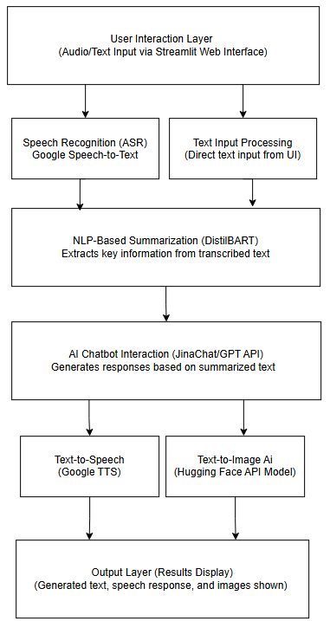

*Figure 3.1: System Design*

* 1. **Requirement Specification**
     1. **Hardware Requirements:**

The following hardware components are required to run the system efficiently:

|  |  |
| --- | --- |
| **Component** | **Specification** |
| **Processor** | Intel i5 (10th Gen) or higher / AMD Ryzen 5 |
| **RAM** | Minimum 8GB (Recommended: 16GB) |
| **Storage** | Minimum 20GB free space (SSD preferred) |
| **GPU (Optional)** | NVIDIA GTX 1650 or higher (for faster AI processing) |
| **Audio Input** | Microphone (for live voice input) |
| **Internet** | Stable broadband connection (for API calls) |

*Table 3.2.1: Hardware Requirements*

* + 1. **Software Requirements:**

The software stack includes various tools and libraries necessary for **developing, deploying, and running** the **Health Bot** application.

#### **Operating System**

* Windows 10/11, Linux (Ubuntu 20.04+), macOS

#### **Programming Language**

* **Python 3.8+** (Preferred due to extensive AI/ML support)

#### **Development Environment & Frameworks**

|  |  |
| --- | --- |
| **Software/Library** | **Purpose** |
| **Streamlit** (streamlit) | Web-based UI for user interaction |
| **Google Speech Recognition** (speech\_recognition) | Converts audio input to text |
| **Natural Language Toolkit (NLTK)** (nltk) | Text processing and tokenization |
| **DistilBART** (transformers) | AI-based text summarization |
| JinaChat / OpenAI GPT API | AI chatbot for conversational responses |
| **Google Text-to-Speech (gTTS)** (gtts) | Converts AI-generated text to speech |
| **Pillow (PIL)** (PIL) | Image handling and processing |
| **Hugging Face API** (requests) | Text-to-image generation |
| **NumPy & Pandas** (numpy, pandas) | Data handling and processing |
| **Python I/O** (io) | File management and audio processing |
| **Requests** (requests) | API calls and HTTP requests |

*Table 3.2.2: Software Requirements*

#### **Cloud & API Dependencies**

* **Google Cloud Speech-to-Text API** (For speech recognition)
* **OpenAI / JinaChat API** (For chatbot integration)
* **Hugging Face API** (For text summarization and image generation)

#### **Version Control**

* **Git & GitHub** (For version control and project collaboration)

#### **Optional Tools**

* **Docker** (For containerized deployment)
* **VS Code / PyCharm** (For coding and debugging)

**CHAPTER 4**

**Implementation and Result**

* 1. **Snap Shots of Result:**

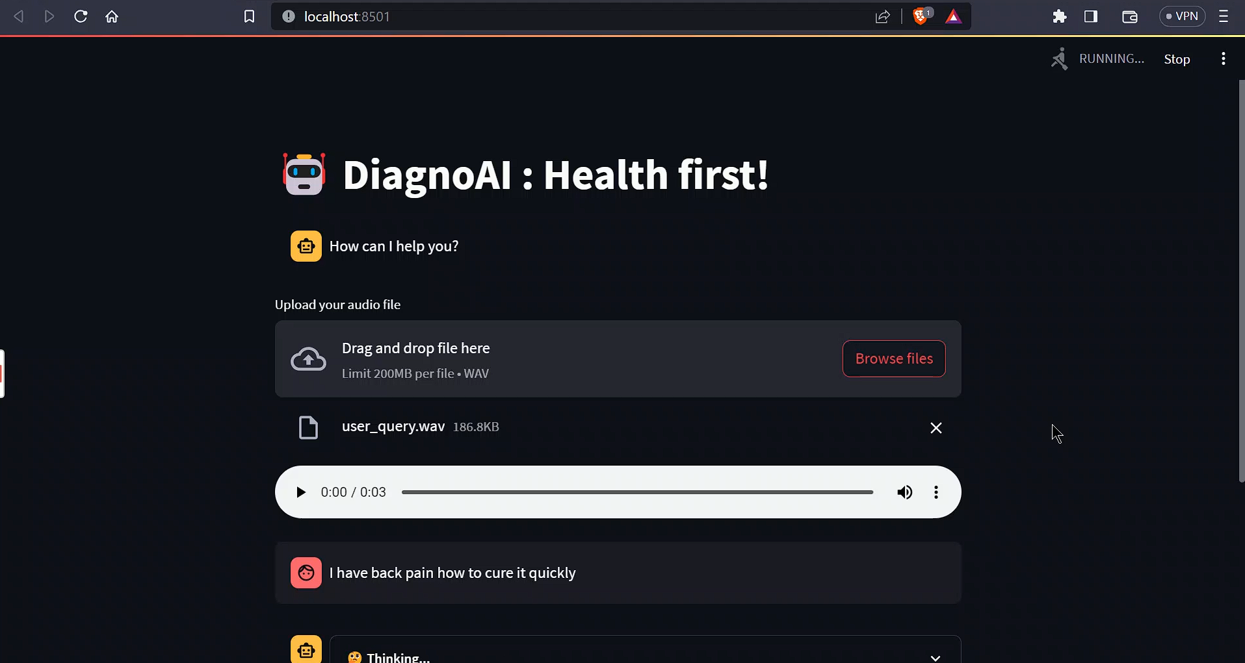

*Figure 4.1.1.: Audio Upload and Transcription*

This snapshot shows the **audio file upload section** in the **Health Bot** interface. Users can upload a .wav audio file, which is then processed using **Google Speech Recognition API**. The system transcribes the speech into text and displays it in the interface for further processing.

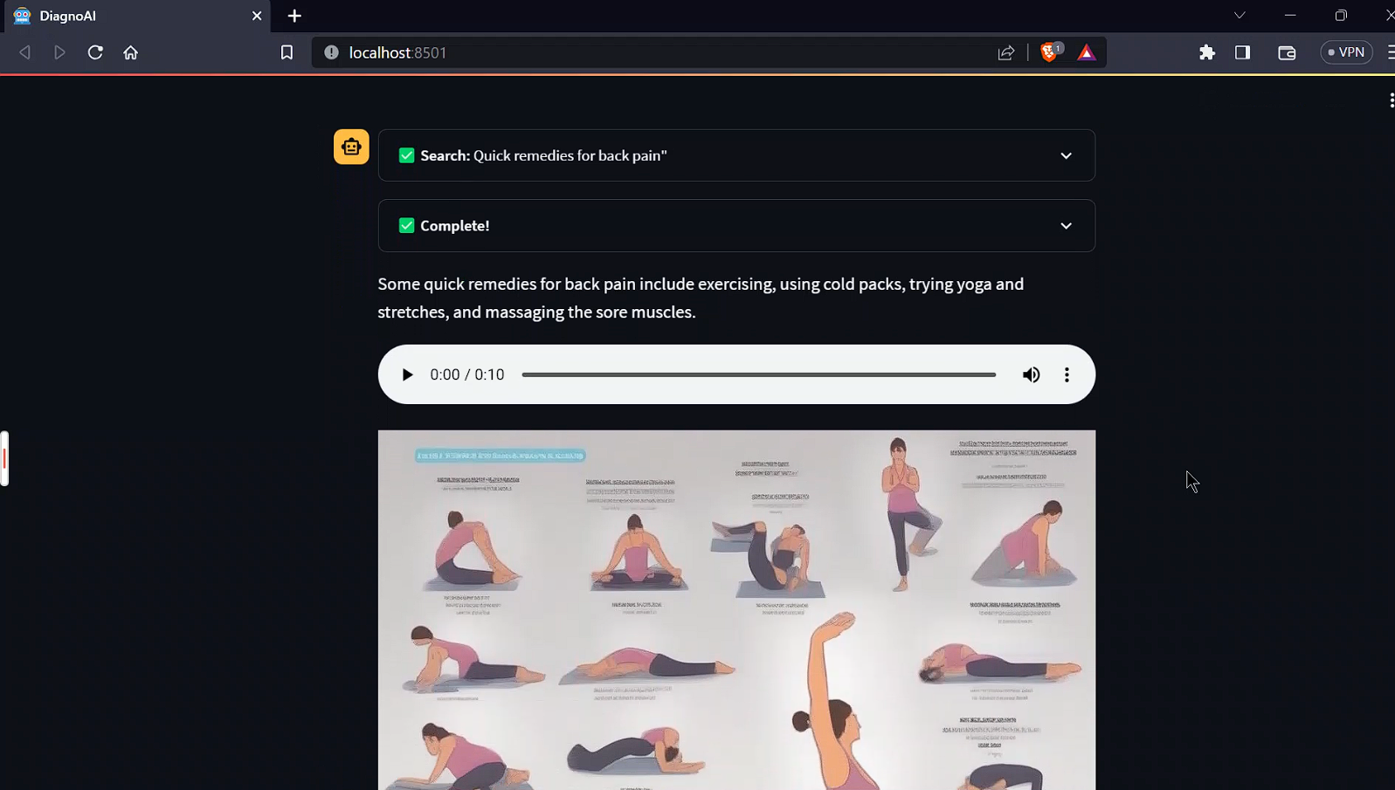

*Figure 4.1.2.: AI Chatbot Responses*

This snapshot displays the **AI chatbot feature**, where users can type or speak their queries. The chatbot processes the transcribed text using **JinaChat (or GPT-based AI models)** and generates a relevant response. The AI ensures that the response is meaningful and contextually accurate.

* 1. **GitHub Link for Code:**

**CHAPTER 5**

**Discussion and Conclusion**

* 1. **Future Work:**

The **Health Bot** has demonstrated its capability in transcribing speech, summarizing text, generating AI-driven responses, and providing multimodal outputs. However, several areas can be improved to enhance its efficiency, accuracy, and user experience.

#### **Suggested Improvements:**

**Real-Time Voice Processing**

* 1. Implement **real-time speech recognition** to enable instant conversation with the AI assistant, eliminating the need for pre-recorded audio uploads.

**Multi-Language Support**

* 1. Extend the system to support multiple languages for **global accessibility**, catering to users with different linguistic backgrounds.

**Enhanced Medical Knowledge Integration**

* 1. Integrate **medical databases** or AI models trained on healthcare data to provide more **accurate and reliable health-related responses**.

**Personalized Health Recommendations**

* 1. Use **machine learning models** to analyze user interactions and provide **personalized health suggestions** based on historical data.

**Mobile Application Development**

* 1. Extend the platform by developing a **mobile-friendly version** for seamless access on smartphones.

**Data Privacy & Security Enhancements**

* 1. Strengthen **data encryption** and compliance with **HIPAA (Health Insurance Portability and Accountability Act)** to ensure **secure handling of health-related conversations**.

**Improved Image Generation**

* 1. Fine-tune the **text-to-image models** to generate more **medically relevant and context-aware visuals**.
  2. **Conclusion:**

The **Health Bot** project successfully integrates **speech recognition, natural language processing, AI-driven conversation, and multimodal outputs** to enhance user interaction and provide health-related assistance. By leveraging advanced **AI models** for transcription, summarization, text generation, speech synthesis, and image creation, the system offers a comprehensive and interactive experience.

The project addresses the **challenge of making health-related information more accessible** by allowing users to interact using voice input. The chatbot’s ability to **convert spoken words into meaningful insights, provide AI-driven responses, and generate visual representations** makes it a **versatile and user-friendly tool**.

Key contributions of this project include:  
 **Improved accessibility** by enabling speech-based interaction.  
 **Enhanced engagement** through AI-driven responses and image generation.  
 **Multimodal support** (text, speech, and visuals) for a richer experience.  
 **Potential applications** in **healthcare, wellness coaching, and AI-assisted consultations**.

While the system demonstrates **promising capabilities**, further enhancements such as **real-time processing, multilingual support, deeper medical knowledge integration, and mobile accessibility** will strengthen its effectiveness. Overall, the **Health Bot** serves as a **powerful AI-driven assistant**, bridging the gap between users and health-related information in an interactive and intuitive manner.

**REFERENCES**

1. Google Speech Recognition API – Official documentation for speech-to-text conversion.  
   <https://cloud.google.com/speech-to-text>
2. Hugging Face API – Models for text summarization and image generation.  
   [https://huggingface.co/models](https://huggingface.co/models" \t "_new)
3. JinaChat & OpenAI GPT – AI-based chatbot integration for interactive responses.  
   [https://jina.ai/](https://jina.ai/" \t "_new)  
   [https://openai.com/gpt](https://openai.com/gpt" \t "_new)
4. Google Text-to-Speech (gTTS) – Text-to-speech conversion for generating voice responses.  
   [https://pypi.org/project/gTTS/](https://pypi.org/project/gTTS/" \t "_new)
5. Streamlit Framework – Web application framework for deploying AI-powered solutions.  
   [https://streamlit.io/](https://streamlit.io/" \t "_new)
6. Natural Language Toolkit (NLTK) – Tokenization and text processing for NLP tasks.  
   [https://www.nltk.org/](https://www.nltk.org/" \t "_new)
7. PIL (Pillow) Library – Image processing for handling and displaying generated images.  
   [https://pillow.readthedocs.io/](https://pillow.readthedocs.io/" \t "_new)
8. DuckDuckGo Search API – Web search tool used for retrieving additional information.  
   https://duckduckgo.com/api