RAVEN
Proposed Solution
Disaster Management & Emergency Response App

An integrated emergency platform combining AI/ML-based cyclone prediction, Bluetooth Mesh communication, SOS response, offline navigation, and an offline AI emergency assistant.

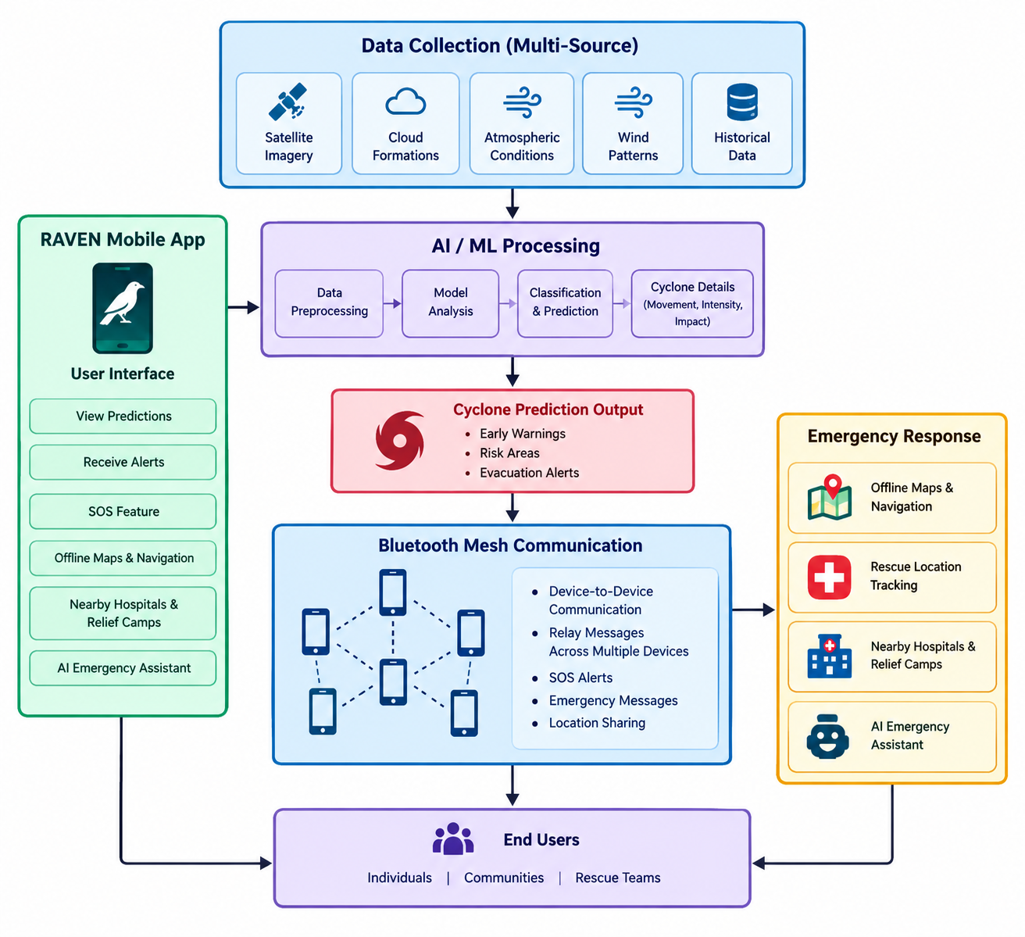
Figure 1. Proposed RAVEN system flow.

1. Proposed Solution Overview
RAVEN is proposed as an end-to-end disaster management and emergency response application. The primary focus is AI/ML-based identification, classification, and prediction of tropical cyclone patterns using multi-source satellite and environmental data. The prediction component is complemented by a Bluetooth Mesh communication layer that can support emergency messaging and SOS alerts when conventional communication infrastructure is unavailable.
The solution also provides offline maps and navigation, rescue-location tracking, information about nearby hospitals and relief camps, and an offline AI emergency assistant. Together, these components connect prediction, preparedness, communication, navigation, and emergency response in a single platform.

2. Problem Addressed
- Mobile networks, Wi-Fi, and internet connectivity may become unavailable during disasters.
- Victims may be unable to send SOS alerts or communicate with nearby people and rescuers.
- Online maps and navigation may not work when internet connectivity is unavailable.
- Finding nearby hospitals, shelters, relief camps, and rescue support can be difficult.
- Sharing a victim's location with nearby rescuers may be difficult during an emergency.
- People may lack immediate guidance about what actions to take during critical situations.
- Accurate and timely tropical cyclone identification, classification, movement, intensity, and impact prediction is a major requirement for preparedness.

3. Proposed System Architecture
The proposed architecture is organized into five major layers: data collection, AI/ML processing, prediction output, offline communication, and emergency-response services.
Layer | Main Components | Purpose
Data Collection | Satellite imagery, cloud formations, atmospheric conditions, wind patterns, historical data | Provide multi-source information for cyclone analysis.
AI/ML Processing | Data preprocessing, model analysis, classification and prediction | Identify cyclone patterns and predict movement, intensity and potential impact.
Prediction Output | Early warnings, risk areas, evacuation alerts | Support timely preparedness and disaster-response decisions.
Bluetooth Mesh | Device-to-device communication, relay, multi-hop messaging, SOS and location sharing | Maintain emergency communication without conventional network infrastructure.
Emergency Response | Offline maps, navigation, rescue tracking, hospitals/relief camps, AI assistant | Guide users and support response when connectivity is unavailable.

4. AI/ML-Based Cyclone Prediction
RAVEN's core proposed capability is the AI/ML-based cyclone prediction system. It processes multi-source satellite and environmental information to identify and classify tropical cyclone patterns and estimate their future behavior.
- Early Detection – identifies developing cyclone systems at an early stage.
- Cyclone Classification – determines the type and severity of the cyclone.
- Path Prediction – predicts the likely movement and trajectory of the cyclone.
- Intensity Prediction – estimates changes in wind speed and cyclone strength.
- Early Warning – provides timely alerts to potentially affected users.
- Evacuation Planning – helps identify high-risk areas and supports evacuation planning.
- Resource Management – supports positioning of rescue teams, food, medicines, and emergency supplies.
- Risk & Impact Assessment – estimates potentially affected regions so communities can prepare before arrival.

4.1 Prediction Workflow
- Collect multi-source satellite and environmental data.
- Preprocess and organize the input data for analysis.
- Apply AI/ML models to identify relevant cyclone patterns.
- Classify the cyclone and estimate its movement and intensity.
- Generate potential impact/risk information.
- Provide early warnings and support evacuation and resource-planning decisions.

5. Bluetooth Mesh Emergency Communication
RAVEN uses Bluetooth Mesh communication to maintain local emergency communication when mobile networks, Wi-Fi, SIM-based services, or internet connectivity are unavailable. Nearby smartphones communicate directly and can relay messages across multiple devices.
- Direct device-to-device communication using Bluetooth.
- Messages can hop from one device to another to form a multi-hop network.
- Supports emergency messages, SOS alerts, and location sharing.
- Designed for situations where cellular towers or internet infrastructure are damaged.
- The PPT describes an approximate 25 m device-to-device range under suitable conditions, with multi-hop communication extending effective coverage.

5.1 Bluetooth Mesh Message Flow
- SEND – A user sends a distress message from the RAVEN application.
- RELAY – The message is automatically passed to nearby RAVEN users.
- HOP – Each available device forwards the message to another connected device.
- REACH – The message eventually reaches the intended person, rescue team, or emergency node.
A key advantage described in the proposal is the absence of a single communication path: if one device leaves the network, messages can use another available path through surrounding devices.

6. SOS Emergency Response
RAVEN includes a one-tap SOS feature for users who are trapped or in danger. The SOS is broadcast through the Bluetooth Mesh network so nearby users can receive the alert and either provide assistance directly or help the message reach an authority/rescue node.
- One-tap emergency SOS activation.
- SOS broadcast through nearby Bluetooth-connected devices.
- Current location can be included with the SOS.
- User emergency/medical details can be included.
- Nearby users can respond or help relay the emergency information.

7. Offline Maps & Navigation
RAVEN provides offline maps so essential navigation remains available when internet connectivity is completely unavailable.
- Stores critical roads, buildings, hospitals, shelters, and evacuation routes locally.
- Supports navigation without requiring an internet connection.
- Helps users identify safer routes during emergencies.
- Divides the area into different zones based on danger level.
- Supports access to emergency facilities and evacuation routes.

8. Offline AI Emergency Assistant
The offline AI emergency assistant is intended to provide immediate guidance when users cannot access internet-based assistance.
- Instant Emergency Guidance – provides step-by-step instructions during disasters and critical situations.
- Smart Situation Analysis – analyzes user inputs to identify the emergency and recommend a safer action.
- Priority & Alert Detection – identifies high-risk situations and prioritizes urgent SOS messages.
- 24/7 Offline Assistance – provides essential emergency guidance without internet connectivity.

9. Integrated RAVEN Workflow
Step | Stage | Proposed Function
1 | Data Input | Multi-source satellite and environmental data are collected.
2 | AI/ML Analysis | Data is processed to identify, classify and predict cyclone behavior.
3 | Prediction & Warning | Movement, intensity and potential impact are used to generate warnings and risk information.
4 | User Preparedness | Users can view predictions, receive alerts, use offline maps and plan safer movement.
5 | Emergency Event | If a user is in danger, the SOS feature can be activated.
6 | Bluetooth Mesh Relay | SOS and emergency messages hop through nearby RAVEN devices.
7 | Response | Nearby users, rescue teams or emergency nodes can receive information and coordinate assistance.
8 | Offline Guidance | The AI emergency assistant and offline maps continue to support the user without internet access.

10. RAVEN Application Functions
- View cyclone predictions and risk information.
- Receive early warnings and emergency alerts.
- Send SOS alerts through Bluetooth Mesh.
- Exchange emergency messages without conventional connectivity.
- Share location information through the emergency communication layer.
- Access offline maps and navigation.
- Locate nearby hospitals and relief camps.
- Use the offline AI emergency assistant for emergency guidance.

11. Expected Benefits
- Earlier awareness of developing cyclone systems through AI/ML-based prediction.
- Improved preparedness through movement, intensity, risk and impact information.
- Emergency communication even when conventional networks are unavailable.
- Faster local dissemination of SOS alerts through multi-hop Bluetooth communication.
- Offline access to navigation, evacuation routes, hospitals and shelters.
- Immediate offline emergency guidance for users during critical situations.
- A unified platform connecting prediction, preparedness, communication and response.

12. Potential Disaster Use Cases
- Floods and cyclones – communication and emergency support when mobile towers and power infrastructure fail.
- Earthquakes and building collapses – SOS and local communication for trapped or isolated people.
- Wildfires and forest emergencies – communication in remote areas with little or no cellular coverage.
- Large-scale emergencies – coordination among crowds, volunteers and rescue teams.
- Remote and rural areas – an additional communication layer where internet/cellular connectivity is weak.
- Accidents and isolated incidents – rapid distress alerts and local coordination.

13. Future Scope
The PPT proposes expanding RAVEN from a local Bluetooth Mesh system into a multi-layer emergency communication network.
- Drone-Powered Mesh – communication drones could act as flying relay nodes over large or inaccessible disaster zones.
- Long-Range RAVEN Devices – dedicated hardware could extend device-to-device communication significantly, depending on hardware, terrain and radio technology.
- Satellite Connectivity – future devices could integrate direct-to-satellite communication for areas beyond terrestrial networks.
- Multi-Layer Emergency Network – Phones → Long-range nodes → Drones → Satellites, providing multiple communication paths.

14. Conclusion
RAVEN is proposed as an end-to-end disaster management and emergency response platform with AI/ML-based cyclone prediction at its core. By identifying cyclone patterns and predicting movement, intensity and potential impact, the system aims to support early warnings, evacuation planning and disaster preparedness.
During or after a disaster, Bluetooth Mesh communication provides a way to exchange SOS alerts and emergency messages without relying on internet, SIM cards, Wi-Fi, or mobile networks. Offline maps and navigation support safer movement and access to emergency facilities, while the offline AI emergency assistant provides essential guidance when connectivity is unavailable.
Together, these capabilities form a proposed solution that connects prediction, preparedness, communication, navigation and emergency response in one platform.

15. Source Basis
This proposed-solution document is prepared from the content and terminology in the provided RAVEN SIH presentation, including its sections on AI/ML cyclone prediction, Bluetooth Mesh communication, SOS emergency response, offline maps, offline AI assistance, applications, future scope and conclusion.

