Task No.2 [Estimate Step Counts]

Part (a) Taking Raw data of smartphone accelerometer.

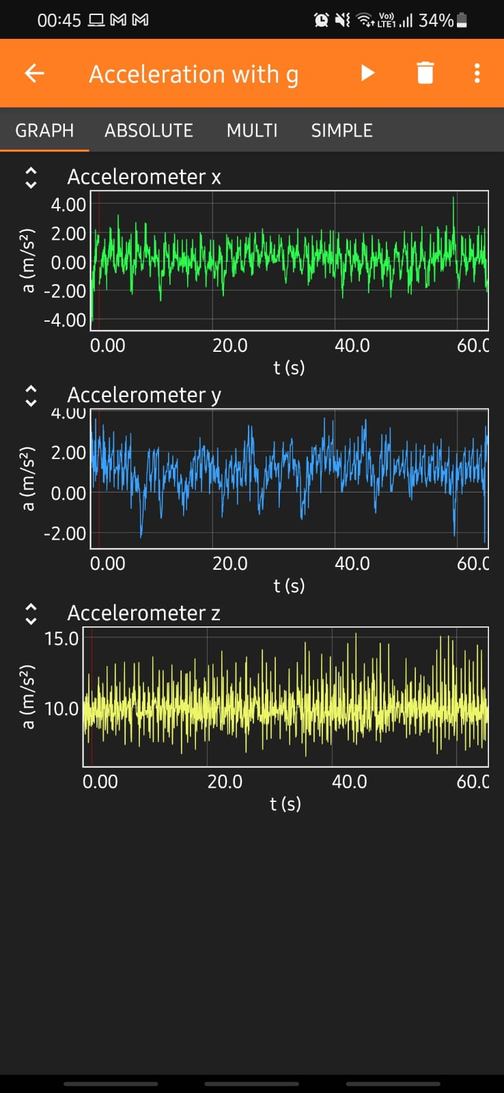 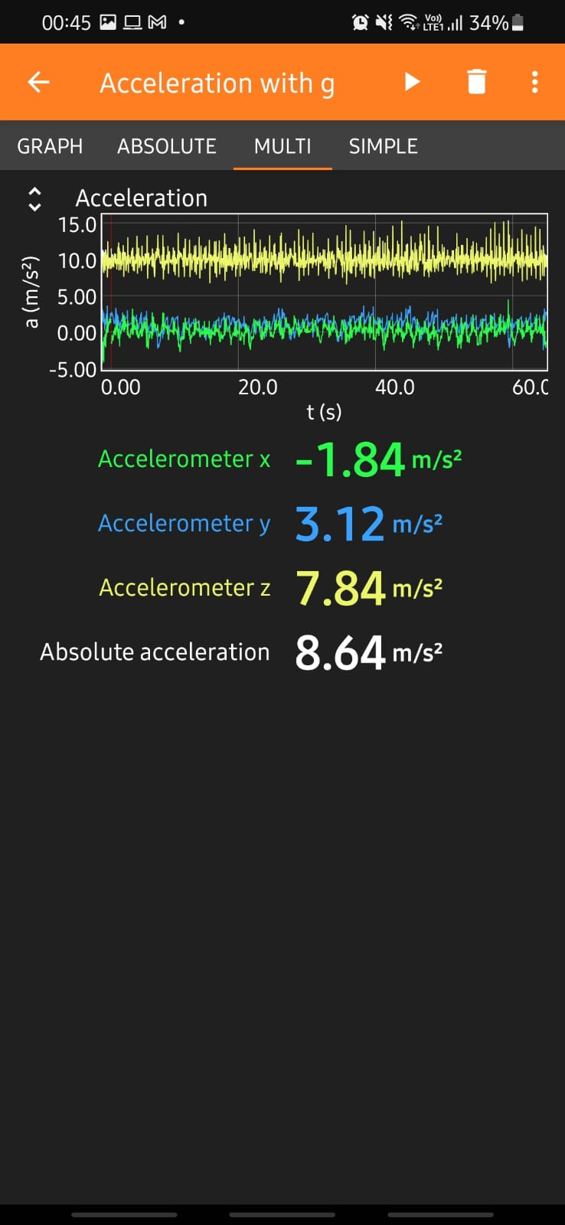

Uploading it to an Excel sheet and Saving it on Drive

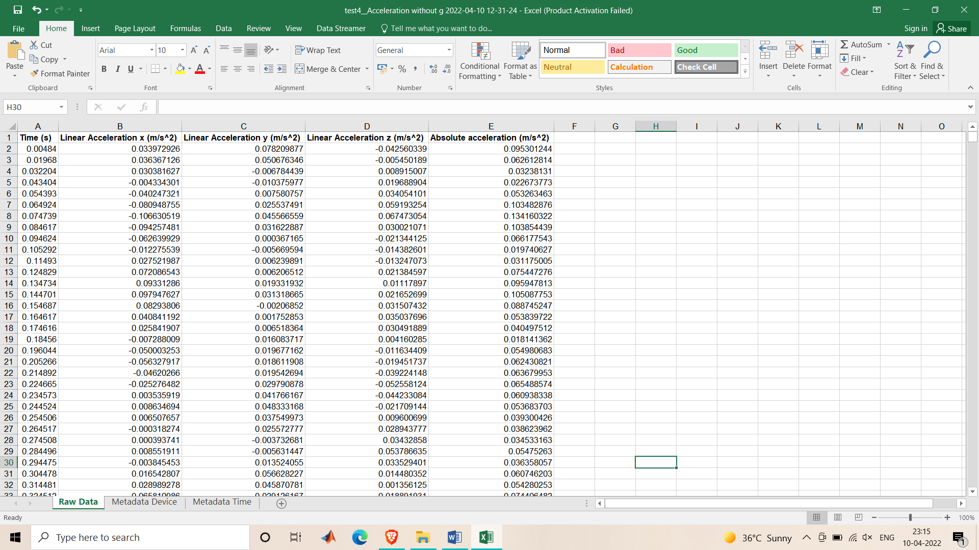

Part(b) Importing the Excel sheet(containing data) in Google Colab

Including libraries such as: pandas, numpy, matplotlib.

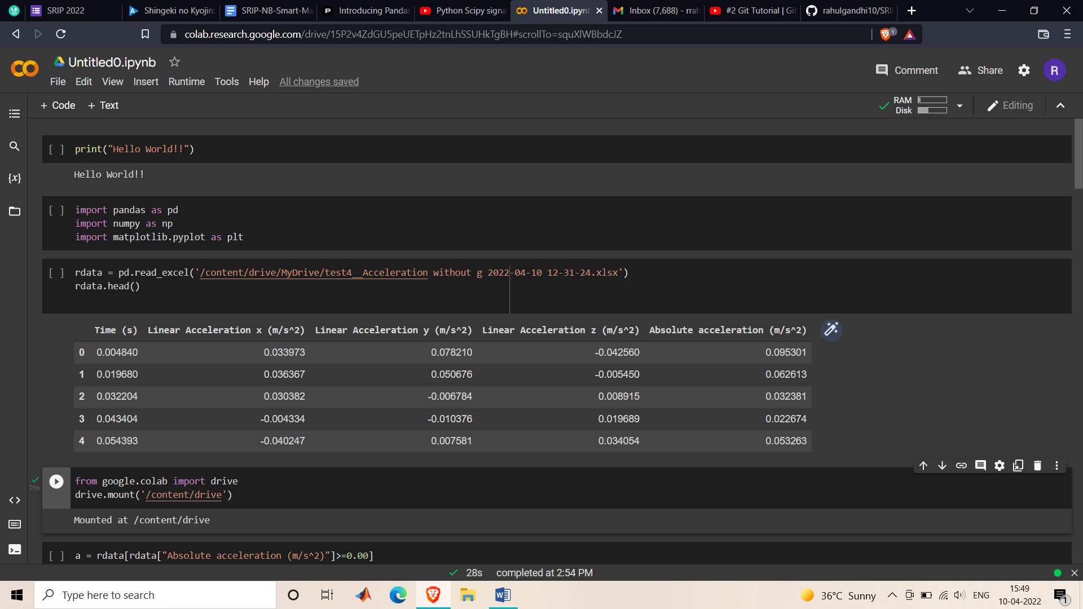

Reading the excel file.



Filtering out the Absolute Acceleration for values only greater than zero.

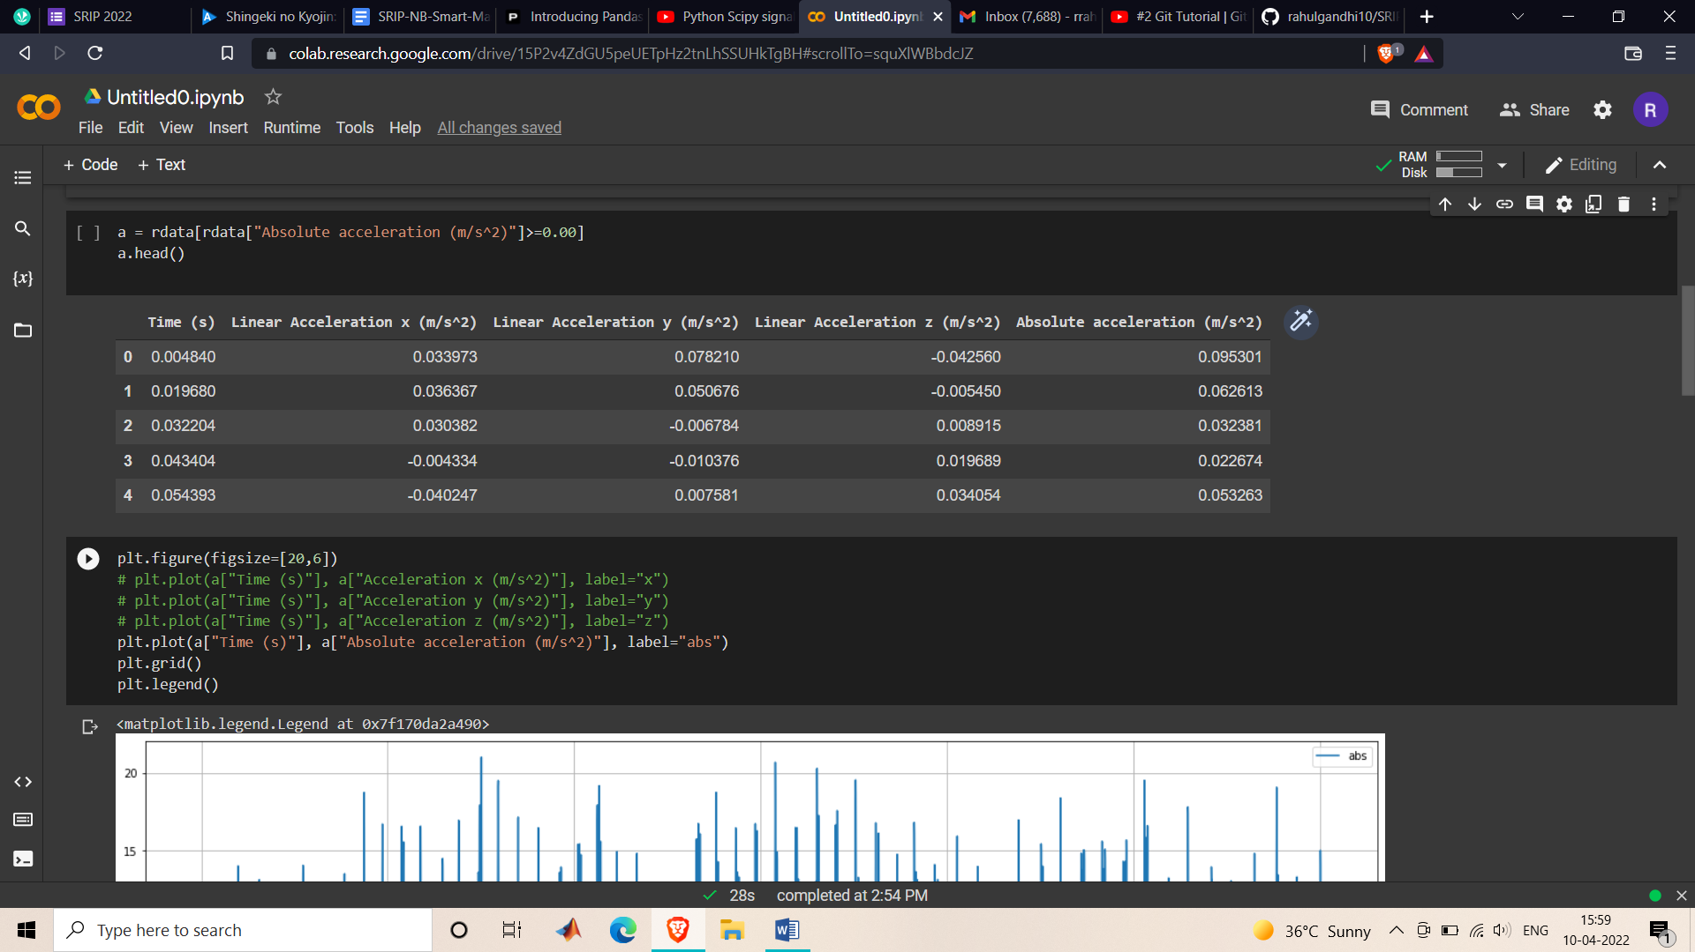

Plotting the Absolute Acceleration values.

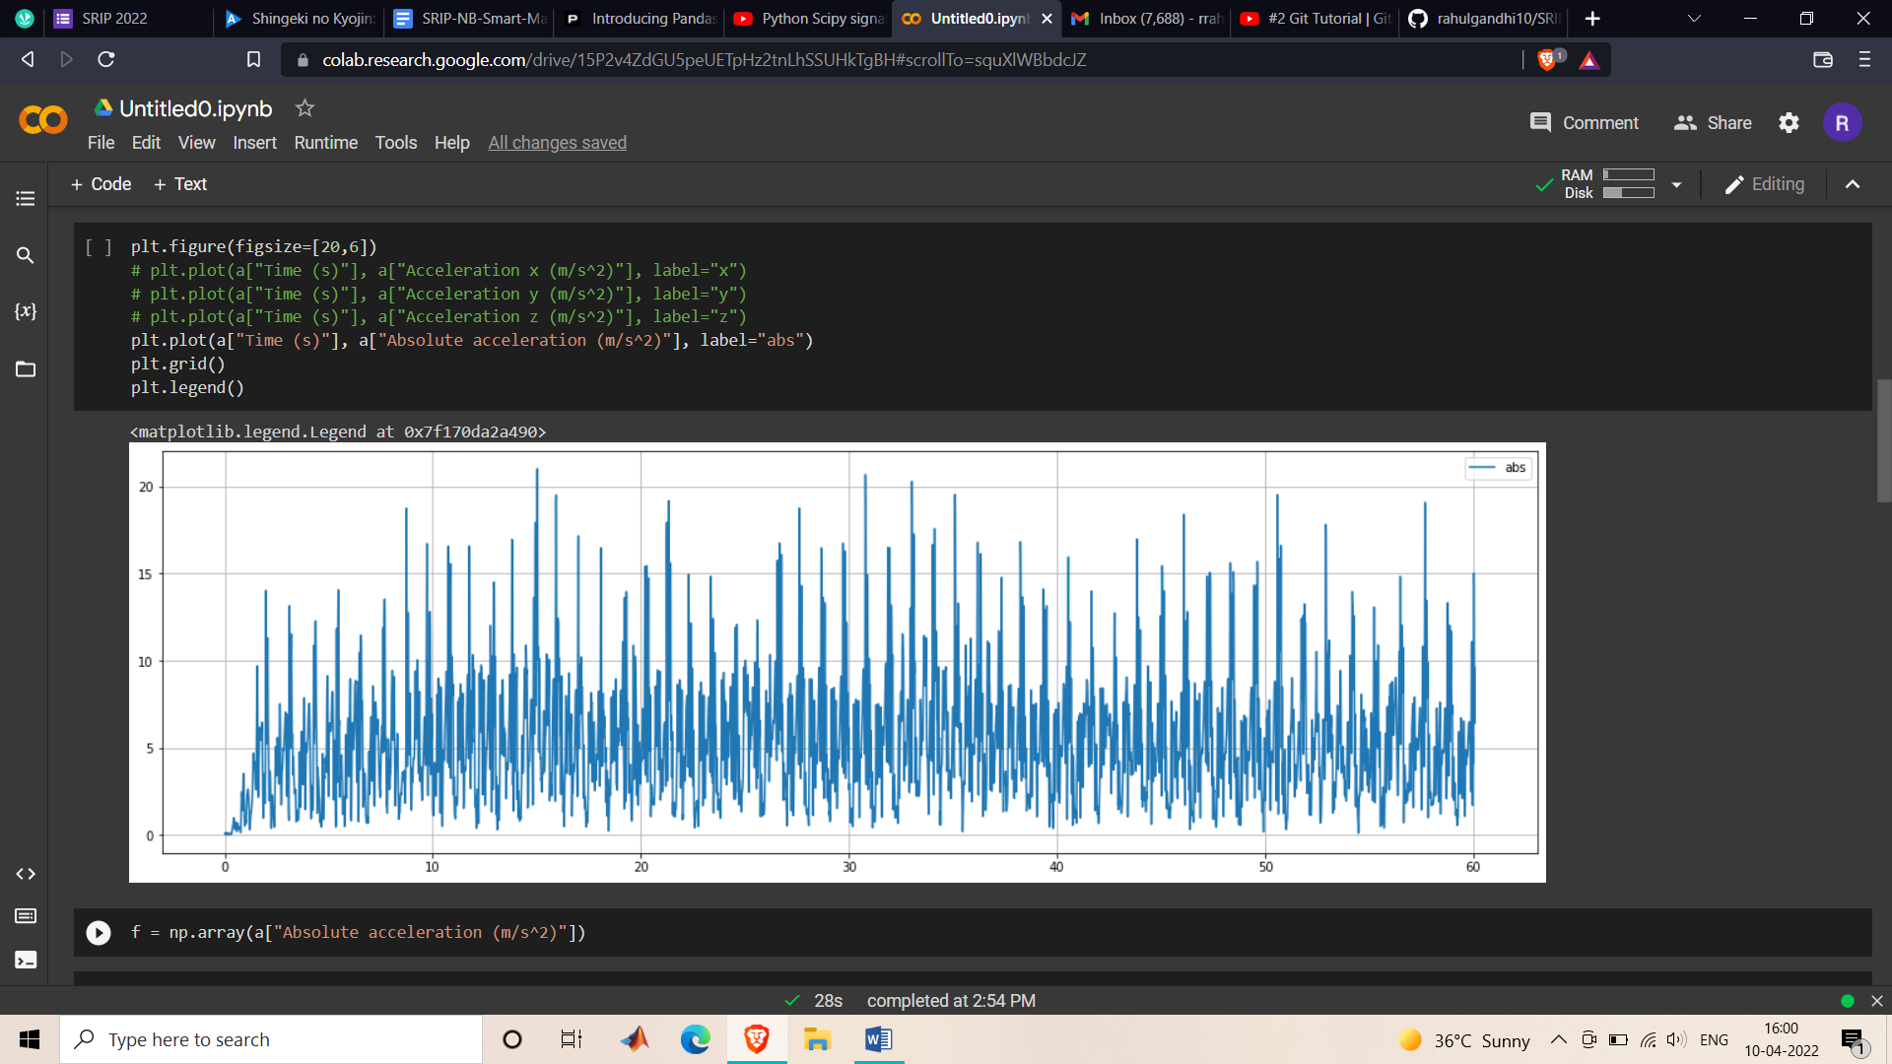

Making an array of values.

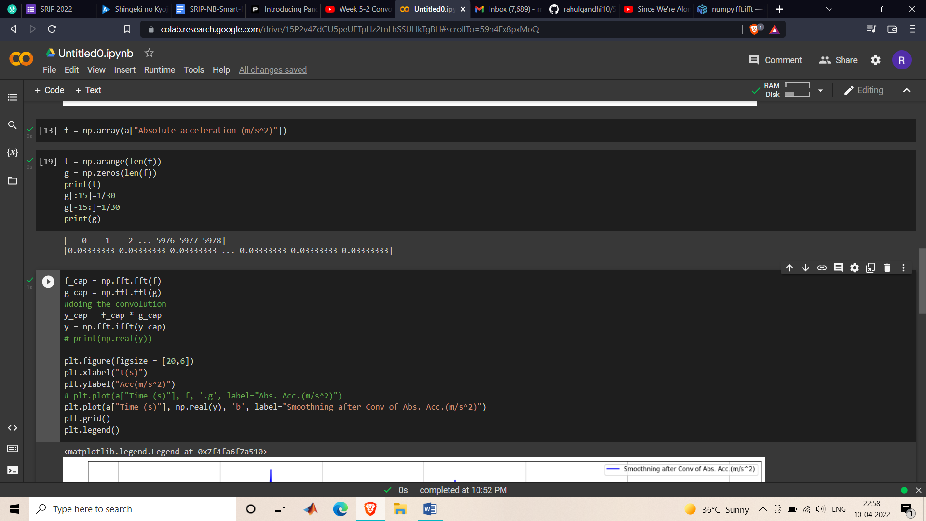

Applying Convolution filter



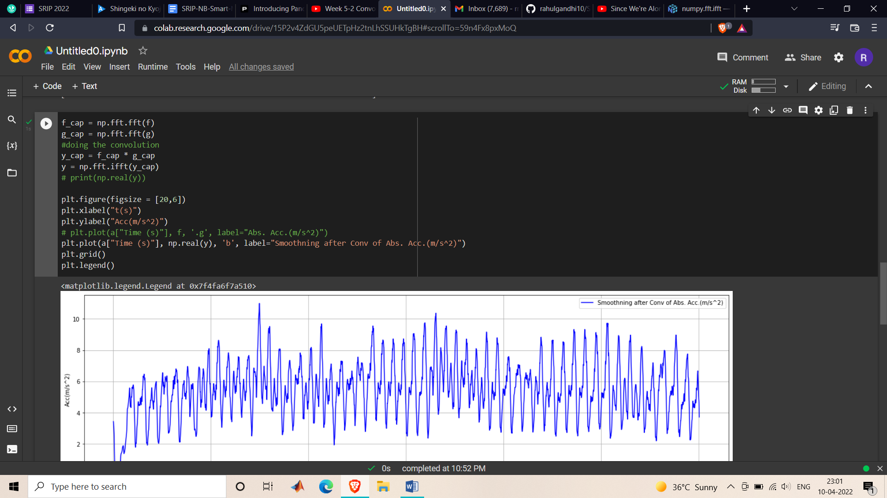

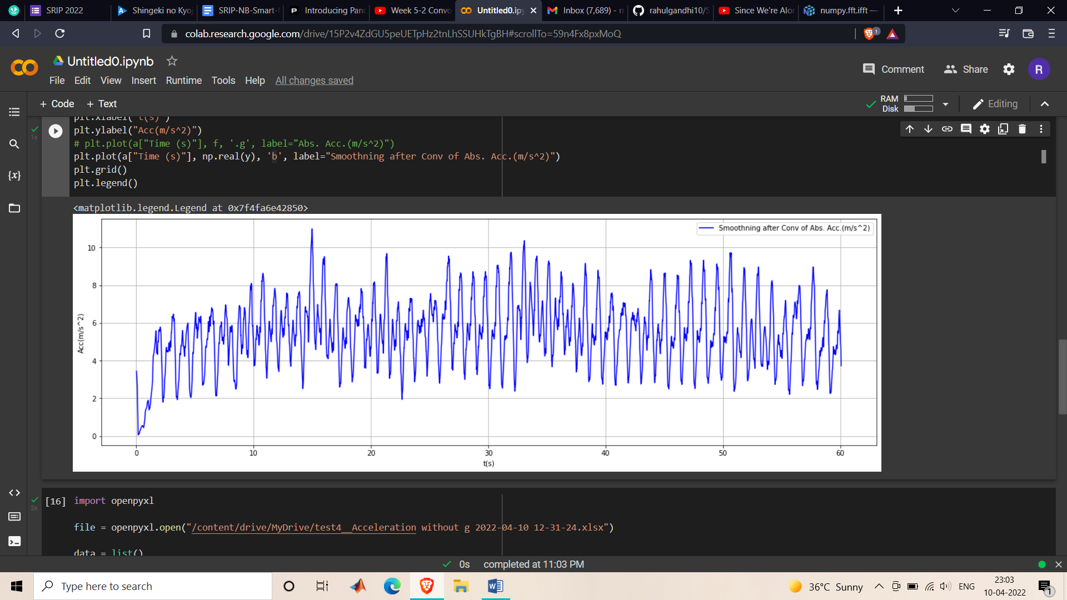

Part(c) Counting the Peak Values

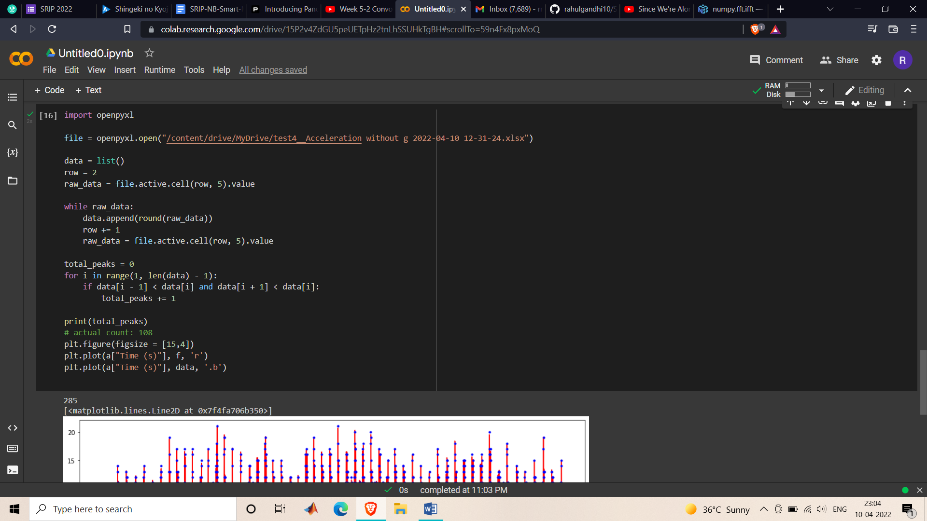

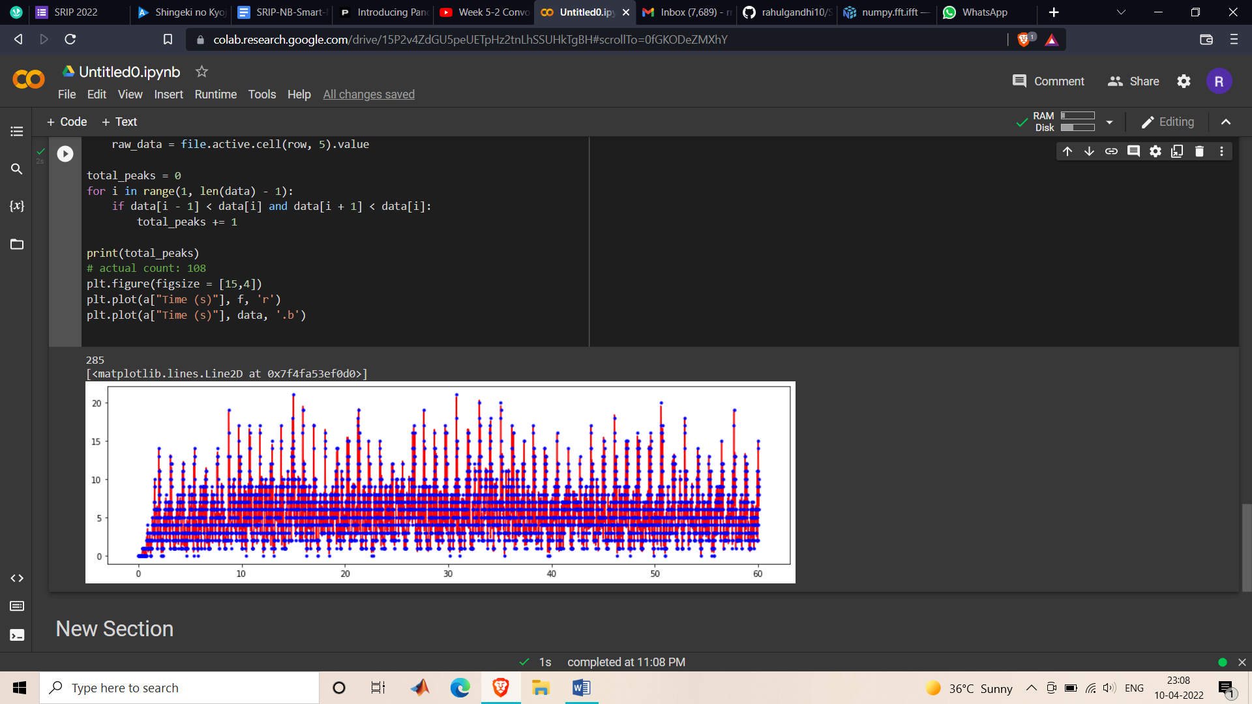

The Peak Value Count gives the Number of Steps Counted/Walked.

Google Colab Link below:

<https://colab.research.google.com/drive/15P2v4ZdGU5peUETpHz2tnLhSSUHkTgBH?usp=sharing>