Solution Architecture
Project: Implement Client Script & UI Policy (Incident)
Document Reference: PRJ-INC-P3-003
Milestone: M3 - Design
Owner: Rahul (Team Lead)
Status: Submission Ready

1. High-Level Architecture
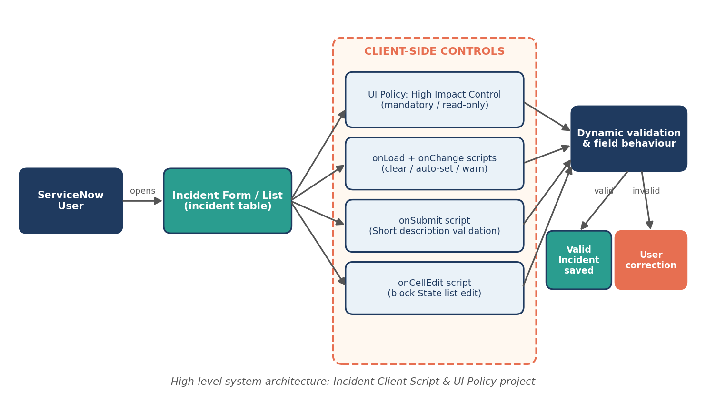

2. Layers
Layer | Components
Presentation | Incident form, Incident list
Declarative logic | High Impact Control UI Policy + 3 actions
Scripted logic | 6 client scripts
Data | incident table (fields: short_description, category, subcategory, impact, urgency, priority, state, assigned_to, assignment_group)

3. Requirement-to-Implementation Mapping
Requirement | Component
FR-01 | Script 5 (onSubmit)
FR-02 | Script 2 (onChange category)
FR-03 | Script 3 (onChange priority)
FR-04 | Script 4 (onChange impact)
FR-05, FR-06, FR-07, FR-10 | UI Policy + Actions
FR-08, FR-09 | Script 6 (onCellEdit)
FR-11 | Script 1 (onLoad)

4. Access Model
Controls apply to all users who open the Incident form or list. No role changes are made. Administrators can deactivate any policy or script individually.

5. Sequence
