PHASE – III

DEVELOPMENT PART 1

|  |  |
| --- | --- |
| DATE | 26-10-2023 |
| TEAM ID / TEAM NAME | Proj_224021_Team_1 |
| PROJECT NAME | PREDICTION HOUSE PRICE USING MACHINE LEARNING |
| STUDENT NAME WITH ID | Murugan M - au610521104056  Monika S - au610521104055  Yuvaraj M - au610521104102  Sathesh PC - au6105211040082  Rahul Ganesh B - au610521104306 |

TITLE

PREDICTION HOUSE PRICE USING MACHINE LEARNING

DEVELOPMENT PART 1

INTRODUTION

When diving into house price prediction using machine learning, data preprocessing plays a crucial role in ensuring accurate and reliable predictions. Data preprocessing involves cleaning, transforming, and organizing the raw data to prepare it for the machine learning model. It's a vital step that directly impacts the model's performance. Techniques like handling missing values, feature scaling, and encoding categorical variables are commonly used. Let me know if you need more specific information or if there's a particular aspect of data preprocessing you'd like to explore further!

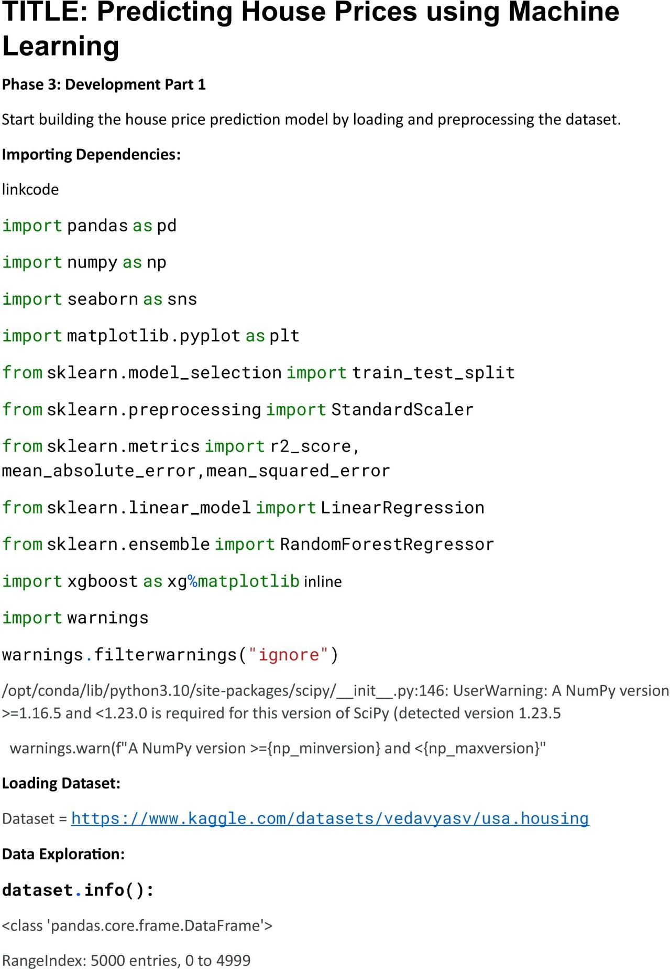

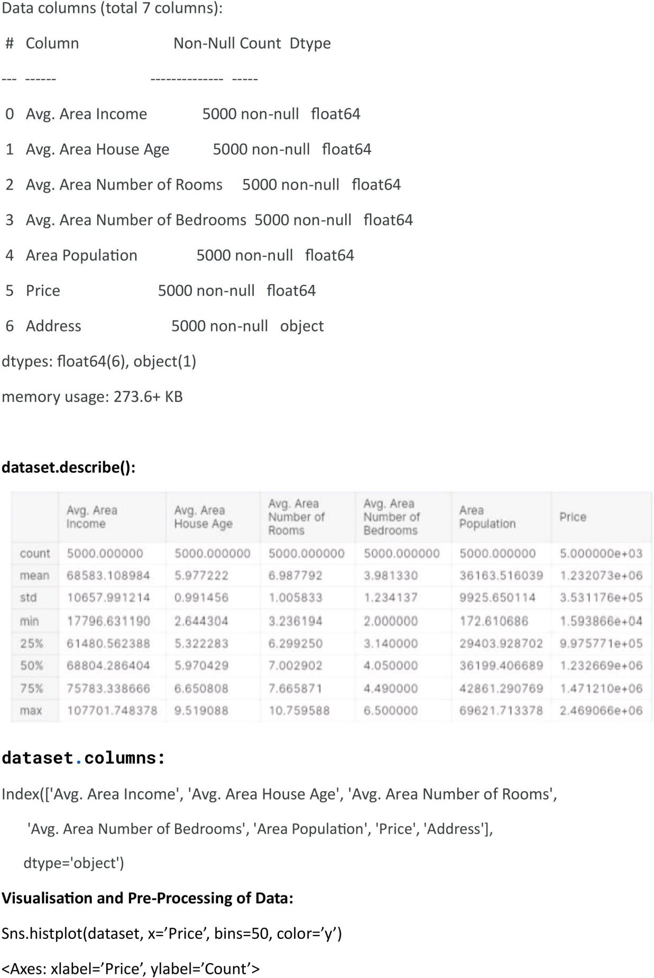

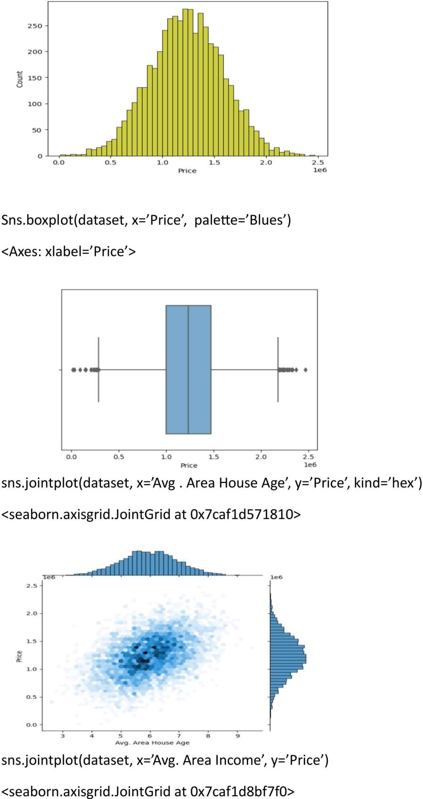

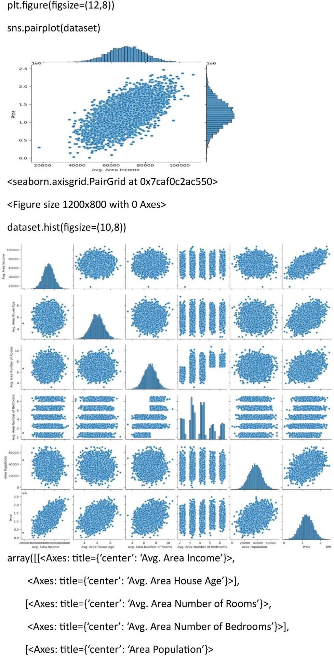

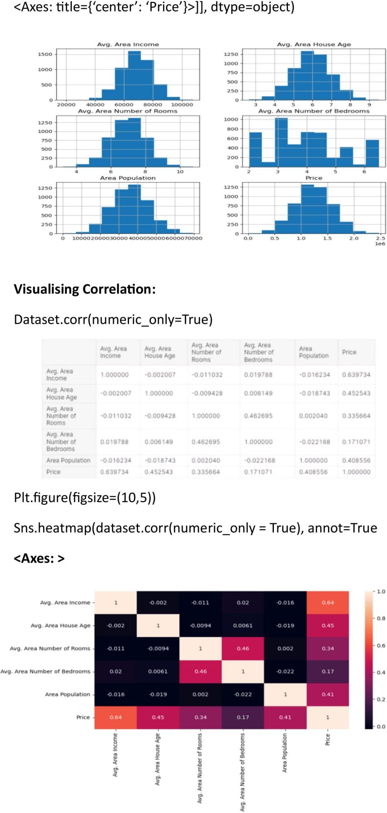

CONCLUSION

Data preprocessing is a fundamental step in house price prediction using machine learning. Properly cleaning and transforming the raw data significantly enhance the accuracy and reliability of the predictive models. Techniques such as handling missing values, feature scaling, and categorical variable encoding are essential for preparing the data for machine learning algorithms. By investing time and effort in thoughtful data preprocessing, practitioners can create more robust and effective predictive models, ultimately leading to more accurate house price predictions.