CLASS TEST - 2
Write a python script to generate result for a particular student.
- Create a student data in a dictionary object as shown below:
stud = {1: {"name":'Amit', "age":23,"marks": [(10,15,12), (11,12,13)]},
2: {"name":'Bhumi',"age":22,"marks": [(13,15,11), (10,10,13)]},
3: {"name":'Bharat',"age":23,"marks": [(12,12,14), (13,14,15)]}
}
NOTE: Here students are getting marks of 3 subjects in 2 attempts of test in a form of tuple
- Create separate user defined functions to (Create a menu for options)
  - Take user input for creating entry of any new student (addStud())
  - Print all marks of a specific student. (Result(name))
  - Display overall result of all students in below given format (Report())
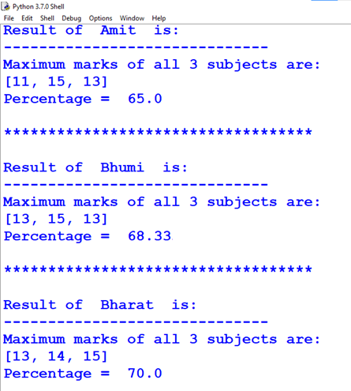

Inside the user defined function you can use any lambda or inbuilt methods / functions like map(), reduce() or filter()

