**HTML** **DOM**

* DOM is an API Interface provided by browser (kind of platform and provided by specific browser)
* When a web page is loaded, browser creates a DOM of the page.
* DOM is divided page wise (Home page/ Login page / Search page –Dom will be different).
* Although most of the DOM structure will be same in all the browser but these are provided by specific browser.

With the document object model, JavaScript gets all the power it needs to create dynamic HTML:

• JavaScript can change all the HTML elements in the page

• JavaScript can change all the HTML attributes in the page

• JavaScript can change all the CSS styles in the page

• JavaScript can remove existing HTML elements and attributes

• JavaScript can add new HTML elements and attributes

• JavaScript can react to all existing HTML events in the page

• JavaScript can create new HTML events in the page

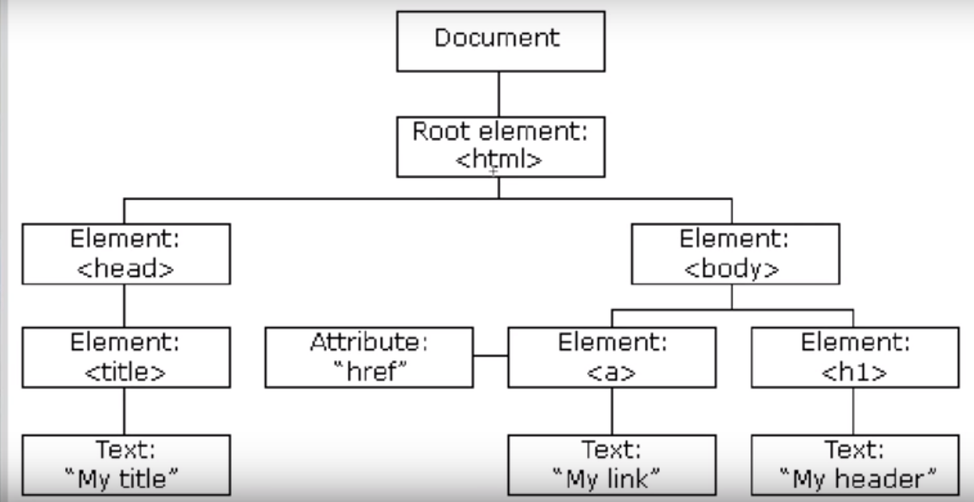

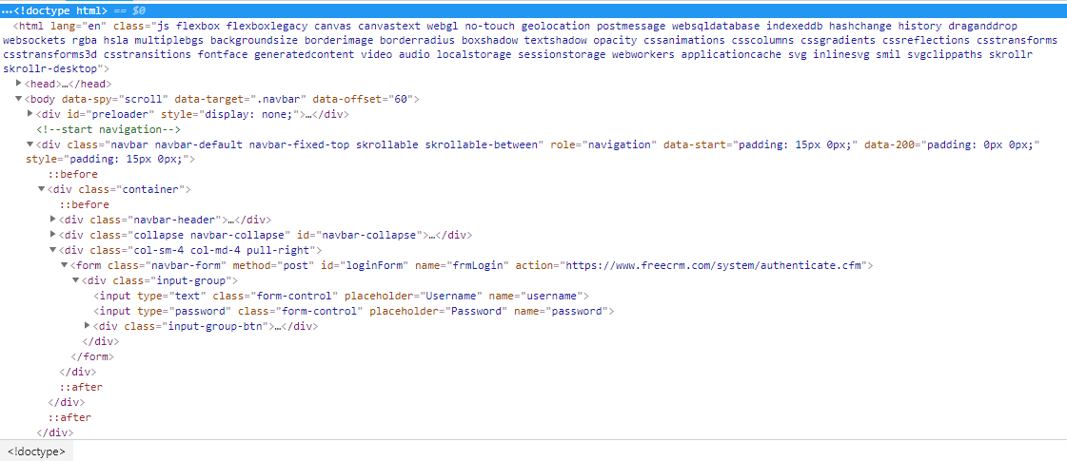

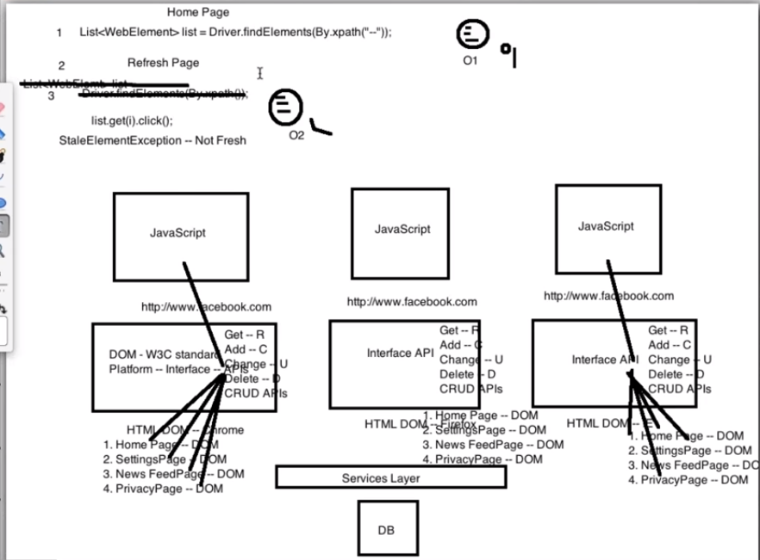

**When is the DOM different than the HTML?**

Here's one possibility: there are mistakes in your HTML and the browser has fixed them for you. Let's say you have a <table> element in your HTML and leave out the required <tbody> element. The browser will just insert that <tbody> for you. It will be there in the DOM, so you'll be able to find it with JavaScript and style it with CSS, even though it's not in your HTML.

The most likely case though, is...

[#](https://css-tricks.com/dom/#article-header-id-1)**JavaScript can manipulate the DOM**

### JavaScript vs. the DOM

JavaScript is a language that the browser reads and does stuff with. But the DOM is where that stuff happens. In fact a lot of what you might think of as a "JavaScript Thing" is more accurately a "DOM API".

