**GIT**

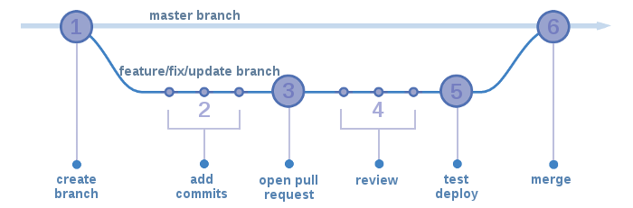

* **git pull origin master**
* **git checkout -b myBranchName**
* **--made changes (after taking latest pull from master in this branch as well)**
* **git status -- files will be in red color**
* **git add myfileName_1**
* **git add myfileName_2**
* **git status ---- files will be in red color**
* **git commit -m "message"**
* **git push origin myBranchName(copy your changes in local, take the latest pull from master and then push)**
* **Create a PR (Pull Request): It can be Approved or Declined**
* **reviewer will merge your changes if it approved into master branch**

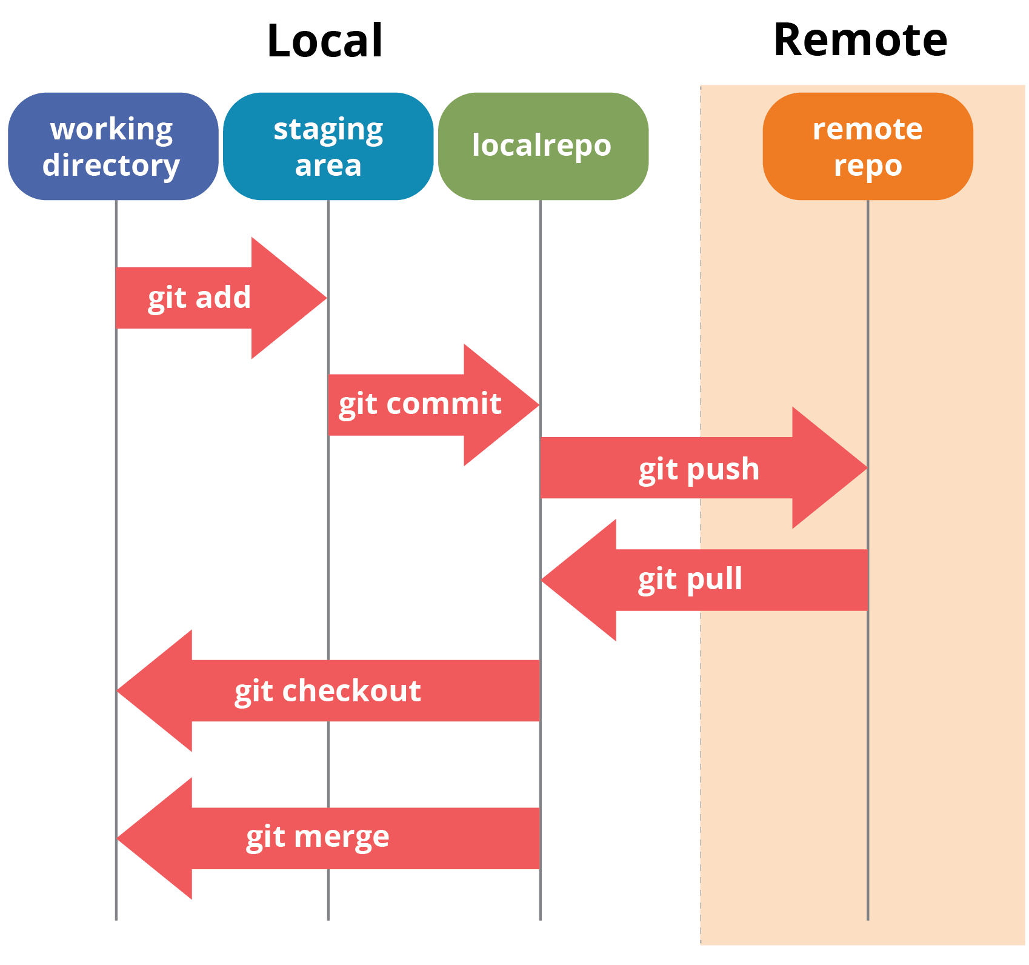

**How to resolve merge conflict?**

**What is git cherrypick?**

Cherry picking in Git means to choose a commit from one branch and apply it onto another. It can be done if you eg. made a mistake and committed a change into wrong branch, but do not want to merge the whole branch. You can just eg. revert the commit and cherry-pick it on another branch.

1. checkout (switch to) target branch.
2. git cherry-pick <commit id>

**What is git rebase?**

In Git, the **rebase** command integrates changes from one branch into another. It is an alternative to the better known "merge" command.