- Write a program to find the sum of n natural using a user defined function
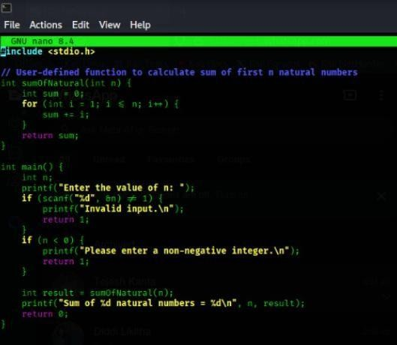
CODE:
OUTPUT:
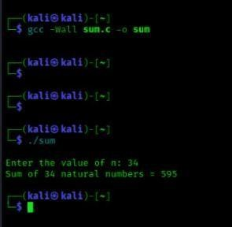

SPACE COMPLEXITY:

  - The loop uses only two variables (s and i), and no extra memory grows with n.
  - So, the memory used stays constant no matter the input size.
  - Therefore, the space complexity is O(1).

- Write a program to find the sum of squares of n natural numbers
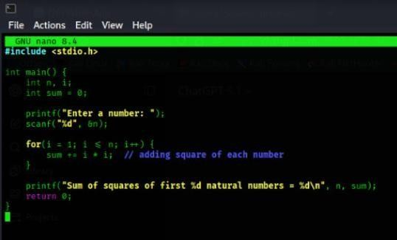
CODE:
OUTPUT:
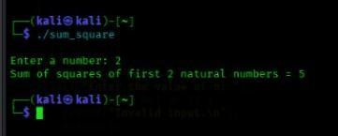

SPACE COMPLEXITY:

  - The program uses only a few variables, and this number does not increase when n becomes bigger.
  - Since the memory used stays the same all the time, the space complexity is O(1).

- Write a program to find the sum of cubes of n natural the sum of cubes of n natural numbers
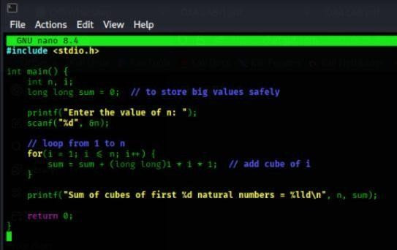
CODE:
OUTPUT:
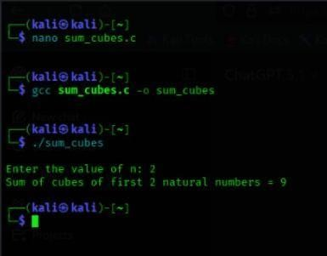
SPACE COMPLEXITY:

  - The loop doesn’t create new memory again and again — it just reuses the same variables.
  - Because the memory doesn’t grow when n grows, the space stays constant.
  - So it is O(1) space.

- Write a program to find the factorial of a given number using recursion

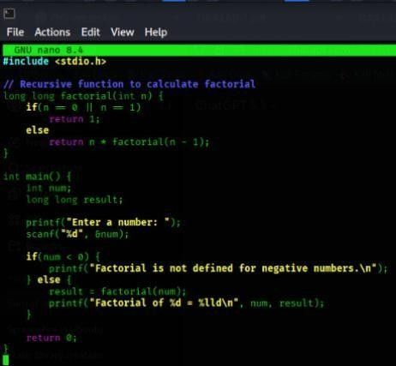
CODE:
OUTPUT:
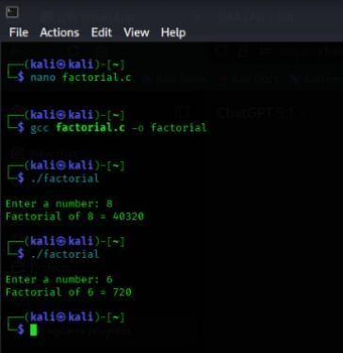

SPACE COMPLEXITY:

  - The function calls itself many times, and each call uses some memory.
  - More calls mean more memory is used, so memory increases with n.
  - That's why the space complexity is O(n).

- Write a program to transpose a 3x3 matrix
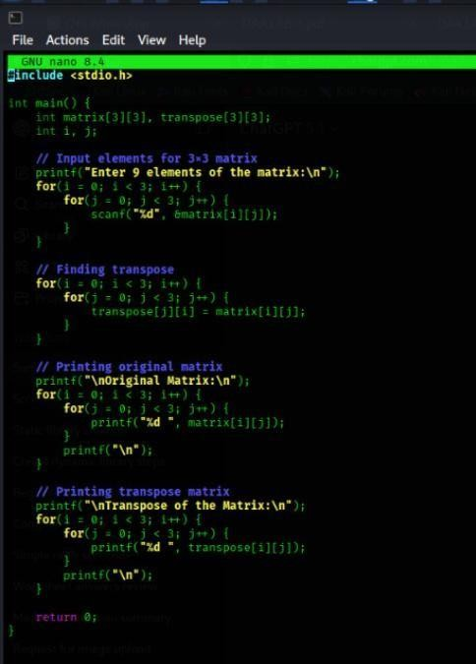
CODE:
OUTPUT:
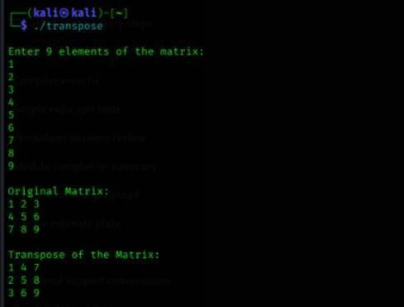
SPACE COMPLEXITY:

  - The program creates a 3×3 array, which is fixed in size and does not grow.

  - You only use a few extra variables for loops.
  - So the space complexity is O(1)
- Write a program to find the Fibonacci series
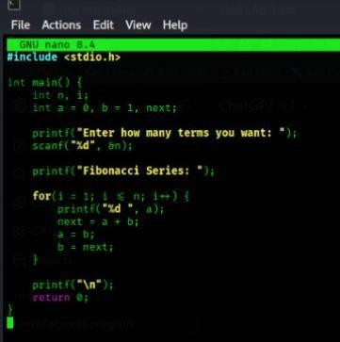
CODE:
OUTPUT:
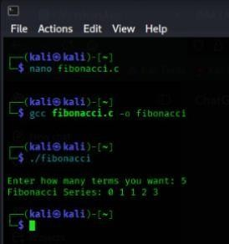

SPACE COMPLEXITY:

  - The program only uses a few variables (a, b, sum, temp) and these do not increase when n increases.
  - No extra memory grows with the loop.
  - So the space complexity is O(1).

