### Creation of a Redshift Cluster

**Screenshots of the configuration of the Redshift cluster that you have created:**

### Setting up a database in the Redshift cluster and running queries to create the dimension and fact tables

**Queries to create the various dimension and fact tables with appropriate primary and foreign keys:**

**Creating DIM_LOCATION table schema**

create table etl_project.DIM_LOCATION

(

location_id int not null DISTKEY SORTKEY,

location varchar(50),

streetname varchar(255),

street_number int,

zipcode int,

lat decimal(10,3),

lon decimal(10,3),

PRIMARY KEY(location_id)

);

**Creating DIM_ATM table schema**

create table etl_project.DIM_ATM

(

atm_id int not null DISTKEY SORTKEY,

atm_number varchar(20),

atm_manufacturer varchar(50),

atm_location_id int,

PRIMARY KEY(atm_id),

FOREIGN KEY(atm_location_id) references etl_project.DIM_LOCATION(location_id)

);

**Creating DIM_DATE table schema**

create table etl_project.DIM_DATE

(

date_id int not null DISTKEY SORTKEY,

full_date_time timestamp,

year int,

month varchar(20),

day int,

hour int,

weekday varchar(20),

PRIMARY KEY(date_id)

);

**Create DIM_CARD_TYPE table schema**

create table etl_project.DIM_CARD_TYPE

(

card_type_id int not null DISTKEY SORTKEY,

card_type varchar(30),

PRIMARY KEY(card_type_id)

);

**Creating FACT_ATM_TRANS table schema**

create table etl_project.FACT_ATM_TRANS

(

trans_id bigint not null DISTKEY SORTKEY,

atm_id int,

weather_loc_id int,

date_id int,

card_type_id int,

atm_status varchar(20),

currency varchar(10),

service varchar(20),

transaction_amount int,

message_code varchar(225),

message_text varchar(225),

rain_3h decimal(10,3),

clouds_all int,

weather_id int,

weather_main varchar(50),

weather_description varchar(255),

PRIMARY KEY(trans_id),

FOREIGN KEY(weather_loc_id) references etl_project.DIM_LOCATION(location_id),

FOREIGN KEY(atm_id) references etl_project.DIM_ATM(atm_id),

FOREIGN KEY(date_id) references etl_project.DIM_DATE(date_id),

FOREIGN KEY(card_type_id) references etl_project.DIM_CARD_TYPE(card_type_id)

);

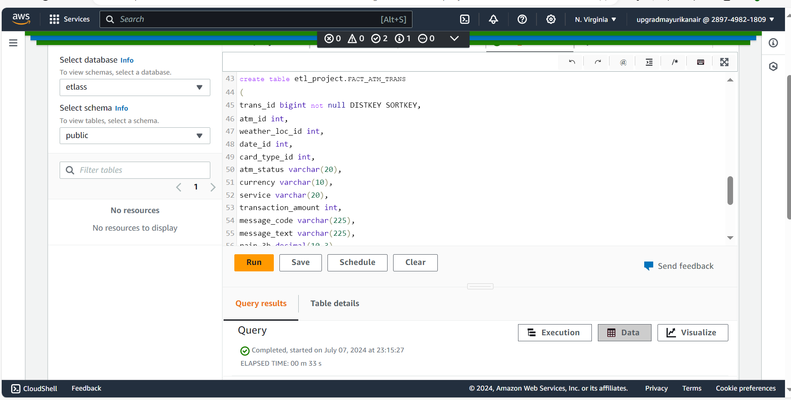

### Loading data into a Redshift cluster from Amazon S3 bucket

**Queries to copy the data from S3 buckets to the Redshift cluster in the appropriate tables**

**Populate DIM_LOCATION**

**copy etl_project.dim_location from 's3://rds-sqoop-hadoop-spark-df-s3-etl/dim_location/part-00000-912fd2fc-67e8-43df-8794-9f99a9010ebc-c000.csv'**

**iam_role 'arn:aws:iam::289749821809:role/Upgrad_ETL_Assignment_Redshift_Role'**

**delimiter ',' region 'us-east-1'**

**CSV;**

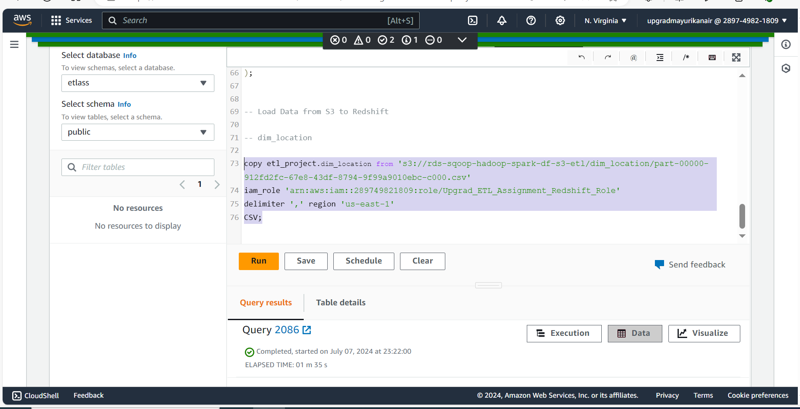

**Populate DIM_ATM**

**copy etl_project.dim_atm from 's3://rds-sqoop-hadoop-spark-df-s3-etl/dim_atm/part-00000-aaaede37-258b-46e2-a173-aed4bd4af971-c000.csv'**

**iam_role 'arn:aws:iam::289749821809:role/Upgrad_ETL_Assignment_Redshift_Role'**

**delimiter ',' region 'us-east-1'**

**CSV;**

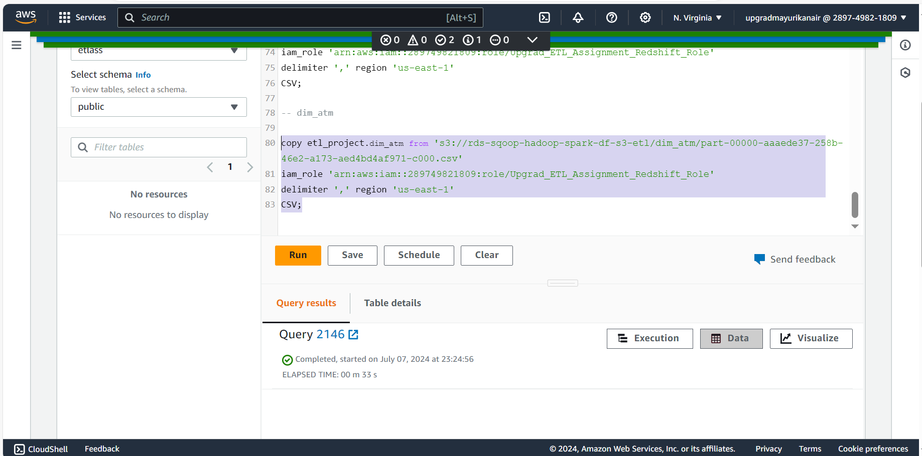

**Populate DIM_DATE**

**copy etl_project.dim_date from 's3://rds-sqoop-hadoop-spark-df-s3-etl/dim_date/part-00000-79563015-5a7a-4445-a4a2-d07aa1dc3e63-c000.csv'**

**iam_role 'arn:aws:iam::289749821809:role/Upgrad_ETL_Assignment_Redshift_Role'**

**delimiter ',' region 'us-east-1'**

**CSV**

**TIMEFORMAT 'auto';**

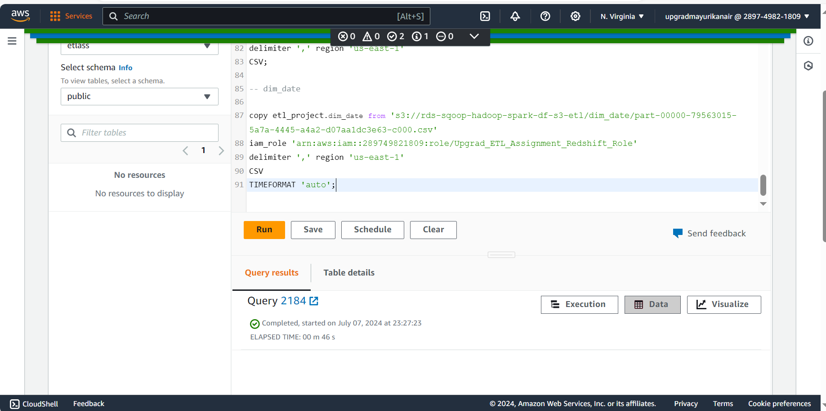

**Populate DIM_CARD_TYPE**

**copy etl_project.dim_card_type from 's3://rds-sqoop-hadoop-spark-df-s3-etl/dim_card_type/part-00000-d6055d44-0809-4a65-8a44-e3d69d9c17c2-c000.csv'**

**iam_role 'arn:aws:iam::289749821809:role/Upgrad_ETL_Assignment_Redshift_Role'**

**delimiter ',' region 'us-east-1'**

**CSV;**

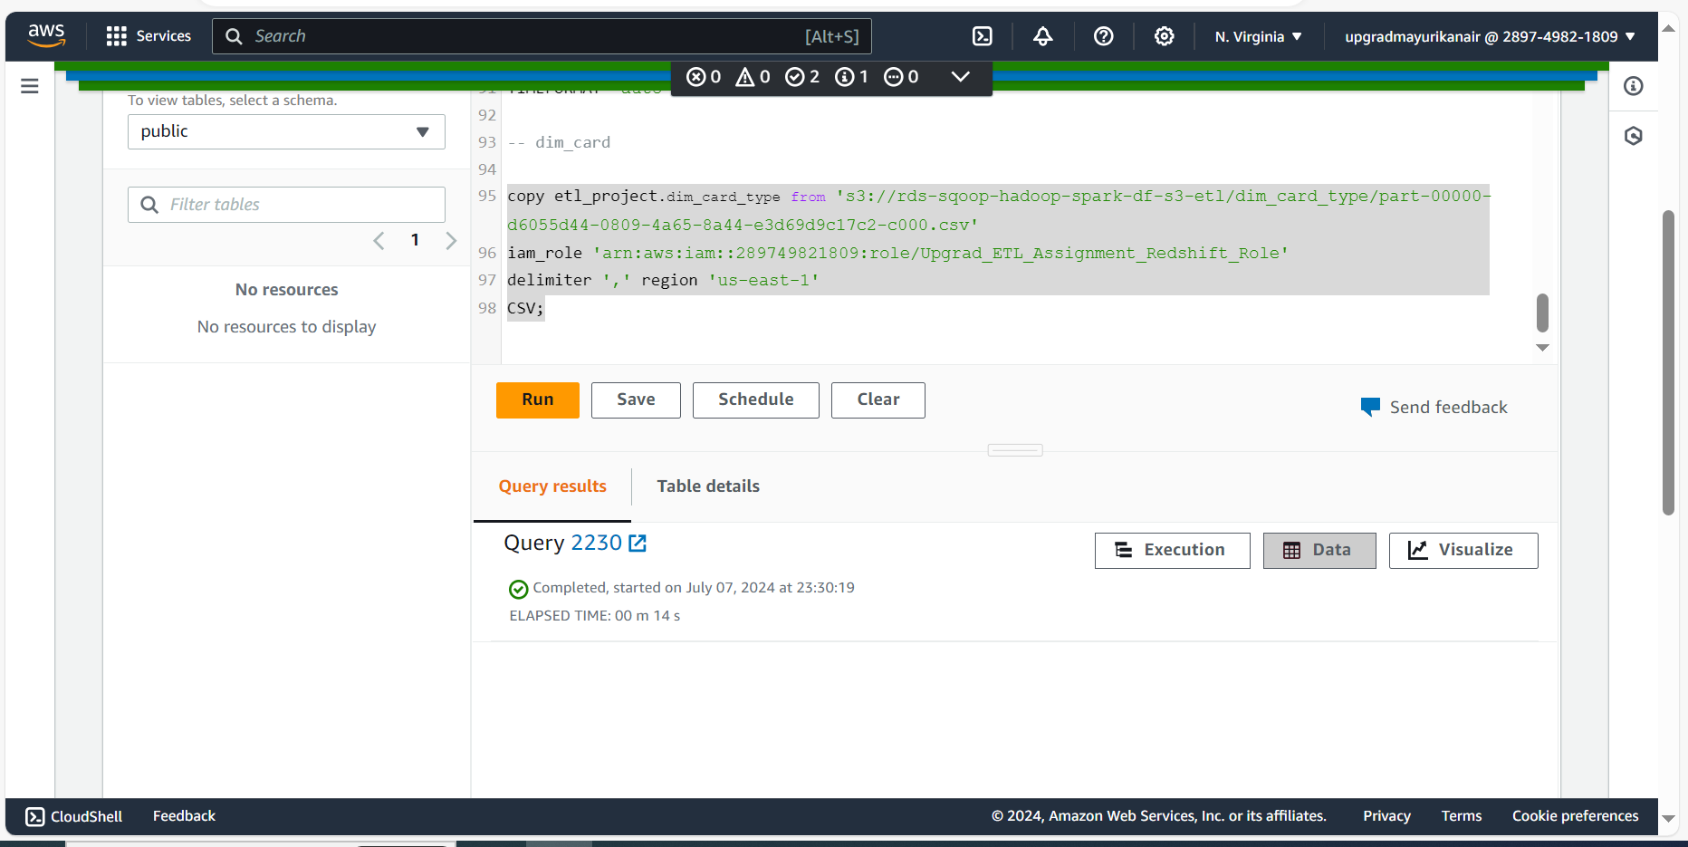

**Populate fact_atm_trans**

**copy etl_project.fact_atm_trans from 's3://rds-sqoop-hadoop-spark-df-s3-etl/fact_atm_trans/part-00000-82437dfd-778b-49ae-b1fb-74d572e6f6f6-c000.csv'**

**iam_role 'arn:aws:iam::289749821809:role/Upgrad_ETL_Assignment_Redshift_Role'**

**delimiter ',' region 'us-east-1'**

**CSV;**

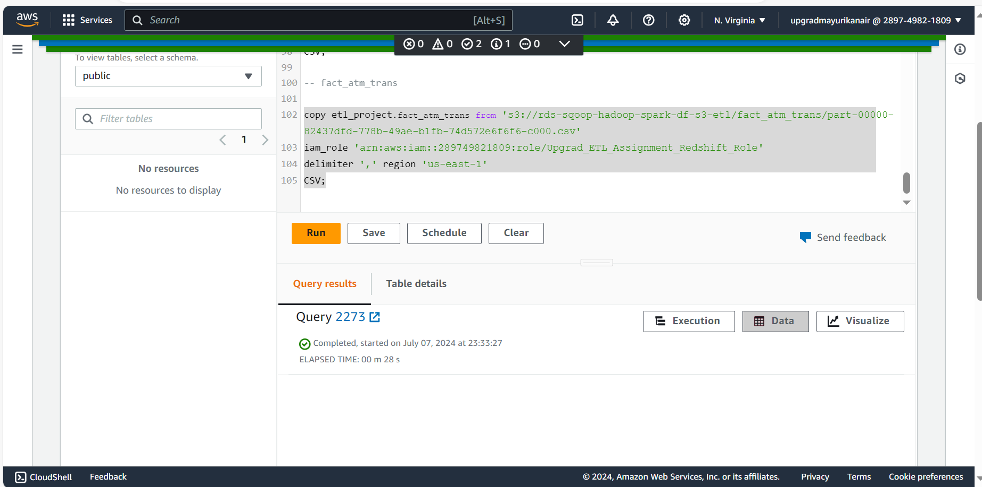

**OVERALL TABLES**

