WEEK 4: PREDICTIVE MODELING AND OPTIMIZATION
IN LOGISTICS SYSTEMS
Logistics Data Analyst Internship | Python-based applied analysis
Dataset: DataCo Smart Supply Chain | Prepared as an educational analytics project

1. Executive Summary
This project develops and evaluates a regression model to estimate actual shipping duration from information available around order placement. The analysis uses 180,519 order-item records spanning 2015-01-01 to 2018-01-31. A chronological holdout keeps the latest 20% of records (36,104 rows; 2017-04-22 to 2018-01-31) out of model training. Ridge regression achieved MAE 0.985 days, RMSE 1.265 days and R² 0.387. This is an improvement over the median-only baseline, but the R² indicates that substantial variation remains unexplained. The report therefore treats the model as a planning aid, not an automated delivery promise.
A separate operational diagnostic flags a record as late when actual shipping days exceed scheduled shipping days. Using that explicit definition, 57.28% of records are flagged. The mode-level differences are useful for prioritizing SLA validation and operational review, but they do not prove that shipping mode alone causes delay.

2. Business Problem and Prediction Target
Logistics teams need an early estimate of shipping duration to set realistic customer expectations, identify orders that may need attention, and allocate support capacity. The prediction target is “Days for shipping (real)” (continuous numeric regression target). The prediction is made conceptually at order placement, using fields that can reasonably be known at that point. The task is to estimate duration—not to claim certainty about a specific delivery date.
- Unit of analysis: dataset order-item record; multiple records can belong to one order.
- Target: actual shipping duration in days.
- Business use: early risk triage, workload planning, and identifying segments for further investigation.
- Separate KPI diagnostic: late proxy = actual shipping days > scheduled shipping days.
Important distinction: the late proxy is a transparent comparison against the scheduled-days field. It should be confirmed against the organization’s formal SLA and delivery timestamp rules before being used for official performance reporting.

3. Dataset and Feature Design
The CSV contains 180,519 records and 53 original columns. For this model, only a focused subset of operational fields was loaded. The selected predictors include scheduled shipping days, shipping mode, order month/year/day-of-year/weekday, product category, customer segment, market, order region, item quantity, item product price, and discount rate.
Feature group | Example fields | Why it may help
Service commitment | Days for shipment (scheduled) | Captures the planned service window.
Fulfilment choice | Shipping Mode | Different modes have different service promises and processes.
Calendar | Order month, weekday, year, day-of-year | Captures recurring calendar patterns without using the raw date as a numeric magnitude.
Order mix | Category, quantity, product price, discount | May proxy for handling needs and order characteristics.
Geography / market | Order Region, Market | May capture broad network or market differences.
Privacy and leakage controls: customer names, emails, passwords, street addresses, and customer identifiers were not loaded. Post-outcome fields such as delivery status, late-delivery-risk label, and shipping date were excluded because they can reveal the outcome or be unavailable at prediction time. Scheduled shipping days and shipping mode are retained because they represent planning information that should be known when the order is created.

4. Data Preparation and Validation
- Parsed the order date into a datetime field and removed records without a valid date or target.
- Sorted rows chronologically before splitting; the earliest 80% trained the models and the latest 20% formed the final holdout.
- One-hot encoded categorical features; unseen categories in the holdout are handled safely.
- Applied median imputation to numeric predictors within the modeling pipeline.
- Kept preprocessing inside the pipeline so encoders/imputers are fitted on training data, not the test set.
A time-based split is more realistic than a random split for forecasting because it tests whether patterns learned from earlier orders carry forward to later orders. However, the dataset is historical and synthetic/anonymized in nature; results may not transfer directly to another carrier, region, or current logistics network.

5. Model Selection and Rationale

5.1 Median baseline
A simple median predictor provides a minimum reference point. A complex model should outperform this baseline to justify its use.

5.2 Ridge regression — primary interpretable benchmark
Ridge regression is a regularized linear model. It is efficient with one-hot encoded categories and helps control overly large coefficients. It provides a practical first model and a useful benchmark for structured tabular data.

5.3 Decision tree — nonlinear comparison
A decision tree can represent threshold-based relationships and interactions. Maximum depth and minimum leaf size were constrained to reduce overfitting. Its performance is compared on exactly the same chronological holdout.

6. Evaluation Results
Model | MAE (days) ↓ | RMSE (days) ↓ | R² ↑
Median baseline | 1.393 | 1.690 | -0.094
Ridge regression | 0.985 | 1.265 | 0.387
Decision tree (depth 10) | 0.990 | 1.272 | 0.380
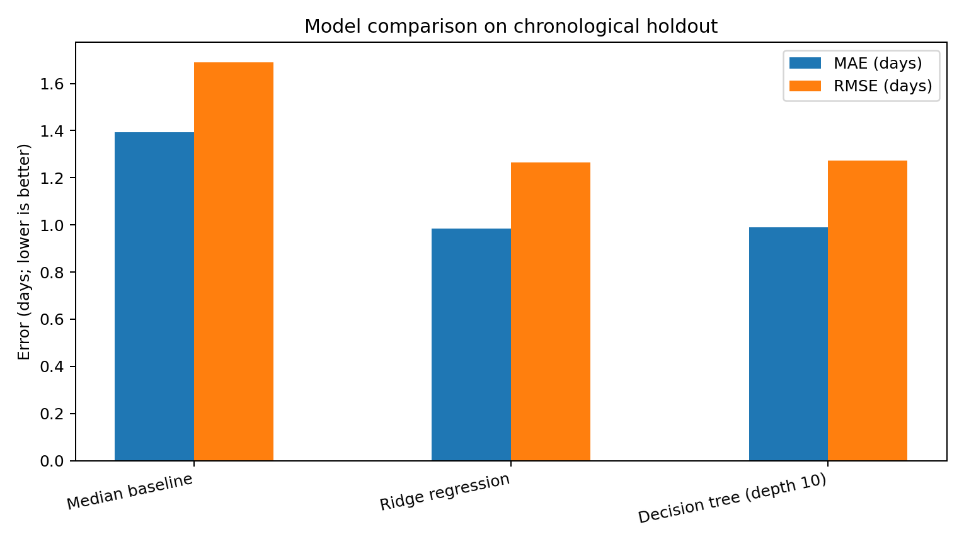
Interpretation: Ridge regression reduces MAE by approximately 29.3% versus the median-only baseline. An MAE of 0.99 days means that the average absolute prediction error is about one day. RMSE is higher than MAE because it penalizes larger errors more heavily. R² of 0.387 means the model explains about 38.7% of target variation on this holdout under the usual R² interpretation; the remaining variation is not captured by the current features/model.
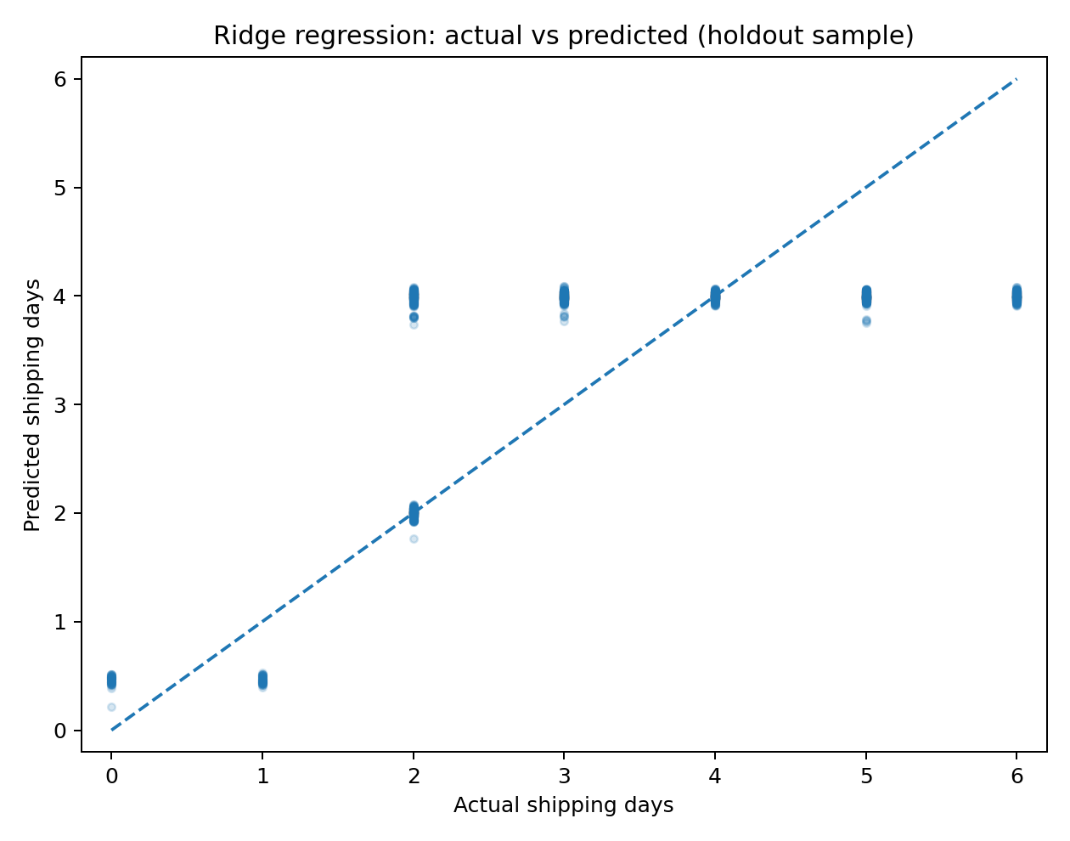
The actual-versus-predicted plot should be read as a diagnostic, not as proof that individual predictions are reliable. Predictions tend toward the central range, so unusually fast or slow shipments may be harder to estimate.

7. Operational Findings and Original Interpretation

7.1 Delivery performance varies by service promise
Across all records, mean actual shipping duration is 3.50 days and the median is 3 days. The late proxy flags 57.28% of records. This is a high share under the selected definition, so management should first validate the SLA logic and then examine late cases by mode, region, and time.
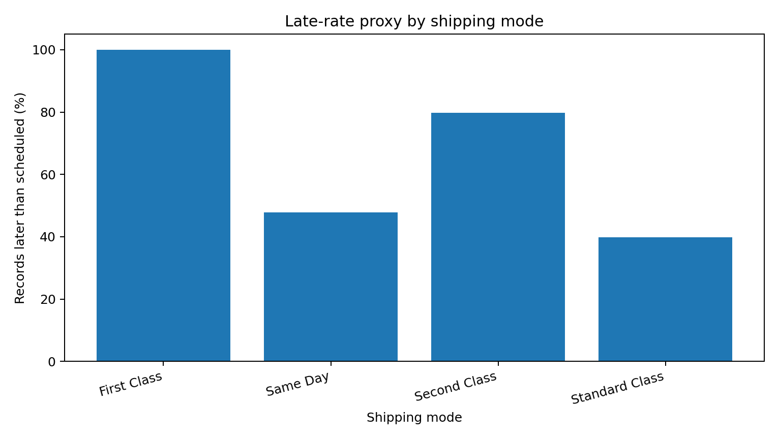
Shipping mode | Records | Mean actual days | Scheduled days | Late proxy
First Class | 27,814 | 2.00 | 1.0 | 100.00%
Same Day | 9,737 | 0.48 | 0.0 | 47.83%
Second Class | 35,216 | 3.99 | 2.0 | 79.73%
Standard Class | 107,752 | 4.00 | 4.0 | 39.77%
A key diagnostic is that First Class records have a 100% late proxy in this dataset (mean actual duration 2.00 days versus a 1-day schedule). This should trigger an audit of the First Class service definition, timestamp logic, and fulfillment workflow—not an immediate conclusion that the mode itself causes failure. Same Day has a lower average duration (about 0.48 days) but still has a 47.83% late proxy because the scheduled value is zero days for these records. That suggests a zero-day target may be too strict or may reflect how the dataset defines a day. This is a concrete example of why metric definitions must be validated before managers compare performance.

7.2 Geographic differences should be investigated, not over-interpreted
Among regions with at least 1,000 records, Central Africa has the highest late proxy at 60.70% (1,677 records). The mean shipping durations across regions are close to 3.5 days, so the rate difference may be driven partly by scheduled-day mix, mode mix, or SLA thresholds rather than a large difference in absolute duration. The next analysis should compare regions within the same shipping mode and scheduled service level.

7.3 Prediction is useful, but not sufficient
The model outperforms a simple baseline, yet its R² remains moderate. This suggests that the current fields do not capture all causes of shipping duration. Potential missing drivers include carrier identity, route distance, warehouse processing time, pickup cutoff, actual dispatch timestamp, weather, capacity utilization, and exception events. The right business use is to prioritize review queues and scenario planning, not to promise exact delivery dates or automatically penalize a carrier.

8. Optimization Plan Based on the Evidence
Priority | Action | How to implement | Success metric
1 — Validate KPI | Audit the lateness definition, especially Same Day and First Class. | Confirm timestamp units, inclusive/exclusive thresholds, and whether 0 scheduled days is valid. | Agreement between report KPI and business SLA; fewer false flags.
2 — Target service-level review | Review First Class and Second Class records against their commitments. | Compare late rates within region and order date; sample actual shipment records and identify process steps causing delay. | Late rate by mode and scheduled-days cohort; on-time rate.
3 — Improve data coverage | Add operational drivers to future model versions. | Capture carrier, route distance, warehouse, pick/pack duration, dispatch time, capacity, and exception reason. | Lower MAE/RMSE on a later-period holdout.
4 — Use predictions as triage | Create a daily queue of orders with predicted duration above the promised window. | Flag orders for human review; show prediction, scheduled duration, and uncertainty/error band. | Share of flagged orders reviewed; late-rate among reviewed orders.
5 — Pilot resource allocation | Run a small pilot for staffing or dispatch adjustments on high-risk segments. | Compare pilot and control groups across comparable weeks/regions; change one operational factor at a time. | Change in on-time rate and cost per shipment without harming service.
6 — Route and cost optimization | Optimize routes only after adding route/cost data. | Use distance, capacity, time windows, toll/fuel and carrier cost in a routing/linear optimization model. | Total cost, distance, utilization, and on-time delivery.
The present dataset does not clearly provide a verified freight-cost measure or route-level distance, so this report does not claim a specific dollar saving or an optimal route. Any cost-minimization claim would require actual cost and route constraints. Optimization should be piloted with a baseline and a control group before scaling.

9. Validation Strategy and Next Iteration
- Use the latest period as an untouched holdout; do not tune models against it repeatedly.
- For model selection, use rolling-origin validation on earlier periods (train on past months, validate on the next month).
- Tune Ridge alpha and tree depth/minimum leaf size using only training-period validation.
- Report MAE and RMSE in days; retain R² as a secondary explanatory metric. MAE is easy to interpret operationally.
- Evaluate error by shipping mode, scheduled days, region, and month to identify where the model is unreliable.
- Monitor drift: retrain only when recent performance and data quality justify it.
The metrics reported here are a first chronological holdout evaluation. A full production evaluation should add rolling cross-validation, prediction intervals or calibrated risk bands, subgroup error checks, and a prospective pilot.

10. Python Implementation
The accompanying script, Week_4_Logistics_Modeling.py, loads only required columns, engineers calendar features, creates a chronological split, fits the median baseline, Ridge regression and constrained decision tree, and reports MAE/RMSE/R². The core training pattern is shown below.
preprocess = ColumnTransformer([
("cat", OneHotEncoder(handle_unknown="ignore", min_frequency=30), categorical),
("num", SimpleImputer(strategy="median"), numeric)
])
model = Pipeline([
("preprocess", preprocess),
("model", Ridge(alpha=2.0))
])
model.fit(X_train, y_train)
predictions = model.predict(X_test)
mae = mean_absolute_error(y_test, predictions)
rmse = mean_squared_error(y_test, predictions) ** 0.5
r2 = r2_score(y_test, predictions)
To keep the implementation reproducible, the complete script and dependency list are included with the report. Run it from the folder containing DataCoSupplyChainDataset.csv after installing pandas, numpy, scikit-learn and matplotlib.

11. Limitations and Responsible Use
- The target is a dataset shipping-duration field, not necessarily the customer-facing doorstep delivery timestamp.
- The lateness KPI is a proxy; validate it against the official SLA before operational use.
- Historical correlations do not prove that a mode or region causes delays.
- The model has moderate explanatory power and average error close to one day; do not use it as an exact delivery guarantee.
- The dataset may not represent current operations; test on fresh data before deployment.
- The project excludes personal customer identifiers from modeling and should continue to minimize personal data.

12. Conclusion
This project demonstrated an end-to-end predictive workflow for logistics: define a shipping-duration target, select order-time features, prepare the data without loading personal identifiers, compare a baseline with two regression models, and evaluate them on a later time period. Ridge regression achieved MAE 0.99 days, RMSE 1.26 days and R² 0.39, improving on the median baseline but leaving meaningful unexplained variation. The operational diagnostic also revealed that the lateness proxy is highly sensitive to the scheduled-day definition, particularly for Same Day and First Class. The immediate recommendation is therefore to validate service-level rules, investigate mode-level exceptions, and add carrier/route/warehouse data before attempting cost optimization. Predictions should be used to prioritize human review and tested through a controlled pilot. A later model iteration should use rolling time validation, subgroup error analysis, and verified cost/route variables so that performance improvements are both measurable and operationally credible.

References
1. DataCo Smart Supply Chain for Big Data Analysis, dataset source: https://data.mendeley.com/datasets/8gx2fvg2k6/5
2. scikit-learn documentation: https://scikit-learn.org/stable/
3. pandas documentation: https://pandas.pydata.org/docs/
4. Matplotlib documentation: https://matplotlib.org/stable/

