LOGISTICS DATA ANALYST INTERNSHIP
WEEK 3 REPORT: ADVANCED DATA ANALYSIS AND VISUALIZATION
Project: Delivery Performance, Shipping Modes, and Regional Bottlenecks
Prepared by: Rahul Gupta

1. Executive Summary
This report analyzes the public DataCo Smart Supply Chain dataset using Python, pandas, NumPy, Matplotlib, and correlation analysis. The working table contains 180,519 order-item records and 53 columns. Average actual shipping time is 3.50 days, compared with a scheduled average of 2.93 days. Using the dataset delivery-status field and the actual-versus-scheduled comparison, 103,400 records (57.28%) are classified as late in this analysis. These results show why monitoring delivery reliability by shipping mode, month, and region is more useful than relying only on an overall average.
Important scope note: the dataset contains sales, order-item totals, and profit fields, but it does not provide a clearly identified direct transportation-cost field. Therefore, this report does not label sales or order totals as transport cost. Cost-driver analysis is limited to available commercial indicators and identifies transportation cost as a data gap for a future study.

2. Dataset and Methodology
Dataset: DataCo SMART SUPPLY CHAIN FOR BIG DATA ANALYSIS (DataCoSupplyChainDataset.csv). The dataset is a historical supply-chain/order-item table rather than a synthetic dataset. Each row represents an order-item record; several rows can relate to the same order. Therefore, counts in this report are record counts, not necessarily unique shipments.
Data dimensions: 180,519 rows × 53 columns. Exact duplicate rows detected: 0. Missing cells across the original table: 336,209 (3.51% of all cells). The Product Description field is entirely empty in this dataset and is not useful for this analysis. Analysis uses delivery duration, scheduled duration, delivery status, shipping mode, order date, order-item quantity, sales, order-item total, and profit fields.
Method: (1) loaded the CSV with pandas using Latin-1 encoding; (2) converted key numeric fields and parsed order dates; (3) created delay_days = actual shipping days − scheduled shipping days; (4) derived a late flag from “Late delivery” status or positive delay; (5) calculated descriptive statistics, group summaries, and Pearson correlations; and (6) produced six charts. Missing values were not blindly filled for every column; each metric was calculated on its available non-null observations.

3. Exploratory Data Analysis and Descriptive Statistics
The average actual shipping time is 3.50 days (median 3.00; standard deviation 1.62; range 0–6 days). The scheduled shipping-time average is 2.93 days. Mean delay (actual minus scheduled) is 0.57 days and median delay is 1.00 days. A positive delay means delivery took longer than the scheduled allowance; a negative value means it arrived earlier than scheduled.
Variable | Mean | Median | Std. dev. | Min–Max
Actual shipping days | 3.50 | 3.00 | 1.62 | 0.00–6.00
Scheduled shipping days | 2.93 | 4.00 | 1.37 | 0.00–4.00
Delay (days) | 0.57 | 1.00 | 1.49 | -2.00–4.00
Item quantity | 2.13 | 1.00 | 1.45 | 1.00–5.00
Sales value | 203.77 | 199.92 | 132.27 | 9.99–1999.99
Order item total | 183.11 | 163.99 | 120.04 | 7.49–1939.99
Profit per order | 21.97 | 31.52 | 104.43 | -4274.98–911.80

4. Visualizations and Interpretation
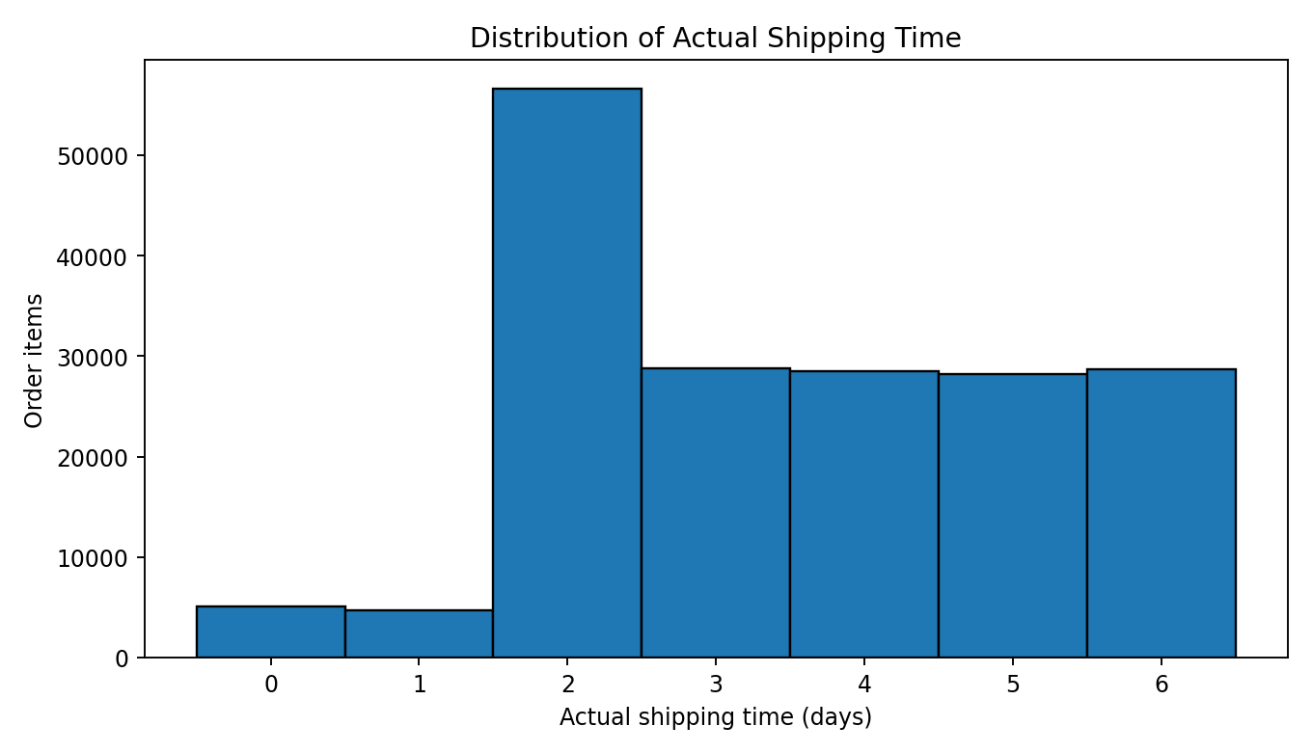
Figure 1. Distribution of actual shipping time.
Why a histogram: it shows the frequency at each shipping duration and makes the spread and common delivery windows visible. The average of 3.50 days and median of 3.00 days provide a baseline, while the 6-day maximum indicates a long-duration tail that should be checked for exceptional routes or records.
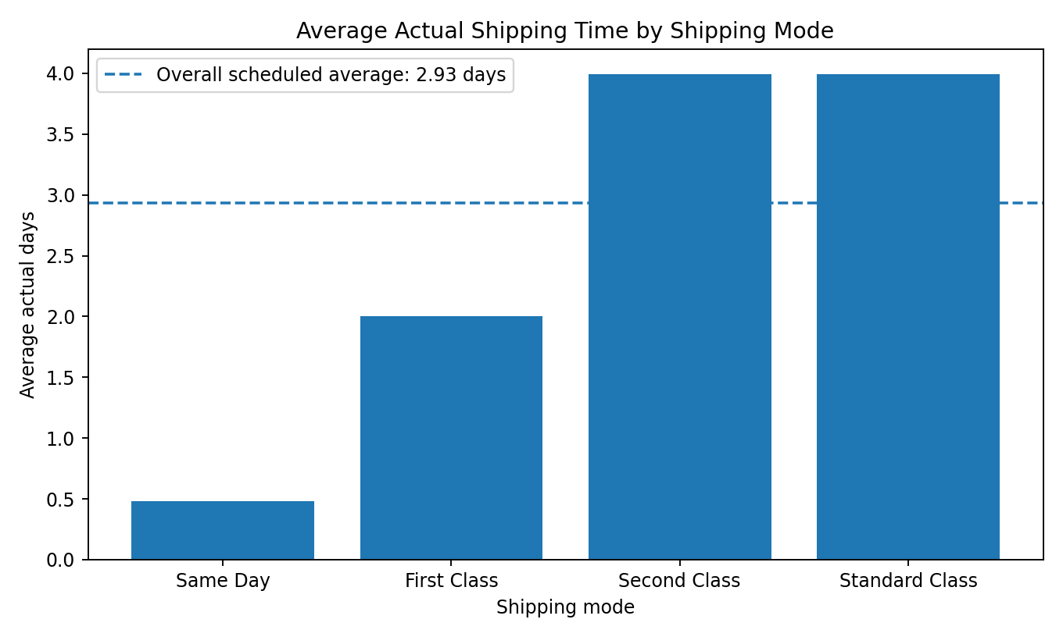
Figure 2. Average actual shipping time by shipping mode.
Why a bar chart: shipping modes are categories, so bars allow a direct comparison. The fastest mode by mean duration is Same Day (0.48 days); the slowest is Standard Class (4.00 days). Mode comparisons should also consider promised delivery windows and cost, not speed alone.
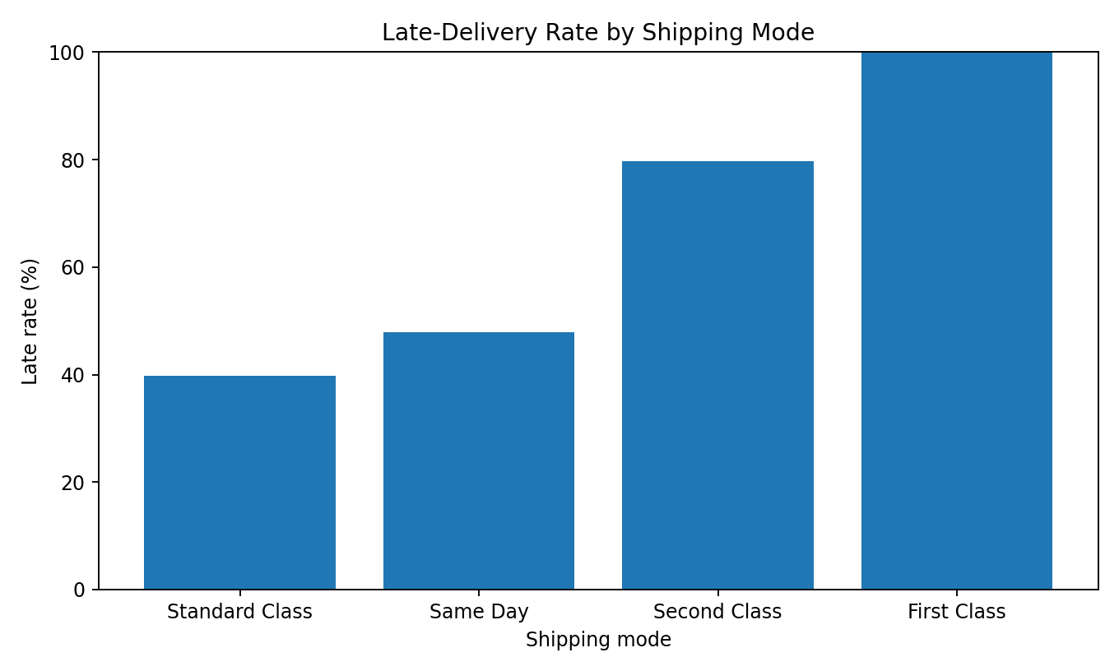
Figure 3. Late-delivery rate by shipping mode.
Why a bar chart: the percentage scale makes service reliability easy to compare. The overall late share in this analysis is 57.28%. The mode with the highest observed late rate is First Class at 100.00%. A high late rate does not prove the mode itself causes lateness: destination mix, scheduled service level, order timing, and route complexity may differ.
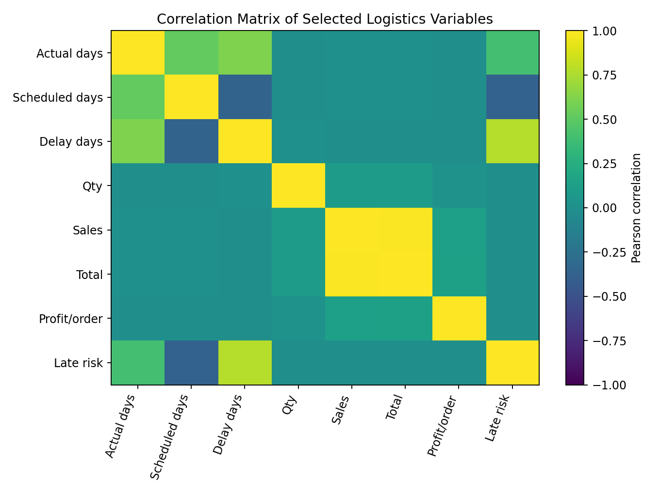
Figure 4. Correlation matrix of selected variables.
Why a heatmap: color encodes correlation strength and direction across multiple numeric variables. Actual and scheduled shipping days have a Pearson correlation of 0.516; delay and the dataset’s late-risk indicator correlate at 0.778. Correlation is association, not causation. The risk field may be defined from delivery timing, so its relationship with delay should not be treated as an independent predictive discovery.
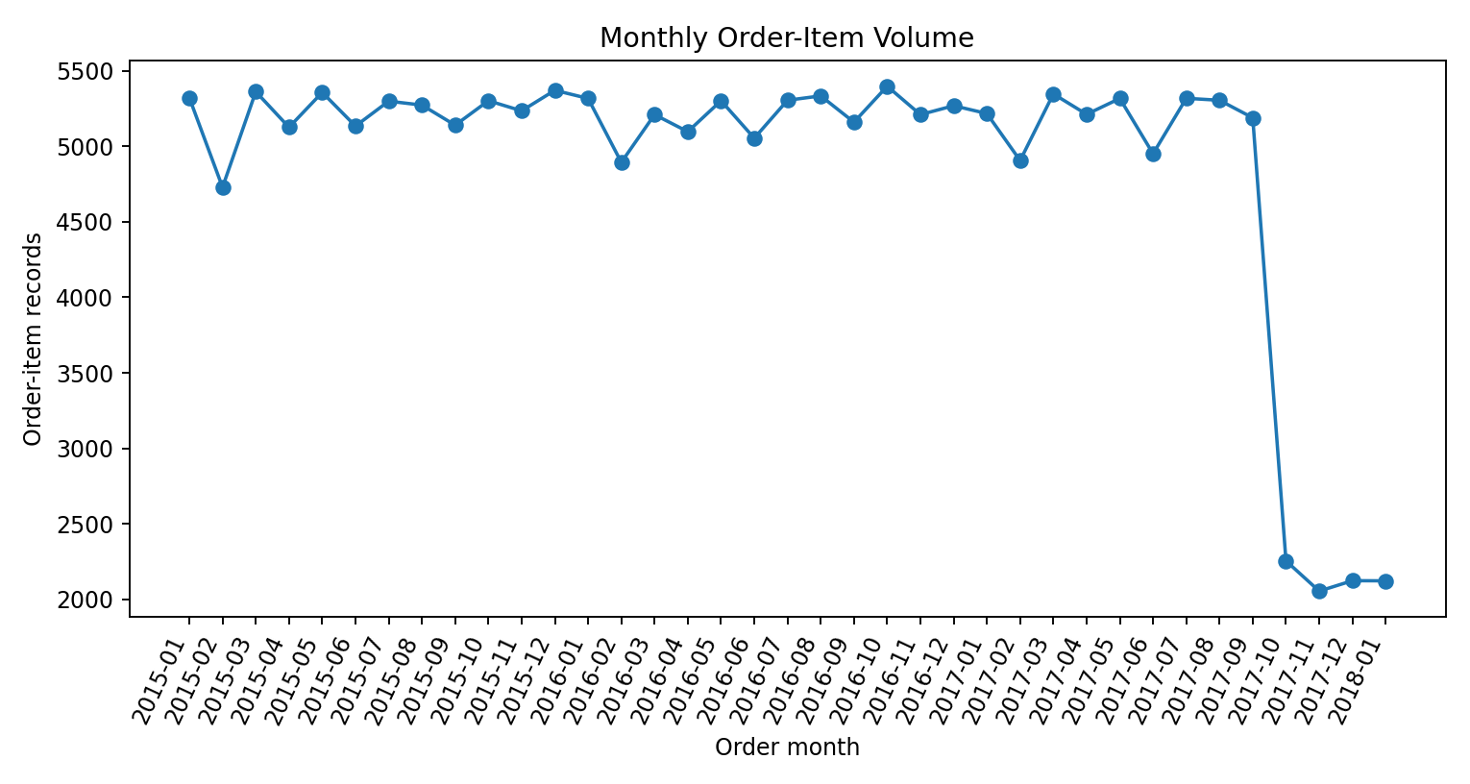
Figure 5. Monthly order-item volume.
Why a line chart: months have a natural time order, and a line makes peaks, troughs, and changes over time easier to notice. Counts are order-item records rather than unique shipments. Monthly volume should be compared with staffing, warehouse capacity, and late rates before claiming a seasonal bottleneck.
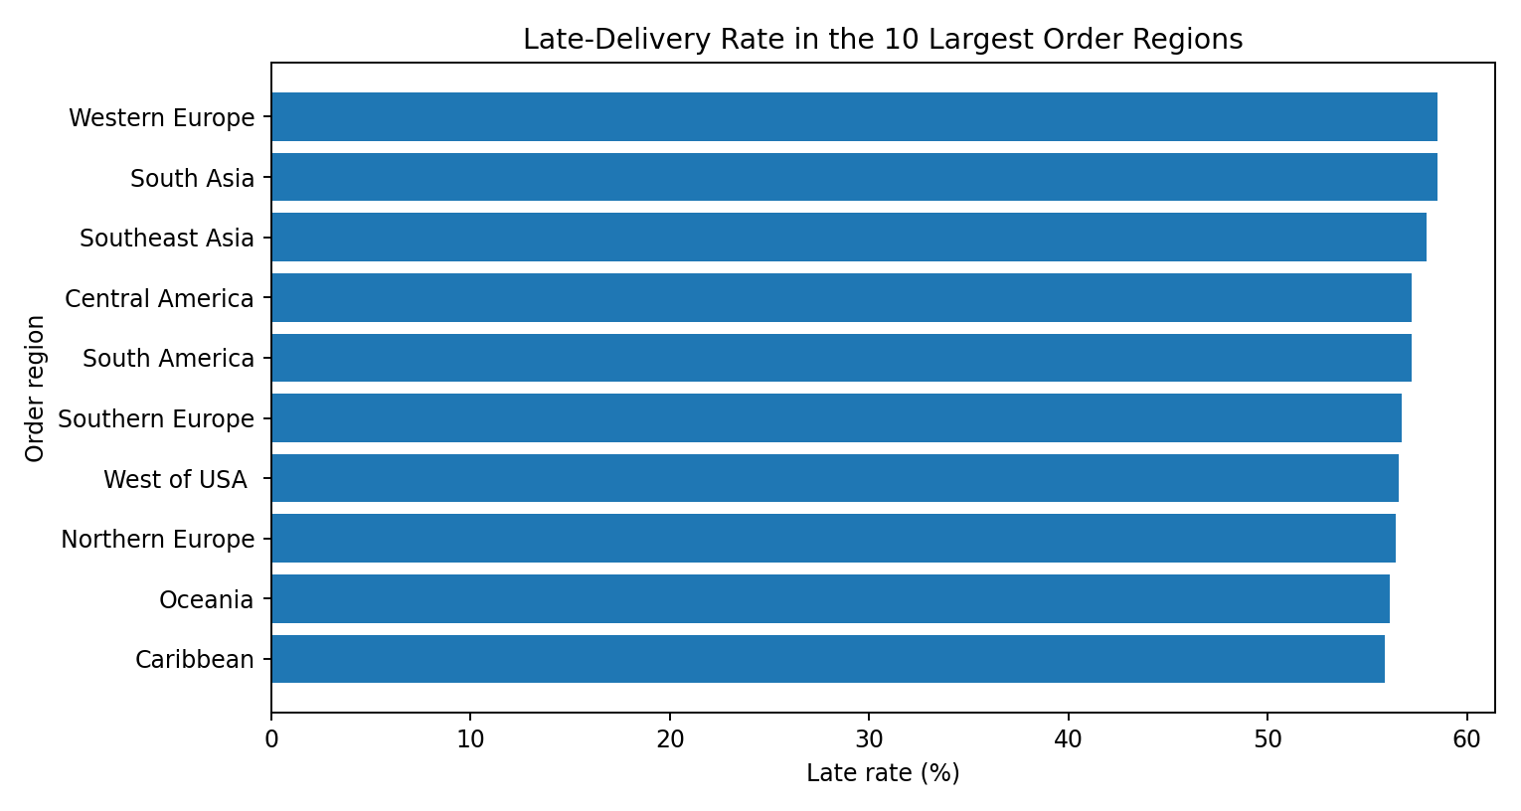
Figure 6. Late-delivery rate in the ten largest order regions.
Why a horizontal bar chart: long region names remain readable and rates can be ranked. This view helps operations teams identify high-volume regions with elevated late rates for route-level investigation. Regional rates can be affected by different shipment mixes and sample sizes, so they are diagnostic signals rather than proof of a root cause.

5. Shipping Mode and Regional Comparison
Shipping mode summary (record-level grouping):
Shipping mode | Records | Avg actual days | Avg scheduled days | Late rate
Standard Class | 107,752 | 4.00 | 4.00 | 39.77%
Second Class | 35,216 | 3.99 | 2.00 | 79.73%
First Class | 27,814 | 2.00 | 1.00 | 100.00%
Same Day | 9,737 | 0.48 | 0.00 | 47.83%
This table is useful because an overall average can hide mode-specific performance. A practical next step is to compare each mode’s actual time with its own scheduled allowance, and then segment by region and order month. A mode with more days is not automatically performing badly if it is designed as a slower, lower-cost service.

6. Correlation and Business Meaning
Pearson correlation between actual and scheduled shipping duration: 0.516. This indicates how actual shipping duration tends to move with the scheduled duration across records. Correlation between delay days and Late_delivery_risk: 0.778. Because late-risk may be constructed from delivery information, this is mainly a consistency check, not evidence of a causal driver. Correlation between actual days and item quantity: -0.001; it should be interpreted cautiously because a row-level item quantity is not the same as total shipment weight or route workload. Correlation between sales and profit per order: 0.132; this is not a transportation-cost relationship.

7. Key Findings and Operational Impact
- 1. Delivery reliability needs active monitoring: 103,400 of 180,519 records (57.28%) were flagged late under the stated rule. Even a small reduction in late share can reduce customer complaints, compensation risk, and repeat support work; the financial value should be quantified with company-specific cost data.
- 2. Shipping-time variation matters: actual delivery spans 0 to 6 days. Averages alone can hide the extreme tail. Teams should inspect long-duration records by destination, mode, order date, and delivery status.
- 3. Mode selection is a service-level decision: the mean actual duration differs between Same Day (0.48 days) and Standard Class (4.00 days). Faster delivery may support urgent orders, while slower modes may be appropriate when promised dates are met and costs are lower.
- 4. Late-rate comparisons can expose investigation priorities: the highest mode-level late rate is 100.00% for First Class. Investigate destination mix, scheduled duration, cut-off times, and handoff delays before changing the carrier or mode.
- 5. Volume should be analyzed alongside reliability: the monthly chart identifies periods with more order-item records. A volume peak only becomes an operational bottleneck when compared with capacity, staffing, dispatch performance, and late rates.
- 6. Cost analysis is limited by the available schema: sales and order-item totals are commercial values, not direct transportation cost. Without freight charges, fuel, distance, carrier invoice, and failed-delivery cost, it would be misleading to declare which route or mode is most expensive.

8. Recommendations
- Create a weekly delivery KPI dashboard with on-time delivery rate, mean/median actual days, average delay, and 90th/95th percentile shipping duration, split by mode and region.
- Prioritize root-cause analysis for late records in the highest late-rate modes and high-volume regions. Compare like-for-like lanes and scheduled service classes before taking corrective action.
- Use exception alerts for shipments whose actual or predicted delivery exceeds the scheduled duration; route these to customer support or dispatch teams before the customer must complain.
- Add direct freight cost, distance, carrier, package weight/volume, dispatch timestamp, promised delivery date, and failed-delivery/re-delivery cost to future data collection. These fields enable a defensible cost-per-shipment and cost-per-kilometre analysis.
- Validate data definitions and avoid counting order-item rows as unique shipments. For shipment-level KPIs, deduplicate or aggregate using a documented shipment/order identifier.
- In Week 4, test a prediction model only after selecting a clear target and avoiding leakage. Use a time-based train/test split and report MAE/RMSE for delay prediction; compare with a simple baseline.

9. Python Code Excerpt
import pandas as pd
import matplotlib.pyplot as plt

df = pd.read_csv("DataCoSupplyChainDataset.csv", encoding="latin1", low_memory=False)
df["Days for shipping (real)"] = pd.to_numeric(df["Days for shipping (real)"], errors="coerce")
df["Days for shipment (scheduled)"] = pd.to_numeric(df["Days for shipment (scheduled)"], errors="coerce")
df["delay_days"] = (df["Days for shipping (real)"] -
df["Days for shipment (scheduled)"])
df["is_late"] = (df["Delivery Status"].eq("Late delivery") |
df["delay_days"].gt(0))

print(df[["Days for shipping (real)", "Days for shipment (scheduled)",
"delay_days"]].describe())
mode_summary = df.groupby("Shipping Mode").agg(
records=("Order Id", "count"),
avg_actual_days=("Days for shipping (real)", "mean"),
late_rate=("is_late", "mean"))
print(mode_summary)

mode_summary["late_rate_pct"] = 100 * mode_summary["late_rate"]
mode_summary["late_rate_pct"].plot(kind="bar", ylabel="Late rate (%)")
plt.tight_layout(); plt.show()

10. Limitations
This is observational historical data. It does not establish why a delay occurred, and it may contain records that share an order ID. “Late” is defined here as the supplied Late delivery status or actual shipping days greater than scheduled days; results can vary if the internship evaluator expects the supplied status field alone. No direct transportation cost variable was found in the columns used, so no claim is made about actual freight cost. Some fields have missing values; descriptive statistics use available values rather than inventing replacements. Regional/mode comparisons should be validated with sample sizes and business context.

11. Conclusion
The analysis of 180,519 order-item records shows that delivery duration and late-delivery rate should be reviewed together and segmented by shipping mode, month, and region. The average actual duration is 3.50 days, and the analysis flags 57.28% of records as late. The charts make the distribution, mode differences, monthly volume, and regional variation easier to interpret. The most useful operational next step is not to assume a cause, but to investigate high-late-rate segments with more detailed route, capacity, and carrier data. Adding direct freight-cost fields would make future cost optimization evidence-based.

References
1. DataCo SMART SUPPLY CHAIN FOR BIG DATA ANALYSIS, public dataset (DataCoSupplyChainDataset.csv).
2. pandas documentation: https://pandas.pydata.org/docs/
3. Matplotlib documentation: https://matplotlib.org/stable/
4. NumPy documentation: https://numpy.org/doc/

