**Project 1: Analysis on Retail Domain – Draft Report**

Rahul Gupta - DSC 680 - Winter 2020

Instructor: Catie Williams

18 Dec, 2020

**https://github.com/rahulgupta271/DSC680_Project_1_Market_analytics_holiday_trend**

**Introduction**

The method by which analytical data is generated and analyzed is Retail Data analysis. This information can be used to report on different facets of the supply chain operation in the retail chain, including purchases, returns, discounts, and more. This information is used by many suppliers, retailers, and marketing teams to identify patterns and learn more about their business. One of the main aspects of this form of growth in analytics in the retail industry is that when they shop, consumers have a more personalized experience [Jones, 2018]. Not just do retailers understand the needs and desires of their consumers better, but the behavior of their customers is just as significant.

**Discussion**

This research examines the association between external variables, such as the weather and the overall economy, and the retail sales of the shops recorded on in the Kaggle.com/datasets/retaildataset dataset. Knowing how consumers operate will provide a company with a great deal of insight into staffing, resupply of stocked products, reasonable times to reduce prices and profits and what to expect during the holiday season.

An anonymized report that detailed the weekly sales amounts of 45 stores, with as many as 99 individual divisions within each of those locations, was the data set that was used in producing this report. The key focus of this analysis will focus on the top 3 retailers with the highest average weekly sales and drill down to the three departments with the highest average sales in each of those retailers, as well. All dimensions considered are against a timeline, but since they are all different measurement units, each element has been converted into a log so that they can be visualized accurately on the same scale. Some characteristics, such as the Consumer Price Index (CPI), had little or no improvement over the time span being studied and proved to be of no real relevance to the findings.

This graph reflects the combined performance of store #20's top three departments, the store with the highest weekly average sales. The three attributes being evaluated are also portrayed in order to demonstrate the WRONG thing to do.

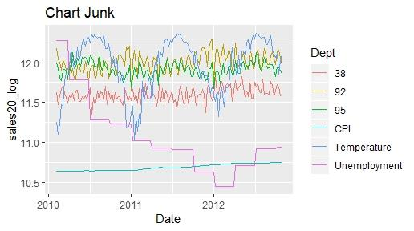

There is lot of things to focus and understand. This next example illustrates how the weather in each of these departments has behaved differently (average temperature). It is important to remember that these shops are situated in different areas when we see how the output differs from one store to another and from one department to another. It is fair to conclude that they are situated in different areas of the world based on the difference of temperature from week to week, so it is safe to deduce that it is entirely probable that temperature would influence stores differently, But once each retailer acknowledges the patterns they are seeing as a result of these external influences, they will see how each individual department has its own predictive modeling to build at each individual store.

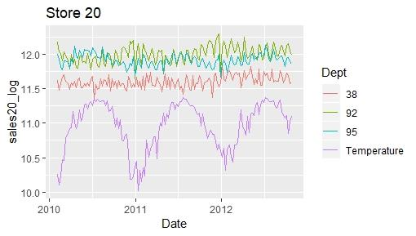

Although this is still a lot, at Store 20, this graph just shows the top three departments and the temperature (in purple). For Department 92, with colder conditions and small increases at the end of each year and more stable results in the middle of the year when temperatures are highest, we can see sales rise. In comparison, during hot season, Department 95 shows growth in revenue, while Department 38 shows stable year-round success and a rise in total sales in 2012.

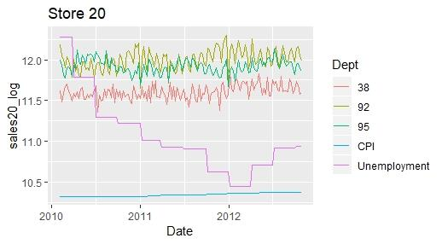

As unemployment continues to decline, Departments 92 and 38 both show upward trends.

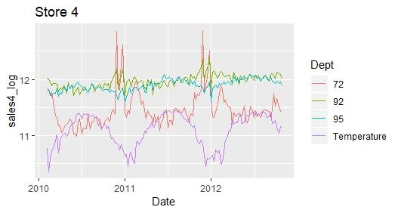

Department 72 displayed dramatic peaks during colder weather at Store 4 and a drop in steady results as the temperatures warmed up. In colder weather, Department 92 still peaked, but did not display as dramatic shifts as Department 72. Over the course of the three years, Department 95 showed modest increases

but continued to see minor dips in sales at the coldest temperatures.

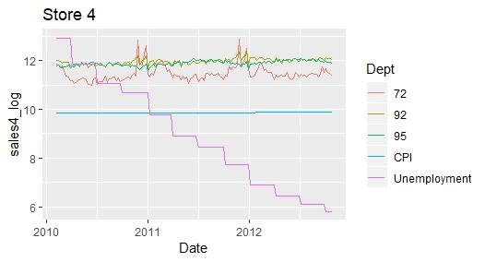

There appears to be no real shift arising from the CPI, which has been stable, or from the decline in the unemployment rate. Sales tend to fluctuate further as a result of environmental changes.

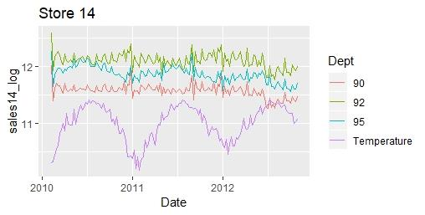

Store 14 seems to reflect sales surges that are consistent with Store 20's results. In colder temperatures, Department 92 has risen considerably. Department 95 reveals post-temperature sales patterns, with higher temperatures representing higher sales and lower temperatures reflecting lower sales. With some minor peaks at year end, Department 90 showed very stable results, but all three of these divisions saw a drop in revenue halfway through 2012.

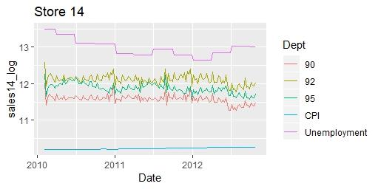

There seems to be no direct link between CPI and unemployment rates as to how these characteristics impact Store 14 profits. The original observation will be that these shifts are associated with the rise in unemployment, with all three of the highest performing departments reflecting a downturn in2012, however by the end of2012, unemployment rates were not as high as they were in2010, when the store posted improved results.

**Conclusion**

If one of these stores chooses to seek market success responses, it is clear that analytics should be broken down into individual divisions, helping certain retailers to consider how each department performs as a function of external variables. With data representing selling (markdown) times, further research may be carried out to obtain more insight as to what the right time to perform a sale will be at the level of an individual agency. As this analysis is not sufficiently long enough to be all inclusive, the code used to create this data should be understood to be entirely reproducible by choosing every store number and department numbers that the consumer wants to investigate.

**References**

https://medium.com/alloytech/retail-analytics-trends-in-2019-and-beyond-c671783c67b7

https://www.strategywise.com/fast-forward-how-retailers-will-use-data-and- analytics-to-succeed-in-2018-and-beyond/