 **Submitted by: Submitted to:**

**NAME: Rahul Gusain Hitesh Kumar Sharma**  
 **SAP: 500084143**  
 **ROLL NO.: R214220900**  
 **BATCH: 1 DevOps (N.HONS)**

# **Application Containerization and Orchestration**

**ASSIGNMENT 1**

**Difference between Metaverse, AR and VR**

The VR and AR are similar in that they both allow the user to experience a different world. But the Metaverse is different in that it is a shared space where all the worlds reside.

Metaverse is a shared space where all the other worlds, AR and VR, reside. With this definition, it can be said that Metaverse is not just about playing games or watching movies; it’s about exploring new worlds with people from all over the globe.

Metaverse is defined as an internet based virtual world which provides avatars with some degree of freedom to interact with each other and their surroundings. VR is a three-dimensional computer-generated simulation of a physical environment. It is interactive and immersive, allowing the user to explore and interact with their surroundings. VR content is mostly created for video games, but it can also be used in other fields such as education, architecture, engineering and more.AR is an interactive experience of a real-world environment where computer generated images are overlaid on top of the live video feed from either a camera or screen. The user can interact with these elements in the virtual world. AR has been used by companies such as Ikea to create AR furniture catalogues which allow customers to virtually place furniture in their own homes before they buy it.

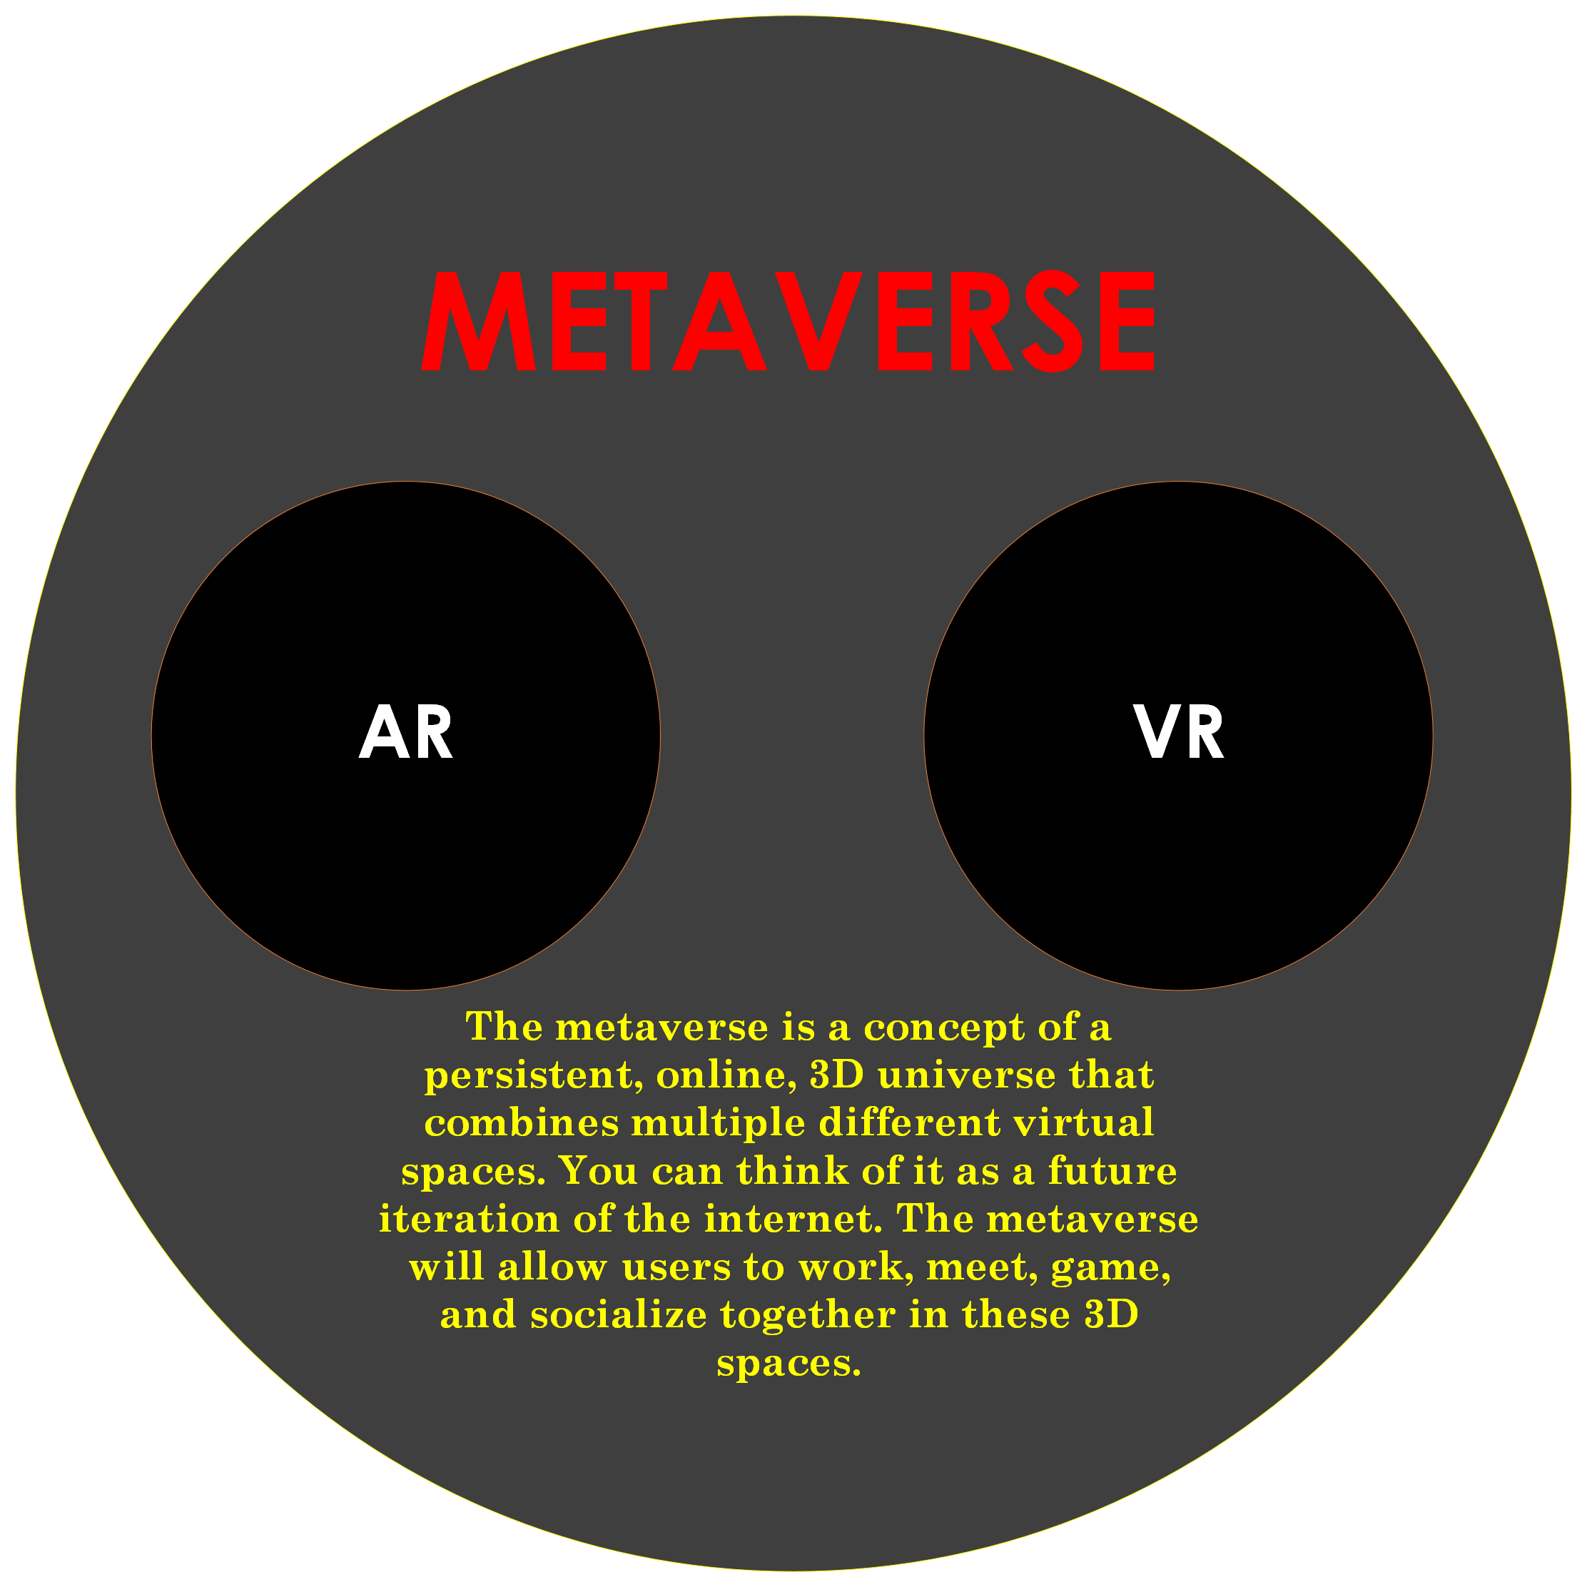

Metaverse is an entirely digital space that shares similarities with both AR and VR worlds. It's designed for people. Virtual Reality or VR is a computer-generated simulation that replicates an environment, real or imagined. It immerses the user in a virtual world, with the intention to create the feeling of being inside this other environment. Augmented Reality or AR is a technology that overlays digital information on top of the user's view of the real world. This information can include anything from text and graphics to video and sound.

Metaverse is an interconnected set of realities that are accessible through multiple devices and inputs, including devices like smartphones and tablets as well as headsets like Oculus Rift, HTC Vive, PlayStation VR etc. VR: Virtual reality is the simulation of a three-dimensional image or environment that can be interacted with in a seemingly real or physical way by placing the user inside and interacting with it.AR: Augmented Reality is a live direct or indirect view of a physical, real-world environment whose elements are augmented (or supplemented) by computer-generated sensory input such as sound, video, graphics or GPS data. Metaverse: A term coined by Neal Stephenson in his book Snow Crash to describe an interconnected virtual reality. The difference between AR and VR is that VR takes you to a different world while AR enhances your current world. The difference between Metaverse and AR/VR is that Metaverse is an interconnected virtual reality while AR/VR are only individual realities.

A person using VR equipment is able to explore and interact with this environment and its objects in a way that feels real. Augmented Reality (AR) is a technology that overlays digital information on the user's view of the physical world, or the physical world itself. It provides features like navigation, object recognition and 3D rendering. Metaverse is a virtual world which can be accessed through various devices such as headsets, smartphones and tablets.

VR is a computer-generated simulation of a three-dimensional environment that can be interacted with in a seemingly real or physical way by placing the user inside and providing them with sensory feedback. Metaverse is an internet-based virtual reality. AR stands for Augmented Reality. It is an interactive experience of a real-world environment where the objects that reside in the real-world are "augmented" by computer generated sensory input such as sound, video, graphics or GPS data. Metaverse is the concept of a collective virtual shared space, created by a computer network where people can interact. It's a 3D virtual world which you can explore with your avatar or digital representation. AR and VR are different in terms of how they work. AR is an overlay on the real-world while VR is an immersive environment that you need to wear to experience it.

AR is better for marketing as it has more real-life applications than VR does. However, VR has more potential for gaming and entertainment as it offers an immersive experience that other technologies cannot provide.

**Metaverse:** Metaverse is a virtual space that consists of 3D environments and objects, which can be manipulated by the users.

**AR:** Augmented Reality is a type of technology that inserts digital information into the user’s environment in real time.

**VR:** Virtual reality is a computer-generated simulation of an environment or situation that allows the user to interact with it in a seemingly physical way.

**Security Threat in Metaverse**

The security threat in the Metaverse is not a new topic. It has been discussed for years and it has been a major concern for the public. With the recent release of Ready Player One, it is once again a hot topic. The movie shows how virtual reality can be used to escape from reality and experience anything that one desires. It also demonstrates how security threats can be exploited to damage or steal data from an individual’s identity or private information.

The issue of security threats in the Metaverse is not only limited to Ready Player One, but it is also a global issue that needs to be addressed by governments and companies alike.

The Metaverse is a virtual world that has been created in the game. It is a place where many people can meet and interact with each other. The players are allowed to create their own avatars and use them to explore the world. The game has become popular for its immersive environment, which has attracted millions of users from around the world.

The Metaverse is not as safe as it seems because there are many security threats that can be found in this virtual environment. One of the most common threats is identity theft, which means that your avatar's identity could be stolen by other players or hackers who want to take advantage of it for their own purposes. In order to prevent this from happening, you should always remember to change your passwords regularly and avoid disclosing your personal information when talking to strangers online

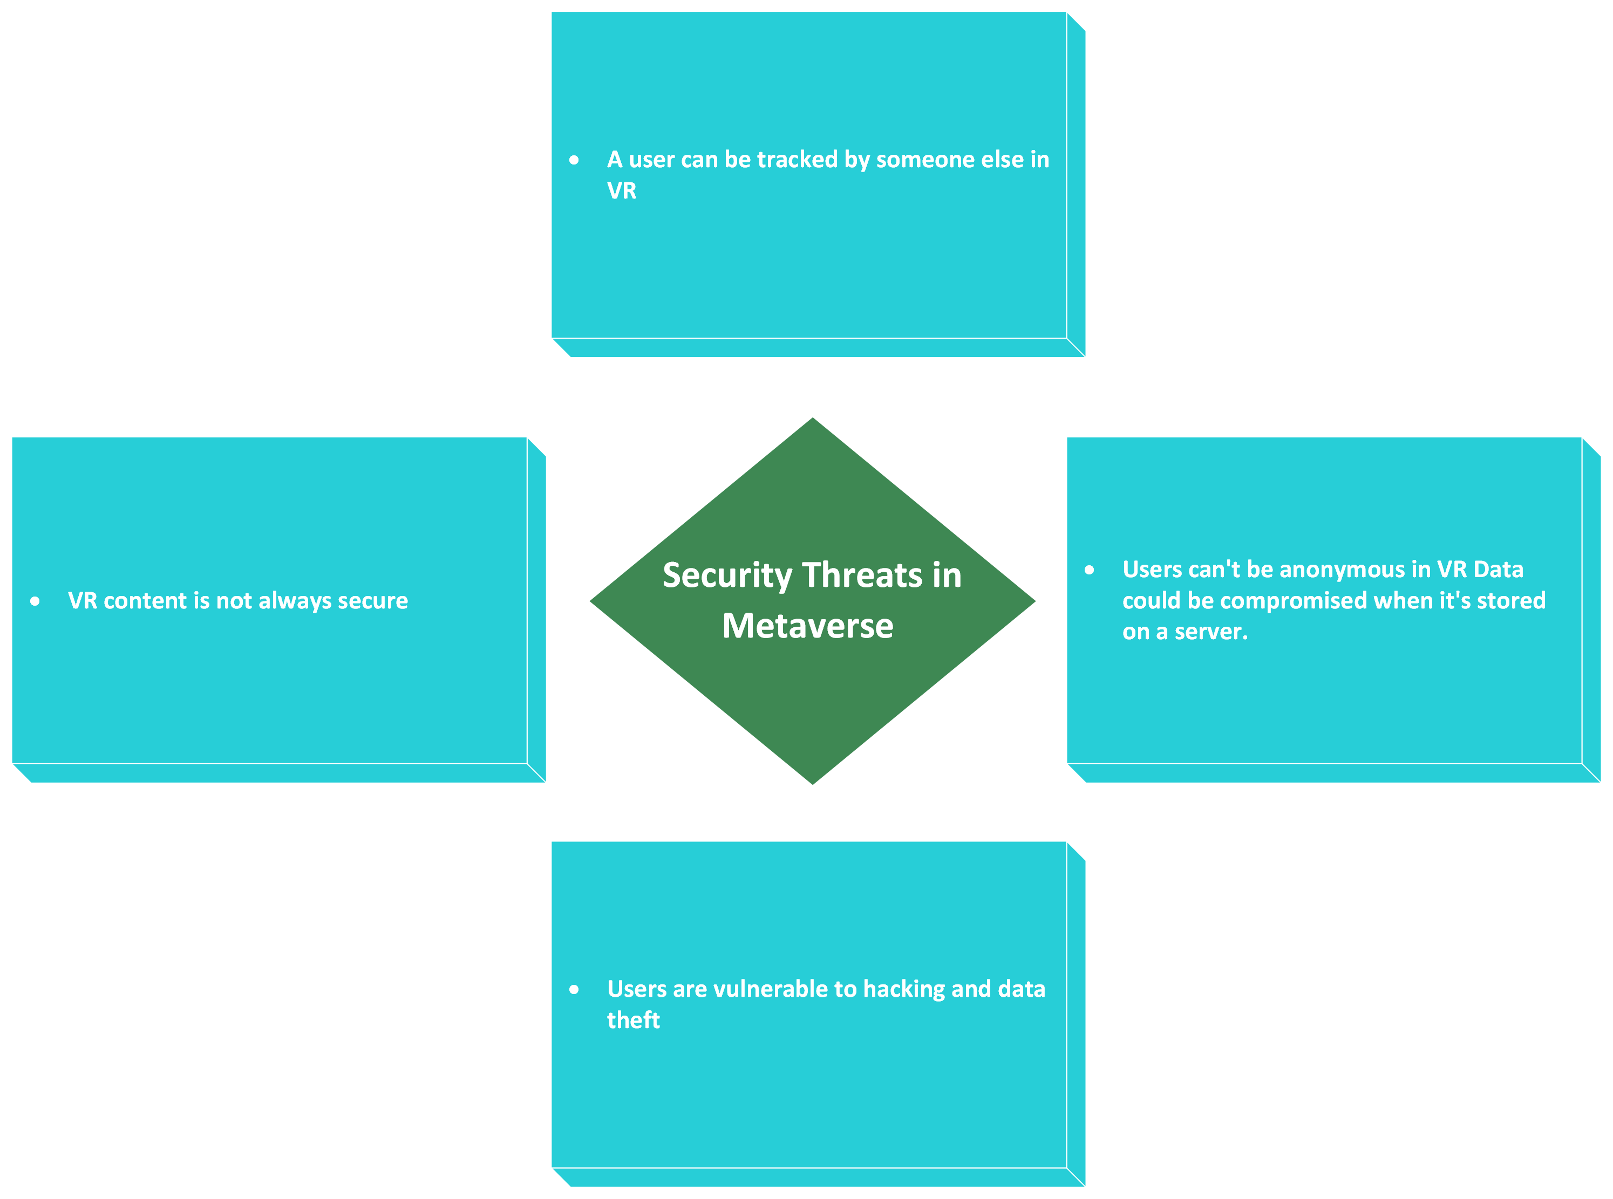

In the world of Metaverse, the security threats are not limited to hackers and thieves. There are many other ways in which people can be hurt or killed. The most popular way to do this is by using a weapon that is specifically designed for killing others. Some of these weapons can be found in Metaverse and some can only be used inside it. One example of a weapon that can only be used inside Metaverse is the laser gun, which shoots laser beams at its target and usually kills them instantly. We need to be mindful of the security risks that come with the benefits of Metaverse. The first risk is identity theft. Identity theft is a big problem in this day and age, and it's only going to get worse as we increasingly rely on our virtual identities.

Another security risk is hacking. As we spend more time online, it becomes easier for hackers to break through our defenses and steal our personal information. The security threat in the metaverse is a serious issue, which has the potential to affect both people and organizations. It can be caused by hackers or malware attacks. To solve this problem, we need to implement some countermeasures such as firewalls, anti-virus software, and intrusion detection systems. The security threats in the Metaverse are not just a concern for the future but are already present. There have been a number of instances where people have lost their digital assets due to hacking and theft in the virtual world. The Metaverse has become an attractive target for hackers because of its popularity and value.

In order to secure your digital assets, you need to take certain precautions such as using strong passwords, two-factor authentication, and other user-friendly security measures.

The security of virtual worlds is a pressing issue. The Metaverse, which is a popular virtual world with billions of users, has been hacked in the past. There are many ways that hackers can take advantage of the Metaverse and its users. They can steal personal information from an individual, or they can do something as drastic as deleting an entire city from the Metaverse.

We need to be aware of these security threats so that we can protect ourselves and our friends in a virtual world. The security threats in the metaverse are an ever-growing concern. The most common threat is that of identity theft, as a result of the lack of anonymity in the metaverse. As a result, many people have resorted to using false identities when they are in the metaverse.

This has led to an increase in another common security threat - that of scamming. Scamming is when someone creates an avatar who looks like someone else and then pretends to be them, either to trick other people or to steal from them.

The security of the Metaverse is a major concern for the public. Blockchain technology, which is the backbone of Metaverse, has been criticized for its lack of security in recent years. In order to protect users' data and assets, we must take measures to ensure that they are always safe. The metaverse is a digital environment that can be accessed through VR and AR devices. A digital environment where people can interact with each other, access information, and conduct transactions. There are still many security threats to be addressed in the future of the metaverse. The first security threat is that people might not realize they are in the metaverse and think they are physically in the real world. This could lead to accidents or injuries because people might not be aware of their surroundings or what they are doing. The second security threat is that there will always be hackers looking for ways to steal data, money, or both from unsuspecting users on these virtual platforms. This leads us to the third security threat: cyber terrorism and warfare which may use these virtual worlds as a new front for them.

It is a virtual world that exists alongside the real world and is an extension of the physical universe. The metaverse can be accessed through virtual reality headsets, smartphones, or any other device with internet access. A key concern for users of virtual worlds is security. Hackers are constantly trying to find ways to break into these worlds and steal data from unsuspecting users. For example, in February 2018, it was reported that a hacker had infiltrated the Pokémon Go servers and downloaded databases containing user information including email addresses and phone numbers.

**Advanced features of Metaverse**

Metaverse is the first blockchain-based platform that allows you to create and share virtual realities with others. It’s a social network for VR content. It has a wide range of features that make it an attractive option for developers, investors, and users.

The Metaverse team has built a new consensus mechanism, called Proof of Work (PoW), which can be used to issue tokens and make smart contracts. The PoW consensus mechanism is more energy efficient than the traditional Proof of Work (PoW) consensus mechanisms because it does not require expensive mining hardware like GPUs or ASICs. This means there are no costly hardware investments required for people who want to contribute their compute power to the network. Metaverse is a blockchain-powered augmented reality platform that aims to build a decentralized, secure and private ecosystem for the digital world.

Metaverse uses digital identities to create transactions and authenticate users. It also has its own cryptocurrency called ETP which is used for value transfers. Metaverse is a blockchain 3.0 platform. It is a decentralized and open digital world with the goal of creating an alternative to the internet. Metaverse is a blockchain-based virtual reality platform that allows users to create, share and experience content and applications.Users can create their own virtual world, explore other worlds and interact with other users through avatars.

Metaverse provides an open platform for developers to build on. It also has a built-in cryptocurrency called ETP which is used as the primary payment method for all transactions within the Metaverse ecosystem.

Metaverse is a 3D virtual world that has been designed to be used as a collaborative platform for businesses. Metaverse is an augmented reality (AR) and virtual reality (VR) platform that has been designed to be used as a collaborative workspace for businesses. It is the first blockchain-based AR/VR world where people from all over the world can create, share, and monetize content and applications. Metaverse should not be confused with other VR or AR platforms such as Second Life or Oculus Rift. Metaverse provides users with two basic functionalities: Digital Land and Digital Assets.

Digital Land refers to the digital space where users can construct buildings, landscapes, etc.; it can also be used to create games or other applications. Digital Assets refer to any digital content created Metaverse is the first public blockchain to provide an open platform for building and deploying decentralized applications in this new and fast-growing market. With its EVC token, Metaverse provides a low-cost value transfer service for digital assets so that everyone can enjoy the benefits of decentralization.

Metaverse has partnered with several companies such as Alibaba, Tencent, Wanda Group, Baidu and more, to build applications on top of the Metaverse platform.

The Metaverse team has created a digital asset system and a peer-to-peer trade system that allows people to create their own digital assets and trade them on an open market. The team also created a Digital Identity System which allows people to identify themselves in the Metaverse world, as well as store all their information securely on the blockchain. Metaverse is a virtual world that is created and owned by its users. It has many advanced features such as the ability to create your own avatar and explore the virtual world.

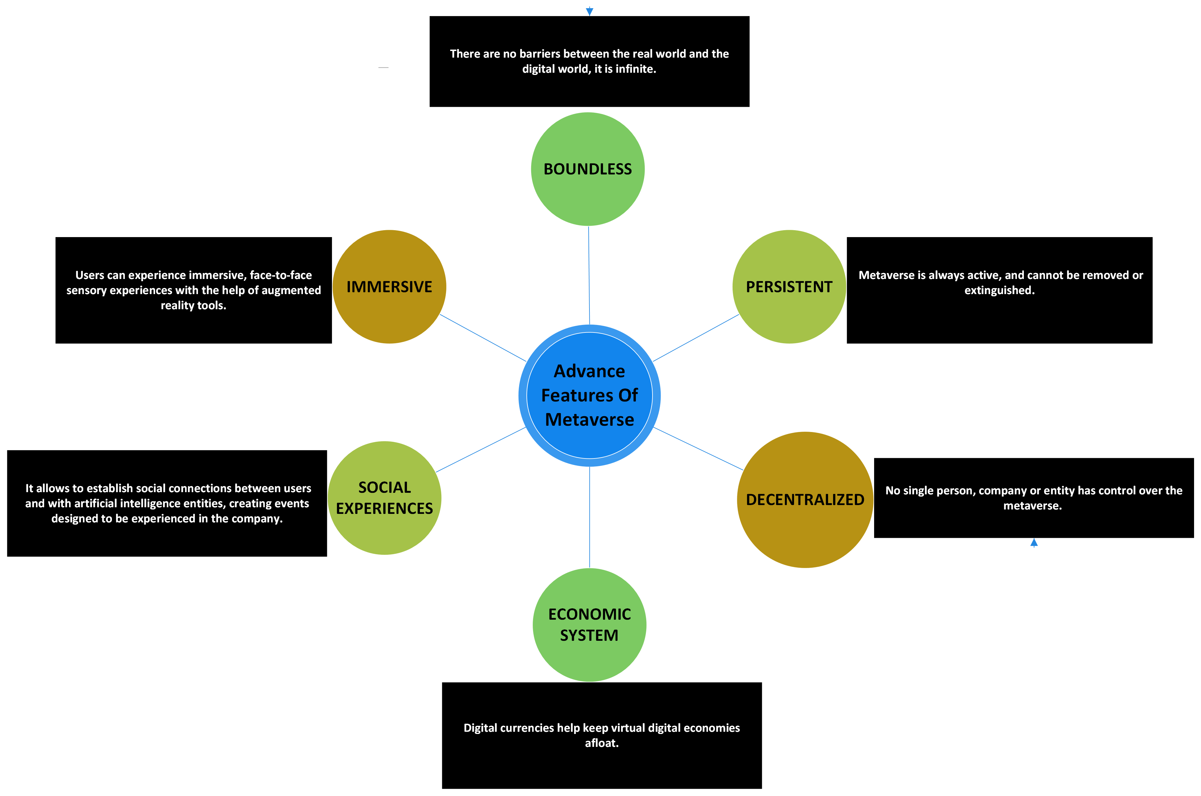

It can be used for a variety of purposes such as exploring, interacting with others, playing games, meeting new people, and more. You can even buy property in Metaverse and store it in your personal inventory. Metaverse is a blockchain-based virtual reality platform that provides a shared space for all the VR apps. It also creates an interface for all the VR services and contents.

We can use Metaverse to create, publish, and distribute our own VR content. And we can also convert 2D videos into 3D videos and upload them to the Metaverse platform. Metaverse is a decentralized platform that enables us to create our own virtual world in which we have complete control over the content. Metaverse is a blockchain-based augmented reality platform. It has a lot of advanced features that make it stand out from other AR platforms.

Metaverse is the first public blockchain project to provide full support for autonomous digital identities and to create an “Internet of Value”, which means it can be used for payments, smart contracts, and digital asset exchange. The Metaverse system uses Oracle to record the history of all transactions conducted in the system. This provides a reliable way for users to verify that these transactions are not tampered with.

**Role of Blockchain in Metaverse**

Metaverse uses the blockchain to create an environment where every digital asset is unique and cannot be replicated. Blockchain has been around for a while, but it is only recently that the idea of its use in the Metaverse became popular. Blockchain is a distributed ledger that is used to store data in a decentralized way. It is also immutable and has no single point of failure.

The most important thing about blockchain technology is that it stores data in blocks, which are connected to each other in chronological order. The blocks are linked together by cryptographic hashes and the data inside them cannot be changed or tampered with. Metaverse is a decentralized public blockchain that aims to build a platform for digital assets and digital identities. It has built-in support for various kinds of smart contracts and has a strong sense of social responsibility. The Metaverse team is developing the world's first web browser with blockchain functionality. The browser integrates seamlessly with the Metaverse blockchain, enabling users to access new types of digital assets and decentralized applications (DApps) directly from their browsers. The project also aims to build a set of open-source development tools in order to help developers create their own DApps on the Metaverse blockchain. Metaverse is an open-source public blockchain that provides digital assets and identity services. The platform uses the ETP token for transactions, which is mined by the Metaverse Virtual Machine.

The Metaverse team wants to create a web of smart properties and digital identities on the blockchain. They also want to provide a platform that allows everyone to create and trade these smart properties, digital identities, and other Dapps. Blockchain technology is going to disrupt many industries in the future, but it will take some time for it to reach its full potential. Blockchain is a type of database that is distributed across many different computers. This means that it can't be controlled by one single person or company.

Blockchain is the underlying technology behind Bitcoin, which is a digital currency. Some people think that blockchain will change the way we do things online because it's much more secure than other types of databases and transactions. It's possible to use blockchain to create a new type of internet called the Metaverse, which will be a virtual reality world where people are represented by their own avatar and can do anything they want, like buy or sell items and participate in virtual reality games.

Metaverse is a blockchain-based public platform that aims to provide services for various social and economic activities. One of the platforms most intriguing features is its ability to create a unique digital identity for each individual. This could be as simple as an ID card or as complex as a digitally-rendered avatar that can be used in video games and other virtual environments. The Metaverse team has also created an online platform called Digital Identity which allows users to create their own digital identities on the blockchain. This process can be completed in just a few minutes and will cost about $2. Digital identities are stored on the blockchain and can be accessed from any device with internet access, which means that it is possible for people from all over the world to use the same identity at once. Blockchain is a decentralized technology that provides a secure way to store data. It also enables the creation of digital currencies and smart contracts.

The Metaverse Blockchain is an open-source public blockchain project that aims to build a decentralized network of Smart Properties and establish an open platform in which digital assets and value can be transferred seamlessly.

Blockchain is a technology that has the potential to revolutionize the way we live and work. It has the ability to create new opportunities, reduce costs, and provide more security. And it can do so in almost any area of our lives, from banking to government services, from supply chains to voting systems. It is also a key component of Metaverse’s architecture.Blockchain technology is an innovative way to store data, and it has been successfully implemented in various industries. Metaverse is one of the first public blockchain projects that applies this technology to the field of digital assets, digital identities, and value intermediaries.

**Future Application of Metaverse**

The metaverse is a collective virtual shared space, created by the convergence of virtually enhanced physical reality and physically persistent virtual space, including the sum of all virtual worlds, augmented reality, and the internet. The future application of Metaverse will be seen in near-future. It will have a major impact on how we live our lives. In this future world, there are two different types of people that exist: those who have an avatar in the Metaverse and those who don’t. Those with avatars become citizens of this new world. They can make friends with people from all over the world and they are able to do anything they want to do in this new world.

Metaverse is a blockchain-based virtual reality platform that has been in development for the last two years. Metaverse uses state of the art technologies to create a decentralized and interoperable network of digital assets. It also provides protection for intellectual property rights, data privacy, and value transactions. The future application of Metaverse will be in the fields of real estate, education, healthcare, entertainment and financial services. The future application of Metaverse is still unknown. It might be a tool for the general public, or it could be used by professionals in the field of medicine or architecture. It might be a tool for the general public, or it could be used by professionals in the field of medicine or architecture.

Metaverse is a blockchain-based virtual reality platform. It aims to create a shared and decentralized world for all of its users. It is still in the early stages of development, but it has already attracted the attention of many investors and developers due to its potential in the future. The Metaverse is a virtual reality environment that is accessed through the internet. The Metaverse combines elements of a traditional video game and social media. The future application of the Metaverse is to create an immersive, interactive world for people to explore and communicate with one another. In the future, we will be able to use it as a platform for augmented reality games, shopping, and more.

The Metaverse is a virtual reality system that can be used by people with different devices or without any device. This system will not only be used for gaming, but also for socializing, shopping, and many other activities. The first use case of the Metaverse is in the gaming industry. There are a lot of games that are already using this technology to create more immersive environments and more realistic characters. The Metaverse will also have applications in the social media industry. On social media platforms, people will be able to create their own avatars and communicate with other avatars inside the virtual world of the Metaverse.

Lastly, businesses can take advantage of this technology to improve customer experience through VR shopping and VR conferencing features. The Metaverse is a virtual world that combines the real and the virtual. It is a public space where people can meet, interact, and share ideas. It provides a common ground for all types of people to come together and communicate with one another. It is not surprising that many have speculated about the future application of this technology. Some people have predicted that it will be used for social interaction, education, and business transactions. Others believe that it will be used for more nefarious purposes such as gambling or even crime-related activities.

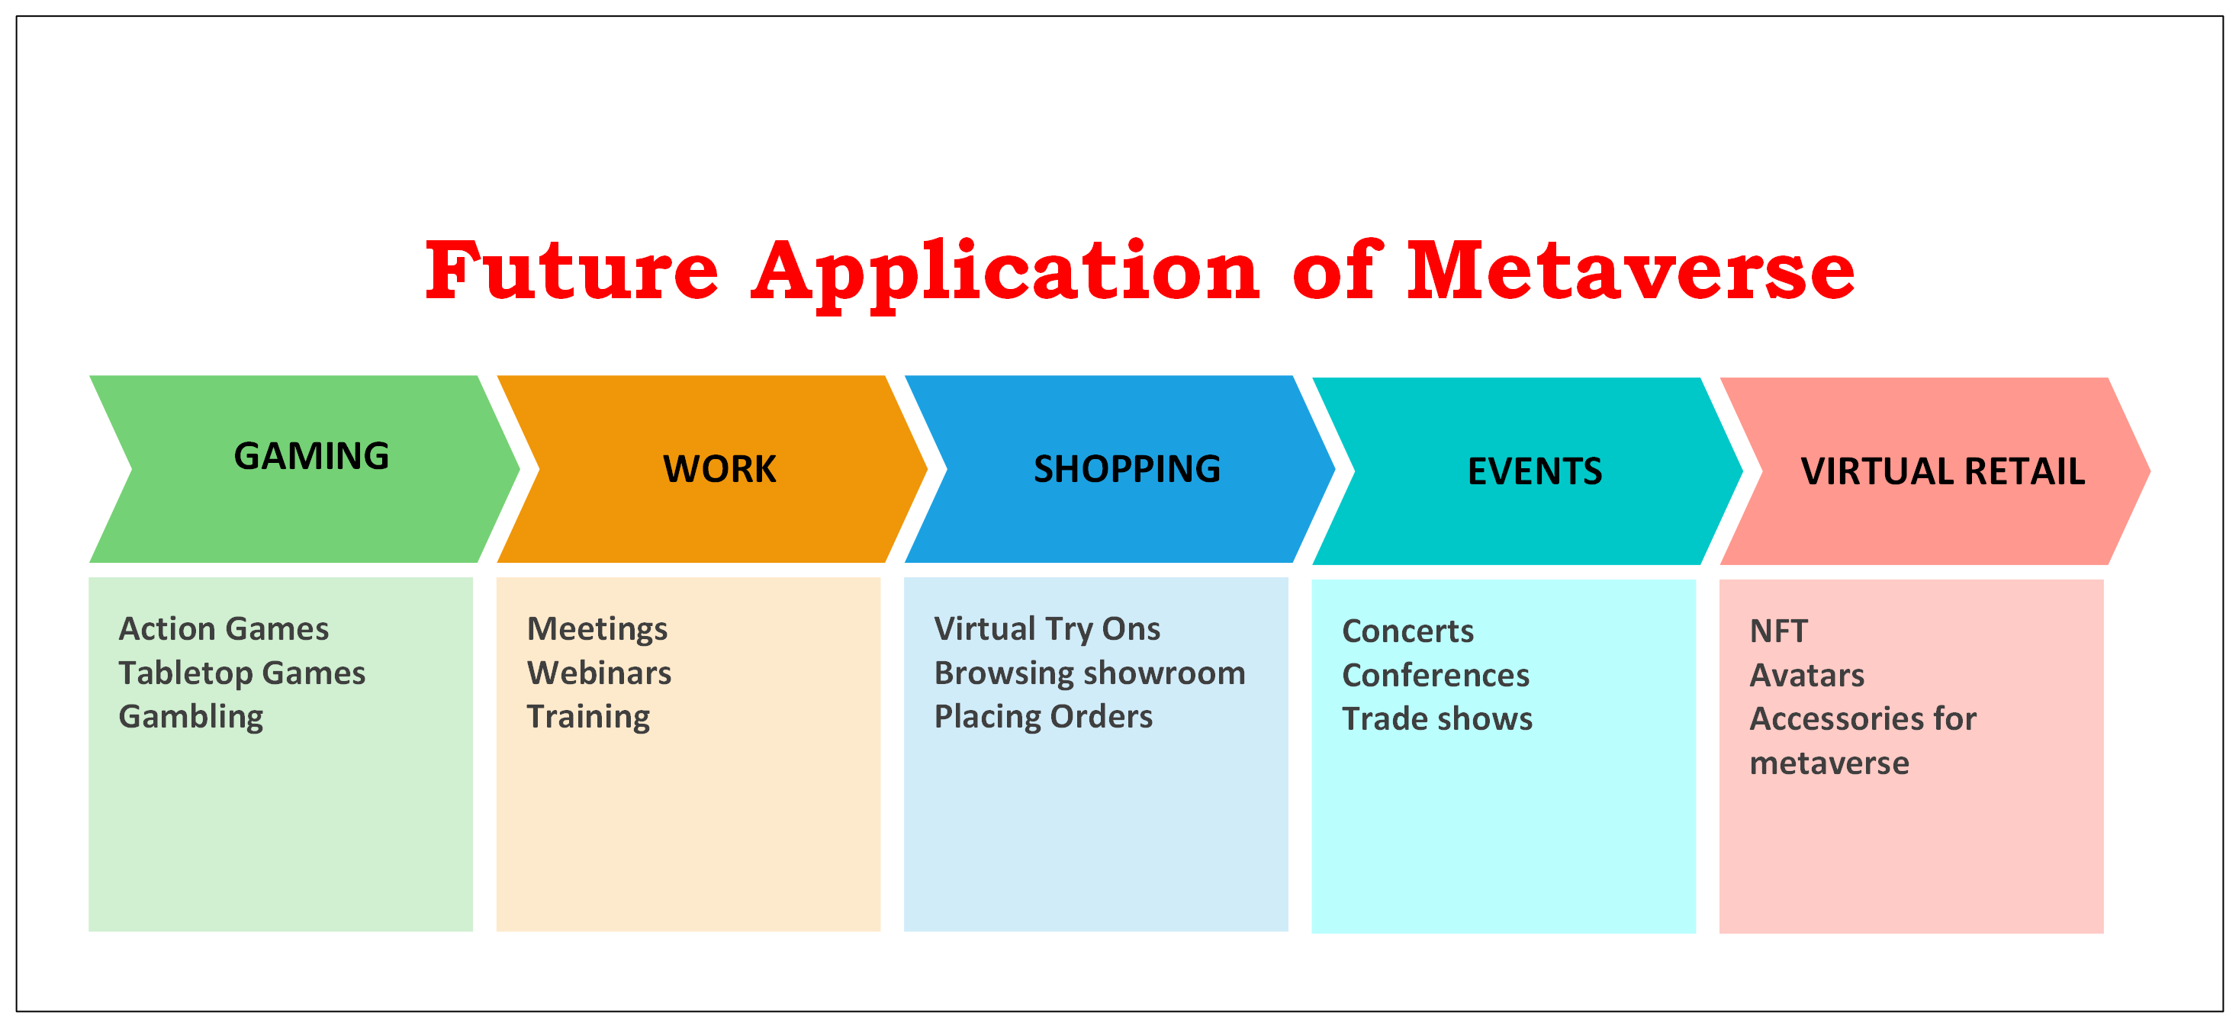

While there are many potential future applications of the Metaverse, one thing is certain: we are still in its infancy stages. The technology has not yet been perfected to allow for seamless transitions between physical reality and virtual reality without any lag or glitches in between. It is used to describe a collective virtual shared space, created by the convergence of virtually enhanced physical reality and physically persistent virtual space. The future application of Metaverse will be to provide immersive experiences for people to explore new worlds in real time with friends and family. The Metaverse is a virtual world that is created by the collective consciousness of its inhabitants. It is a world in which people can share their thoughts, ideas, and visions with anyone else who visits and also be able to interact with each other.In the future, the Metaverse will become more immersive and interactive. The virtual worlds will be created by our collective consciousness from our thoughts, ideas, and visions.

Metaverse is a concept in which a collective virtual shared space, created by the convergence of virtually enhanced physical reality and physically persistent virtual space, is seamlessly connected with the physical world. In the future, it will be possible to use our augmented reality devices to walk around in this virtual world. This will be an interesting place for people to socialize and interact with each other. The future of Metaverse is still unclear and it remains to be seen how the world will look like when all the virtual worlds are interconnected. But one thing is for sure, the future of Metaverse will be largely influenced by how we design and use it today. Metaverse is a blockchain-based digital world that will be built in the future. It is an open source and decentralized platform that will allow users to create their own virtual spaces. Users can create their own worlds and monetize them by charging for access, selling goods and services, or creating an advertising platform. The world would be fully customizable in terms of its geography, economy, social structure, and more.