

# **ADBMS Lab**

**Submitted by: Submitted to:**

**NAME : Rahul Gusain Dr.Ankit Khare**

**SAP: 500084143**

**ROLL NO.: R214220900**

**BATCH: 1 DevOps**

**LAB 10**

**EXPERIMENT-10**

**Title: 10. To understand the concepts of function and procedure in PL/SQL.**

Objective: Students will be able to implement the Pl/SQL programs using function and procedure.

**1) Write a PL/SQL code to accept the value of A, B & C display which is greater**.

DECLARE

x number: = 12;

y number: = 18;

z number: = 24;

maximum number;

FUNCTION find_max (x IN number, y IN number, z IN number)

RETURN number

IS

largest number;

BEGIN

if x>y and x>z then

largest: = x;

else

if y>x and y>z then

largest: = y;

else

largest: = z;

end if;

end if;

RETURN largest;

END;

begin

dbms_output.put_line ('X = '||x||', Y = '||y||', Z = '||z);

maximum: = find_max (12, 18, 24);

IF maximum = x then

dbms_output.put_line ('X is the greatest');

end if;

if maximum = y then

dbms_output.put_line ('Y is the greatest');

end if;

if maximum = z then

dbms_output.put_line ('Z is the greatest');

end if;

end;

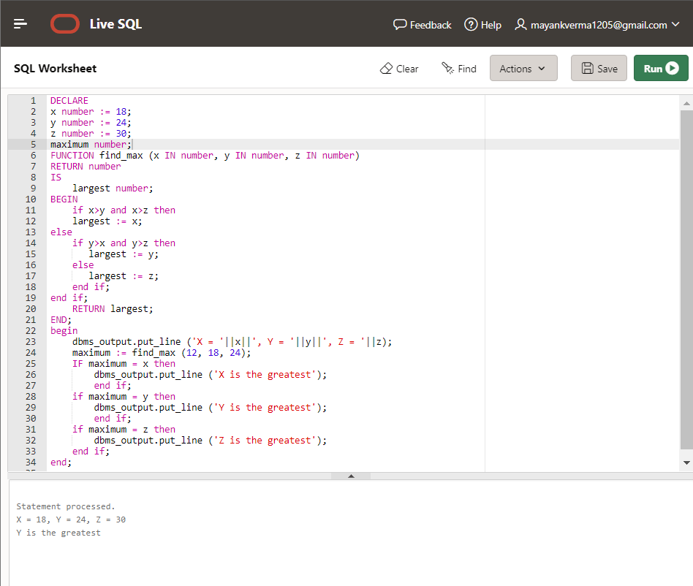

**2) Using PL/SQL Statements create a simple loop that display message “Welcome to PL/SQL Programming” 20 times.**

DECLARE

counter number: =1;

FUNCTION Print (count IN number)

RETURN number

IS

c number;

BEGIN

c: = 1;

WHILE c <= 20

LOOP

dbms_output.put_line (c || ' Welcome to PL/SQL Programming');

c: = c+1;

END LOOP;

RETURN c;

END;

BEGIN

counter: = Print(counter);

END;

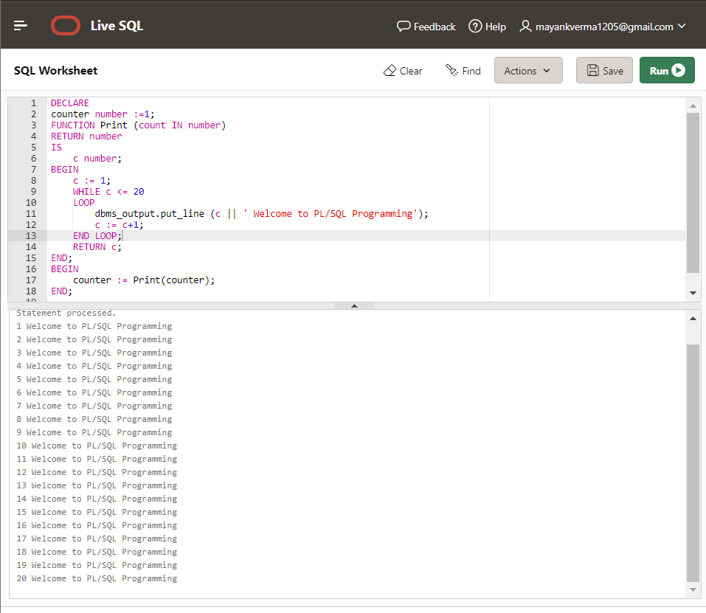

**3) Write a PL/SQL code block to find the factorial of a number.**

DECLARE

x number;

factorial_store number;

FUNCTION find_factorial (x number)

RETURN number

IS

fact number;

BEGIN

IF x = 0 THEN

fact: = 1;

ELSE

fact: = x * find_factorial(x-1);

END IF;

RETURN fact;

END;

BEGIN

x: = 10;

factorial_store: = find_factorial(x);

dbms_output.put_line (' Factorial of '|| x || ' is ' || factorial_store);

END;

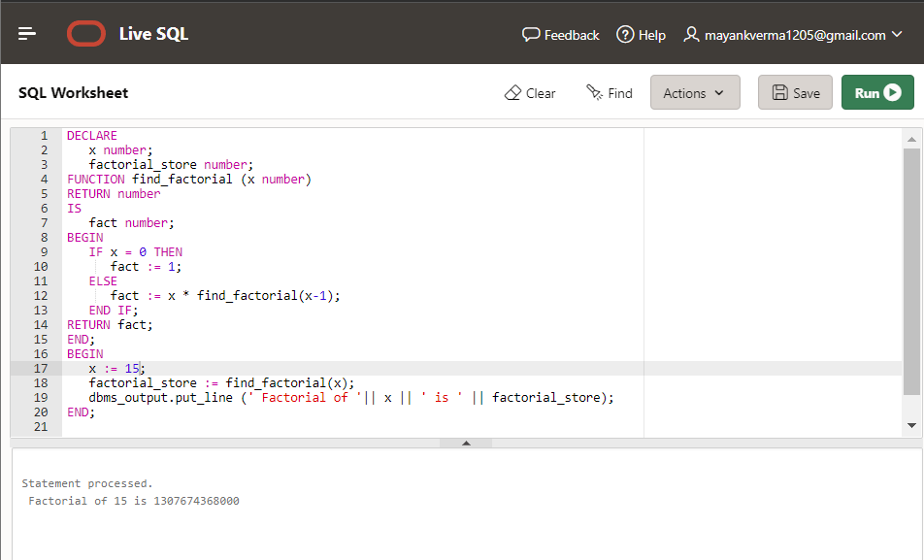

**4) Write a PL/SQL program to generate Fibonacci series**

DECLARE

x number: = 0;

y number: = 1;

z number: = 0;

initialize number: = 1;

n number: = 10;

temp_store number;

temp_return number: =0;

FUNCTION Fibonacci_Generator (first_term IN OUT number, second_term IN OUT number, add_counter IN OUT number, count_var IN OUT number, limithead IN OUT number)

RETURN number

IS

temp_return number;

BEGIN

while count_var <= limithead

loop

dbms_output.put_line (first_term || ' ');

add_counter: = second_term;

second_term: = first_term + second_term;

first_term: = add_counter;

count_var: = count_var+1;

END LOOP;

RETURN temp_return;

END;

BEGIN

temp_store: = Fibonacci_Generator (x, y, z, initialize, n);

END;

Output

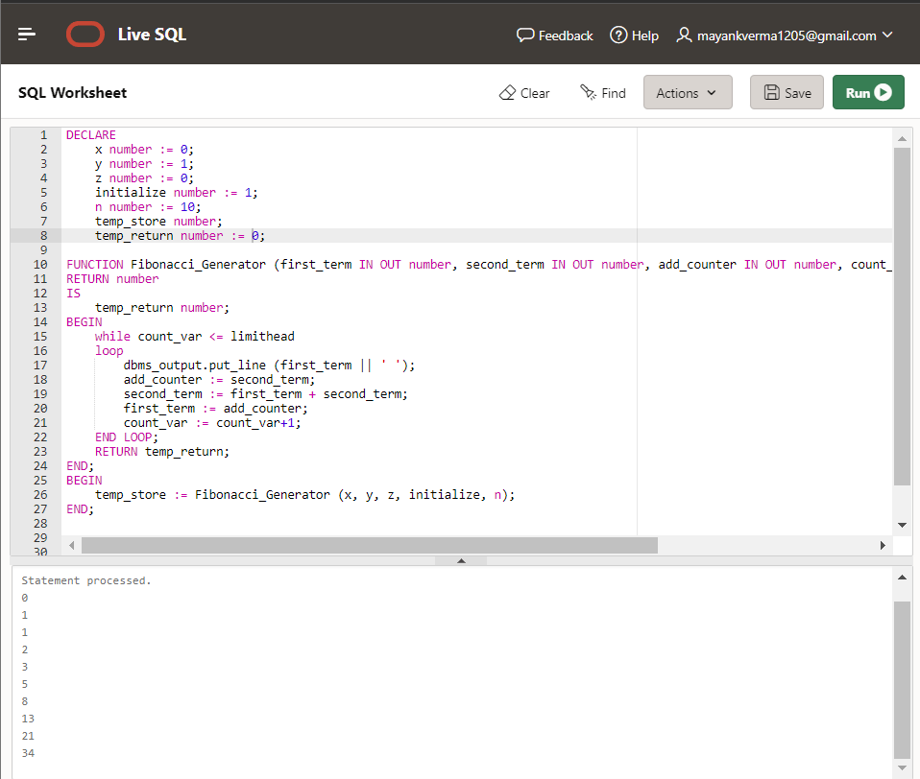

**5) Write a PL/SQL code to fund the sum of first N numbers**

DECLARE

x NUMBER;

n NUMBER;

i NUMBER;

FUNCTION find_sum (n IN NUMBER)

RETURN NUMBER

IS

summation NUMBER: = 0;

BEGIN

FOR i IN 1...n

LOOP

summation: = i*(i+1)/2;

END LOOP;

RETURN summation;

END;

BEGIN

n: = 10;

x: = find_sum(n);

dbms_output.put_line('Sum of first 10 numbers is: ' || x);

END;

