

# **ADBMS Lab**

**Submitted by: Submitted to:**

**NAME : Rahul Gusain Dr.Ankit Khare**

**SAP: 500084143**

**ROLL NO.: R214220900**

**BATCH: 1 DevOps**

**LAB 2**

**EXPERIMENT-2**

**Title: 2. To understand and apply the concept of Constraints.**

**Objective:** To understand the concept of data constraints that is enforced on data being stored in the table. Focus on Primary Key and the Foreign Key.

**1. Create the tables described below:**

**Table name: CLIENT_MASTER_1**

**Description:** used to store client information.

| **Column name** | **data type** | **Size** | **Constraints** |
| --- | --- | --- | --- |
| CLIENTNO | Varchar | 6 | Primary key / first letter must start with ‘C’ |
| NAME | Varchar | 20 | Not Null |
| ADDRESS 1 | Varchar | 30 |  |
| ADDRESS 2 | Varchar | 30 |  |
| CITY | Varchar | 15 |  |
| PINCODE | Integer | 8 |  |
| STATE | Varchar | 15 |  |
| BALDUE | Decimal | 10,2 |  |

**Table Name: PRODUCT_MASTER_1 Description:** used to store product information

| **Column name** | **data type** | **Size** | **Attributes** |
| --- | --- | --- | --- |
| PRODUCTNO | Varchar | 6 | Primary Key/ first letter must start with ‘P’ |
| DESCRIPTION | Varchar | 15 | Not Null |
| PROFITPERCENT | Decimal | 4,2 | Not Null |
| UNIT MEASURE | Varchar | 10 | Not Null |
| QTYONHAND | Integer | 8 | Not Null |
| REORDERL VL | Integer | 8 | Not Null |
| SELLPRICE | Decimal | 8,2 | Not Null |
| COSTPRICE | Decimal | 8,2 | Not Null |

**Table Name: SALESMAN_MASTER _1**

**Description:**  used to store salesman information working for the company.

| **Column name** | **data type** | **Size** | **Attributes** |
| --- | --- | --- | --- |
| SALESMANNO | Varchar | 6 | Primary Key/ first letter must start with ‘S’ |
| SALESMANNAME | Varchar | 20 | Not Null |
| ADDRESS 1 | Varchar | 30 | Not Null |
| ADDRESS 2 | Varchar | 30 |  |
| CITY | Varchar | 20 |  |
| PINCODE | Integer | 8 |  |
| STATE | Varchar | 20 |  |
| SALAMT | Real | 8,2 | Not Null , Cannot be 0 |
| TGTTOGET | Decimal | 6,2 | Not Null , Cannot be 0 |
| YTDSALES | Double | 6,2 | Not Null |
| REMARKS | Varchar | 60 |  |

**2. Reinsert the data in these two tables based upon Lab 1.**

INSERT INTO CLIENT_MASTER_1 VALUES ('C00001', 'Ivan bayross', NULL, NULL, 'Mumbai', 400054, 'Maharashtra', 15000);

INSERT INTO CLIENT_MASTER_1 VALUES ('C00002', 'Mamta muzumdar', NULL, NULL, 'Madras', 780001, 'Tamil nadu', 0);

INSERT INTO CLIENT_MASTER_1 VALUES ('C00003', 'Chhaya bankar', NULL, NULL, 'Mumbai', 400057, 'Maharashtra', 5000);

INSERT INTO CLIENT_MASTER_1 VALUES ('C00004', 'Ashwini joshi', NULL, NULL, 'Bangalore', 560001, 'Karnataka', 0);

INSERT INTO CLIENT_MASTER_1 VALUES ('C00005', 'Hansel colaco', NULL, NULL, 'Mumbai', 400060, 'Maharashtra', 2000);

INSERT INTO CLIENT_MASTER_1 VALUES ('C00006', 'Deepak sharma', NULL, NULL, 'Mangalore', 560050, 'Karnataka', 0);

INSERT INTO PRODUCT_MASTER_1 VALUES ('P00001', 'T-shirt', 5, 'Piece', 200, 50, 350, 250);

INSERT INTO PRODUCT_MASTER_1 VALUES ('P0345', 'Shirts', 6, 'Piece', 150, 50, 500, 350);

INSERT INTO PRODUCT_MASTER_1 VALUES ('P06734', 'Cotton jeans', 5, 'Piece', 100, 20, 600, 450);

INSERT INTO PRODUCT_MASTER_1 VALUES ('P07865', 'Jeans', 5, 'Piece', 100, 20, 750, 500);

INSERT INTO PRODUCT_MASTER_1 VALUES ('P07868', 'Trousers', 2, 'Piece', 150, 50, 850, 550);

INSERT INTO PRODUCT_MASTER_1 VALUES ('P07885', 'Pull Overs', 2.5, 'Piece', 80, 30, 700, 450);

INSERT INTO PRODUCT_MASTER_1 VALUES ('P07965', 'Denim jeans', 4, 'Piece', 100, 40, 350, 250);

INSERT INTO PRODUCT_MASTER_1 VALUES ('P07975', 'Lycra tops', 5, 'Piece', 70, 30, 300, 175);

INSERT INTO PRODUCT_MASTER_1 VALUES ('PO8865', 'Skirts', 5, 'Piece', 75, 30, 450, 300);

INSERT INTO SALESMAN_MASTER_1 VALUES ('S00001', 'Aman', 'A/14', 'Worli', 'Mumbai', 400002, 'Maharashtra', 0, 0, 0, NULL);

INSERT INTO SALESMAN_MASTER_1 VALUES ('S00002', 'Omkar', '65', 'Nariman', 'Mumbai', 400001, 'Maharastra', 0, 0, 0, NULL);

INSERT INTO SALESMAN_MASTER_1 VALUES ('S00003', 'Raj', 'P-7', 'Bandra', 'Mumbai', 400032, 'Maharashtra', 0, 0, 0, NULL);

INSERT INTO SALESMAN_MASTER_1 VALUES ('S00004', 'Ashish', 'A/5', 'Juhu', 'Mumbai', 400044, 'Maharashtra', 0, 0, 0, NULL);

**3. Display the contents of each table.**

SELECT * FROM CLIENT_MASTER_1;

SELECT * FROM PRODUCT_MASTER_1;

SELECT * FROM SALESMAN_MASTER_1;

**4. Create table AUTHOR = {Author_ID , Lastname, Firstname, Email, City, Country}**

Where:

Author_ID – text data type, 5 characters, primary key

Lastname – text data type, 15 characters, not null

Firstname – text data type, 15 characters, not null

Email – text data type, 40 characters,

City – text data type, 15 characters,

Country – text data type, 15 characters,

CREATE TABLE AUTHOR(

AUTHOR_ID VARCHAR(5) PRIMARY KEY NOT NULL,

LASTNAME VARCHAR(15) NOT NULL,

FIRSTNAME VARCHAR(15) NOT NULL,

EMAIL VARCHAR(50),

CITY VARCHAR(15),

COUNTRY VARCHAR(15)

);

**5. Create Table BOOK={ Book_ID, Book_Title, Copies)**

Where :

Book_ID – text data type, 5 characters Primary Key Start With Character **B**

Book_Title - Text data Type Not Null

Copies- No.of copies Data Type int always greater the 2

CREATE TABLE BOOK(

BOOK_ID VARCHAR(5) PRIMARY KEY CHECK(BOOK_ID LIKE '%B'),

BOOKTITLE VARCHAR(40) NOT NULL,

COPIES INTEGER CHECK(COPIES>2) NOT NULL

);

**6. Create table AUTHOR_LIST = {Author_ID , Book_ID , Role}**

Where:

Author_ID – text data type, 5 characters, referenced by Author_ID from AUTHOR

table

Book_ID – text data type, 5 characters

Role – text data type, 15 characters

and primary key is: Author_ID, Book_ID

CREATE TABLE AUTHOR_LIST(

AUTHOR_ID VARCHAR(5),

BOOK_ID VARCHAR(5),

ROLE VARCHAR(15),

PRIMARY KEY(AUTHOR_ID, BOOK_ID)

);

**7. Add four records in each tables AUTHOR, BOOK, BOOK_LIST.**

INSERT INTO AUTHOR VALUES ('A1001', 'GUSAIN', 'RAHUL', '500084143@stu.upes.ac.in', 'DEHRADUN', 'INDIA');

INSERT INTO AUTHOR VALUES ('A1002', 'KUMAR', 'ROHIT', '500082652@stu.upes.ac.in', 'DEHRADUN', 'INDIA');

INSERT INTO AUTHOR VALUES ('A1003', 'DUTTA', 'ANANYA', '500083514@stu.upes.ac.in', 'DEHRADUN', 'INDIA');

INSERT INTO AUTHOR VALUES ('A1004', 'BALODHI', 'VAISHNAV', '500082607@stu.upes.ac.in', 'DEHRADUN', 'INDIA');

INSERT INTO BOOK VALUES ('101B', 'PHILOSOPHY', 16);

INSERT INTO BOOK VALUES ('102B', 'PSYCHOLOGY', 25);

INSERT INTO BOOK VALUES ('103B', 'CSA', 18);

INSERT INTO BOOK VALUES ('104B', 'DSA', 19);

INSERT INTO AUTHOR_LIST VALUES ('A1001', '101B', 'WRITER');

INSERT INTO AUTHOR_LIST VALUES ('A1002', '102B', 'WRITER');

INSERT INTO AUTHOR_LIST VALUES ('A1003', '103B', 'WRITER');

INSERT INTO AUTHOR_LIST VALUES ('A1004', '104B', 'WRITER');

SELECT * FROM AUTHOR;

SELECT * FROM BOOK;

SELECT * FROM AUTHOR_LIST;

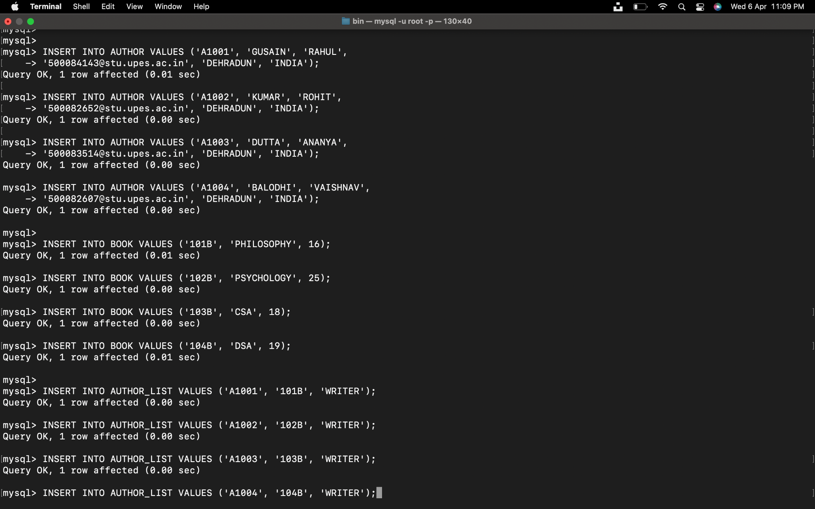

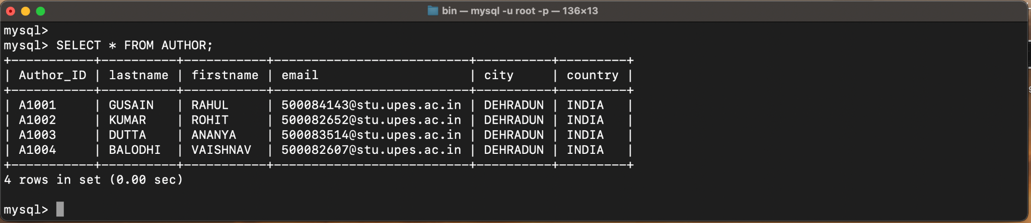

**8. Alter structure of table AUTHOR_LIST add the field Publisher data type of 30 Character.**

ALTER TABLE AUTHOR_LIST ADD PUBLISHER VARCHAR(30);

SELECT * FROM AUTHOR_LIST;

