# 

# 

# **ADBMS Lab**

**Submitted by: Submitted to:**

**NAME : Rahul Gusain Dr.Ankit Khare**

**SAP: 500084143**

**ROLL NO.: R214220900**

**BATCH: 1 DevOps**

**LAB 3**

**Experiment-3**

**Title: 3. To understand and use SQL Sub-Query**

**Objective:** To understand the use of sql subquery.

**1. Create the following table.**

Supplier-(scode,sname,scity,turnover)

Part-(pcode,weigh,color,cost,sellingprice)

Supplier_Part-(scode,pcode,qty)

CREATE TABLE SUPPLIER(SCODE VARCHAR(6) PRIMARY KEY, SNAME VARCHAR(20) ,SCITY VARCHAR(30),TURNOVER INT);

CREATE TABLE PART(PCODE VARCHAR(6) PRIMARY KEY, WEIGH INT , COLOR VARCHAR(30),COST INT,SELLINGPRICE INT);

CREATE TABLE SUPPLIER_PART(SCODE VARCHAR(6) , PCODE VARCHAR(6) , QTY INT, PRIMARY KEY(SCODE,PCODE), FOREIGN KEY (SCODE) REFERENCES SUPPLIER (SCODE), FOREIGN KEY (PCODE) REFERENCES PART (PCODE));

DESCRIBE TABLE SUPPLIER;

DESCRIBE TABLE PART;

DESCRIBE SUPPLIER_PART;

**2. Populate the table**

INSERT INTO SUPPLIER VALUES ('S00001', 'Rahul','Dehradun',500000);

INSERT INTO SUPPLIER VALUES ('S00002', 'Abhipriya','Bhagalpur', 550000);

INSERT INTO SUPPLIER VALUES ('S00003', 'Ananya','Mangalore',400000);

INSERT INTO SUPPLIER VALUES ('S00004', 'Bhoomi','Lalitpur',NULL);

INSERT INTO SUPPLIER VALUES ('S00005', 'Disha','Bombay',350000);

INSERT INTO PART VALUES ('P00001', 70 ,'BLACK',10,20);

INSERT INTO PART VALUES ('P00002', 22,'TURQUOISE',30,60);

INSERT INTO PART VALUES ('P00003', 24,'WHITE',12,40);

INSERT INTO PART VALUES ('P00004', 14,'PINK',20,30);

INSERT INTO PART VALUES ('P00005', 34,'RED',40,80);

INSERT INTO SUPPLIER_PART VALUES ('S00001', 'P00001', 100 );

INSERT INTO SUPPLIER_PART VALUES ('S00002', 'P00002', 50);

INSERT INTO SUPPLIER_PART VALUES ('S00003', 'P00003', 40 );

INSERT INTO SUPPLIER_PART VALUES ('S00004', 'P00004', 68);

INSERT INTO SUPPLIER_PART VALUES ('S00005', 'P00005', 50);

SELECT * FROM SUPPLIER;

SELECT * FROM PART;

SELECT * FROM SUPPLIER_PART;

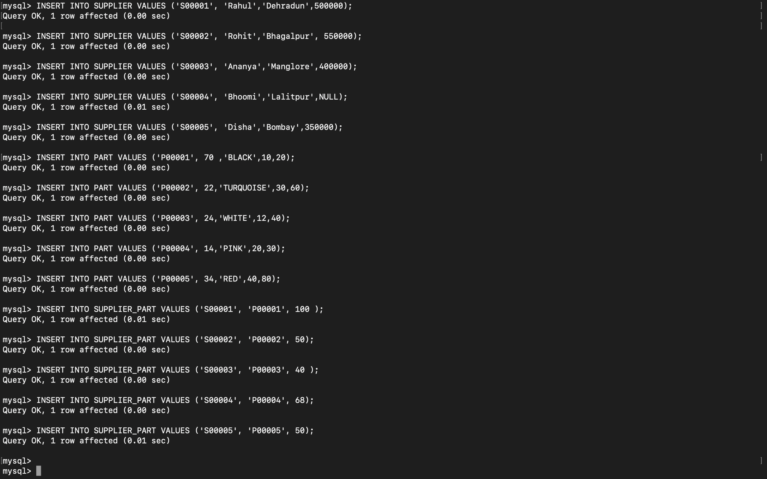

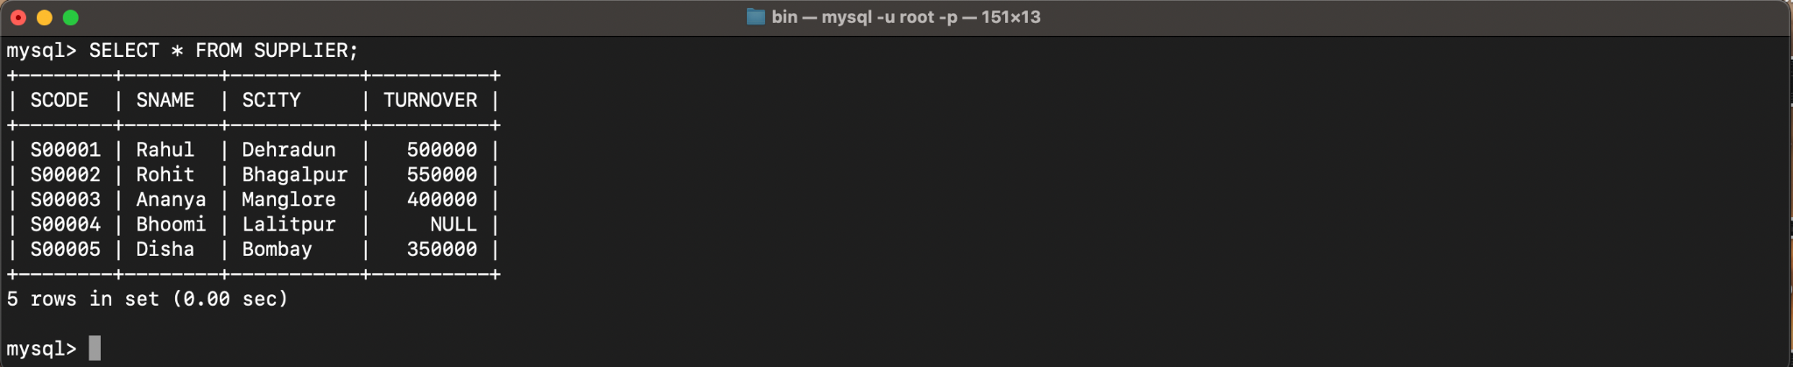

**3. Write appropriate SQL Statement for the following:**

1. Get the supplier number and part number in ascending order of supplier number.

SELECT SCODE, PCODE FROM SUPPLIER_PART ORDER BY SCODE ASC;

2. Get the details of supplier who operate from Bombay with turnover 50.

SELECT * FROM SUPPLIER WHERE SCITY='Bombay' AND TURNOVER>50;

3. Get the total number of supplier.

SELECT COUNT(SCODE) FROM SUPPLIER;

4. Get the part number weighing between 25 and 35.

SELECT PCODE, WEIGH FROM PART WHERE WEIGH BETWEEN 25 AND 35;

5. Get the supplier number whose turnover is null.

SELECT SCODE FROM SUPPLIER WHERE TURNOVER IS NULL;

6. Get the part number that cost 20, 30 or 40 rupees.

SELECT PCODE, SELLINGPRICE FROM PART WHERE SELLINGPRICE IN (20,30,40);

7. Get the total quantity of part 2 that is supplied.

SELECT SUM(SUPPLIER_PART.QTY) FROM SUPPLIER_PART WHERE SUPPLIER_PART.PCODE='P00002';

8. Get the name of supplier who supply part 2.

SELECT SNAME FROM SUPPLIER WHERE SCODE =(SELECT SCODE FROM SUPPLIER_PART WHERE PCODE='P00002');

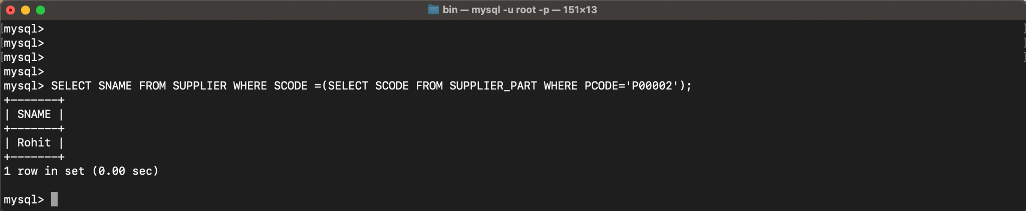

9. Get the part number whose cost is greater than the average cost.

SELECT PCODE FROM PART WHERE COST>(SELECT AVG (COST) FROM PART);

10. Get the supplier number and turnover in descending order of turnover.

SELECT SCODE, TURNOVER FROM SUPPLIER ORDER BY TURNOVER DESC;

