# 

# 

# **ADBMS Lab**

**Submitted by: Submitted to:**

**NAME : Rahul Gusain Dr.Ankit Khare**

**SAP: 500084143**

**ROLL NO.: R214220900**

**BATCH: 1 DevOps**

**LAB 4**

**EXPERIMENT-4**

**Title: 4. Use of Inbuilt functions and relational algebra operation**

**Objective:** To understand the use of inbuilt function and relational algebra with sql query.

1. **Create the following two tables (EMP and DEPT)**

**EMP TABLE**

EMPNO ENAME JOB MGR HIREDATE SAL COMM DEPTNO

---------- ---------- --------- ---------- --------- ---------- ---------- ----------

7369 SMITH CLERK 7902 17-DEC-80 500 800 20

7499 ALLEN SALESMAN 7698 20-FEB-81 1600 300 30

7521 WARD SALESMAN 7698 22-FEB-81 1250 500 30

7566 JONES MANAGER 7839 02-APR-81 2975 20

7654 MARTIN SALESMAN 7698 28-SEP-81 1250 1400 30

7698 BLAKE MANAGER 7839 01-MAY-81 2850 30

7782 CLARK MANAGER 7839 09-JUN-81 2450 10

7788 SCOTT ANALYST 7566 09-DEC-82 3000 20

7839 KING PRESIDENT 17-NOV-81 5000 10

7844 TURNER SALESMAN 7698 08-SEP-81 1500 0 30

7876 ADAMS CLERK 7788 12-JAN-83 1100 20

7900 JAMES CLERK 7698 03-DEC-81 950 30

7902 FORD ANALYST 7566 03-DEC-81 3000 20

7934 MILLER CLERK 7782 23-JAN-82 1300 10

**DEPT TABLE**

DEPTNO DNAME LOC

---------- -------------- -------------

10 ACCOUNTING NEW YORK

20 RESEARCH DALLAS

30 SALES CHICAGO

40 OPERATIONS BOSTON

Write the Nested Queries for the following queries

1. List the details of the emps whose Salaries more than the employee BLAKE.

SELECT * FROM EMP WHERE SAL>(SELECT SAL FROM EMP WHERE ENAME = 'BLAKE');

1. List the emps whose Jobs are same as ALLEN.

SELECT * FROM EMP WHERE JOB = (SELECT JOB FROM EMP WHERE ENAME = 'ALLEN');

1. List the Emps whose Sal is same as FORD or SMITH in desc order of Names.

SELECT * FROM EMP WHERE SAL IN (SELECT SAL FROM EMP WHERE ENAME = 'FORD' OR ENAME = 'SMITH') ORDER BY ENAME DESC;

1. List the emps Whose Jobs are same as MILLER or Sal is more than ALLEN.

SELECT * FROM EMP WHERE JOB = (SELECT JOB FROM EMP WHERE ENAME = 'MILLER') OR SAL > (SELECT SAL FROM EMP WHERE ENAME = 'ALLEN');

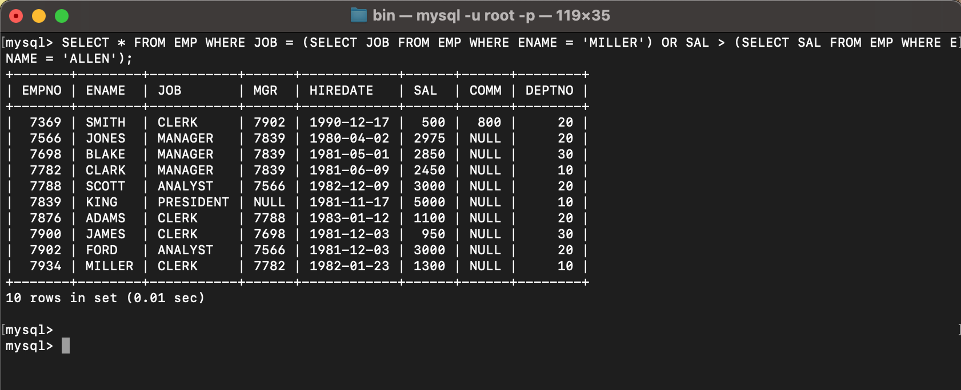

1. Find the highest paid employee of sales department.

SELECT ENAME FROM EMP WHERE SAL = (SELECT MAX(SAL) FROM EMP WHERE DEPTNO = (SELECT DEPTNO FROM DEPT WHERE DNAME = 'SALES'));

1. List the employees who are senior to most recently hired employee working under king.

SELECT ENAME FROM EMP WHERE HIREDATE < (SELECT MAX(HIREDATE) FROM EMP WHERE MGR IN (SELECT EMPNO FROM EMP WHERE ENAME = 'KING'));

1. List the names of the emps who are getting the highest sal dept wise.

SELECT ENAME, DEPTNO FROM EMP WHERE SAL IN (SELECT MAX(SAL) FROM EMP GROUP BY DEPTNO);

1. List the emps whose sal is equal to the average of max and minimum

SELECT ENAME FROM EMP WHERE SAL = (SELECT (MAX(SAL) + MIN(SAL))/2 FROM EMP);

1. List the emps who joined in the company on the same date.

SELECT ENAME FROM EMP E WHERE HIREDATE IN (SELECT HIREDATE FROM EMP WHERE E.EMPNO <> EMPNO);

1. Find out the emps who joined in the company before their Managers.

SELECT ENAME FROM EMP E WHERE HIREDATE < (SELECT HIREDATE FROM EMP WHERE EMPNO = E.MGR);

