

# **ADBMS Lab**

**Submitted by: Submitted to:**

**NAME : Rahul Gusain Dr.Ankit Khare**

**SAP: 500084143**

**ROLL NO.: R214220900**

**BATCH: 1 DevOps**

**LAB 7**

**EXPERIMENT-7**

**Title: 7. To understand the concepts of Index.   
Objective:** Students will be able to implement the concept of index.

**1. Execute the following index related queries:**

1) Create an index of name employee_idx on EMPLOYEES with column Last_Name, Department_id

CREATE INDEX EMPLOYEE_IDX ON EMPLOYEES (LAST_NAME, DEPARTMENT_ID);

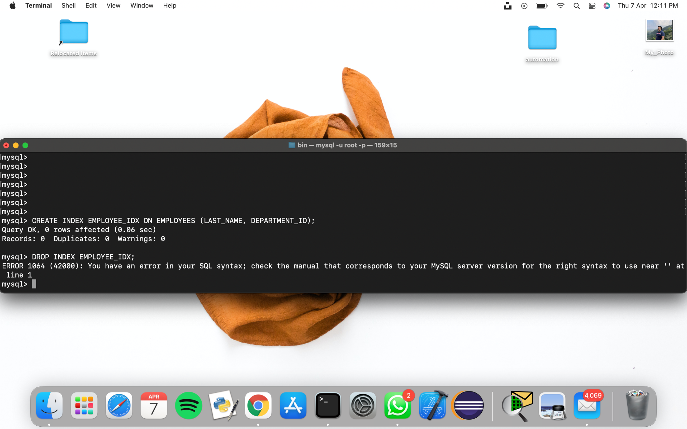

**2) Find the ROWID for the above table and create a unique index on employee_id column of the EMPLOYEES.**

SELECT ROW_NUMBER() OVER(ORDER BY DEPARTMENT_ID) AS ID, EMPLOYEE_ID, FIRST_NAME, LAST_NAME, DEPARTMENT_ID FROM EMPLOYEES;

CREATE UNIQUE INDEX EMPLOYEE_UNI_IDX ON EMPLOYEES (EMPLOYEE_ID);

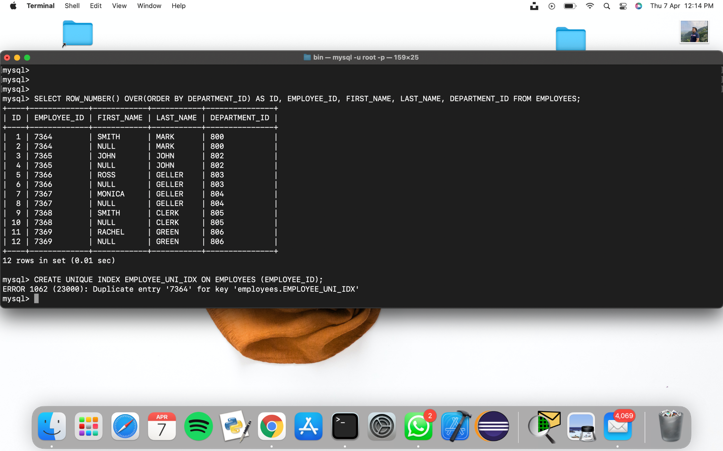

**3) Create a reverse index on employee_id column of the EMPLOYEES.**

CREATE INDEX EMP_REVERSE ON EMPLOYEES (EMPLOYEE_ID) REVERSE;

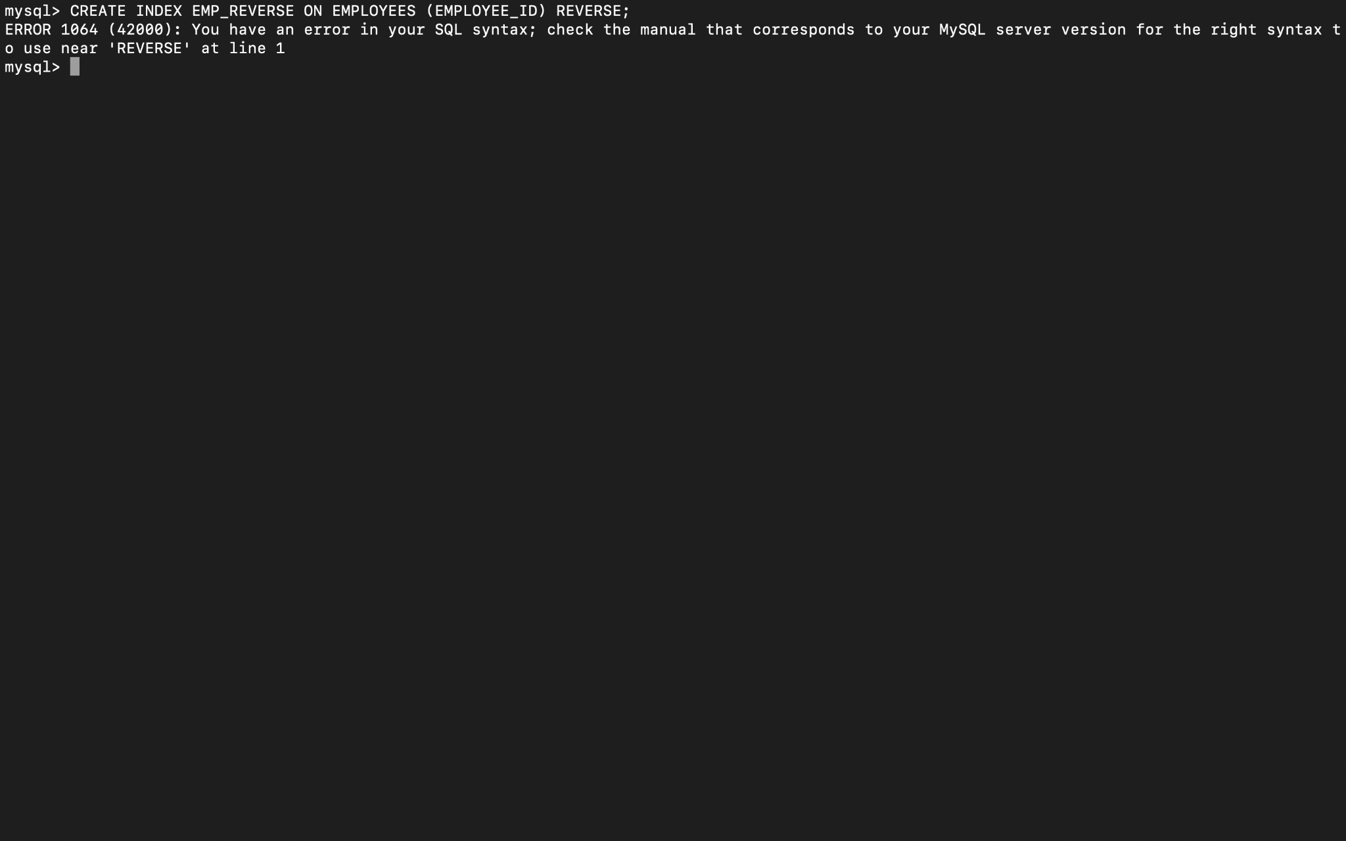

**4) Create a unique and composite index on employee_id and check whether there is duplicity of tuples or not.**

CREATE UNIQUE INDEX EMPLOYEE_UNI_COMP ON EMPLOYEES (EMPLOYEE_ID, DEPARTMENT_ID);

SELECT * FROM EMPLOYEES WHERE EMPLOYEE_ID = 'E1' AND DEPARTMENT_ID = 'DP4';



**5) Create Function-based indexes defined on the SQL functions UPPER(column_name) or LOWER(column_name) to facilitate case-insensitive searches(on column Last_Name).**

CREATE INDEX LAST_NAME_IDX ON EMPLOYEES (UPPER(LAST_NAME));

CREATE INDEX LAST_NAME_IDX2 ON EMPLOYEES (lower(LAST_NAME));



**6) Drop the function based index on column Last_Name.**

DROP INDEX LAST_NAME_IDX;

DROP INDEX LAST_NAME_IDX2;

