

# **ADBMS Lab**

**Submitted by: Submitted to:**

**NAME : Rahul Gusain Dr.Ankit Khare**

**SAP: 500084143**

**ROLL NO.: R214220900**

**BATCH: 1 DevOps**

**LAB 8**

**EXPERIMENT-8**

**Title: 8. To understand the concepts of Sequence.**

**Objective:** Students will be able to implement the concept of sequence.

1) Create a sequence by name EMPID_SEQ starting with value 100 with an interval of 1.

**CREATE SEQUENCE EMPID_SEQ**

**START WITH 100**

**INCREMENT BY 1**

**MINVALUE 100**

**MAXVALUE 200**

**CYCLE;**

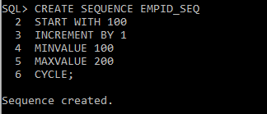

2) Write a SQL command for finding the current and the next status of EMPID_SEQ.

**SELECT EMPID_SEQ.NEXTVAL FROM EMP;**

**SELECT EMPID_SEQ.CURRVAL FROM EMP;**

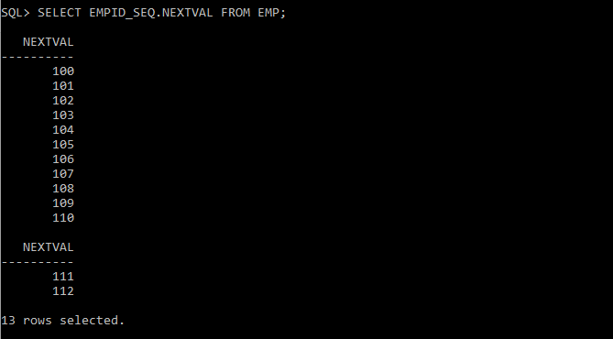

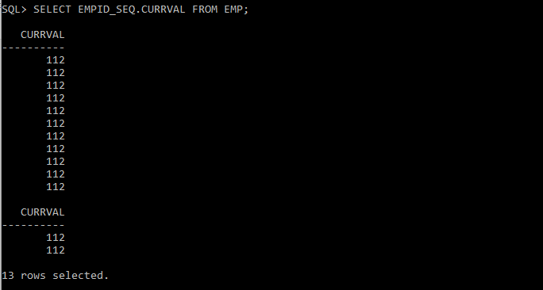

3) Change the Cache value of the sequence EMPID_SEQ to 20 and maxvalue to 1000.

**ALTER SEQUENCE EMPID_SEQ**

**MAXVALUE 1000**

**CACHE 20;**

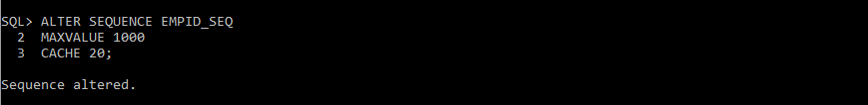

4) Insert values in employees table using sequences for employee_id column.

**INSERT INTO EMP VALUES (EMPID_SEQ.NEXTVAL, 'DEVASHISH', 'BOSS', '8000', '16-NOV-99', '6000', '4000', '10');**

**SELECT * FROM EMP;**

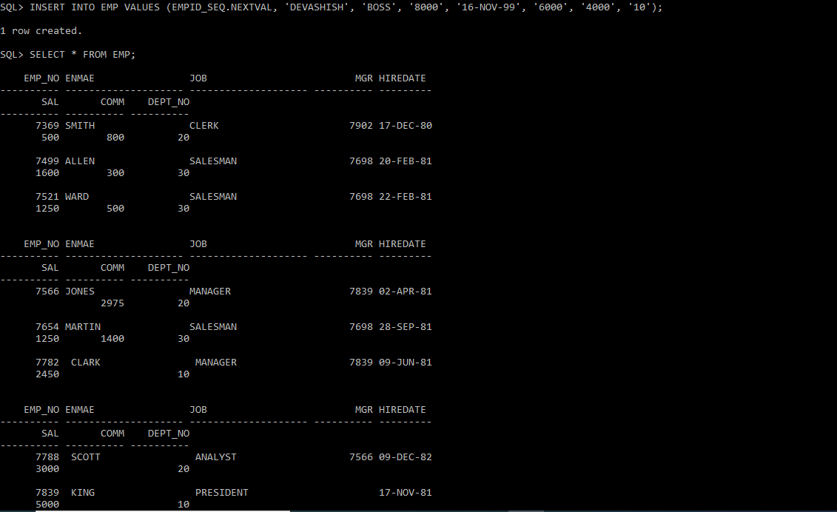

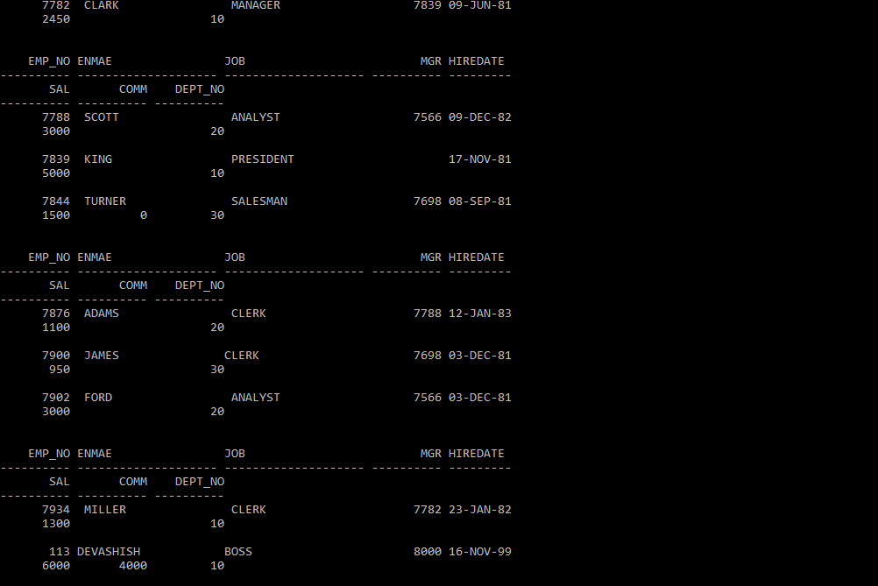

5) Drop sequence EMPID_SEQ.

**DROP SEQUENCE EMPID_SEQ;**

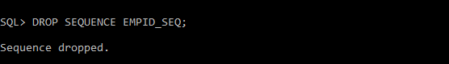

6) Create a sequence called REVERSE to generate numbers in the descending order from 10000 to 1000 with a decrement of 5.

**CREATE SEQUENCE REVERSE**

**START WITH 10000**

**INCREMENT BY -5**

**MINVALUE 1000**

**MAXVALUE 10000**

**CYCLE**

**CACHE 3;**

