

# **ADBMS Lab**

**Submitted by: Submitted to:**

**NAME : Rahul Gusain Dr.Ankit Khare**

**SAP: 500084143**

**ROLL NO.: R214220900**

**BATCH: 1 DevOps**

**LAB 9**

**EXPERIMENT-9**

**Title: To understand the concepts of PL/SQL programming.**

**Objective: Students will be able to implement the basic concepts of Pl/SQL.**

1. **Write a PL/SQL code to accept the value of A, B & C display which is greater.**

DECLARE

a NUMBER := 40;

b NUMBER := 60;

c NUMBER := 80;

BEGIN

IF a > b

AND a > c THEN

dbms_output.Put_line('Greatest number is '||a);

ELSIF b > a

AND b > c THEN

dbms_output.Put_line('Greatest number is '||b);

ELSE

dbms_output.Put_line('Greatest number is '||c);

END IF;

END;

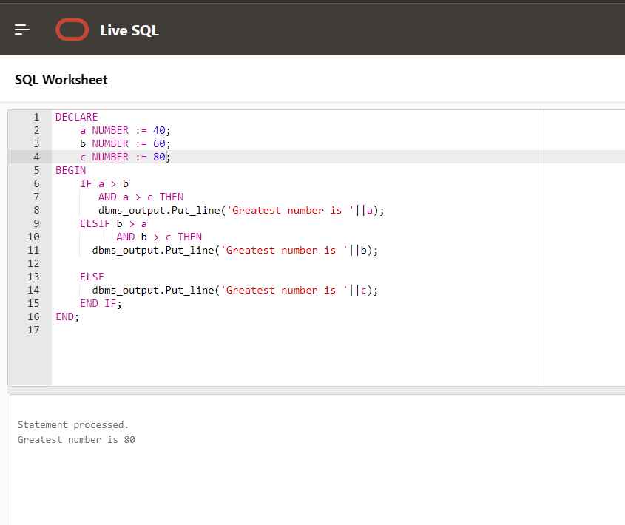

1. **Using PL/SQL Statements create a simple loop that display message “Welcome to PL/SQL Programming” 20 times.**

Code

Declare

a number := 20;

begin

for a in 1 .. 20 loop

dbms_output.put_line('Welcome to PL/SQL Programming');

end loop ;

END;

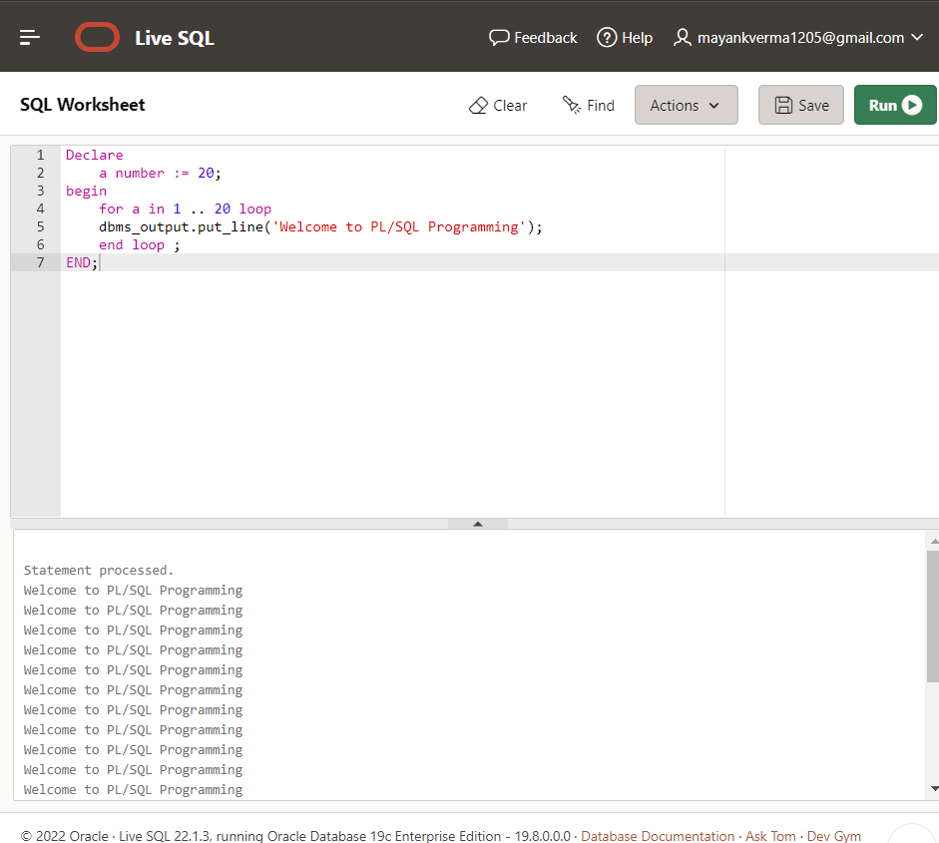

1. **Write a PL/SQL code block to find the factorial of a number.**

Declare

a number := 20;

b number := 10;

begin

for i in 1..a loop

b := b*1;

end loop;

dbms_output.put_line('Fctorial of a is' ||b );

END;

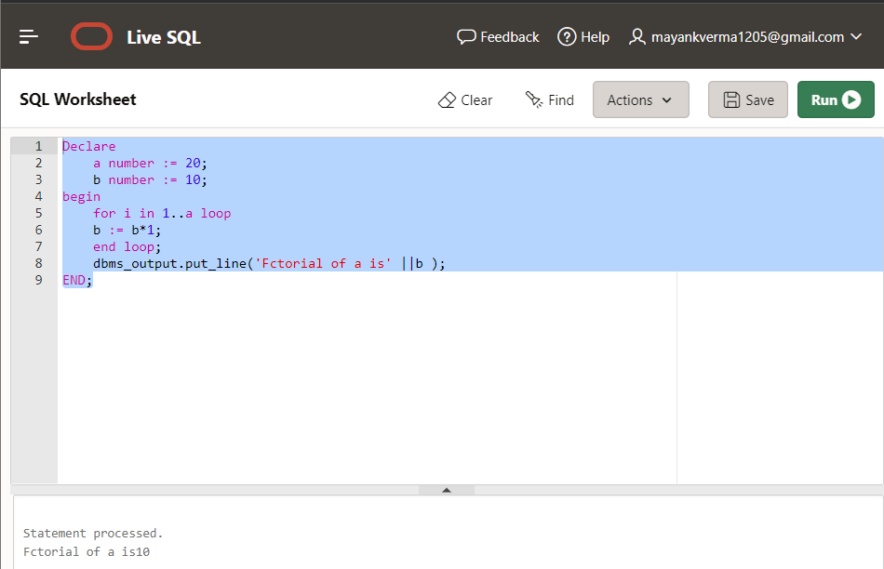

1. **Write a PL/SQL program to generate Fibonacci series.**

Declare

n number := 20;

f0 number := 0;

f1 number :=10;

fib number;

BEGIN

dbms_output.put_line('the Fibonacci series is' );

for i in 1..n loop

fib := f0 + f1;

f0 := f1 ;

f1 := fib;

dbms_output.put_line( fib );

end loop;

END;

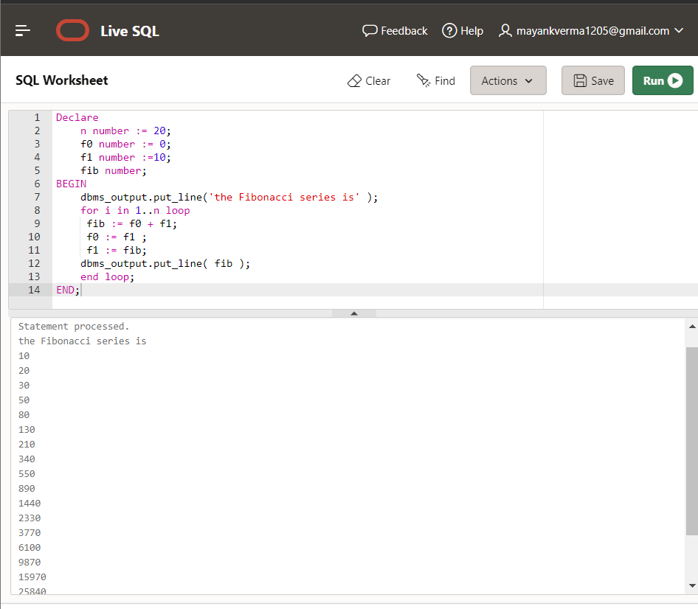

1. **Write a PL/SQL code to fund the sum of first N number**

Declare

a number := 200;

b number := 0;

BEGIN

for i in 1..a loop

b := b+i ;

end loop ;

dbms_output.put_line( 'The sum of first N number is' || b );

END;

