**Submitted by: Submitted to:**

**NAME: Rahul Gusain Dr. Hitesh Kumar Sharma**

**SAP: 500084143**

**ROLL NO.: R214220900**

**BATCH: 1 DevOps**

# Build and Release Management

**LAB EXERCISE 5**

**Aim:** Static Code Analysis Using SonarQube

**Step 1:** Create a new maven project named “**Lab-5”.**

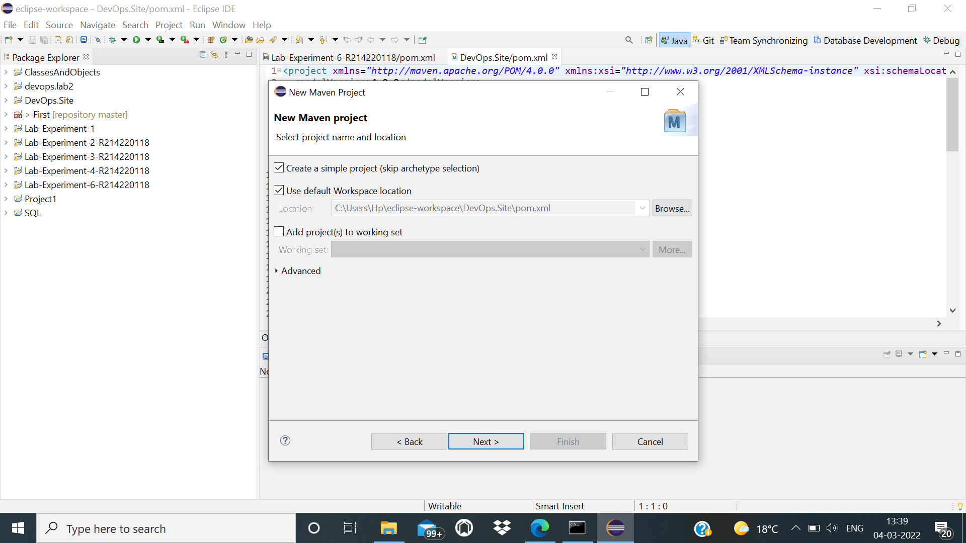

**Step 2:** Create a new package in the maven project named as “**pkg1”.**

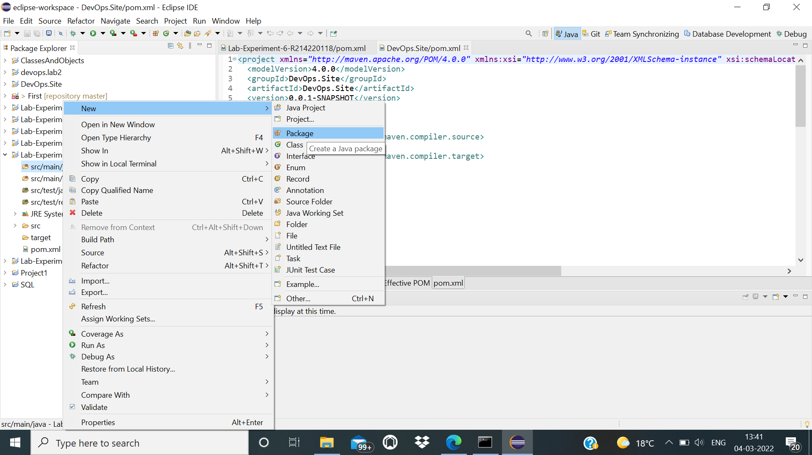

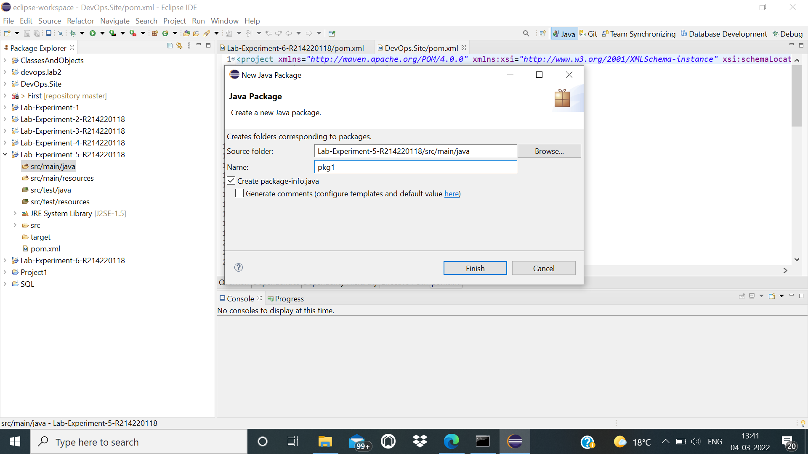

**Step 3:** Create a new class in the same package of the project named as “**MyClass1”.**

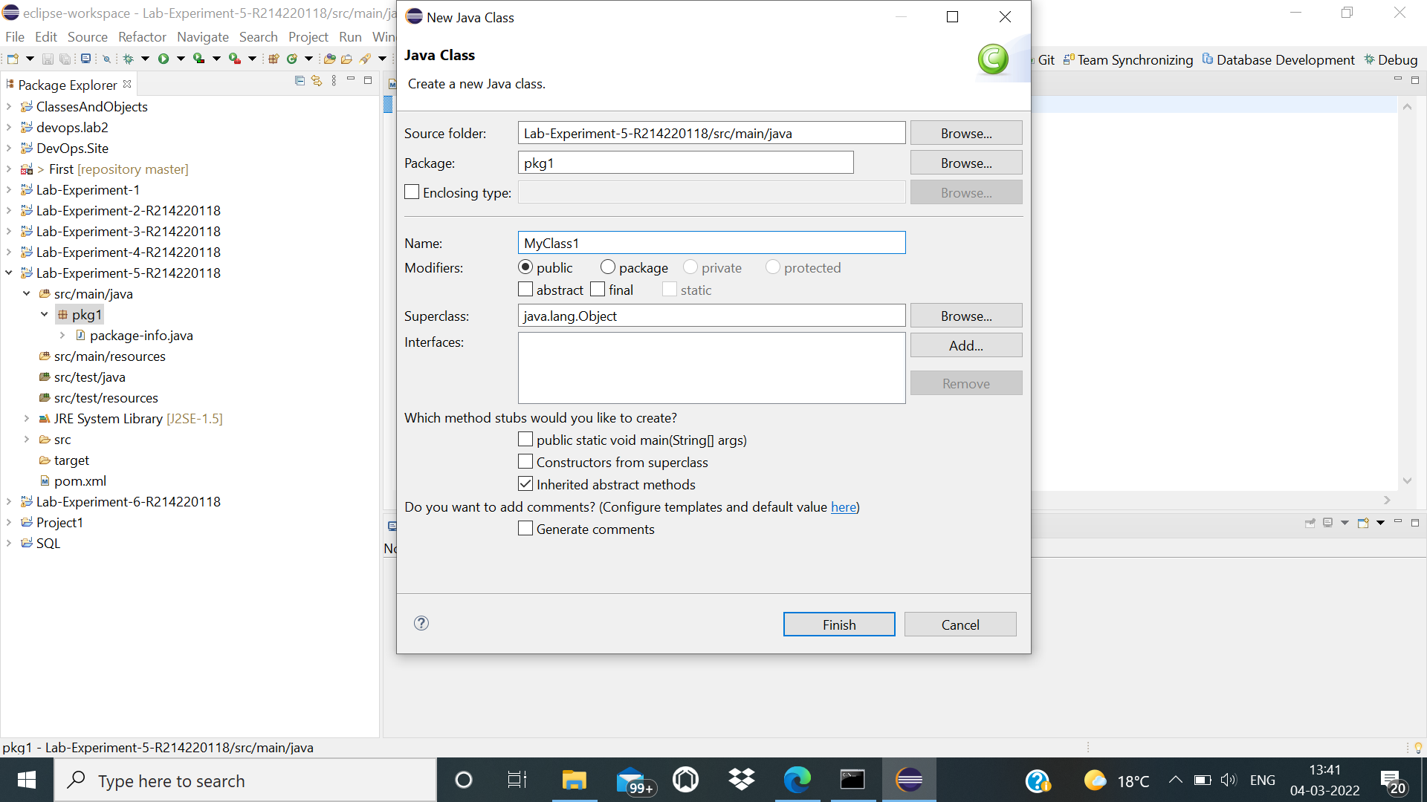

**Step 4:** Write the code for which we want to perform the static code analysis.

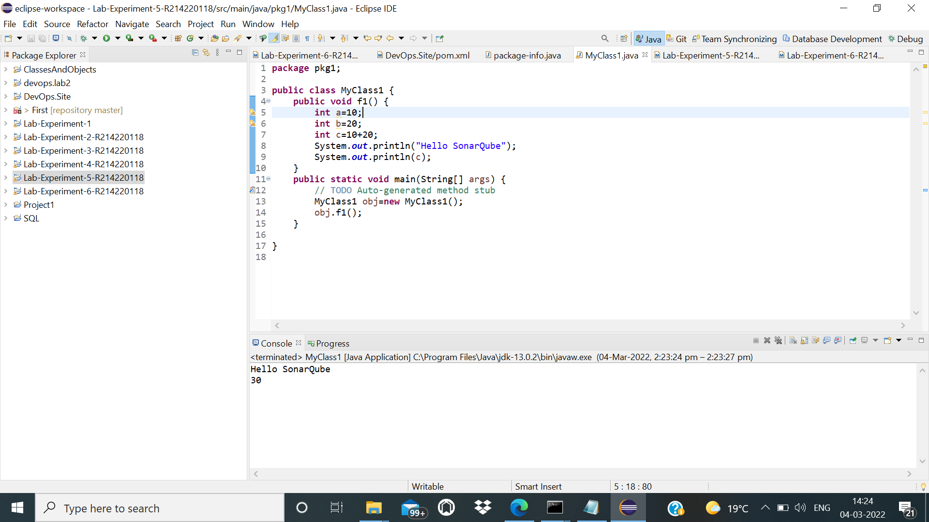

**Step 5:** Open the CLI available and then go to the folder where the sonarqube application is installed and then use the StartSonar.bat file to run Sonarqube .

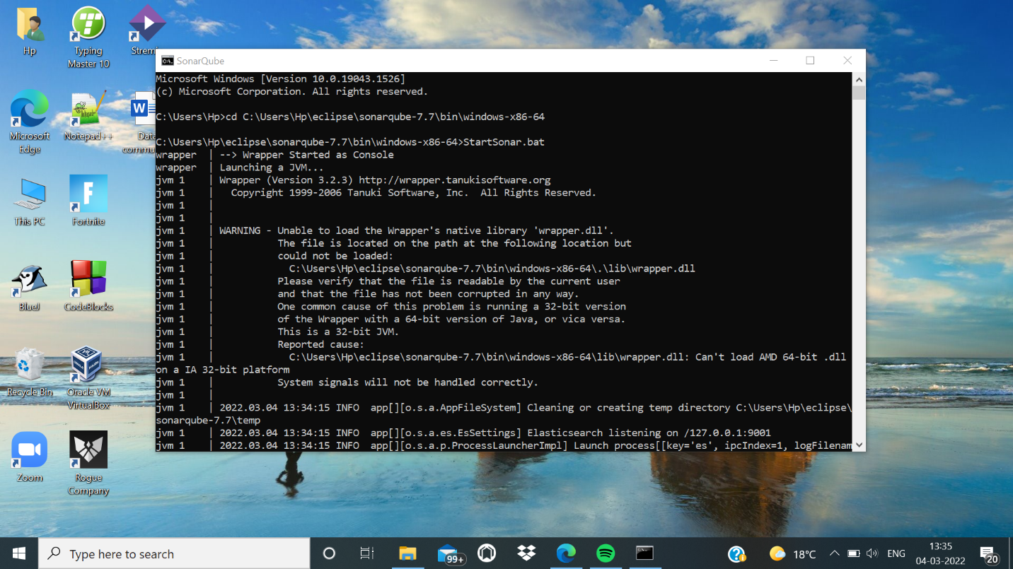

**Step 6:** After running the file run all the goals in the maven project and then open in the target folder and then run it .

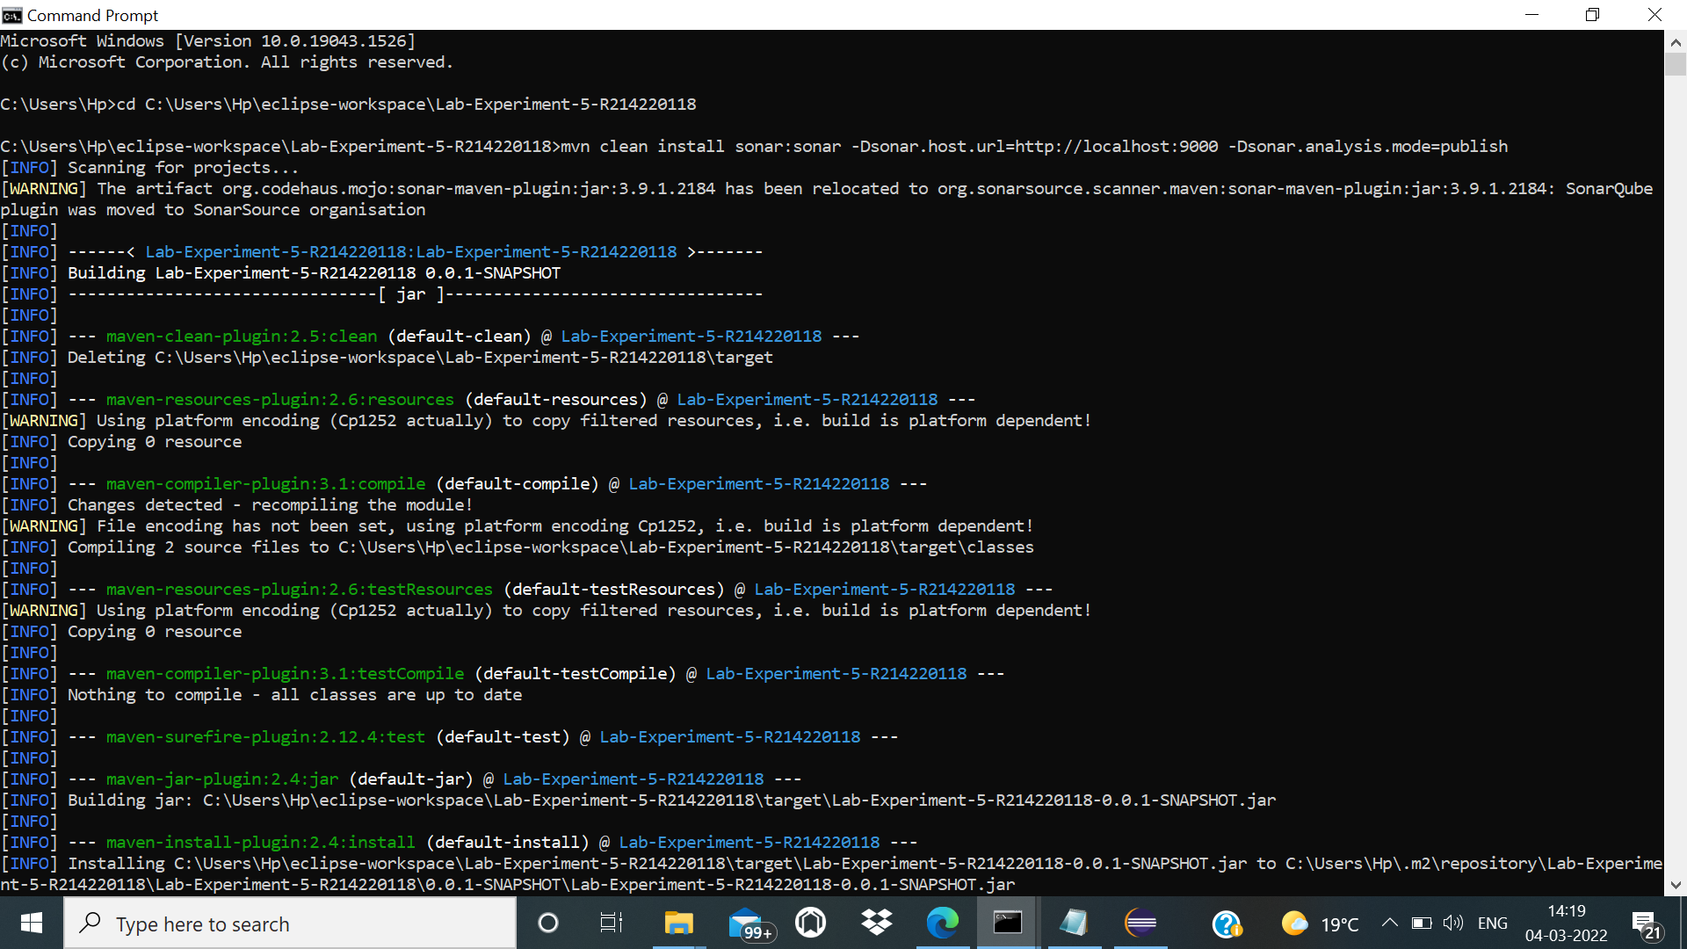

**Step 7:** Lastly go to any search engine and then search for localhost:9000 which is the default port to run Sonarqube , we can see that a file named my our project is created , we have successfully done the source code analysis with the help of Sonarqube

