

**Submitted by:** **Submitted to:**

**NAME: Rahul Gusain Omkarendra Tiwari**

**SAP: 500084143**

**ROLL NO.: R214220900**

**BATCH: 1 DevOps**

# **CI-CD Lab**

**JAVA PARSER**

Create a java project and add the java parser library to it.

Step1: create java project:

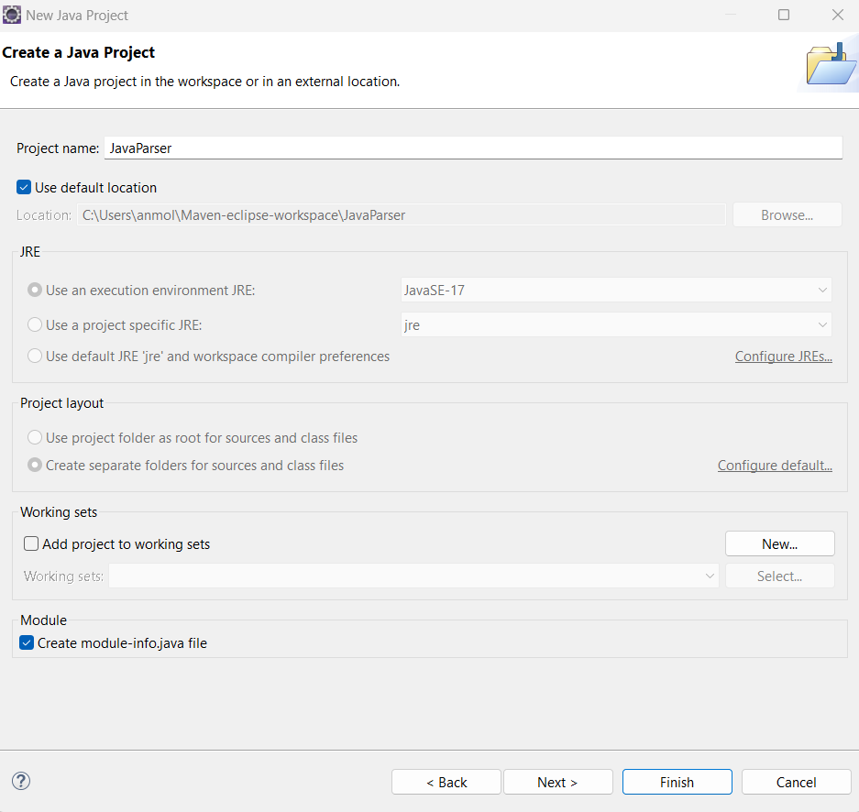

Step2: go to the directory where project is saved.

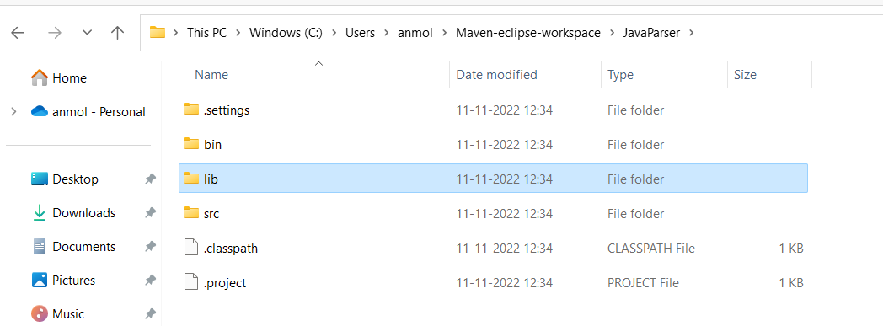

Step3: Create a lib folder and paste the java parser.jar file in it.

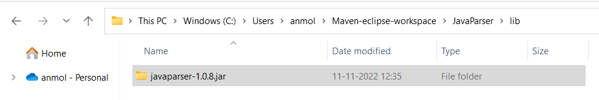

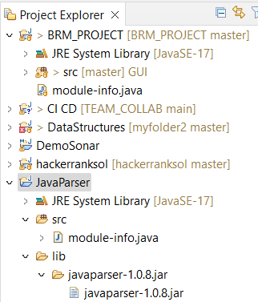

Step4: Now right click on lib folder and click on configure path, select Modulepath and click on Add JARS and apply it.

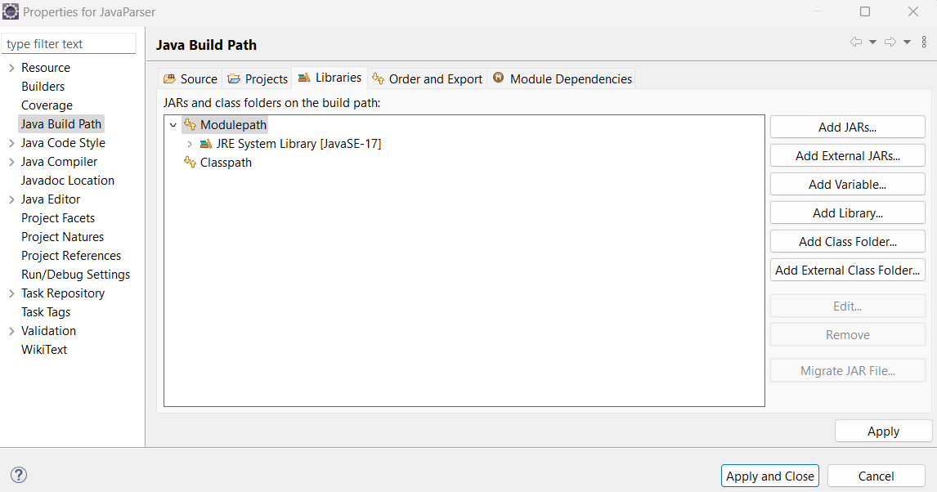

Srep5:Refresh the project and we have done with it.

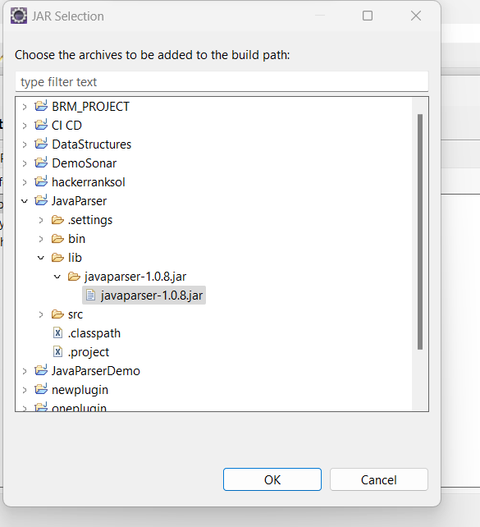

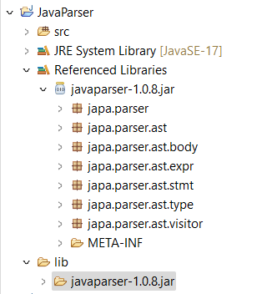

* Write a method to mine a directory and print class name for each java file.

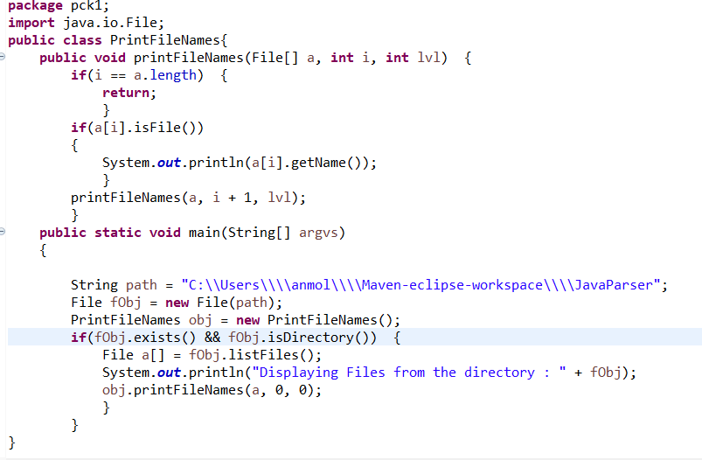

**output**

