

**Submitted by:** **Submitted to:**

**NAME: Rahul Gusain Omkarendra Tiwari ROLL NO.: R214220900**  
**BATCH: 1 DevOps**

# **CI - CD Lab**

**Pipeline Using Jenkins**

**Step 1: create a pipeline project**

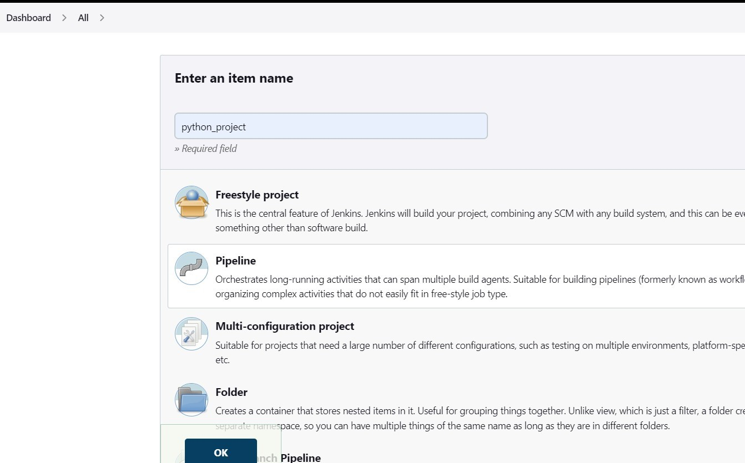

**Step 2: Add python code in the git repo then give its URL, credentials to connect with Jenkins .**

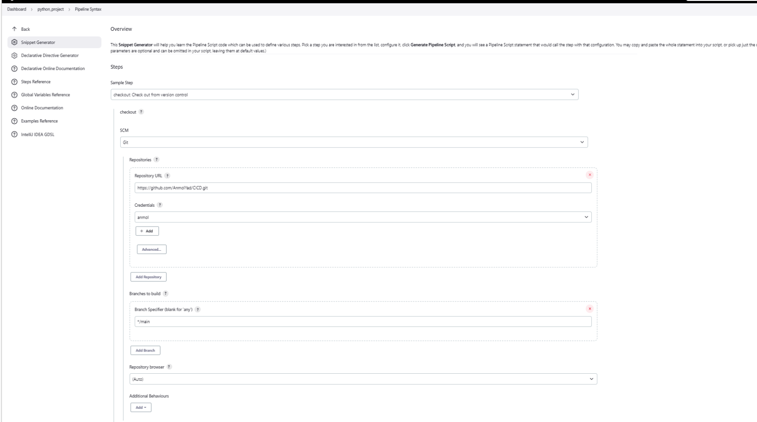

**Step3: Generate pipeline script**

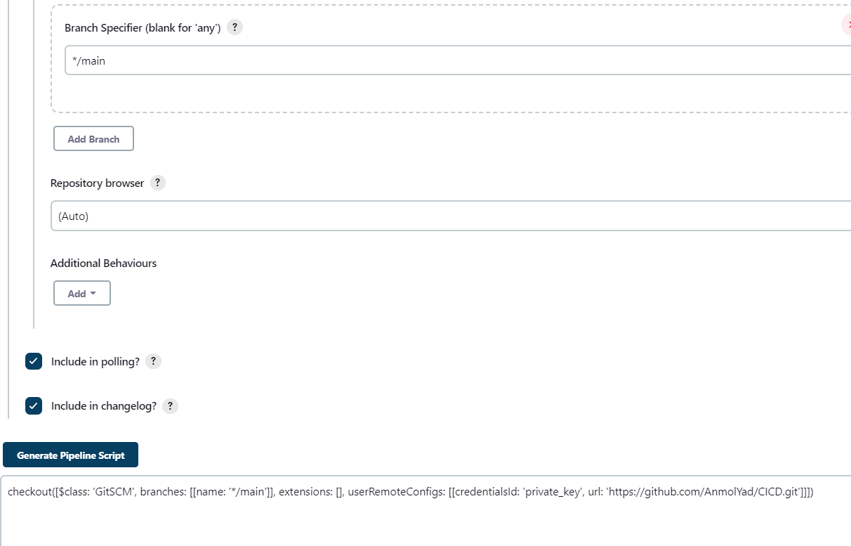

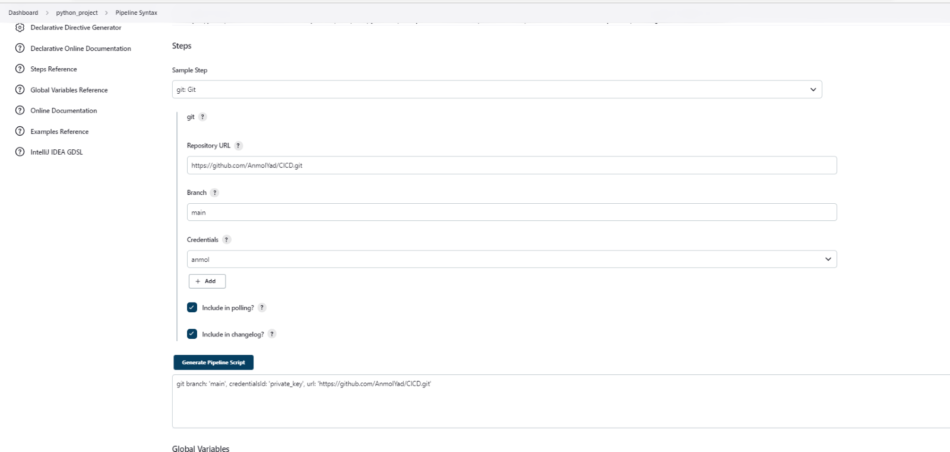

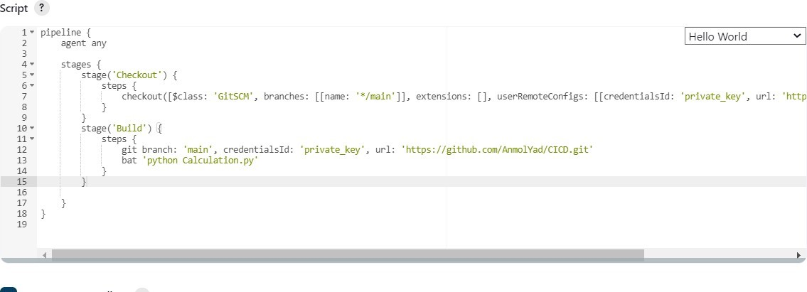

**//python code**

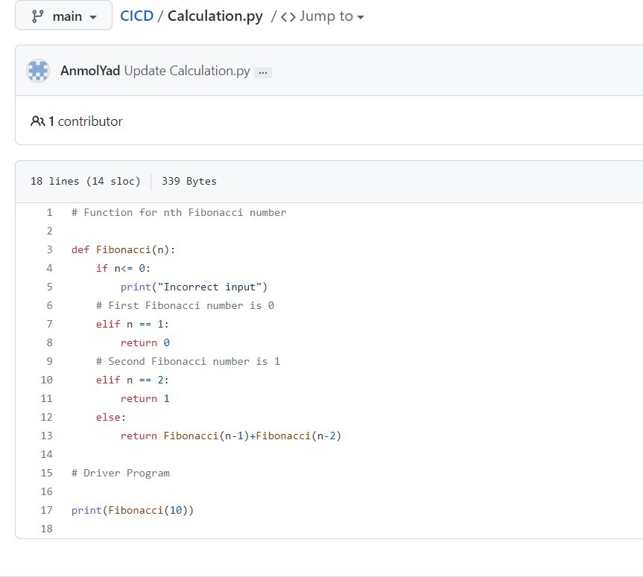

**//build**

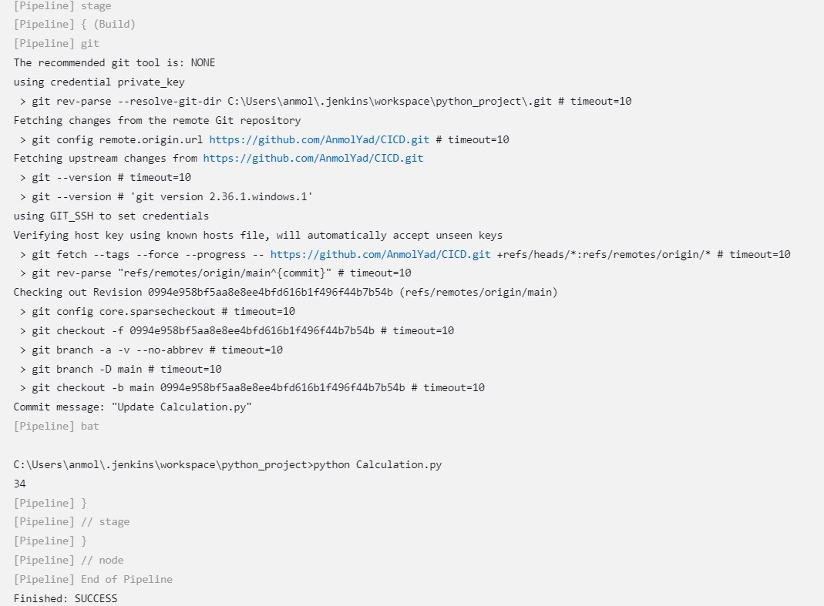

**//add testing stage and build again**

