

**Submitted by:** **Submitted to:**

**NAME: Rahul Gusain Omkarendra Tiwari**

**SAP: 500084143**

**ROLL NO.: R214220900**

**BATCH: 1 DevOps**

# **CI-CD Lab**

**Jenkins Jobs - sequential execution (Trigger one job after the other)**

Step 1: Create a new job.

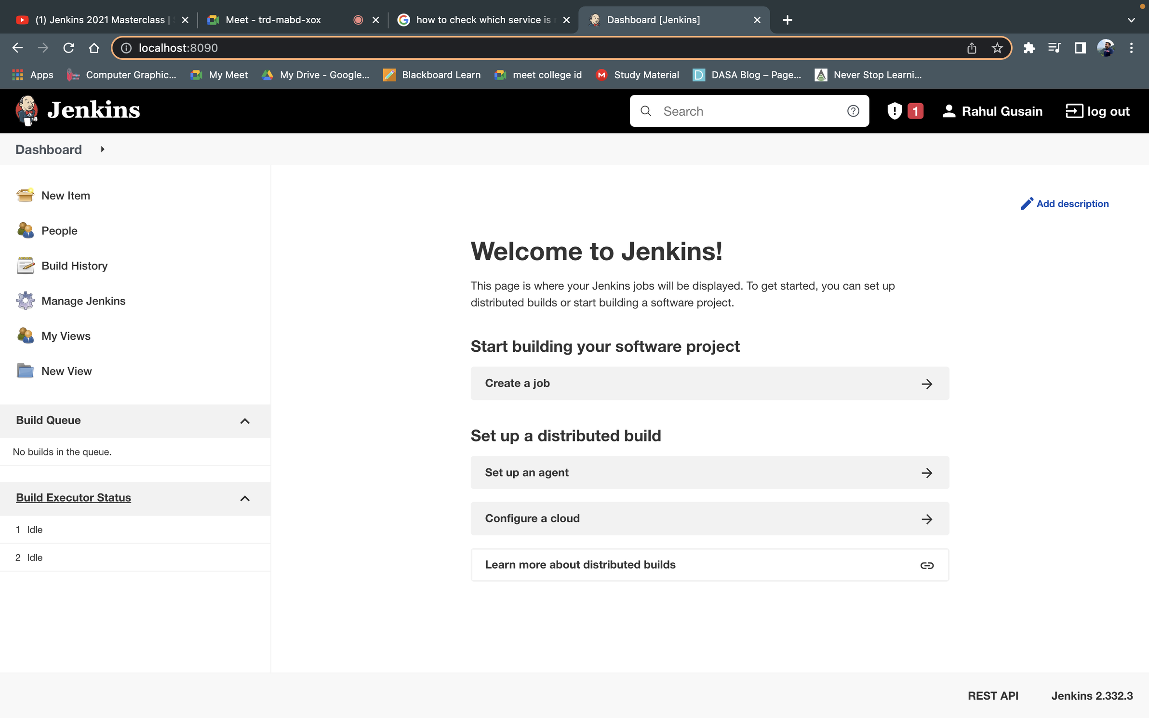

Step 2: Configure the build steps.

Select - Add build step > Windows batch command

Write some sample commands as follows.

Press Save.

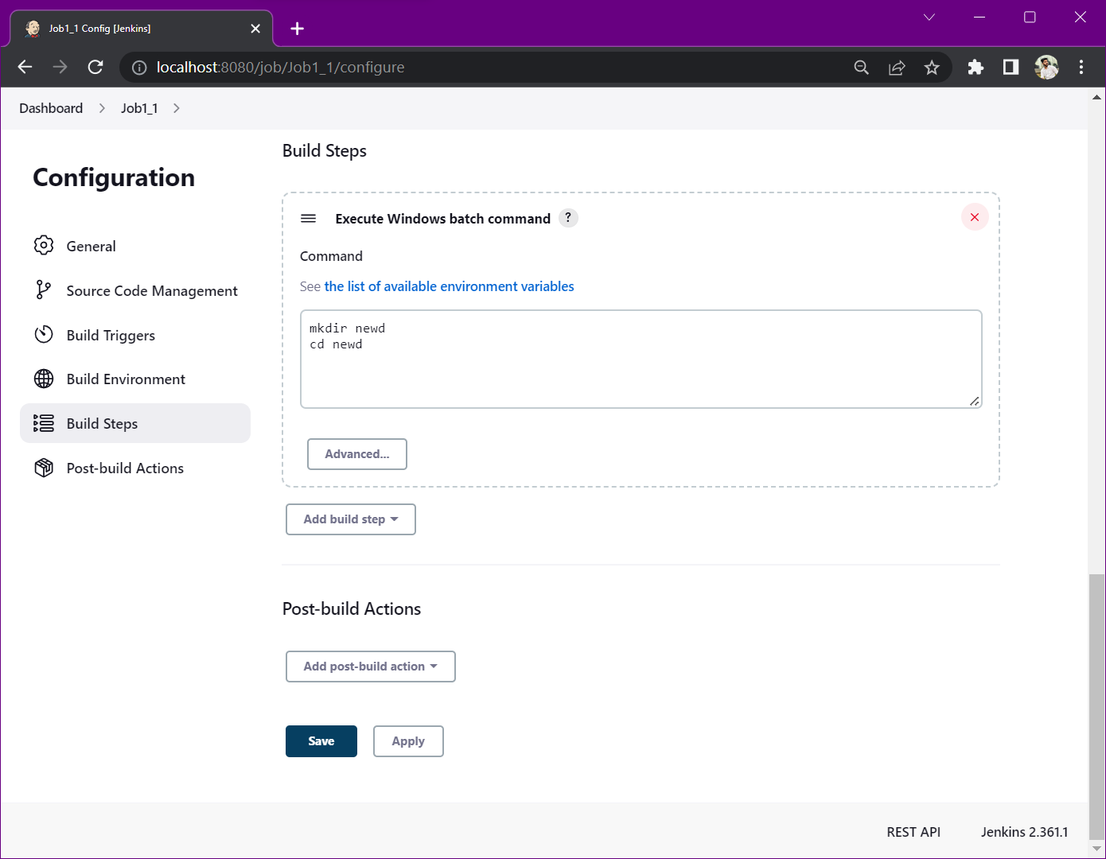

Step 3: Press Build now. And then click on Console Output.

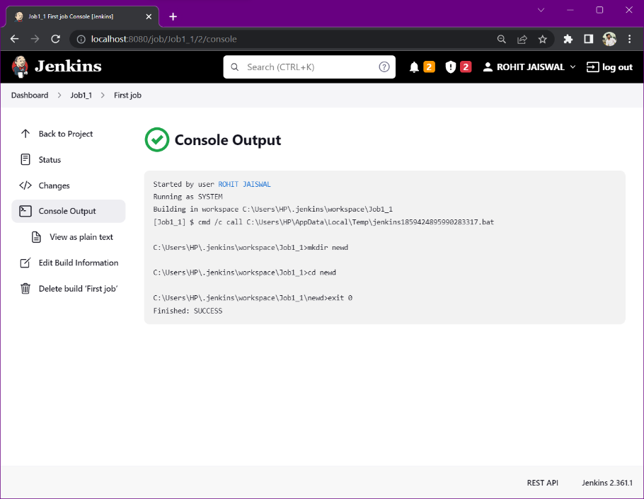

Step 4: Create second job.

Step 5: In build trigger section, tick the check box which says – Build after other projects are build.  
Select the first job in “Projects to watch” section > Trigger only if build is stable.

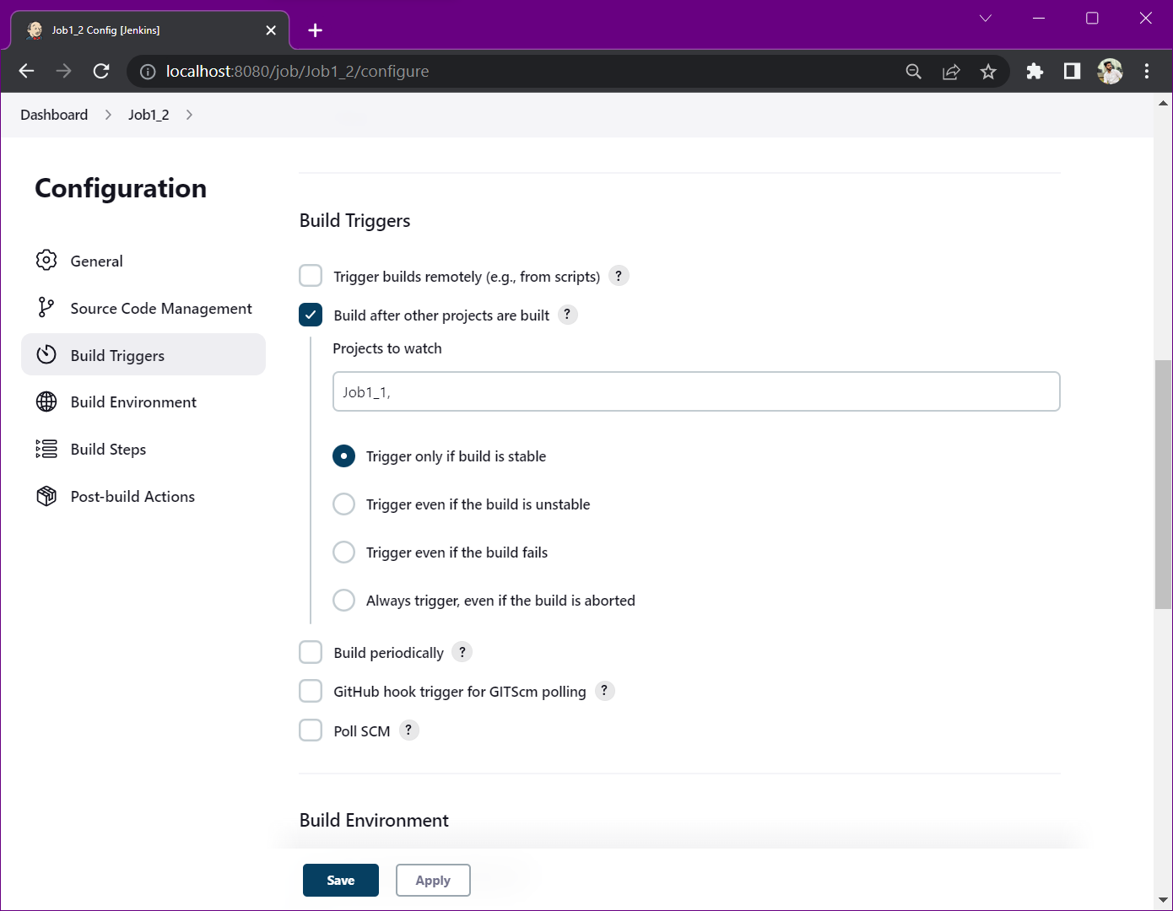

Step 6: Configure the build steps.

Select - Add build step > Windows batch command

Write some sample commands as follows.

Press Save

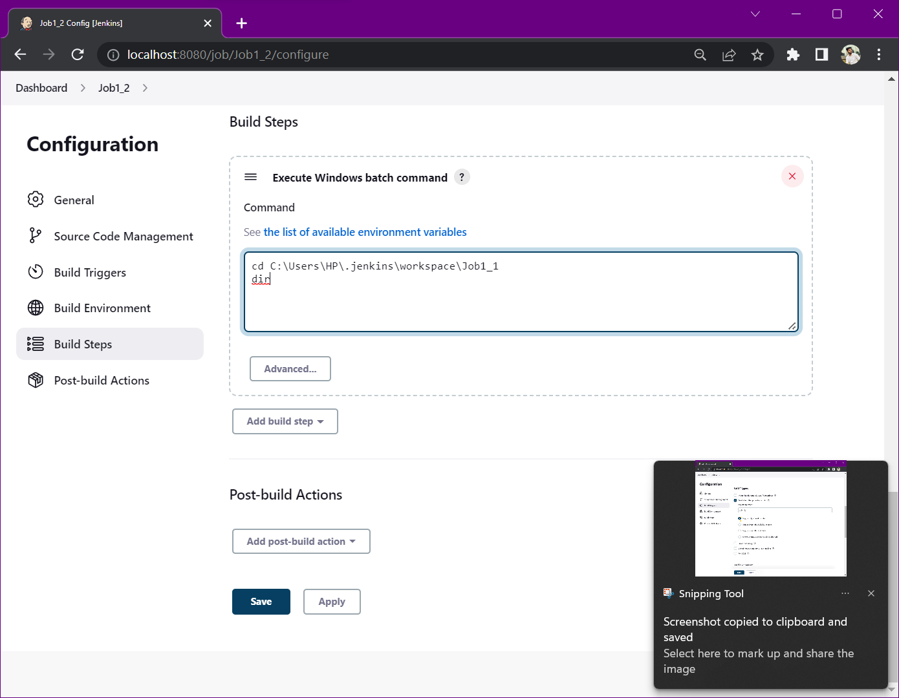

Step 7: Create third job.

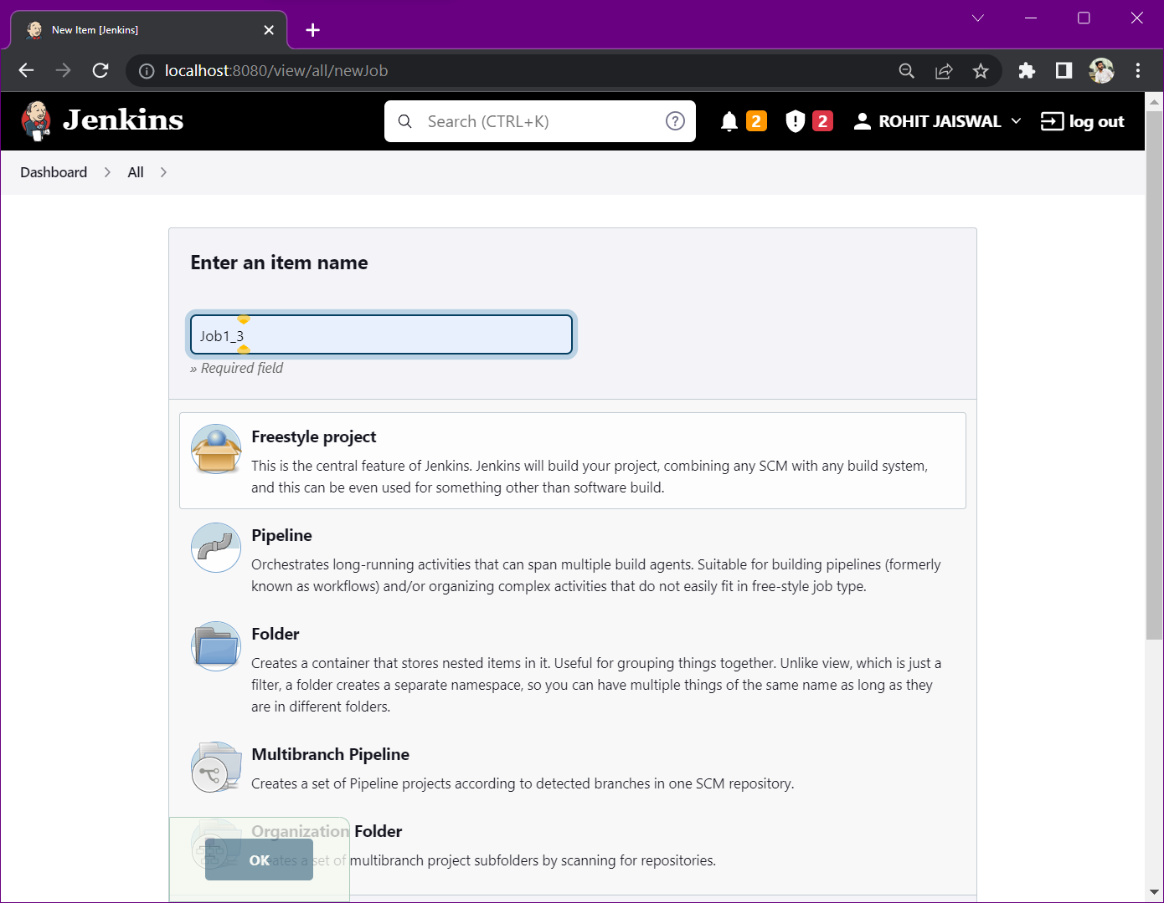

Step 8: In build trigger section, tick the check box which says – Build after other projects are build.  
Select the second job in “Projects to watch” section > Trigger only if build is stable.

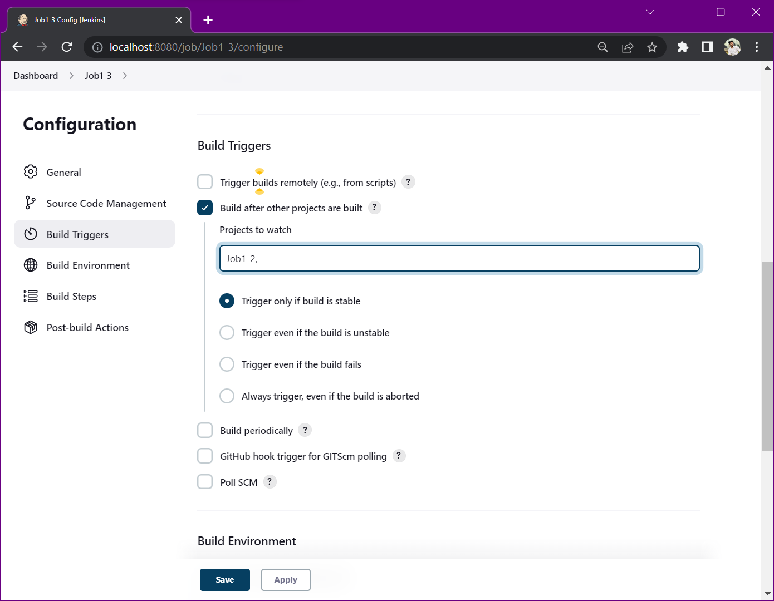

Step 9: Configure the build steps.

Select - Add build step > Windows batch command

Write some sample commands as follows.

Press Save

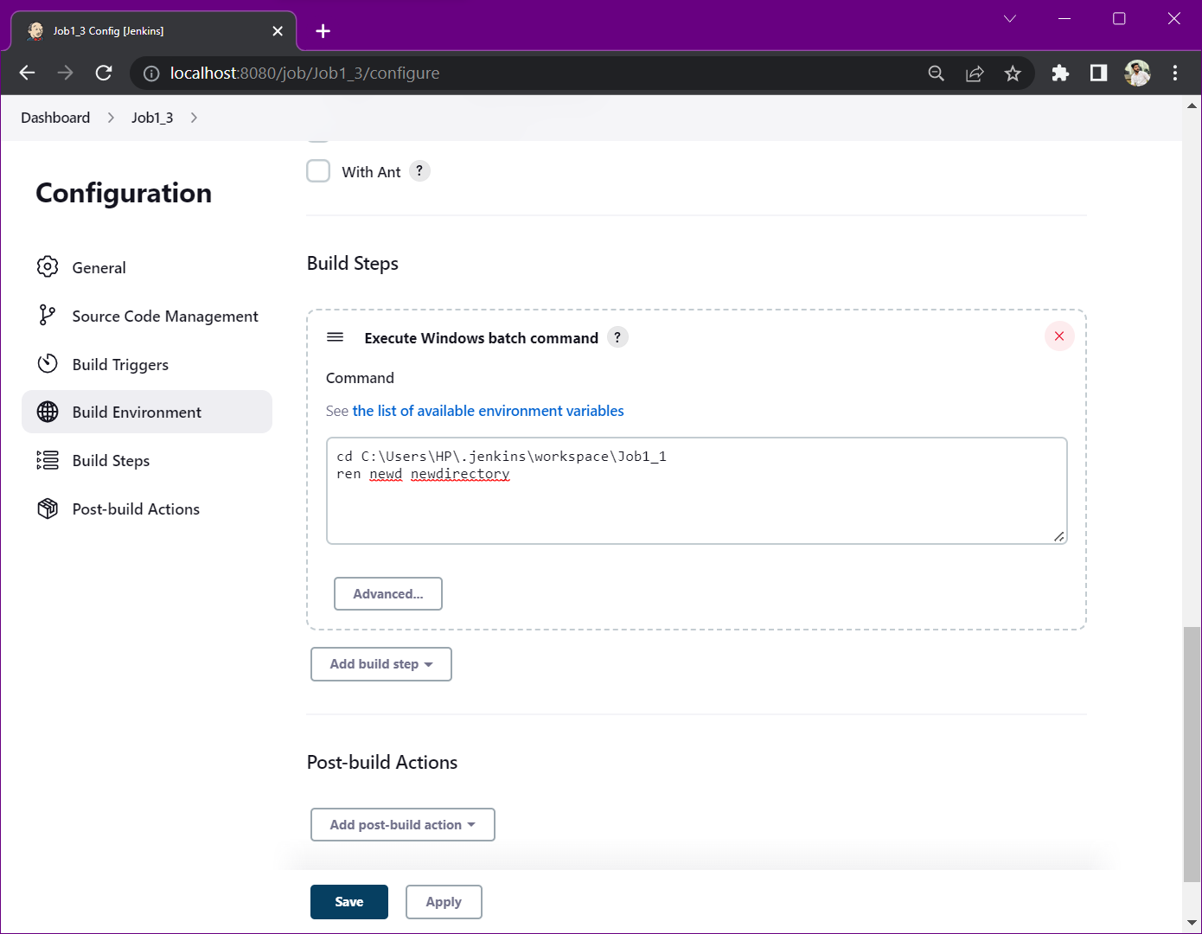

Step 10: Create fourth job.

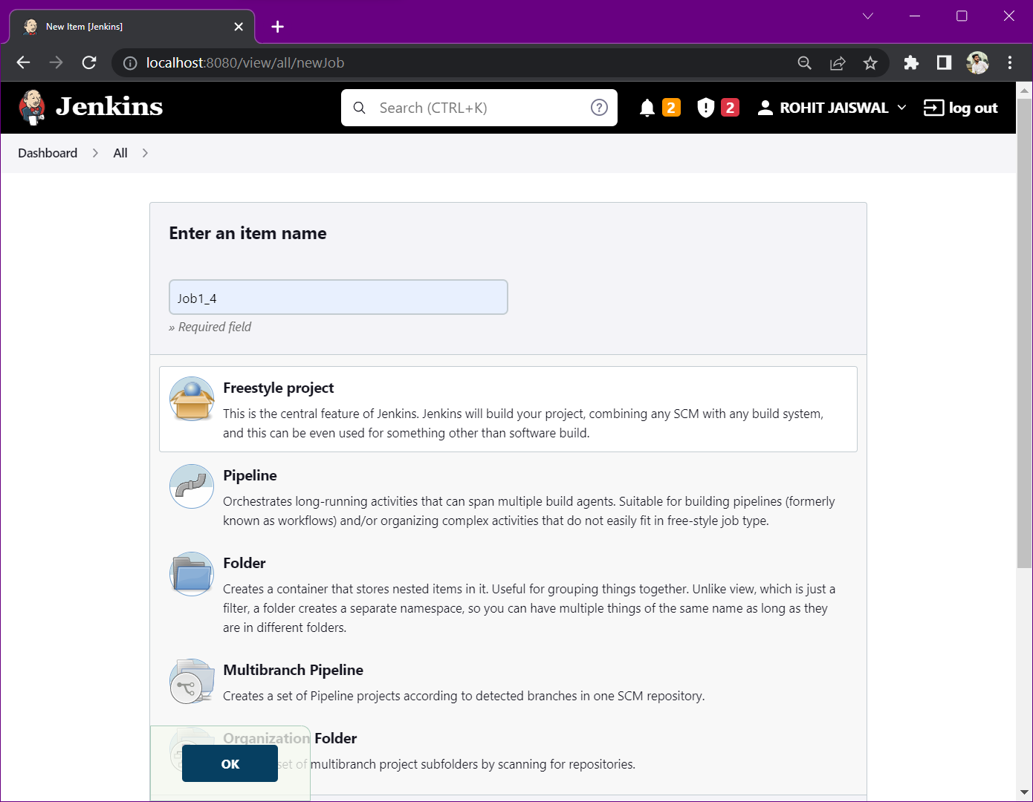

Step 11: In build trigger section, tick the check box which says – Build after other projects are build.  
Select the first job in “Projects to watch” section > Trigger only if build is stable.

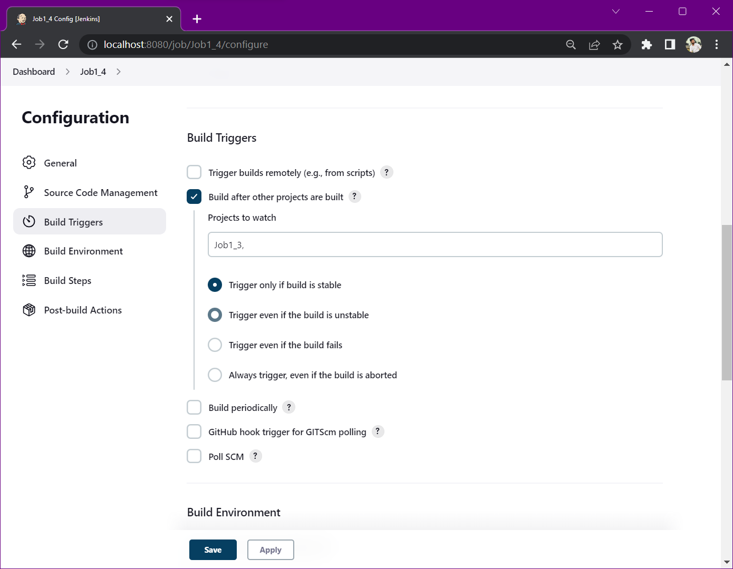

Step 12: Configure the build steps.

Select - Add build step > Windows batch command

Write some sample commands as follows.

Press Save

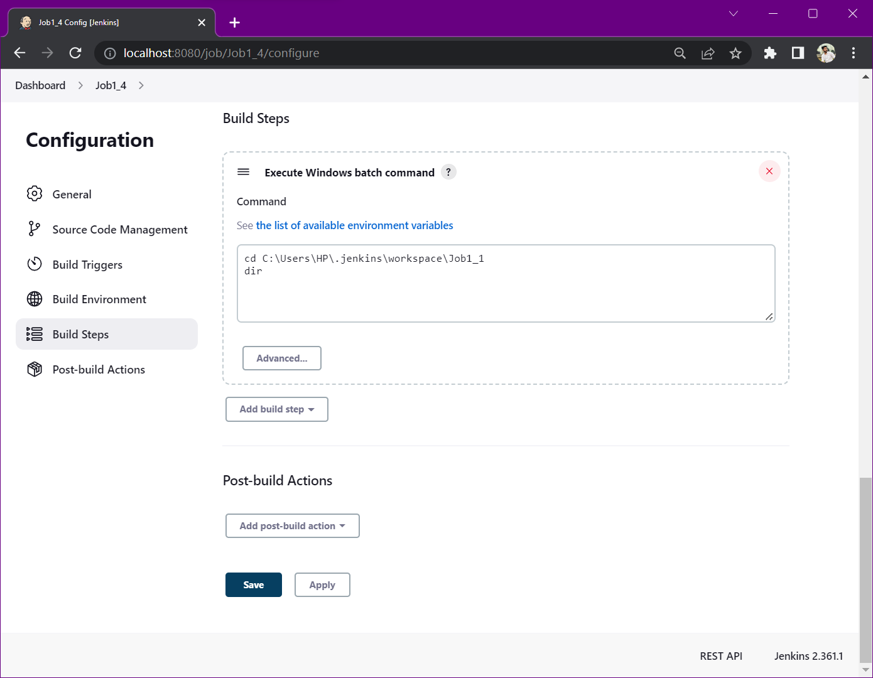

NOTE: We can see that build of Job 1 has been successfully created. Whereas, for 2nd, 3rd & 4th job, we have not created any build.

Step 13: Move to job 2 & create a build for this job.

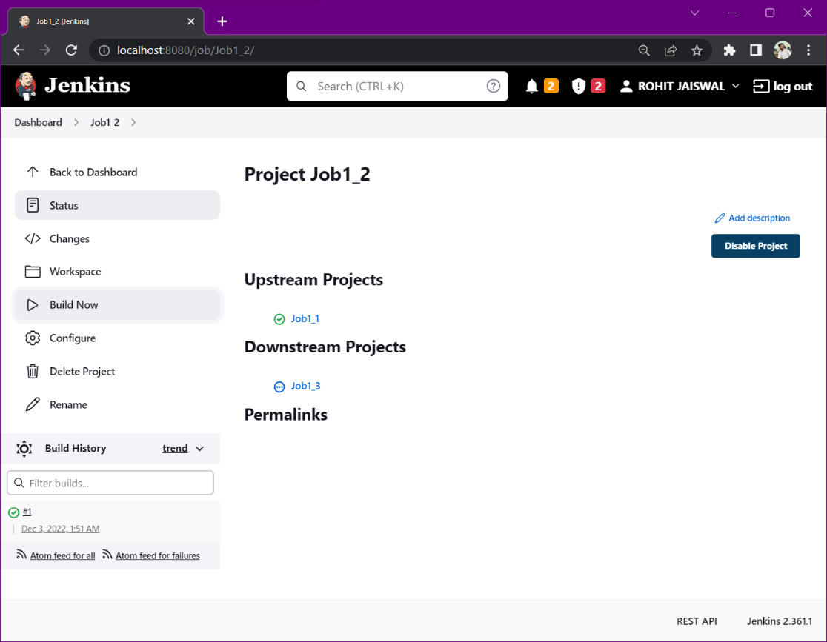

NOTE: Build of 2nd, 3rd & 4th job has been created just by creating the build of Job 2.

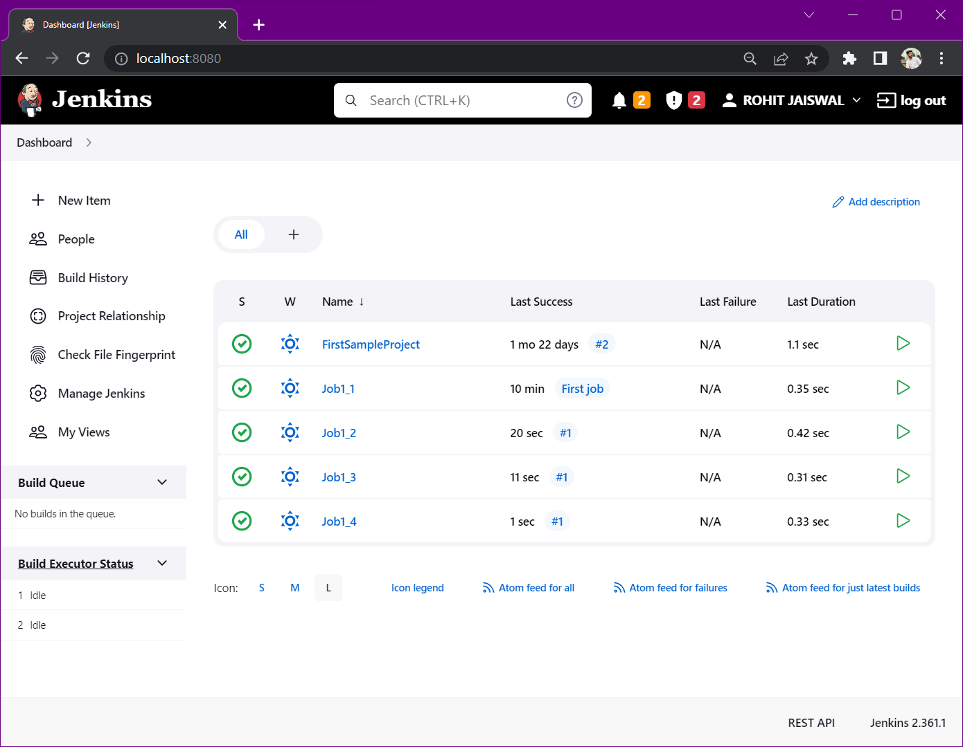

Step 14: Open the console output for 2nd, 3rd & 4th job’s build and check if the task specified in the commands has been performed correctly or not.

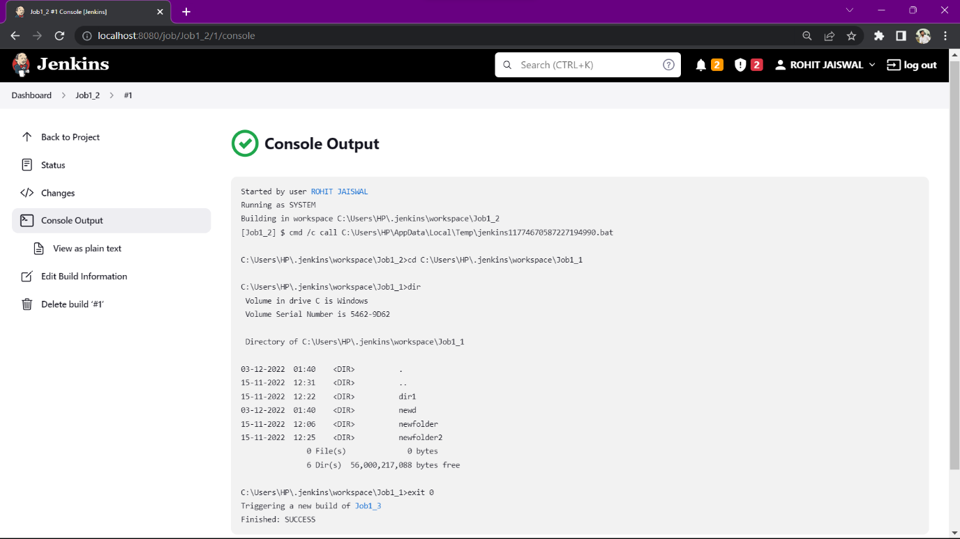

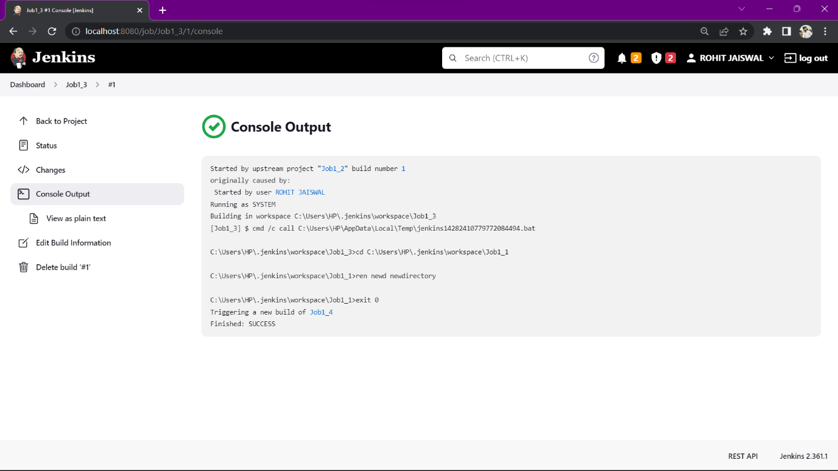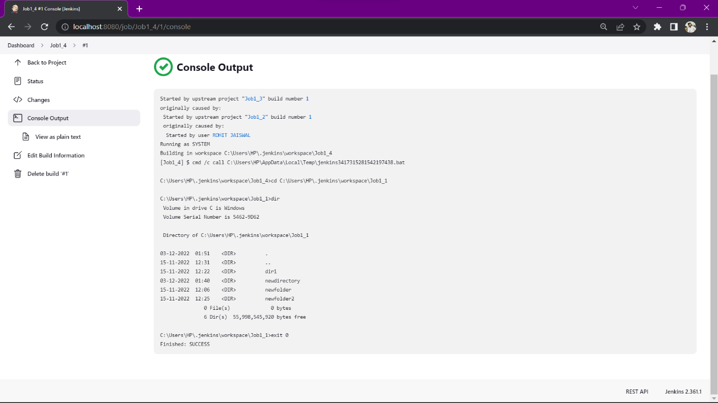

**CONCLUSION: *On a successful and stable build creation of Job 2; Job 3 and Job 4 got triggered automatically leading to creation to their builds as well.***