**Submitted by:** **Submitted to:**

**NAME: Rahul Gusain Omkarendra Tiwari ROLL NO.: R214220900**

**BATCH: 1 DevOps**

# **CI - CD Lab**

# MyPlugin--Plugin with two buttons and respective messages

Step 1: First create a plugin project for that I showed steps in screenshots:

* First go to File →New→ Other→ plugin project.

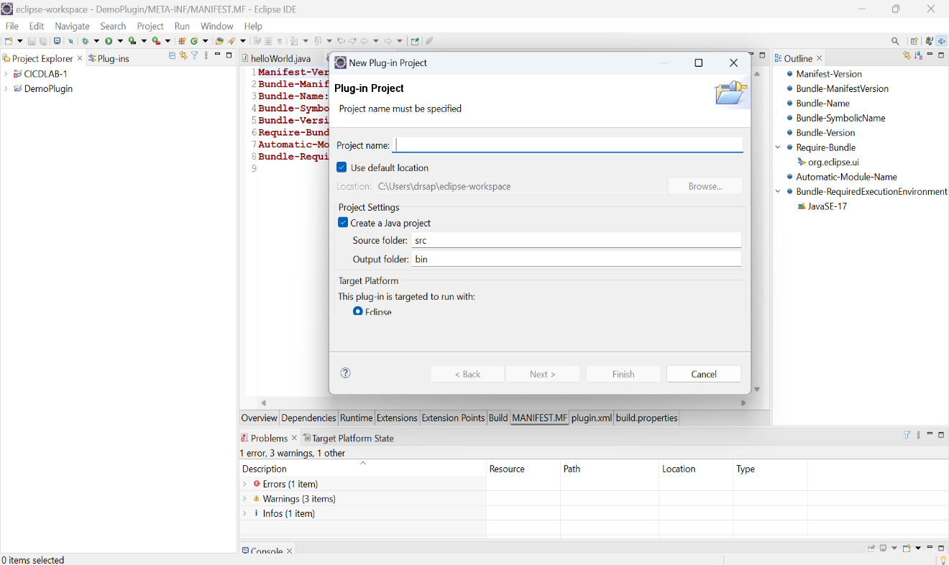

Select →Next→ give name → press next and then select Hello,World Command →Finish

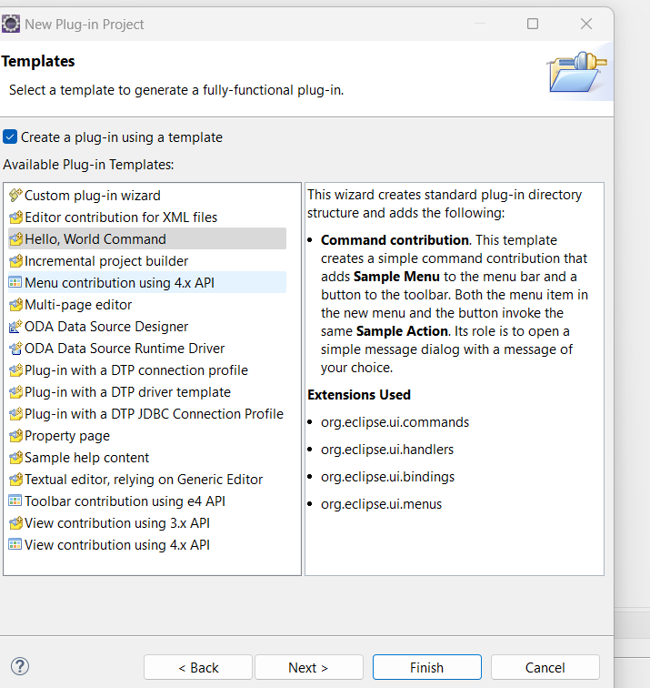

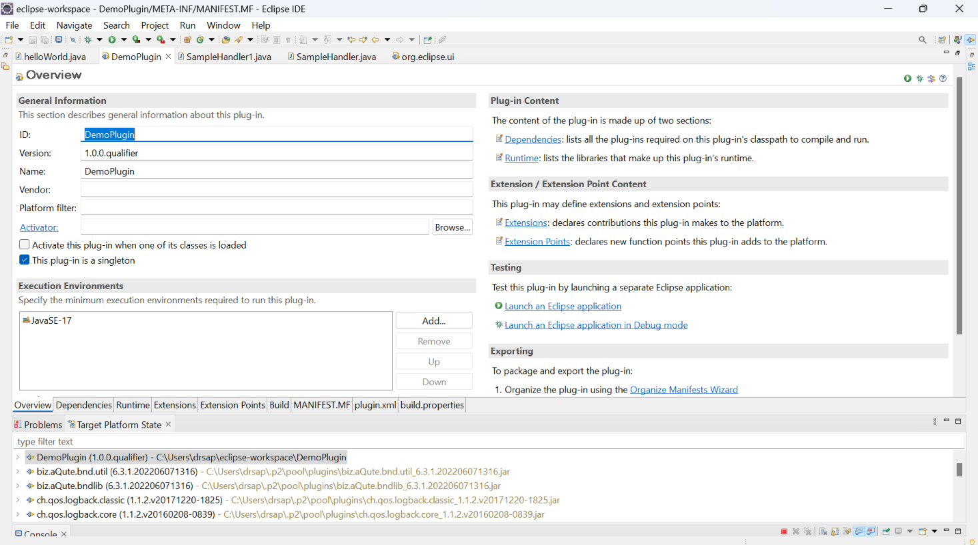

**Note :If you run as an Ecplise Application there is a single Sample menu which will print a simple Hello message.**

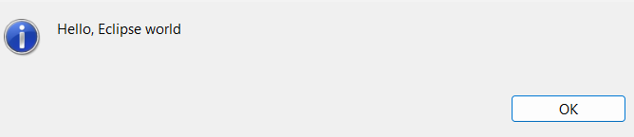

**Step 2 :-**

To add another menu button with different messages we need to create another Handler.java file with some different messages in my case I have created a java file with the name SampleHandler1.java

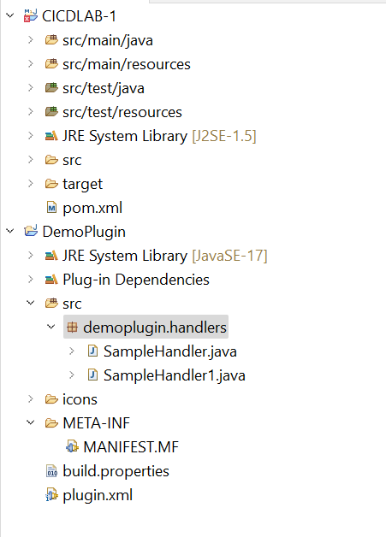

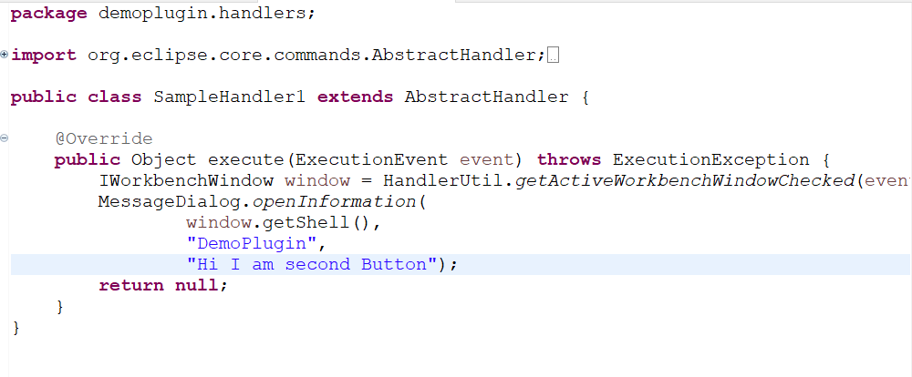

Step 3:- Make changes in Extensions or in plugin.xml file.

* Extension in simple hello world plugin environment :

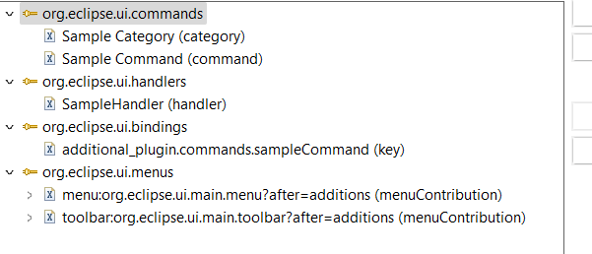

* Extension after making changes to get two menu with different messages.

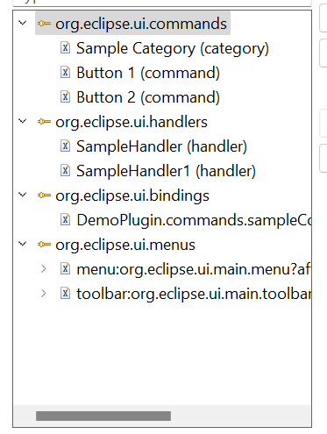

Step 4:

Plugin.xml file before making changes:

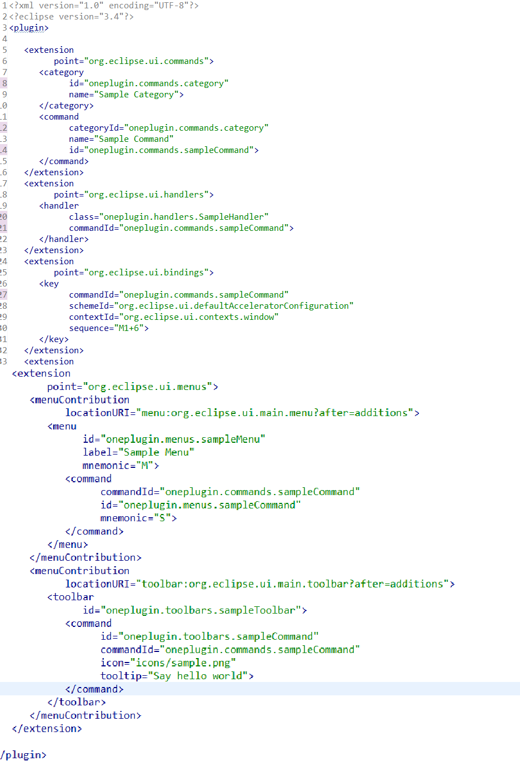

After making changes plugin.xml file look like:

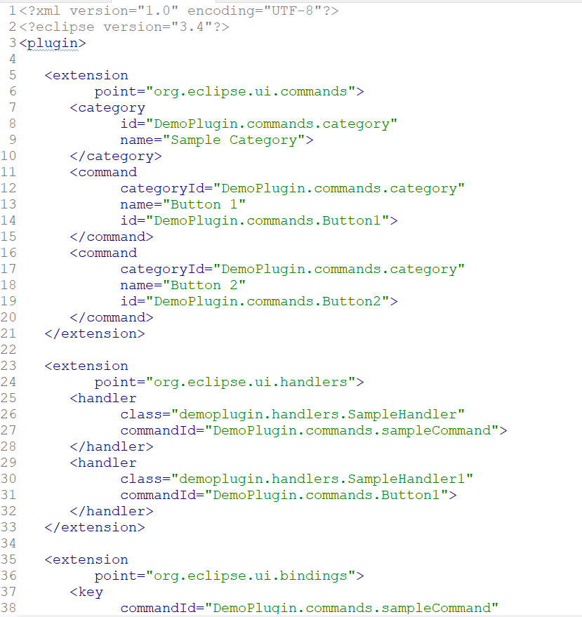

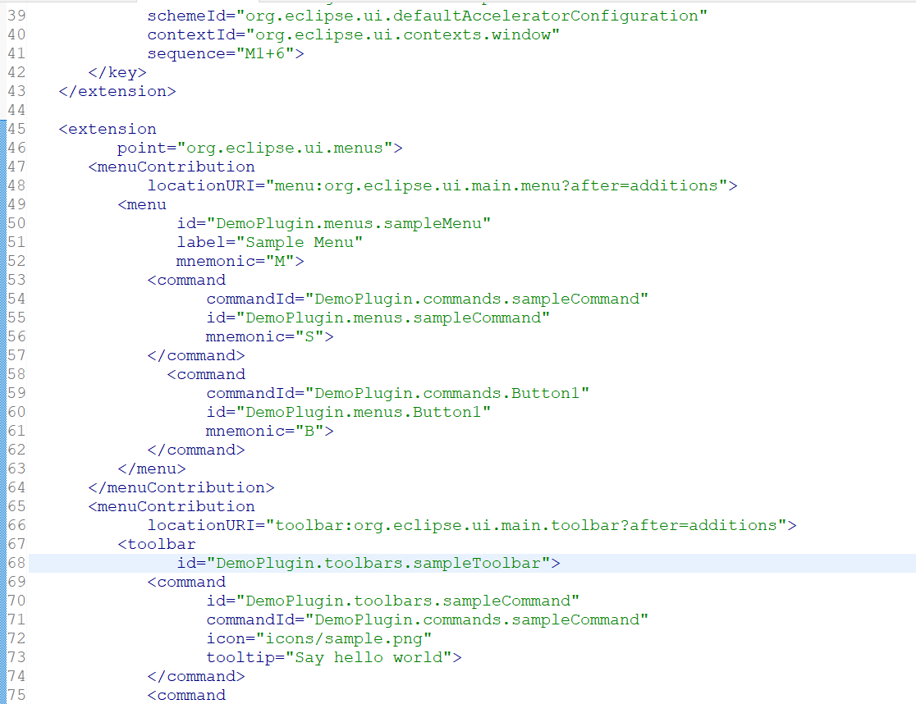

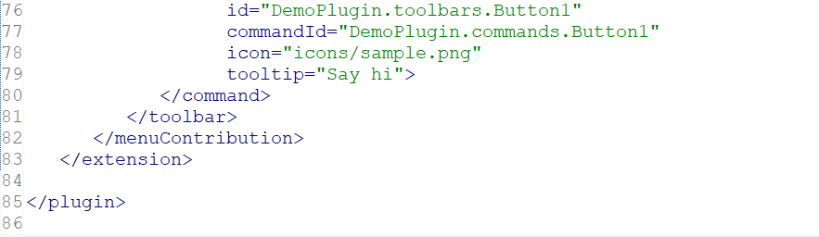

* This will create two menu buttons with different messages.
* Now the ouput will be look like :

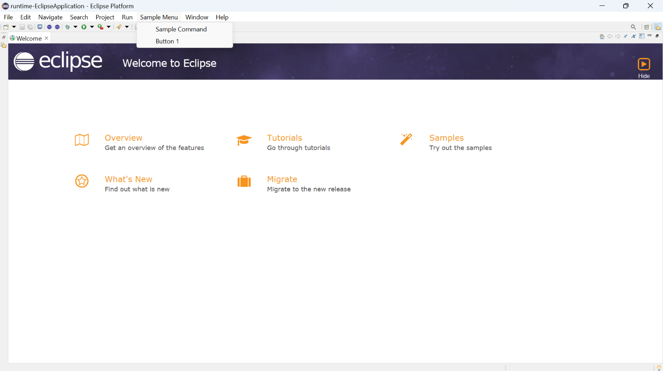

* If I press Sample Command button message would be print :

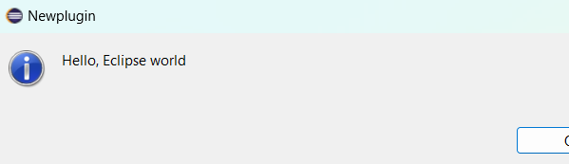

* If I press button 1 message would be print:

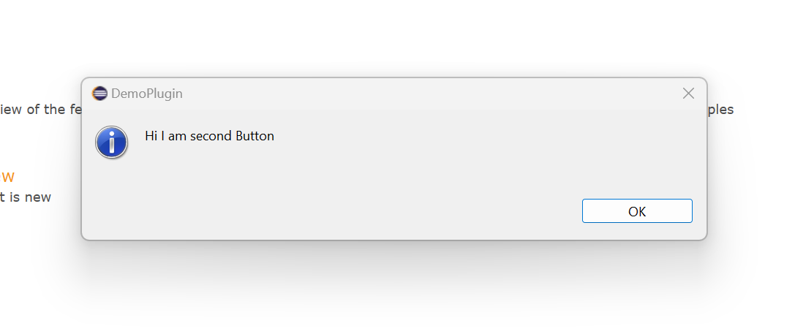

* + That’s the only work we need to do and our job is finish