

**Submitted by:** **Submitted to:**

**NAME: Rahul Gusain Omkarendra Tiwari ROLL NO.: R214220900**  
**BATCH: 1 DevOps**

# **CI - CD Lab**

**Static Code Analysis-2**

1. Create a class containing many methods in it.

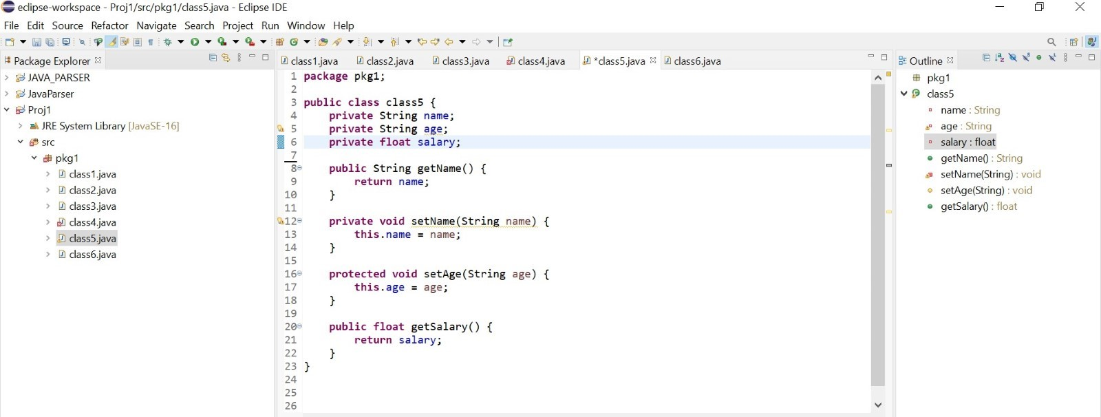

1. Print names of all the methods used in class5 in class6.

