

# **Data Communication & Computer Networks Lab**

**Submitted by: Submitted to:**

**NAME : Rahul Gusain**

**SAP : 500084143**

**ROLL NO. : R214220900 Ved Prakash Bhardwaj**

**BATCH: 1 DevOps**

**EXPERIMENT 3**

Familiarization of Transmission media

**Aim:** Study in detail the following transmission media in computer networks:

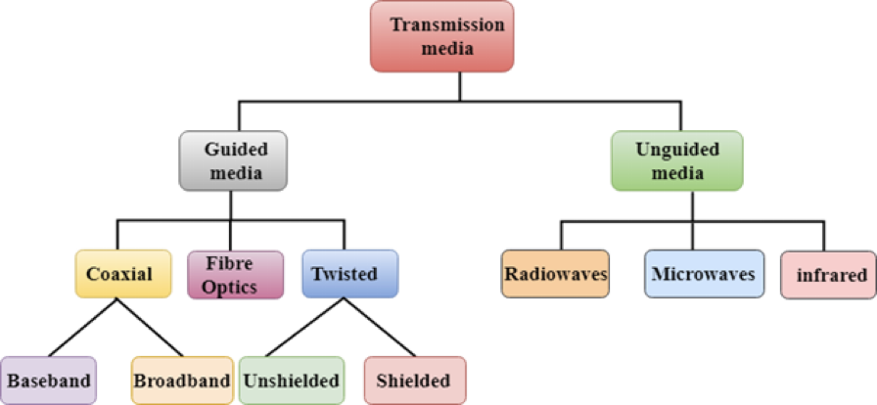

**Apparatus (Software):** No Software or hardware is needed.

**Theory:** Transmission media is a communication channel that transmits information from sender to receiver. Data is transmitted through electromagnetic signals. There are two types of transmission media, wired media and wireless media. In wired media, the medium characteristics are more important, whereas, in wireless media, the signal characteristics are more important. Different transmission media have different properties such as bandwidth, delay, cost and ease of installation and maintenance. The transmission media is available in the physical layer- the lowest layer of the OSI reference model.

**Procedure:** Explain each transmission medium in detail with a suitable diagram. Also, write a short note on each transmission medium.

**Conclusion:** Gain knowledge about transmission media in computer networks.

The transmission medium can be defined as a pathway that can transmit information from a sender to a receiver. Transmission media are located below the physical layer and are controlled by the physical layer. Transmission media are also called communication channels.

Transmission media are of two types −

* Guided Transmission Medium
* Unguided Transmission Medium

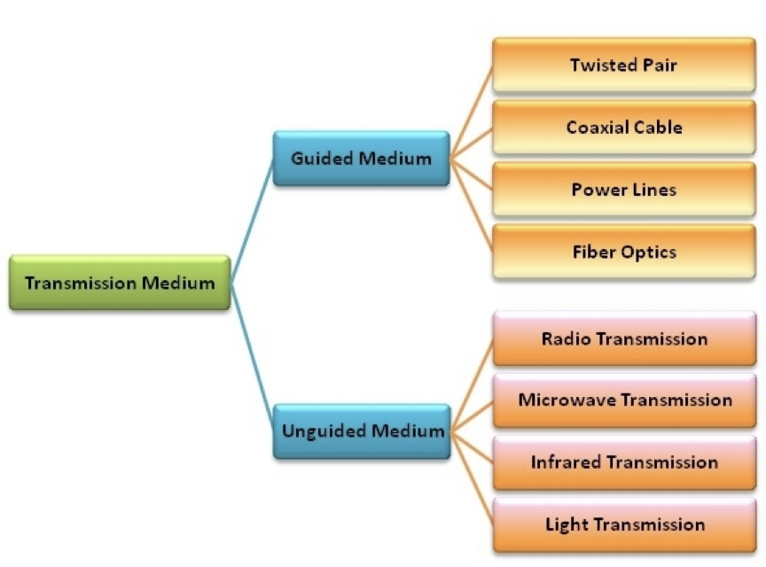

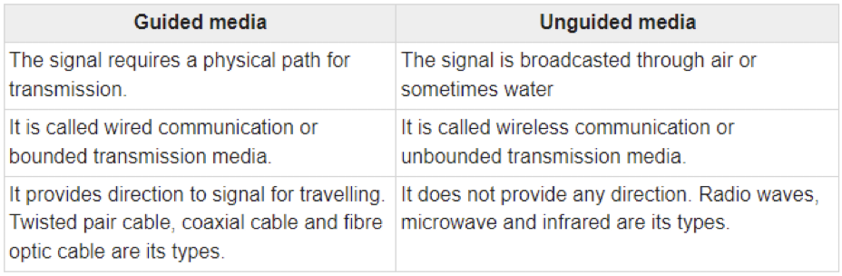

**Guided Transmission Medium**

Guided transmission media are also called bounded media or wired media. They comprise cables or wires through which data is transmitted. They are called guided since they provide a physical conduit from the sender device to the receiver device. The signal travelling through these media are bounded by the physical limits of the medium.

The most popular guided media are −

* Twisted pair cable
* Coaxial cable
* Power lines
* Fibre optics

**Twisted Pair Copper**

It is the most used media across the world. All the local telephone exchanges are made of twisted-pair copper. These telephone lines are reused as last-mile DSL access links to access the internet from home.

Twisted pair copper wires are also used in Ethernet LAN cables within homes and offices.

It supports low to High Data Rates which is in the order of Gigabytes.

These wires are effective up to a maximum distance of a few kilometres/miles, because the signal strength is lost significantly beyond the distance.

Generally, they come in two variants as follows −

* UTP (unshielded twisted pair)
* STP (shielded twisted pair)

For every variant, there are multiple sub-variants, based on the thickness of the material (like UTP-3, UTP-5, UTP-7 etc.)

The twisted-pair copper is diagrammatically represented as follows −

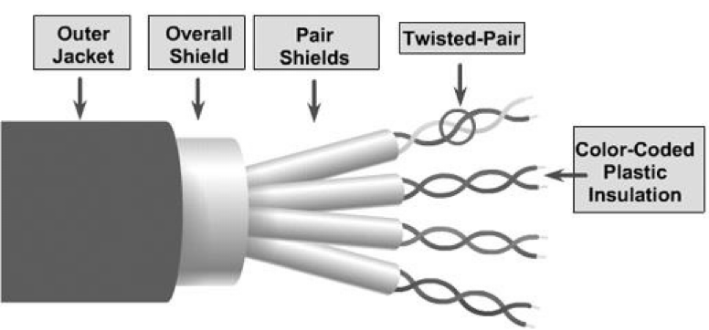

**Copper Co-axial Cables**

Co-axial copper cables consist of an inner copper conductor and an outer copper shield, which are separated by a dielectric insulating material, helpful in preventing signal losses.

Copper co-axial cables are used in cable TV networks and as trunk lines between telecommunication equipment.

It serves as an internet access line from the home and supports medium to high data rates.

The copper co-axial cable is diagrammatically represented as follows −

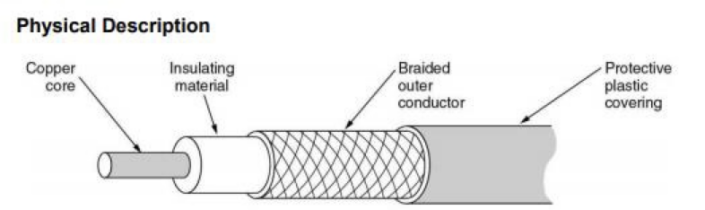

**Fibre Optic Cables**

In fibre optic cables the information is transmitted by the propagation of optical signals (light) fibre optic cables and not through electrical/electromagnetic signals. Because of this, fibre optics communication supports longer distances as there is no electrical interference.

The fibre optic cables are made of very thin strands of glass (silica). It supports high data rates.

It is used for accessing the internet from home through FTTH (Fiber-To-The-Home) lines.

Examples − OC-48, OC-192, FTTC, HFC.

The fibre optic cable is diagrammatically represented as follows –

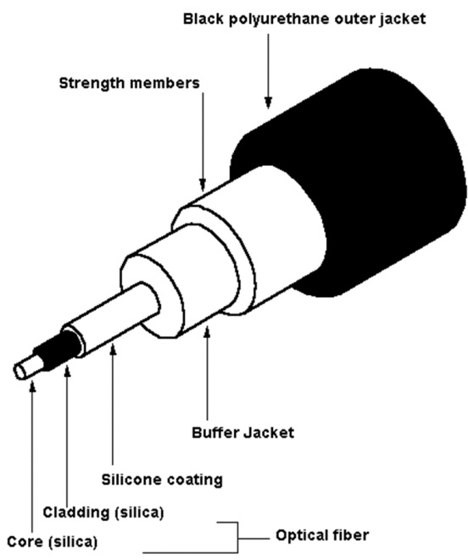

**Unguided Transmission Medium**

Unguided transmission media are also called wireless media. They transport data in the form of electromagnetic waves that do not require any cables for transmission. These media are bounded by geographical boundaries. This type of communication is commonly referred to as wireless communications.

Unguided signals can travel in three ways −

* Ground propagation
* Sky propagation
* Line–of–sight propagation

The commonly used unguided transmissions are −

* Radio transmission
* Microwave transmission
* Infrared transmission
* Light transmission

**(i) Radio waves –**

These are easy to generate and can penetrate through buildings. The sending and receiving antennas need not be aligned. Frequency Range: 3KHz – 1GHz. AM and FM radios and cordless phones use Radio waves for transmission.

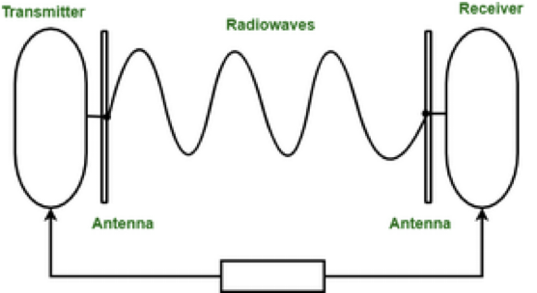

Further Categorized as (i) Terrestrial and (ii) Satellite.

**(ii) Microwaves –**

It is a line of sight transmission i.e. the sending and receiving antennas need to be properly aligned with each other. The distance covered by the signal is directly proportional to the height of the antenna. Frequency Range: 1GHz – 300GHz. These are majorly used for mobile phone communication and television distribution.

The electromagnetic waves having frequencies between 1 and 300 GHz are known as a microwave. Microwave systems use very high-frequency radio or television signals to transmit data through space. Therefore, the transmitter and receiver of a microwaves system, which is mounted on very high towers, should be invisible to each other, i.e., they both should be in a line of sight. Moreover, the signals become weak after travelling a certain distance and require power amplification.

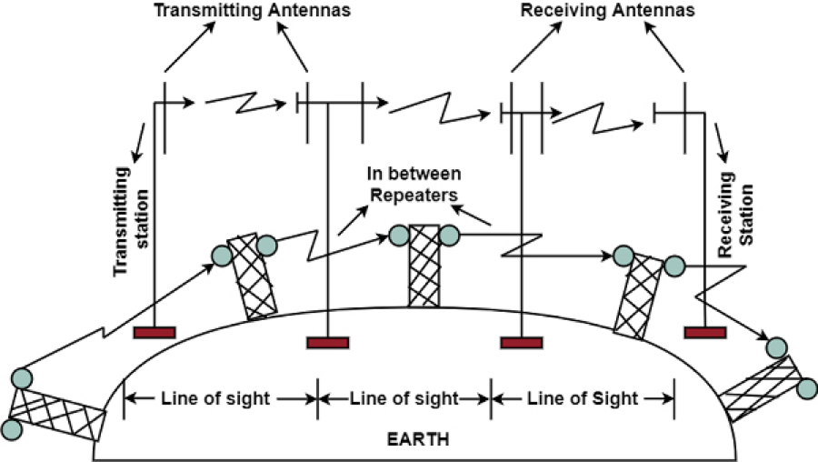

**(iii) Infrared –**

Infrared waves are used for very short distance communication. They cannot penetrate through obstacles. This prevents interference between systems. Frequency Range: 300GHz – 400THz. It is used in TV remotes, wireless mouse, keyboards, printers, etc.

