

# **Data Communication & Computer Networks Lab**

**Submitted by: Submitted to:**

**NAME : Rahul Gusain**

**SAP : 500084143**

**ROLL NO. : R214220900 Ved Prakash Bhardwaj**

**BATCH: 1 DevOps**

**EXPERIMENT 1**

**Familiarization of Network devices**

**REPEATER:** A repeater is a network device that retransmits a received signal with more power and to an extended geographical or topological network boundary than what would be capable with the original signal.

A repeater is implemented in computer networks to expand the coverage area of the network, repropagate a weak or broken signal and or service remote nodes. Repeaters amplify the received/input signal to a higher frequency domain so that it is reusable, scalable and available.

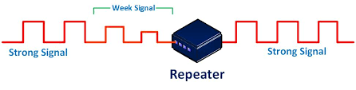

**HUB:** A hub is a common connection point, also known as a network hub, which is used for the connection of devices in a network. It works as a central connection for all the devices that are connected through a hub. The hub has numerous ports. If a packet reaches one port, it is able to see all the segments of the network due to a packet being copied to the other ports. A network hub has no routing tables or intelligence (unlike a network switch or router), which is used to send information and broadcast all network data across each and every connection.

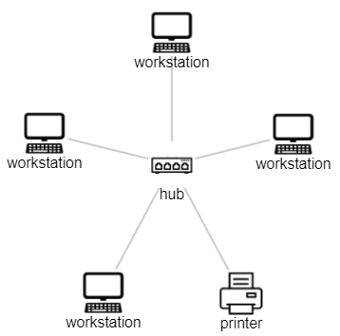

**SWITCH:** A switch is a multiport bridge with a buffer and a design that can help it function better (a large number of ports indicate less traffic). A switch is a data connection layer device. Before forwarding data, the switch may check for faults, which makes it extremely efficient because it doesn't transport packets with errors and only forwards good packets to the correct port. To put it another way, the switch separates hosts' collision domains while maintaining the broadcast domain

.

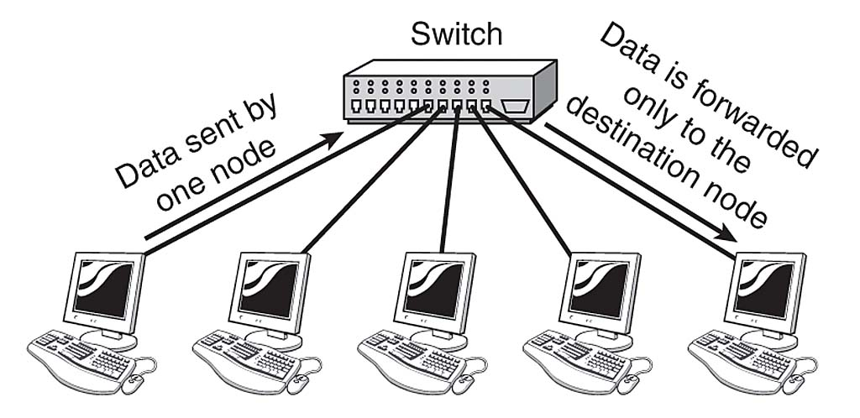

**ROUTER:** In the same way that switches route data packets based on their IP addresses, routers do the same. The router is basically a device that performs network layer functions. Routers connect LANs and WANs and decide how to route data packets using a dynamically updated routing table. The router divides the broadcast domains of hosts connected through it.

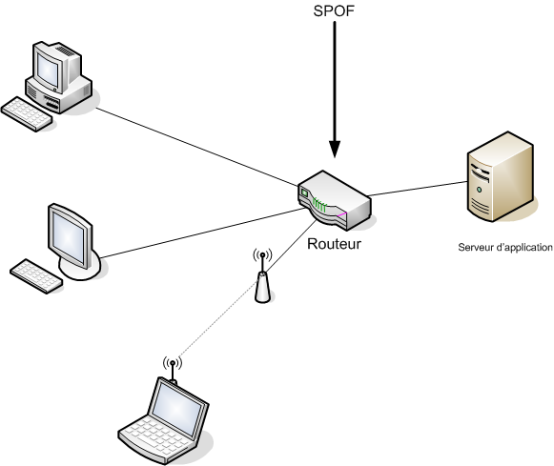

**BRIDGE:** A data connection layer device is referred to as a bridge. A bridge is a repeater that also has the capacity to filter data by reading the source and destination MAC addresses. It may also be used to connect two LANs using the same protocol. Because it only has one input and output port, it is a two-port device.

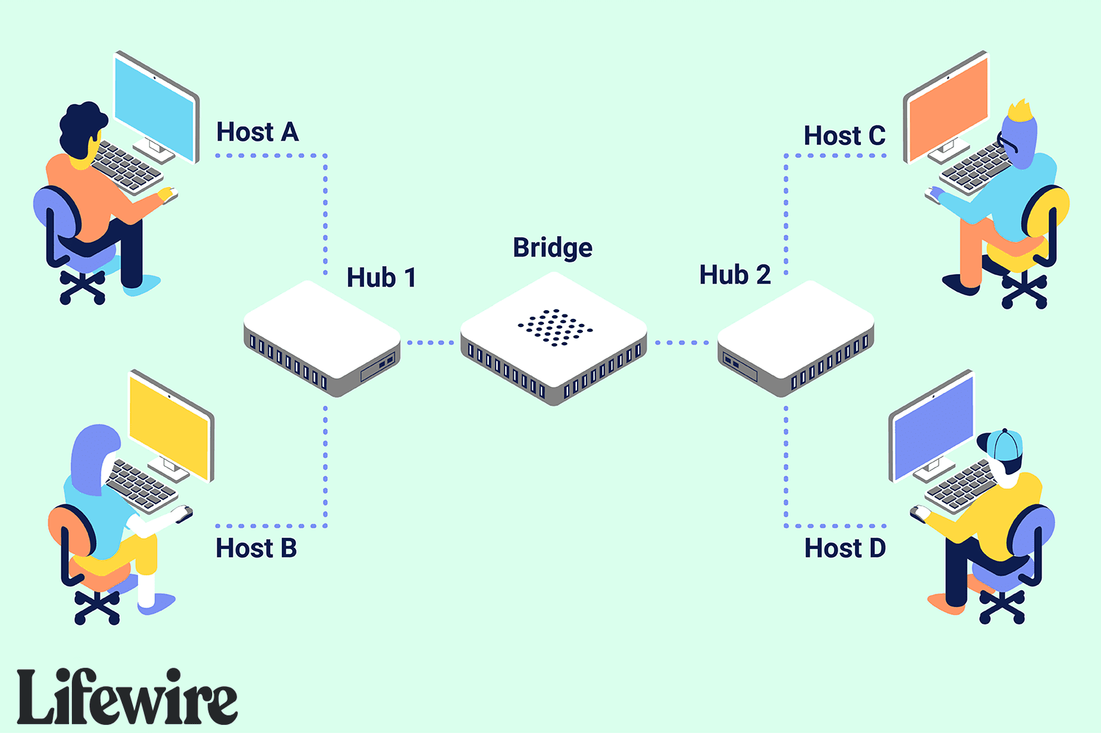

**GATEWAY:** A gateway is basically a device or hardware which acts as a “gate” among the networks. Thus it can also be defined as a node that acts as an entrance for the other nodes in the network. It is also responsible for enabling the traffic flow within the network. Gateway uses more than one protocol for communication thus its activities are much more complex than a switch or a router.

