Rahul Kumar Hotta

Tel: 7008262278 | Email: rahulhotta99@gmail.com

Tulasi nagar 3rd line, Berhampur, Odisha

Nationality: Indian | Birthday: 24/02/2002 | Website: https://portfolio

-

614

.pages.dev/

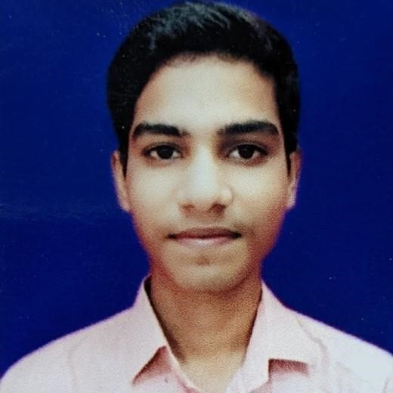

Objective I am a web developer focused on crafting clean and user-friendly

experiences, I am passionate about building excellent software that improves the lives of those around me.

Skills HTML

CSS

JAVASCRIPT

REACT.JS

BOOTSTRAP

PYTHON

|  |  |
| --- | --- |
| Education |  |
| 08/2019 – 4/2023 | B.tech - 8.05 CGPA  National institute of science and technology |
| 05/2017 - 03/2019 | Intermediate - 68%  Arihant junior college |
| 03/2005 - 03/2017 | Matriculation SSVM - 82.5% |

Ramahari nagar

# Project

Expense tracker :

This is a website that will help you to track the user 's expenses.

The website can be accessed using the link below:

<https://expense-tracker-4ve.pages.dev/>

portfolio website:

I have developed a portfolio website which lets the user know about my skills and works.

The website can be accessed using the link below:

<https://portfolio-614.pages.dev/>

Books search website:

I have developed a website which lets the user search and buy books.

The website can be accessed using the link below:

<https://libot.pages.dev/>

Notes management website:

I have developed a note taking website which helps the user to create and manage notes.

The website can be accessed using the link below:

<https://upbeat-ritchie-c74b9f.netlify.app/>