Session 1 Assignment 1

Problem Statement : Import Acadgild VM into Oracle virtual box by following the document given in the dashboard.

Steps done :

- Installed Oracle Virtual Box and imported the Acadgild VM. Configured RAM to be of 3 Gb.

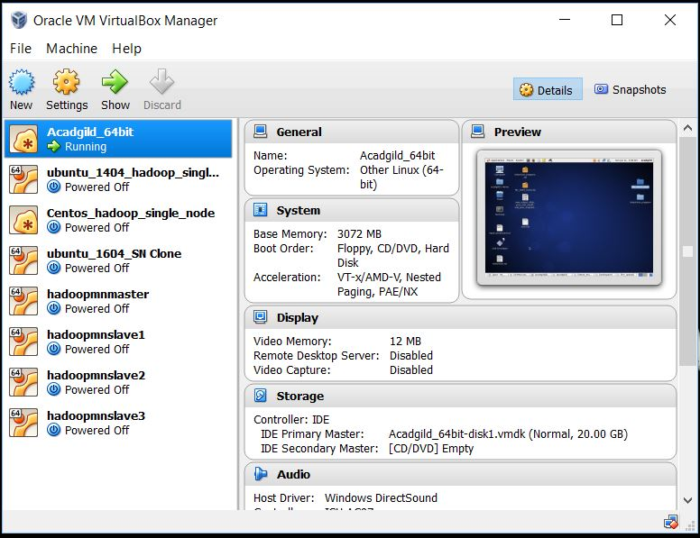

2) Boot up the Acadgild VM

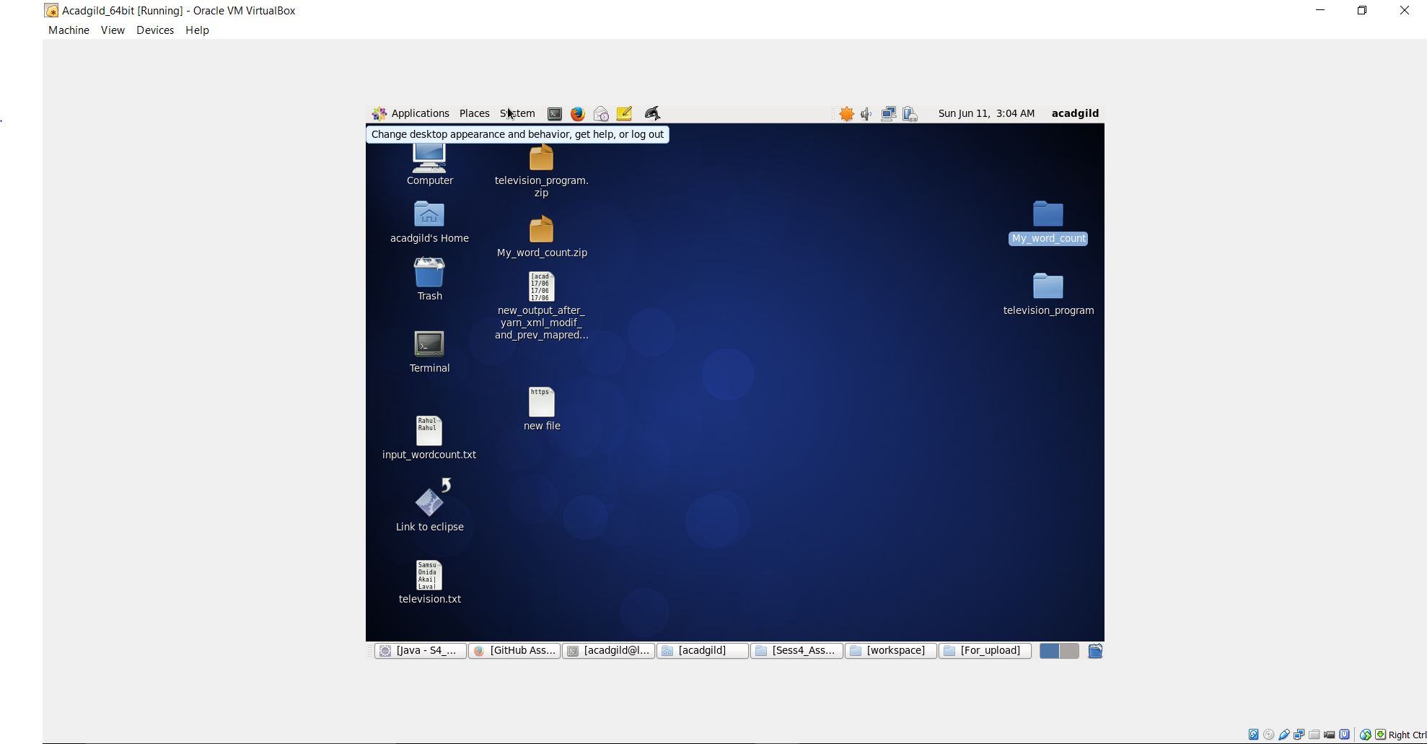

- Started all the daemons and did a jps showing all the daemons running.
