Session 2 Assignement 1 : Task 1, Task 2

Problem Statement :

Task 1:
Check whether /user/acadgild directory exists or not in the HDFS.
If it doesn't exist, then create this.
Create a directory /user/acadgild/hadoop.

Task 2:
Create a file in HDFS under directory /user/aca
dgild/hadoop, with name word-count.txt.
Whatever we type on screen should get appended to the file.
Try to type (on screen) few lines from any online article or textbook.

Steps done :

- Executed a ls command to check whether hadoop folder is there in /user/acadgild.
- Executed mkdir command to create a new folder named hadoop in /user/acadgild.

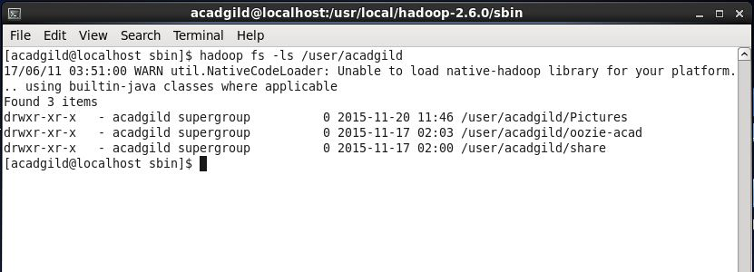
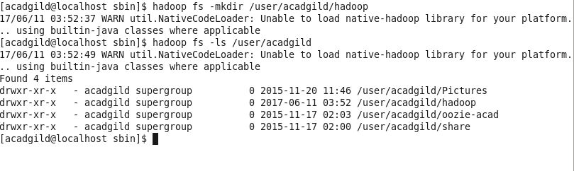

- Executed appendToFile command with required directory and file name which will create a file named word-count.txt in /user/acadgild/hadoop.
It will also wait for user input where we can text string which will be appended to word-count.txt.
