Session 2 Assignment 2

Problem Statement :
Task 1
Create a file max-temp.txt in local FS.
Put some 10-15 records of date and temperature example:
dd-mm-yyyy,temperature
Example:
10-01-1990,10
10-02-1991,20
Move this file to HDFS at /user/acadgild/hadoop.

Task 2
Change the permission of the file /user/acadgild/hadoop/max-temp.txt, such that
only the owner and the group members have full control over the file.
Others do not have any control over it.

Steps done:

- Confirming Max-temp.txt doen not exists in hadoop

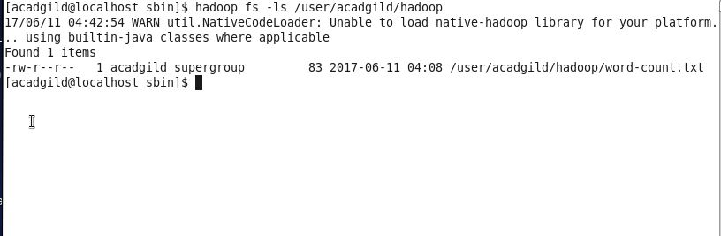

- Move this file to hdfs by executing put command. Check the permission by executing ls command
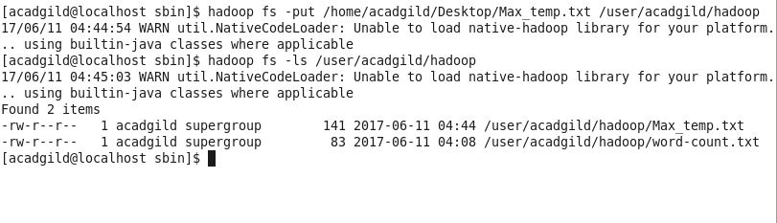

- Confirm from browser on localhost:500070
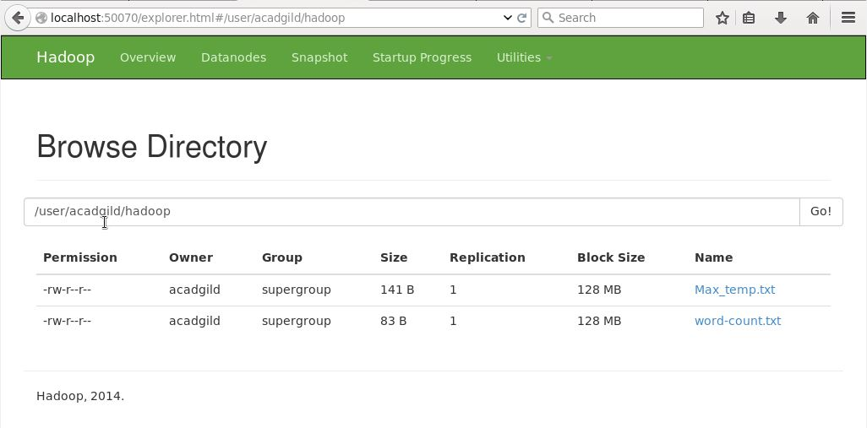

- Change the permission

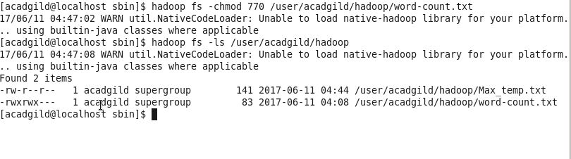

- Confirm from browser
