Steps Done:

1) Invalid records are ignored and Company name and Sales are written as output of First Task as sequence file.

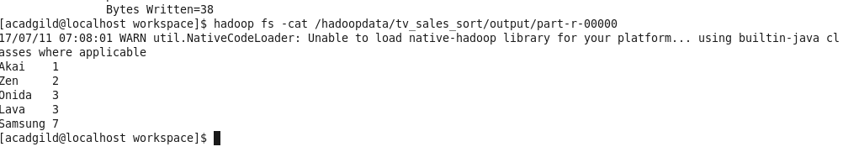
2) The Sequence File is taken as input of next task where output is sorted as per sales of each company.

