Steps Done :

1) Invalid records are ignored and Company name and Sales are written as output of First Task as sequence file.

2) Min Sales , Max Sales and number of reducers to be used are given input for the second task. In this case, Min Sales is given 0, Max Sales as 10 and Number of reducers as 2.
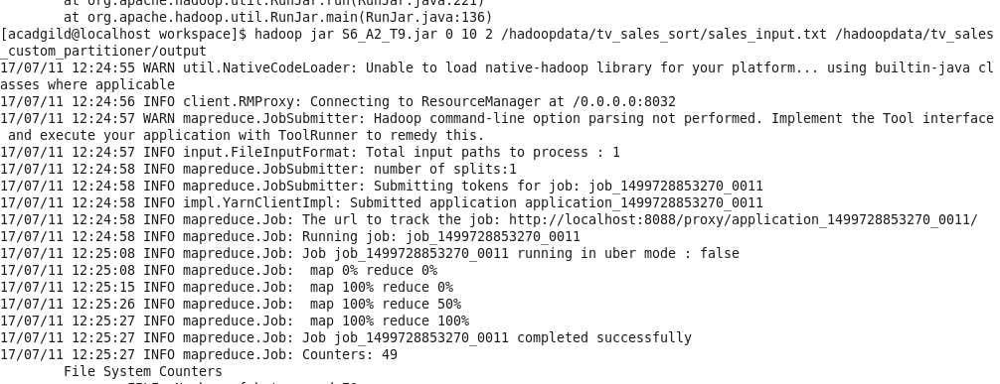
3) Final Output

